UNITED STATES
SECURITIES AND EXCHANGE COMMISSION
Washington, D.C. 20549
FORM 8-K
CURRENT REPORT
PURSUANT TO SECTION 13 OR 15(d) of the SECURITIES EXCHANGE ACT OF 1934
Date of Report (Date of earliest event reported): March 16, 2026
Vistagen Therapeutics, Inc.
(Exact name of registrant as specified in its charter)
Nevada |  |  | 000-54014 |  |  | 20-5093315
(State or other jurisdiction of  incorporation) |  |  | (Commission File Number) |  |  | (IRS Employer  Identification Number)
343 Allerton Ave.
South San Francisco, California 94080
(Address of principal executive offices)
(650) 577-3600
(Registrant’s telephone number, including area code)
Not Applicable
(Former name or former address, if changed since last report)
Check the appropriate box below if the Form 8-K filing is intended to simultaneously satisfy the filing obligation of the registrant under any of the following provisions:
o Written communications pursuant to Rule 425 under the Securities Act (17 CFR 230.425)
o Soliciting material pursuant to Rule 14a-12 under the Exchange Act (17 CFR 240.14a -12)
o Pre-commencement communications pursuant to Rule 14d-2(b) under the Exchange Act (17 CFR 240.14d -2(b))
o Pre-commencement communications pursuant to Rule 13e-4(c) under the Exchange Act (17 CFR 240.13e -4(c))
Securities registered pursuant to Section 12(b) of the Act:
Title of each class |  |  | Trading Symbol(s) |  |  | Name of each exchange on which registered
Common Stock, par value $0.001 per share |  |  | VTGN |  |  | Nasdaq Capital Market
Indicate by check mark whether the registrant is an emerging growth company as defined in Rule 405 of the Securities Act of 1933 (17 CFR 230.405) or Rule 12b-2 of the Securities Exchange Act of 1934 (17 CFR 240.12b-2)
Emerging Growth Company o
If an emerging growth company, indicate by check mark if the registrant has elected not to use the extended transition period for complying with any new or revised financial accounting standards provided pursuant to Section 13(a) of the Exchange Act o

Item 7.01 Regulation FD Disclosure.

On March 16, 2026, Vistagen Therapeutics, Inc. (the “Company”) began utilizing a new corporate presentation, a copy of which is attached to this Current Report on Form 8-K as Exhibit 99.1.

The information under this Item 7.01 and Exhibit 99.1 attached hereto are intended to be furnished and shall not be deemed “filed” for purposes of Section 18 of the Securities Exchange Act of 1934, as amended (the “Exchange Act”), or otherwise subject to the liabilities of that section, nor shall such information be deemed incorporated by reference in any filing under the Securities Act of 1933, as amended, or the Exchange Act, except as expressly set forth by specific reference in such a filing.

Item 9.01 Financial Statements and Exhibits.
(d)Exhibits Index
Exhibit No. |  |  |  |  |  | Description
99.1 |  |  |  |  |  | Vistagen Therapeutics, Inc. Corporate Presentation, dated March 2026
104 |  |  |  |  |  | Cover Page Interactive Data File (embedded within the Inline XBRL document)

Signatures
Pursuant to the requirements of the Securities Exchange Act of 1934, the registrant has duly caused this report to be signed on its behalf by the undersigned thereunto duly authorized.
 |  |  | Vistagen Therapeutics, Inc.
Date: March 16, 2026 |  |  | By: |  |  | /s/ Shawn K. Singh
Shawn K. Singh
President and Chief Executive Officer
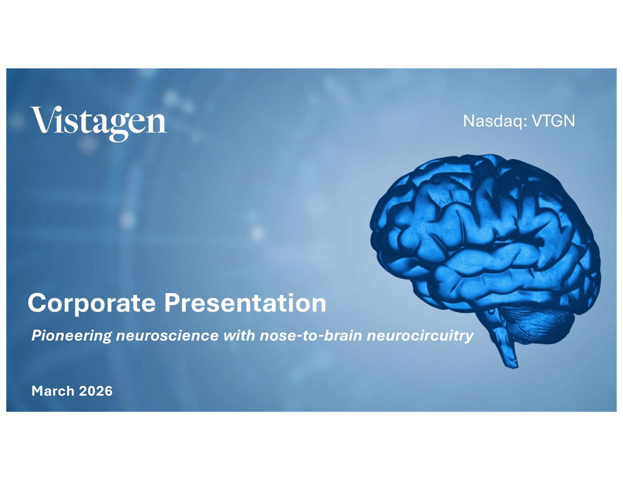

1 Nasdaq: VTGN Corporate Presentation Pioneering neuroscience with nose-to-brain neurocircuitry March 2026

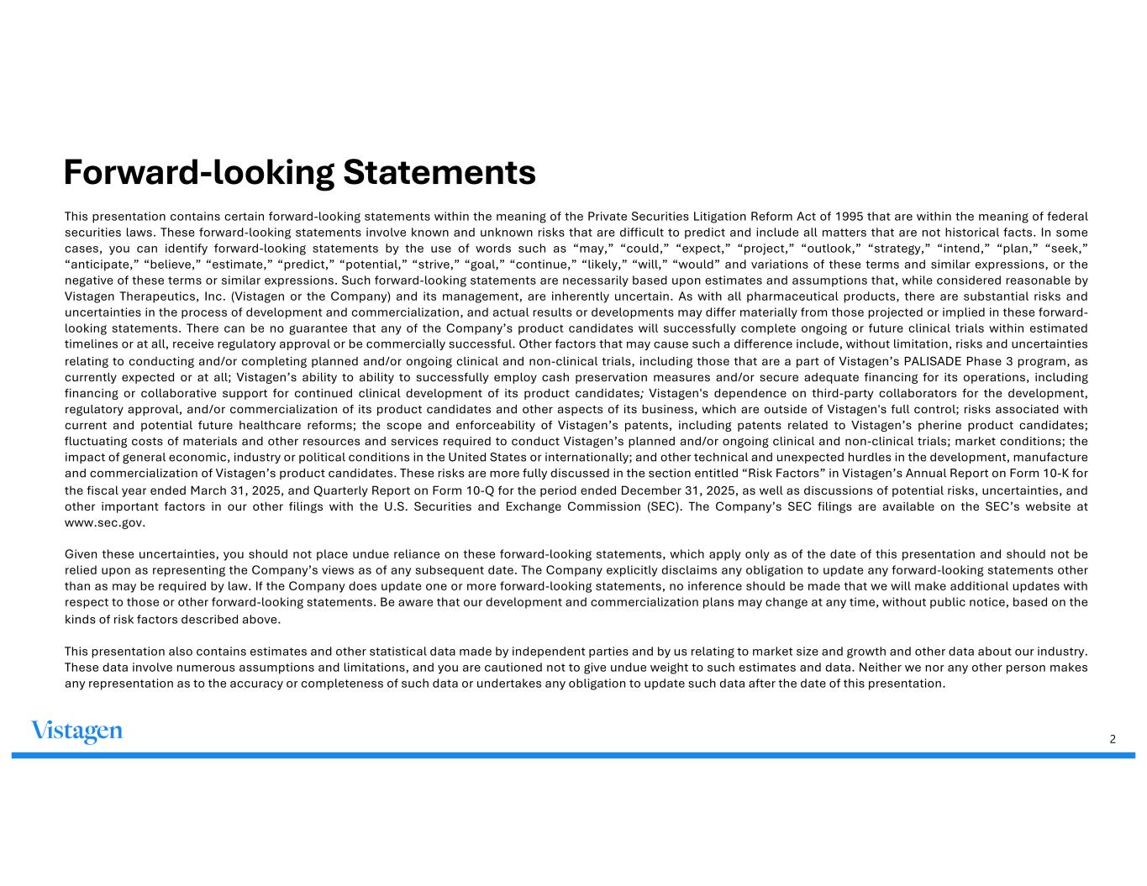
2 Forward-looking Statements This presentation contains certain forward-looking statements within the meaning of the Private Securities Litigation Reform Act of 1995 that are within the meaning of federal securities laws. These forward-looking statements involve known and unknown risks that are difficult to predict and include all matters that are not historical facts. In some cases, you can identify forward-looking statements by the use of words such as “may,” “could,” “expect,” “project,” “outlook,” “strategy,” “intend,” “plan,” “seek,” “anticipate,” “believe,” “estimate,” “predict,” “potential,” “strive,” “goal,” “continue,” “likely,” “will,” “would” and variations of these terms and similar expressions, or the negative of these terms or similar expressions. Such forward-looking statements are necessarily based upon estimates and assumptions that, while considered reasonable by Vistagen Therapeutics, Inc. (Vistagen or the Company) and its management, are inherently uncertain. As with all pharmaceutical products, there are substantial risks and uncertainties in the process of development and commercialization, and actual results or developments may differ materially from those projected or implied in these forward- looking statements. There can be no guarantee that any of the Company’s product candidates will successfully complete ongoing or future clinical trials within estimated timelines or at all, receive regulatory approval or be commercially successful. Other factors that may cause such a difference include, without limitation, risks and uncertainties relating to conducting and/or completing planned and/or ongoing clinical and non-clinical trials, including those that are a part of Vistagen’s PALISADE Phase 3 program, as currently expected or at all; Vistagen’s ability to ability to successfully employ cash preservation measures and/or secure adequate financing for its operations, including financing or collaborative support for continued clinical development of its product candidates; Vistagen's dependence on third-party collaborators for the development, regulatory approval, and/or commercialization of its product candidates and other aspects of its business, which are outside of Vistagen's full control; risks associated with current and potential future healthcare reforms; the scope and enforceability of Vistagen’s patents, including patents related to Vistagen’s pherine product candidates; fluctuating costs of materials and other resources and services required to conduct Vistagen’s planned and/or ongoing clinical and non-clinical trials; market conditions; the impact of general economic, industry or political conditions in the United States or internationally; and other technical and unexpected hurdles in the development, manufacture and commercialization of Vistagen’s product candidates. These risks are more fully discussed in the section entitled “Risk Factors” in Vistagen’s Annual Report on Form 10-K for the fiscal year ended March 31, 2025, and Quarterly Report on Form 10-Q for the period ended December 31, 2025, as well as discussions of potential risks, uncertainties, and other important factors in our other filings with the U.S. Securities and Exchange Commission (SEC). The Company’s SEC filings are available on the SEC’s website at www.sec.gov. Given these uncertainties, you should not place undue reliance on these forward-looking statements, which apply only as of the date of this presentation and should not be relied upon as representing the Company’s views as of any subsequent date. The Company explicitly disclaims any obligation to update any forward-looking statements other than as may be required by law. If the Company does update one or more forward-looking statements, no inference should be made that we will make additional updates with respect to those or other forward-looking statements. Be aware that our development and commercialization plans may change at any time, without public notice, based on the kinds of risk factors described above. This presentation also contains estimates and other statistical data made by independent parties and by us relating to market size and growth and other data about our industry. These data involve numerous assumptions and limitations, and you are cautioned not to give undue weight to such estimates and data. Neither we nor any other person makes any representation as to the accuracy or completeness of such data or undertakes any obligation to update such data after the date of this presentation.

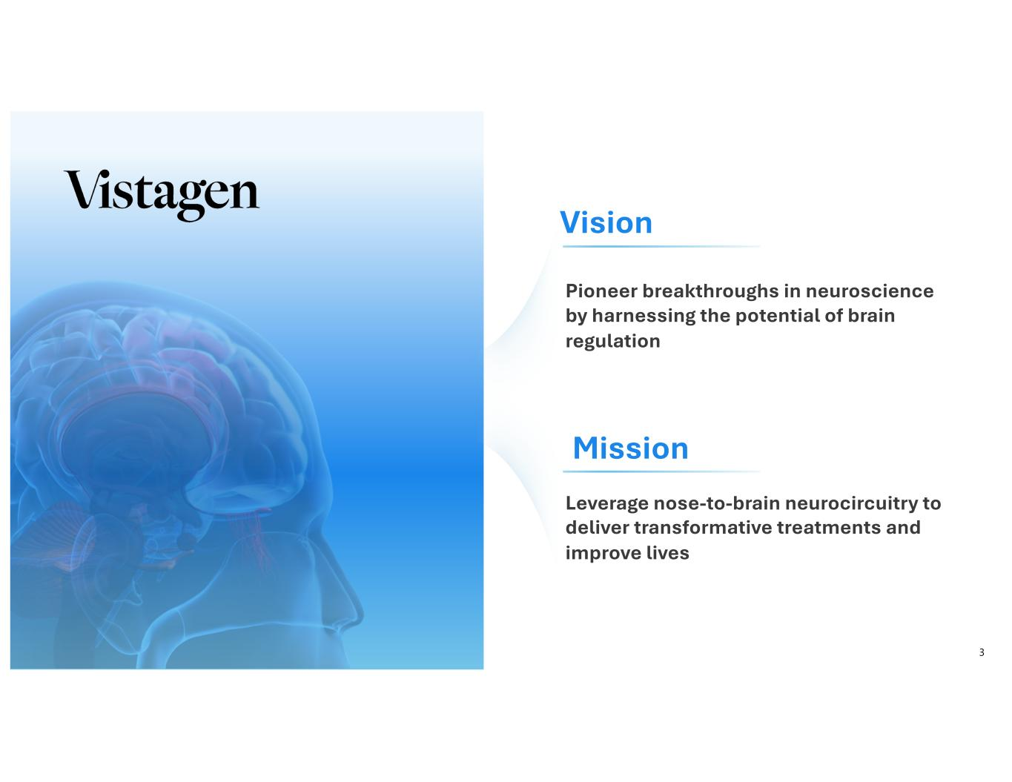
3 Vision Mission Pioneer breakthroughs in neuroscience by harnessing the potential of brain regulation Leverage nose-to-brain neurocircuitry to deliver transformative treatments and improve lives

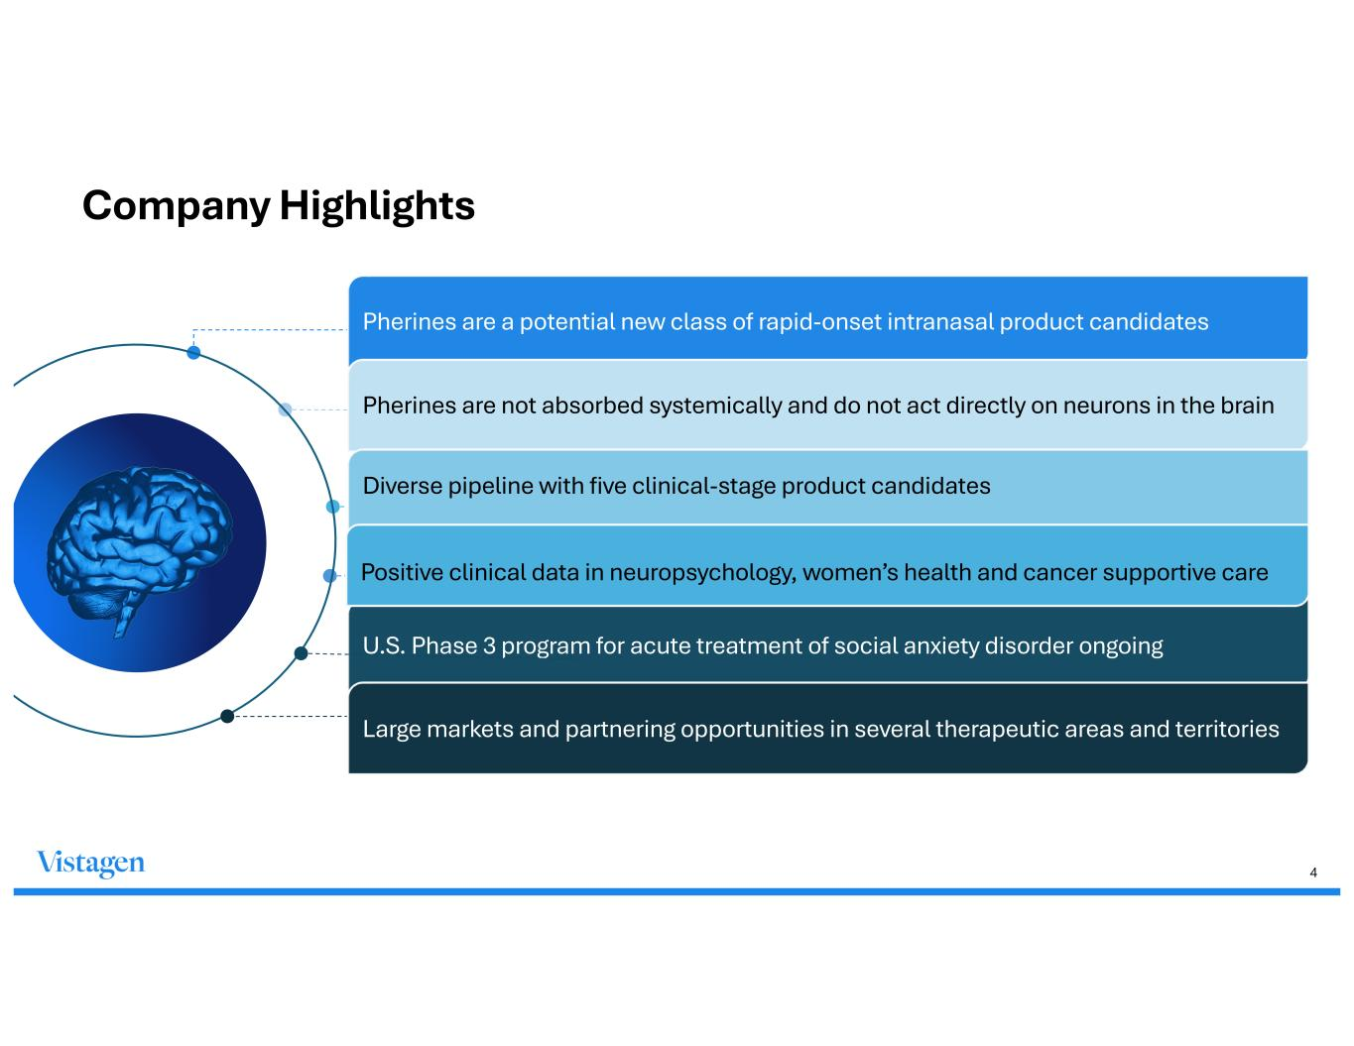
4 Company Highlights Pherines are a potential new class of rapid-onset intranasal product candidates Pherines are not absorbed systemically and do not act directly on neurons in the brain Diverse pipeline with five clinical-stage product candidates U.S. Phase 3 program for acute treatment of social anxiety disorder ongoing Large markets and partnering opportunities in several therapeutic areas and territories Positive clinical data in neuropsychology, women’s health and cancer supportive care

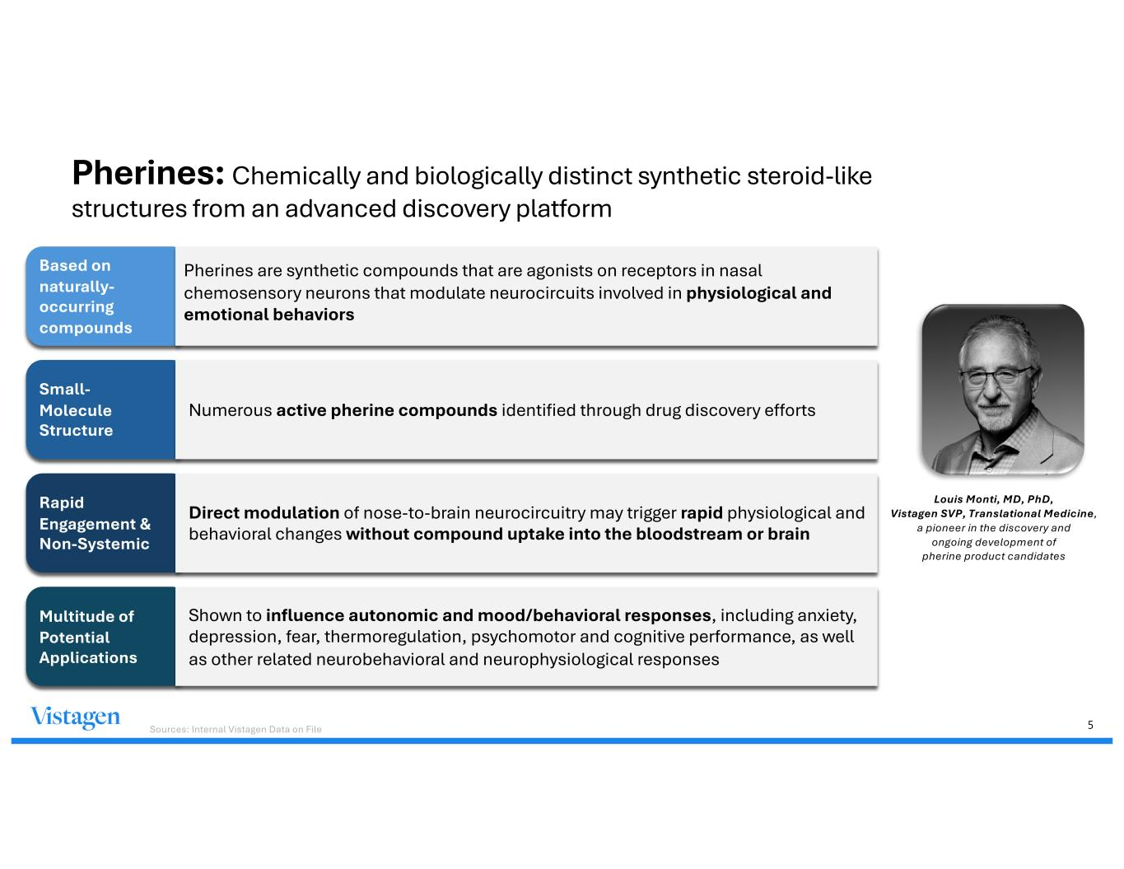
5 Pherines: Chemically and biologically distinct synthetic steroid-like structures from an advanced discovery platform Louis Monti, MD, PhD, Vistagen SVP, Translational Medicine, a pioneer in the discovery and ongoing development of pherine product candidates Based on naturally- occurring compounds Pherines are synthetic compounds that are agonists on receptors in nasal chemosensory neurons that modulate neurocircuits involved in physiological and emotional behaviors Small- Molecule Structure Numerous active pherine compounds identified through drug discovery efforts Rapid Engagement & Non-Systemic Direct modulation of nose-to-brain neurocircuitry may trigger rapid physiological and behavioral changes without compound uptake into the bloodstream or brain Multitude of Potential Applications Shown to influence autonomic and mood/behavioral responses, including anxiety, depression, fear, thermoregulation, psychomotor and cognitive performance, as well as other related neurobehavioral and neurophysiological responses Sources: Internal Vistagen Data on File

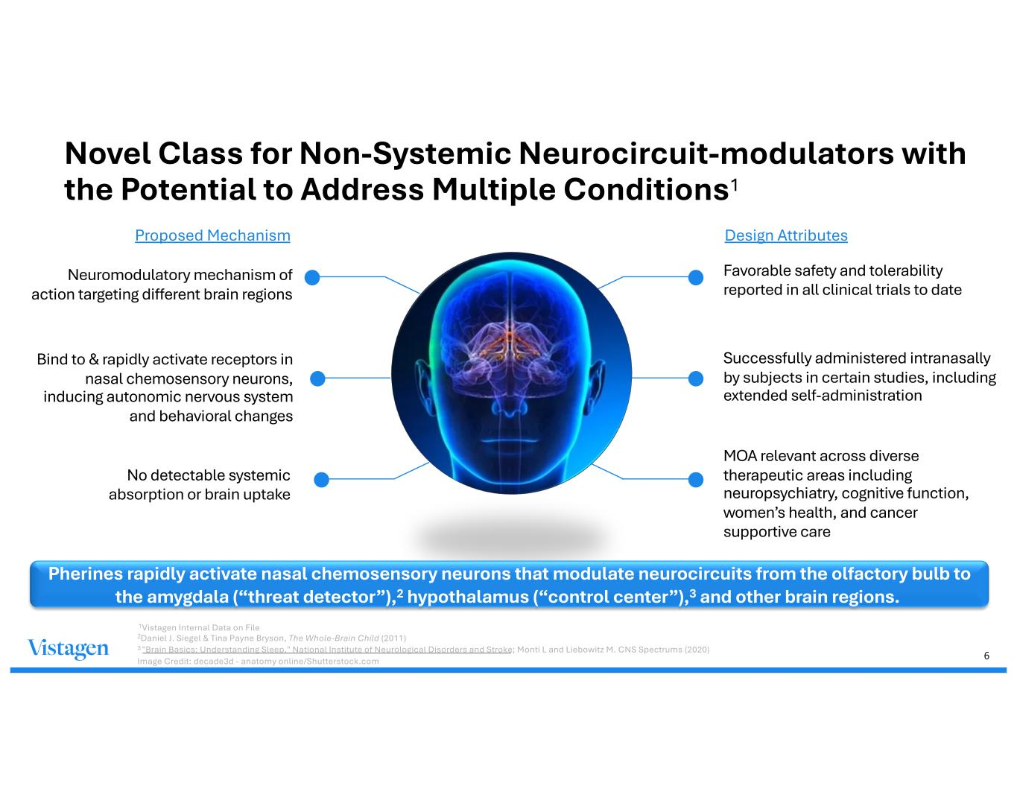
6 Favorable safety and tolerability reported in all clinical trials to date Bind to & rapidly activate receptors in nasal chemosensory neurons, inducing autonomic nervous system and behavioral changes Successfully administered intranasally by subjects in certain studies, including extended self-administration MOA relevant across diverse therapeutic areas including neuropsychiatry, cognitive function, women’s health, and cancer supportive care Novel Class for Non-Systemic Neurocircuit-modulators with the Potential to Address Multiple Conditions1 Pherines rapidly activate nasal chemosensory neurons that modulate neurocircuits from the olfactory bulb to the amygdala (“threat detector”),2 hypothalamus (“control center”),3 and other brain regions. No detectable systemic absorption or brain uptake Proposed Mechanism Design Attributes Neuromodulatory mechanism of action targeting different brain regions 1Vistagen Internal Data on File 2Daniel J. Siegel & Tina Payne Bryson, The Whole-Brain Child (2011) 3 "Brain Basics: Understanding Sleep," National Institute of Neurological Disorders and Stroke; Monti L and Liebowitz M. CNS Spectrums (2020) Image Credit: decade3d - anatomy online/Shutterstock.com

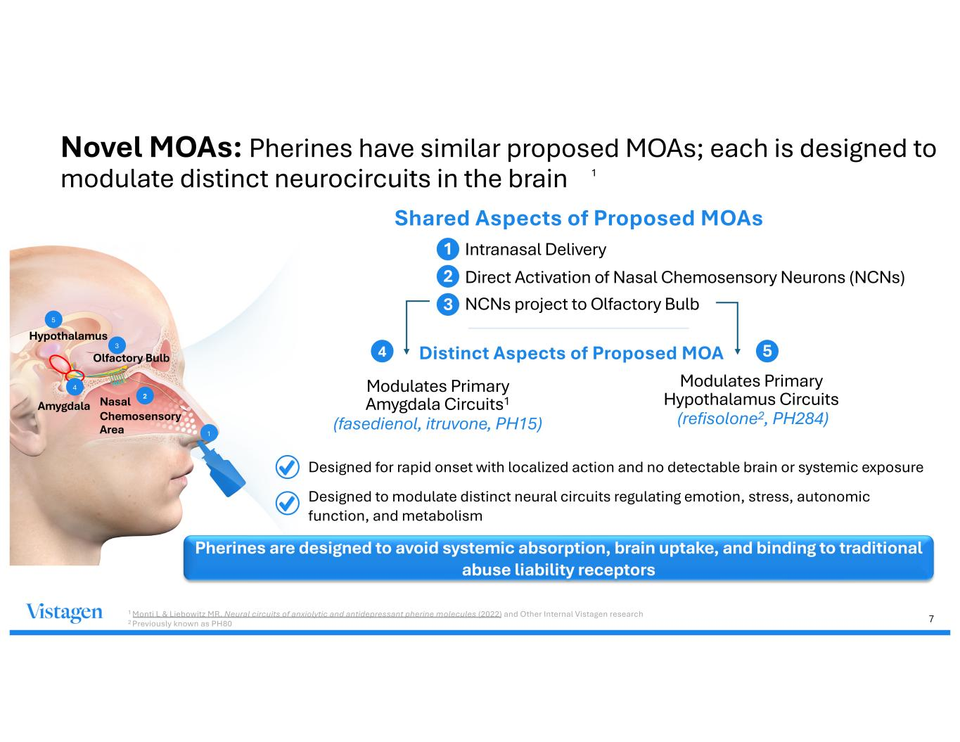
7 Novel MOAs: Pherines have similar proposed MOAs; each is designed to modulate distinct neurocircuits in the brain 1 Monti L & Liebowitz MR, Neural circuits of anxiolytic and antidepressant pherine molecules (2022) and Other Internal Vistagen research 2 Previously known as PH80 1 Olfactory Bulb Nasal Chemosensory Area 2 Hypothalamus Amygdala 4 3 5 Intranasal Delivery Direct Activation of Nasal Chemosensory Neurons (NCNs) NCNs project to Olfactory Bulb Shared Aspects of Proposed MOAs 1 2 3 Modulates Primary Amygdala Circuits1 (fasedienol, itruvone, PH15) Modulates Primary Hypothalamus Circuits (refisolone2, PH284) 4 5 Designed for rapid onset with localized action and no detectable brain or systemic exposure Designed to modulate distinct neural circuits regulating emotion, stress, autonomic function, and metabolism Pherines are designed to avoid systemic absorption, brain uptake, and binding to traditional abuse liability receptors Distinct Aspects of Proposed MOA 1

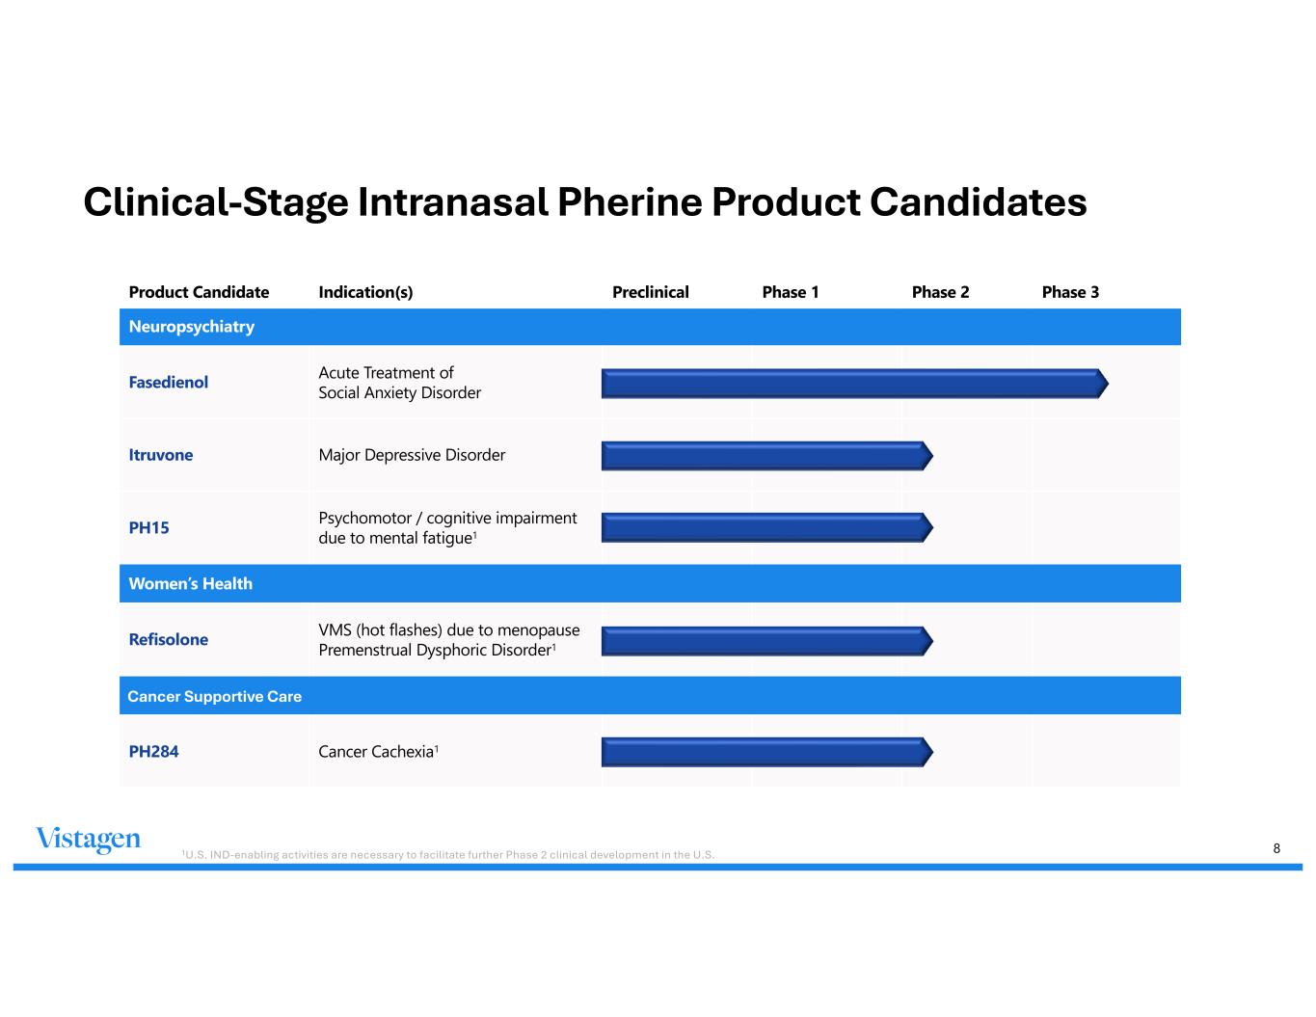
8 Product Candidate Indication(s) Preclinical Phase 1 Phase 2 Phase 3 Neuropsychiatry Fasedienol Acute Treatment of Social Anxiety Disorder Itruvone Major Depressive Disorder PH15 Psychomotor / cognitive impairment due to mental fatigue1 Women’s Health Refisolone VMS (hot flashes) due to menopause Premenstrual Dysphoric Disorder1 PH284 Cancer Cachexia1 Cancer Supportive Care Clinical-Stage Intranasal Pherine Product Candidates 1U.S. IND-enabling activities are necessary to facilitate further Phase 2 clinical development in the U.S.

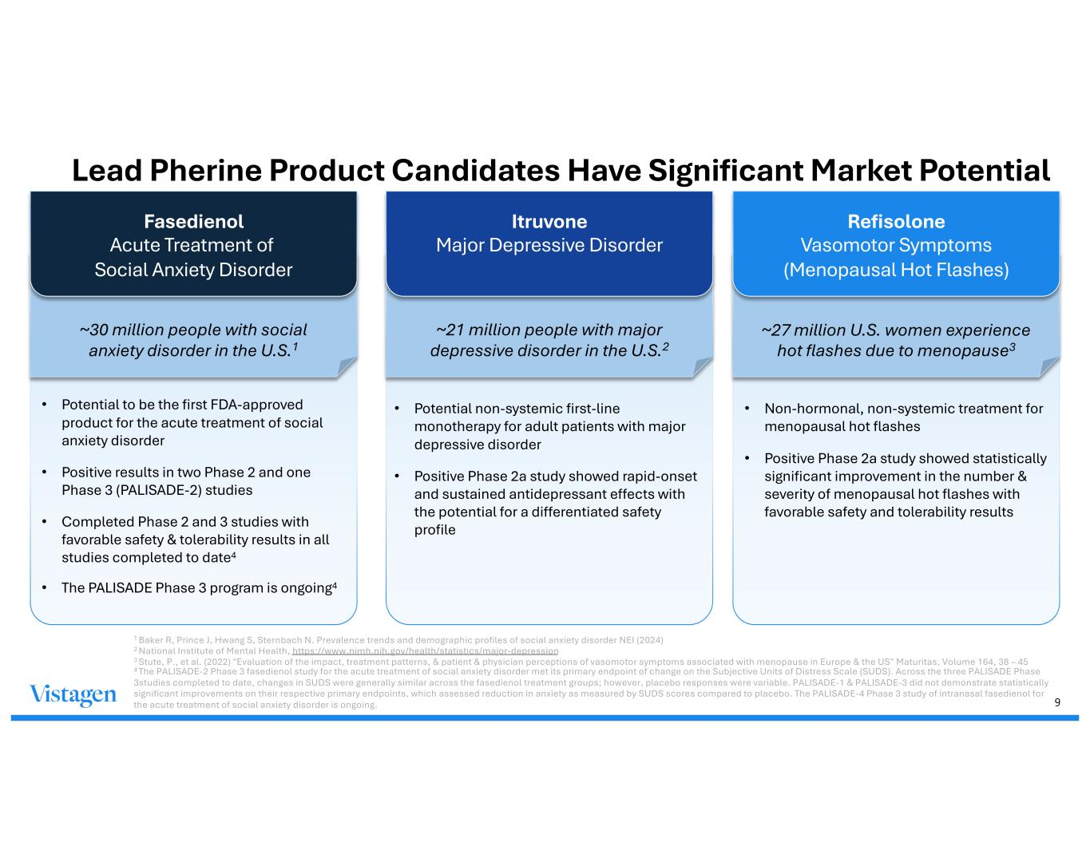
9 Lead Pherine Product Candidates Have Significant Market Potential Fasedienol Acute Treatment of Social Anxiety Disorder ~30 million people with social anxiety disorder in the U.S.1 • Potential to be the first FDA-approved product for the acute treatment of social anxiety disorder • Positive results in two Phase 2 and one Phase 3 (PALISADE-2) studies • Completed Phase 2 and 3 studies with favorable safety & tolerability results in all studies completed to date4 • The PALISADE Phase 3 program is ongoing4 Itruvone Major Depressive Disorder ~21 million people with major depressive disorder in the U.S.2 • Potential non-systemic first-line monotherapy for adult patients with major depressive disorder • Positive Phase 2a study showed rapid-onset and sustained antidepressant effects with the potential for a differentiated safety profile Refisolone Vasomotor Symptoms (Menopausal Hot Flashes) ~27 million U.S. women experience hot flashes due to menopause3 • Non-hormonal, non-systemic treatment for menopausal hot flashes • Positive Phase 2a study showed statistically significant improvement in the number & severity of menopausal hot flashes with favorable safety and tolerability results 1 Baker R, Prince J, Hwang S, Sternbach N. Prevalence trends and demographic profiles of social anxiety disorder NEI (2024) 2 National Institute of Mental Health, https://www.nimh.nih.gov/health/statistics/major-depression 3 Stute, P., et al. (2022) "Evaluation of the impact, treatment patterns, & patient & physician perceptions of vasomotor symptoms associated with menopause in Europe & the US" Maturitas, Volume 164, 38 – 45 4 The PALISADE-2 Phase 3 fasedienol study for the acute treatment of social anxiety disorder met its primary endpoint of change on the Subjective Units of Distress Scale (SUDS). Across the three PALISADE Phase 3studies completed to date, changes in SUDS were generally similar across the fasedienol treatment groups; however, placebo responses were variable. PALISADE-1 & PALISADE-3 did not demonstrate statistically significant improvements on their respective primary endpoints, which assessed reduction in anxiety as measured by SUDS scores compared to placebo. The PALISADE-4 Phase 3 study of intranasal fasedienol for the acute treatment of social anxiety disorder is ongoing.

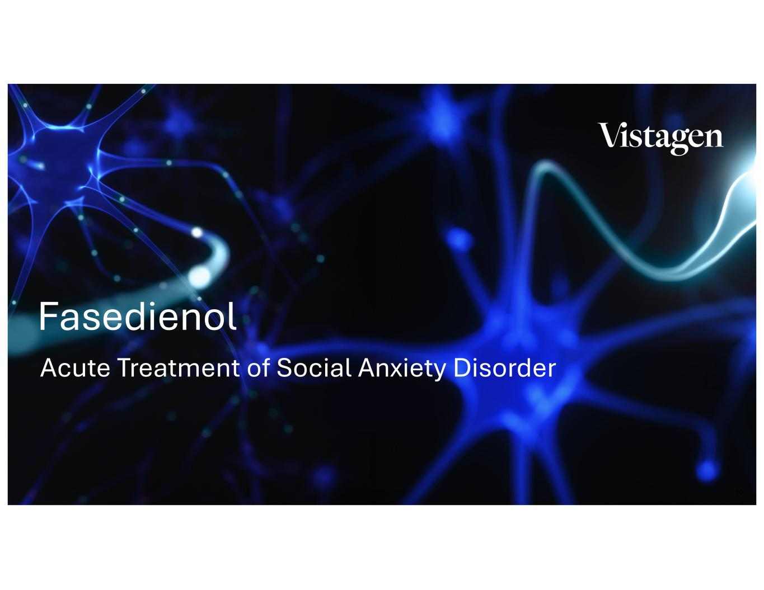
10 Acute Treatment of Social Anxiety Disorder Fasedienol

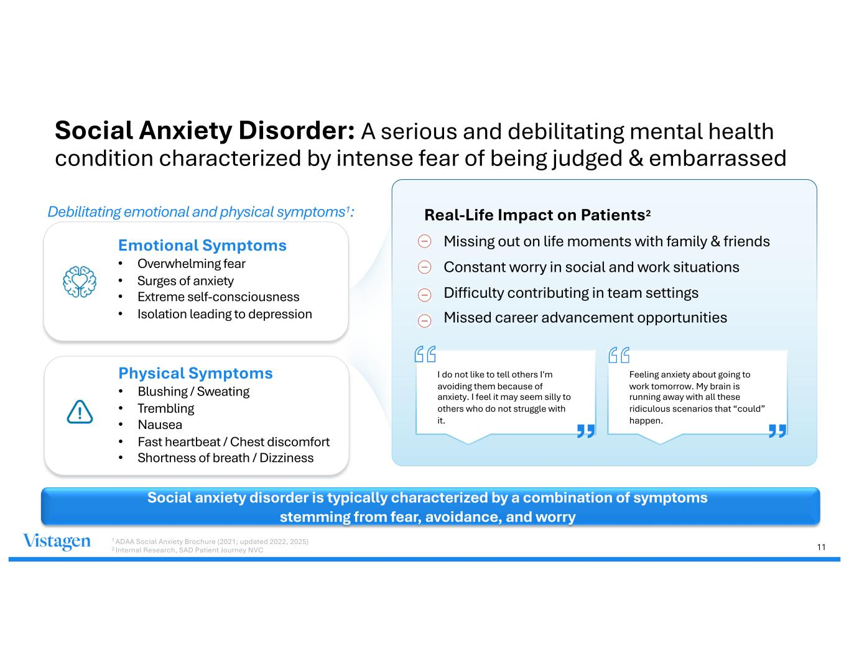
11 Social Anxiety Disorder: A serious and debilitating mental health condition characterized by intense fear of being judged & embarrassed Social anxiety disorder is typically characterized by a combination of symptoms stemming from fear, avoidance, and worry Emotional Symptoms • Overwhelming fear • Surges of anxiety • Extreme self-consciousness • Isolation leading to depression Debilitating emotional and physical symptoms1: Physical Symptoms • Blushing / Sweating • Trembling • Nausea • Fast heartbeat / Chest discomfort • Shortness of breath / Dizziness Real-Life Impact on Patients2 • Missing out on life moments with family & friends • Constant worry in social and work situations • Difficulty contributing in team settings • Missed career advancement opportunities I do not like to tell others I'm avoiding them because of anxiety. I feel it may seem silly to others who do not struggle with it. Feeling anxiety about going to work tomorrow. My brain is running away with all these ridiculous scenarios that “could” happen. 1 ADAA Social Anxiety Brochure (2021; updated 2022, 2025) 2 Internal Research, SAD Patient Journey NVC

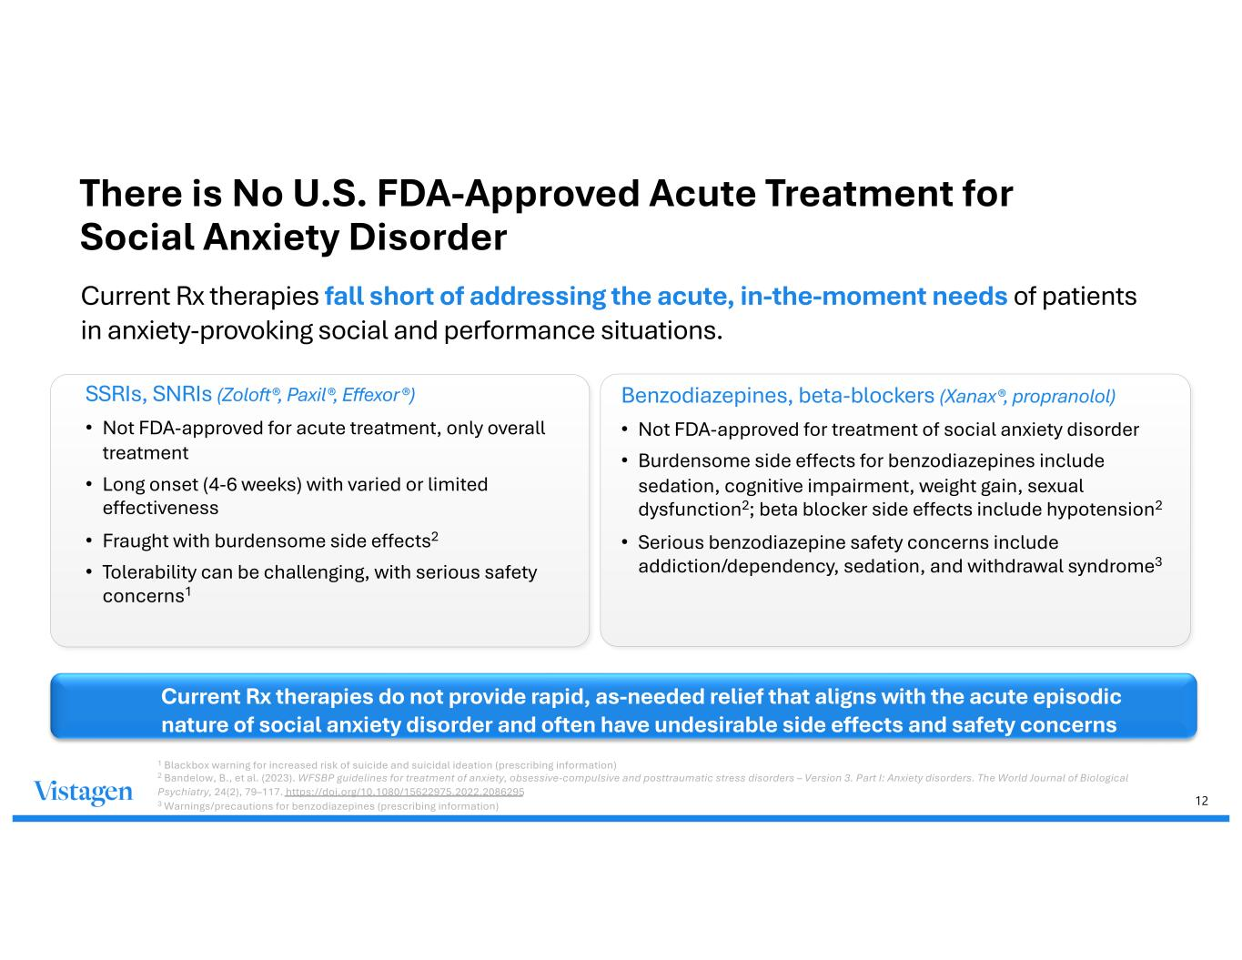
12 There is No U.S. FDA-Approved Acute Treatment for Social Anxiety Disorder Current Rx therapies fall short of addressing the acute, in-the-moment needs of patients in anxiety-provoking social and performance situations. 1 Blackbox warning for increased risk of suicide and suicidal ideation (prescribing information) 2 Bandelow, B., et al. (2023). WFSBP guidelines for treatment of anxiety, obsessive-compulsive and posttraumatic stress disorders – Version 3. Part I: Anxiety disorders. The World Journal of Biological Psychiatry, 24(2), 79–117. https://doi.org/10.1080/15622975.2022.2086295 3 Warnings/precautions for benzodiazepines (prescribing information) SSRIs, SNRIs (Zoloft®, Paxil®, Effexor®) • Not FDA-approved for acute treatment, only overall treatment • Long onset (4-6 weeks) with varied or limited effectiveness • Fraught with burdensome side effects2 • Tolerability can be challenging, with serious safety concerns1 Benzodiazepines, beta-blockers (Xanax®, propranolol) • Not FDA-approved for treatment of social anxiety disorder • Burdensome side effects for benzodiazepines include sedation, cognitive impairment, weight gain, sexual dysfunction2; beta blocker side effects include hypotension2 • Serious benzodiazepine safety concerns include addiction/dependency, sedation, and withdrawal syndrome3 Current Rx therapies do not provide rapid, as-needed relief that aligns with the acute episodic nature of social anxiety disorder and often have undesirable side effects and safety concerns

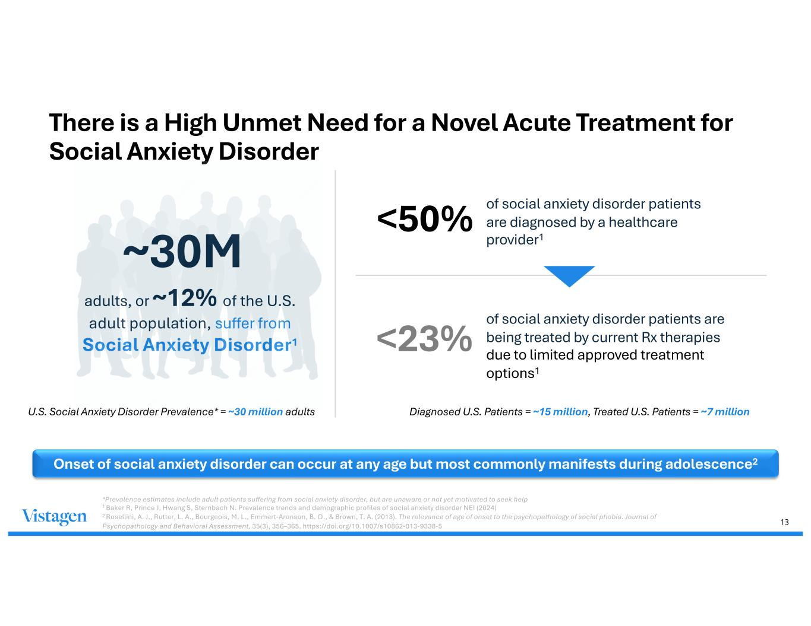
13 Onset of social anxiety disorder can occur at any age but most commonly manifests during adolescence2 ~30M adults, or ~12% of the U.S. adult population, suffer from Social Anxiety Disorder1 U.S. Social Anxiety Disorder Prevalence* = ~30 million adults <50% of social anxiety disorder patients are diagnosed by a healthcare provider1 <23% of social anxiety disorder patients are being treated by current Rx therapies due to limited approved treatment options1 Diagnosed U.S. Patients = ~15 million, Treated U.S. Patients = ~7 million There is a High Unmet Need for a Novel Acute Treatment for Social Anxiety Disorder *Prevalence estimates include adult patients suffering from social anxiety disorder, but are unaware or not yet motivated to seek help 1 Baker R, Prince J, Hwang S, Sternbach N. Prevalence trends and demographic profiles of social anxiety disorder NEI (2024) 2 Rosellini, A. J., Rutter, L. A., Bourgeois, M. L., Emmert-Aronson, B. O., & Brown, T. A. (2013). The relevance of age of onset to the psychopathology of social phobia. Journal of Psychopathology and Behavioral Assessment, 35(3), 356–365. https://doi.org/10.1007/s10862-013-9338-5

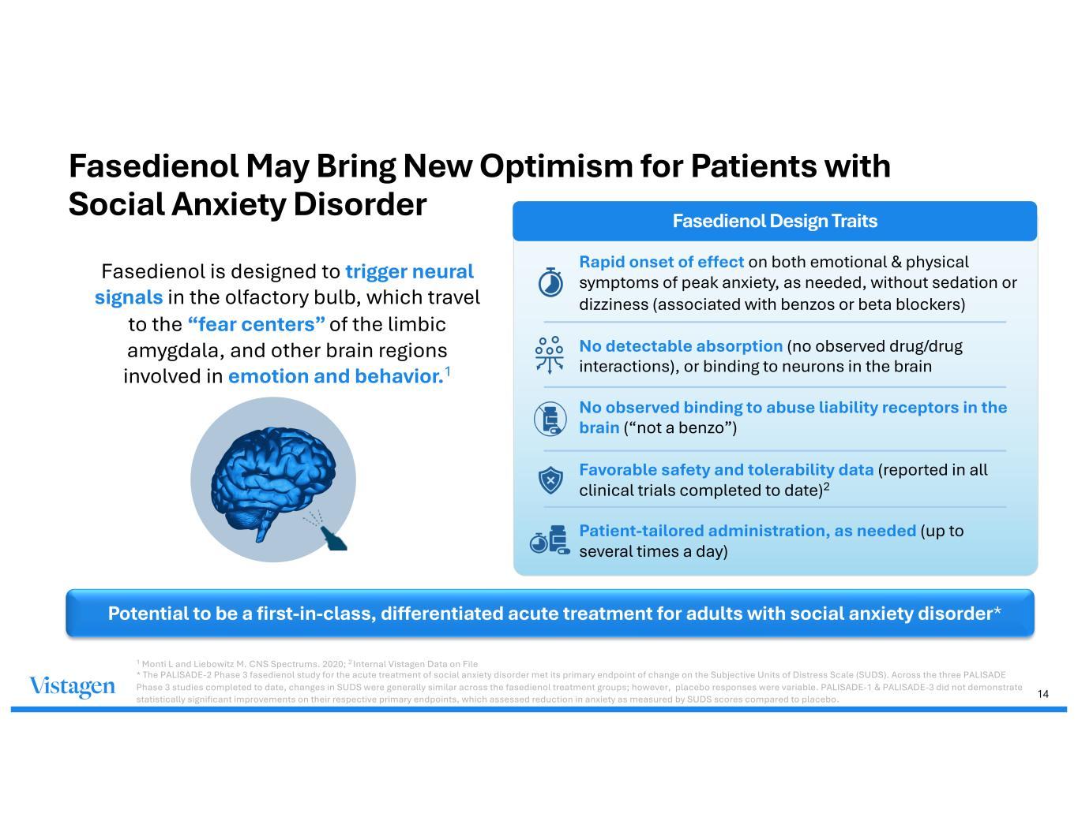
14 Fasedienol May Bring New Optimism for Patients with Social Anxiety Disorder Fasedienol is designed to trigger neural signals in the olfactory bulb, which travel to the “fear centers” of the limbic amygdala, and other brain regions involved in emotion and behavior.1 Fasedienol Design Traits Rapid onset of effect on both emotional & physical symptoms of peak anxiety, as needed, without sedation or dizziness (associated with benzos or beta blockers) No detectable absorption (no observed drug/drug interactions), or binding to neurons in the brain No observed binding to abuse liability receptors in the brain (“not a benzo”) Favorable safety and tolerability data (reported in all clinical trials completed to date)2 Patient-tailored administration, as needed (up to several times a day) 1 Monti L and Liebowitz M. CNS Spectrums. 2020; 2 Internal Vistagen Data on File * The PALISADE-2 Phase 3 fasedienol study for the acute treatment of social anxiety disorder met its primary endpoint of change on the Subjective Units of Distress Scale (SUDS). Across the three PALISADE Phase 3 studies completed to date, changes in SUDS were generally similar across the fasedienol treatment groups; however, placebo responses were variable. PALISADE-1 & PALISADE-3 did not demonstrate statistically significant improvements on their respective primary endpoints, which assessed reduction in anxiety as measured by SUDS scores compared to placebo. Potential to be a first-in-class, differentiated acute treatment for adults with social anxiety disorder*

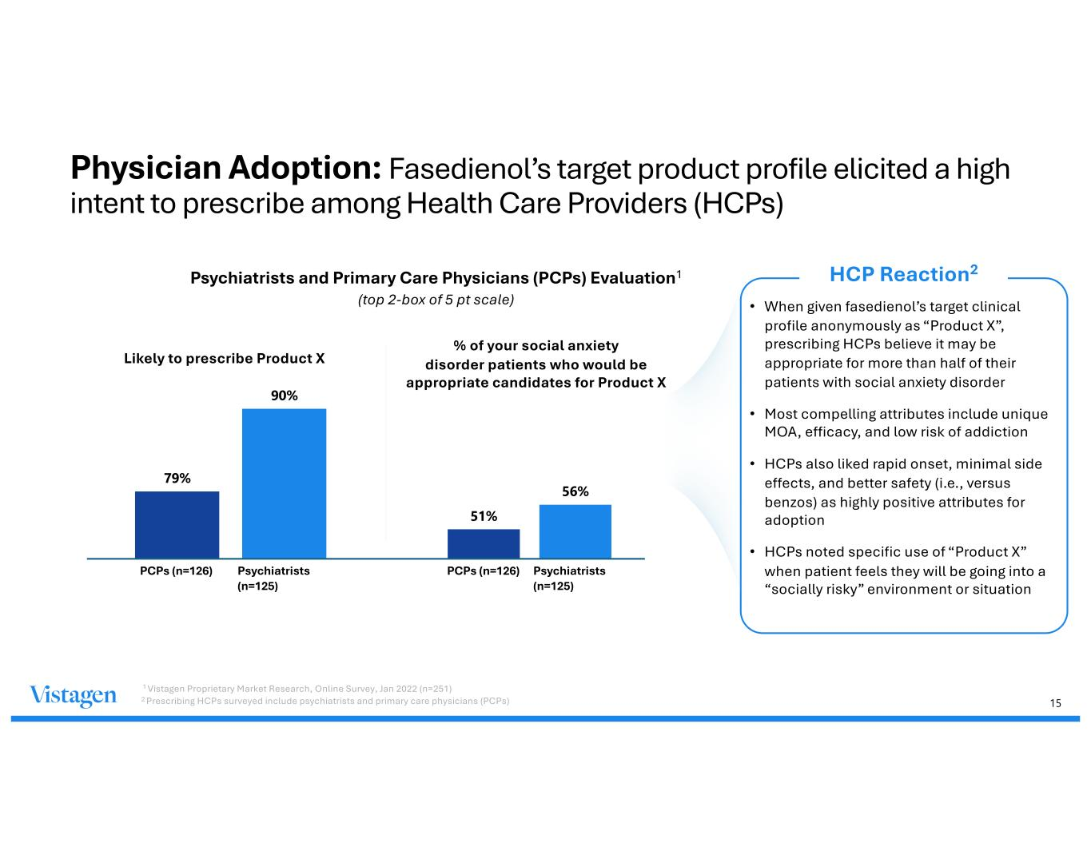
15 Physician Adoption: Fasedienol’s target product profile elicited a high intent to prescribe among Health Care Providers (HCPs) Psychiatrists and Primary Care Physicians (PCPs) Evaluation1 (top 2-box of 5 pt scale) Likely to prescribe Product X % of your social anxiety disorder patients who would be appropriate candidates for Product X 79% 90% • When given fasedienol’s target clinical profile anonymously as “Product X”, prescribing HCPs believe it may be appropriate for more than half of their patients with social anxiety disorder • Most compelling attributes include unique MOA, efficacy, and low risk of addiction • HCPs also liked rapid onset, minimal side effects, and better safety (i.e., versus benzos) as highly positive attributes for adoption • HCPs noted specific use of “Product X” when patient feels they will be going into a “socially risky” environment or situation HCP Reaction2 Psychiatrists (n=125) Psychiatrists (n=125) PCPs (n=126) PCPs (n=126) 51% 56% 1 Vistagen Proprietary Market Research, Online Survey, Jan 2022 (n=251) 2 Prescribing HCPs surveyed include psychiatrists and primary care physicians (PCPs)

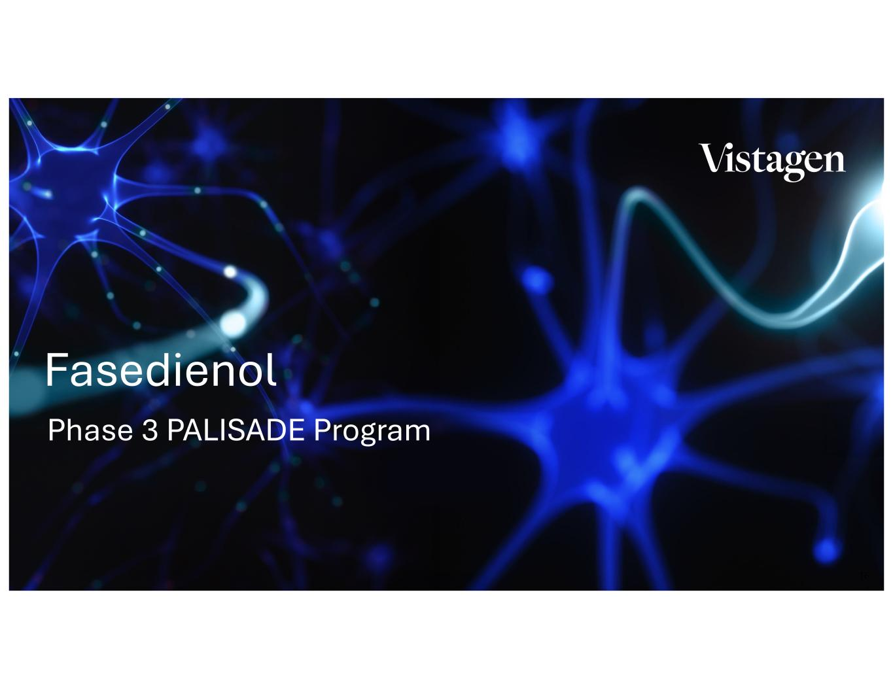
16 Phase 3 PALISADE Program Fasedienol

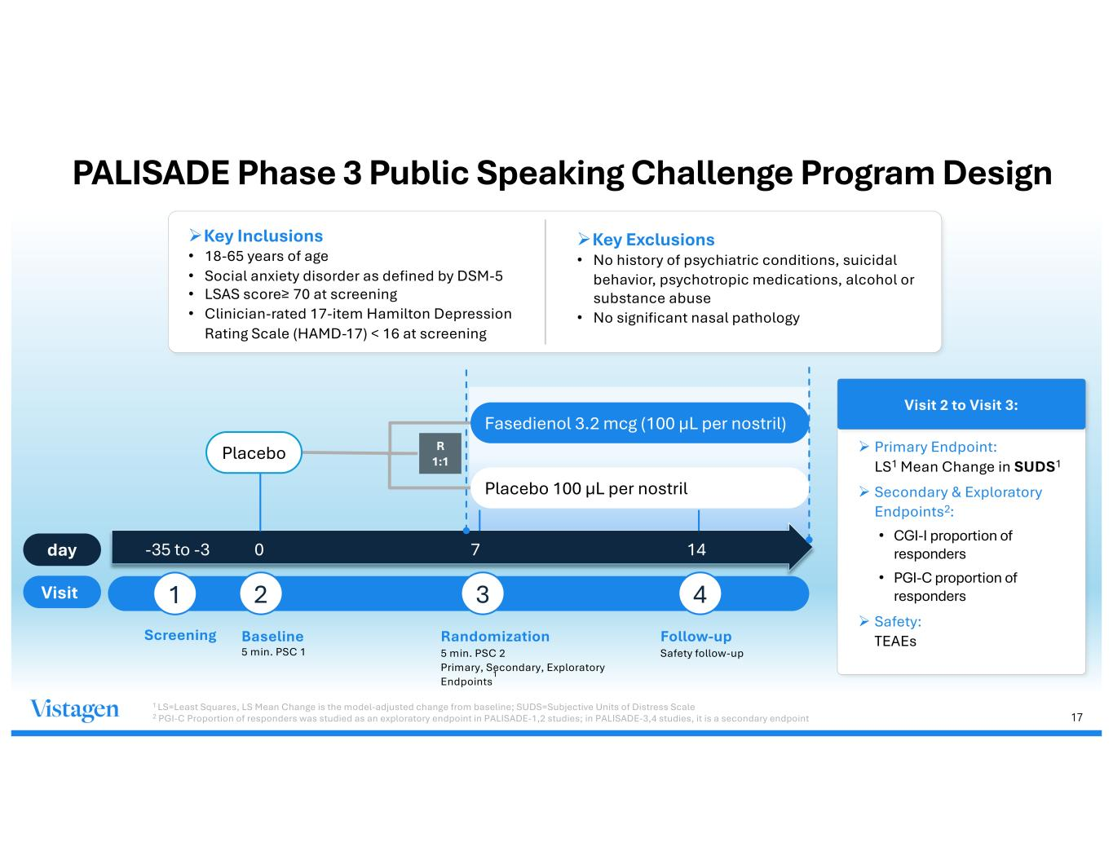
17 PALISADE Phase 3 Public Speaking Challenge Program Design ØKey Inclusions • 18-65 years of age • Social anxiety disorder as defined by DSM-5 • LSAS score≥ 70 at screening • Clinician-rated 17-item Hamilton Depression Rating Scale (HAMD-17) < 16 at screening ØKey Exclusions • No history of psychiatric conditions, suicidal behavior, psychotropic medications, alcohol or substance abuse • No significant nasal pathology Baseline 5 min. PSC 1 -35 to -3 0 7 14 R 1:1 day Visit 1 2 3 4 Screening Randomization 5 min. PSC 2 Primary, Secondary, Exploratory Endpoints 1 Follow-up Safety follow-up Fasedienol 3.2 mcg (100 µL per nostril) Placebo 100 µL per nostril Placebo Visit 2 to Visit 3: Ø Primary Endpoint: LS1 Mean Change in SUDS1 Ø Secondary & Exploratory Endpoints2: • CGI-I proportion of responders • PGI-C proportion of responders Ø Safety: TEAEs 1 LS=Least Squares, LS Mean Change is the model-adjusted change from baseline; SUDS=Subjective Units of Distress Scale 2 PGI-C Proportion of responders was studied as an exploratory endpoint in PALISADE-1,2 studies; in PALISADE-3,4 studies, it is a secondary endpoint

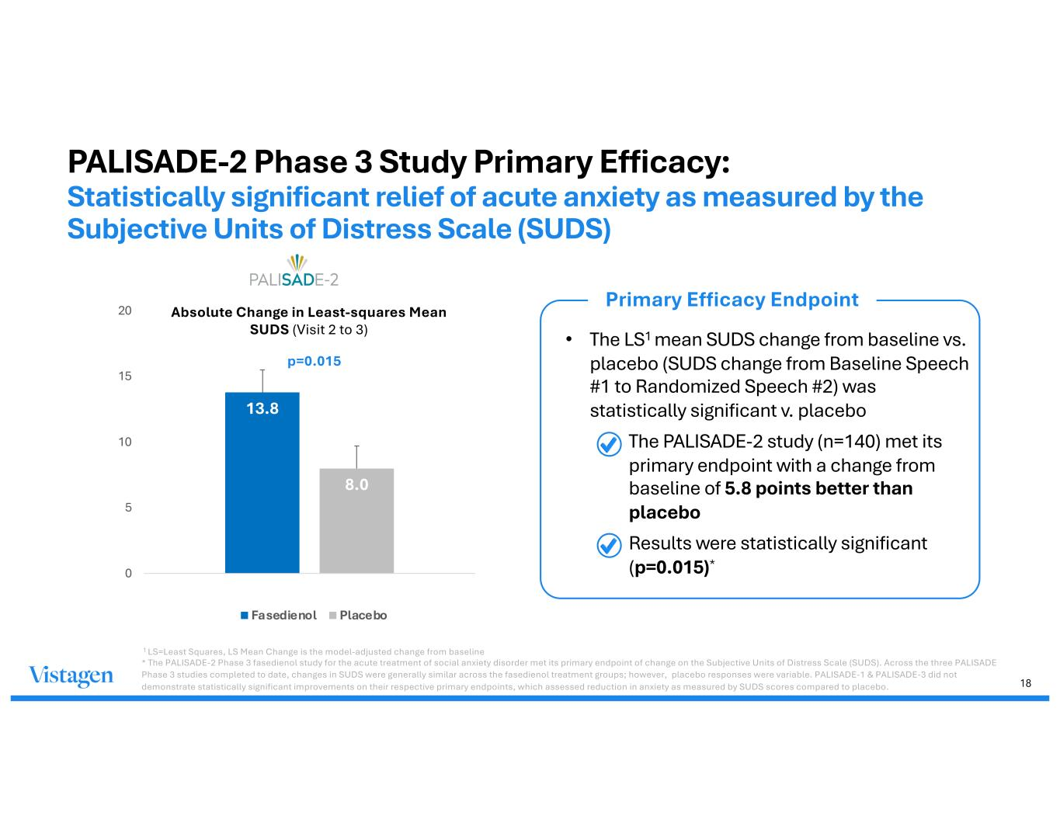
18 PALISADE-2 Phase 3 Study Primary Efficacy: Statistically significant relief of acute anxiety as measured by the Subjective Units of Distress Scale (SUDS) 13.8 8.0 0 5 10 15 20 (p=0.015) Absolute Change in Least-squares Mean SUDS (Visit 2 to 3) Fasedienol Placebo • The LS1 mean SUDS change from baseline vs. placebo (SUDS change from Baseline Speech #1 to Randomized Speech #2) was statistically significant v. placebo • The PALISADE-2 study (n=140) met its primary endpoint with a change from baseline of 5.8 points better than placebo • Results were statistically significant (p=0.015)* Primary Efficacy Endpoint p=0.015 1 LS=Least Squares, LS Mean Change is the model-adjusted change from baseline * The PALISADE-2 Phase 3 fasedienol study for the acute treatment of social anxiety disorder met its primary endpoint of change on the Subjective Units of Distress Scale (SUDS). Across the three PALISADE Phase 3 studies completed to date, changes in SUDS were generally similar across the fasedienol treatment groups; however, placebo responses were variable. PALISADE-1 & PALISADE-3 did not demonstrate statistically significant improvements on their respective primary endpoints, which assessed reduction in anxiety as measured by SUDS scores compared to placebo.

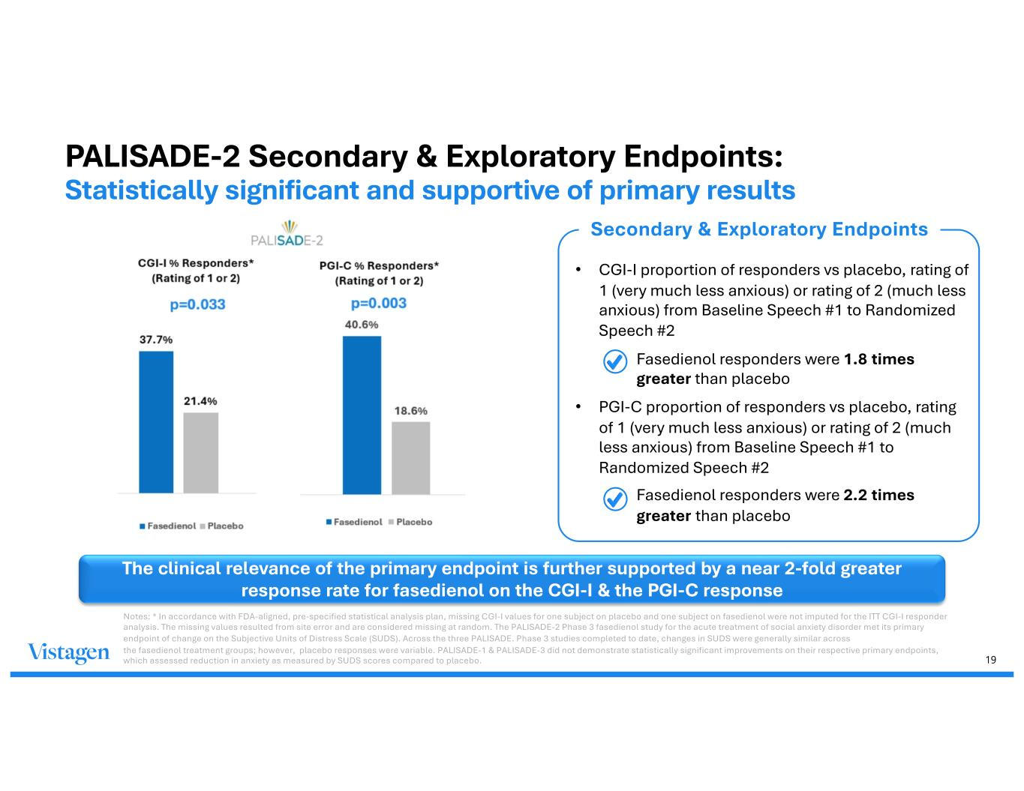
19 PALISADE-2 Secondary & Exploratory Endpoints: Statistically significant and supportive of primary results • CGI-I proportion of responders vs placebo, rating of 1 (very much less anxious) or rating of 2 (much less anxious) from Baseline Speech #1 to Randomized Speech #2 • Fasedienol responders were 1.8 times greater than placebo • PGI-C proportion of responders vs placebo, rating of 1 (very much less anxious) or rating of 2 (much less anxious) from Baseline Speech #1 to Randomized Speech #2 • Fasedienol responders were 2.2 times greater than placebo The clinical relevance of the primary endpoint is further supported by a near 2-fold greater response rate for fasedienol on the CGI-I & the PGI-C response Secondary & Exploratory Endpoints Notes: * In accordance with FDA-aligned, pre-specified statistical analysis plan, missing CGI-I values for one subject on placebo and one subject on fasedienol were not imputed for the ITT CGI-I responder analysis. The missing values resulted from site error and are considered missing at random. The PALISADE-2 Phase 3 fasedienol study for the acute treatment of social anxiety disorder met its primary endpoint of change on the Subjective Units of Distress Scale (SUDS). Across the three PALISADE. Phase 3 studies completed to date, changes in SUDS were generally similar across the fasedienol treatment groups; however, placebo responses were variable. PALISADE-1 & PALISADE-3 did not demonstrate statistically significant improvements on their respective primary endpoints, which assessed reduction in anxiety as measured by SUDS scores compared to placebo.

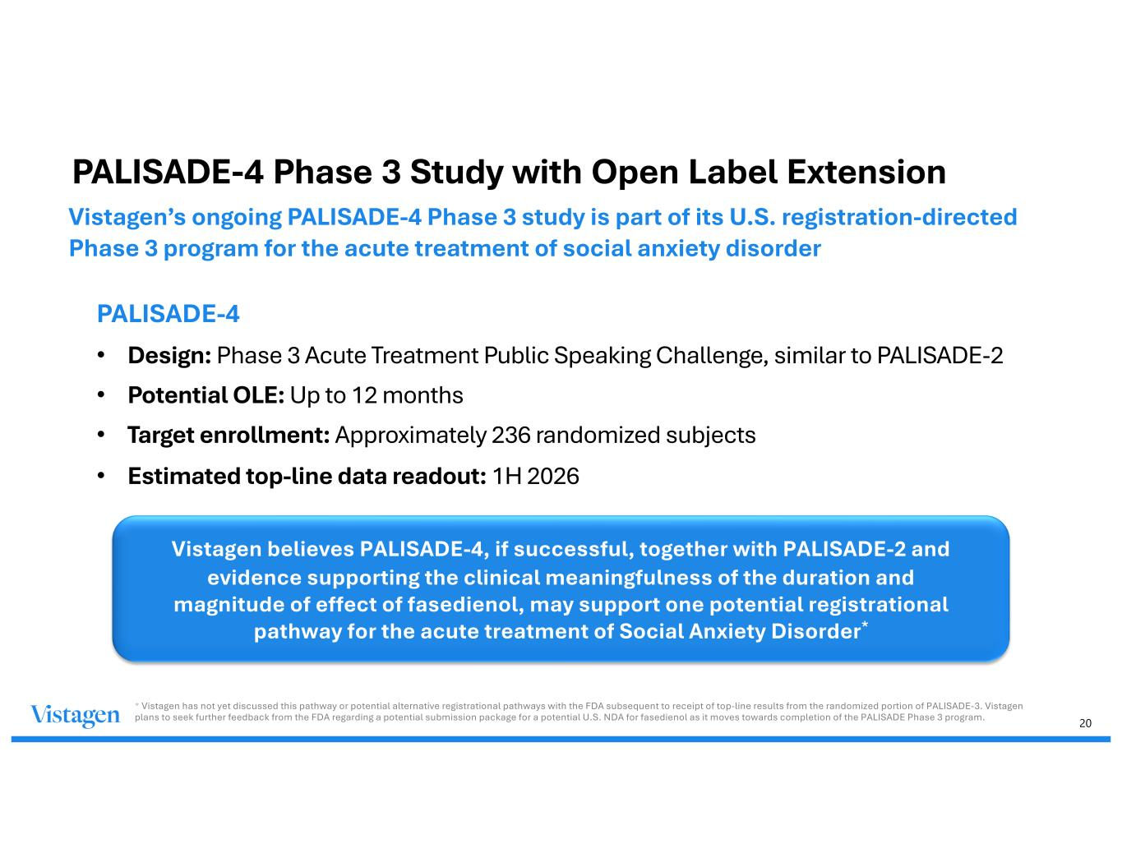
20 PALISADE-4 Phase 3 Study with Open Label Extension PALISADE-4 • Design: Phase 3 Acute Treatment Public Speaking Challenge, similar to PALISADE-2 • Potential OLE: Up to 12 months • Target enrollment: Approximately 236 randomized subjects • Estimated top-line data readout: 1H 2026 Vistagen believes PALISADE-4, if successful, together with PALISADE-2 and evidence supporting the clinical meaningfulness of the duration and magnitude of effect of fasedienol, may support one potential registrational pathway for the acute treatment of Social Anxiety Disorder* Vistagen’s ongoing PALISADE-4 Phase 3 study is part of its U.S. registration-directed Phase 3 program for the acute treatment of social anxiety disorder * Vistagen has not yet discussed this pathway or potential alternative registrational pathways with the FDA subsequent to receipt of top-line results from the randomized portion of PALISADE-3. Vistagen plans to seek further feedback from the FDA regarding a potential submission package for a potential U.S. NDA for fasedienol as it moves towards completion of the PALISADE Phase 3 program.

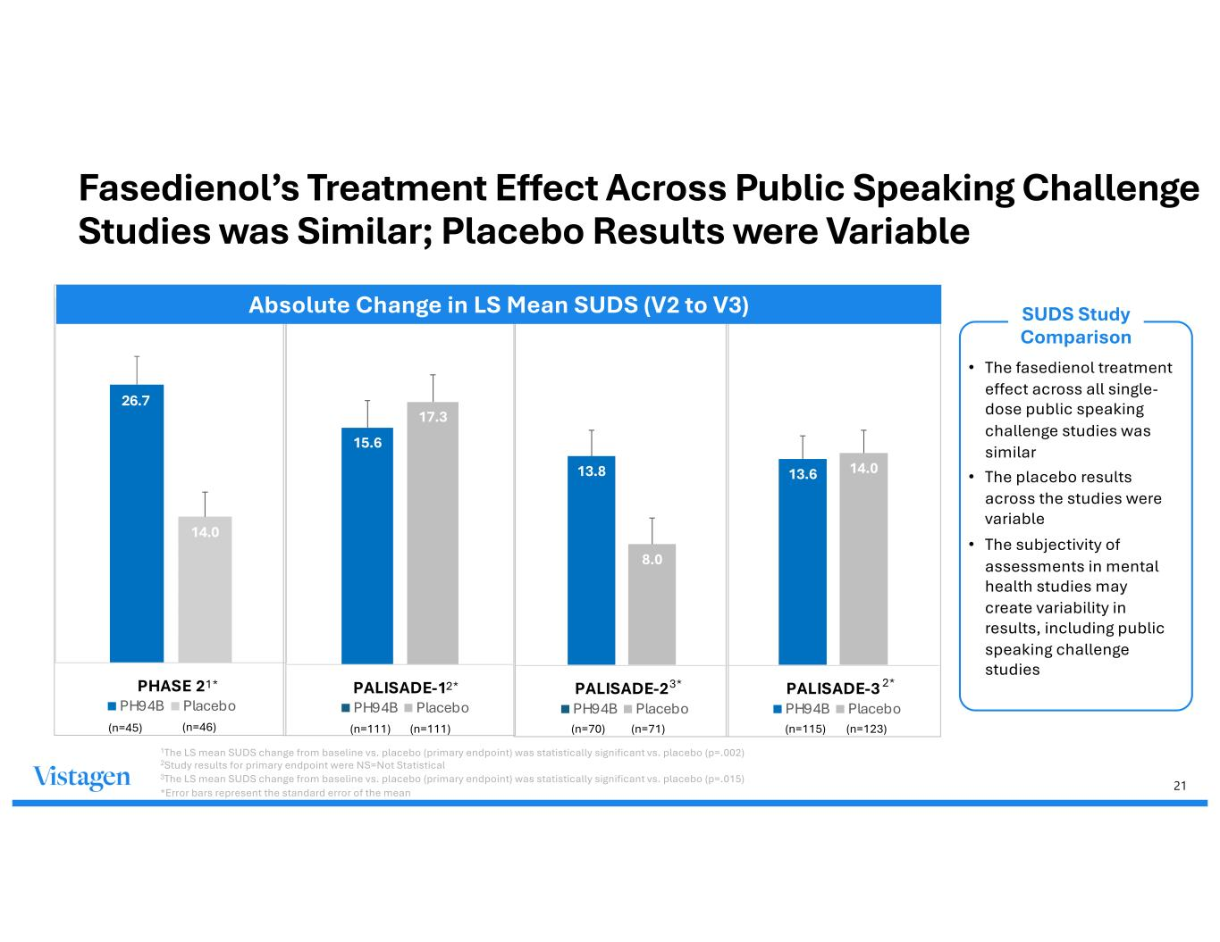
21 26.7 14.0 PHASE 2 PH94B Placebo Fasedienol’s Treatment Effect Across Public Speaking Challenge Studies was Similar; Placebo Results were Variable 13.6 14.0 PALISADE-3 PH94B Placebo 13.8 8.0 PALISADE-2 PH94B Placebo 15.6 17.3 PALISADE-1 PH94B Placebo (n=111) (n=111) (n=70) (n=71) (n=115) (n=123) 2*2* 3* Absolute Change in LS Mean SUDS (V2 to V3) 1* SUDS Study Comparison • The fasedienol treatment effect across all single- dose public speaking challenge studies was similar • The placebo results across the studies were variable • The subjectivity of assessments in mental health studies may create variability in results, including public speaking challenge studies (n=45) (n=46) 1The LS mean SUDS change from baseline vs. placebo (primary endpoint) was statistically significant vs. placebo (p=.002) 2Study results for primary endpoint were NS=Not Statistical 3The LS mean SUDS change from baseline vs. placebo (primary endpoint) was statistically significant vs. placebo (p=.015) *Error bars represent the standard error of the mean

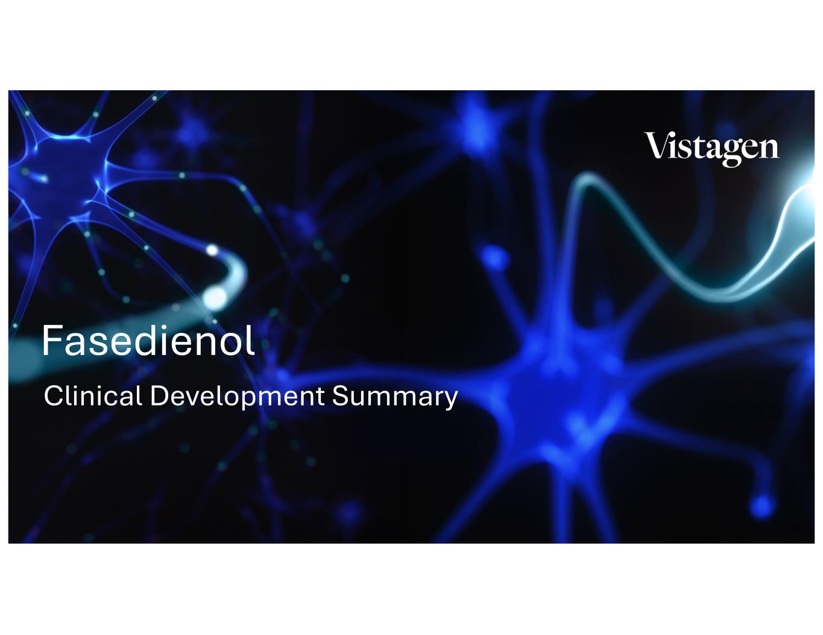
22 Clinical Development Summary Fasedienol

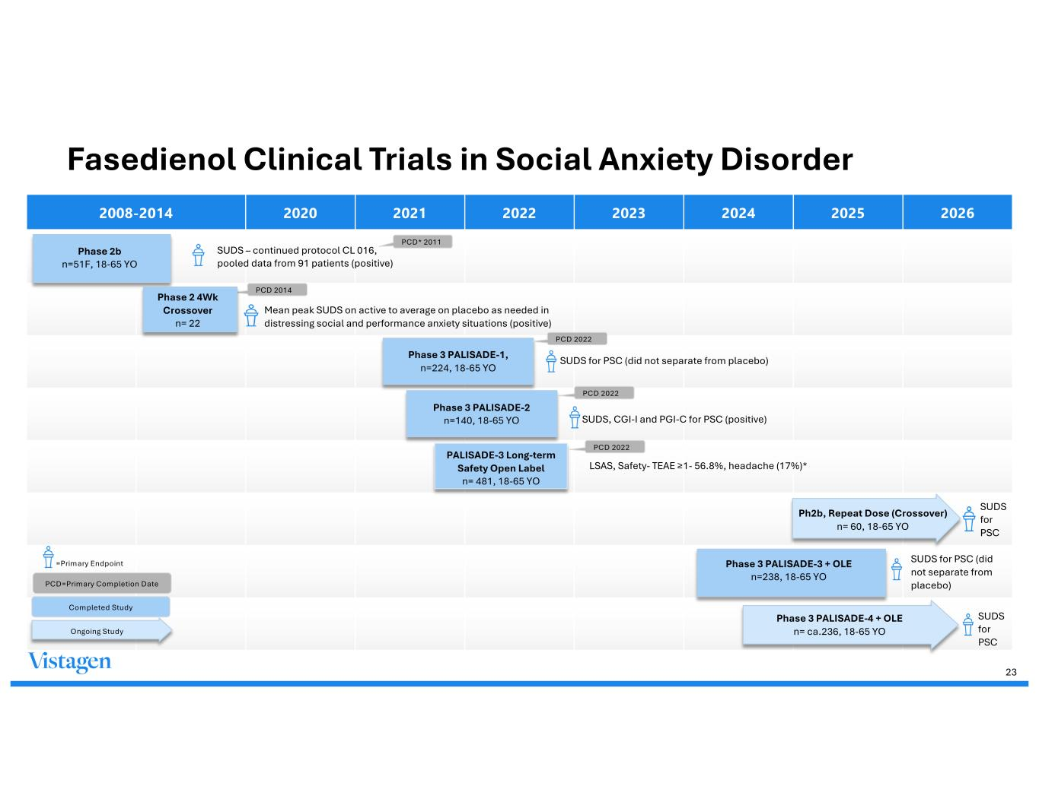
Fasedienol Clinical Trials in Social Anxiety Disorder 2008-2014 2020 2021 2022 2023 2024 2025 2026 SUDS – continued protocol CL 016, pooled data from 91 patients (positive) Mean peak SUDS on active to average on placebo as needed in distressing social and performance anxiety situations (positive) Phase 3 PALISADE-1, n=224, 18-65 YO SUDS for PSC (did not separate from placebo) SUDS, CGI-I and PGI-C for PSC (positive) PALISADE-3 Long-term Safety Open Label n= 481, 18-65 YO LSAS, Safety- TEAE ≥1- 56.8%, headache (17%)* Ph2b, Repeat Dose (Crossover) n= 60, 18-65 YO SUDS for PSC SUDS for PSC (did not separate from placebo) Phase 3 PALISADE-4 + OLE n= ca.236, 18-65 YO SUDS for PSC PCD 2022 Phase 3 PALISADE-3 + OLE n=238, 18-65 YO =Primary Endpoint PCD=Primary Completion Date PCD 2022 PCD 2022 PCD 2014 PCD* 2011 23 Phase 3 PALISADE-2 n=140, 18-65 YO Phase 2b n=51F, 18-65 YO Phase 2 4Wk Crossover n= 22 Completed Study Ongoing Study

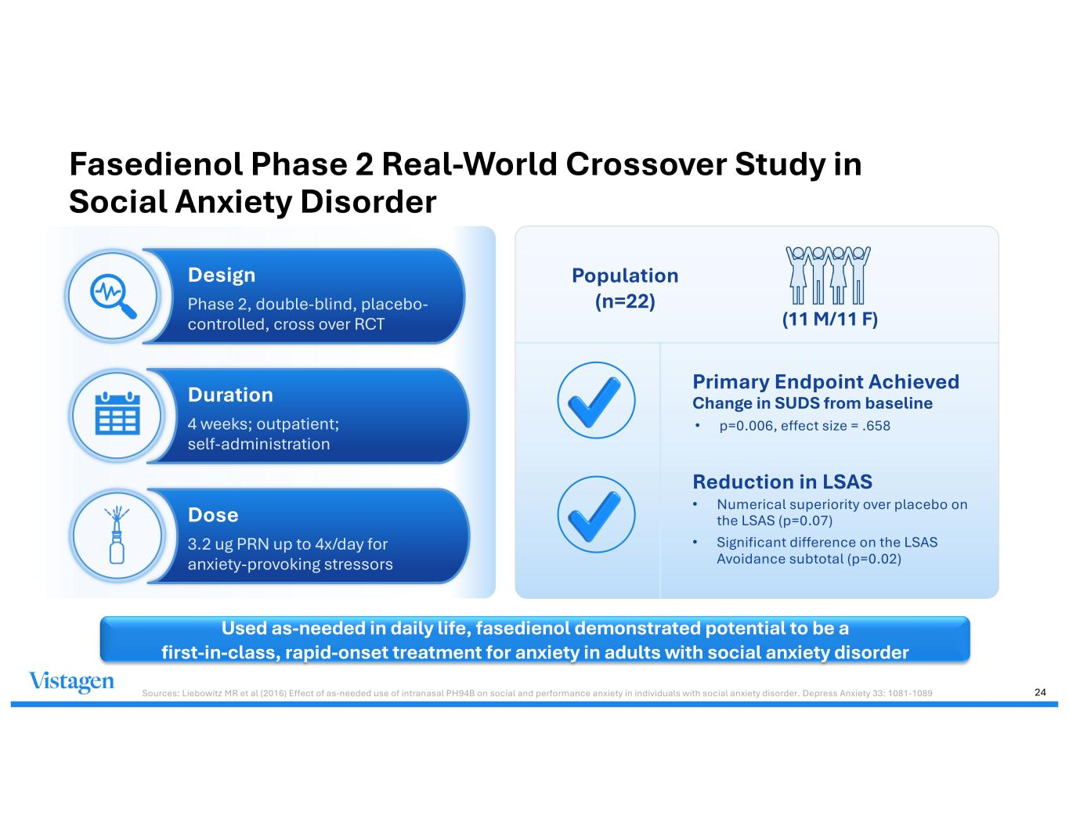
Fasedienol Phase 2 Real-World Crossover Study in Social Anxiety Disorder Sources: Liebowitz MR et al (2016) Effect of as-needed use of intranasal PH94B on social and performance anxiety in individuals with social anxiety disorder. Depress Anxiety 33: 1081-1089 Used as-needed in daily life, fasedienol demonstrated potential to be a first-in-class, rapid-onset treatment for anxiety in adults with social anxiety disorder Design Phase 2, double-blind, placebo- controlled, cross over RCT Dose 3.2 ug PRN up to 4x/day for anxiety-provoking stressors Duration 4 weeks; outpatient; self-administration Primary Endpoint Achieved Change in SUDS from baseline • p=0.006, effect size = .658 Reduction in LSAS • Numerical superiority over placebo on the LSAS (p=0.07) • Significant difference on the LSAS Avoidance subtotal (p=0.02) Population (n=22) (11 M/11 F) 24

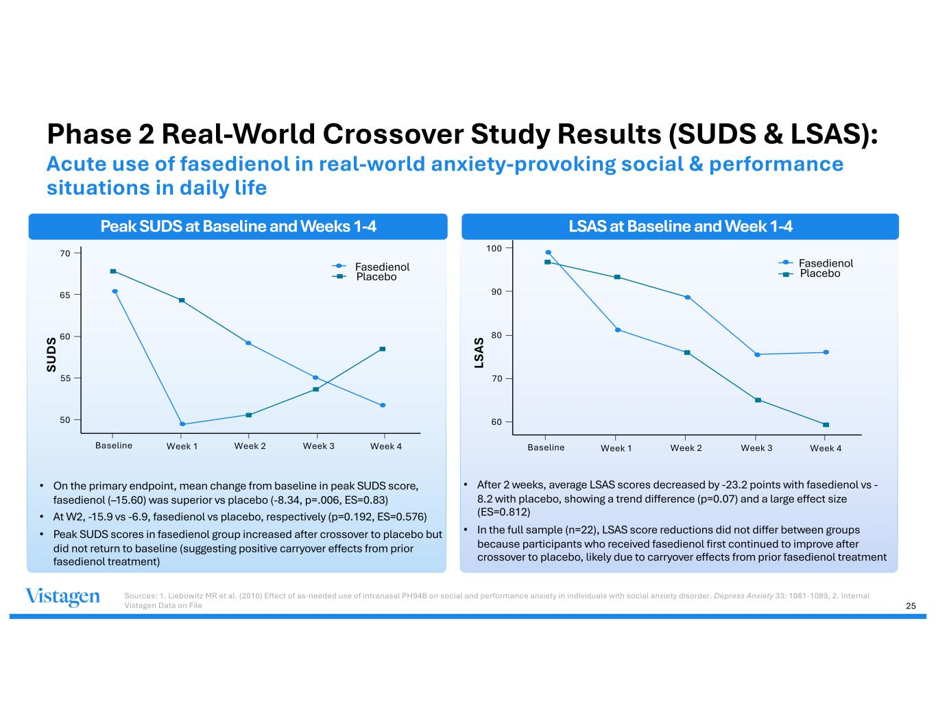
• On the primary endpoint, mean change from baseline in peak SUDS score, fasedienol (–15.60) was superior vs placebo (-8.34, p=.006, ES=0.83) • At W2, -15.9 vs -6.9, fasedienol vs placebo, respectively (p=0.192, ES=0.576) • Peak SUDS scores in fasedienol group increased after crossover to placebo but did not return to baseline (suggesting positive carryover effects from prior fasedienol treatment) • After 2 weeks, average LSAS scores decreased by -23.2 points with fasedienol vs - 8.2 with placebo, showing a trend difference (p=0.07) and a large effect size (ES=0.812) • In the full sample (n=22), LSAS score reductions did not differ between groups because participants who received fasedienol first continued to improve after crossover to placebo, likely due to carryover effects from prior fasedienol treatment 70 65 60 55 50 Baseline Week 1 Week 2 Week 3 Week 4 SU D S Fasedienol Placebo 100 90 80 70 60 LS A S Fasedienol Placebo Baseline Week 1 Week 2 Week 3 Week 4 Sources: 1. Liebowitz MR et al. (2016) Effect of as-needed use of intranasal PH94B on social and performance anxiety in individuals with social anxiety disorder. Depress Anxiety 33: 1081-1089, 2. Internal Vistagen Data on File Phase 2 Real-World Crossover Study Results (SUDS & LSAS): Acute use of fasedienol in real-world anxiety-provoking social & performance situations in daily life Peak SUDS at Baseline and Weeks 1-4 LSAS at Baseline and Week 1-4 25

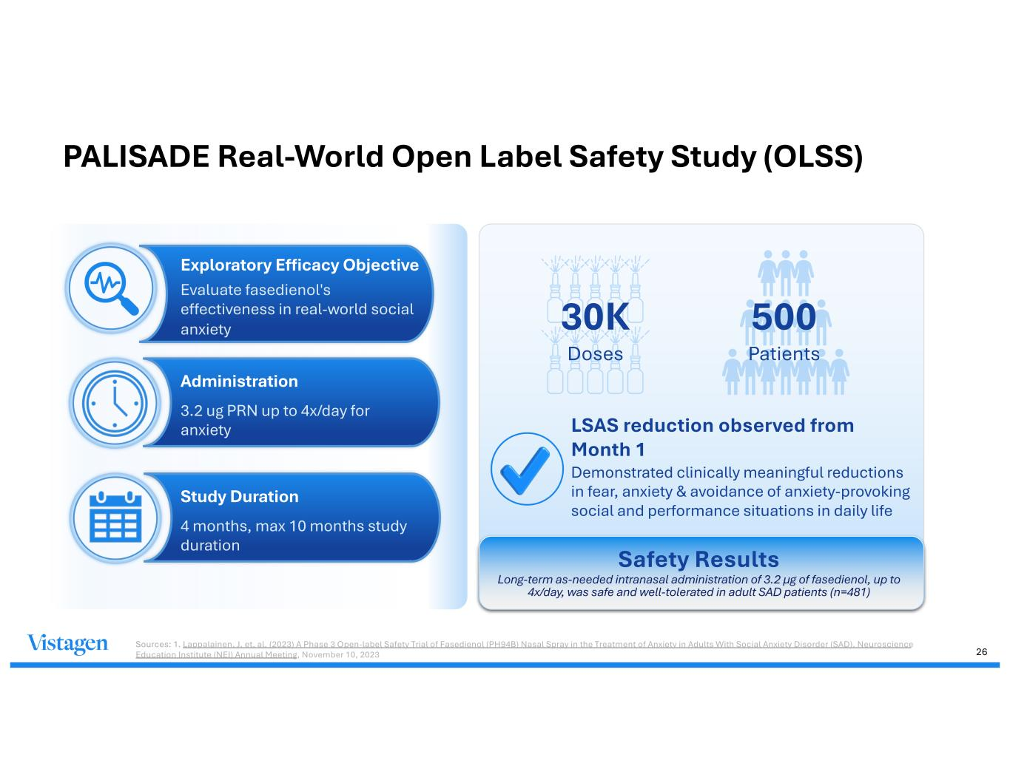
PALISADE Real-World Open Label Safety Study (OLSS) Exploratory Efficacy Objective Evaluate fasedienol's effectiveness in real-world social anxiety Study Duration 4 months, max 10 months study duration Administration 3.2 ug PRN up to 4x/day for anxiety 30K Doses 500 Patients LSAS reduction observed from Month 1 Demonstrated clinically meaningful reductions in fear, anxiety & avoidance of anxiety-provoking social and performance situations in daily life Safety Results Long-term as-needed intranasal administration of 3.2 µg of fasedienol, up to 4x/day, was safe and well-tolerated in adult SAD patients (n=481) 26 Sources: 1. Lappalainen, J. et. al. (2023) A Phase 3 Open-label Safety Trial of Fasedienol (PH94B) Nasal Spray in the Treatment of Anxiety in Adults With Social Anxiety Disorder (SAD). Neuroscience Education Institute (NEI) Annual Meeting, November 10, 2023

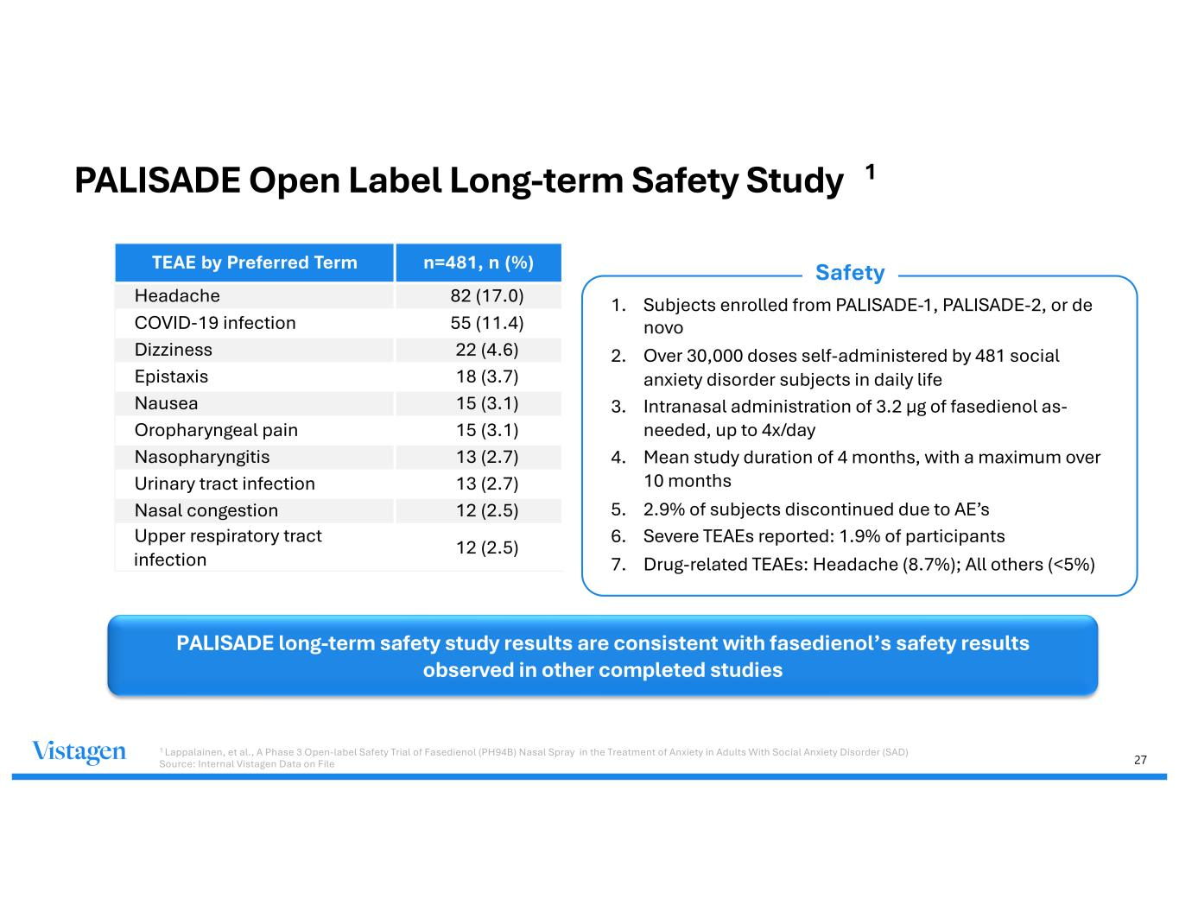
27 TEAE by Preferred Term n=481, n (%) Headache 82 (17.0) COVID-19 infection 55 (11.4) Dizziness 22 (4.6) Epistaxis 18 (3.7) Nausea 15 (3.1) Oropharyngeal pain 15 (3.1) Nasopharyngitis 13 (2.7) Urinary tract infection 13 (2.7) Nasal congestion 12 (2.5) Upper respiratory tract infection 12 (2.5) 1. Subjects enrolled from PALISADE-1, PALISADE-2, or de novo 2. Over 30,000 doses self-administered by 481 social anxiety disorder subjects in daily life 3. Intranasal administration of 3.2 μg of fasedienol as- needed, up to 4x/day 4. Mean study duration of 4 months, with a maximum over 10 months 5. 2.9% of subjects discontinued due to AE’s 6. Severe TEAEs reported: 1.9% of participants 7. Drug-related TEAEs: Headache (8.7%); All others (<5%) PALISADE Open Label Long-term Safety Study PALISADE long-term safety study results are consistent with fasedienol’s safety results observed in other completed studies 1 Lappalainen, et al., A Phase 3 Open-label Safety Trial of Fasedienol (PH94B) Nasal Spray in the Treatment of Anxiety in Adults With Social Anxiety Disorder (SAD) Source: Internal Vistagen Data on File 1 Safety

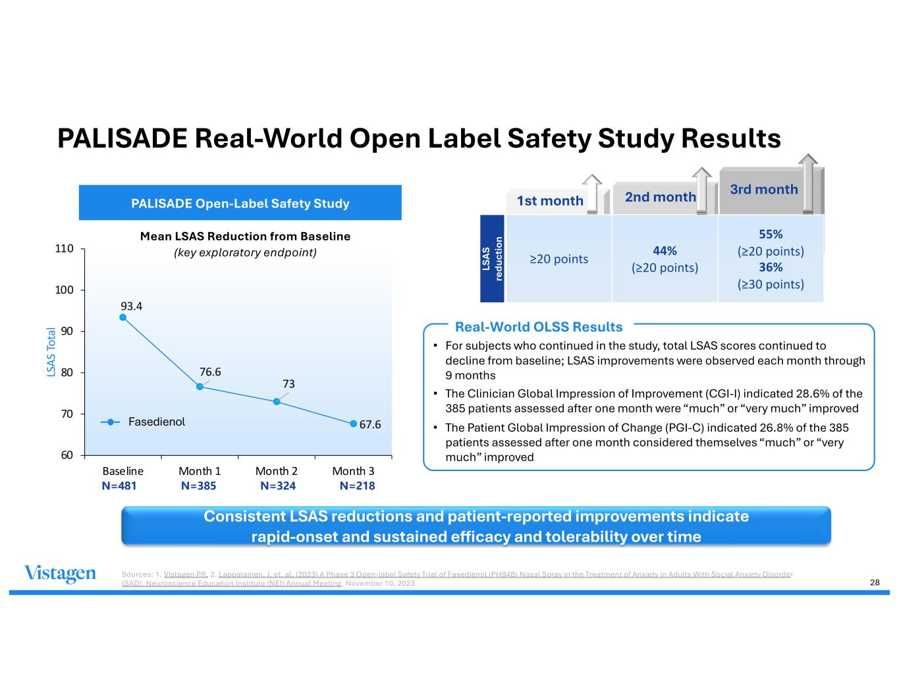
Your Title Here Vestibulum neque elit, Class apt taciti sociosqu ad litora torquent. Your Title Here Vestibulum neque elit, Class apt taciti sociosqu ad litora torquent. Vestibulum neque elit, Class apt taciti sociosqu ad litora torquent. LS AS re du ct io n 93.4 76.6 73 67.6 60 70 80 90 100 110 Baseline Month 1 Month 2 Month 3 LS AS To ta l PALISADE Open-Label Safety Study Mean LSAS Reduction from Baseline (key exploratory endpoint) N=481 N=385 N=324 N=218 ≥20 points 44% (≥20 points) 55% (≥20 points) 36% (≥30 points) Fasedienol PALISADE Real-World Open Label Safety Study Results Consistent LSAS reductions and patient-reported improvements indicate rapid-onset and sustained efficacy and tolerability over time Sources: 1. Vistagen PR, 2. Lappalainen, J. et. al. (2023) A Phase 3 Open-label Safety Trial of Fasedienol (PH94B) Nasal Spray in the Treatment of Anxiety in Adults With Social Anxiety Disorder (SAD). Neuroscience Education Institute (NEI) Annual Meeting, November 10, 2023 1st month 2nd month 3rd month Real-World OLSS Results 28 • For subjects who continued in the study, total LSAS scores continued to decline from baseline; LSAS improvements were observed each month through 9 months • The Clinician Global Impression of Improvement (CGI-I) indicated 28.6% of the 385 patients assessed after one month were “much” or “very much” improved • The Patient Global Impression of Change (PGI-C) indicated 26.8% of the 385 patients assessed after one month considered themselves “much” or “very much” improved

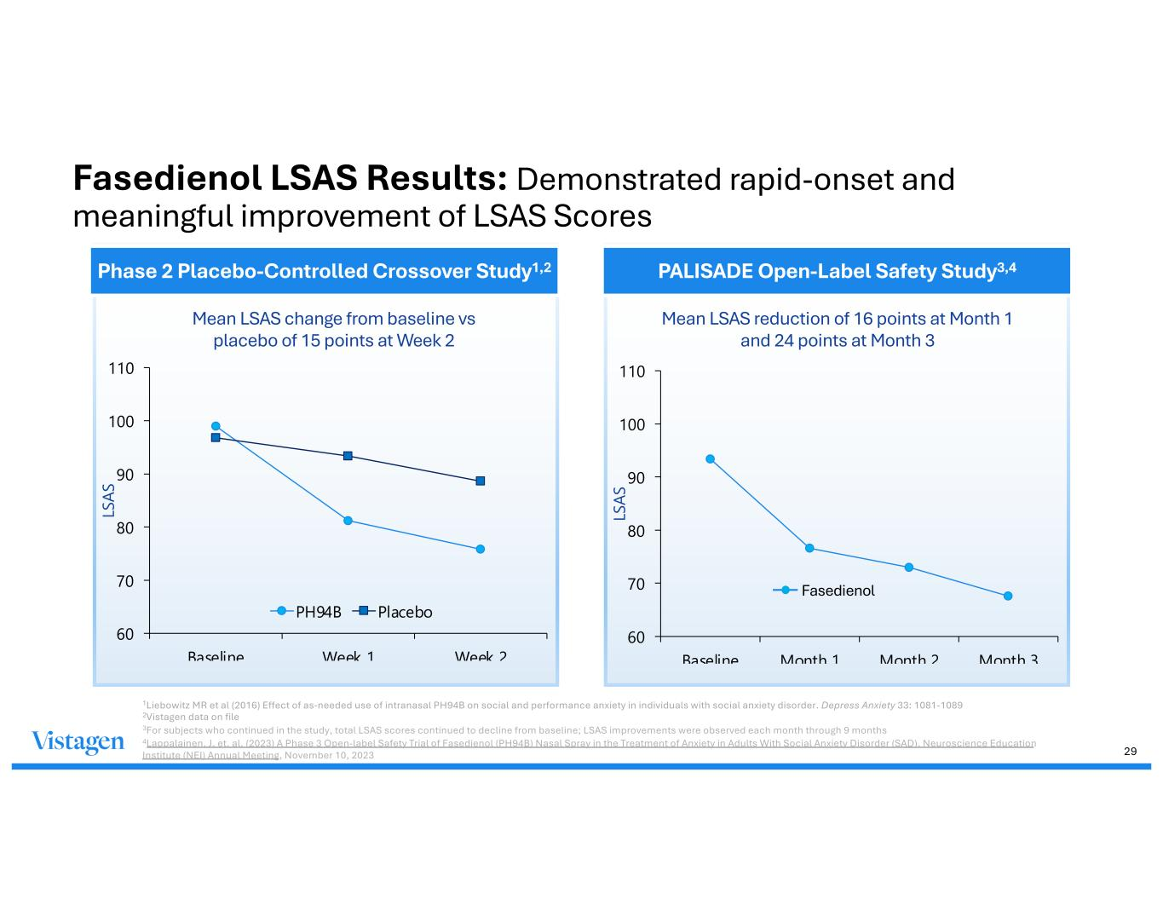
Fasedienol LSAS Results: Demonstrated rapid-onset and meaningful improvement of LSAS Scores 60 70 80 90 100 110 Baseline Week 1 Week 2 LS AS PH94B Placebo 60 70 80 90 100 110 Baseline Month 1 Month 2 Month 3 LS AS Mean LSAS reduction of 16 points at Month 1 and 24 points at Month 3 Mean LSAS change from baseline vs placebo of 15 points at Week 2 Fasedienol 1Liebowitz MR et al (2016) Effect of as-needed use of intranasal PH94B on social and performance anxiety in individuals with social anxiety disorder. Depress Anxiety 33: 1081-1089 2Vistagen data on file 3For subjects who continued in the study, total LSAS scores continued to decline from baseline; LSAS improvements were observed each month through 9 months 4Lappalainen, J. et. al. (2023) A Phase 3 Open-label Safety Trial of Fasedienol (PH94B) Nasal Spray in the Treatment of Anxiety in Adults With Social Anxiety Disorder (SAD). Neuroscience Education Institute (NEI) Annual Meeting, November 10, 2023 Phase 2 Placebo-Controlled Crossover Study1,2 PALISADE Open-Label Safety Study3,4 29

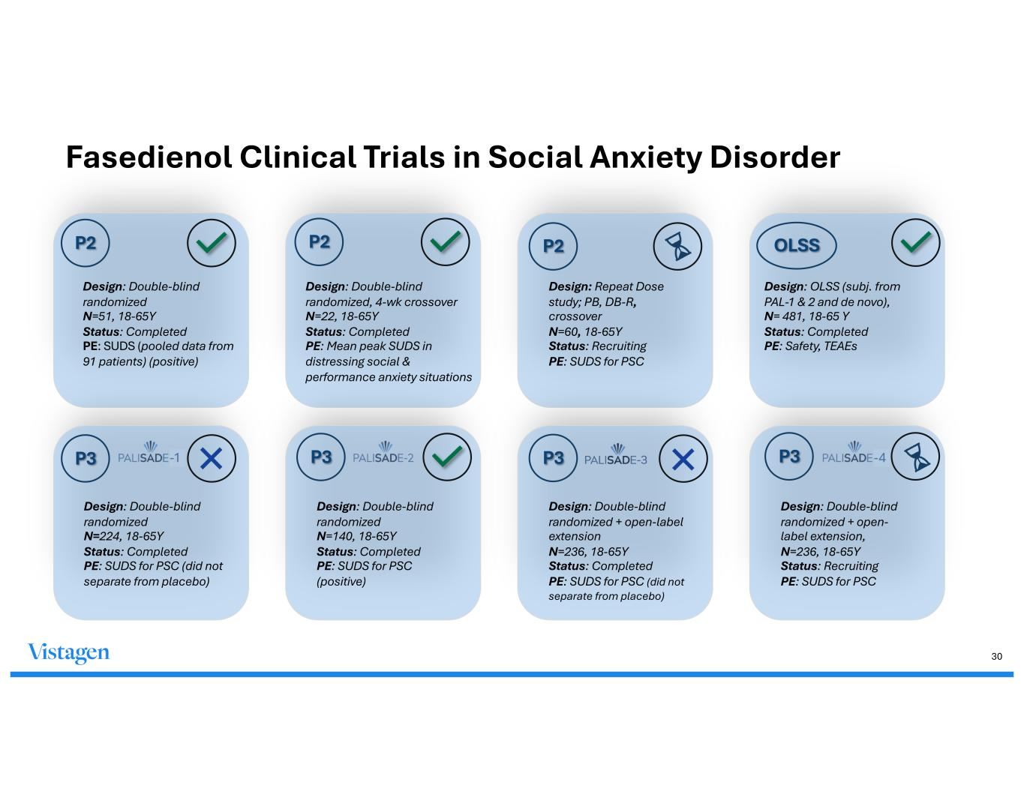
P2 Design: Double-blind randomized N=51, 18-65Y Status: Completed PE: SUDS (pooled data from 91 patients) (positive) Design: Double-blind randomized, 4-wk crossover N=22, 18-65Y Status: Completed PE: Mean peak SUDS in distressing social & performance anxiety situations P2 P3 Design: Repeat Dose study; PB, DB-R, crossover N=60, 18-65Y Status: Recruiting PE: SUDS for PSC P2 P3 Design: Double-blind randomized N=140, 18-65Y Status: Completed PE: SUDS for PSC (positive) Design: Double-blind randomized + open-label extension N=236, 18-65Y Status: Completed PE: SUDS for PSC (did not separate from placebo) P3 Design: Double-blind randomized N=224, 18-65Y Status: Completed PE: SUDS for PSC (did not separate from placebo) P3 Design: Double-blind randomized + open- label extension, N=236, 18-65Y Status: Recruiting PE: SUDS for PSC -1 OLSS Design: OLSS (subj. from PAL-1 & 2 and de novo), N= 481, 18-65 Y Status: Completed PE: Safety, TEAEs -4 30 Fasedienol Clinical Trials in Social Anxiety Disorder

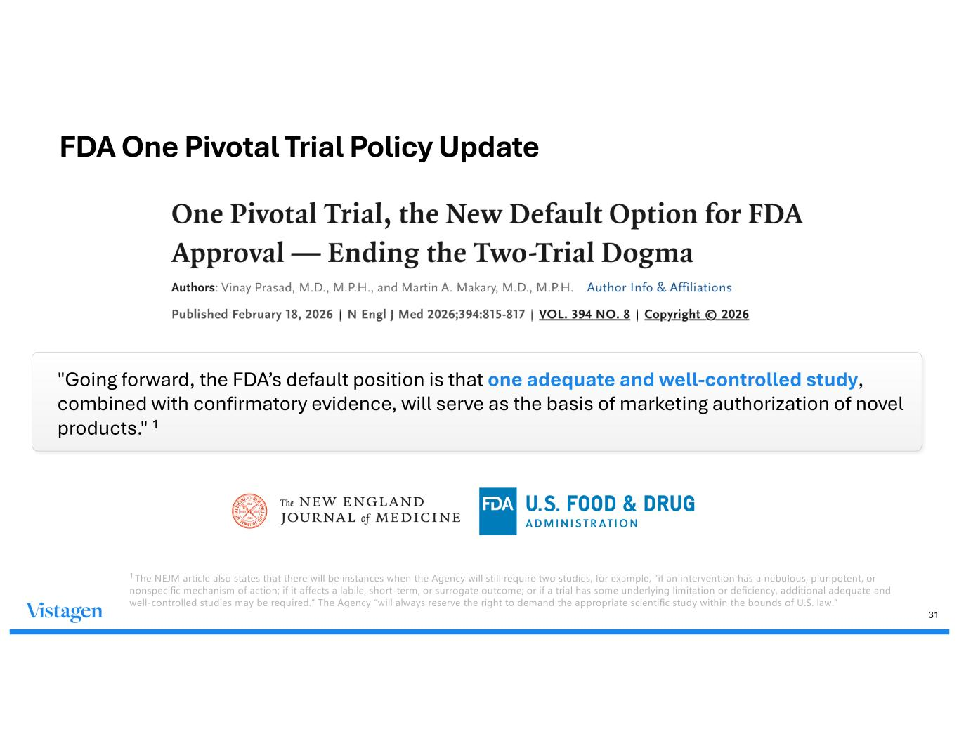
31 "Going forward, the FDA’s default position is that one adequate and well-controlled study, combined with confirmatory evidence, will serve as the basis of marketing authorization of novel products." 1 1 The NEJM article also states that there will be instances when the Agency will still require two studies, for example, “if an intervention has a nebulous, pluripotent, or nonspecific mechanism of action; if it affects a labile, short-term, or surrogate outcome; or if a trial has some underlying limitation or deficiency, additional adequate and well-controlled studies may be required.” The Agency “will always reserve the right to demand the appropriate scientific study within the bounds of U.S. law.” FDA One Pivotal Trial Policy Update

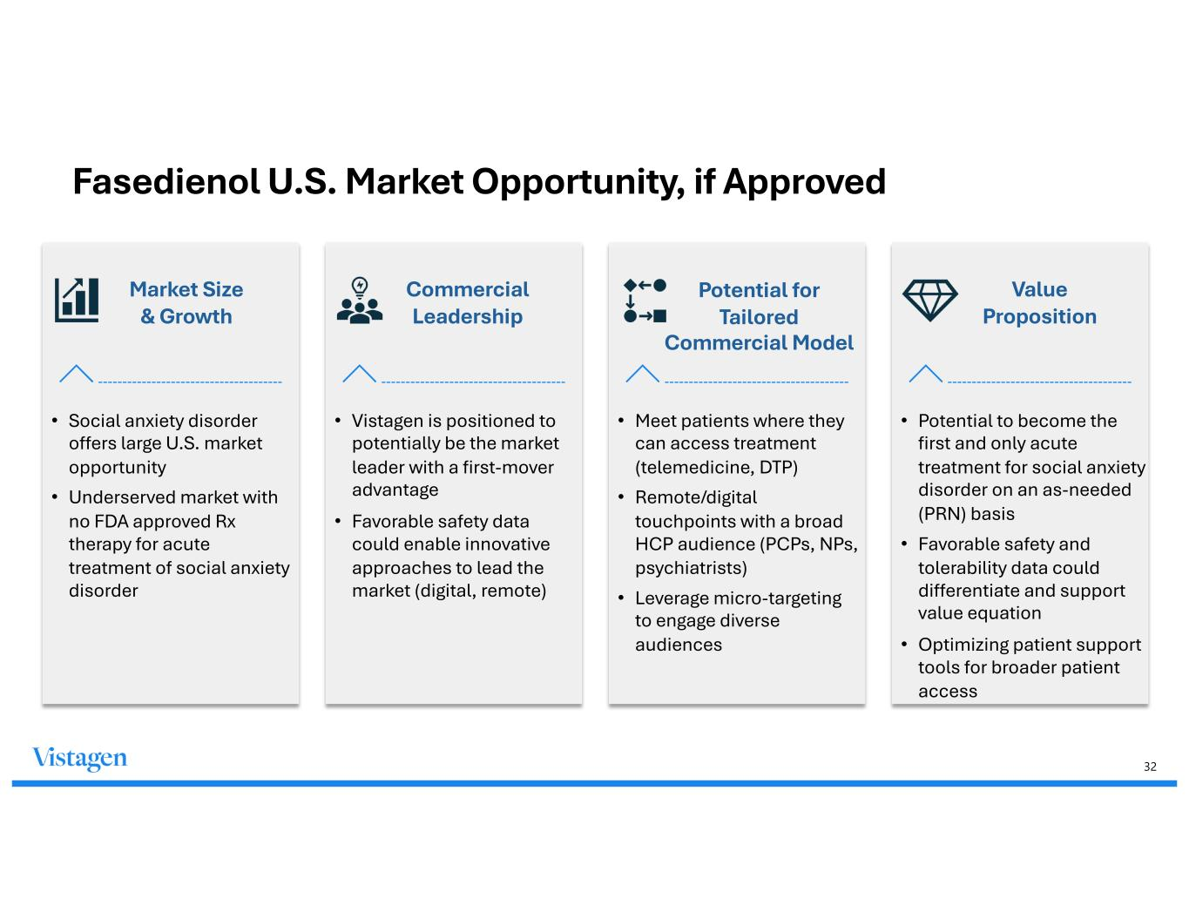
32 Fasedienol U.S. Market Opportunity, if Approved Market Size & Growth Commercial Leadership Potential for Tailored Commercial Model Value Proposition • Social anxiety disorder offers large U.S. market opportunity • Underserved market with no FDA approved Rx therapy for acute treatment of social anxiety disorder • Vistagen is positioned to potentially be the market leader with a first-mover advantage • Favorable safety data could enable innovative approaches to lead the market (digital, remote) • Meet patients where they can access treatment (telemedicine, DTP) • Remote/digital touchpoints with a broad HCP audience (PCPs, NPs, psychiatrists) • Leverage micro-targeting to engage diverse audiences • Potential to become the first and only acute treatment for social anxiety disorder on an as-needed (PRN) basis • Favorable safety and tolerability data could differentiate and support value equation • Optimizing patient support tools for broader patient access

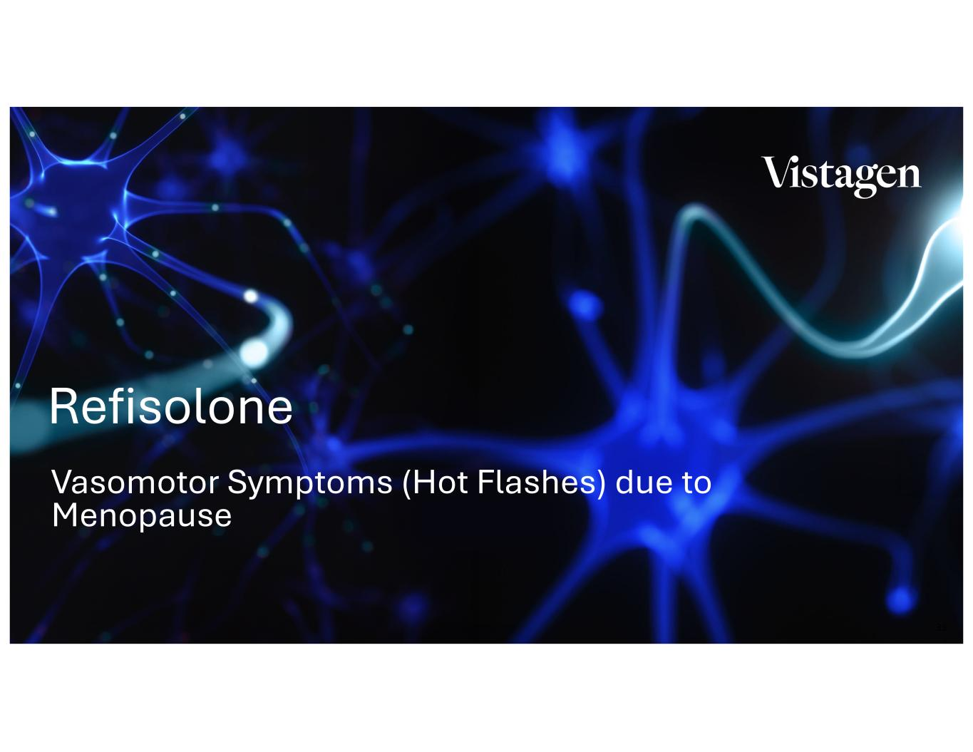
33 Vasomotor Symptoms (Hot Flashes) due to Menopause Refisolone

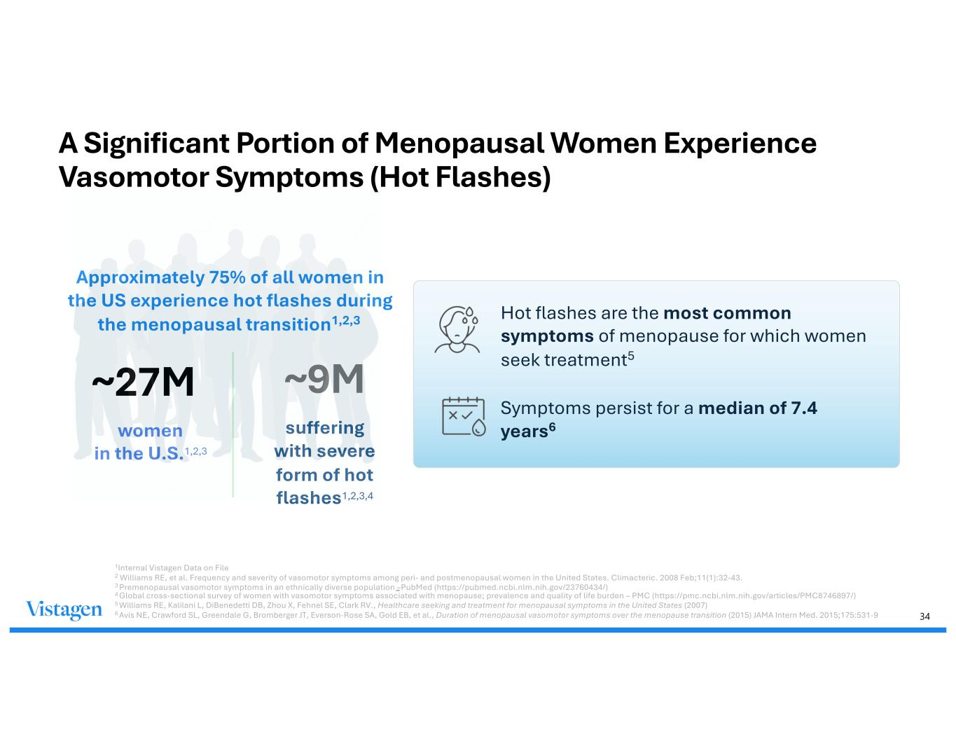
34 A Significant Portion of Menopausal Women Experience Vasomotor Symptoms (Hot Flashes) ~27M women in the U.S.1,2,3 ~9M suffering with severe form of hot flashes1,2,3,4 Symptoms persist for a median of 7.4 years6 Hot flashes are the most common symptoms of menopause for which women seek treatment5 Approximately 75% of all women in the US experience hot flashes during the menopausal transition1,2,3 1Internal Vistagen Data on File 2 Williams RE, et al. Frequency and severity of vasomotor symptoms among peri- and postmenopausal women in the United States. Climacteric. 2008 Feb;11(1):32-43. 3 Premenopausal vasomotor symptoms in an ethnically diverse population –PubMed (https://pubmed.ncbi.nlm.nih.gov/23760434/) 4 Global cross-sectional survey of women with vasomotor symptoms associated with menopause; prevalence and quality of life burden – PMC (https://pmc.ncbi.nlm.nih.gov/articles/PMC8746897/) 5 Williams RE, Kalilani L, DiBenedetti DB, Zhou X, Fehnel SE, Clark RV., Healthcare seeking and treatment for menopausal symptoms in the United States (2007) 6 Avis NE, Crawford SL, Greendale G, Bromberger JT, Everson-Rose SA, Gold EB, et al., Duration of menopausal vasomotor symptoms over the menopause transition (2015) JAMA Intern Med. 2015;175:531-9

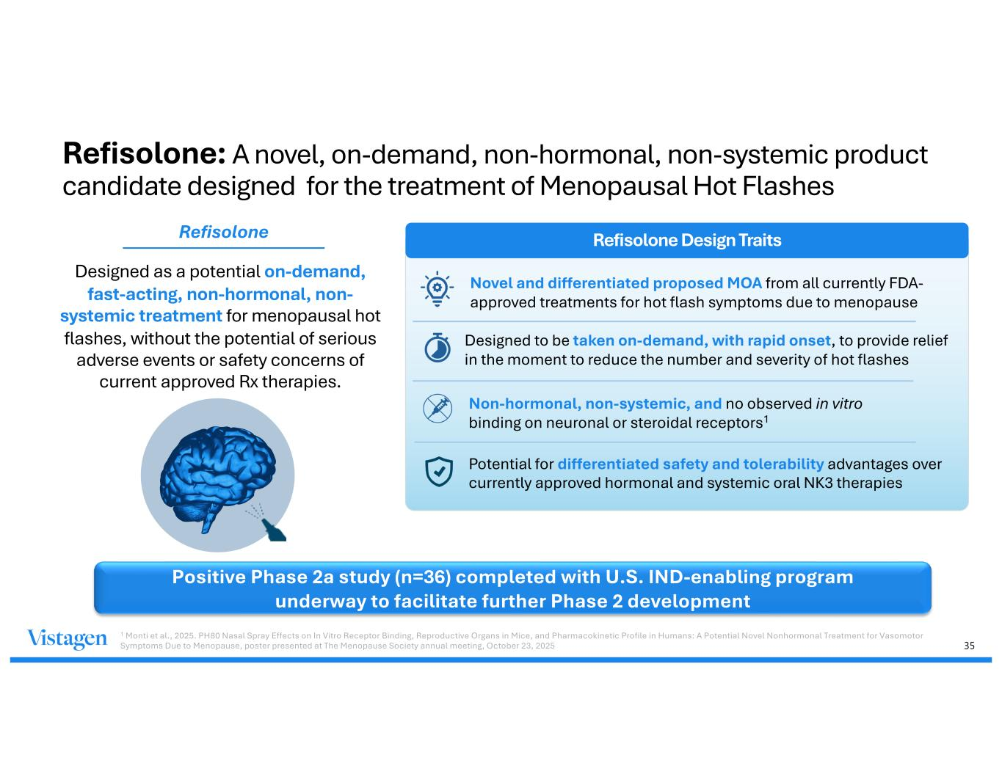
35 Refisolone: A novel, on-demand, non-hormonal, non-systemic product candidate designed for the treatment of Menopausal Hot Flashes Designed as a potential on-demand, fast-acting, non-hormonal, non- systemic treatment for menopausal hot flashes, without the potential of serious adverse events or safety concerns of current approved Rx therapies. Refisolone Design Traits Novel and differentiated proposed MOA from all currently FDA- approved treatments for hot flash symptoms due to menopause Designed to be taken on-demand, with rapid onset, to provide relief in the moment to reduce the number and severity of hot flashes Non-hormonal, non-systemic, and no observed in vitro binding on neuronal or steroidal receptors1 Potential for differentiated safety and tolerability advantages over currently approved hormonal and systemic oral NK3 therapies Refisolone Positive Phase 2a study (n=36) completed with U.S. IND-enabling program underway to facilitate further Phase 2 development 1 Monti et al., 2025. PH80 Nasal Spray Effects on In Vitro Receptor Binding, Reproductive Organs in Mice, and Pharmacokinetic Profile in Humans: A Potential Novel Nonhormonal Treatment for Vasomotor Symptoms Due to Menopause, poster presented at The Menopause Society annual meeting, October 23, 2025

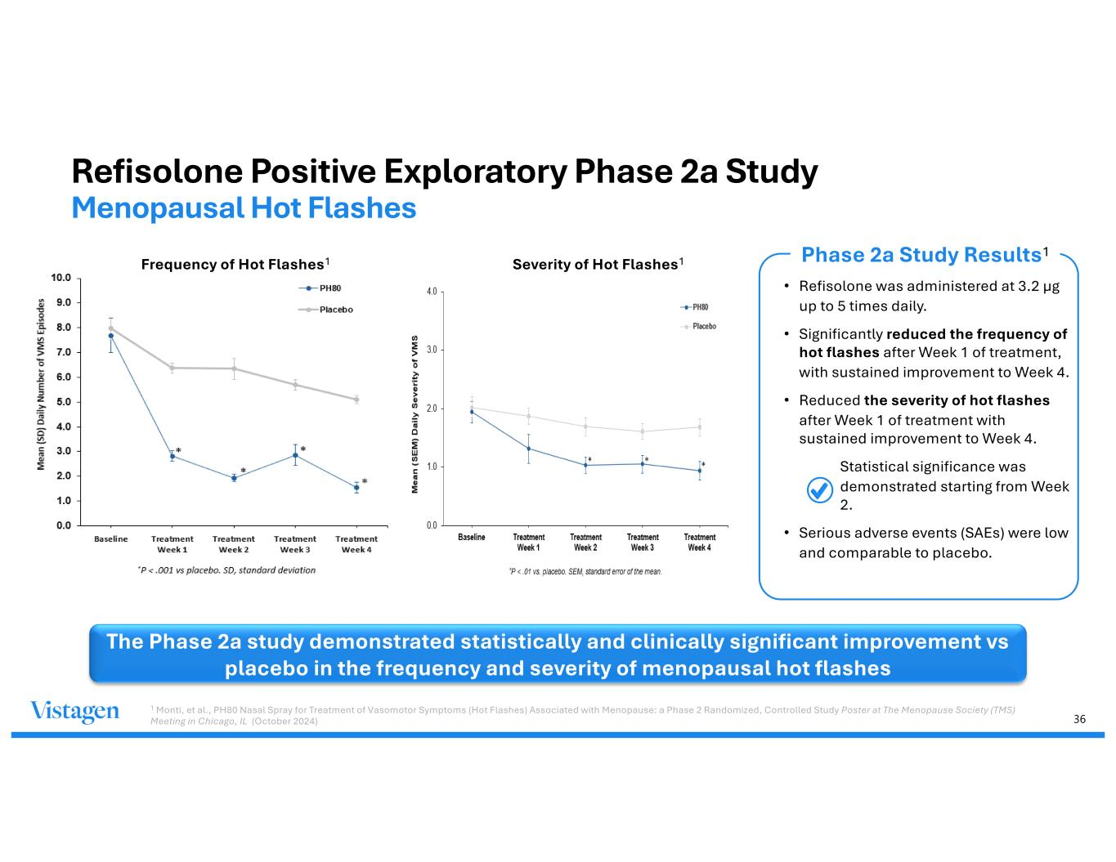
36 Refisolone Positive Exploratory Phase 2a Study Menopausal Hot Flashes The Phase 2a study demonstrated statistically and clinically significant improvement vs placebo in the frequency and severity of menopausal hot flashes Phase 2a Study Results1 • Refisolone was administered at 3.2 µg up to 5 times daily. • Significantly reduced the frequency of hot flashes after Week 1 of treatment, with sustained improvement to Week 4. • Reduced the severity of hot flashes after Week 1 of treatment with sustained improvement to Week 4. • Statistical significance was demonstrated starting from Week 2. • Serious adverse events (SAEs) were low and comparable to placebo. Frequency of Hot Flashes1 Severity of Hot Flashes1 1 Monti, et al., PH80 Nasal Spray for Treatment of Vasomotor Symptoms (Hot Flashes) Associated with Menopause: a Phase 2 Randomized, Controlled Study Poster at The Menopause Society (TMS) Meeting in Chicago, IL (October 2024)

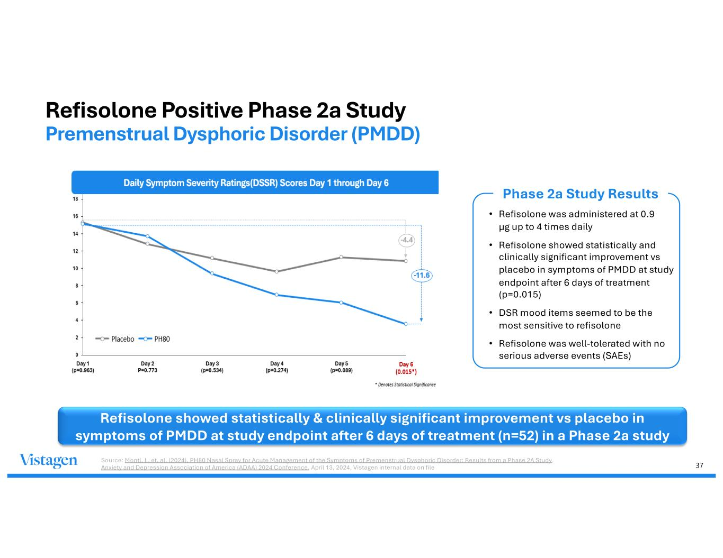
37 Refisolone Positive Phase 2a Study Premenstrual Dysphoric Disorder (PMDD) Refisolone showed statistically & clinically significant improvement vs placebo in symptoms of PMDD at study endpoint after 6 days of treatment (n=52) in a Phase 2a study Phase 2a Study Results • Refisolone was administered at 0.9 µg up to 4 times daily • Refisolone showed statistically and clinically significant improvement vs placebo in symptoms of PMDD at study endpoint after 6 days of treatment (p=0.015) • DSR mood items seemed to be the most sensitive to refisolone • Refisolone was well-tolerated with no serious adverse events (SAEs) Source: Monti, L. et. al. (2024). PH80 Nasal Spray for Acute Management of the Symptoms of Premenstrual Dysphoric Disorder: Results from a Phase 2A Study. Anxiety and Depression Association of America (ADAA) 2024 Conference. April 13, 2024, Vistagen internal data on file

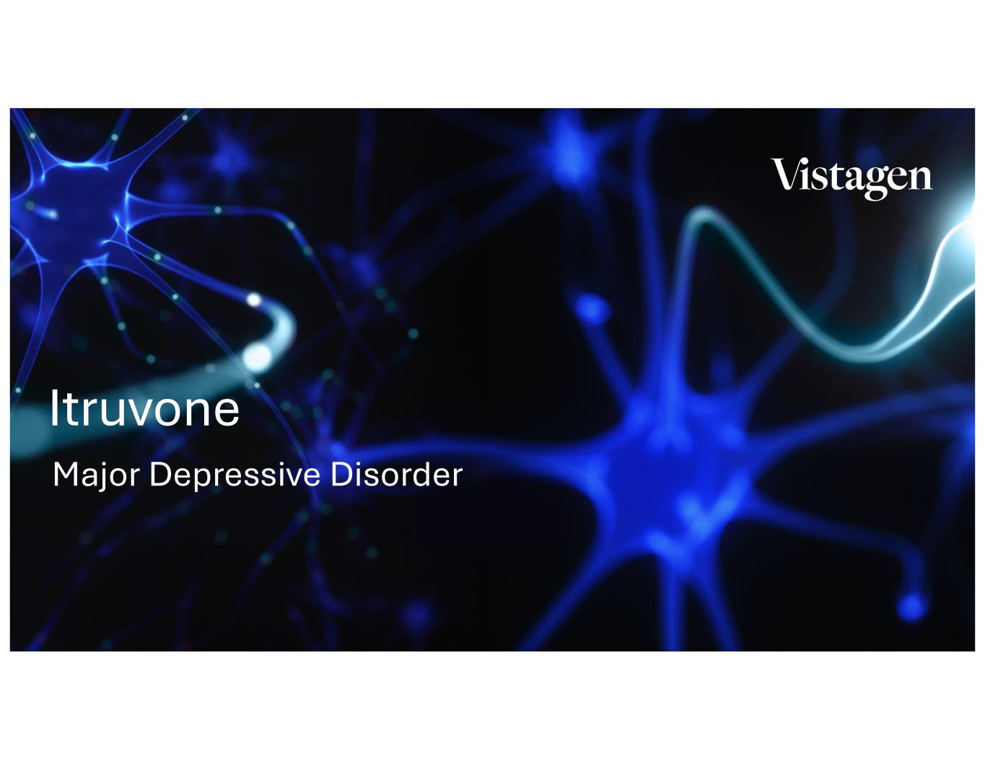
38 Major Depressive Disorder Itruvone

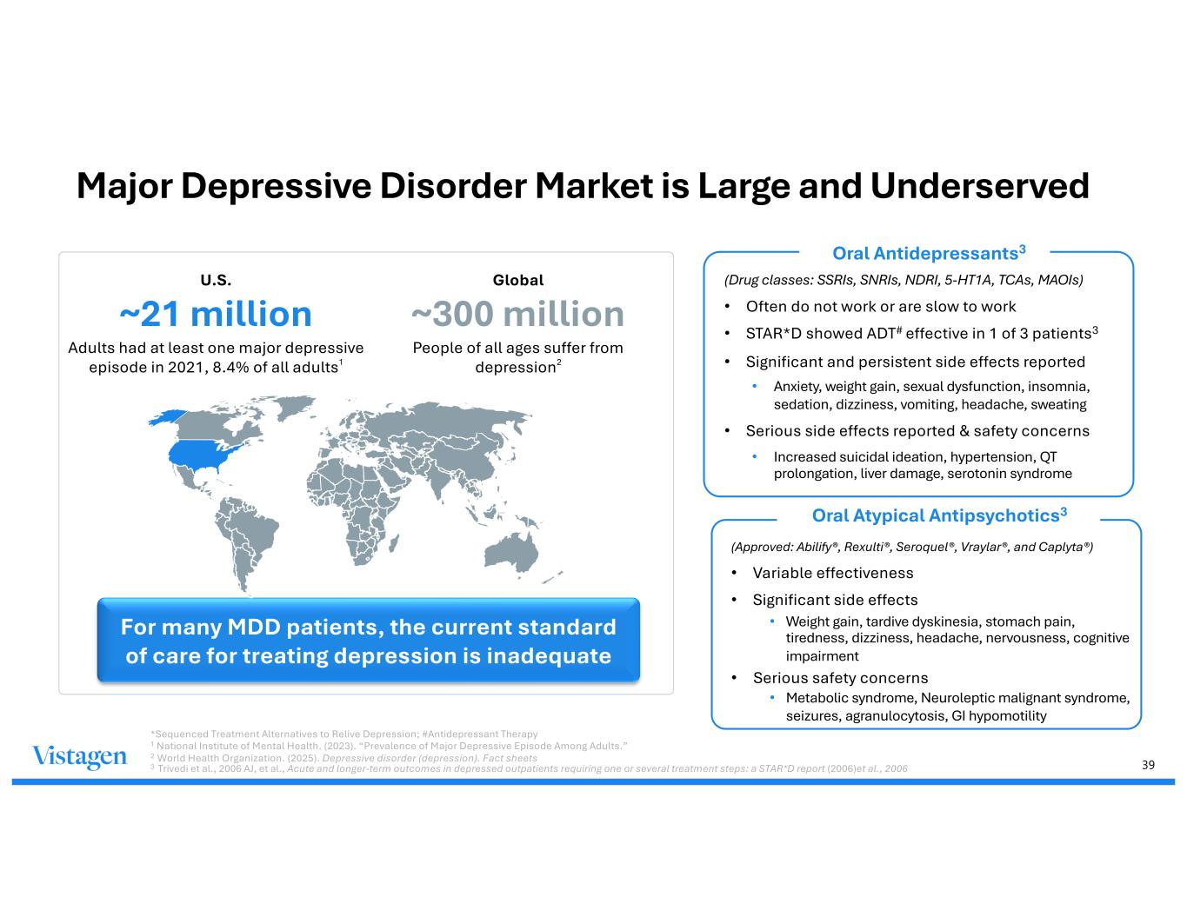
39 Major Depressive Disorder Market is Large and Underserved (Drug classes: SSRIs, SNRIs, NDRI, 5-HT1A, TCAs, MAOIs) • Often do not work or are slow to work • STAR*D showed ADT# effective in 1 of 3 patients3 • Significant and persistent side effects reported • Anxiety, weight gain, sexual dysfunction, insomnia, sedation, dizziness, vomiting, headache, sweating • Serious side effects reported & safety concerns • Increased suicidal ideation, hypertension, QT prolongation, liver damage, serotonin syndrome For many MDD patients, the current standard of care for treating depression is inadequate U.S. ~21 million Adults had at least one major depressive episode in 2021, 8.4% of all adults1 Global ~300 million People of all ages suffer from depression2 *Sequenced Treatment Alternatives to Relive Depression; #Antidepressant Therapy 1 National Institute of Mental Health. (2023). “Prevalence of Major Depressive Episode Among Adults.” 2 World Health Organization. (2025). Depressive disorder (depression). Fact sheets 3 Trivedi et al., 2006 AJ, et al., Acute and longer-term outcomes in depressed outpatients requiring one or several treatment steps: a STAR*D report (2006)et al., 2006 Oral Antidepressants3 (Approved: Abilify®, Rexulti®, Seroquel®, Vraylar®, and Caplyta®) • Variable effectiveness • Significant side effects • Weight gain, tardive dyskinesia, stomach pain, tiredness, dizziness, headache, nervousness, cognitive impairment • Serious safety concerns • Metabolic syndrome, Neuroleptic malignant syndrome, seizures, agranulocytosis, GI hypomotility Oral Atypical Antipsychotics3

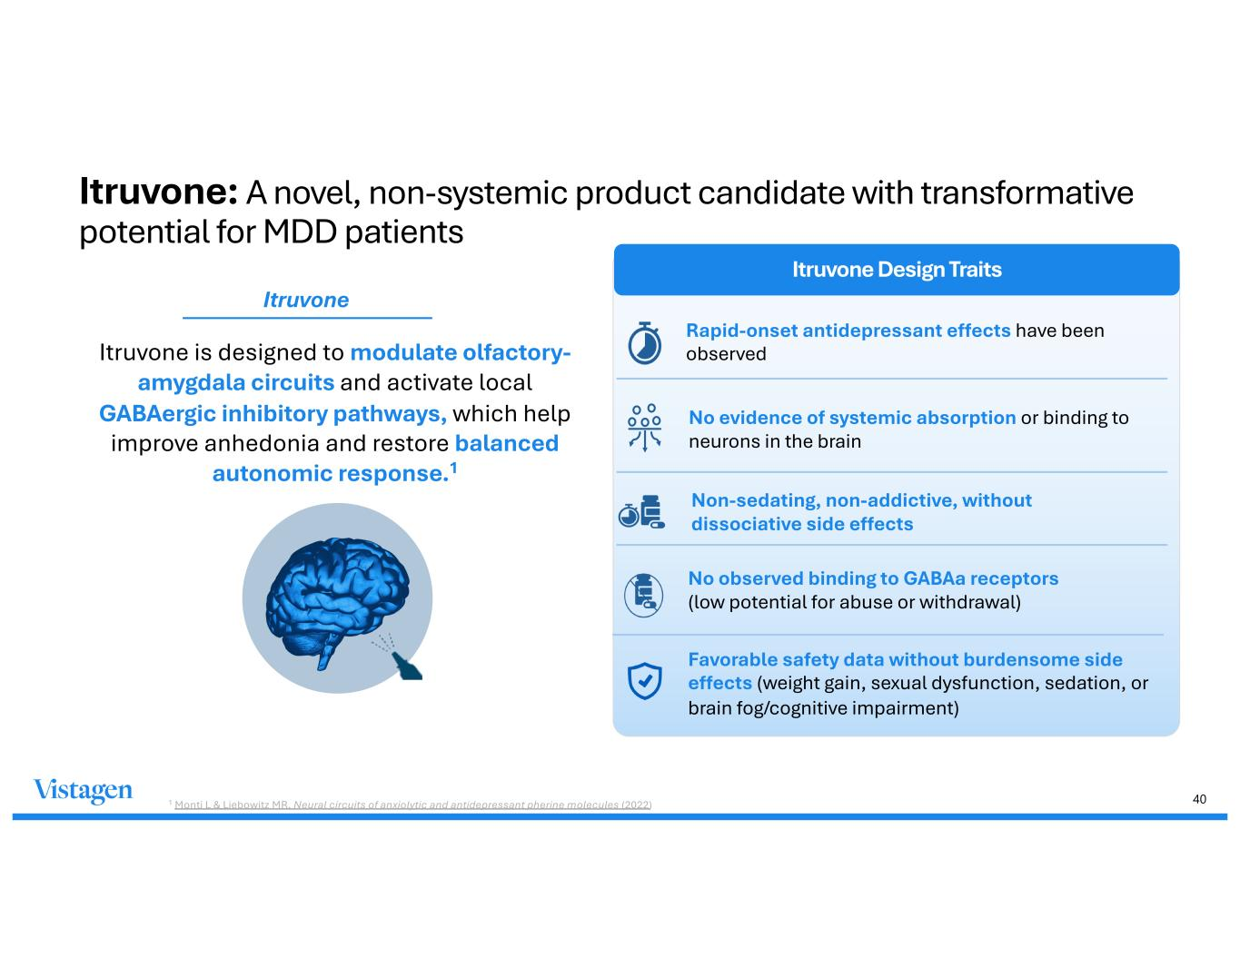
40 Itruvone is designed to modulate olfactory- amygdala circuits and activate local GABAergic inhibitory pathways, which help improve anhedonia and restore balanced autonomic response.1 Itruvone Design Traits Rapid-onset antidepressant effects have been observed No evidence of systemic absorption or binding to neurons in the brain 1 Monti L & Liebowitz MR, Neural circuits of anxiolytic and antidepressant pherine molecules (2022) No observed binding to GABAa receptors (low potential for abuse or withdrawal) Favorable safety data without burdensome side effects (weight gain, sexual dysfunction, sedation, or brain fog/cognitive impairment) Non-sedating, non-addictive, without dissociative side effects Itruvone Itruvone: A novel, non-systemic product candidate with transformative potential for MDD patients

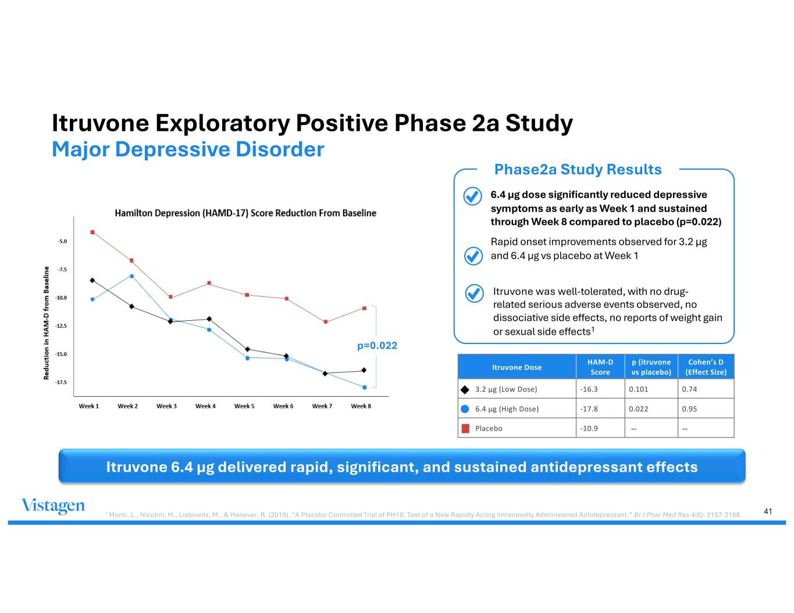
41 Itruvone Exploratory Positive Phase 2a Study Major Depressive Disorder • 6.4 µg dose significantly reduced depressive symptoms as early as Week 1 and sustained through Week 8 compared to placebo (p=0.022) • Rapid onset improvements observed for 3.2 µg and 6.4 µg vs placebo at Week 1 Phase2a Study Results Itruvone 6.4 µg delivered rapid, significant, and sustained antidepressant effects Itruvone Dose HAM-D Score p (itruvone vs placebo) Cohen’s D (Effect Size) 3.2 µg (Low Dose) -16.3 0.101 0.74 6.4 µg (High Dose) -17.8 0.022 0.95 Placebo -10.9 -- -- p=0.022 1 Monti, L., Nicolini, H., Liebowitz, M., & Hanover, R. (2019). “A Placebo Controlled Trial of PH10: Test of a New Rapidly Acting Intranasally Administered Antidepressant.” Br J Phar Med Res 4(6): 2157-2168. • Itruvone was well-tolerated, with no drug- related serious adverse events observed, no dissociative side effects, no reports of weight gain or sexual side effects1

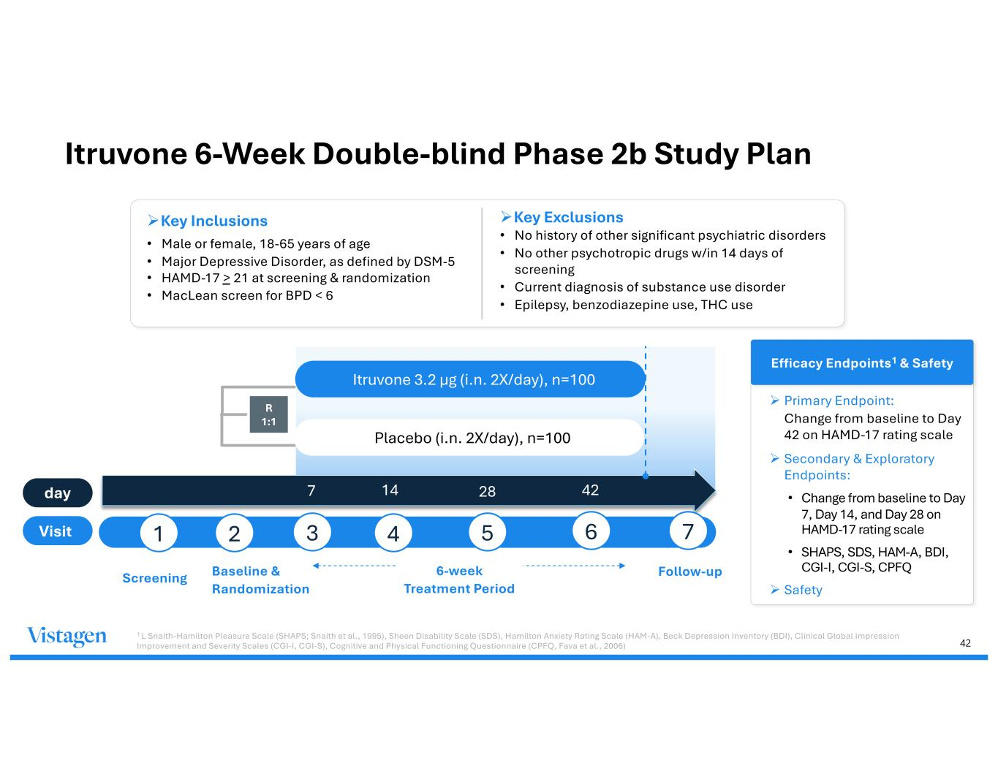
42 Itruvone 6-Week Double-blind Phase 2b Study Plan ØKey Inclusions • Male or female, 18-65 years of age • Major Depressive Disorder, as defined by DSM-5 • HAMD-17 > 21 at screening & randomization • MacLean screen for BPD < 6 ØKey Exclusions • No history of other significant psychiatric disorders • No other psychotropic drugs w/in 14 days of screening • Current diagnosis of substance use disorder • Epilepsy, benzodiazepine use, THC use Baseline & Randomization 7 R 1:1 day Visit Screening Follow-up Itruvone 3.2 µg (i.n. 2X/day), n=100 Placebo (i.n. 2X/day), n=100 Efficacy Endpoints1 & Safety Ø Primary Endpoint: Change from baseline to Day 42 on HAMD-17 rating scale Ø Secondary & Exploratory Endpoints: • Change from baseline to Day 7, Day 14, and Day 28 on HAMD-17 rating scale • SHAPS, SDS, HAM-A, BDI, CGI-I, CGI-S, CPFQ Ø Safety 1 L Snaith-Hamilton Pleasure Scale (SHAPS; Snaith et al., 1995), Sheen Disability Scale (SDS), Hamilton Anxiety Rating Scale (HAM-A), Beck Depression Inventory (BDI), Clinical Global Impression Improvement and Severity Scales (CGI-I, CGI-S), Cognitive and Physical Functioning Questionnaire (CPFQ, Fava et al., 2006) 1 2 3 4 5 6 14 28 42 7 6-week Treatment Period

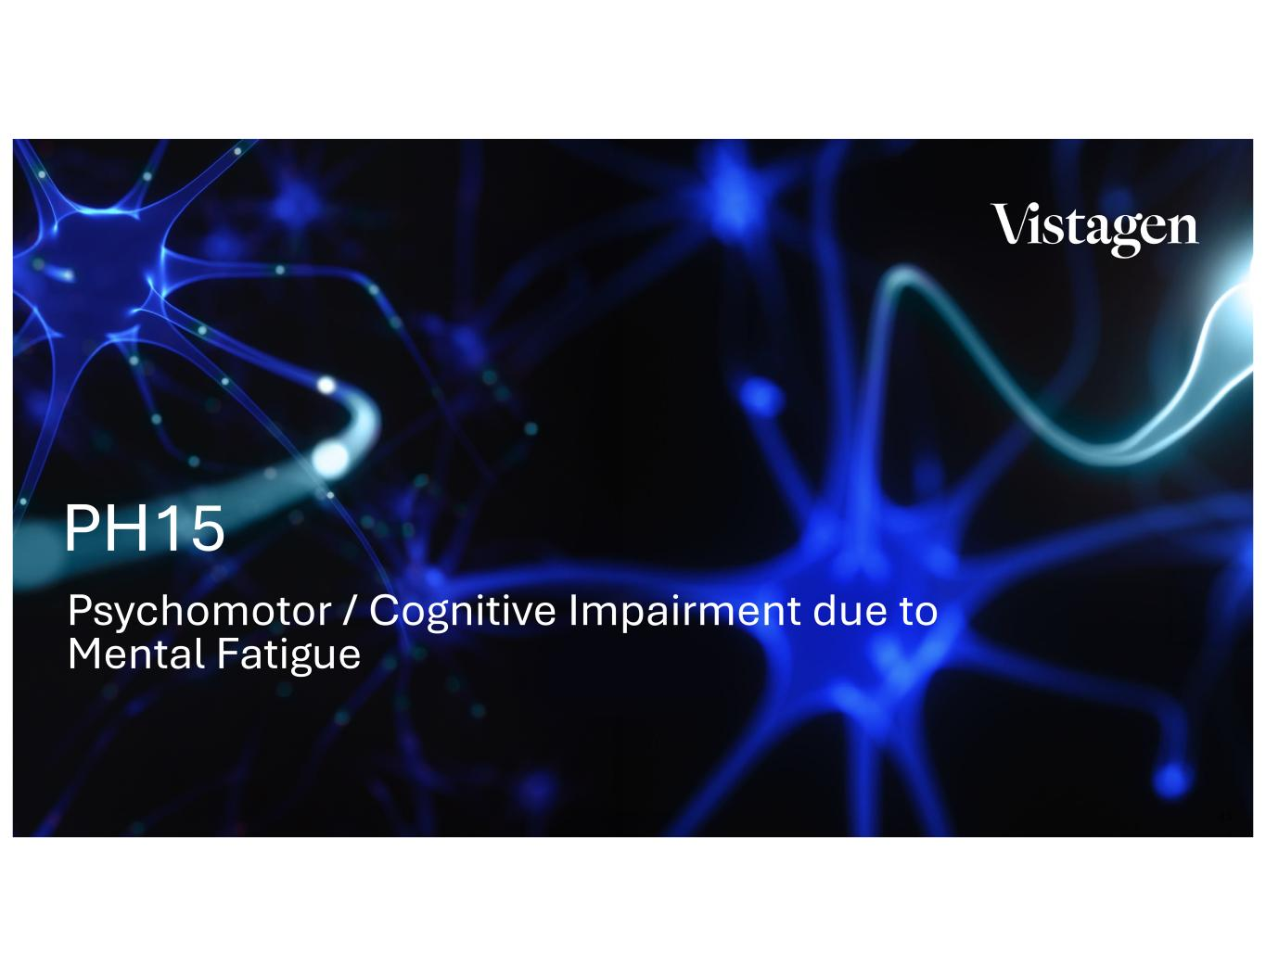
43 Psychomotor / Cognitive Impairment due to Mental Fatigue PH15

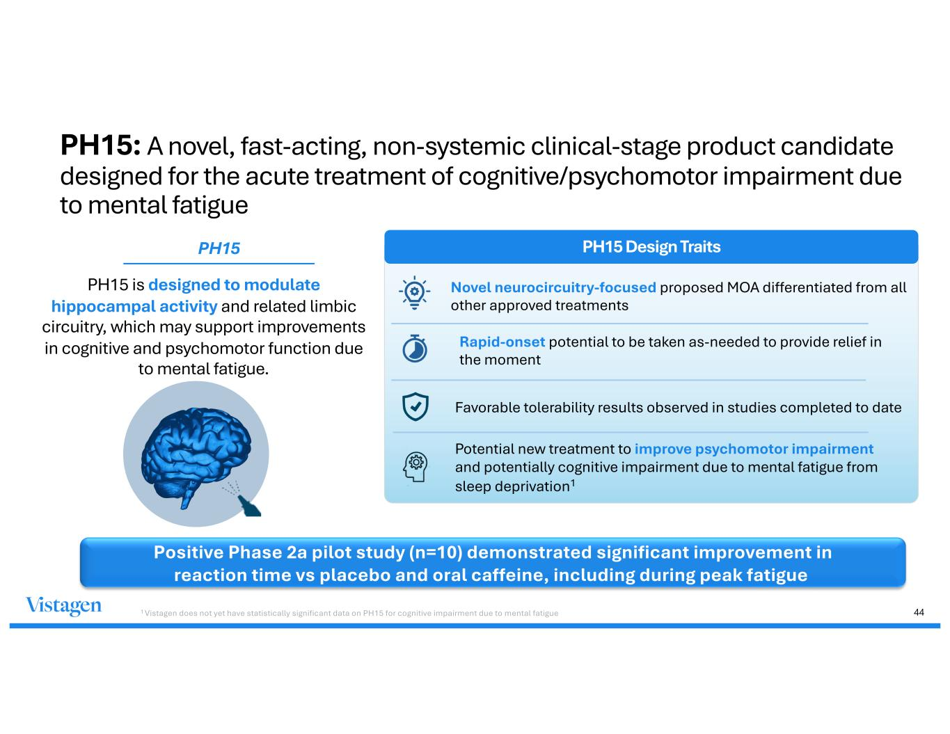
44 PH15: A novel, fast-acting, non-systemic clinical-stage product candidate designed for the acute treatment of cognitive/psychomotor impairment due to mental fatigue PH15 is designed to modulate hippocampal activity and related limbic circuitry, which may support improvements in cognitive and psychomotor function due to mental fatigue. PH15 Design Traits Novel neurocircuitry-focused proposed MOA differentiated from all other approved treatments Rapid-onset potential to be taken as-needed to provide relief in the moment Favorable tolerability results observed in studies completed to date Potential new treatment to improve psychomotor impairment and potentially cognitive impairment due to mental fatigue from sleep deprivation1 PH15 Positive Phase 2a pilot study (n=10) demonstrated significant improvement in reaction time vs placebo and oral caffeine, including during peak fatigue 1 Vistagen does not yet have statistically significant data on PH15 for cognitive impairment due to mental fatigue

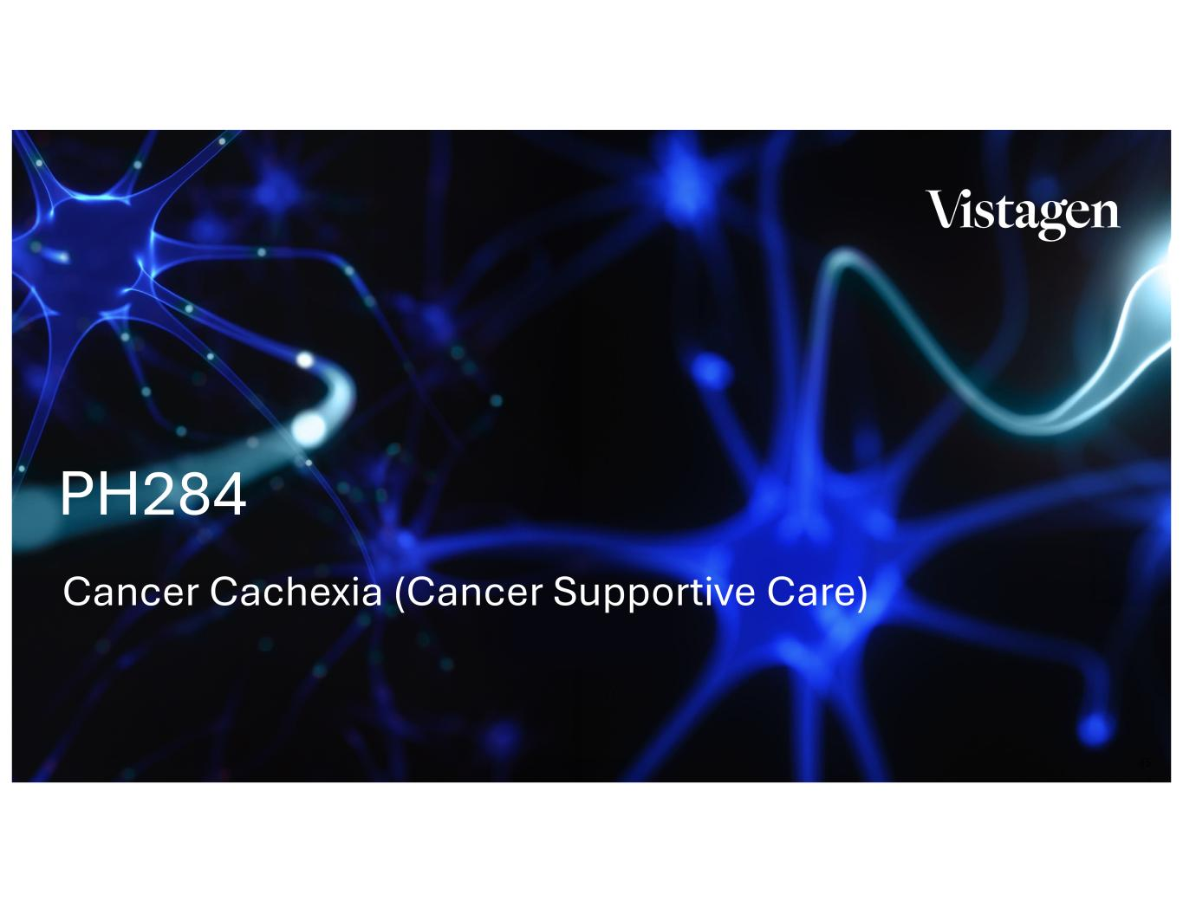
45 Cancer Cachexia (Cancer Supportive Care) PH284

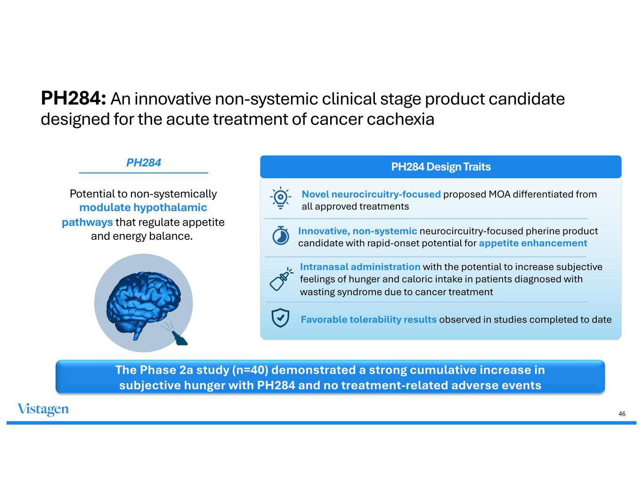
46 PH284: An innovative non-systemic clinical stage product candidate designed for the acute treatment of cancer cachexia Potential to non-systemically modulate hypothalamic pathways that regulate appetite and energy balance. PH284 Design Traits Novel neurocircuitry-focused proposed MOA differentiated from all approved treatments Innovative, non-systemic neurocircuitry-focused pherine product candidate with rapid-onset potential for appetite enhancement Intranasal administration with the potential to increase subjective feelings of hunger and caloric intake in patients diagnosed with wasting syndrome due to cancer treatment Favorable tolerability results observed in studies completed to date PH284 The Phase 2a study (n=40) demonstrated a strong cumulative increase in subjective hunger with PH284 and no treatment-related adverse events


47 Contact us: Investors: IR@vistagen.com Media: media@vistagen.com Business Development: busdev@vistagen.com

