UNITED STATES

SECURITIES AND EXCHANGE COMMISSION

Washington, D.C. 20549

 | FORM 8-K
 | CURRENT REPORT
 | PURSUANT TO SECTION 13 OR 15(d) of the SECURITIES EXCHANGE ACT OF 1934
 | Date of Report (Date of earliest event reported): December 19, 2019
 | VistaGen Therapeutics, Inc.
 | (Exact name of registrant as specified in its charter)
NEVADA | 000-54014 |  |  | 20-5093315
(State or other jurisdiction of incorporation) | (Commission File Number) |  |  | (IRS Employer Identification Number)
 | 343 Allerton Ave.
 | South San Francisco, California 94090
 | (Address of principal executive offices)
 | (650) 577-3600
 | (Registrant’s telephone number, including area code)
 | Not Applicable
 | (Former name or former address, if changed since last report)

Check the appropriate box below if the Form 8-K filing is intended to simultaneously satisfy the filing obligation of the registrant under any of the following provisions:

- Written communications pursuant to Rule 425 under the Securities Act (17 CFR 230.425)

- Soliciting material pursuant to Rule 14a-12 under the Exchange Act (17 CFR 240.14a -12)

- Pre-commencement communications pursuant to Rule 14d-2(b) under the Exchange Act (17 CFR 240.14d -2(b))

- Pre-commencement communications pursuant to Rule 13e-4(c) under the Exchange Act (17 CFR 240.13e -4(c))

Securities registered pursuant to Section 12(b) of the Act:
 | Title of each class |  |  | Trading Symbol(s) |  | Name of each exchange on which registered
Common Stock, par value $0.001 per share |  |  |  | VTGN |  |  | Nasdaq Capital Market

Indicate by check mark whether the registrant is an emerging growth company as defined in Rule 405 of the Securities Act of 1933 (17 CFR 230.405) or Rule 12b-2 of the Securities Exchange Act of 1934 (17 CFR 240.12b-2)

Emerging Growth Company ☐

If an emerging growth company, indicate by check mark if the registrant has elected not to use the extended transition period for complying with any new or revised financial accounting standards provided pursuant to Section 13(a) of the Exchange Act ☐

Item 7.01. Regulation FD Disclosure.

On December 26, 2019, VistaGen Therapeutics, Inc. (the “Company”) began utilizing a new corporate presentation. A copy of the updated corporate presentation is attached to this Current Report on Form 8-K as Exhibit 99.1.

The information in Item 7.01 of this Current Report on Form 8-K, including the information set forth in Exhibit 99.1, is being furnished and shall not be deemed “filed” for purposes of Section 18 of the Securities Exchange Act of 1934, as amended (the “Exchange Act”), nor shall Exhibit 99.1 filed herewith be deemed incorporated by reference in any filing under the Securities Act of 1933, as amended, or the Exchange Act, except as shall be expressly set forth by specific reference in such a filing.

Item 8.01. Other Events.

On December 19, 2019, the Company announced successful results from a first-step, Phase 1b clinical study with healthy U.S. military Veterans, which measured NMDAR (N-methyl-D-aspartate receptor) target engagement of the Company's investigational product candidate, AV-101, an oral NMDAR glycine site antagonist, for potential treatment of suicidal ideation in Veterans. A copy of the press release is attached to this Current Report on Form 8-K as Exhibit 99.2.

Item 9.01. Exhibits.

See Exhibit Index.

Signatures

Pursuant to the requirements of the Securities Exchange Act of 1934, the registrant has duly caused this report to be signed on its behalf by the undersigned thereunto duly authorized.

VistaGen Therapeutics, Inc.

Date: December 27, 2019 By: /s/ Shawn K. Singh

Shawn K. Singh

Chief Executive Officer

 |  |  | EXHIBIT INDEX
Exhibit Number |  | Description
99.1 |  | VistaGen Therapeutics, Inc. Corporate Presentation, dated December 2019.
99.2 |  | Press Release issued by VistaGen Therapeutics, Inc., dated December 19, 2019.

Exhibit 99.1
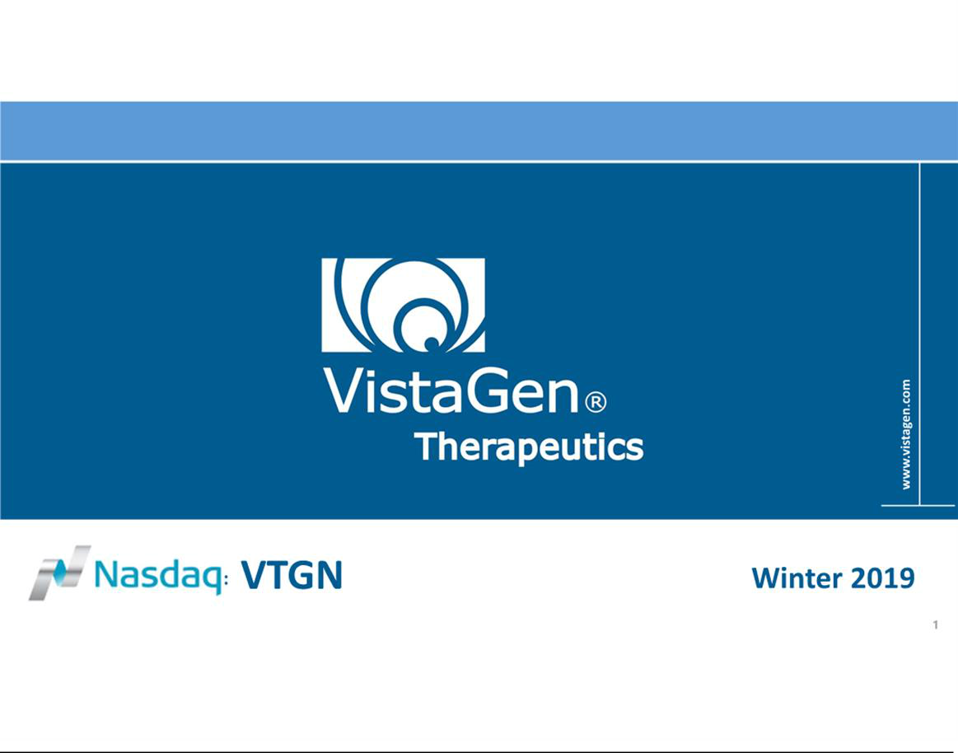

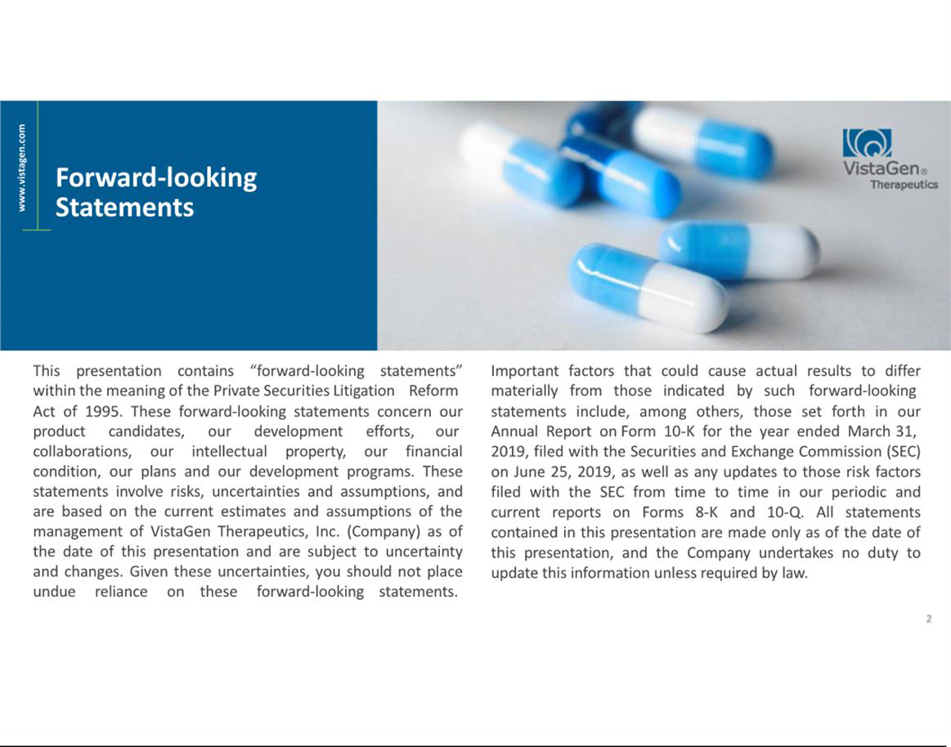

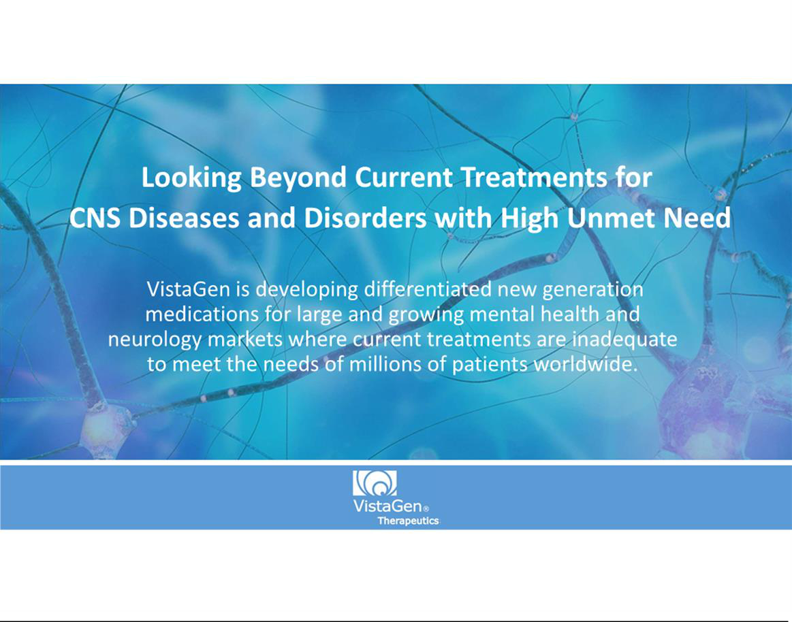

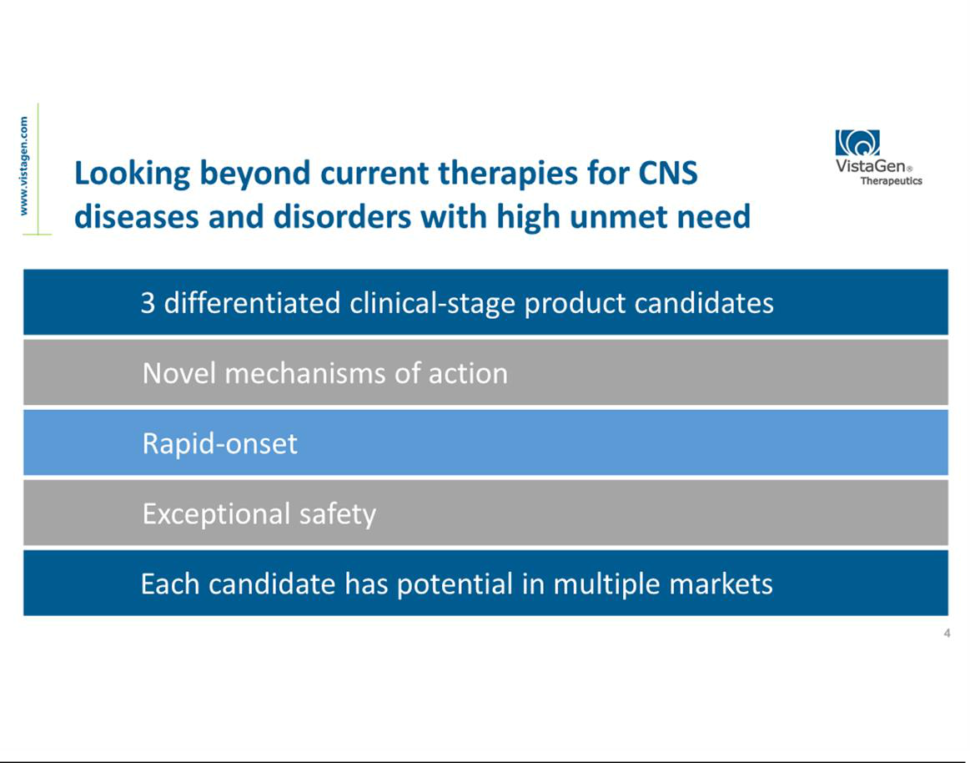

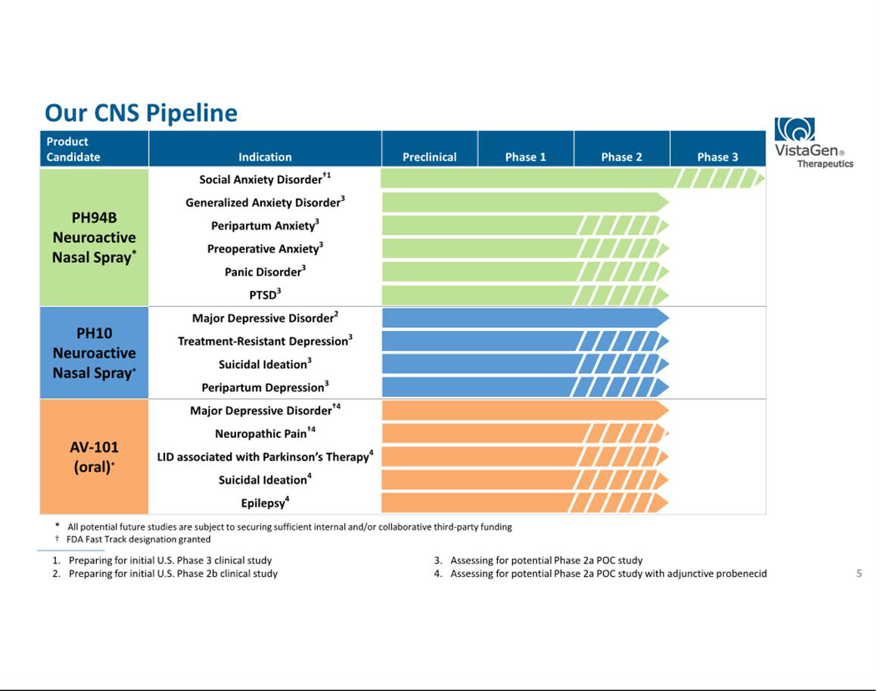

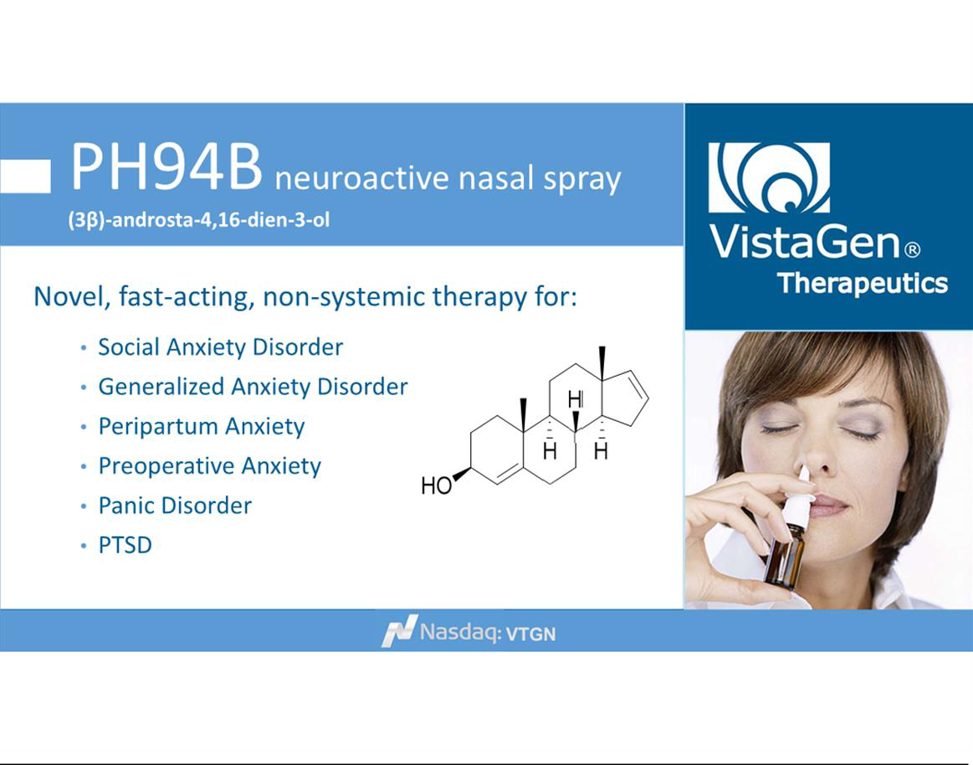

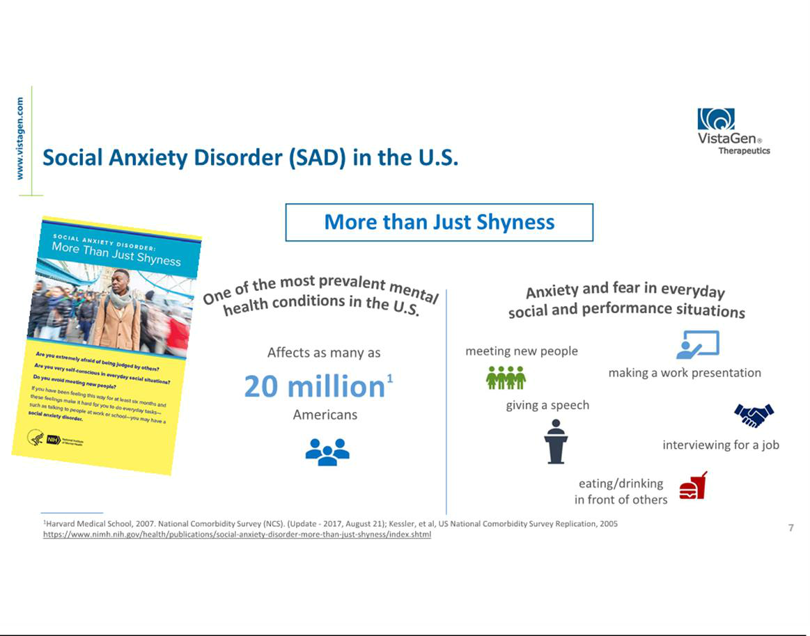

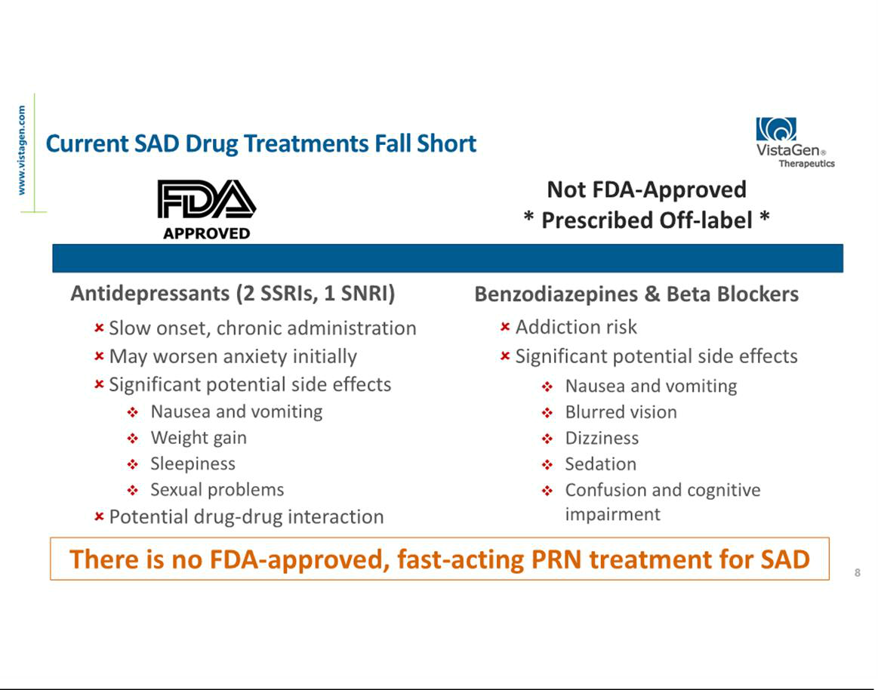

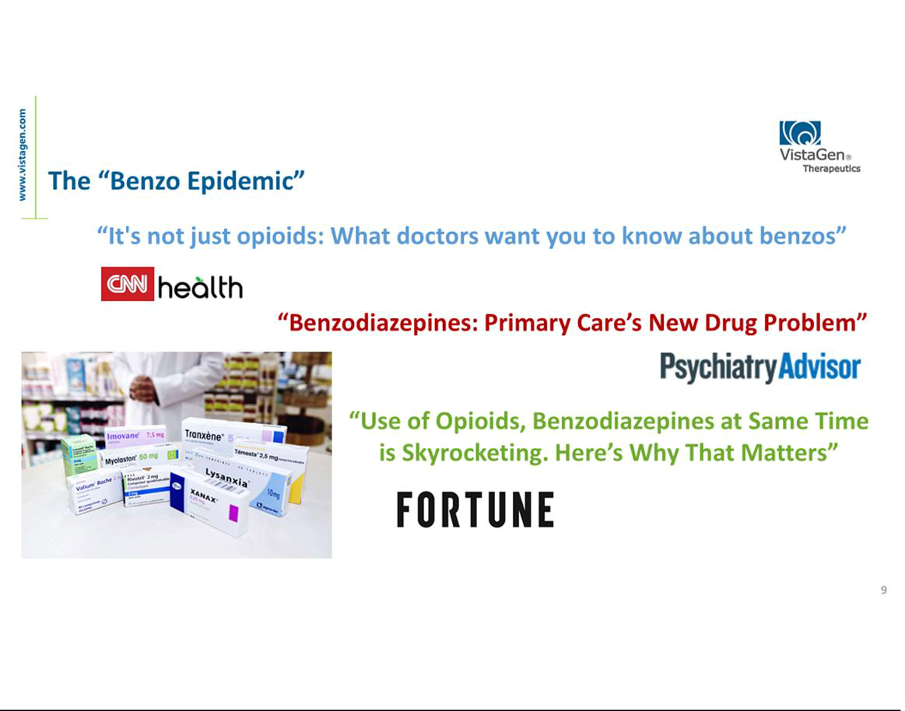

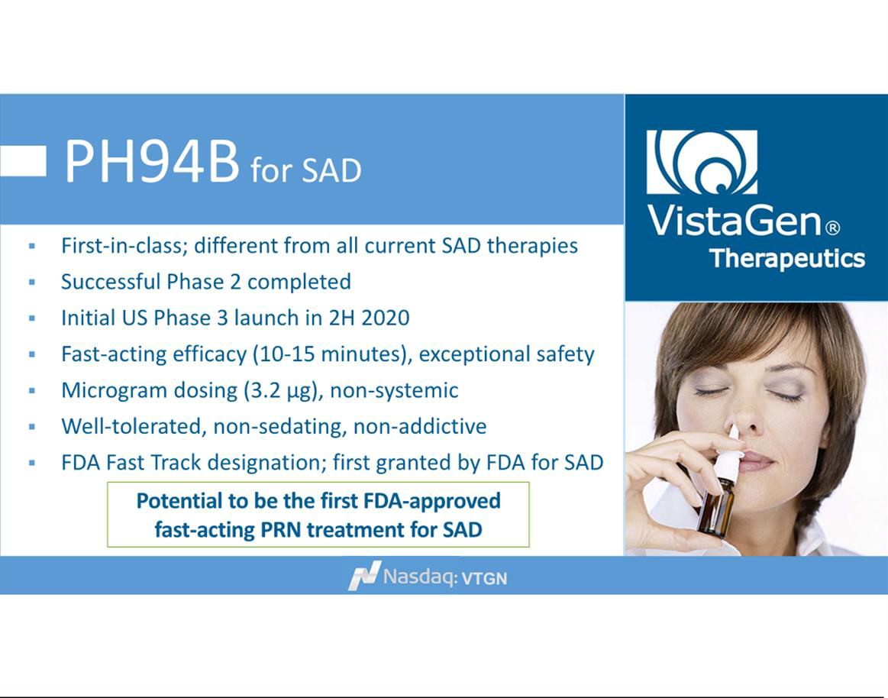

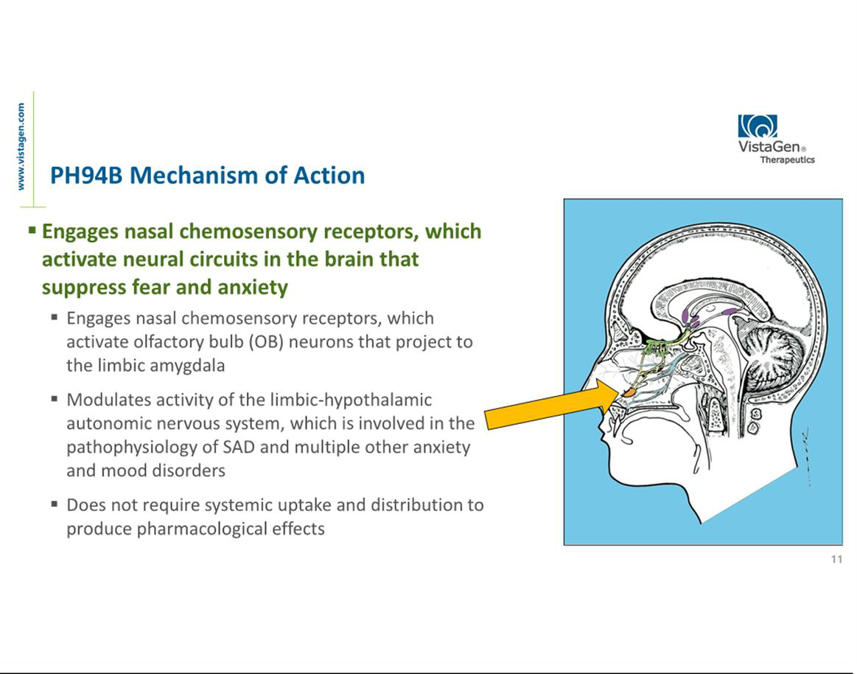

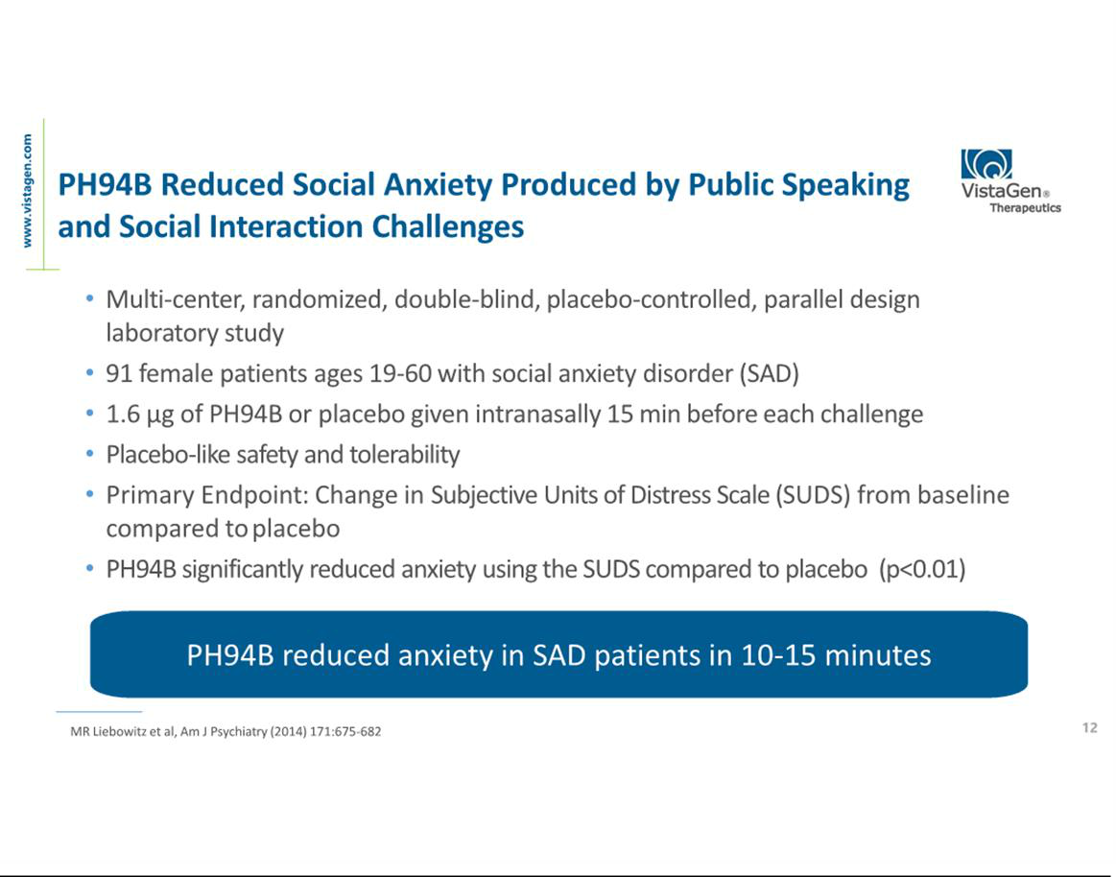

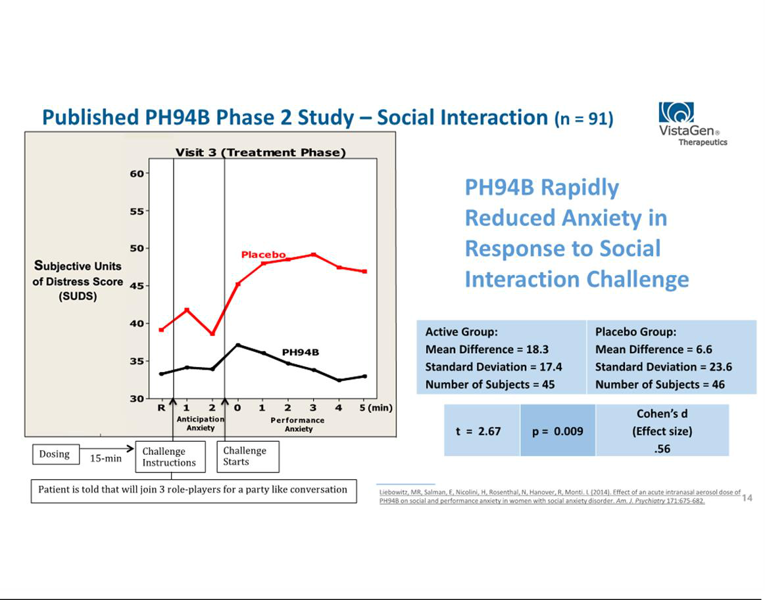

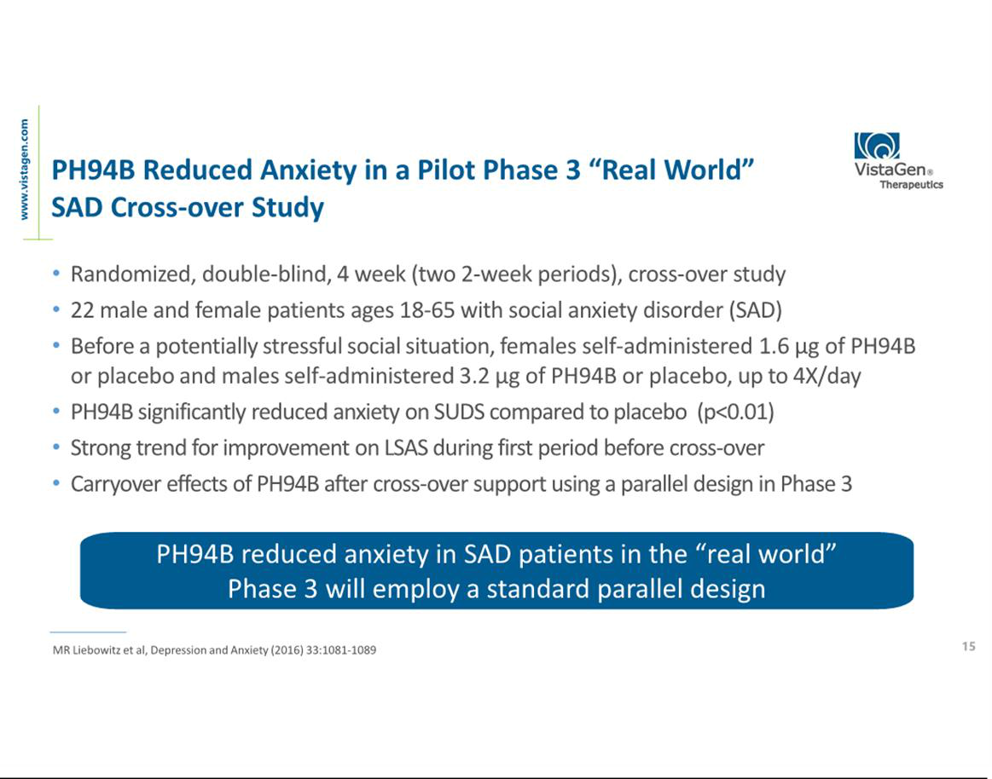

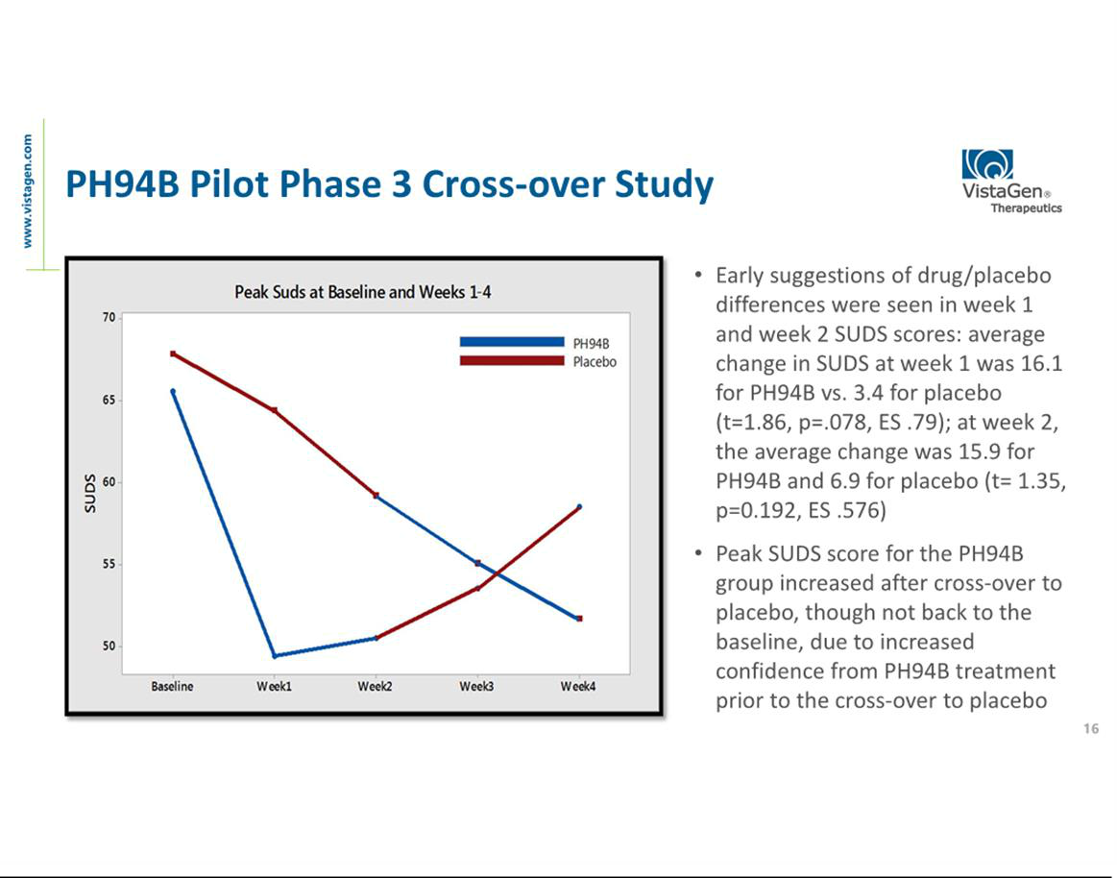

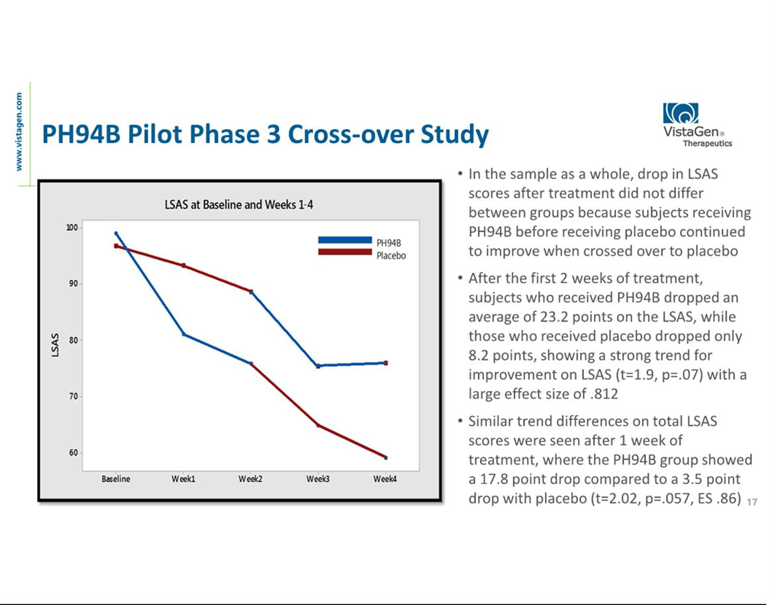

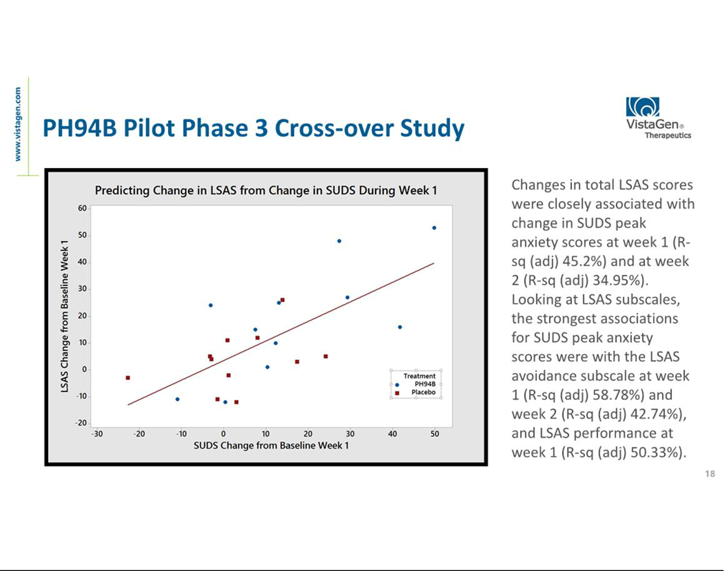

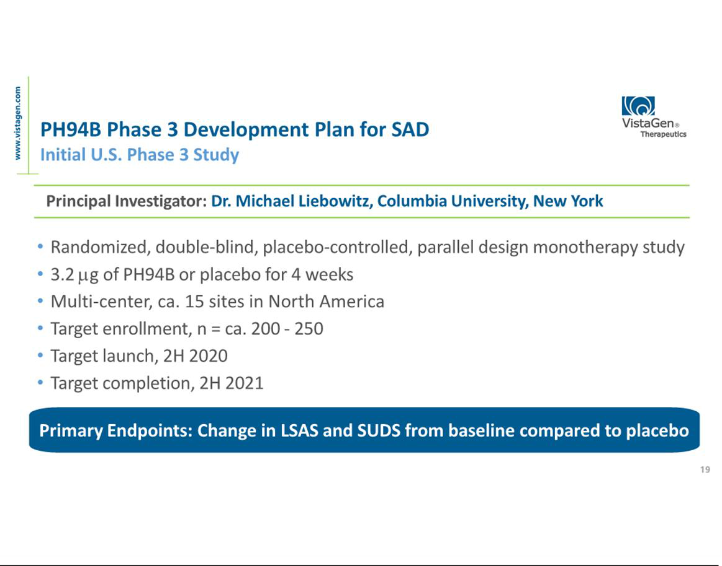

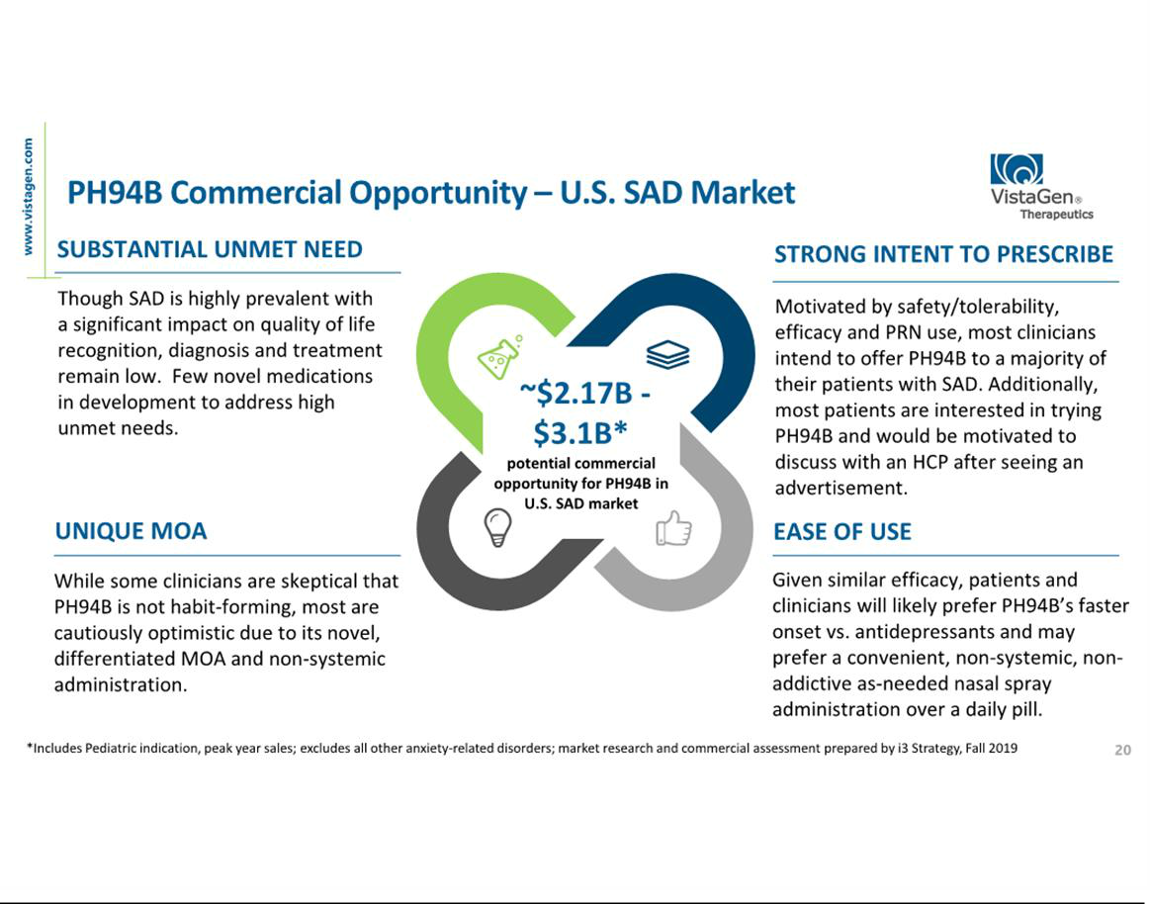

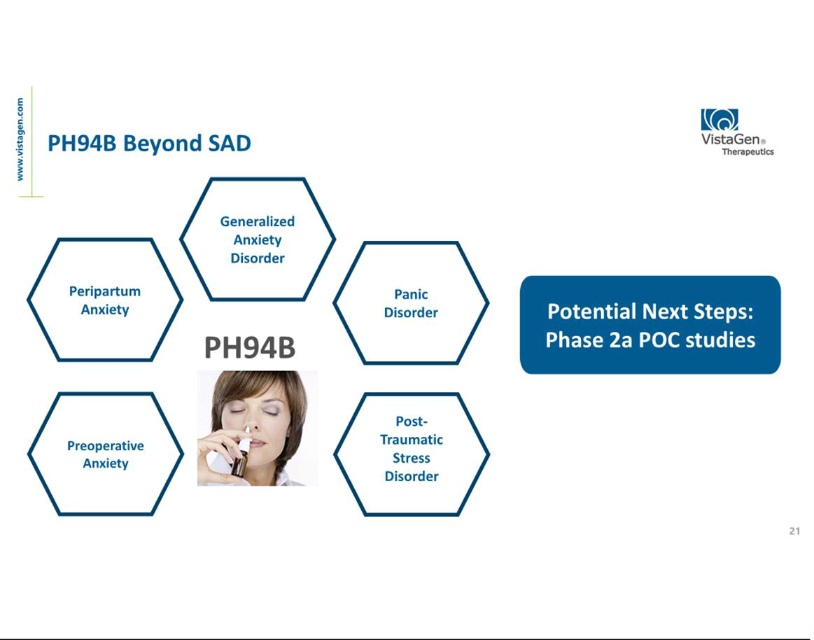

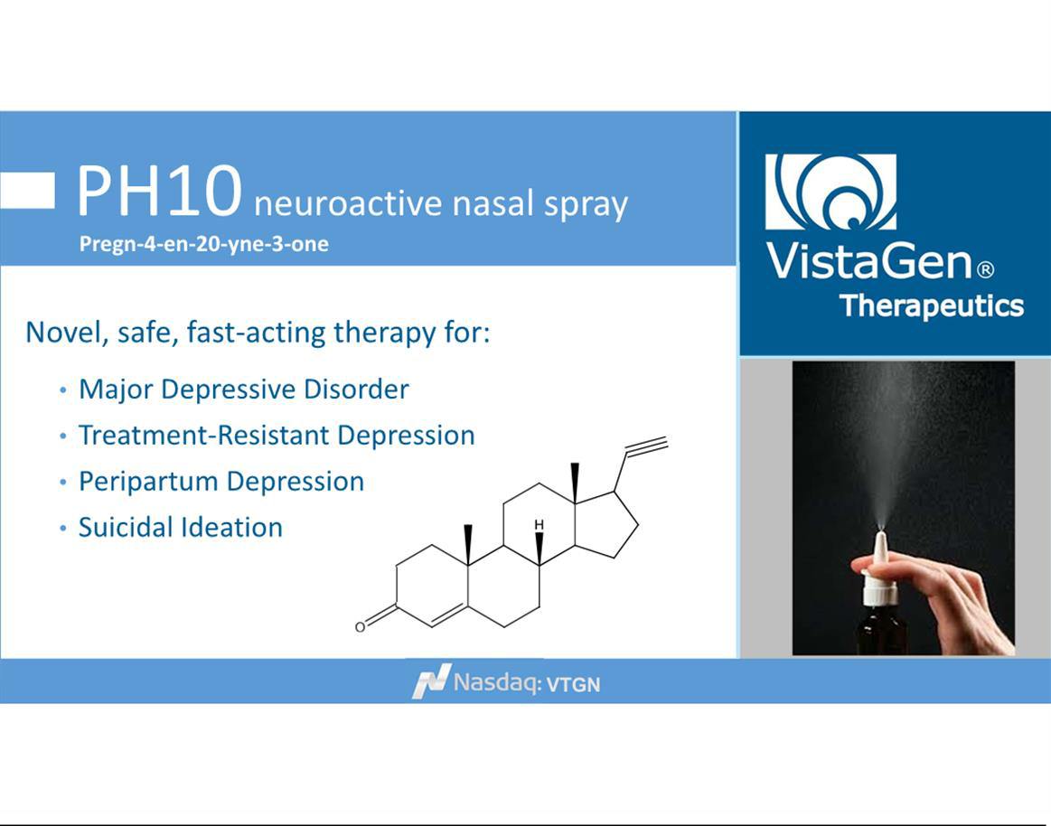

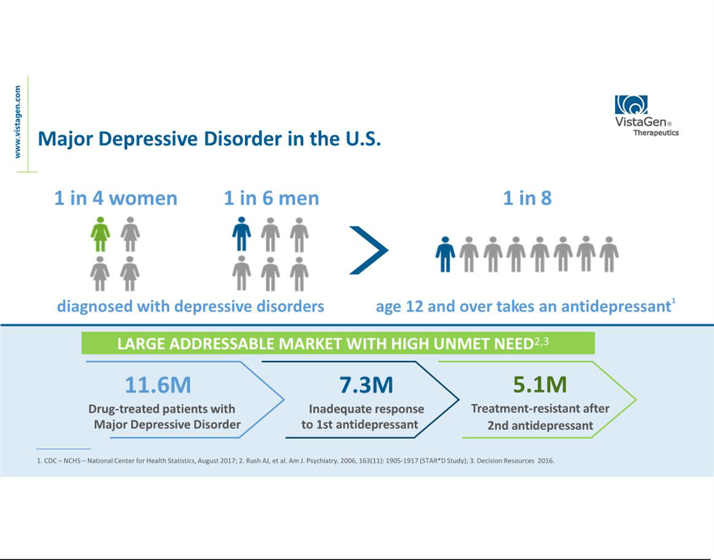

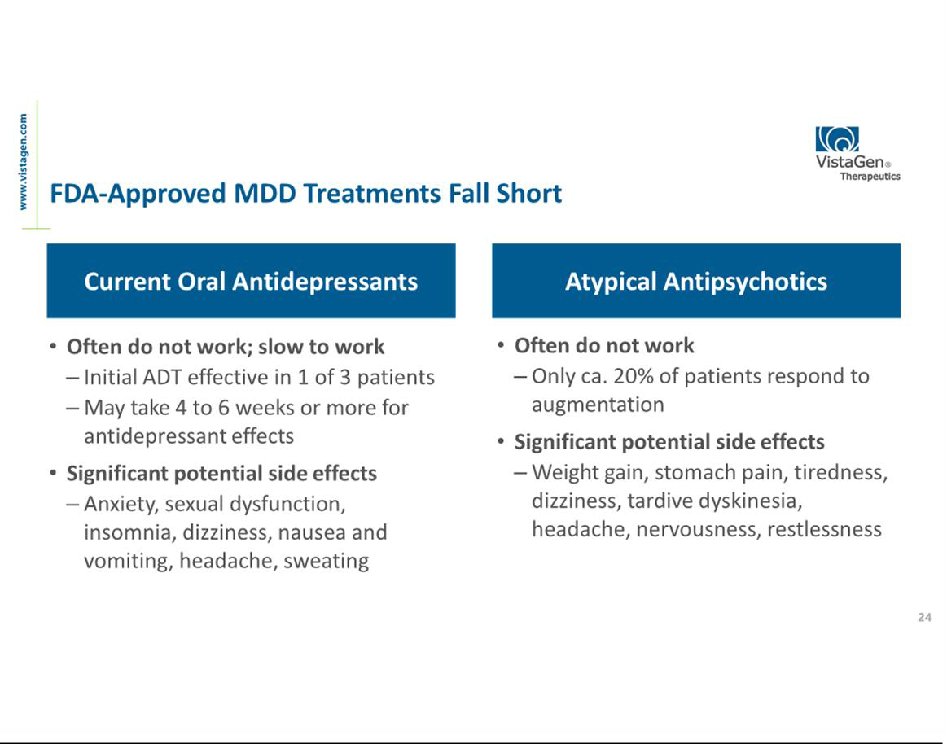

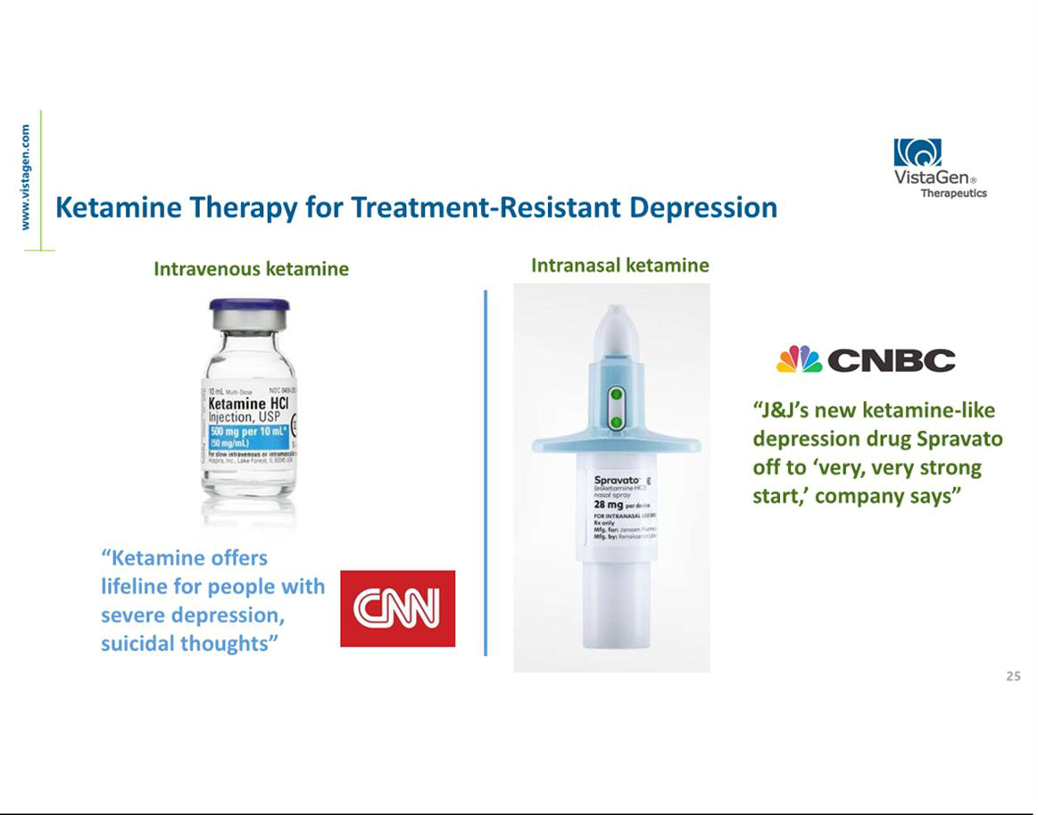

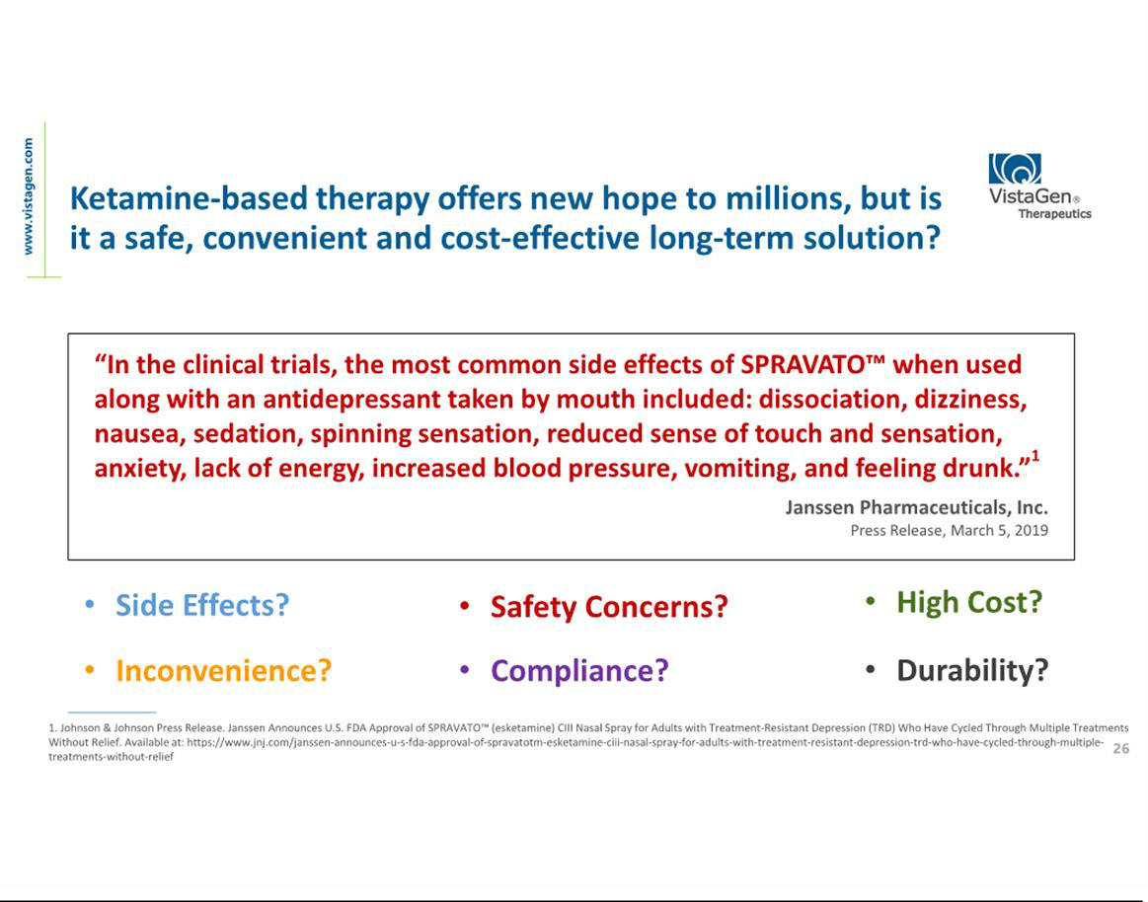

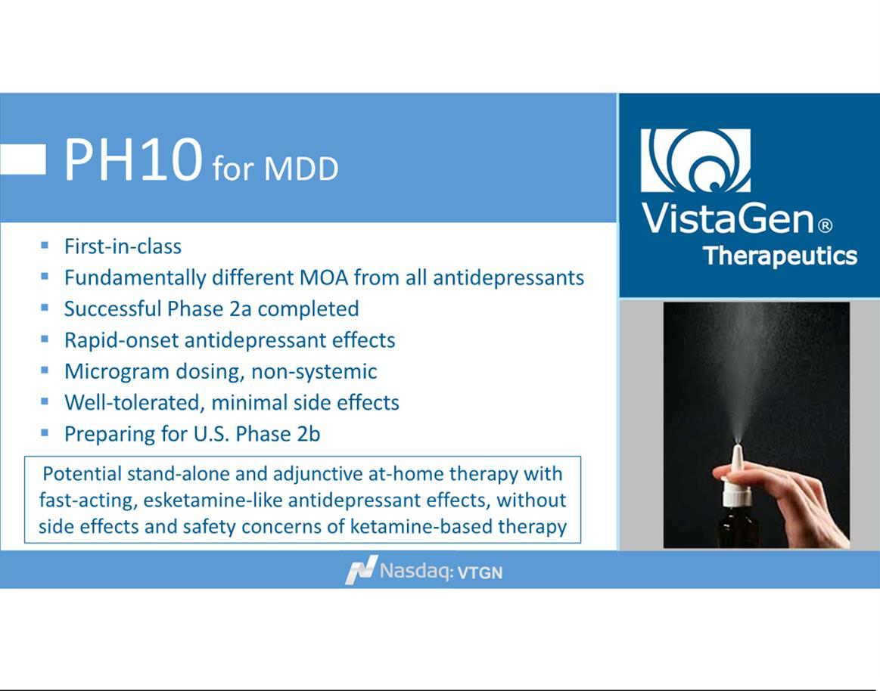

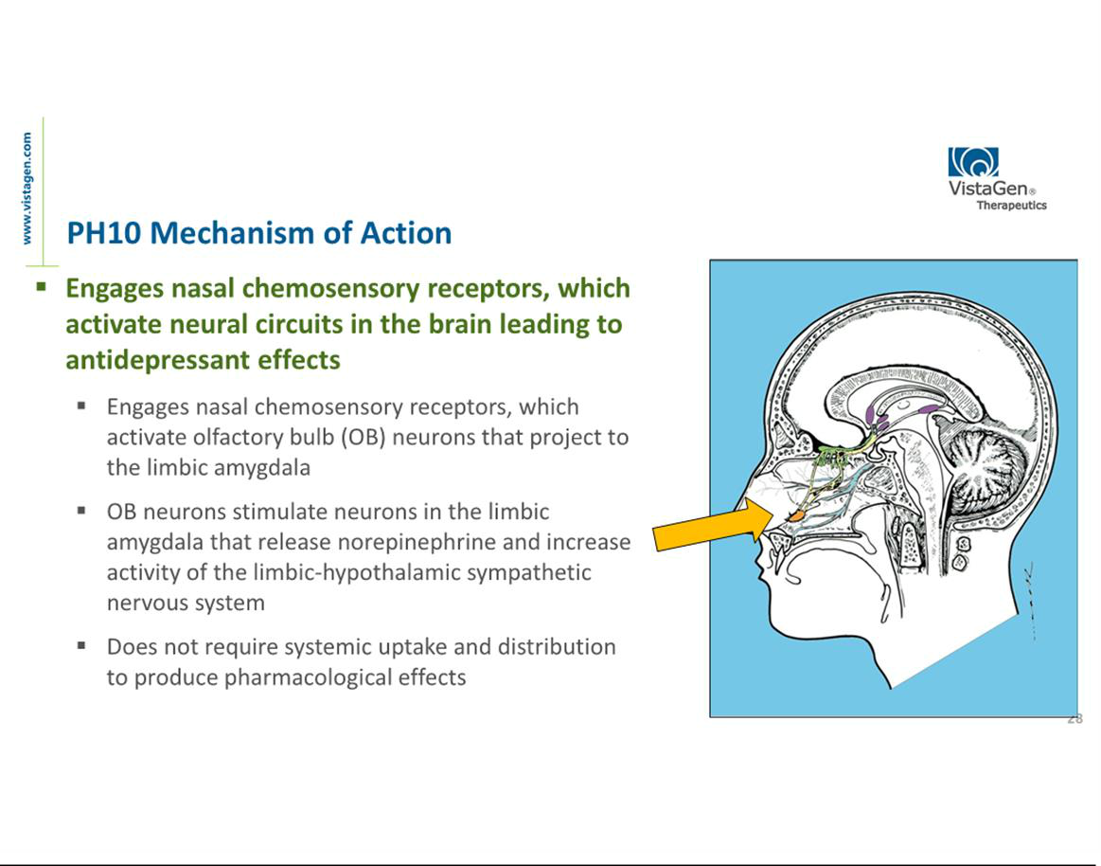

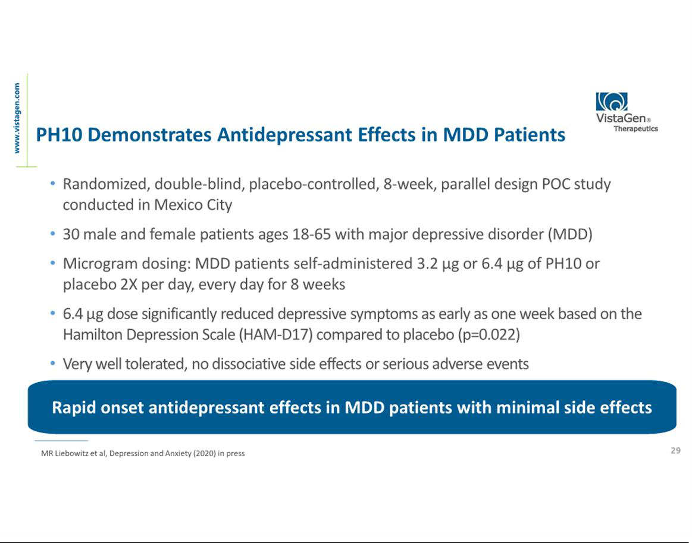

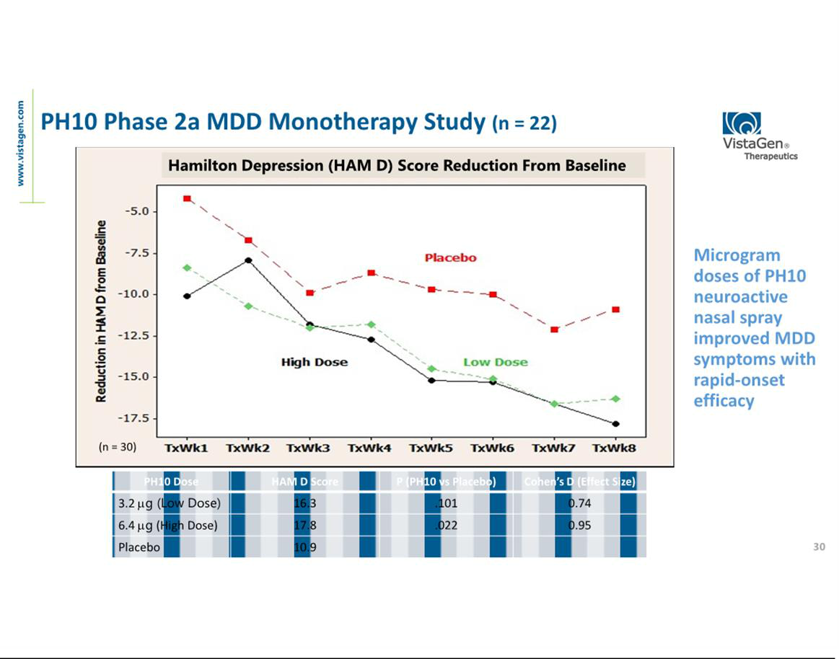

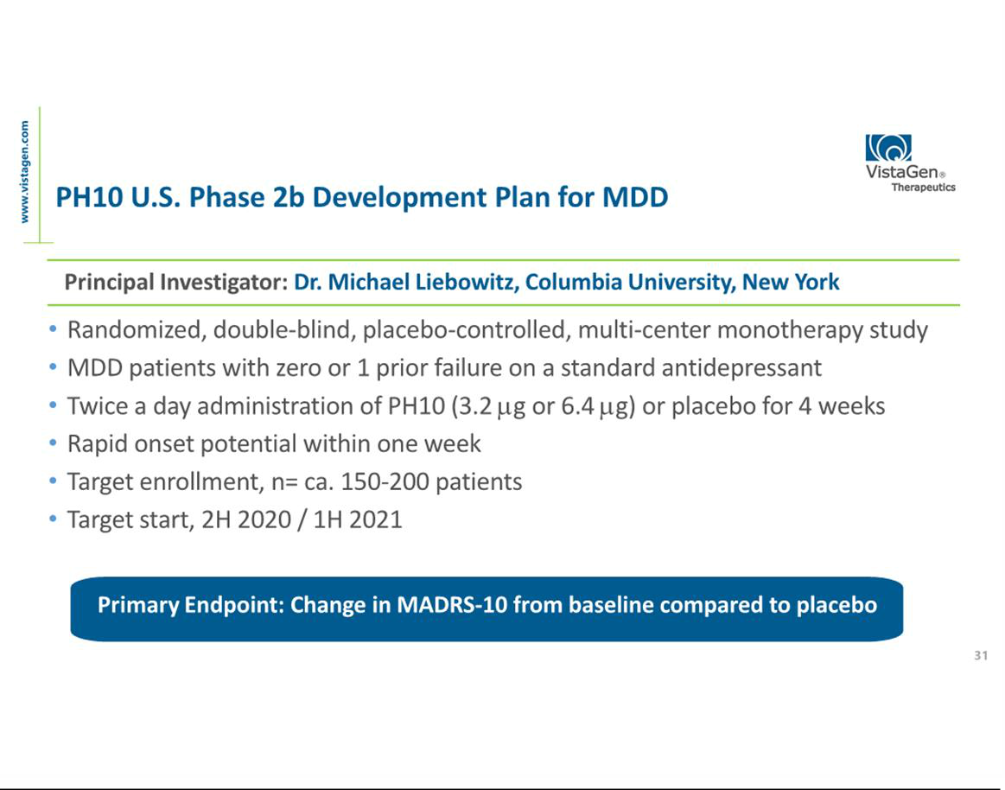

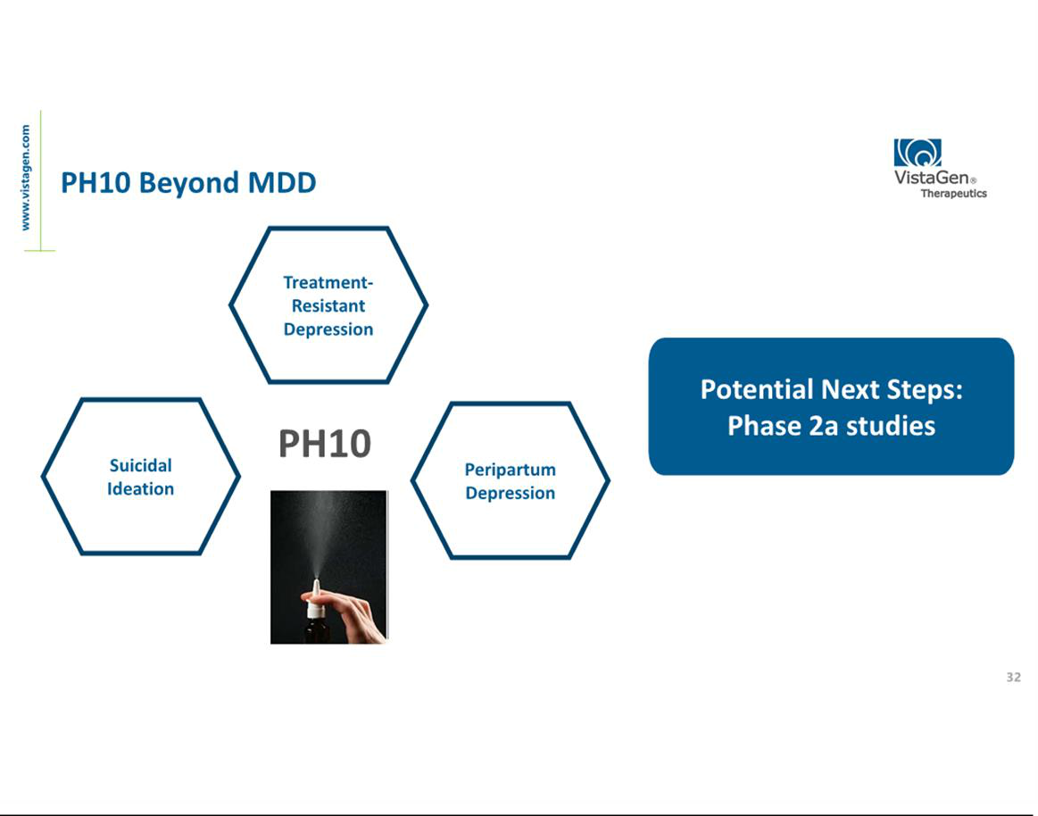

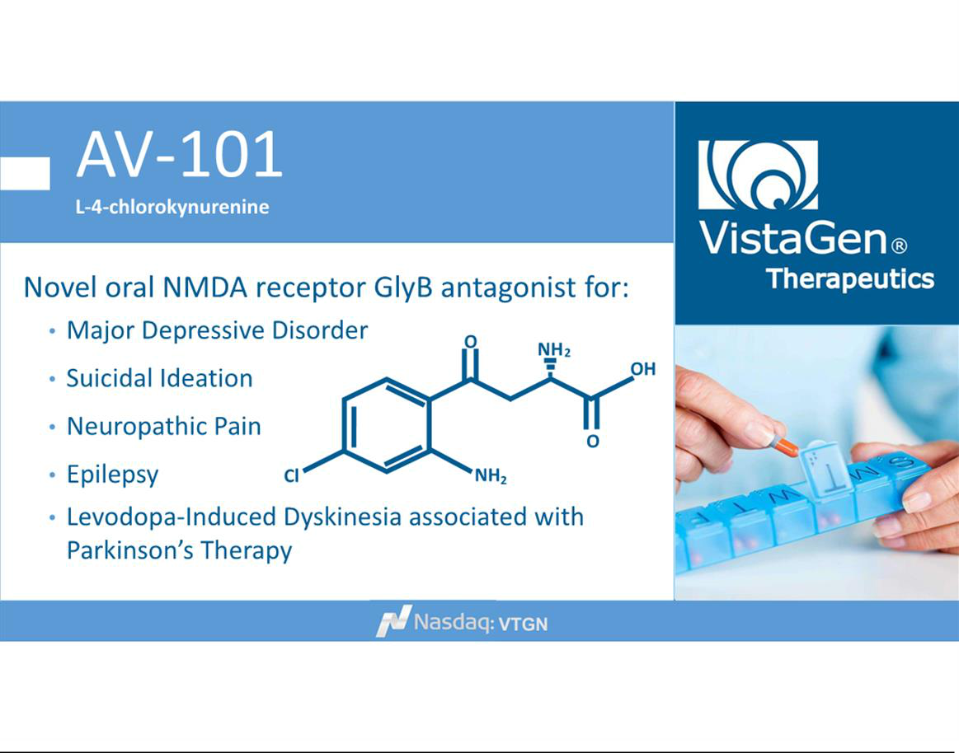

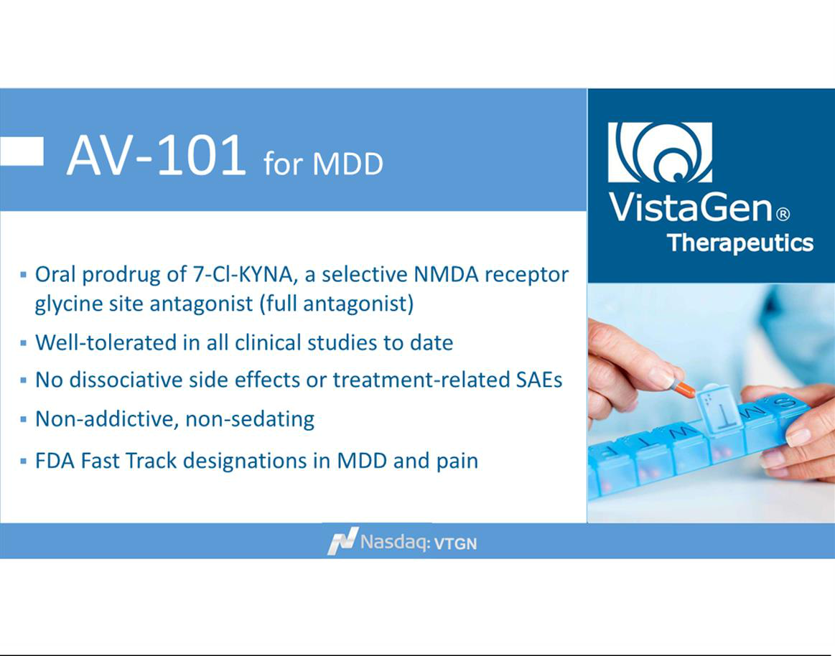

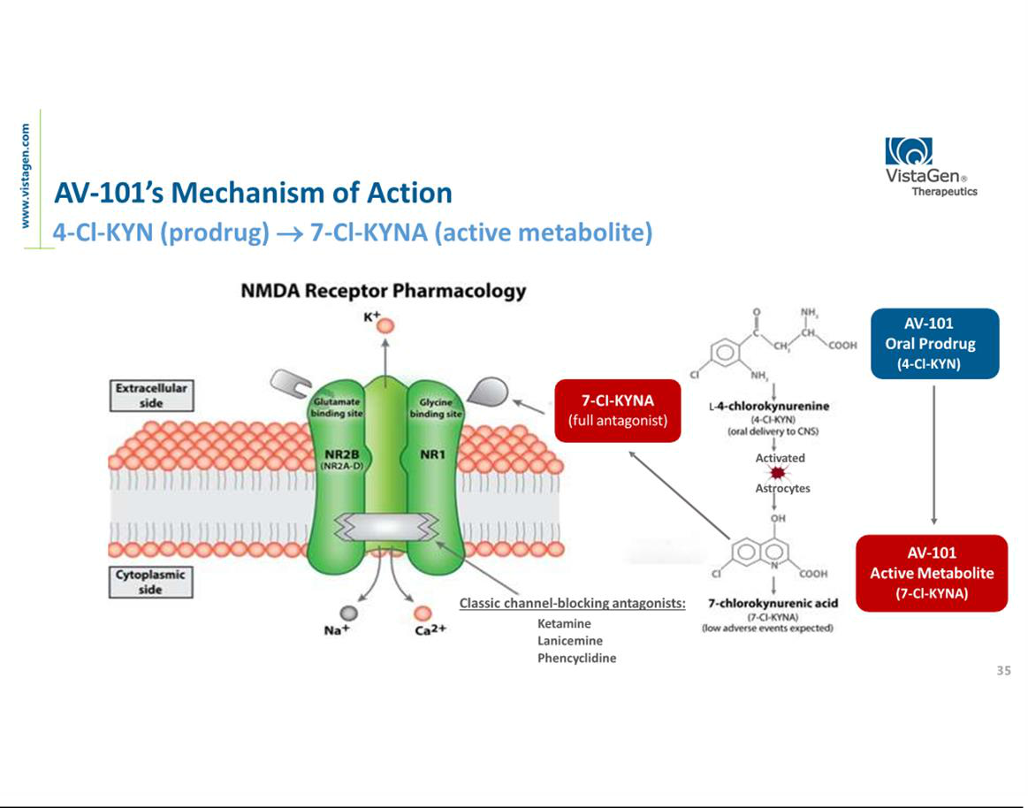

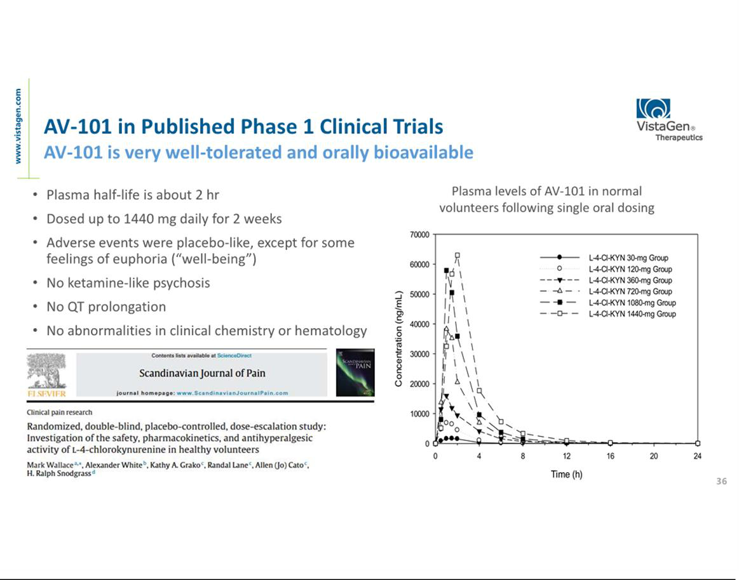

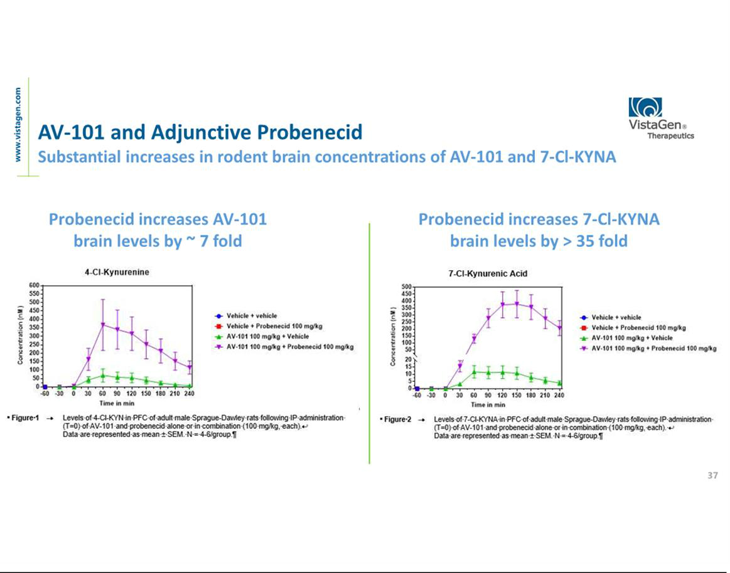

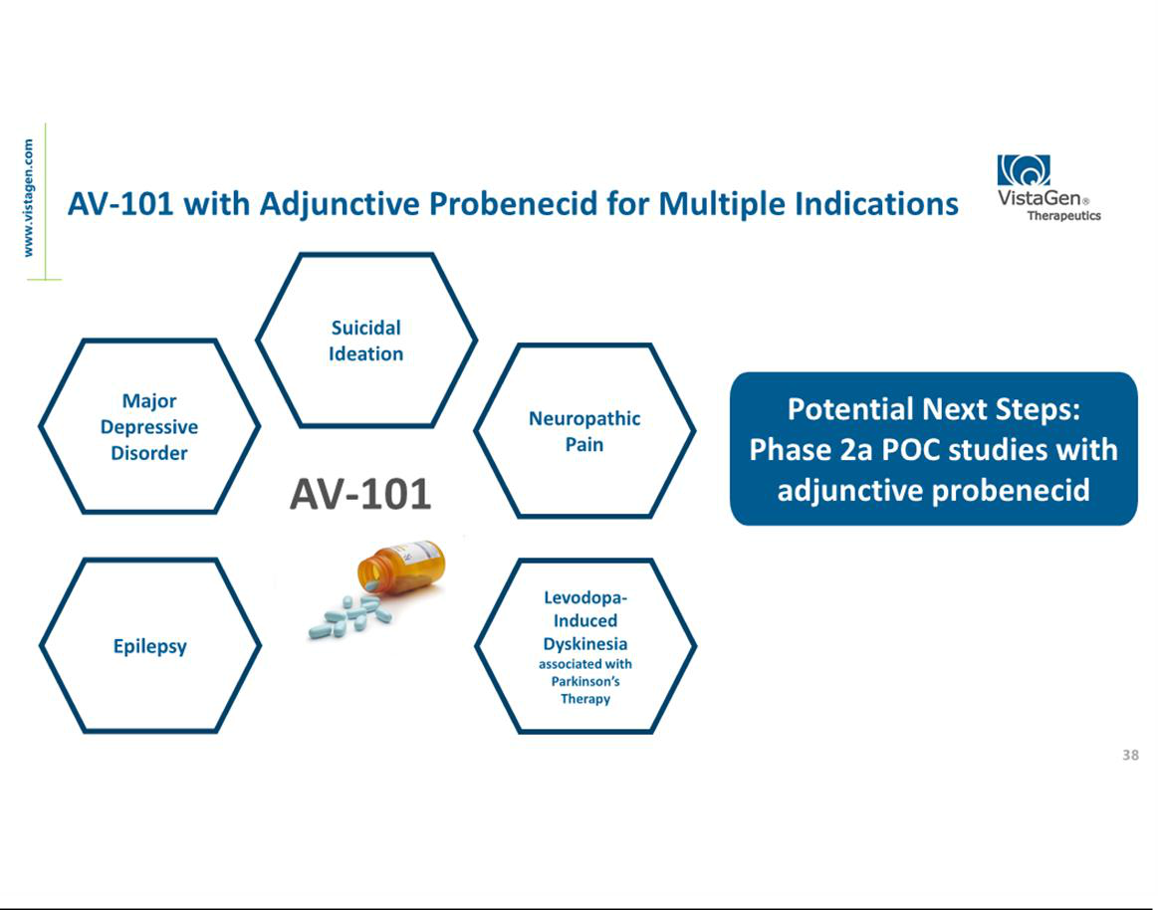

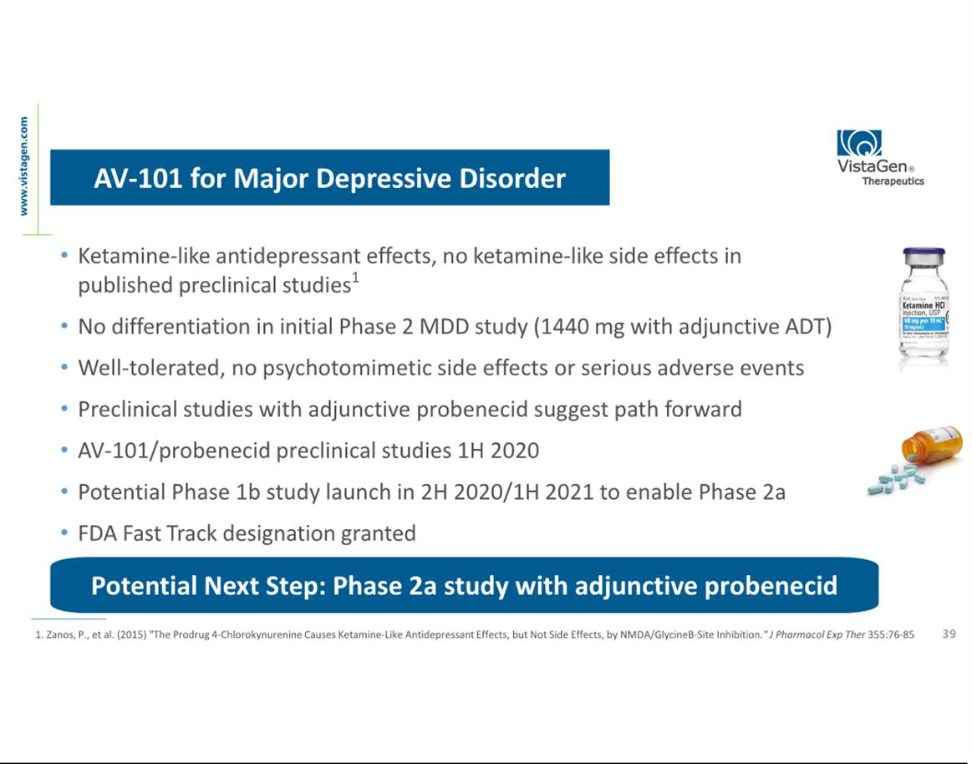

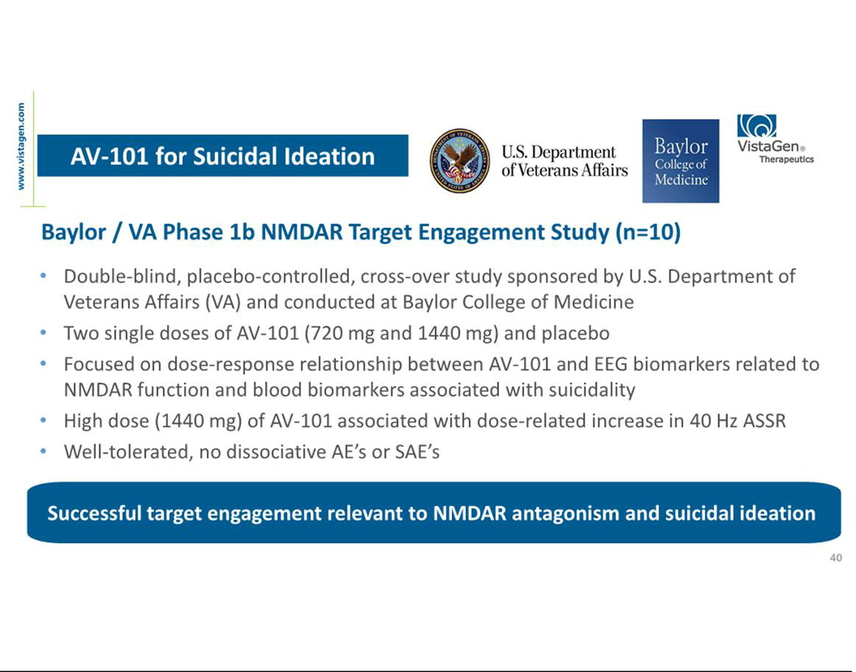

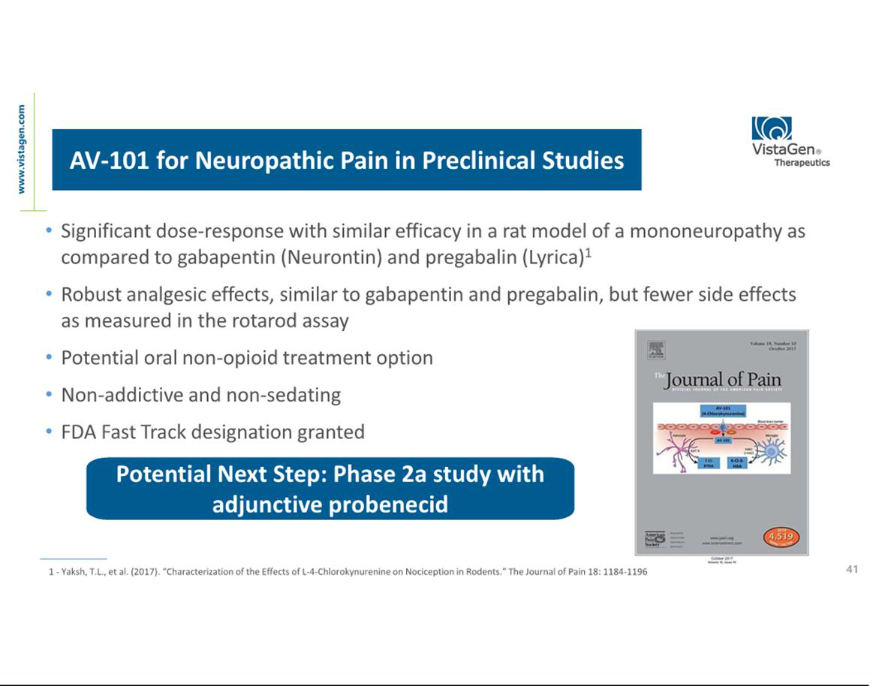

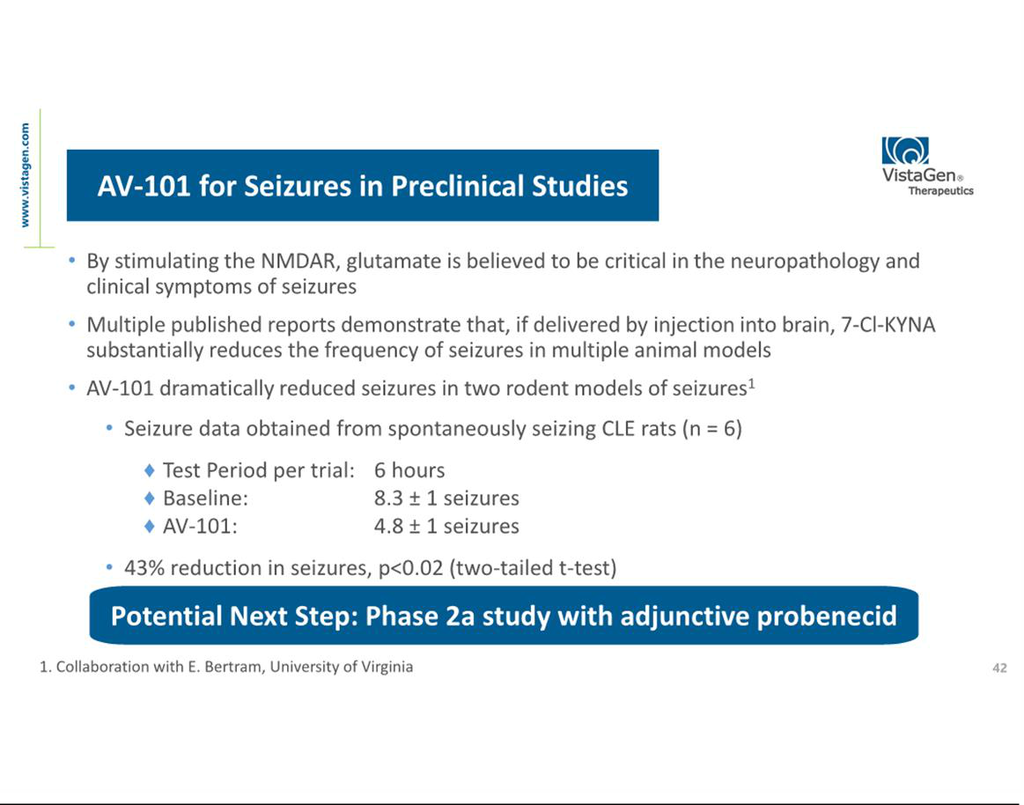

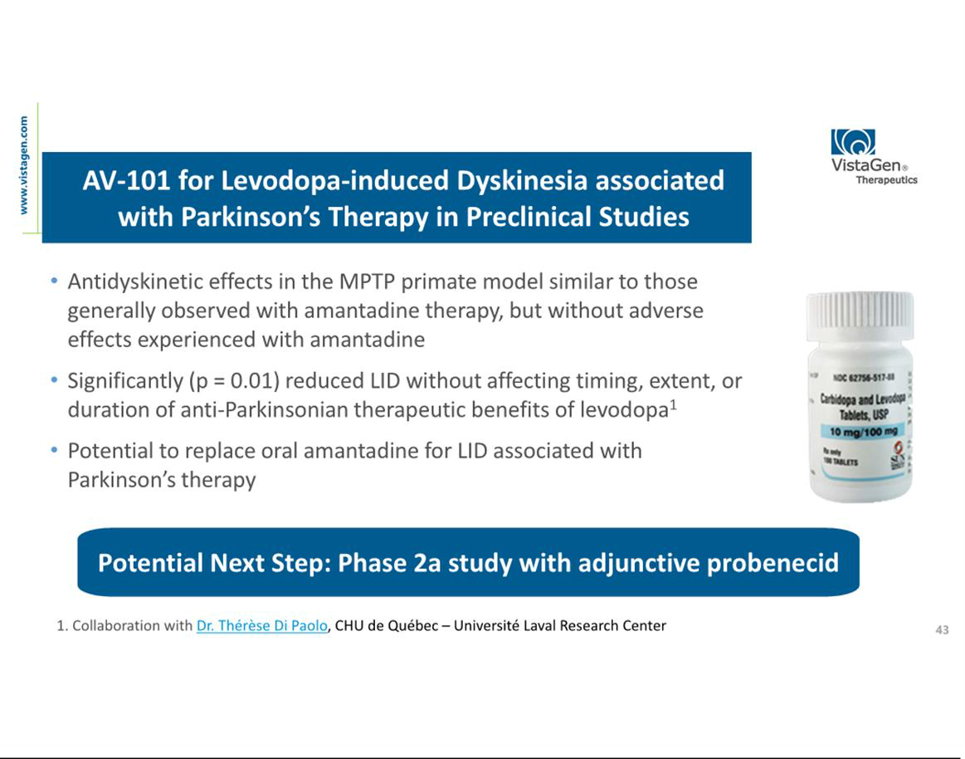

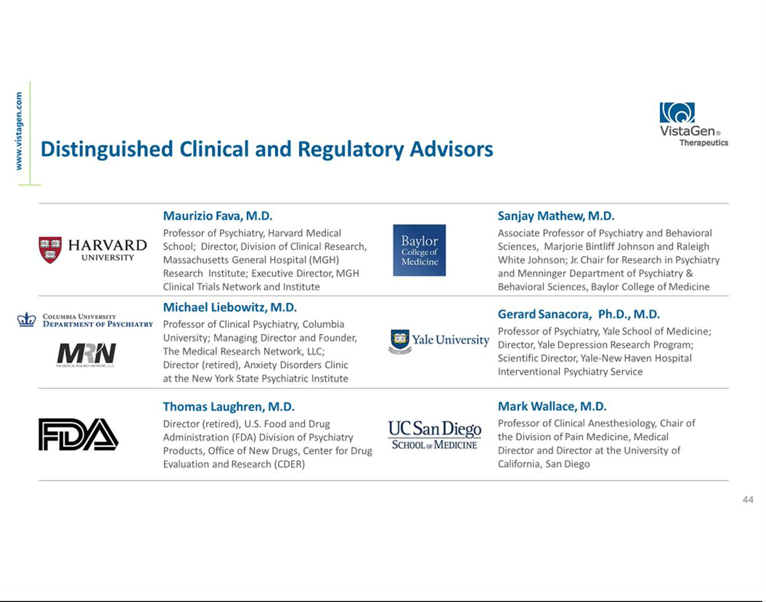

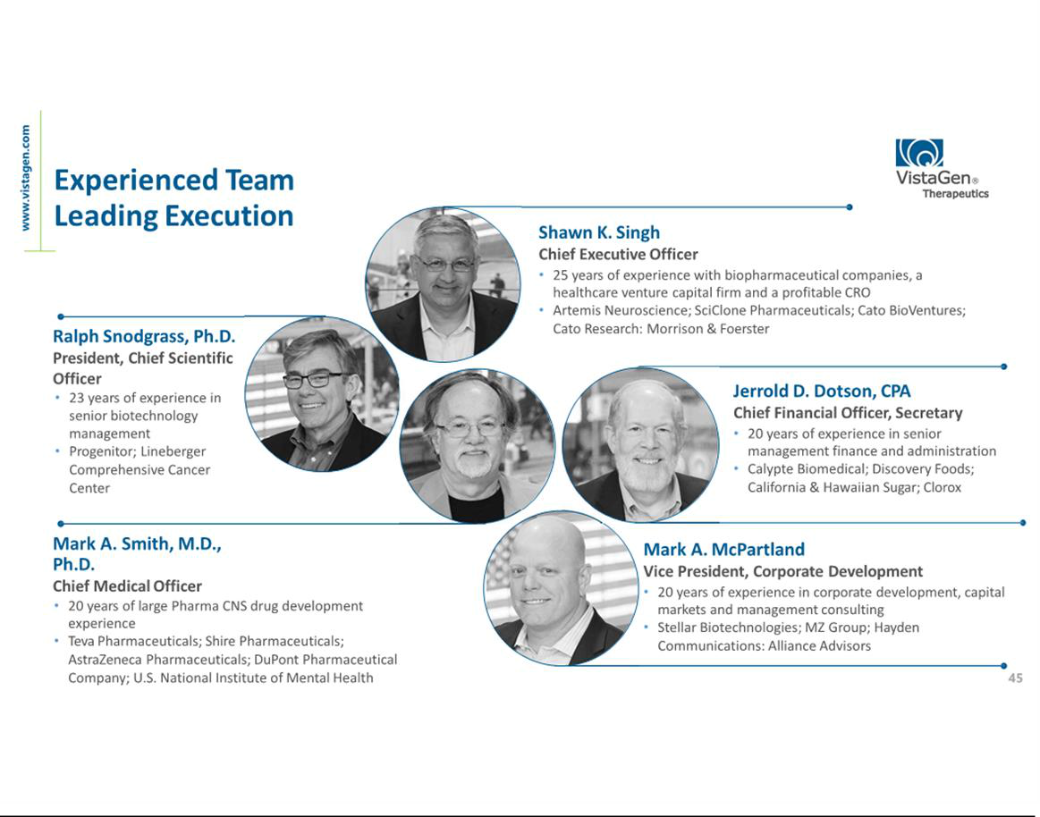

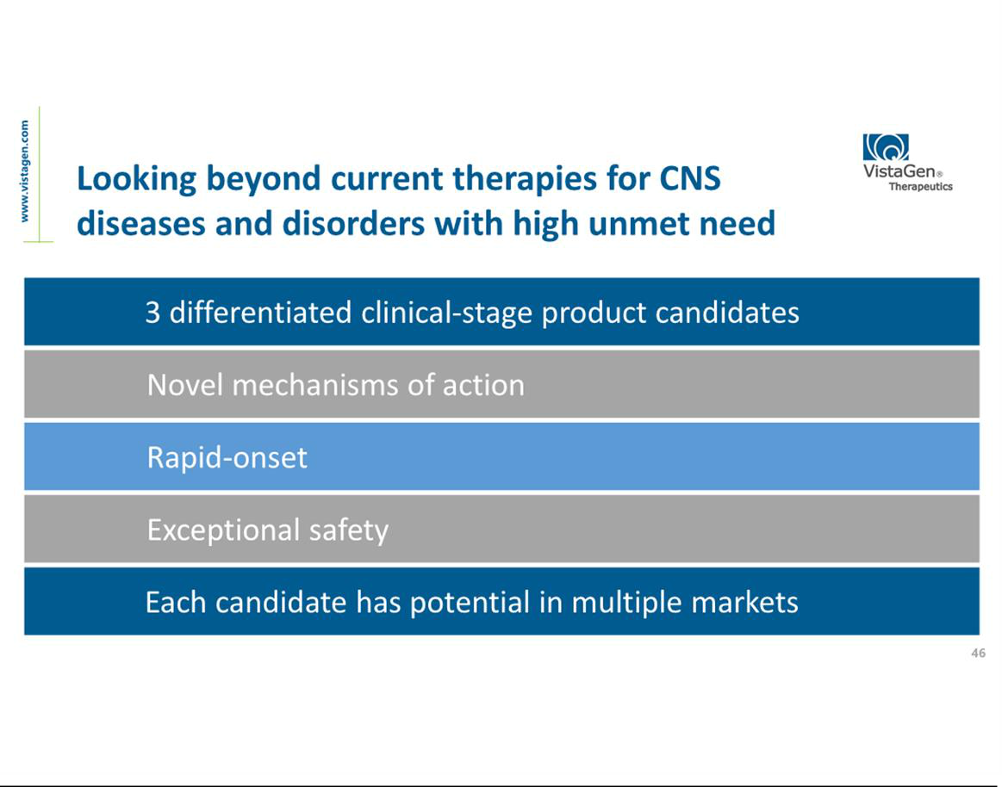

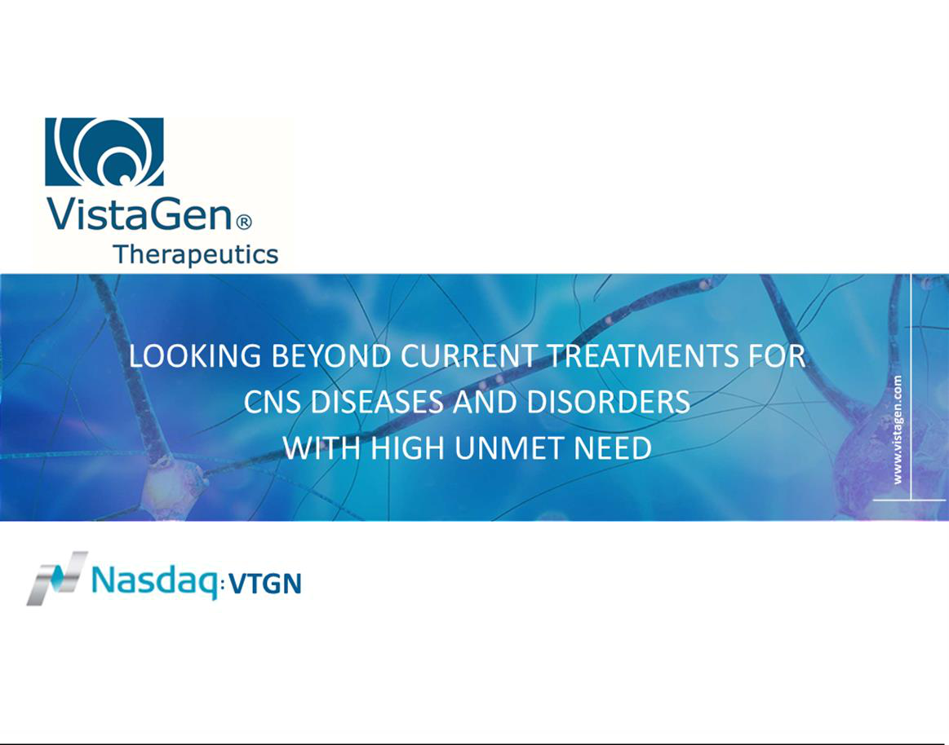

Exhibit 99.2


VistaGen and Baylor College of Medicine Announce Successful Results of First-Step Target Engagement Study with VistaGen’s AV-101 Focused on Treating Suicidal Ideation in Veterans

Multiple electrophysiological biomarkers indicate AV-101’s NMDA receptor target engagement

Both AV-101 doses were well-tolerated and not associated with dissociative or serious adverse events

Poster presented at 2019 Annual Meeting of American College of Neuropsychopharmacology

SOUTH SAN FRANCISCO, Calif. and HOUSTON, Texas, December 19 , 2019 – VistaGen Therapeutics (NASDAQ: VTGN), a clinical-stage biopharmaceutical company developing new generation medicines for central nervous system (CNS) diseases and disorders with high unmet need, and Baylor College of Medicine (Baylor), today announced successful results from a first-step, Phase 1b clinical study with healthy U.S. military Veterans, which measured NMDAR (N-methyl-D-aspartate receptor) target engagement of VistaGen’s investigational product candidate, AV-101, an oral NMDAR glycine site antagonist, for potential treatment of suicidal ideation in Veterans. The findings from the study were presented in a poster, titled “Evoked and Resting State Gamma Mechanics to Test NMDA Receptor Engagement of Kynurenine Pathway Modulator AV-101 in Healthy Veterans,” at the 2019 Annual Meeting of the American College of Neuropsychopharmacology (ACNP) on December 11, 2019.

In the Phase 1b target engagement study, 10 healthy volunteer Veterans from Operation Enduring Freedom, Operation Iraqi Freedom or Operation New Dawn received single doses of AV-101 (720 mg and 1440 mg) and placebo, in a double-blind, randomized, cross-over controlled trial. The primary goal of the study was to identify and define a dose-response relationship between AV-101 and multiple electrophysiological (EEG) biomarkers related to NMDAR function, as well as blood biomarkers associated with suicidality. The findings suggest that, in healthy Veterans, the higher dose of AV-101 (1440 mg) was associated with dose-related increase in the 40 Hz Auditory Steady State Response (ASSR), a robust measure of the integrity of inhibitory interneuron synchronization.

Both doses of AV-101 were well-tolerated, and there were no dissociative adverse events or serious adverse events.

Dr. Marijn Lijffijt, assistant professor of psychiatry research at Baylor and the Michael E. DeBakey VA Medical Center (MEDVAMC) in Houston served as Principal Investigator of the study. VistaGen and the U.S. Department of Veterans Affairs (VA) entered into a Material Transfer Cooperative Research and Development Agreement (MT CRADA) regarding clinical trial material for this study, and VA funding was provided for all other study costs.

“According to the VA, over 20 veterans take their lives each day – a number that is alarming and unfortunate,” said Mark A. Smith, M.D, Ph.D., VistaGen’s Chief Medical Officer. “Nearly every day we hear stories in the news about how the suicide rate is increasing, and how it’s even higher among U.S. Veterans than non-Veterans. Better therapies are needed for Veterans who are suffering from suicidal ideation. We interpret the findings of this biomarker study to mean that the high dose of AV-101 was sufficient to reduce NMDA function. Based on our recent preclinical studies demonstrating the ability of the transport inhibitor probenecid to markedly increase concentrations of AV-101 (approximately 7-fold) and its active metabolite 7-chloro-kynurenic acid (approximately 35-fold) in the rodent brain, it may be possible to increase and prolong NMDA antagonism even further when AV-101 and probenecid are combined. These human target engagement findings represent our first-step collaboration with Baylor and the VA, and they increase our confidence in AV-101’s safety and its potential, especially with adjunctive probenecid, to treat this major health concern. We look forward to future discussions with Baylor and the VA regarding a second-step program involving Veterans who are battling suicidal ideation.”

“Overall, this study is a promising start on the path to explore AV-101’s potential to address the morbidity and mortality associated with suicidal depression,” said Sanjay J. Mathew, M.D., vice chair for research and professor of psychiatry and behavioral sciences at Baylor, and a Staff Psychiatrist at MEDVAMC. “Substantially increased concentrations of 7-Cl-KYNA in VistaGen’s recent preclinical studies of AV-101 with adjunctive probenecid are notable. Future clinical studies in military veterans could examine the effect of AV-101, at the 1440 mg dose combined with probenecid, in suicide risk. We look forward to further collaborations with VistaGen and the VA.”

About VistaGen

VistaGen Therapeutics is a clinical-stage biopharmaceutical company developing new generation medicines for CNS diseases and disorders where current treatments are inadequate, resulting in high unmet need. VistaGen's pipeline is focused on clinical-stage CNS drug candidates with a differentiated mechanism of action, an exceptional safety profile in all clinical studies to date, and therapeutic potential in multiple large and growing CNS markets. For more information, please visit www.vistagen.com and connect with VistaGen on Twitter, LinkedIn and Facebook.

About Baylor College of Medicine

Baylor College of Medicine in Houston is recognized as health sciences university and is known for excellence in education, research and patient care. It is the only private medical school in the greater southwest and is ranked 22nd among medical schools for research and 4th for primary care by U.S. News & World Report. Baylor is listed 20th among all U.S. medical schools for National Institutes of Health funding and No. 1 in Texas. The Baylor pediatrics program ranked 8th among all pediatric programs, reflecting the strong affiliation with Texas Children’s Hospital where our faculty care for pediatric patients and our students and residents train. Nationally our physician assistant program was ranked 3rd in the health disciplines category and our nurse anesthesia program ranked 2nd. Located in the Texas Medical Center, Baylor has affiliations with seven teaching hospitals and jointly owns and operates Baylor St. Luke’s Medical Center, part of CHI St. Luke’s Health. Currently, Baylor has more than 3,000 trainees in medical, graduate, nurse anesthesia, physician assistant, orthotics and genetic counseling as well as residents and postdoctoral fellows. Follow Baylor College of Medicine on Facebook and Twitter.

About AV-101

AV-101 (4-Cl-KYN) belongs to a new generation of investigational medicines in neuropsychiatry and neurology known as NMDA (N-methyl-D-aspartate) receptor modulators. The NMDA receptor is a pivotal receptor in the brain and abnormal NMDA function is associated with numerous CNS diseases and disorders. AV-101 is an oral prodrug of 7-Cl-KYNA, a potent and selective full antagonist of the glycine co-agonist site of the NMDA receptor. With its exceptional safety profile in all studies to date, AV-101 has potential to be a new at-home, non-sedating treatment for multiple large market CNS indications where current treatments are inadequate to meet high unmet patient needs. VistaGen is currently focused on potential development of AV-101 for MDD, neuropathic pain, suicidal ideation and dyskinesia associated with levodopa treatment for PD. The FDA has granted Fast Track designation for development of AV-101 as both a potential adjunctive treatment for MDD and as a non-opioid treatment for neuropathic pain.

About Suicide

According to the World Health Organization (WHO), every year approximately 800,000 people worldwide take their own life and many more attempt suicide.1 Suicide is a major public health concern in the United States as rates of suicide have been increasing for both men and women and across all age groups. Suicide is the 10th leading cause of death in the U.S. and is one of just three leading causes that are on the rise.2 The Center for Disease Control and Prevention (CDC) reported that in the U.S. the age-adjusted rate of suicide increased by 24 percent between 1999 and 2014.3 The number of U.S. citizens who die by suicide is, since 2010, higher than those who die in motor vehicle accidents. People of all genders, ages, and ethnicities can be at risk for suicide and suicidal behavior is complex and there is no single cause. In fact, many different factors contribute to someone making a suicide attempt, including, but not limited to, depression, other mental health disorders or substance abuse disorder; certain other medical conditions; chronic pain; prior suicide attempt; and family history of mental disorder or substance abuse.4 Additionally, it has been found that the Veteran population is at significantly higher risk for suicide. After adjusting for differences in age, risk for suicide was 19 percent higher among male Veterans compared with U.S. civilian adult men and 2.5 times higher among female Veterans compared with U.S. civilian adult women.5 Despite these many risk factors, suicide is not inevitable for those that have one or more risk factor(s). Starting a conversation, reducing stigma, providing support and resources and working to develop safe and novel treatments for those in need can help prevent suicide and save the lives of many.

- http://www.who.int/news-room/fact-sheets/detail/suicide

- https://www.cdc.gov/media/releases/2018/p0607-suicide-prevention.html

3 Curtin SC, Warner M, Hedegaard H. Increase in suicide in the United States, 1999–2014. NCHS data brief, no, 241. Hyattsville, MD: National Center for Health Statistics. 2016.

- https://www.nimh.nih.gov/health/topics/suicide-prevention/index.shtml

5 https://www.mentalhealth.va.gov/docs/2016suicidedatareport.pdf

Veterans who are in crisis or having thoughts of suicide, and those who know a Veteran in crisis, should call the Veterans Crisis Line for confidential support 24 hours a day, seven days a week, 365 days a year at 800-273-8255 and press 1, chat online at VeteransCrisisLine.net/Chat or send a text message to 838255.

To reach the National Suicide Prevention Lifeline network, please call 1-800-273-8255 (available 24 hours every day). Learn more about VA’s suicide-prevention resources and programs at www.mentalhealth.va.gov/suicide_prevention/.

Additional materials can be found on VistaGen’s Resources page here.

Forward-Looking Statements

This release contains various statements concerning VistaGen's future expectations, plans and prospects, including without limitation, our expectations regarding development and commercialization of our three drug candidates: (i) PH94B for social anxiety disorder and multiple other anxiety disorders; (ii) PH10 for MDD and multiple additional depression disorders and suicidal ideation, and (iii) AV-101 for MDD, neuropathic pain, epilepsy, dyskinesia associated with levodopa therapy for Parkinson's disease and suicidal ideation. In addition, statements concerning the Company’s future expectations may include statements regarding intellectual property and commercial protection of our drug candidates. Each of these statements constitute forward-looking statements for the purposes of the safe harbor provisions under the Private Securities Litigation Reform Act of 1995. These forward-looking statements are neither promises nor guarantees of future performance and are subject to a variety of risks and uncertainties, many of which are beyond our control, and may cause actual results to differ materially from those contemplated in these forward-looking statements. Those risks include the following: (i) we may encounter unexpected adverse events in patients during our clinical development of any product candidate that cause us to discontinue further development; (ii) we may not be able to successfully demonstrate the safety and efficacy of our product candidates at each stage of clinical development; (iii) success in preclinical studies or in early-stage clinical trials may not be repeated or observed future studies, and ongoing or future preclinical and clinical results may not support further development of, or be sufficient to gain regulatory approval to market PH94B, PH10 and/or AV-101; (iv) decisions or actions of regulatory agencies may negatively affect the progress of, and our ability to proceed with, further clinical studies or to obtain marketing approval for our drug candidates; (v) we may not be able to obtain or maintain adequate intellectual property protection and other forms of marketing and data exclusivity for our product candidates; (vi) we may not have access to or be able to secure substantial additional capital to support our operations, including our ongoing preclinical and clinical development activities; and (vii) we may encounter technical and other unexpected hurdles in the manufacturing and development of any of our product candidates. Certain other risks are more fully discussed in the section entitled "Risk Factors" in our most recent annual report on Form 10-K, and subsequent quarterly reports on Form 10-Q, as well as discussions of potential risks, uncertainties, and other important factors in our other filings with the Securities and Exchange Commission (SEC). Our SEC filings are available on the SEC's website at www.sec.gov. In addition, any forward-looking statements represent our views only as of the issuance of this release and should not be relied upon as representing our views as of any subsequent date. We explicitly disclaim any obligation to update any forward-looking statements.

Company Contact

Mark A. McPartland

VistaGen Therapeutics Inc.

Phone: +1 (650) 577-3600

Email: IR@vistagen.com

Investor Contact

Valter Pinto / Allison Soss

KCSA Strategic Communications

Phone: +1 (212) 896-1254/+1 (212) 896-1267

Email: VistaGen@KCSA.com

Media Contact

Caitlin Kasunich / Lisa Lipson

KCSA Strategic Communications

Phone: +1 (212) 896-1241/+1 (508) 843-6428

Email: VistaGen@KCSA.com

