UNITED STATES

SECURITIES AND EXCHANGE COMMISSION

Washington, D.C. 20549

FORM 8-K

CURRENT REPORT

PURSUANT TO SECTION 13 OR 15(d) of the SECURITIES EXCHANGE ACT OF 1934

Date of Report (Date of earliest event reported): October 8, 2019

VistaGen Therapeutics, Inc.

(Exact name of registrant as specified in its charter)

NEVADA

(State or other jurisdiction of incorporation)

000-54014

(Commission File Number)

20-5093315

(IRS Employer Identification Number)

343 Allerton Ave.

South San Francisco, California 94090

(Address of principal executive offices)

(650) 577-3600

(Registrant’s telephone number, including area code)

Not Applicable

(Former name or former address, if changed since last report)

Check the appropriate box below if the Form 8-K filing is intended to simultaneously satisfy the filing obligation of the registrant under any of the following provisions:

- Written communications pursuant to Rule 425 under the Securities Act (17 CFR 230.425)

- Soliciting material pursuant to Rule 14a-12 under the Exchange Act (17 CFR 240.14a -12)

- Pre-commencement communications pursuant to Rule 14d-2(b) under the Exchange Act (17 CFR 240.14d -2(b))

- Pre-commencement communications pursuant to Rule 13e-4(c) under the Exchange Act (17 CFR 240.13e -4(c))

Securities registered pursuant to Section 12(b) of the Act:
 | Title of each class |  |  | Trading Symbol(s) |  | Name of each exchange on which registered
Common Stock, par value $0.001 per share |  |  |  | VTGN |  | Nasdaq Capital Market

Indicate by check mark whether the registrant is an emerging growth company as defined in Rule 405 of the Securities Act of 1933 (17 CFR 230.405) or Rule 12b-2 of the Securities Exchange Act of 1934 (17 CFR 240.12b-2)

Emerging Growth Company ☐

If an emerging growth company, indicate by check mark if the registrant has elected not to use the extended transition period for complying with any new or revised financial accounting standards provided pursuant to Section 13(a) of the Exchange Act ☐

Item 7.01. Regulation FD Disclosure.

On October 8, 2019, VistaGen Therapeutics, Inc. (the “Company”) began utilizing a new corporate presentation, a copy of which is attached to this Current Report on Form 8-K as Exhibit 99.1.

The information in Item 7.01 of this Current Report on Form 8-K, including the information set forth in Exhibit 99.1, is being furnished and shall not be deemed “filed” for purposes of Section 18 of the Securities Exchange Act of 1934, as amended (the “Exchange Act”), nor shall Exhibit 99.1 filed herewith be deemed incorporated by reference in any filing under the Securities Act of 1933, as amended, or the Exchange Act, except as shall be expressly set forth by specific reference in such a filing.

Item 8.01. Other Events.

On October 8, 2019, the Company issued a press release announcing that the last patient completed dosing in the Company's ELEVATE Phase 2 clinical study of AV-101 as an adjunctive treatment with an FDA-approved oral antidepressant for major depressive disorder. The Company remains on track to report top line results of the ELEVATE study before the end of 2019. A copy of the press release is attached to this Current Report on Form 8-K as Exhibit 99.2.

This Current Report on Form 8-K and the exhibit(s) attached hereto may contain, among other things, certain forward-looking statements within the meaning of the Private Securities Litigation Reform Act of 1995, including, without limitation, (i) statements with respect to the Company's plans, objectives, expectations and intentions; and (ii) other statements identified by words such as "may", "could", "would", "should", "believes", "expects", "anticipates", "estimates", "intends", "plans" or similar expressions. These statements are based upon the current beliefs and expectations of the Company's management and are subject to significant risks and uncertainties.

Item 9.01. Exhibits.

See Exhibit Index.

Signatures

Pursuant to the requirements of the Securities Exchange Act of 1934, the registrant has duly caused this report to be signed on its behalf by the undersigned thereunto duly authorized.

VistaGen Therapeutics, Inc.

Date: October 8, 2019 By: /s/ Shawn K. Singh

Shawn K. Singh

Chief Executive Officer

 |  |  |  | EXHIBIT INDEX
Exhibit
Number |  |  |  | Description
 | 99.1 |  |  | VistaGen Therapeutics, Inc. Corporate Presentation, dated October 2019.
99.2 |  |  |  | Press Release issued by VistaGen Therapeutics, Inc., dated October 8, 2019.

Exhibit 99.1
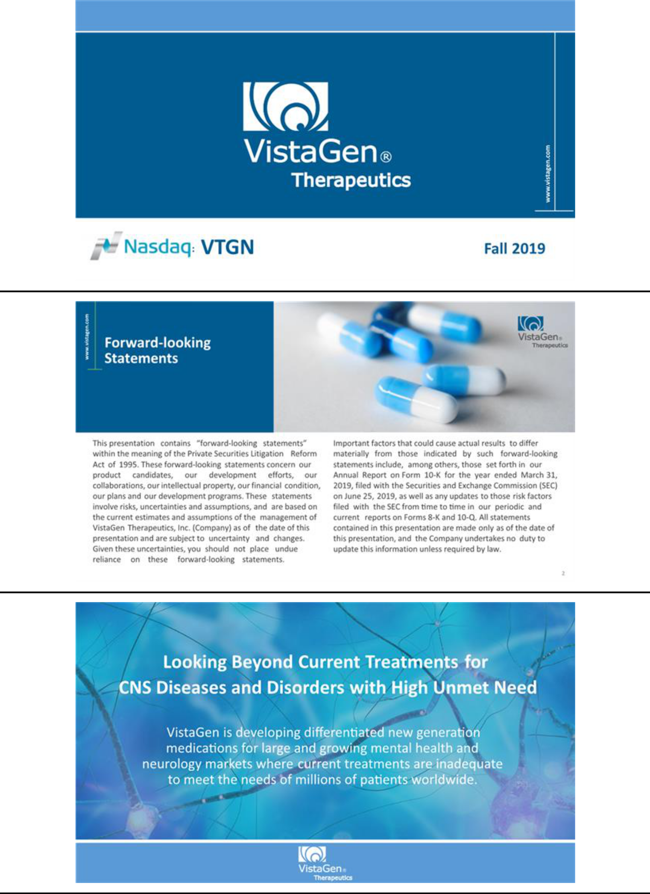

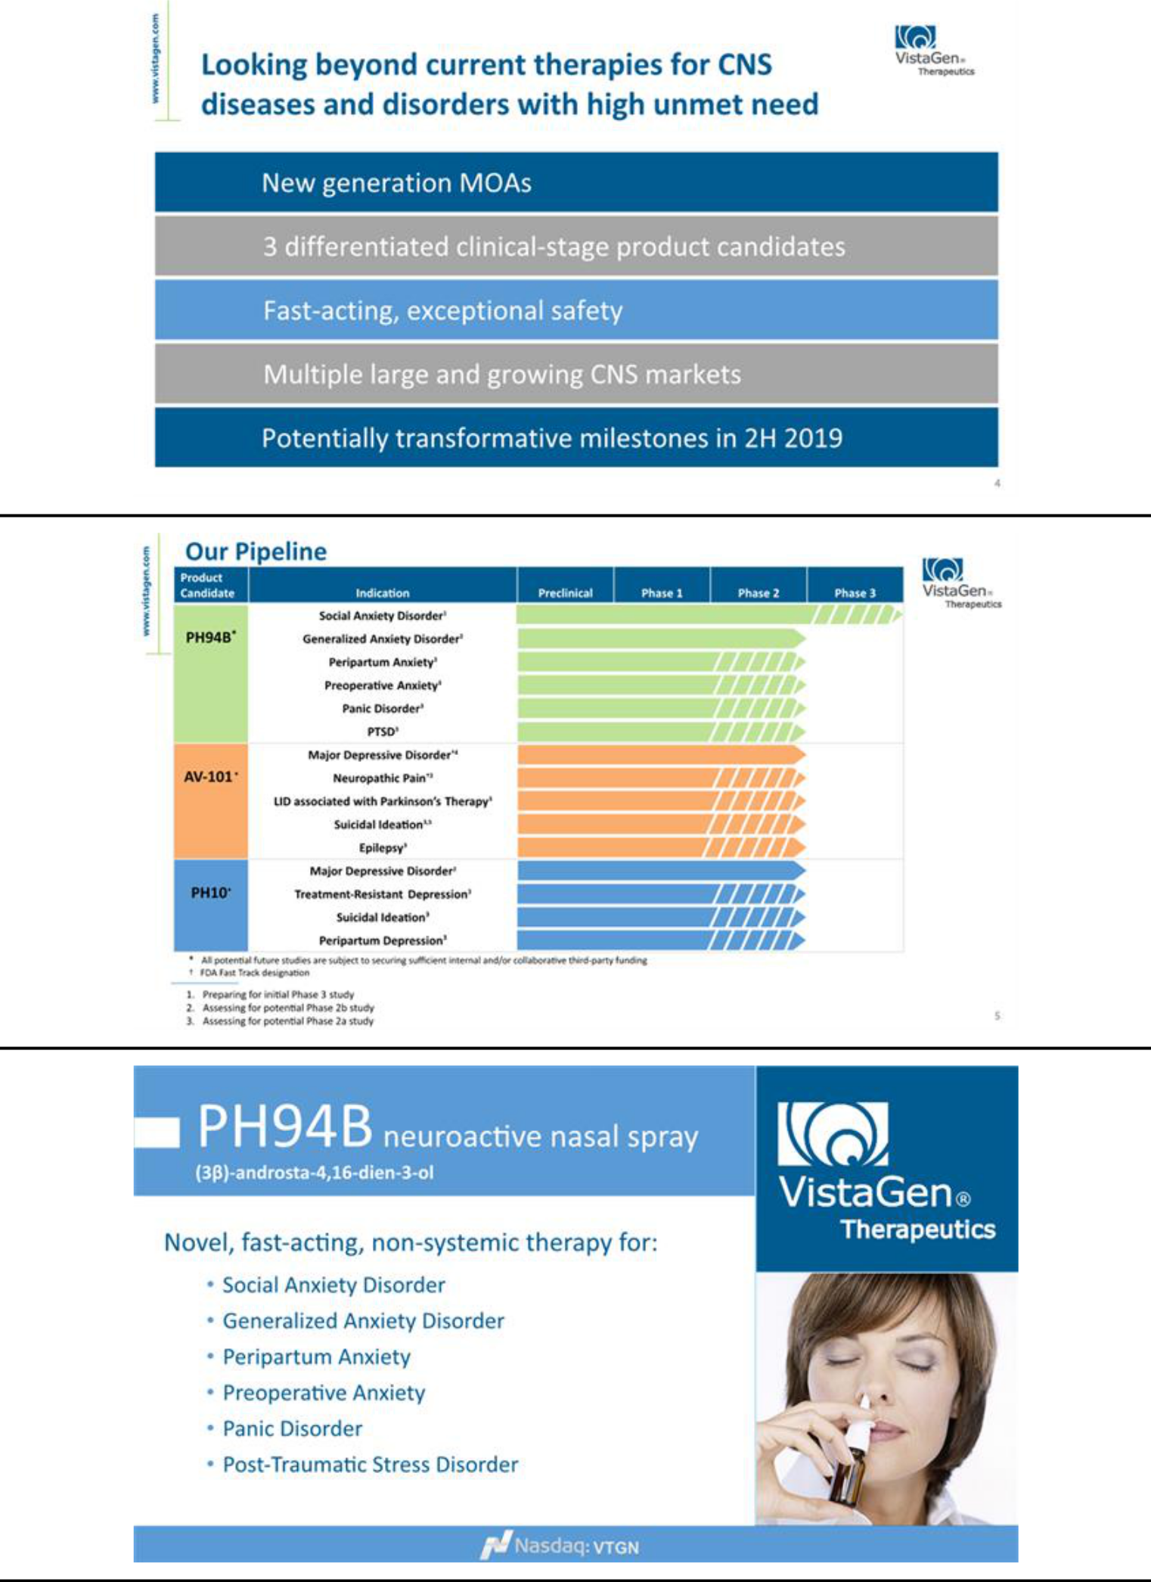

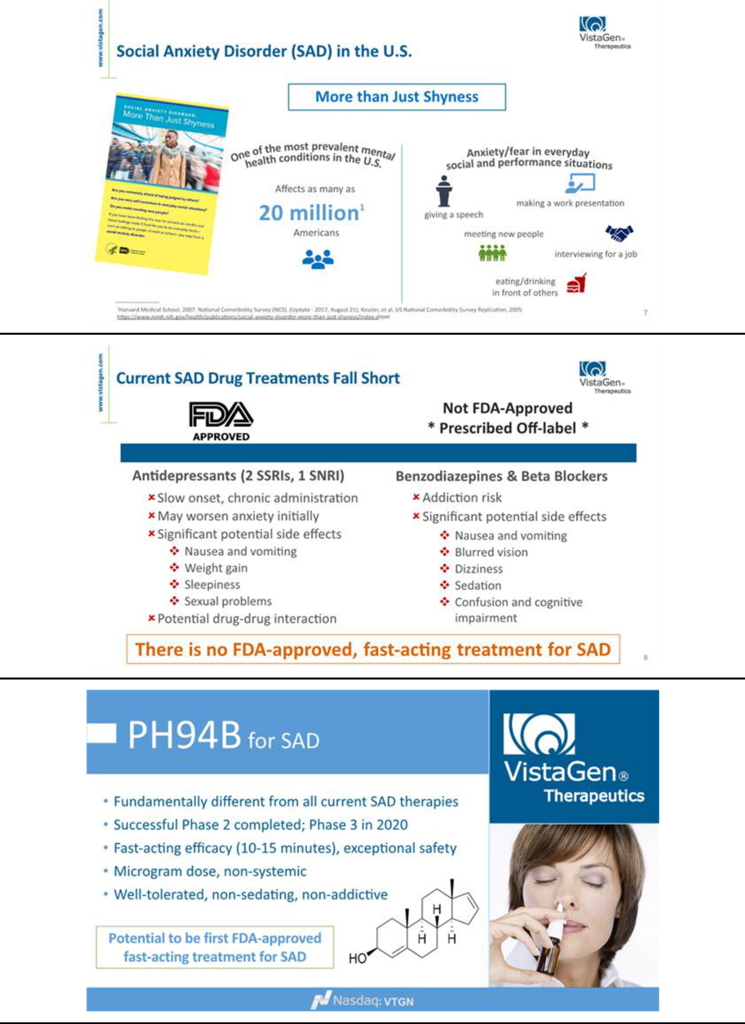

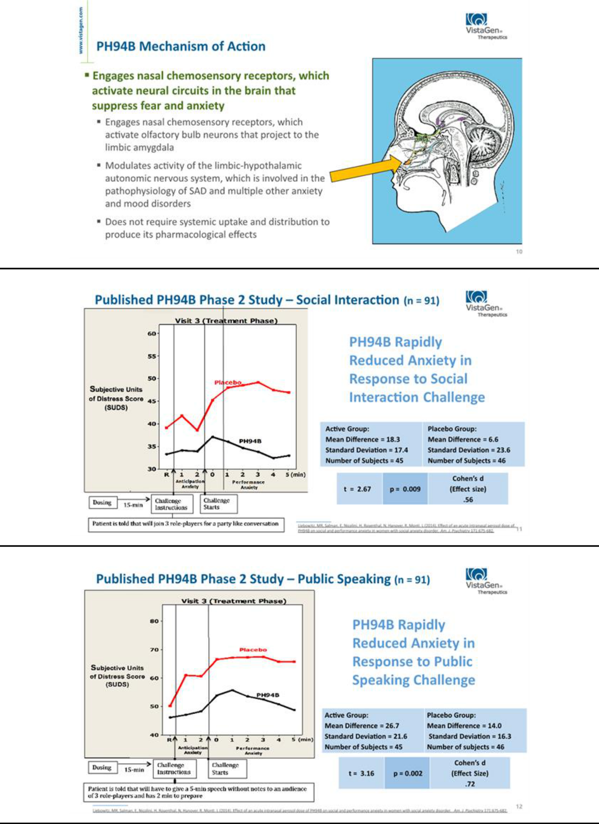

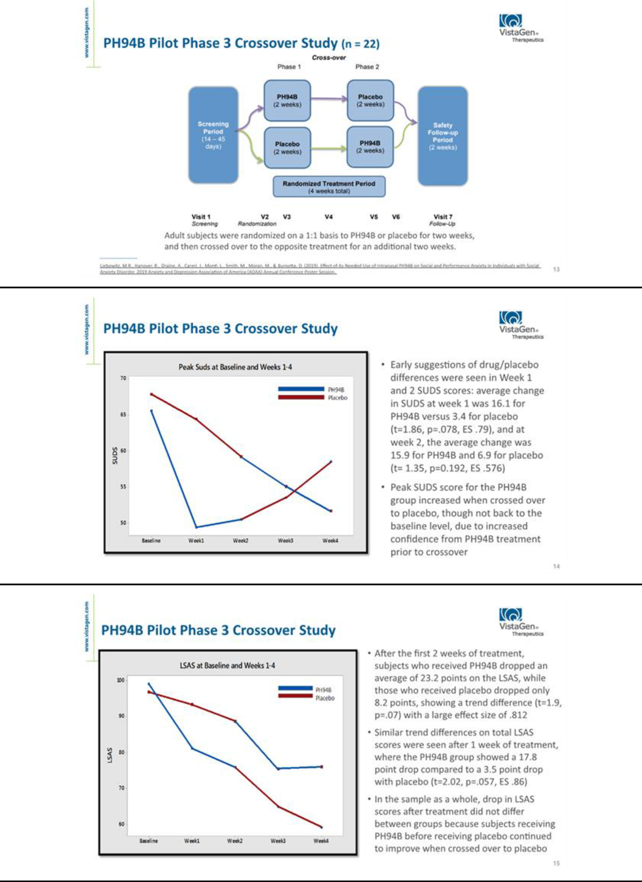

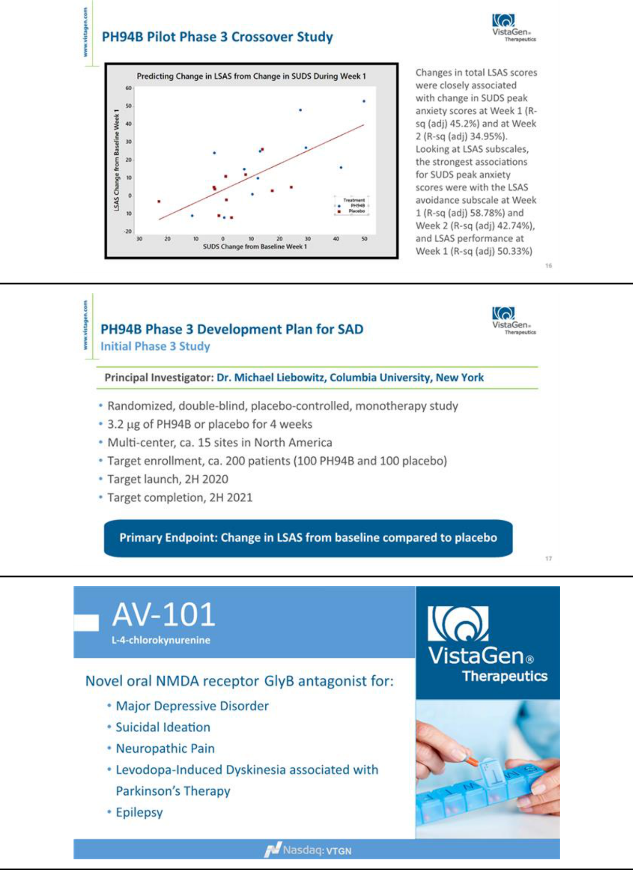

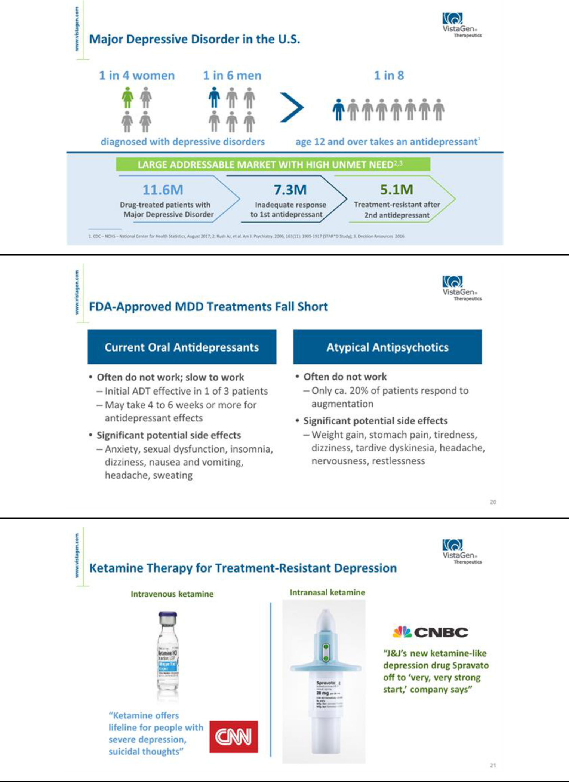

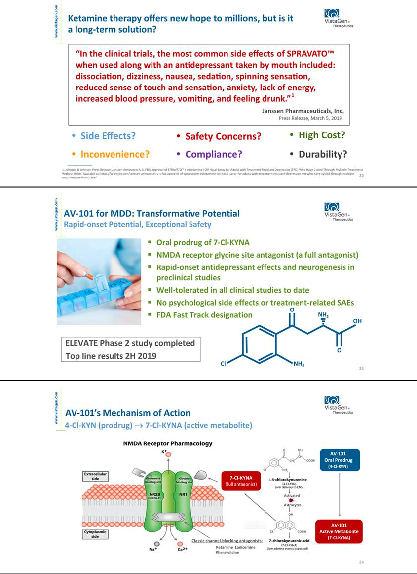

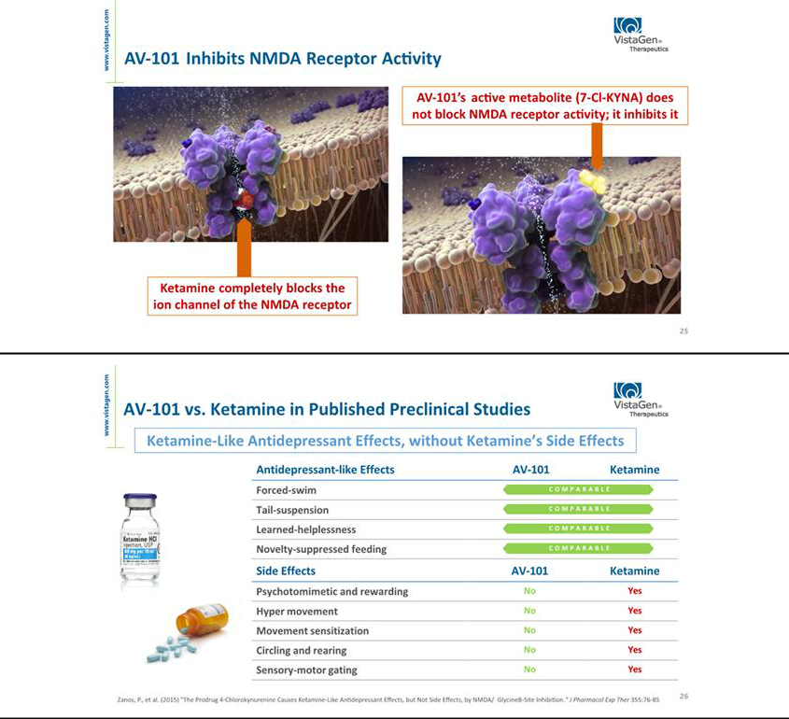

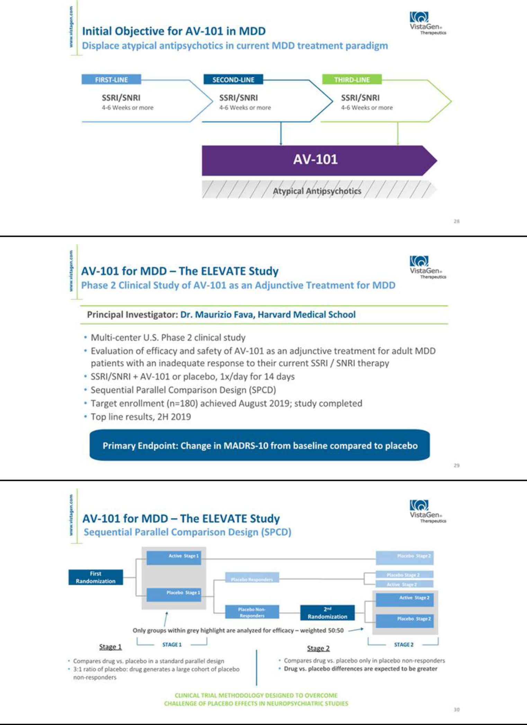

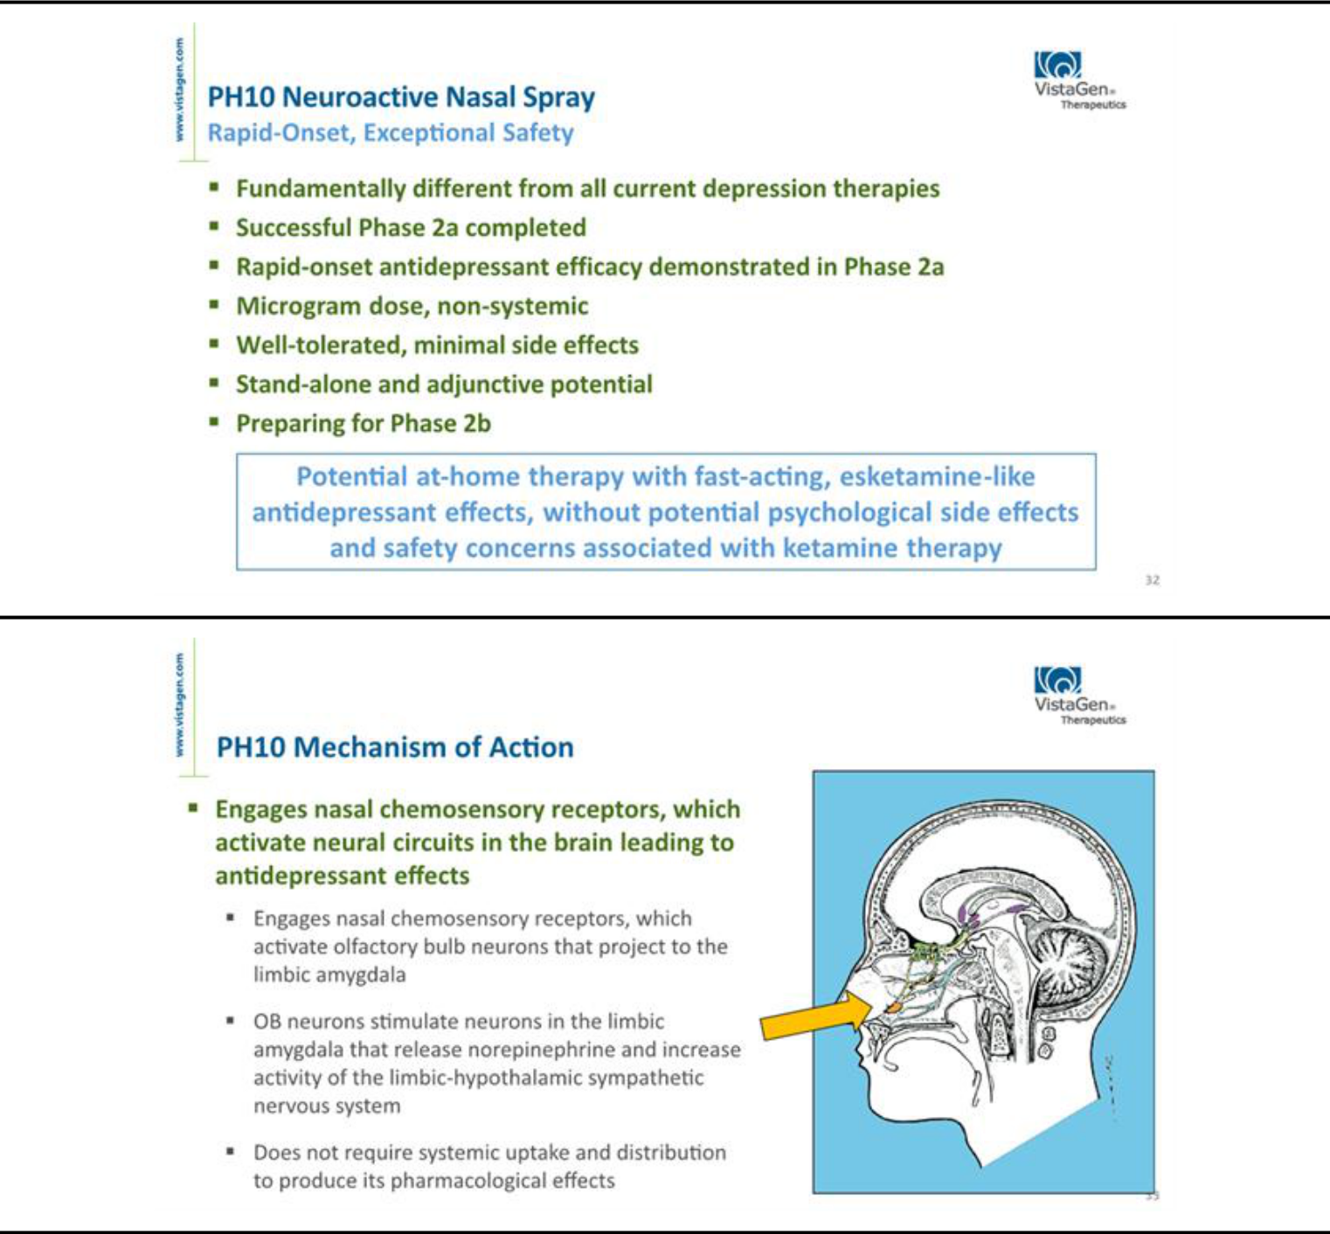

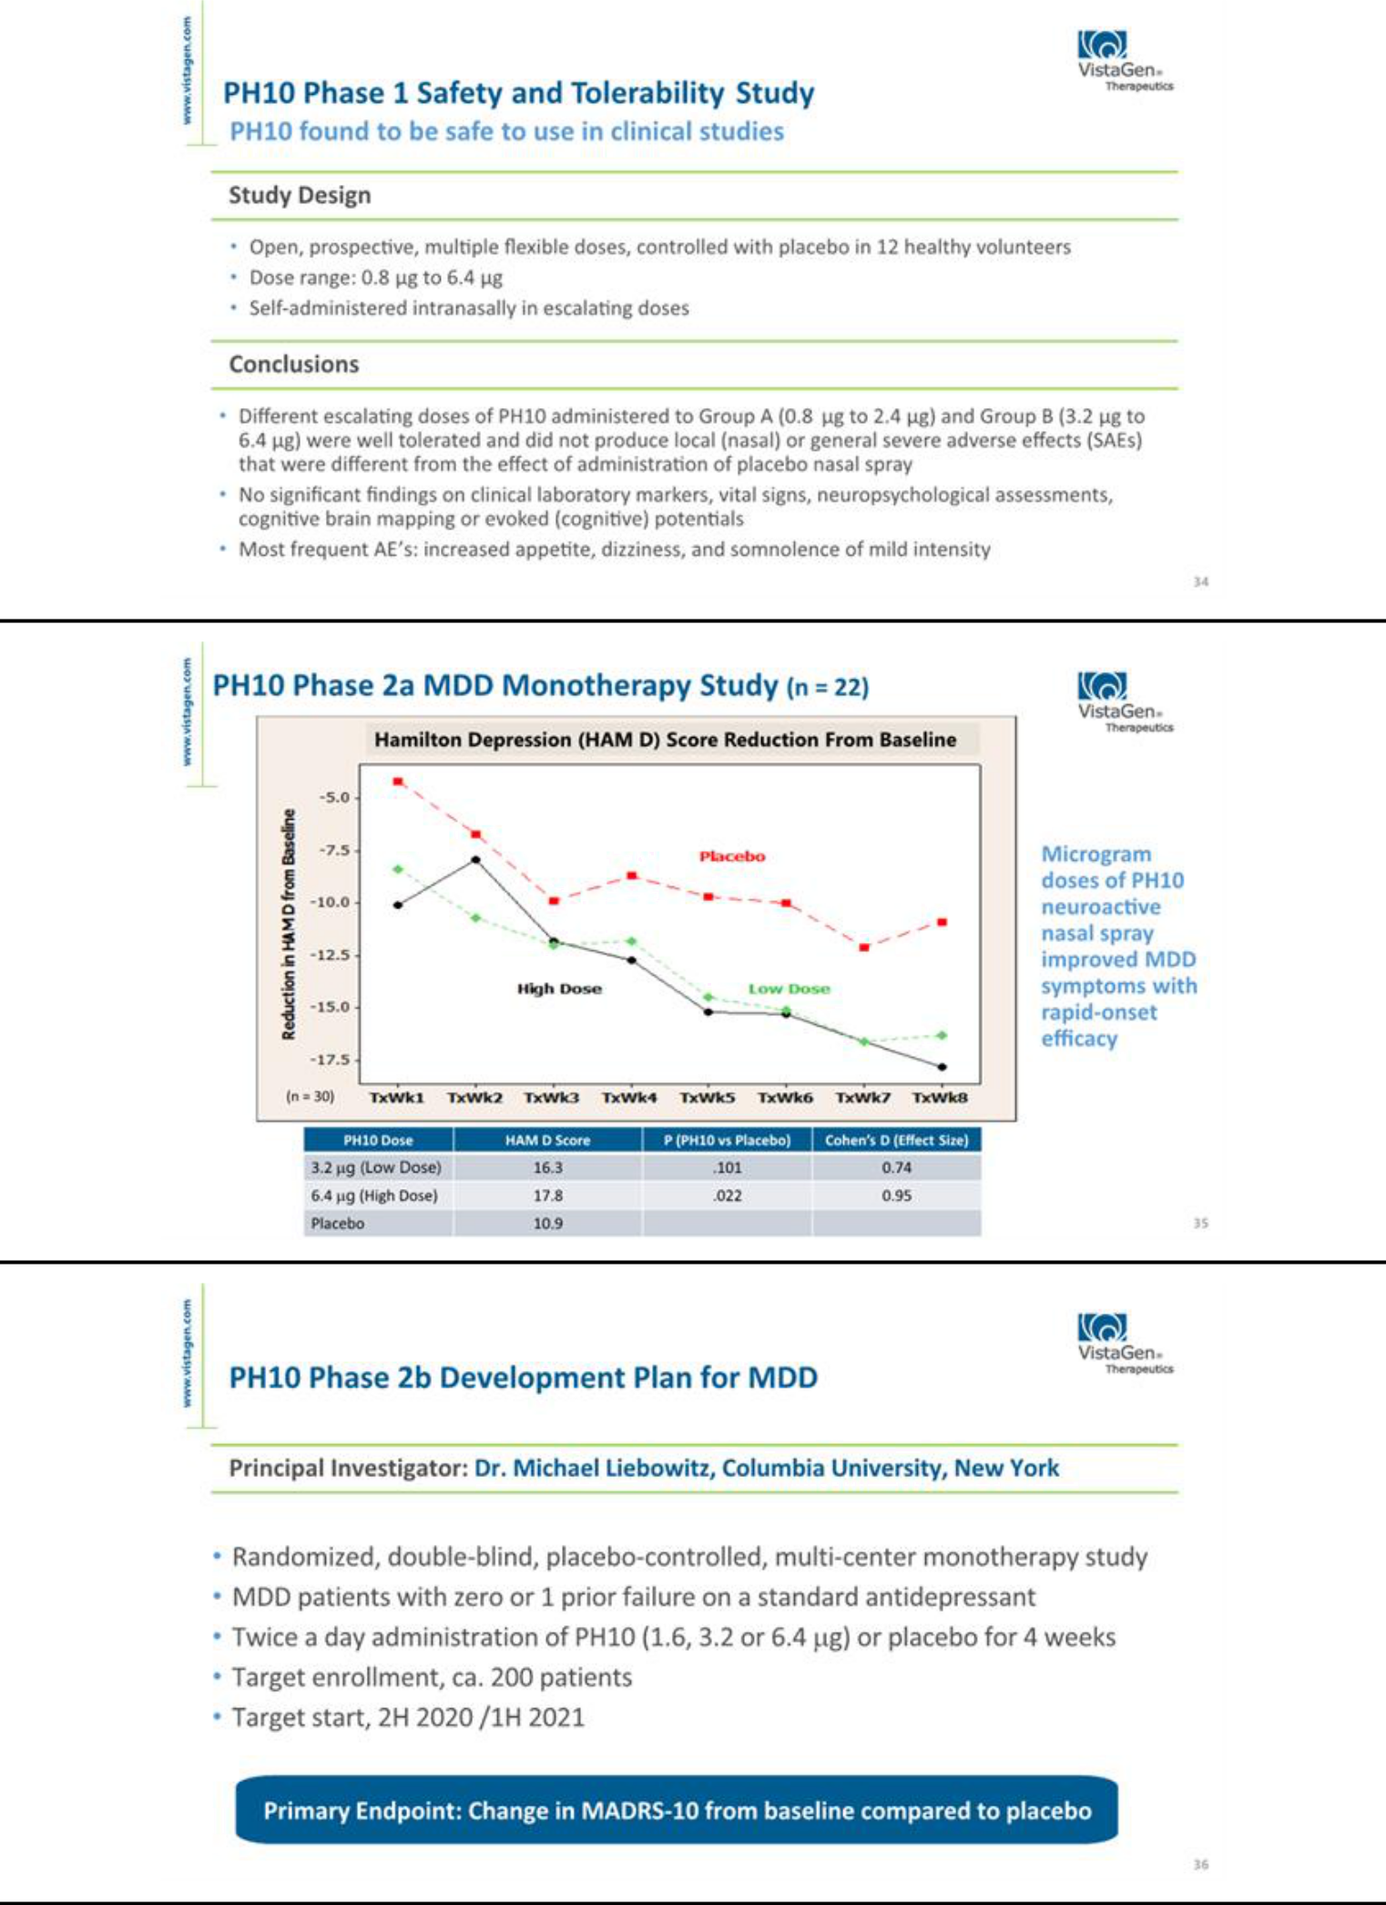

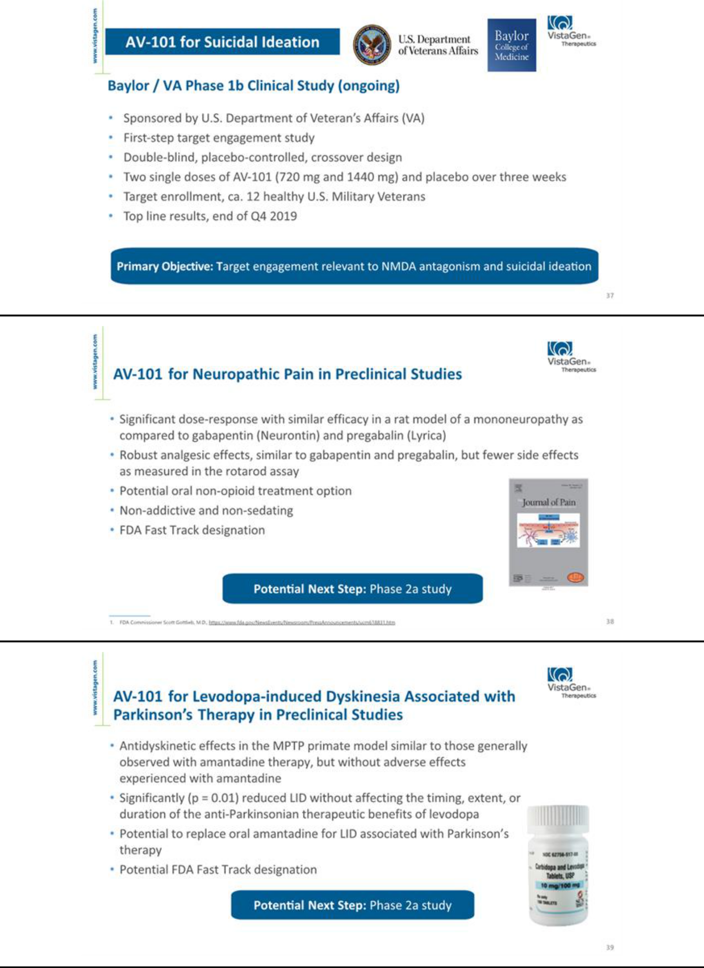

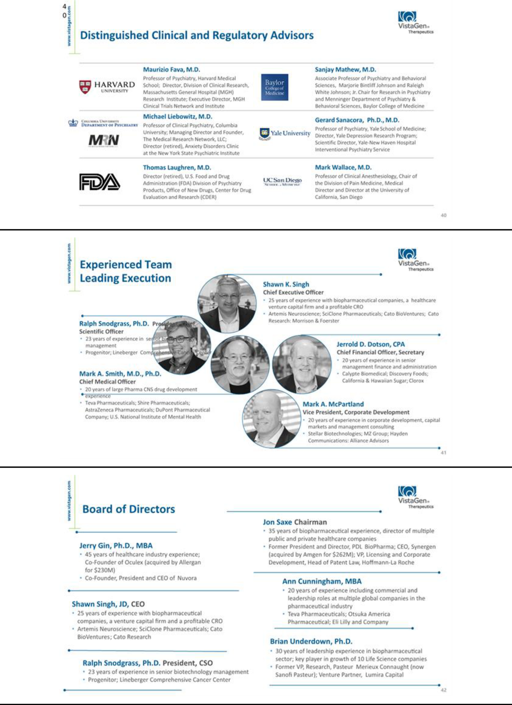

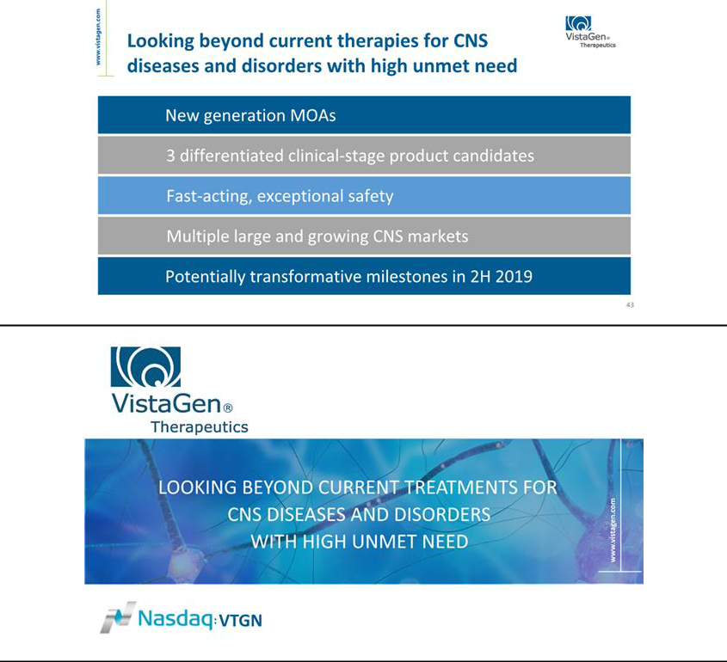

Exhibit 99.2


VistaGen Therapeutics Announces Last Patient Completes Dosing in the ELEVATE Phase 2 Study of AV-101 for Major Depressive Disorder

Company on Track to Report Top Line Results Before Year End

SOUTH SAN FRANCISCO, Calif., October 08, 2019 – VistaGen Therapeutics (NASDAQ: VTGN), a clinical-stage biopharmaceutical company developing new generation medicines for central nervous system (CNS) diseases and disorders with high unmet need, announced today that the last patient has completed dosing in the ELEVATE Phase 2 clinical study of AV-101, the Company’s novel, oral NMDA (N-methyl-D-aspartate) receptor glycine site antagonist, as an adjunctive (add-on) treatment with an FDA-approved oral antidepressant for major depressive disorder (MDD). The Company remains on track to report top line results of the ELEVATE study before the end of 2019.

About AV-101

AV-101 (4-Cl-KYN) belongs to a new generation of investigational medicines in neuropsychiatry and neurology known as NMDA glutamate receptor modulators. The NMDA receptor is a pivotal receptor in the brain and abnormal NMDA function is associated with numerous CNS diseases and disorders. AV-101 is an oral prodrug of 7-Cl-KYNA, a potent and selective full antagonist of the glycine coagonist site of the NMDA receptor. With its exceptional safety profile in all studies to date, AV-101 has potential to be a new at-home treatment for multiple large market CNS indications where current treatments are inadequate to satisfy high unmet patient needs. VistaGen is currently focused on AV-101’s potential to treat depression, dyskinesia associated with levodopa therapy for Parkinson’s disease, epilepsy, neuropathic pain and suicidal ideation. The FDA has granted Fast Track designation for development of AV-101 as a potential adjunctive treatment for MDD and as a non-opioid treatment for neuropathic pain.

About the ELEVATE Study

Among VistaGen's key objectives for AV-101 in MDD is to replace atypical antipsychotics in the current MDD drug treatment paradigm and redefine the standard of care for individuals who are unable to reduce their symptoms of depression with their current oral antidepressant alone. The ELEVATE study is VistaGen’s U.S. multi-center, randomized, double-blind, placebo-controlled Phase 2 clinical study to evaluate the efficacy and safety of adjunctive use of AV-101 in adult MDD patients who have an inadequate response to standard FDA-approved oral antidepressant therapy. VistaGen achieved target enrollment (n = 180) in the ELEVATE study in August 2019. The primary endpoint of the ELEVATE study is the change from baseline on the Montgomery-Åsberg Depression Rating Scale (MADRS-10) total score.

About Major Depressive Disorder (MDD)

MDD is a serious neurobiologically-based mood disorder, affecting approximately 17.3 million adults in the U.S., or 7.1% of the U.S. adult population, according to the U.S. National Institute of Mental Health. Individuals diagnosed with MDD exhibit depressive symptoms, such as a depressed mood or a loss of interest or pleasure in daily activities, for more than a two-week period, as well as impaired social, occupational, educational or other important functioning which has a negative impact on their quality of life. Globally, MDD affects nearly 300 million people of all ages and is the leading cause of disability according to the World Health Organization.

About VistaGen

VistaGen Therapeutics is a clinical-stage biopharmaceutical company developing new generation medicines for CNS diseases and disorders where current treatments are inadequate, resulting in high unmet need. VistaGen's pipeline includes three differentiated, clinical-stage CNS drug candidates, AV-101, PH10 and PH94B, each with an exceptional safety profile in all clinical studies to date and therapeutic potential in multiple large and growing CNS markets. For more information, please visit www.vistagen.com and connect with VistaGen on Twitter, LinkedIn and Facebook.

Forward-Looking Statements

This release contains various statements concerning VistaGen's future expectations, plans and prospects, including without limitation, our expectations regarding development and commercialization of our three drug candidates, (i) AV-101 for depression, dyskinesia associated with levodopa therapy for Parkinson’s disease, epilepsy, neuropathic pain and suicidal ideation ; (ii) PH94B for social anxiety disorder, generalized anxiety disorder, peripartum anxiety, preoperative anxiety, panic disorder and post-traumatic stress disorder; and (iii) PH10 for MDD, peripartum depression and suicidal ideation. In addition, statements concerning the Company’s future expectations may include statements regarding intellectual property and commercial protection of our drug candidates. Each of these statements constitute forward-looking statements for the purposes of the safe harbor provisions under the Private Securities Litigation Reform Act of 1995. These forward-looking statements are neither promises nor guarantees of future performance and are subject to a variety of risks and uncertainties, many of which are beyond our control, and may cause actual results to differ materially from those contemplated in these forward-looking statements. Among these risks is the possibility that (i) we may encounter unexpected adverse events in patients during our clinical development of any product candidate that cause us to discontinue further development, (ii) we may not be able to successfully demonstrate the safety and efficacy of our product candidates at each stage of clinical development, including for AV-101 during the ELEVATE study, (iii) success in preclinical studies or in early-stage clinical trials may not be repeated or observed in ongoing or future studies, and ongoing or future preclinical and clinical results may not support further development of, or be sufficient to gain regulatory approval to market AV-101, (iv) decisions or actions of regulatory agencies may negatively affect the progress of, and our ability to proceed with, clinical studies or to obtain marketing approval for our drug candidates, (v) we may not be able to obtain or maintain adequate intellectual property protection and other forms of marketing and data exclusivity for our product candidates, (vi) we may not have access to or be able to secure substantial additional capital required to support our operations, including our ongoing clinical development activities, and (vii) we may encounter technical and other unexpected hurdles in the manufacturing and development of any of our product candidates. Certain other risks are more fully discussed in the section entitled "Risk Factors" in our most recent annual report on Form 10-K and subsequent quarterly reports on Form 10-Q, as well as discussions of potential risks, uncertainties, and other important factors in our other filings with the Securities and Exchange Commission (SEC). Our SEC filings are available on the SEC's website at www.sec.gov. In addition, any forward-looking statements represent our views only as of the issuance of this release and should not be relied upon as representing our views as of any subsequent date. We explicitly disclaim any obligation to update any forward-looking statements.

Company Contact

Mark A. McPartland

VistaGen Therapeutics Inc.

Phone: +1 (650) 577-3600

Email: IR@vistagen.com

Investor Contact

Valter Pinto / Allison Soss

KCSA Strategic Communications

Phone: +1 (212) 896-1254/+1 (212) 896-1267

Email: VistaGen@KCSA.com

Media Contact

Caitlin Kasunich / Lisa Lipson

KCSA Strategic Communications

Phone: +1 (212) 896-1241/+1 (508) 843-6428

Email: VistaGen@KCSA.com

###

