UNITED STATES
SECURITIES AND EXCHANGE COMMISSION
Washington, D.C. 20549

FORM 8-K

CURRENT REPORT
PURSUANT TO SECTION 13 OR 15(d) of the SECURITIES EXCHANGE ACT OF 1934

Date of Report (Date of earliest event reported): May 2, 2019

VistaGen Therapeutics, Inc.
(Exact name of registrant as specified in its charter)

NEVADA | 001-37761 | 20-5093315
(State or other jurisdiction of incorporation) | (Commission File Number) | (IRS Employer Identification Number)

343 Allerton Ave.
South San Francisco, California 94090
(Address of principal executive offices)

(650) 577-3600
(Registrant’s telephone number, including area code)

Not Applicable
(Former name or former address, if changed since last report)

Check the appropriate box below if the Form 8-K filing is intended to simultaneously satisfy the filing obligation of the registrant under any of the following provisions:

☐ Written communications pursuant to Rule 425 under the Securities Act (17 CFR 230.425)
☐ Soliciting material pursuant to Rule 14a-12 under the Exchange Act (17 CFR 240.14a -12)
☐ Pre-commencement communications pursuant to Rule 14d-2(b) under the Exchange Act (17 CFR 240.14d -2(b))
☐ Pre-commencement communications pursuant to Rule 13e-4(c) under the Exchange Act (17 CFR 240.13e -4(c))

Indicate by check mark whether the registrant is an emerging growth company as defined in Rule 405 of the Securities Act of 1933 (17 CFR 230.405) or Rule 12b-2 of the Securities Exchange Act of 1934 (17 CFR 240.12b-2)

Emerging growth company [ ]

If an emerging growth company, indicate by check mark if the registrant has elected not to use the extended transition period for complying with any new or revised financial accounting standards provided pursuant to Section 13(a) of the Exchange Act. [ ]

Securities registered pursuant to Section 12(b) of the Act:

Title of each class |  | Trading Symbol |  | Name of each exchange on which registered
Common Stock, par value $0.001 per share |  | VTGN |  | Nasdaq Capital Market

Item 7.01 Regulation FD Disclosure.

VistaGen Therapeutics, Inc. (the “Company”) today began utilizing a new corporate presentation. A copy of the Corporate Presentation is attached hereto as Exhibit 99.1.

The information in this Item 7.01 of this Current Report on Form 8-K, including the information set forth in Exhibit 99.1, is being furnished and shall not be deemed “filed” for purposes of Section 18 of the Securities Exchange Act of 1934, as amended (the “Exchange Act”), nor shall Exhibit 99.1 filed herewith be deemed incorporated by reference in any filing under the Securities Act of 1933, as amended, or the Exchange Act, except as shall be expressly set forth by specific reference in such a filing.

Item 8.01 Other Items.

The Company today announced topline results from an exploratory clinical study of AV-101 as a monotherapy in patients with treatment-resistant depression (“TRD”). The 19-patient study was sponsored and conducted by the U.S National Institute of Mental Health (“NIMH”). A copy of the press release is attached to this Current Report on Form 8-K as Exhibit 99.2.

Item 9.01 Financial Statements and Exhibits.

(d) Exhibits Index

Exhibit No. |  | Description
99.1 |  | Corporate Presentation, dated May 2, 2019
99.2 |  | Press Release issued by VistaGen Therapeutics, Inc., dated May 2, 2019.

Signatures

Pursuant to the requirements of the Securities Exchange Act of 1934, the registrant has duly caused this report to be signed on its behalf by the undersigned thereunto duly authorized.

 | VistaGen Therapeutics, Inc.
Date: May 2, 2019 | By: | /s/ Shawn K. Singh
Shawn K. Singh
Chief Executive Officer

EXHIBIT INDEX

Exhibit No. |  | Description
99.1 |  | Corporate Presentation, dated May 2, 2019
99.2 |  | Press Release issued by VistaGen Therapeutics, Inc., dated May 2, 2019.

Exhibit 99.1

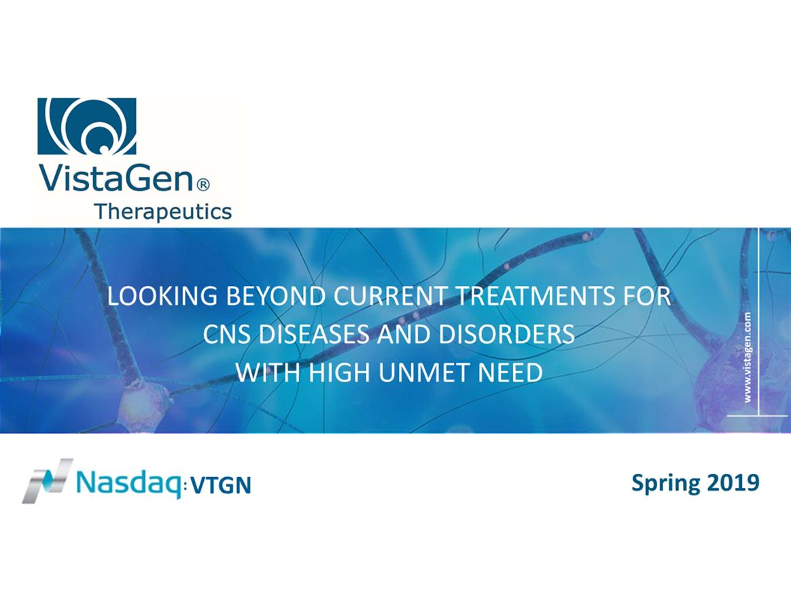

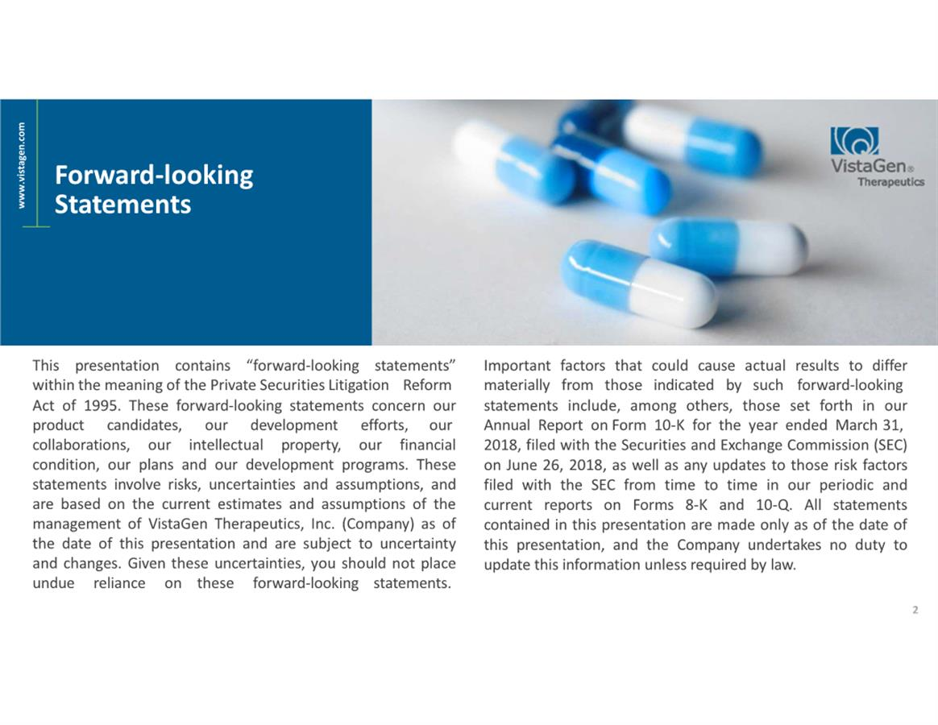

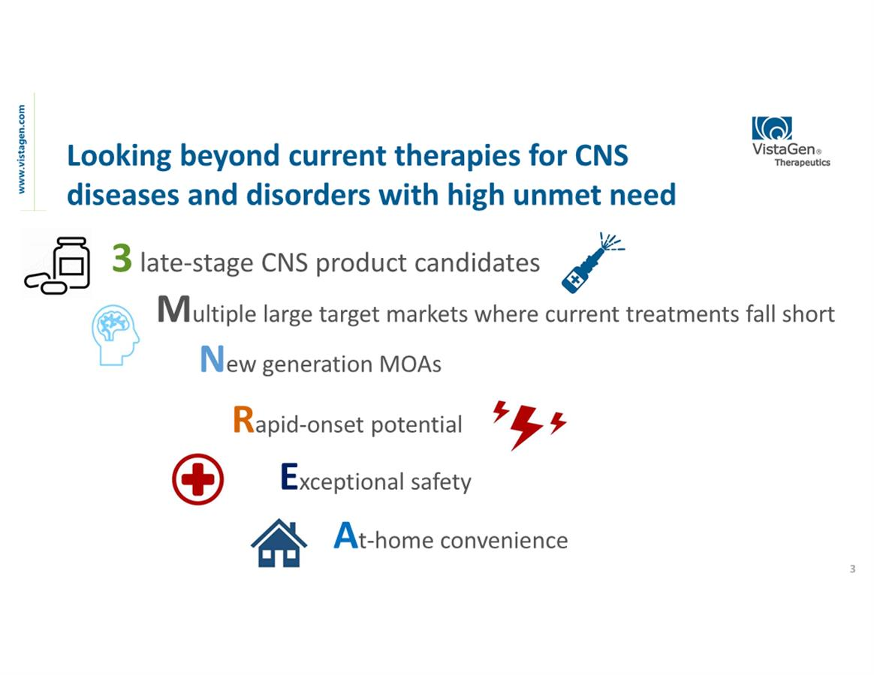

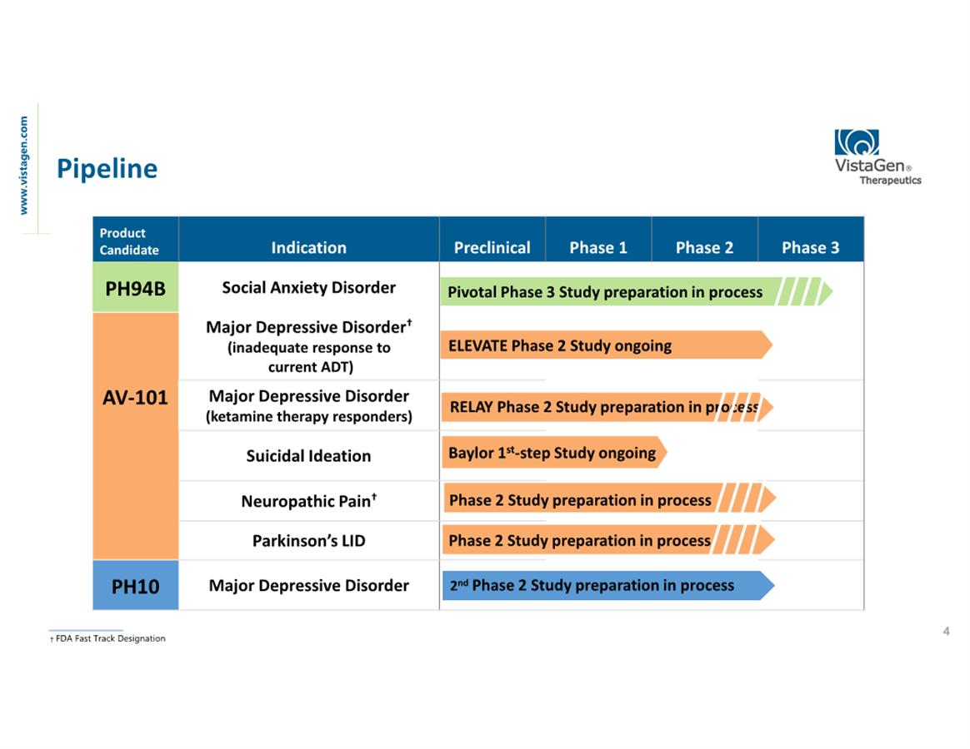

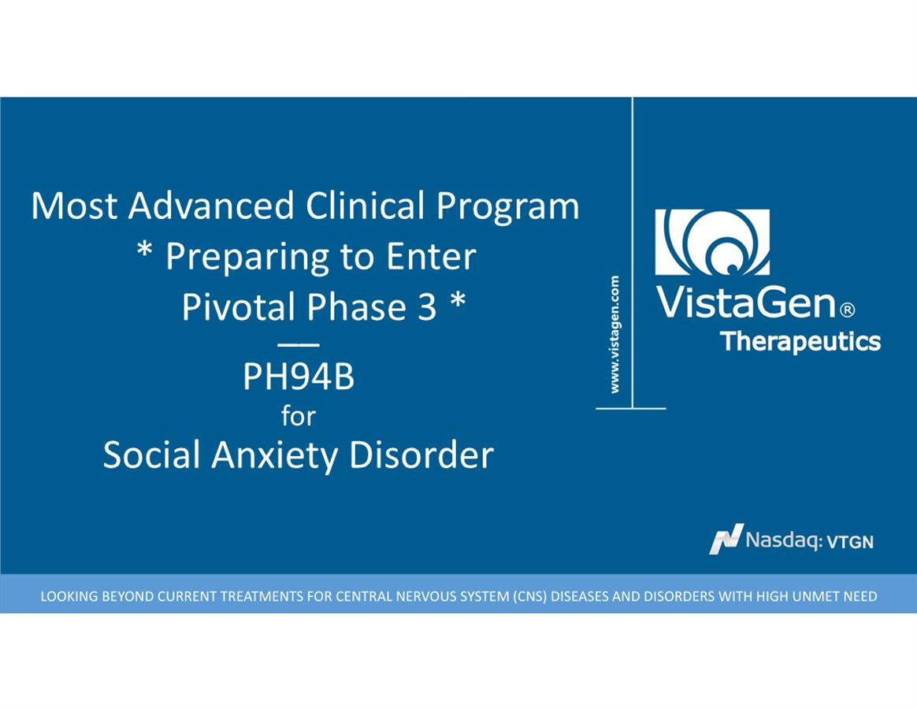

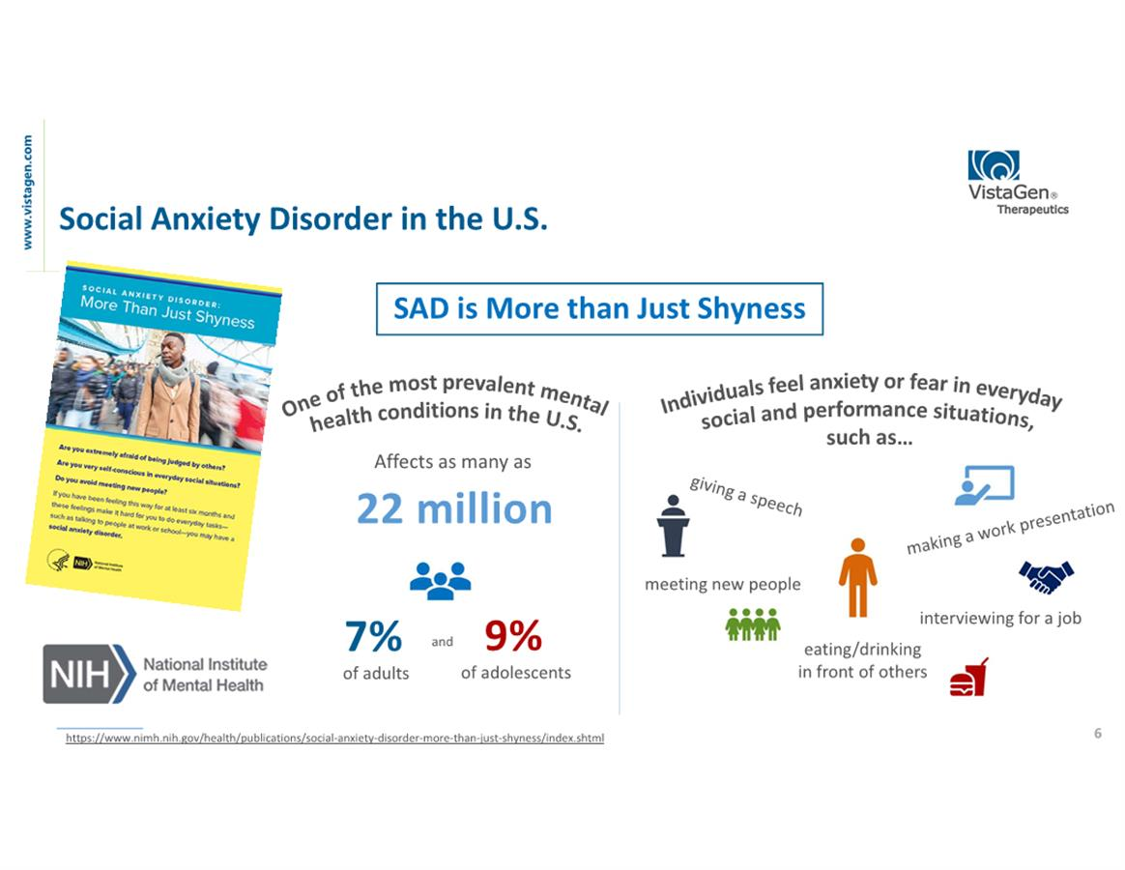

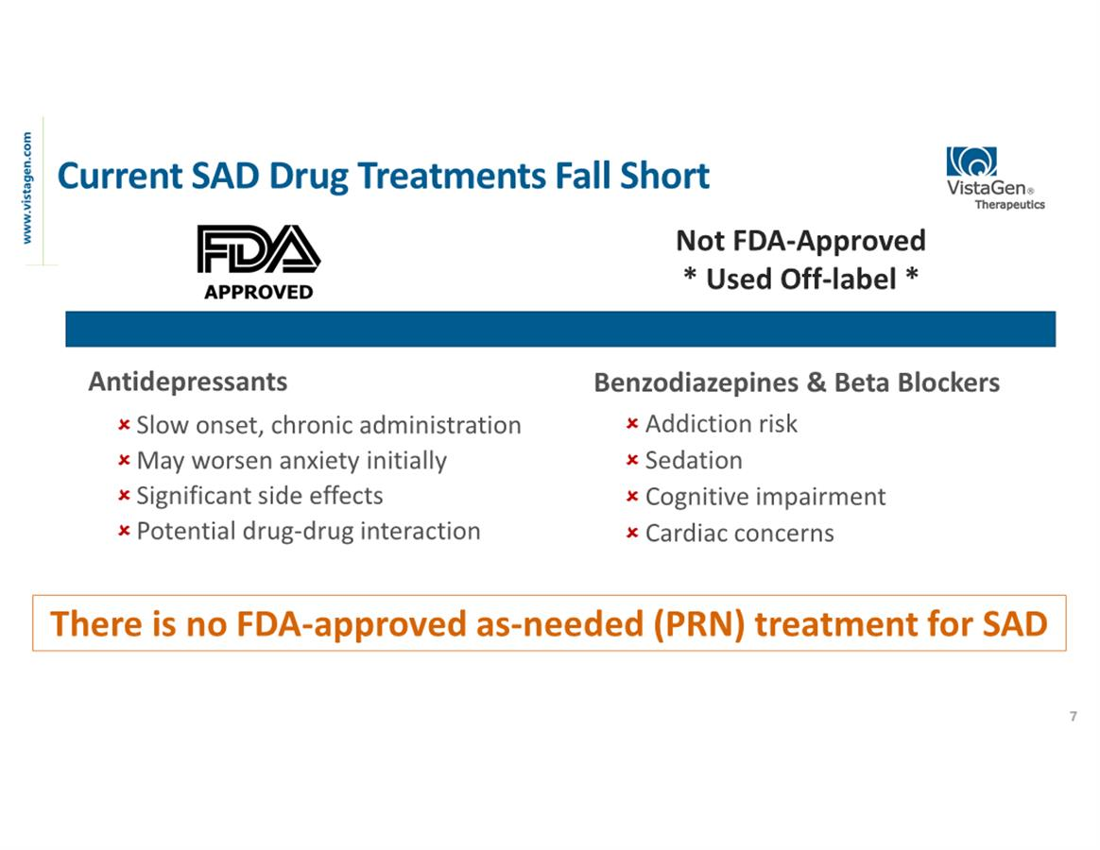

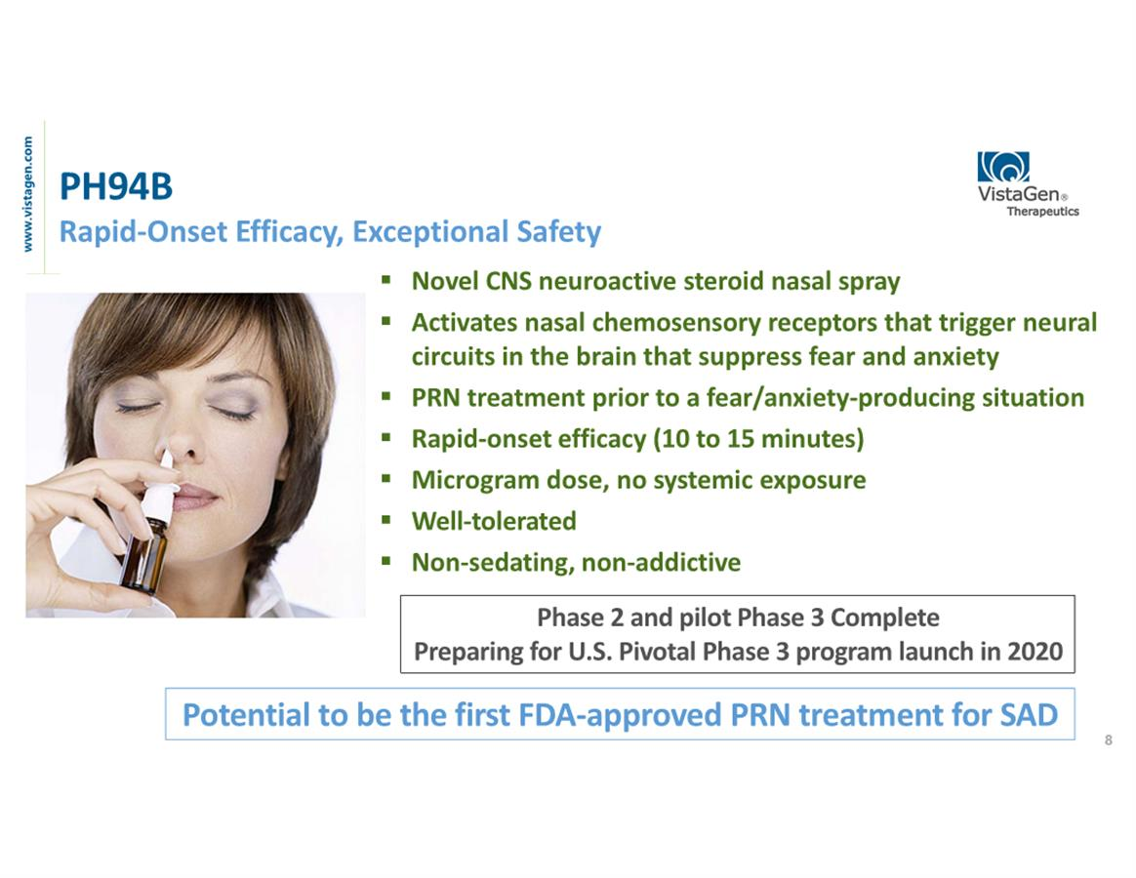

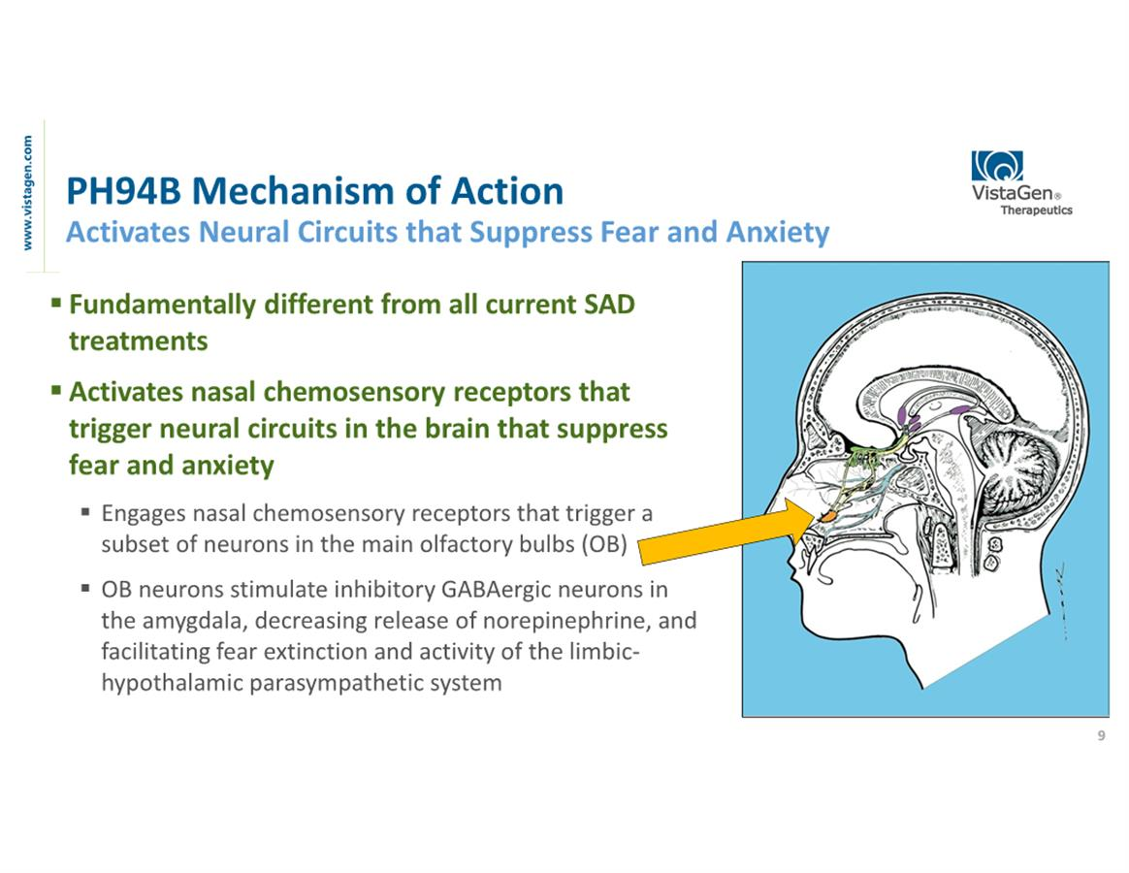

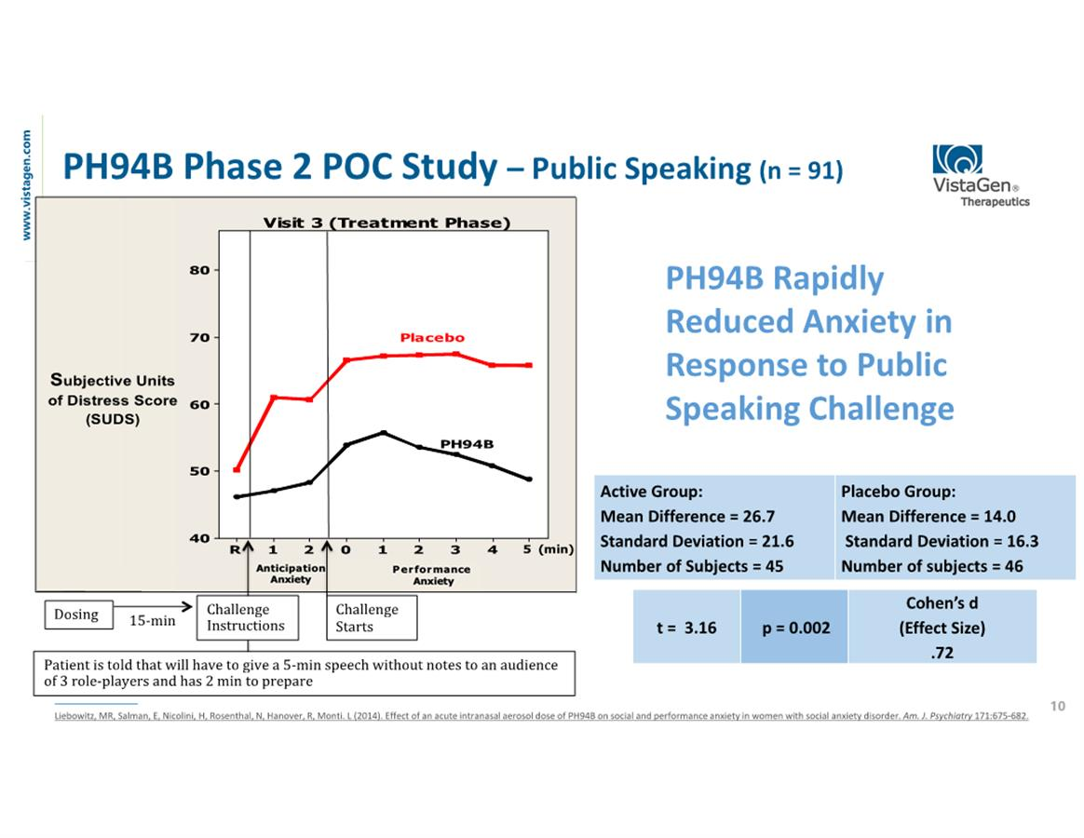

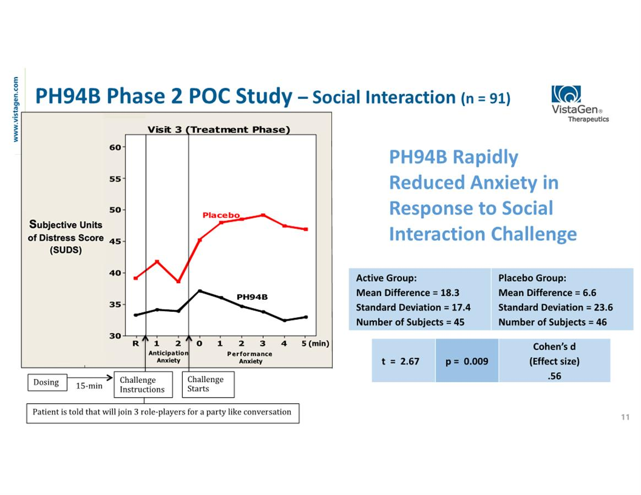

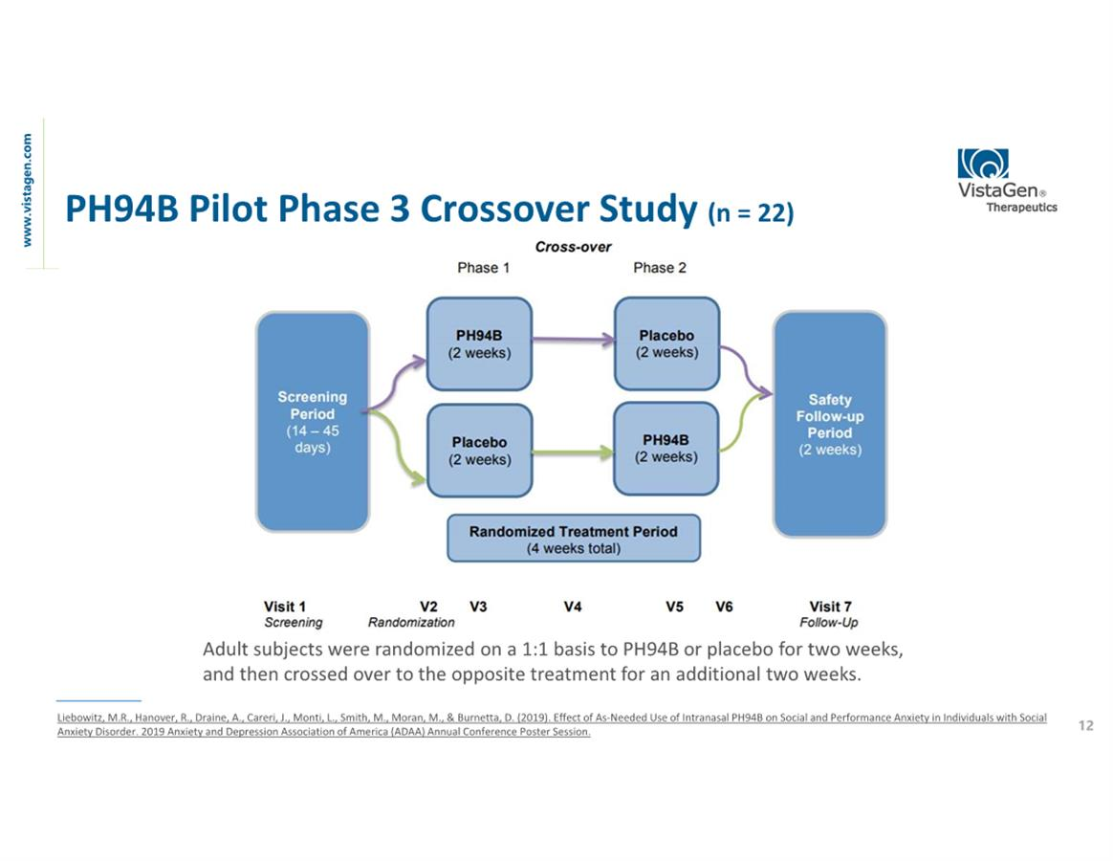

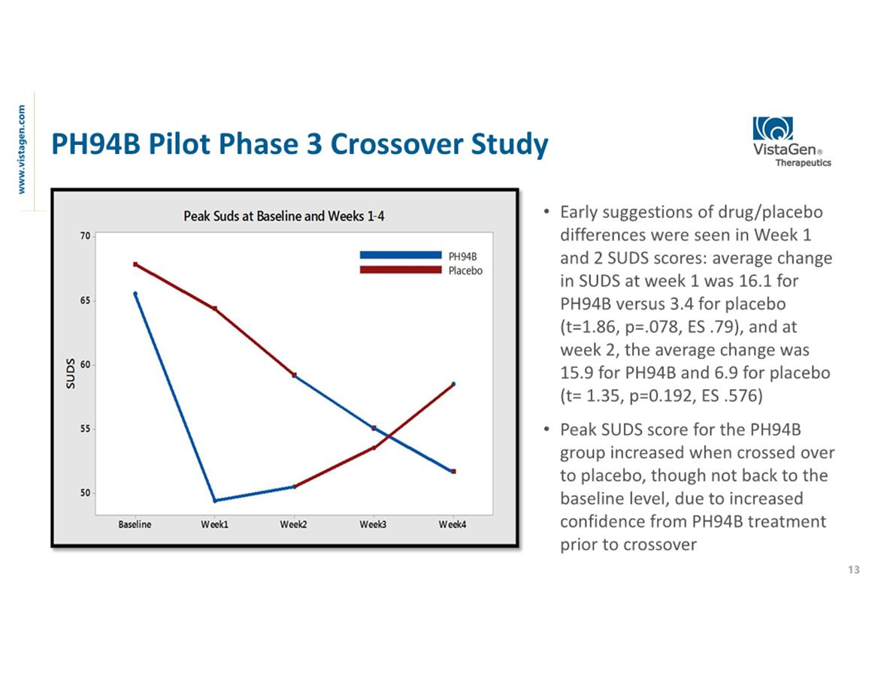

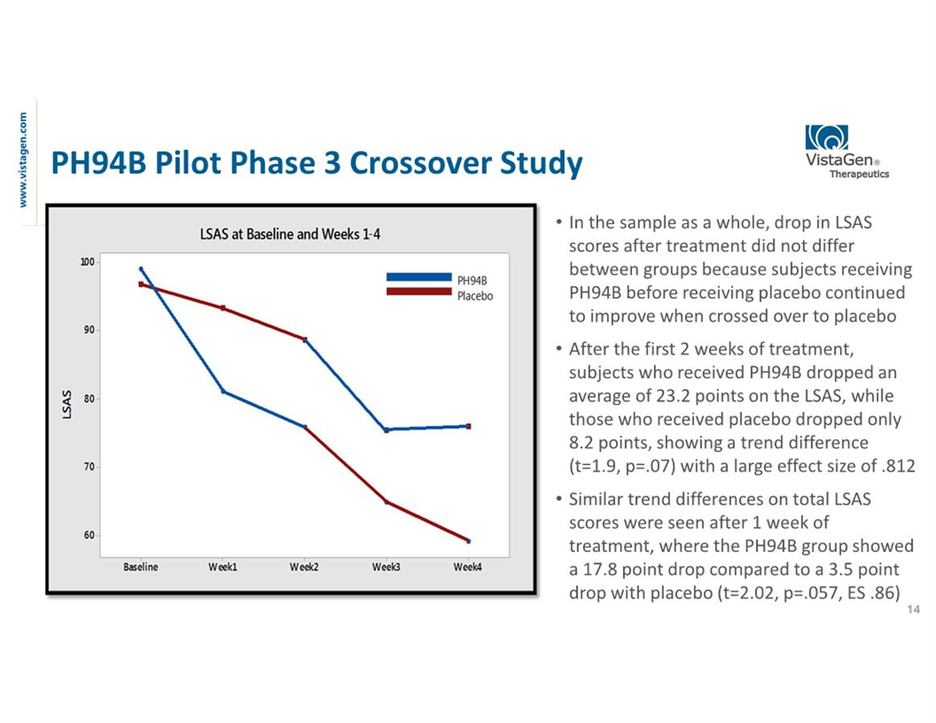

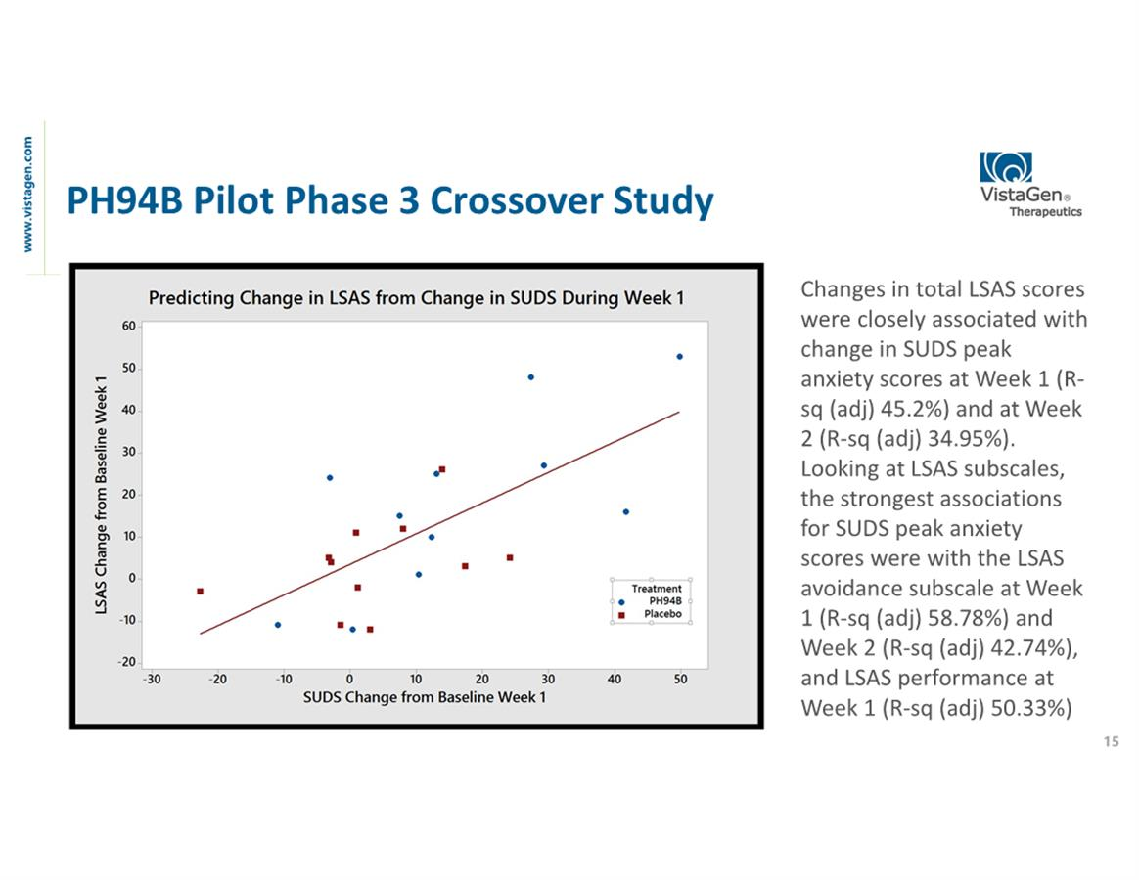

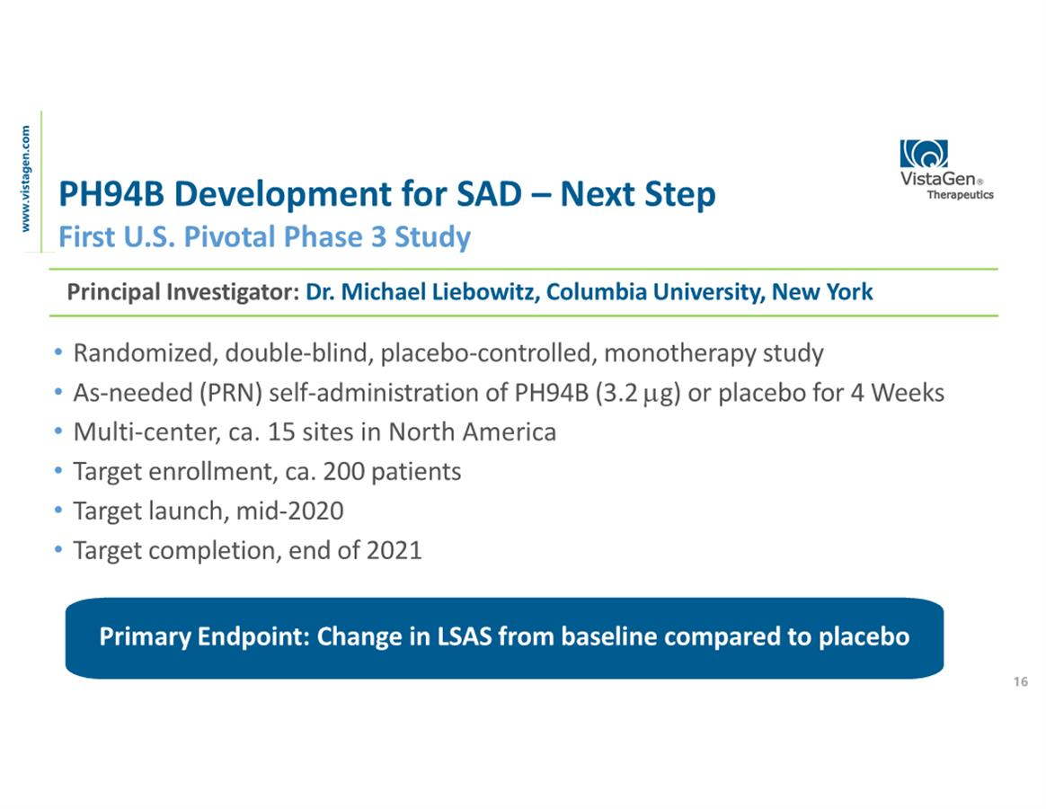

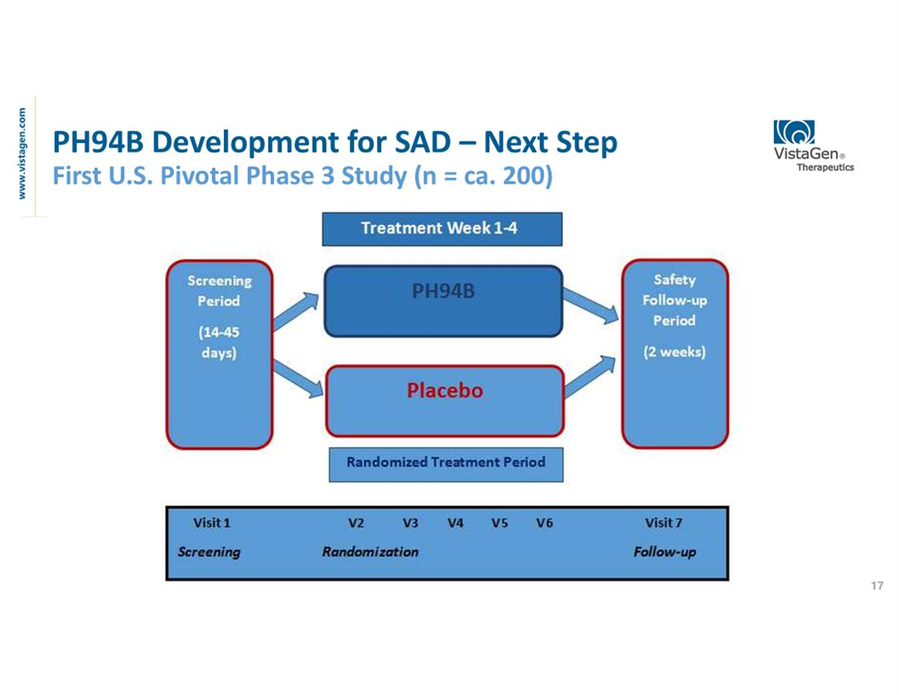

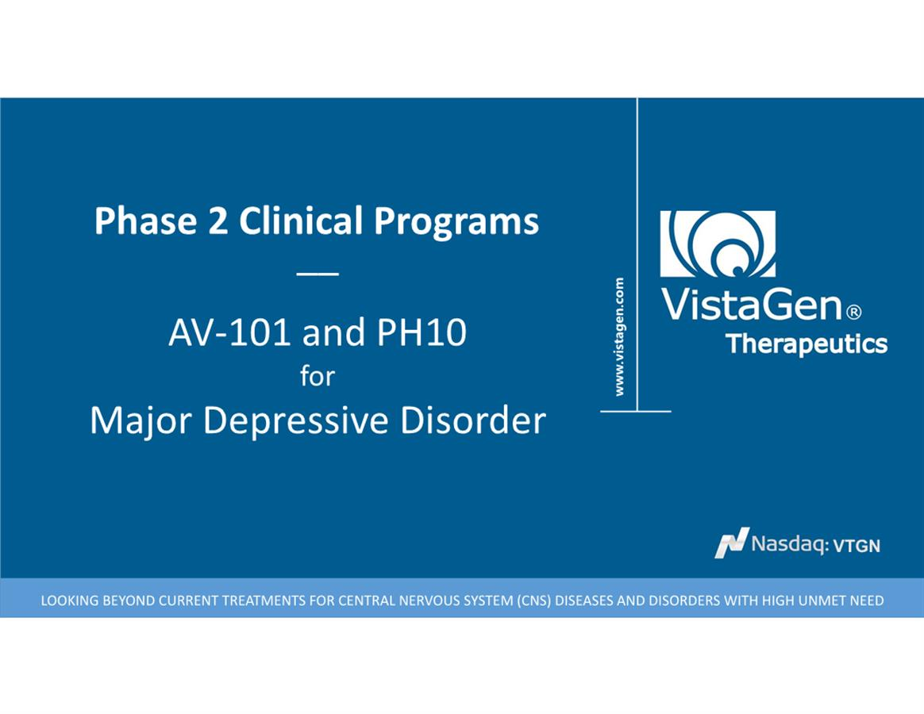

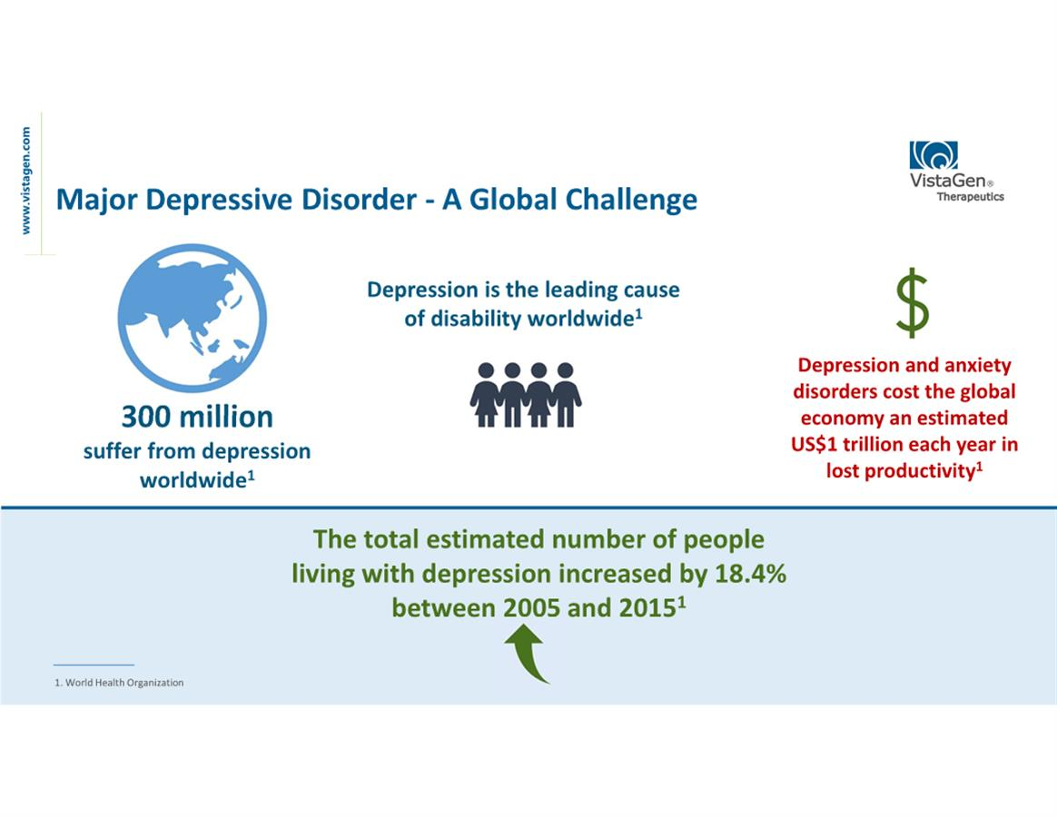

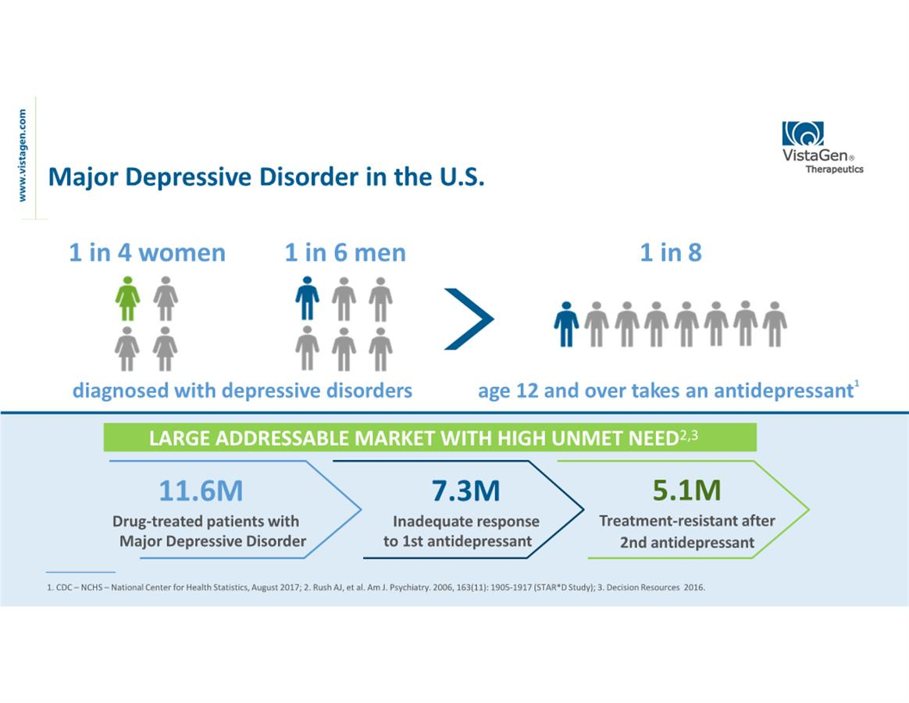

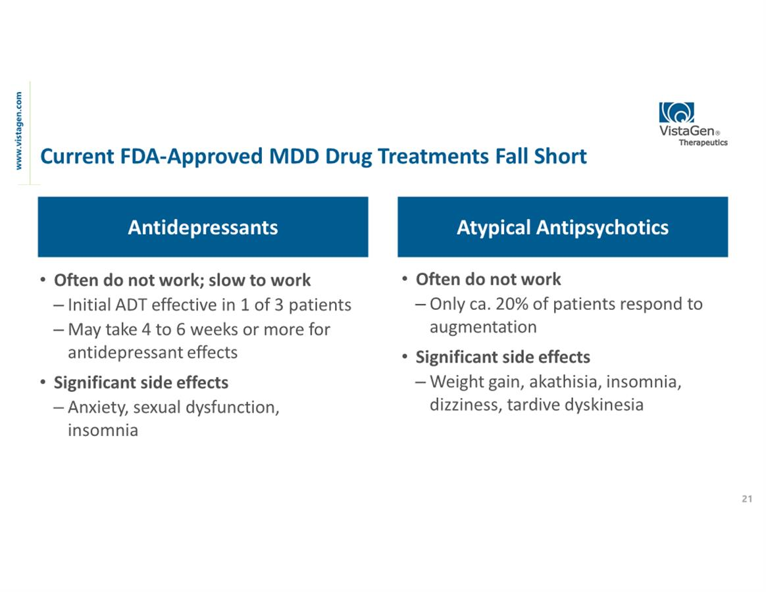

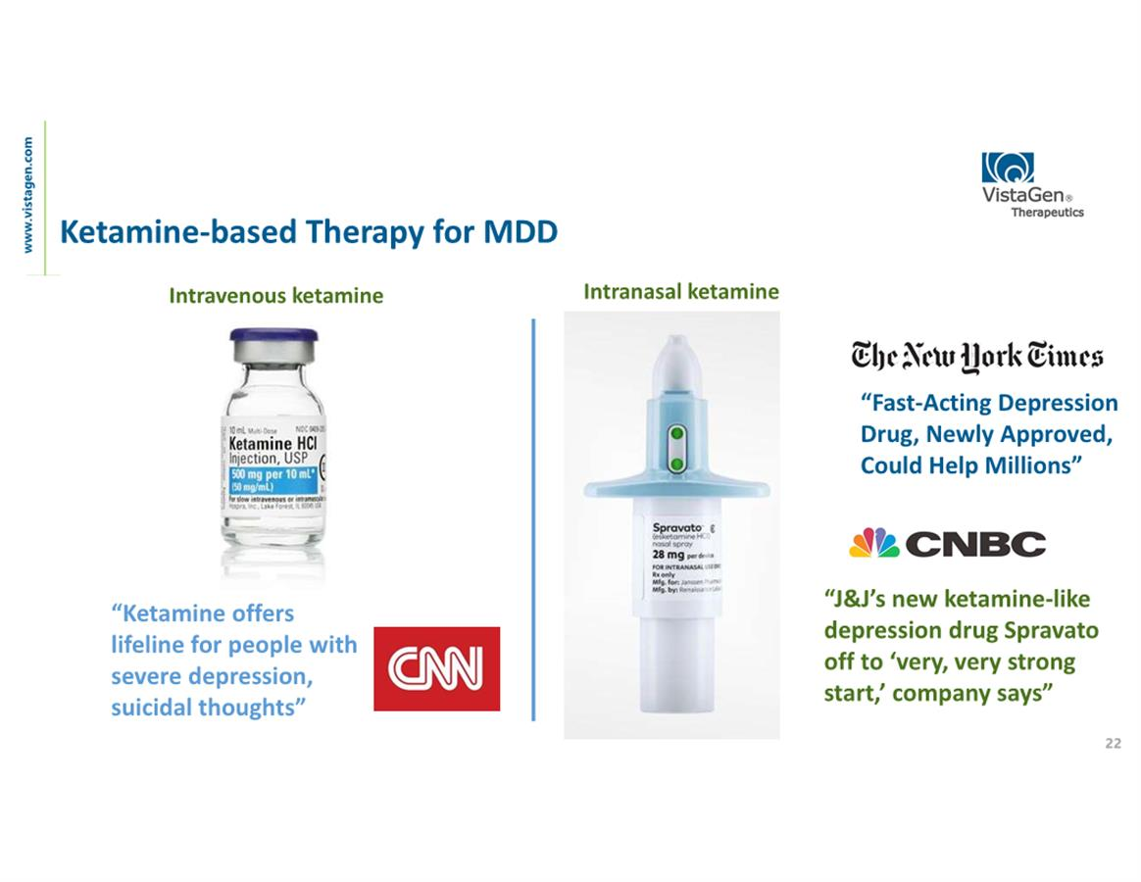

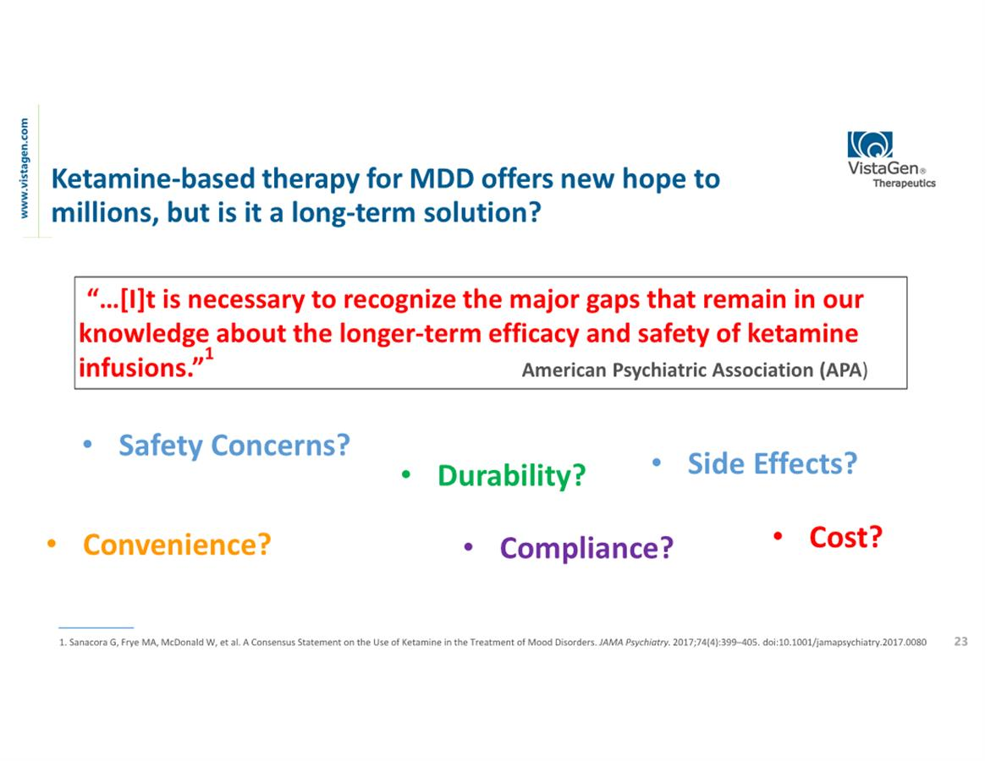

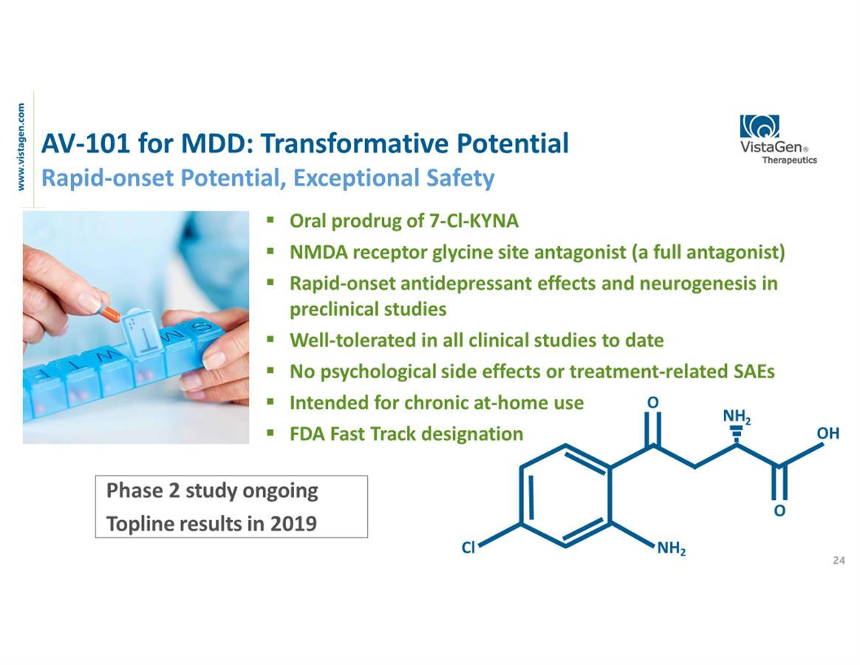

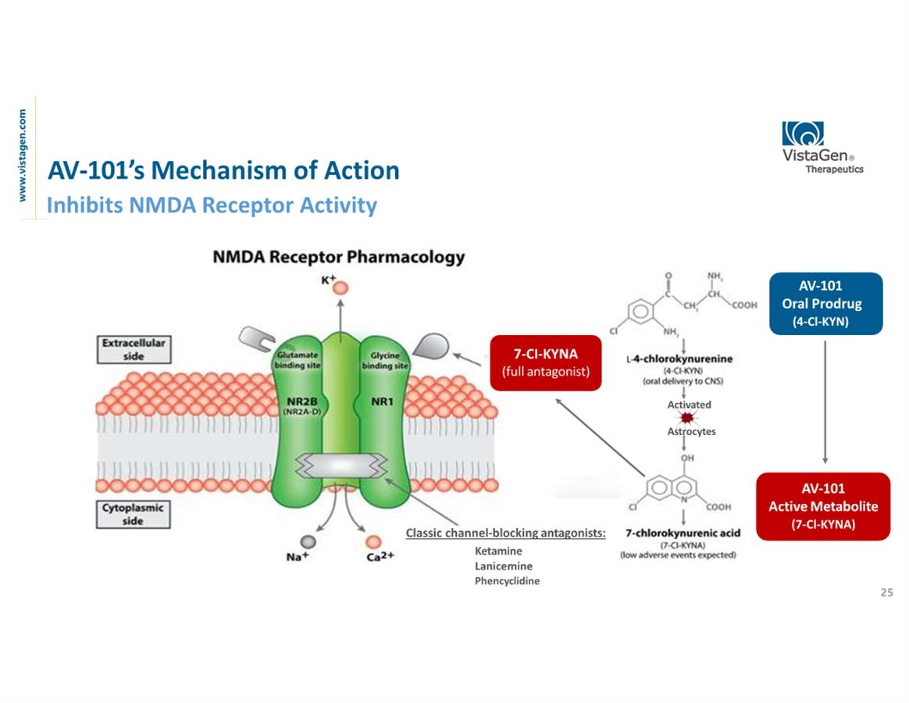

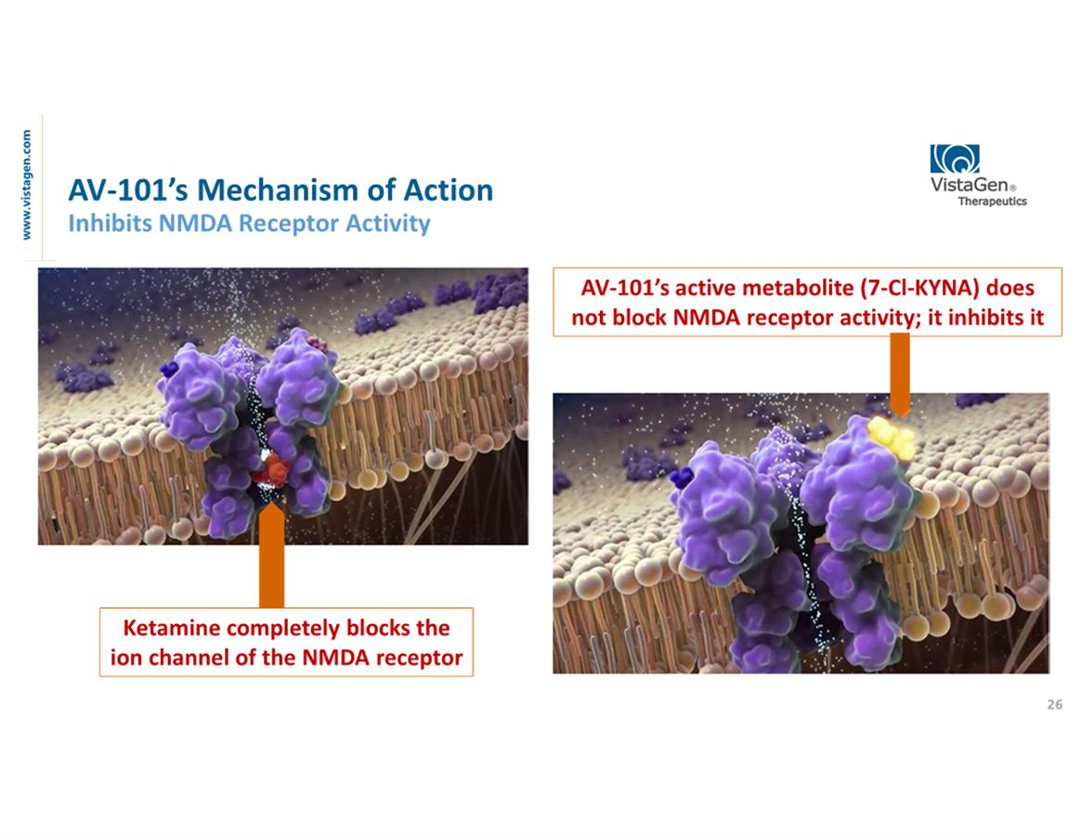

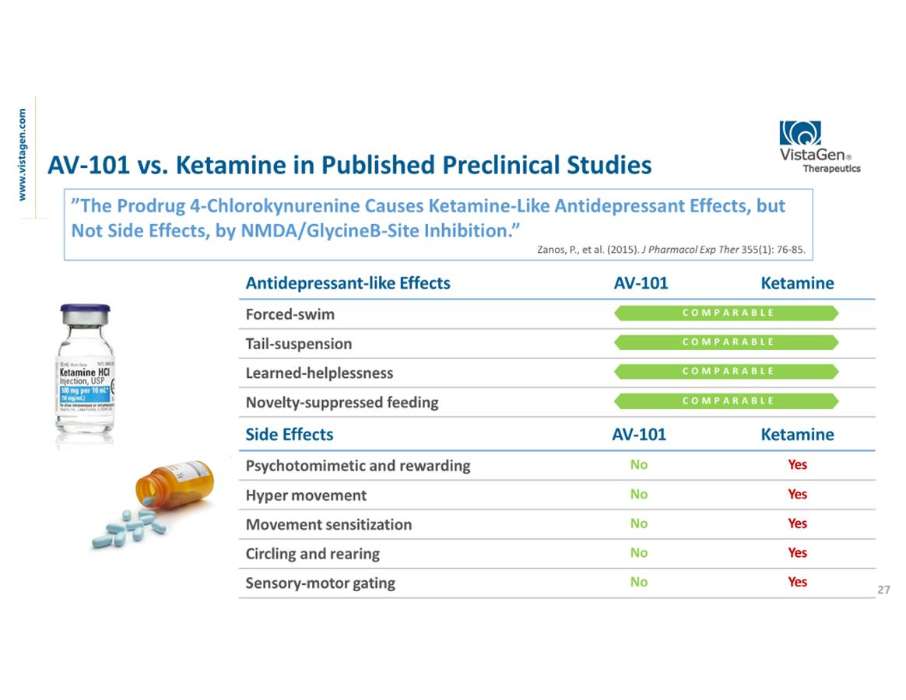

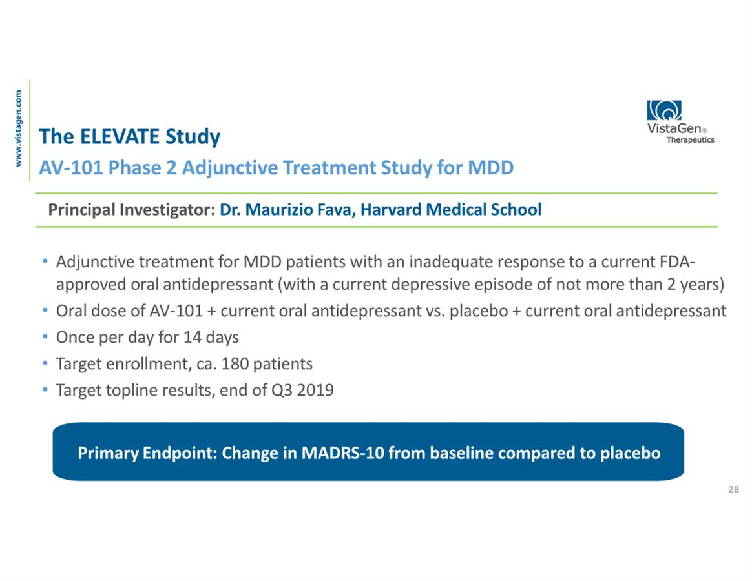

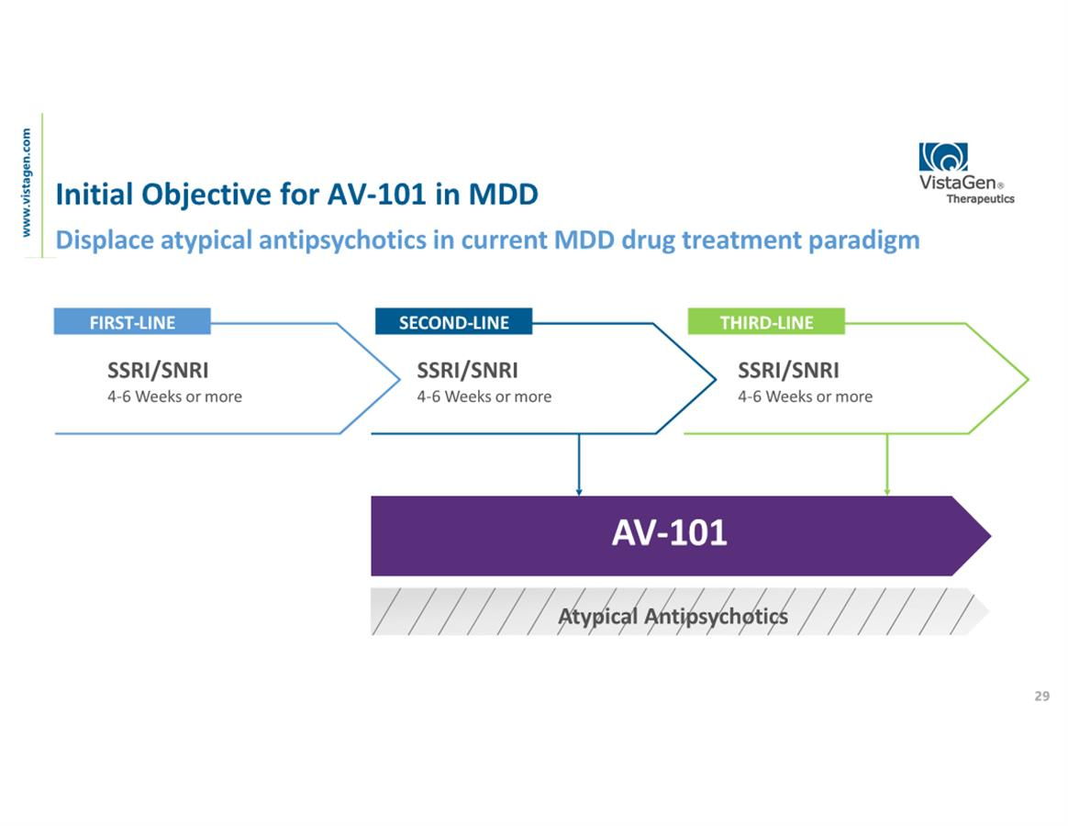

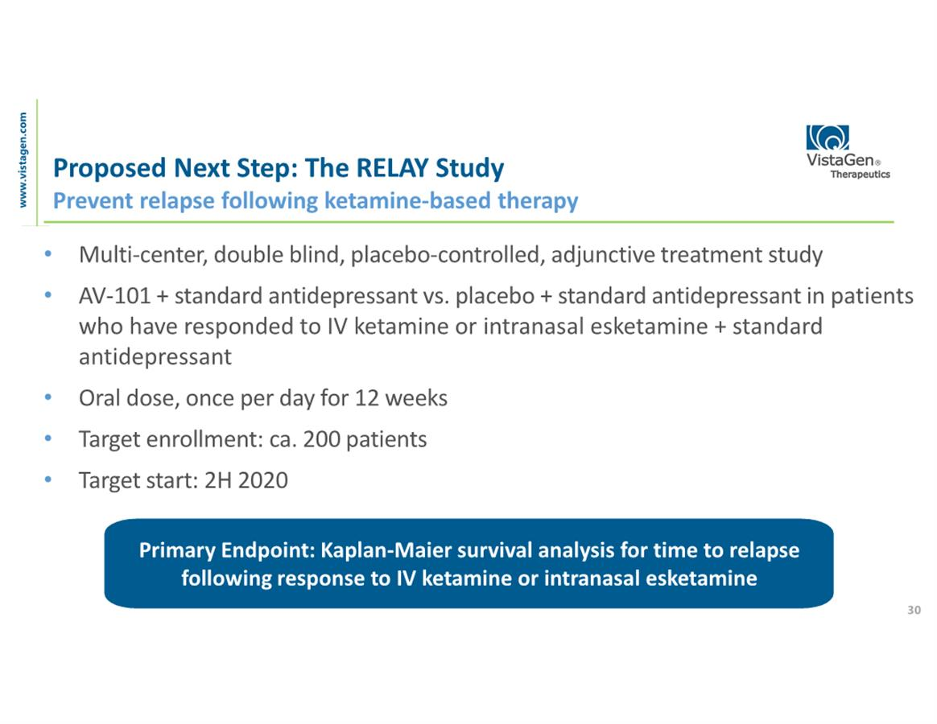

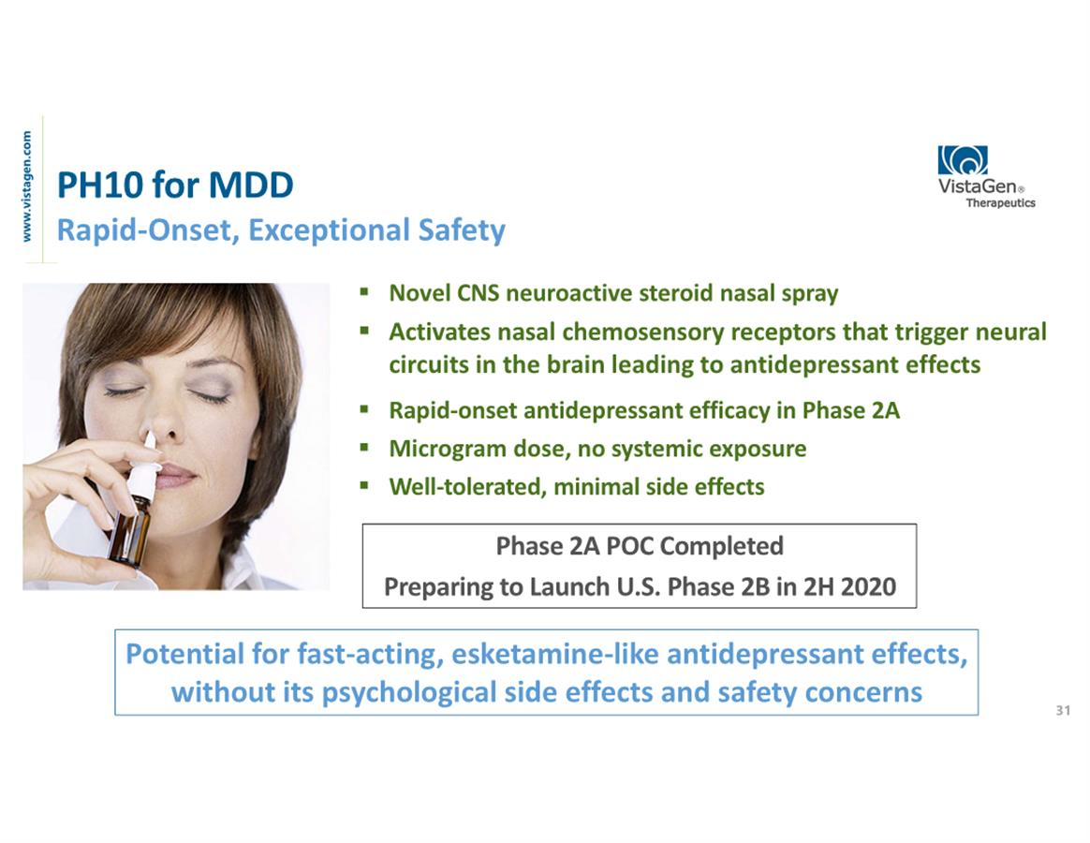

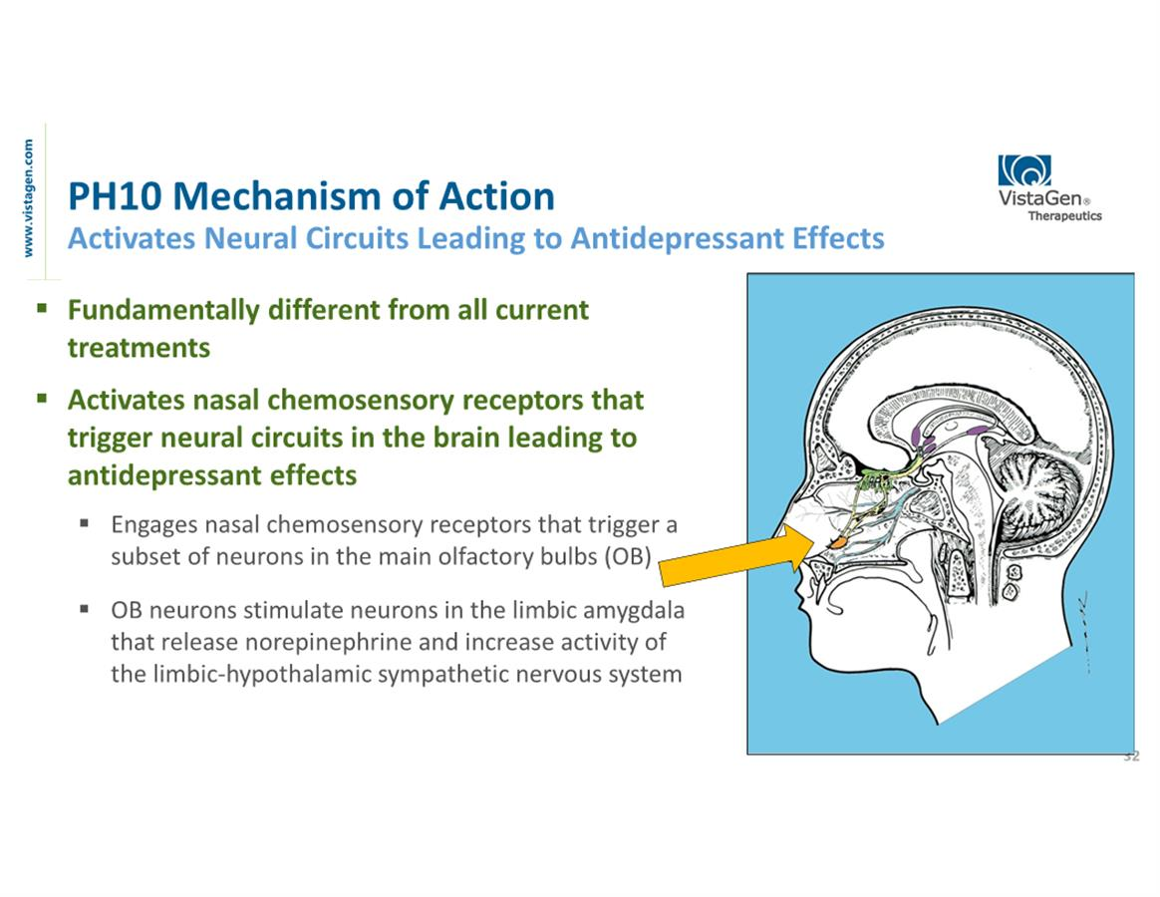

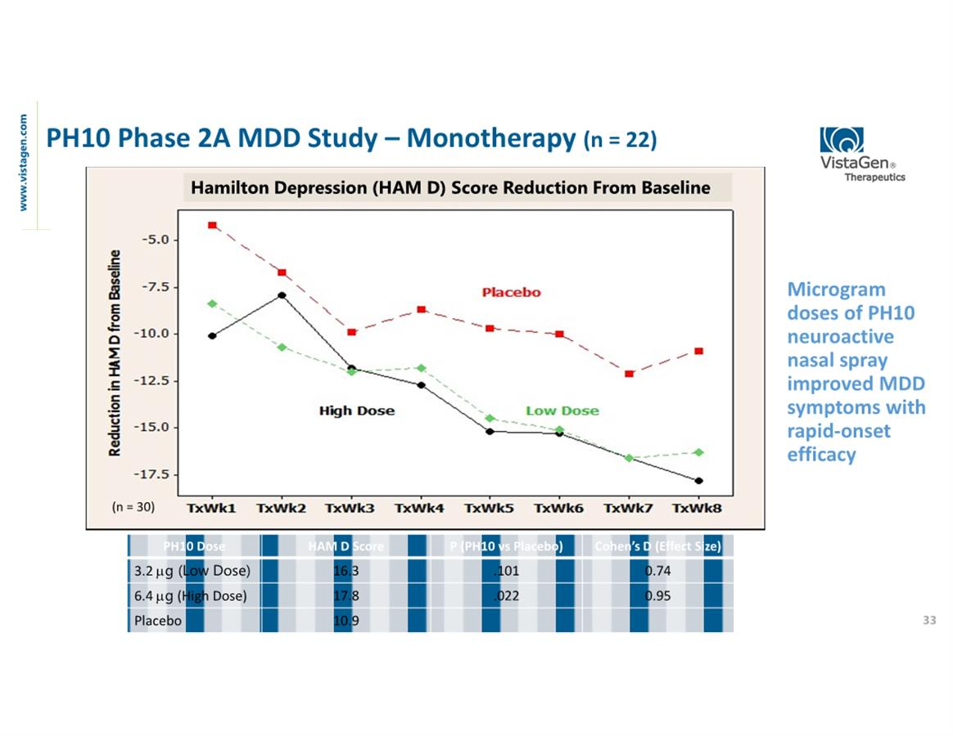

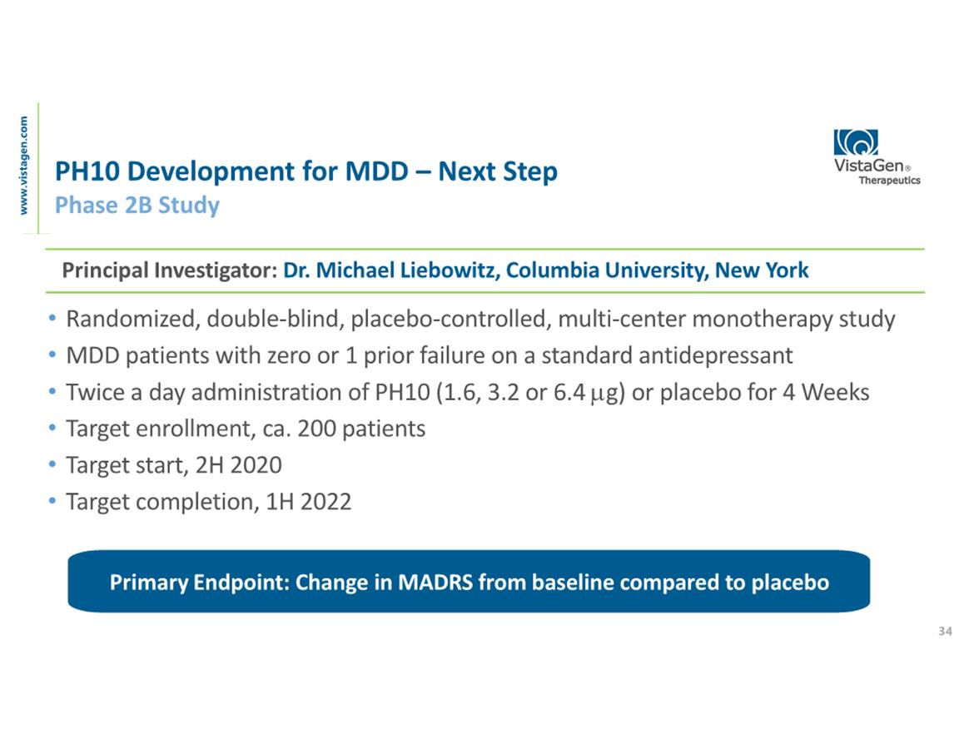

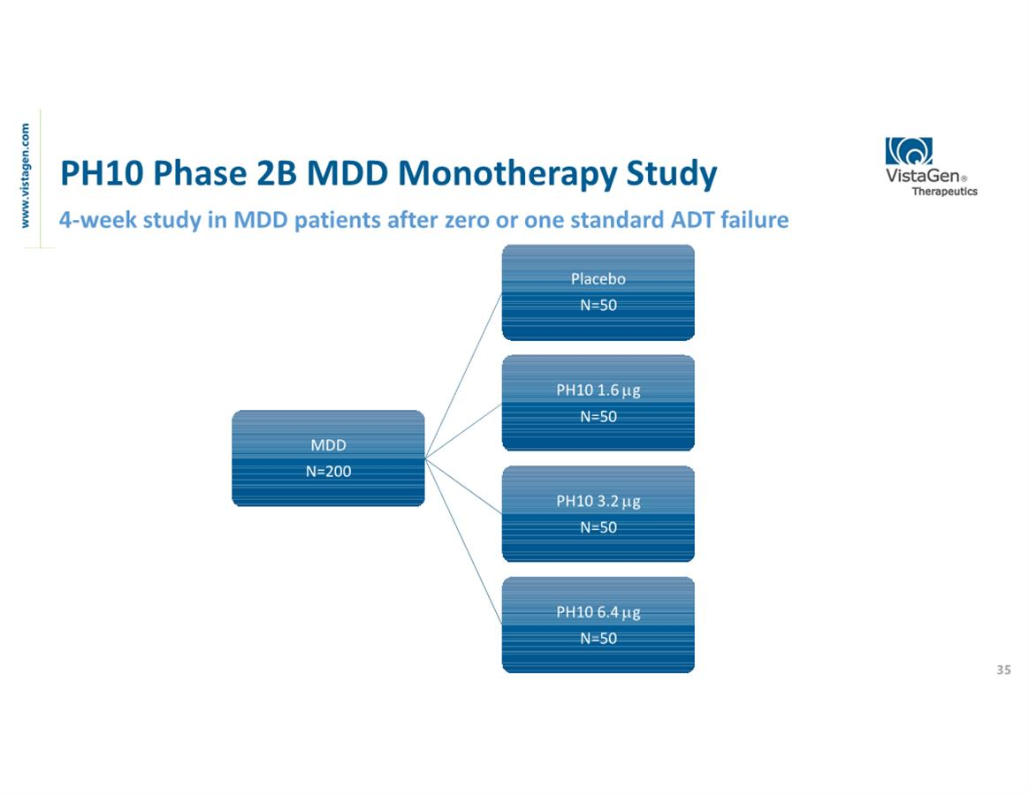

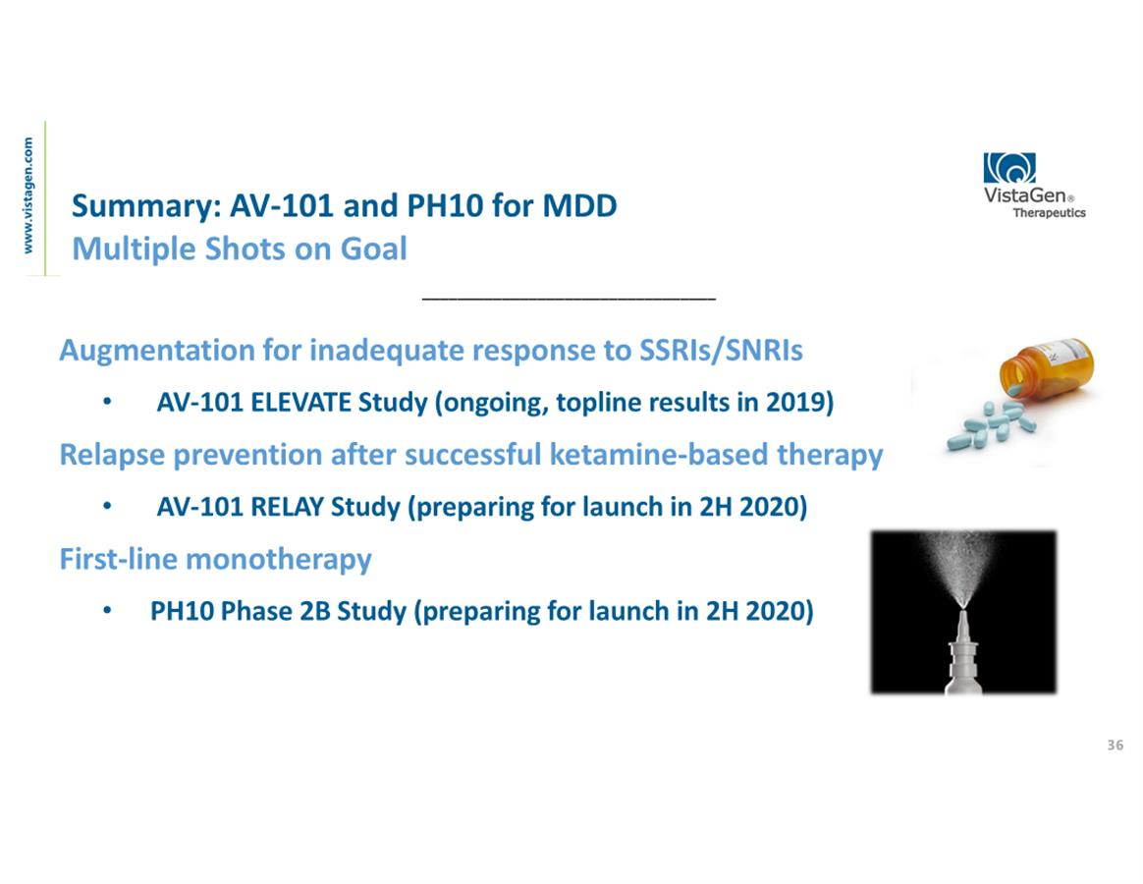

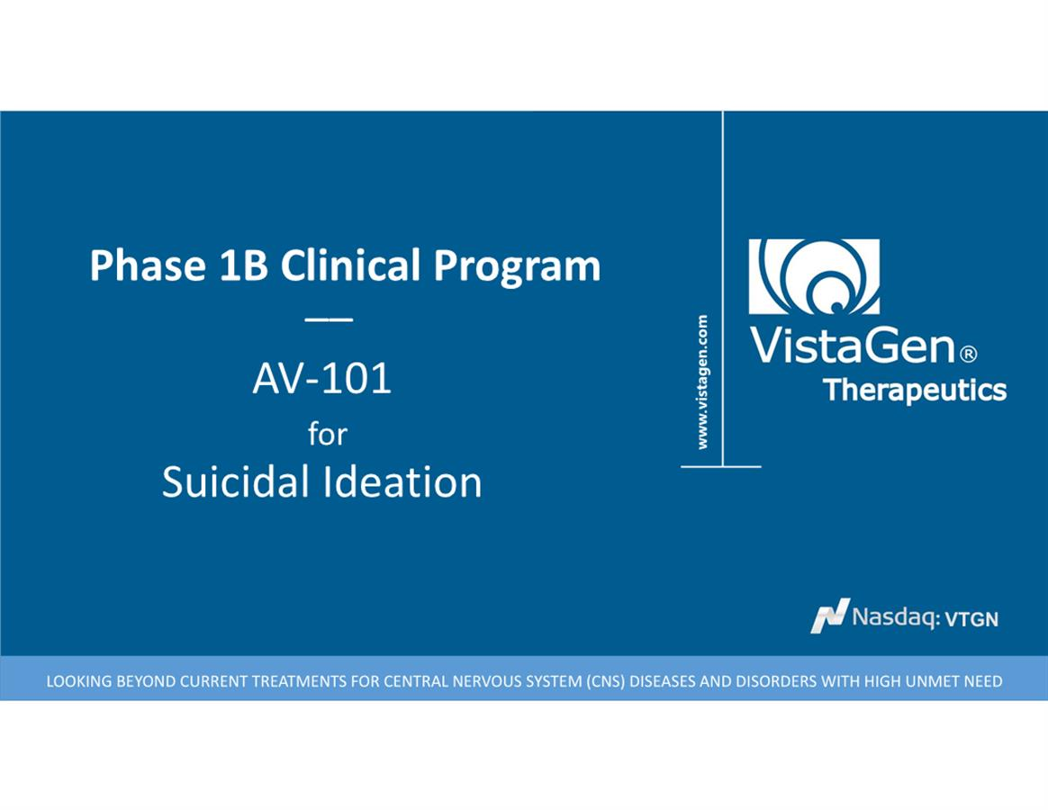

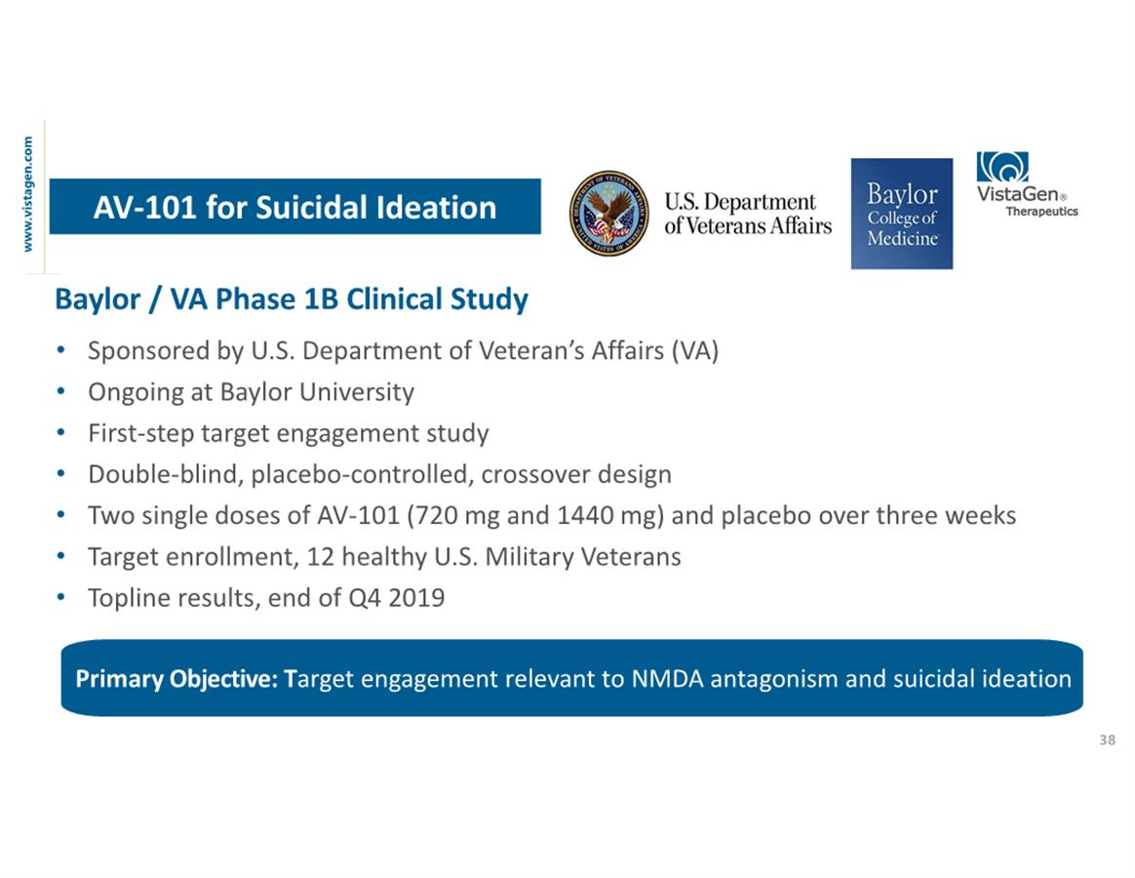

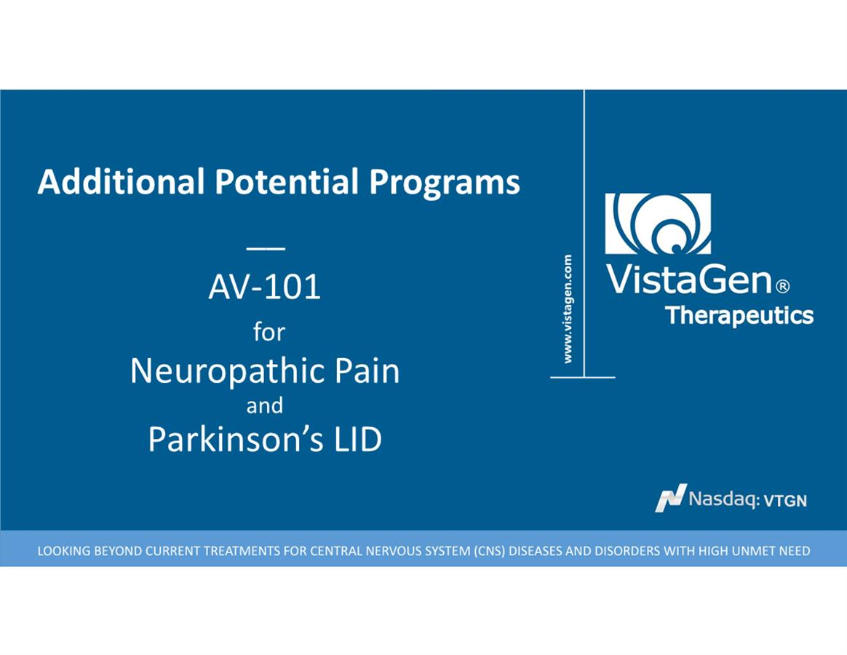

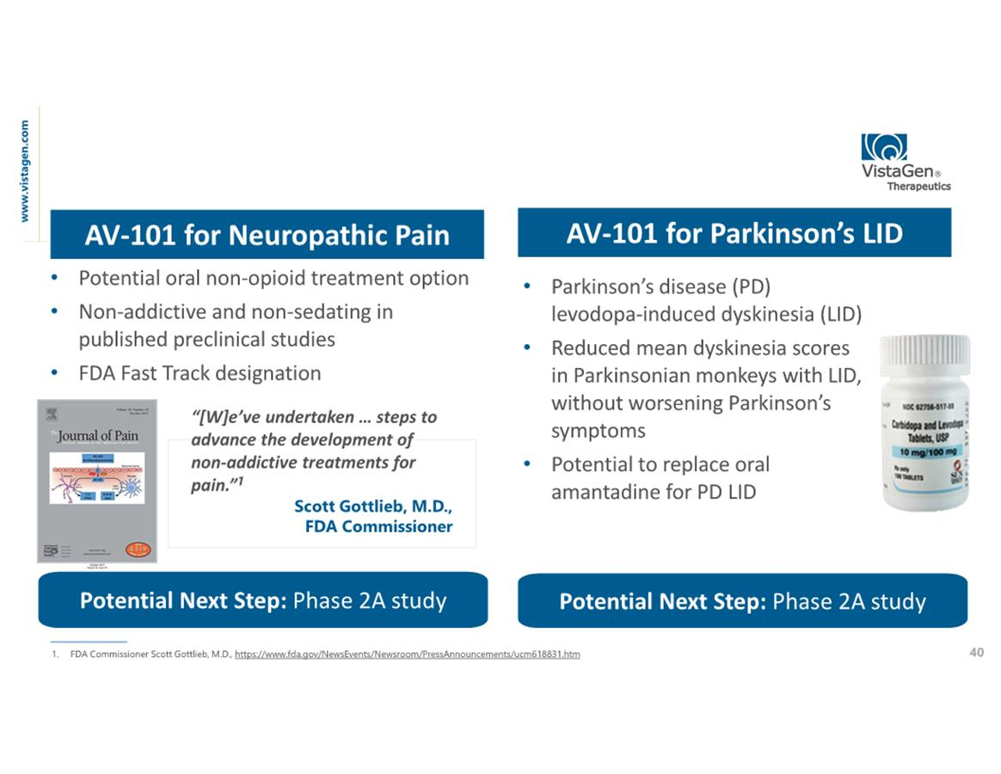

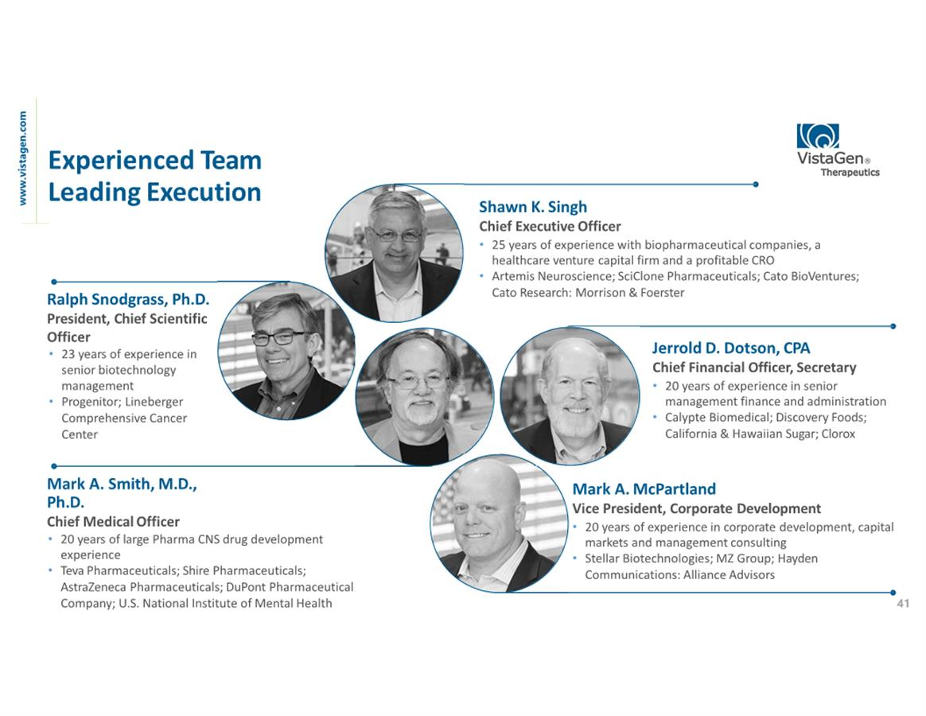

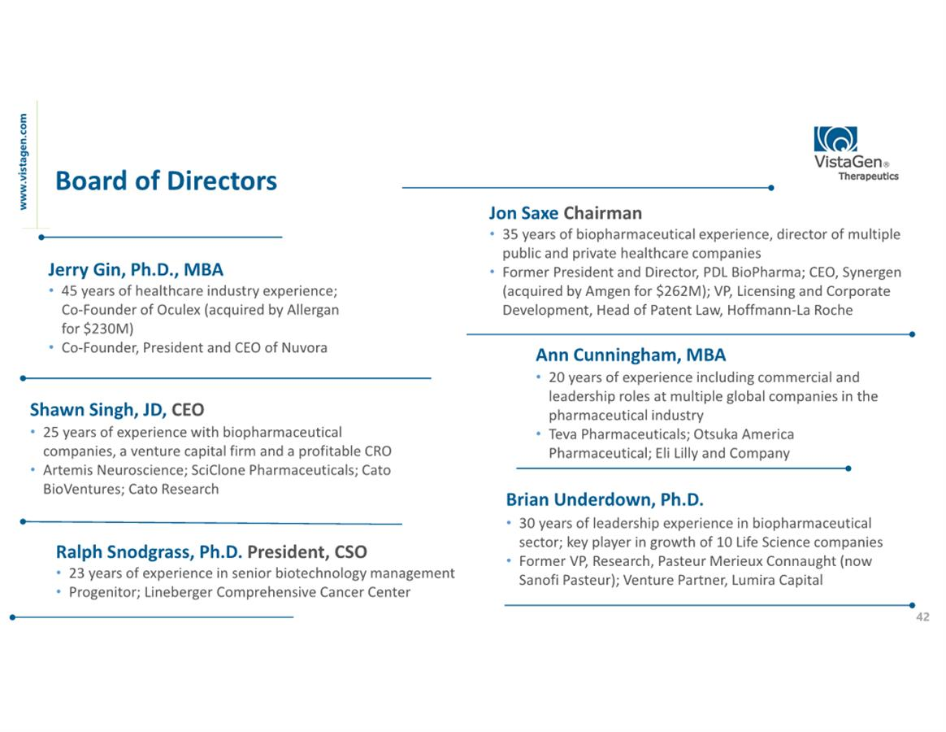

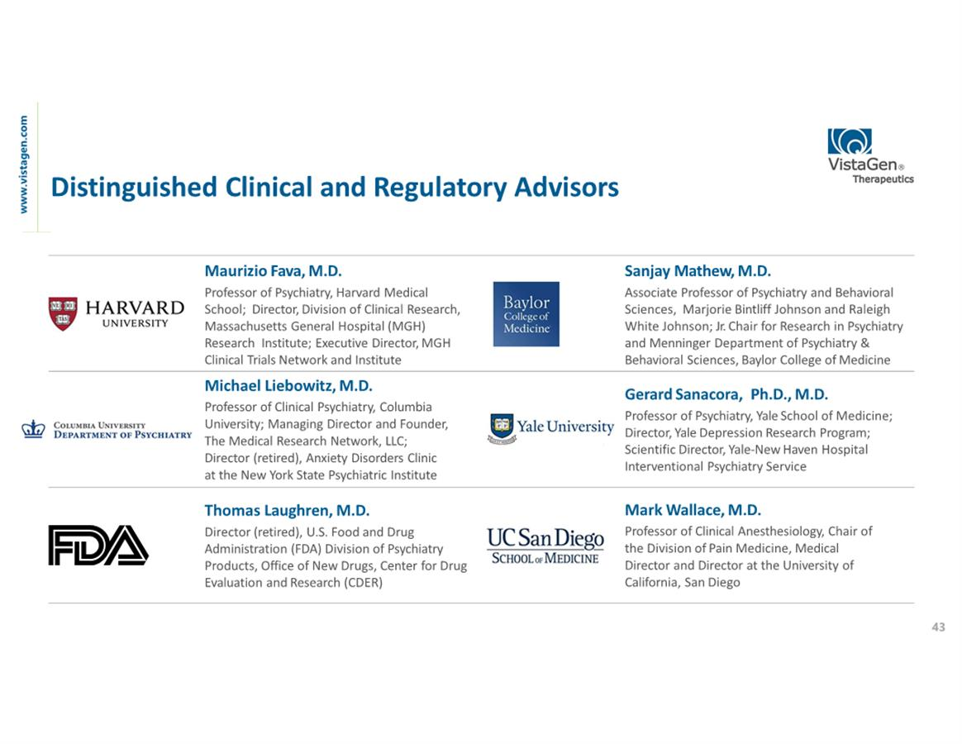

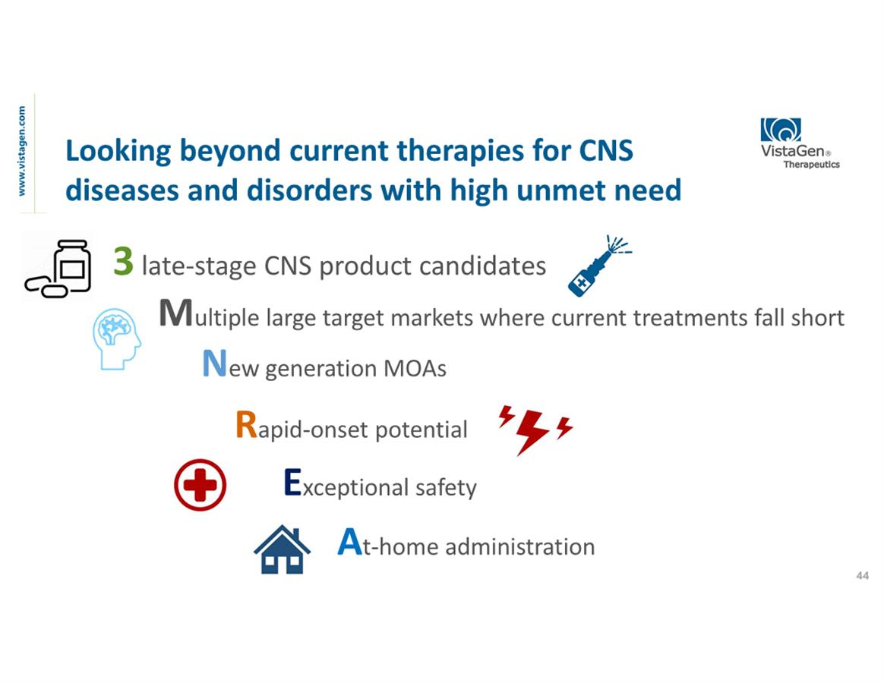

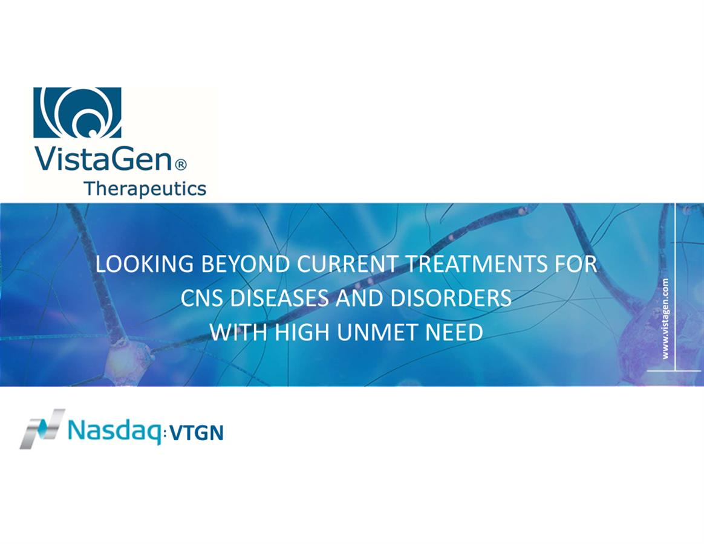

Exhibit 99.2



VistaGen Reports Top Line Results from NIMH’s Exploratory Study of
AV-101 Monotherapy for Treatment-Resistant Depression

SOUTH SAN FRANCISCO, Calif., May 2, 2019 - VistaGen Therapeutics (NASDAQ: VTGN), a clinical-stage biopharmaceutical company developing new generation medicines for depression, social anxiety disorder and other central nervous system (CNS) diseases and disorders with high unmet need, today announced top line results from an exploratory Phase 2 clinical study of AV-101 as a monotherapy (which is treatment without a concurrent FDA-approved antidepressant) in patients with treatment-resistant depression (TRD). In the 19-patient study sponsored and conducted by the U.S National Institute of Mental Health (NIMH), AV-101 did not demonstrate significant separation from placebo on the primary outcome measure, the change from baseline in the Hamilton Depression Rating Scale (HDRS) total score compared to placebo. A key objective of the study was to evaluate safety in TRD patients, and, consistent with VistaGen’s Phase 1 studies, AV-101 was very well-tolerated with no ketamine-like psychological side effects or safety concerns and no treatment-related serious adverse events.

“Although this small NIMH monotherapy study did not meet its primary endpoint in this very difficult-to-treat TRD population, we remain firmly committed to developing novel treatments for those suffering from MDD. In contrast to the NIMH study, our ongoing ELEVATE study is designed to evaluate AV-101 as a novel adjunctive therapy in a significantly different population of MDD patients, namely those whose current depressive episode is less than 2 years. ELEVATE is on track and we will announce top line results later this year,” stated Shawn Singh, VistaGen’s CEO. “We greatly appreciate our long-standing relationship with the NIMH and are grateful for their efforts conducting and providing financial sponsorship for this exploratory study. In addition, we appreciate receiving additional positive safety data from this study and are encouraged that AV-101 was very well-tolerated, without any troubling side effects or safety concerns, in TRD patients suffering from one of the most debilitating forms of depression.”

The double-blind, placebo-controlled, crossover study was conducted at the National Institutes of Health (NIH) Clinical Center in Bethesda, Maryland. Patients with TRD were required to taper off all antidepressant medications, including all adjunctive atypical antipsychotics, for 2 to 5 weeks, and then remain medication free for an additional 2 weeks prior to dosing. Patients were then randomized to receive either a daily dose of AV-101 for 14 days (1080 mg for 7 days followed by 1440 mg for 7 days) or placebo for 14 days. After a 2- to 3-week washout period following the initial 14-day dosing phase, patients were crossed over to the opposite arm of the study.

People who are currently struggling with Major Depressive Disorder (MDD) are considered to have TRD if they have not responded adequately to at least 2 different antidepressants of adequate dose and duration in their current depressive episode. Patients in this NIMH study had serious, long-lasting episodes of depression. The average length of the current depressive episode of the TRD patients in this study was 8.6 years. Prior to participating in this study, patients had undergone an average of 7.8 attempts to treat their TRD over their lifetime, using multiple different antidepressant drugs.

The NIMH plans to present detailed results from this study at a scientific meeting later this year.

About Major Depressive Disorder (MDD)
Major depressive disorder is a serious neurobiologically-based mood disorder, affecting approximately 16 million adults in the U.S., according to the NIMH. Individuals diagnosed with MDD exhibit depressive symptoms, such as a depressed mood or a loss of interest or pleasure in daily activities, for more than a two-week period, as well as impaired social, occupational, educational or other important functioning which has a negative impact on their quality of life. Globally, MDD affects nearly 300 million people of all ages and is the leading cause of disability worldwide.

About Treatment-Resistant Depression (TRD)
People who are currently struggling with MDD are considered to have TRD if they have not responded adequately to at least 2 different antidepressants of adequate dose and duration in their current depressive episode. TRD is a chronic condition that places an ongoing emotional, functional, and economic burden on the individual, their loved ones and society.

About AV-101
AV-101 (4-Cl-KYN) is an investigational, oral NMDA receptor glycine site antagonist with potential to be a treatment for multiple CNS indications with high unmet need. AV-101 is currently in a Phase 2 clinical study (the ELEVATE study) for adjunctive treatment of MDD and a first-step target engagement study in healthy volunteer U.S. military Veterans. The FDA has granted Fast Track designation for development of AV-101 as both a potential adjunctive treatment for MDD and as a non-opioid treatment for neuropathic pain.

About ELEVATE
Among VistaGen’s core objectives for AV-101 is to displace atypical antipsychotics, such as aripiprazole and brexpiprazole, in the current MDD drug treatment paradigm. The Company’s ELEVATE study is designed to advance on that objective. The ELEVATE study is an ongoing randomized, double-blind, placebo-controlled, multi-center U.S. Phase 2 clinical study to evaluate the efficacy and safety of adjunctive use of AV-101 in adult MDD patients who have an inadequate response to standard FDA-approved antidepressant therapy, either a selective serotonin reuptake inhibitor (SSRI), a serotonin norepinephrine reuptake inhibitor (SNRI), or bupropion. Only patients whose current depression episode is less than 2 years will be randomized to receive either AV-101 or placebo, in addition to their ongoing standard FDA-approved antidepressant. The primary endpoint of the study is the change from baseline on the Montgomery-Åsberg Depression Rating Scale (MADRS) total score.

About VistaGen

VistaGen Therapeutics is a clinical-stage biopharmaceutical company developing new generation medicines for depression, social anxiety disorder and other CNS diseases and disorders with high unmet need. VistaGen’s current CNS pipeline includes three drug candidates, AV-101, PH10, and PH94B, with potential for at-home use, rapid-onset therapeutic benefits and exceptional safety. For more information, please visit www.vistagen.com and connect with VistaGen on Twitter, LinkedIn and Facebook.

Forward-Looking Statements
This release contains various statements concerning VistaGen's future expectations, plans and prospects, including without limitation, our expectations regarding development and commercialization of our drug candidates, including AV-101 for MDD, all of which constitute forward-looking statements for the purposes of the safe harbor provisions under the Private Securities Litigation Reform Act of 1995. These forward-looking statements are neither promises nor guarantees of future performance and are subject to a variety of risks and uncertainties, many of which are beyond our control, and may cause actual results to differ materially from those contemplated in these forward-looking statements. Among these risks is the possibility that (i) we may encounter unexpected adverse events in patients during our clinical development of any product candidate that cause us to discontinue further development, (ii) we may not be able to successfully demonstrate the safety and efficacy of our product candidates at each stage of clinical development, (iii) success in preclinical studies or in early-stage clinical trials may not be repeated or observed in ongoing or future studies, and ongoing or future preclinical and clinical results may not support further development of, or be sufficient to gain regulatory approval to market our drug candidates, including AV-101, (iv) decisions or actions of regulatory agencies may negatively affect the progress of, and our ability to proceed with, further clinical studies or to obtain marketing approval for our drug candidates, (v) we may not be able to obtain or maintain adequate intellectual property protection and other forms of marketing and data exclusivity for our product candidates, (vi) we may not have access to or be able to secure substantial additional capital to support our operations, including our ongoing clinical development activities, and (vii) we may encounter technical and other unexpected hurdles in the manufacturing and development of any of our product candidates. Certain other risks are more fully discussed in the section entitled "Risk Factors" in our most recent annual report on Form 10-K, and subsequent quarterly reports on Form 10-Q, as well as discussions of potential risks, uncertainties, and other important factors in our other filings with the Securities and Exchange Commission (SEC). Our SEC filings are available on the SEC's website at www.sec.gov. In addition, any forward-looking statements represent our views only as of the issuance of this release and should not be relied upon as representing our views as of any subsequent date. We explicitly disclaim any obligation to update any forward-looking statements.

Company Contact
Mark A. McPartland
VistaGen Therapeutics Inc.
Phone: +1 (650) 577-3600
Email: IR@vistagen.com

Investor Contact
Valter Pinto / Allison Soss
KCSA Strategic Communications
Phone: +1 (212) 896-1254/+1 (212) 896-1267
Email: VistaGen@KCSA.com

Media Contact
Caitlin Kasunich / Lisa Lipson
KCSA Strategic Communications
Phone: +1 (212) 896-1241/+1 (508) 843-6428
Email: VistaGen@KCSA.com

###

