UNITED STATES

SECURITIES AND EXCHANGE COMMISSION

Washington, D.C. 20549

FORM 8-K

CURRENT REPORT

PURSUANT TO SECTION 13 OR 15(d) of the SECURITIES EXCHANGE ACT OF 1934

Date of Report (Date of earliest event reported): September 14, 2018

VistaGen Therapeutics, Inc.

(Exact name of registrant as specified in its charter)

NEVADA

(State or other jurisdiction of incorporation)

001-37761

(Commission File Number)

20-5093315

(IRS Employer Identification Number)

343 Allerton Ave.

South San Francisco, California 94090

(Address of principal executive offices)

(650) 577-3600

(Registrant’s telephone number, including area code)

Not Applicable

(Former name or former address, if changed since last report)

Check the appropriate box below if the Form 8-K filing is intended to simultaneously satisfy the filing obligation of the registrant under any of the following provisions:

- Written communications pursuant to Rule 425 under the Securities Act (17 CFR 230.425)

- Soliciting material pursuant to Rule 14a-12 under the Exchange Act (17 CFR 240.14a -12)

- Pre-commencement communications pursuant to Rule 14d-2(b) under the Exchange Act (17 CFR 240.14d -2(b))

- Pre-commencement communications pursuant to Rule 13e-4(c) under the Exchange Act (17 CFR 240.13e -4(c))

Item 5.07 Submission of Matters to a Vote of Security Holders.

On September 14, 2018, VistaGen Therapeutics, Inc. (the “Company”) held its 2018 Annual Meeting of Stockholders (the “Annual Meeting”). The matters voted upon at the Annual Meeting and the results of the voting are set forth below.

Proposal No. 1- Election of Directors
Director Nominees |  |  | For |  | Withheld
 | Jon S. Saxe |  | 4,915,906 |  | 97,194
 | Shawn K. Singh | 4,899,517 |  | 113,583
 | H. Ralph Snodgrass | 4,885,209 |  | 127,891
 | Brian J. Underdown | 4,876,074 |  | 137,026
 | Jerry B. Gin | 4,852,173 |  | 160,927

The Company’s Directors are elected by the affirmative vote of a plurality of the votes cast. Accordingly, the Company's stockholders elected each of the nominees named above to serve on the Company's Board of Directors until the 2019 Annual Meeting of Stockholders, or until their successors are elected and qualified.

Proposal No. 2- Ratification of Appointment of Auditors
 | For |  | Against |  | Abstain
 | 15,901,502 |  | 902,448 | 208,892

The vote required to approve this proposal was the affirmative vote of a majority of the votes cast on the proposal. Accordingly, stockholders ratified the appointment of OUM & Co, LLP as the Company’s registered independent public accounting firm for the fiscal year ending March 31, 2019.

For more information about the foregoing proposals, please review the Company’s definitive proxy statement, filed with the Securities and Exchange Commission on July 27, 2018.

Item 7.01 Regulation FD Disclosure.

On September 14, 2018, the Company utilized a new corporate presentation at the Annual Meeting (the “Corporate Presentation”). A copy of the Corporate Presentation is attached hereto as Exhibit 99.1.

The information in this Item 7.01 of this Current Report on Form 8-K, including the information set forth in Exhibit 99.1, is being furnished and shall not be deemed “filed” for purposes of Section 18 of the Securities Exchange Act of 1934, as amended (the “Exchange Act”), nor shall Exhibit 99.1 filed herewith be deemed incorporated by reference in any filing under the Securities Act of 1933, as amended, or the Exchange Act, except as shall be expressly set forth by specific reference in such a filing.

In addition, this Current Report on Form 8-K and the exhibit(s) attached hereto may contain, among other things, certain forward-looking statements within the meaning of the Private Securities Litigation Reform Act of 1995, including, without limitation, (i) statements with respect to the Company's plans, objectives, expectations and intentions; and (ii) other statements identified by words such as "may", "could", "would", "should", "believes", "expects", "anticipates", "estimates", "intends", "plans" or similar expressions. These statements are based upon the current beliefs and expectations of the Company's management and are subject to significant risks and uncertainties.

Item 9.01 Exhibits.

See Exhibit Index.

Signatures

Pursuant to the requirements of the Securities Exchange Act of 1934, the registrant has duly caused this report to be signed on its behalf by the undersigned thereunto duly authorized.

VistaGen Therapeutics, Inc.

Date: September 18, 2018 By: /s/ Shawn K. Singh

Shawn K. Singh

Chief Executive Officer

EXHIBIT INDEX

Exhibit Number |  |  | Description
 | 99.1 |  | Corporate Presentation, dated September 2018

Exhibit 99.1


-1-
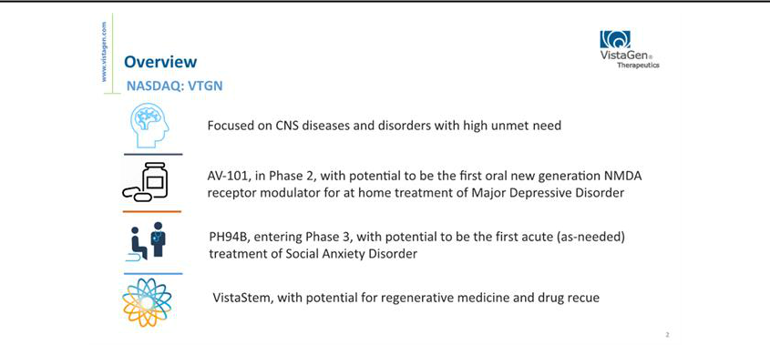

-2-
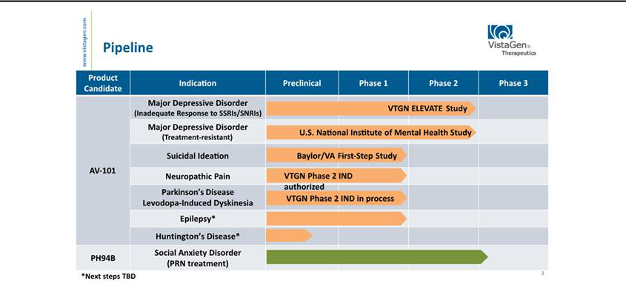

-3-

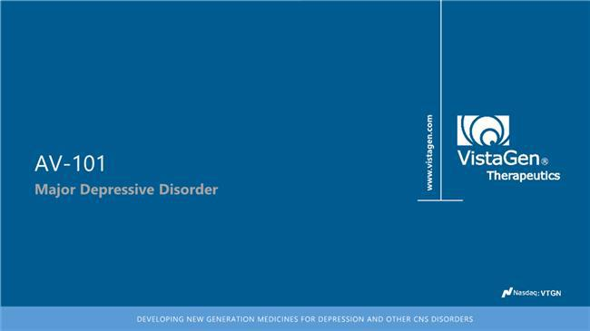

-4-
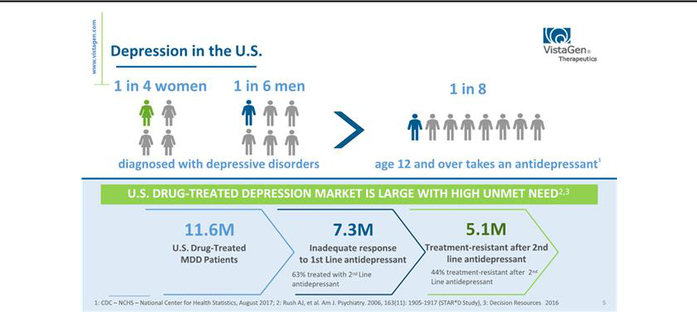

-5-
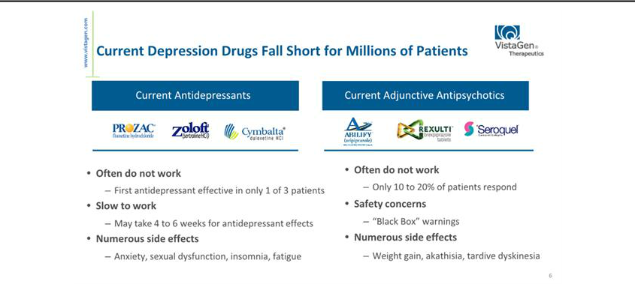

-6-

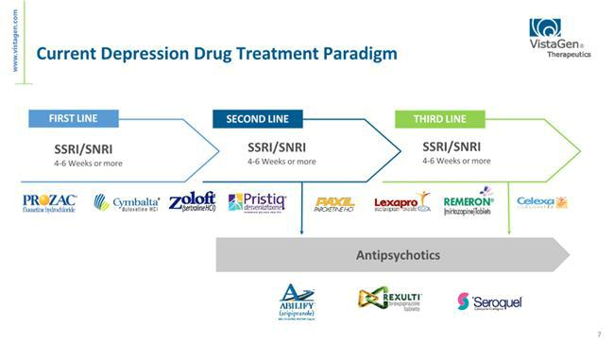

-7-
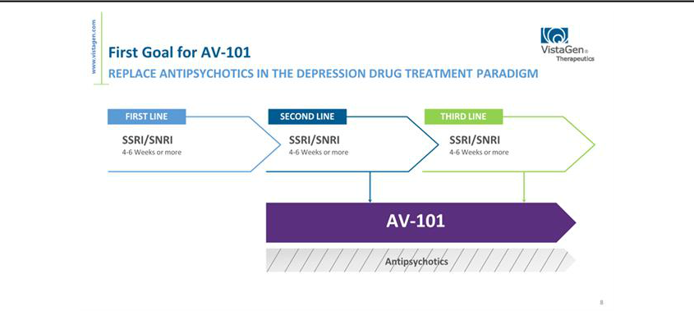

-8-
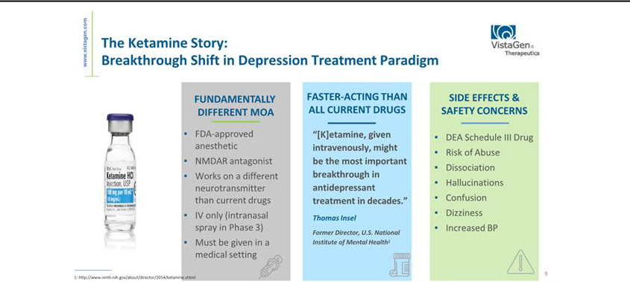

-9-



-10-
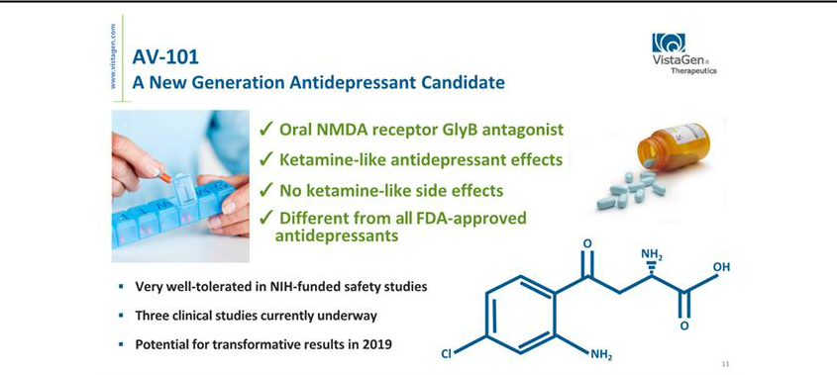

-11-
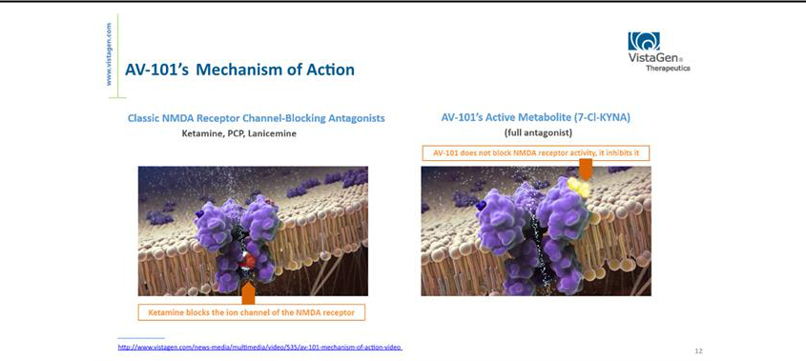

-12-

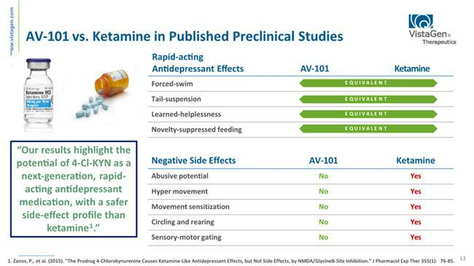

-13-
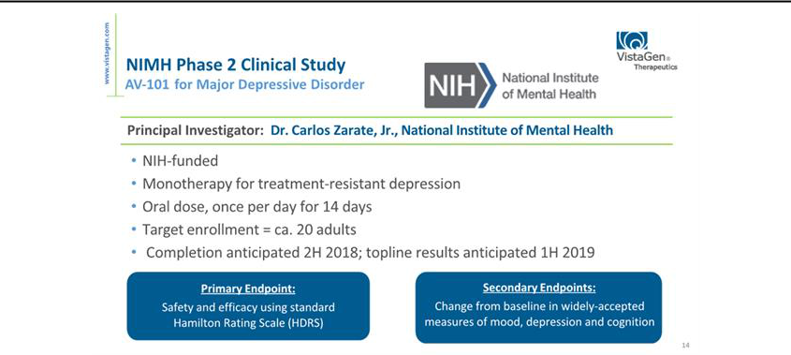

-14-
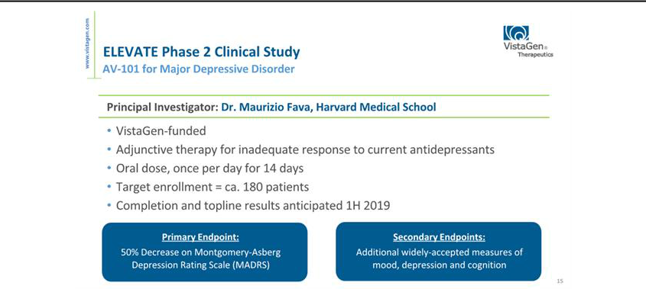

-15-

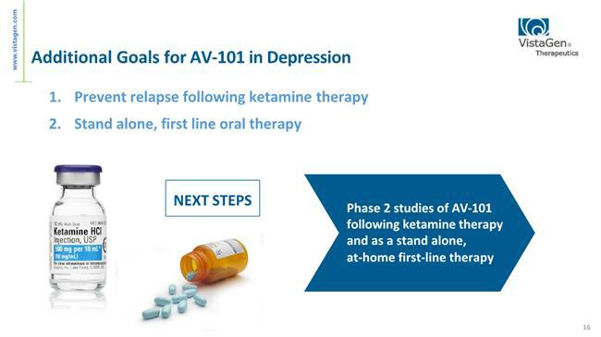

-16-
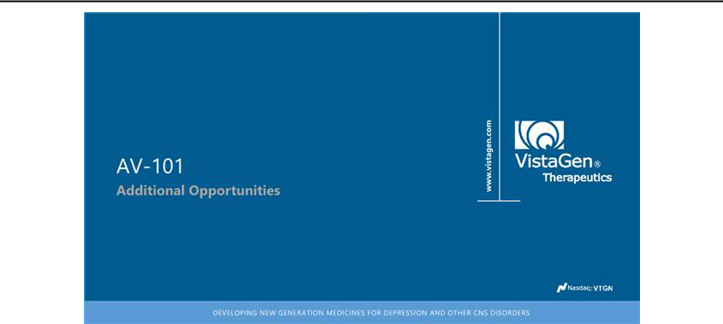

-17-
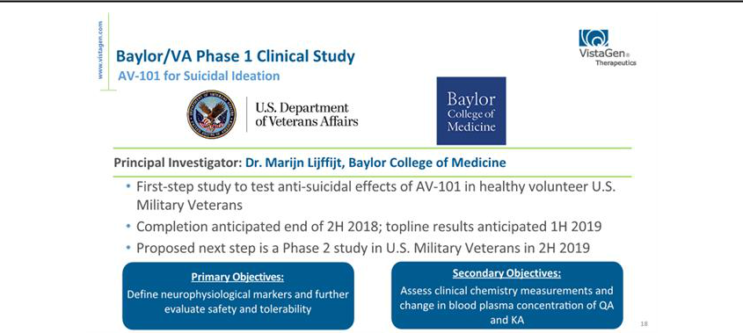

-18-

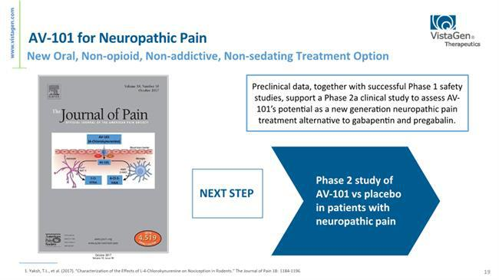

-19-
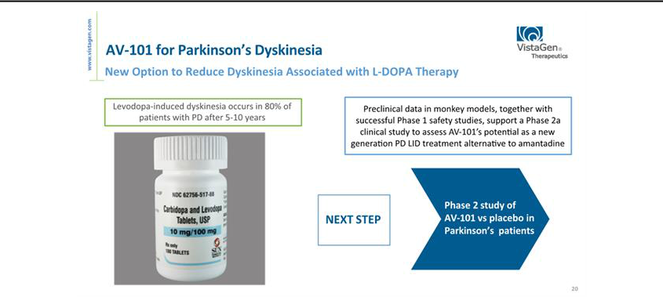

-20-
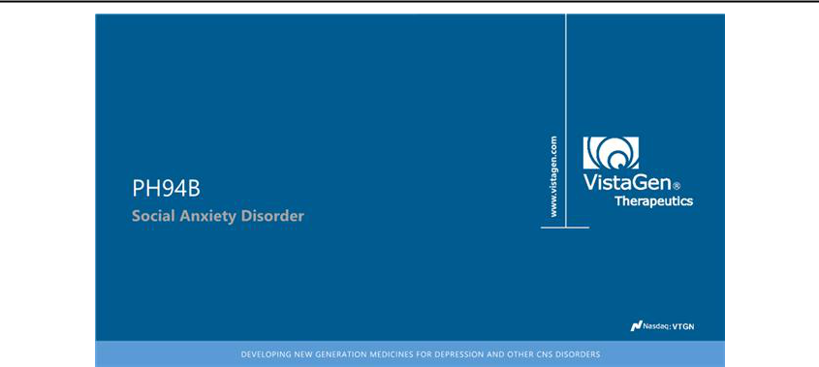

-21-

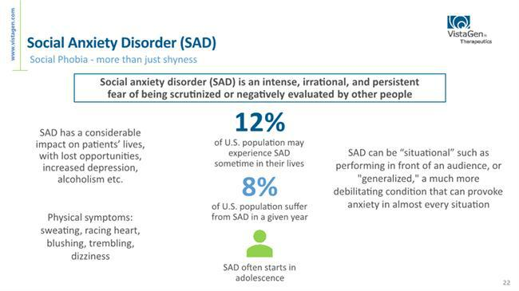

-22-
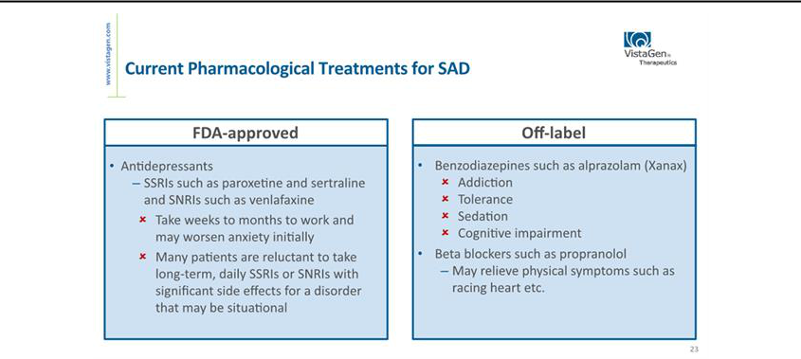

-23-
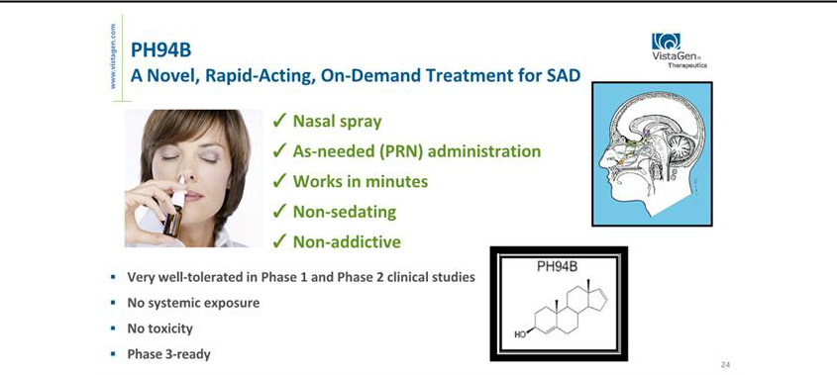

-24-

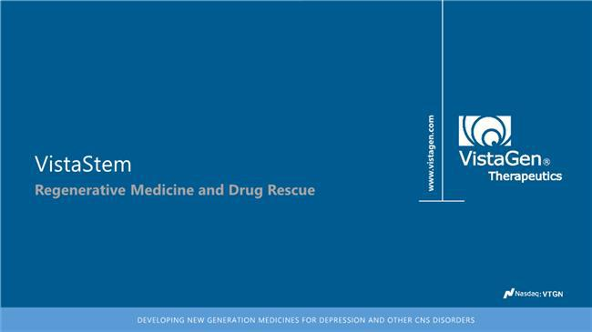

-25-
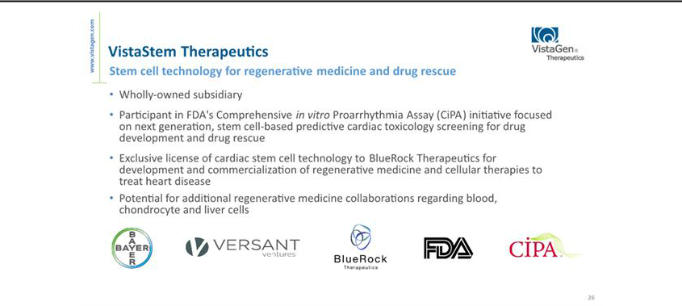

-26-
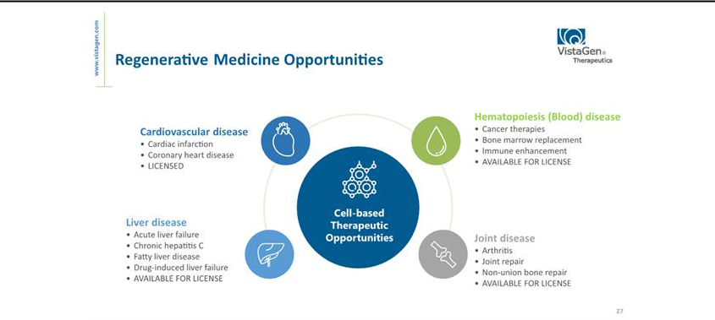

-27-

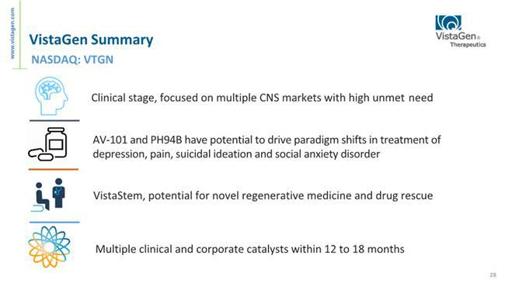

-28-


-29-

