UNITED STATES

SECURITIES AND EXCHANGE COMMISSION

Washington, D.C. 20549

FORM 8-K

CURRENT REPORT

PURSUANT TO SECTION 13 OR 15(d) of the SECURITIES EXCHANGE ACT OF 1934

Date of Report (Date of earliest event reported): March 13, 2019

VistaGen Therapeutics, Inc.

(Exact name of registrant as specified in its charter)

NEVADA

(State or other jurisdiction of incorporation)

001-37761

(Commission File Number)

20-5093315

(IRS Employer Identification Number)

343 Allerton Ave.

South San Francisco, California 94090

(Address of principal executive offices)

(650) 577-3600

(Registrant’s telephone number, including area code)

Not Applicable

(Former name or former address, if changed since last report)

Check the appropriate box below if the Form 8-K filing is intended to simultaneously satisfy the filing obligation of the registrant under any of the following provisions:

- Written communications pursuant to Rule 425 under the Securities Act (17 CFR 230.425)

- Soliciting material pursuant to Rule 14a-12 under the Exchange Act (17 CFR 240.14a -12)

- Pre-commencement communications pursuant to Rule 14d-2(b) under the Exchange Act (17 CFR 240.14d -2(b))

- Pre-commencement communications pursuant to Rule 13e-4(c) under the Exchange Act (17 CFR 240.13e -4(c))

Item 7.01 Regulation FD Disclosure.

On March 13, 2019, VistaGen Therapeutics, Inc. (the “Company”) began utilizing a new corporate presentation. A copy of the Corporate Presentation is attached hereto as Exhibit 99.1.

The information in this Item 7.01 of this Current Report on Form 8-K, including the information set forth in Exhibit 99.1, is being furnished and shall not be deemed “filed” for purposes of Section 18 of the Securities Exchange Act of 1934, as amended (the “Exchange Act”), nor shall Exhibit 99.1 filed herewith be deemed incorporated by reference in any filing under the Securities Act of 1933, as amended, or the Exchange Act, except as shall be expressly set forth by specific reference in such a filing.

Item 8.01 Other Events.

On March 13, 2019, the Company announced that the U.S. Patent and Trademark Office has issued a Notice of Allowance for U.S. Patent Application 15/812,599 related to certain methods of production for AV-101, the Company’s oral NMDA receptor glycine site antagonist in Phase 2 development for major depressive disorder. A copy of this press release is attached to this Current Report on Form 8-K as Exhibit 99.2.

Item 9.01 Financial Statements and Exhibits.

See Exhibit Index.

Signatures

Pursuant to the requirements of the Securities Exchange Act of 1934, the registrant has duly caused this report to be signed on its behalf by the undersigned thereunto duly authorized.

 | VistaGen Therapeutics, Inc.
Date: March 14, 2019 | By: | /s/ Shawn K. Singh
 |  | Shawn K. Singh
 |  | Chief Executive Officer

 |  |  |  | EXHIBIT INDEX
Exhibit No. |  |  |  | Description
 | 99.1 |  |  | Corporate Presentation, dated March 13, 2019
 | 99.2 |  |  | Press Release issued by VistaGen Therapeutics, Inc., dated March 13, 2019

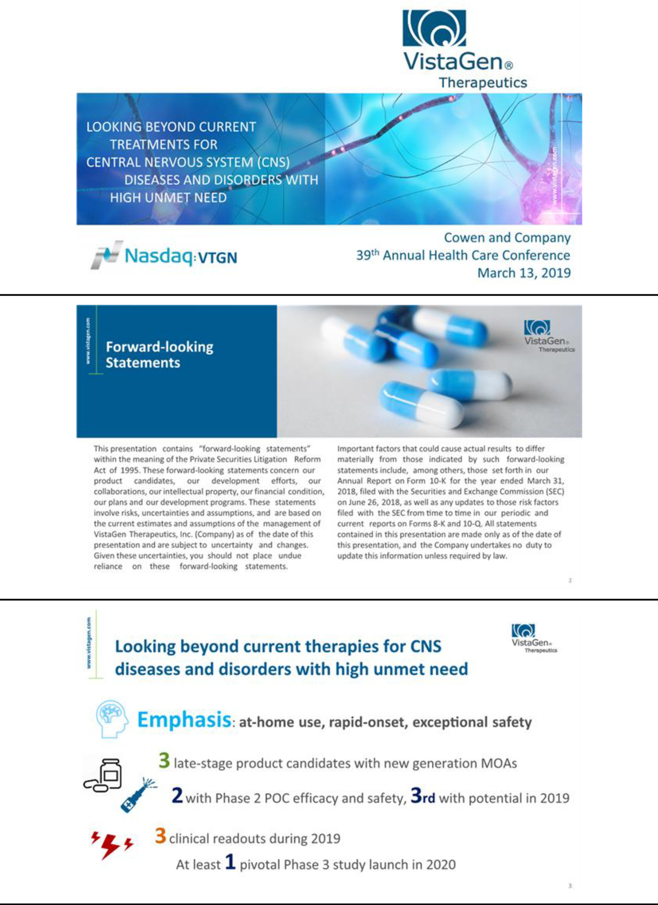

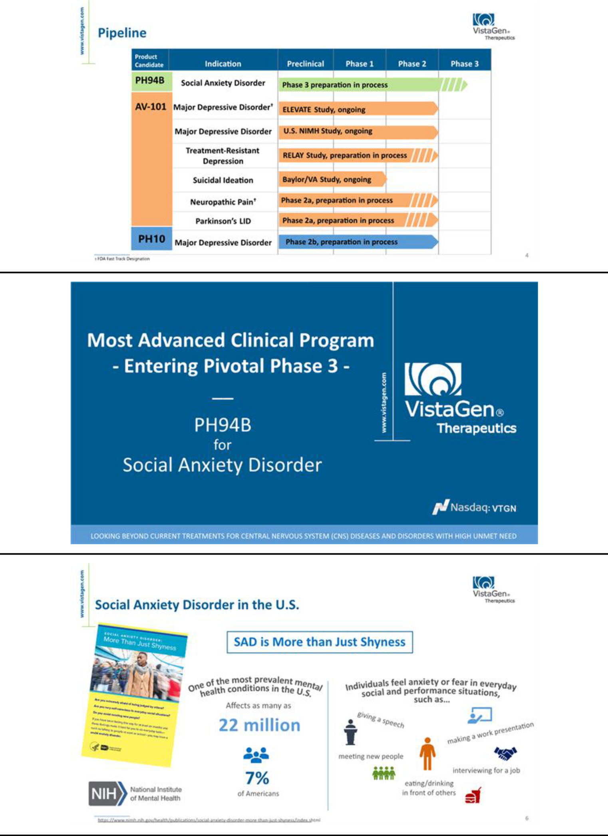

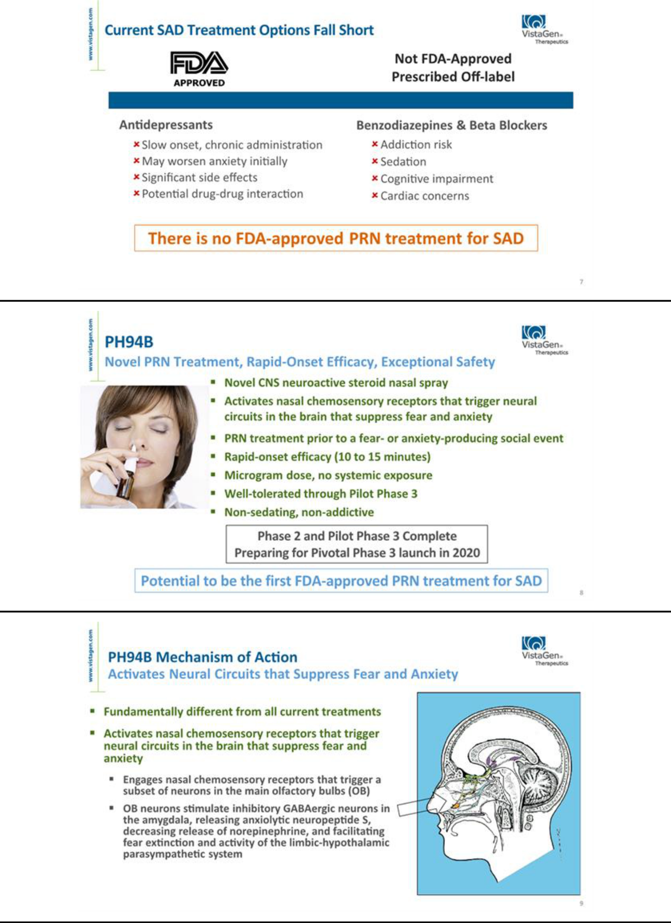

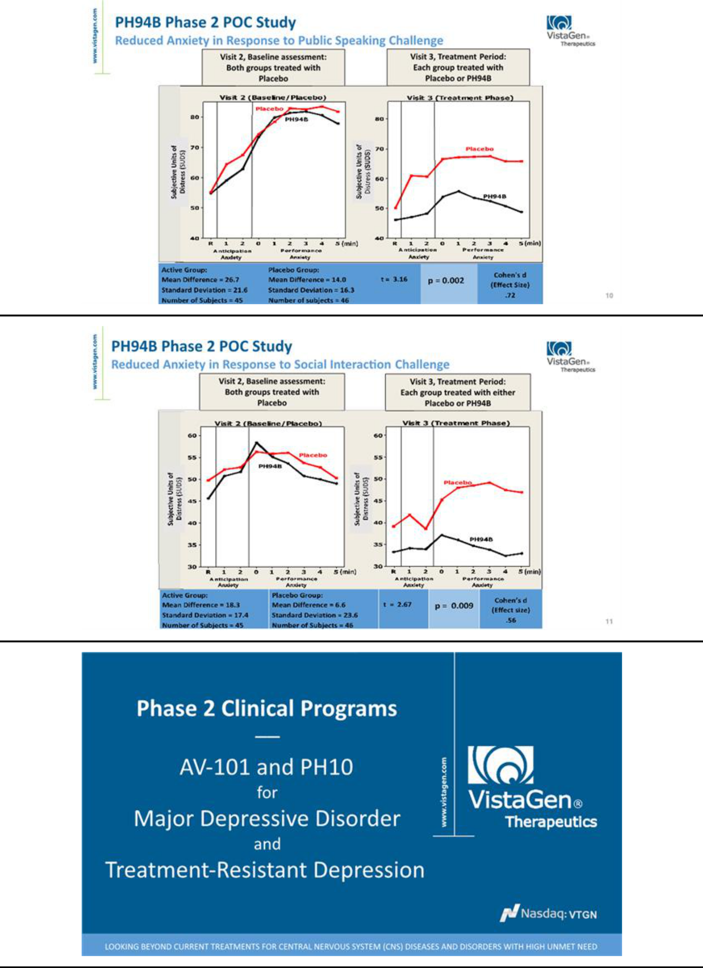

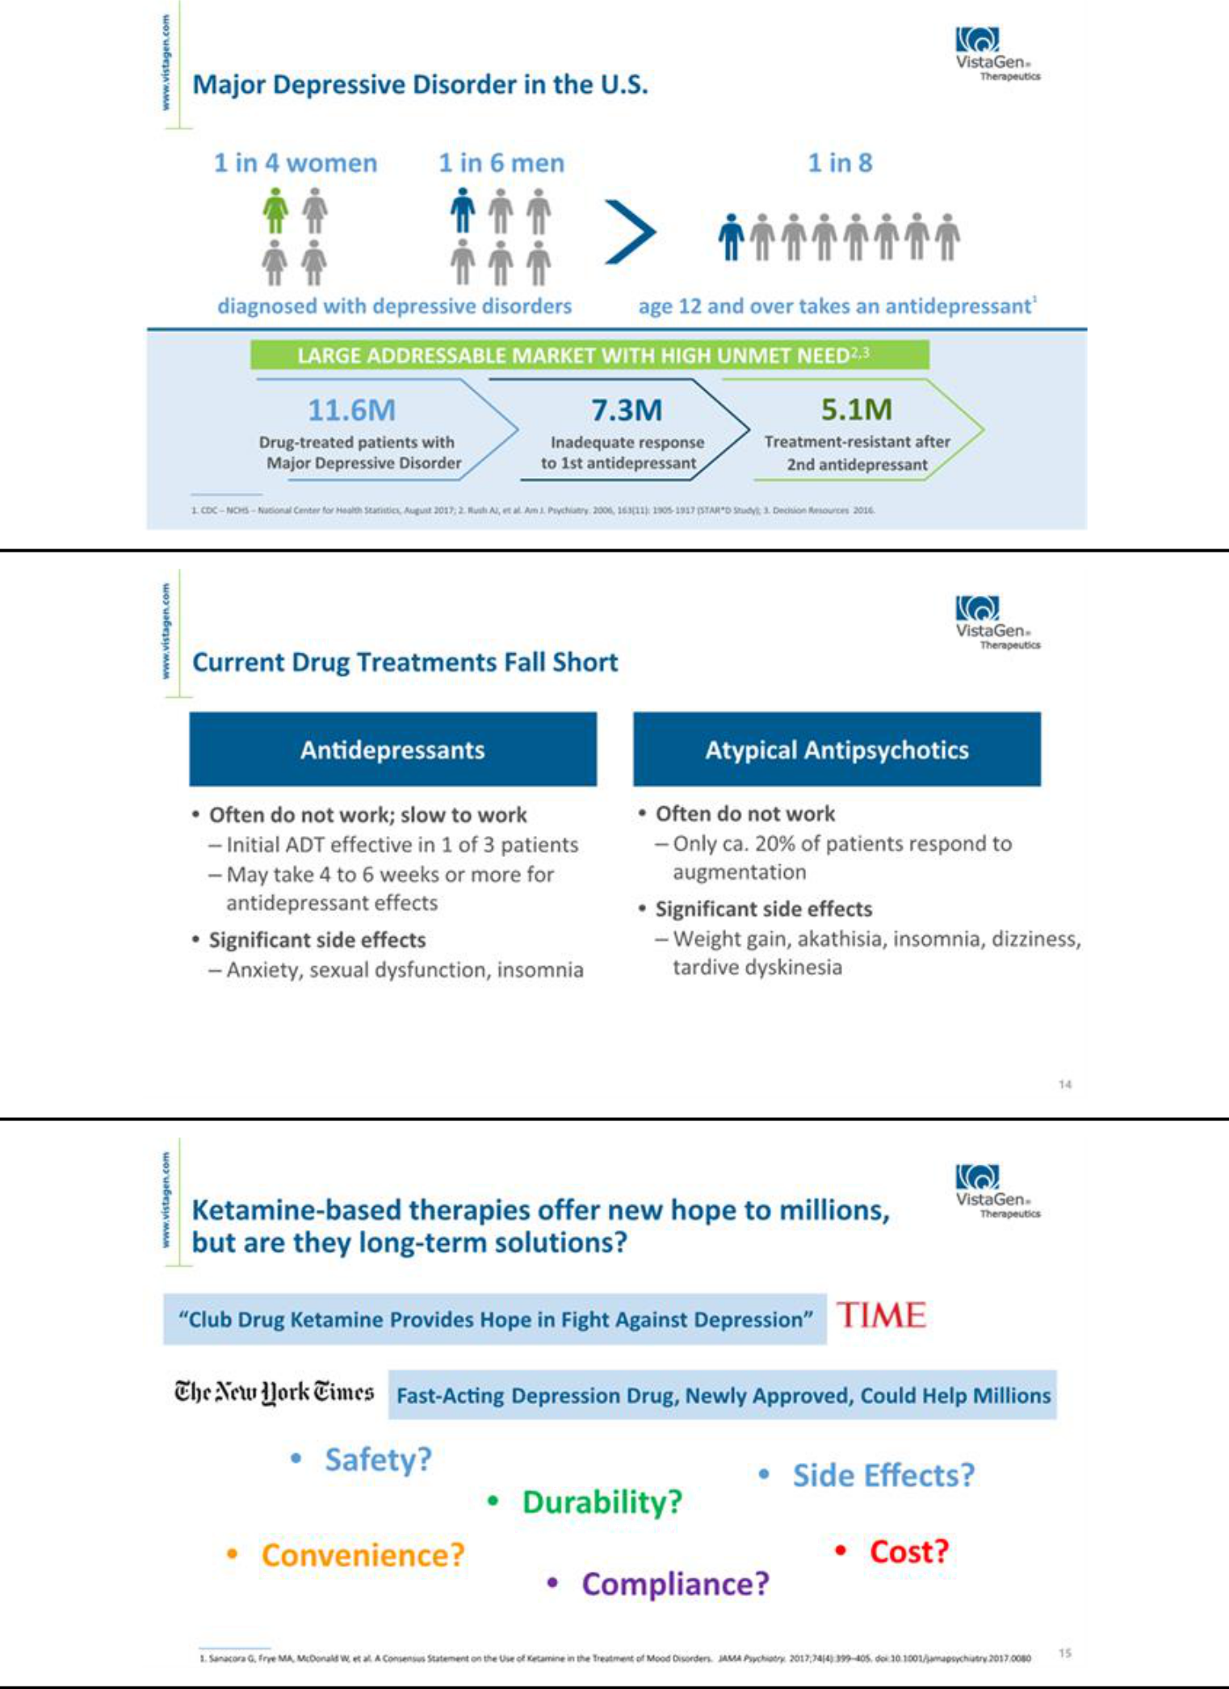

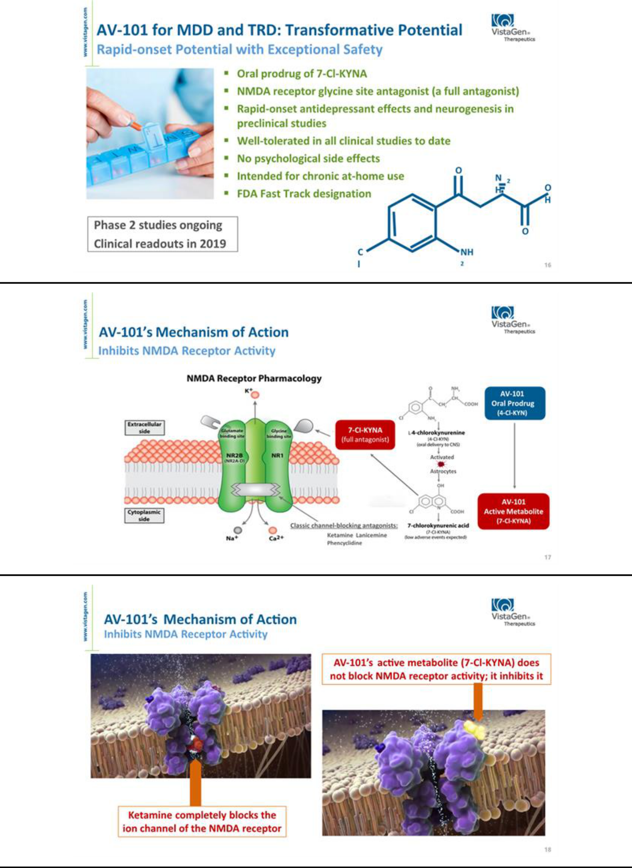

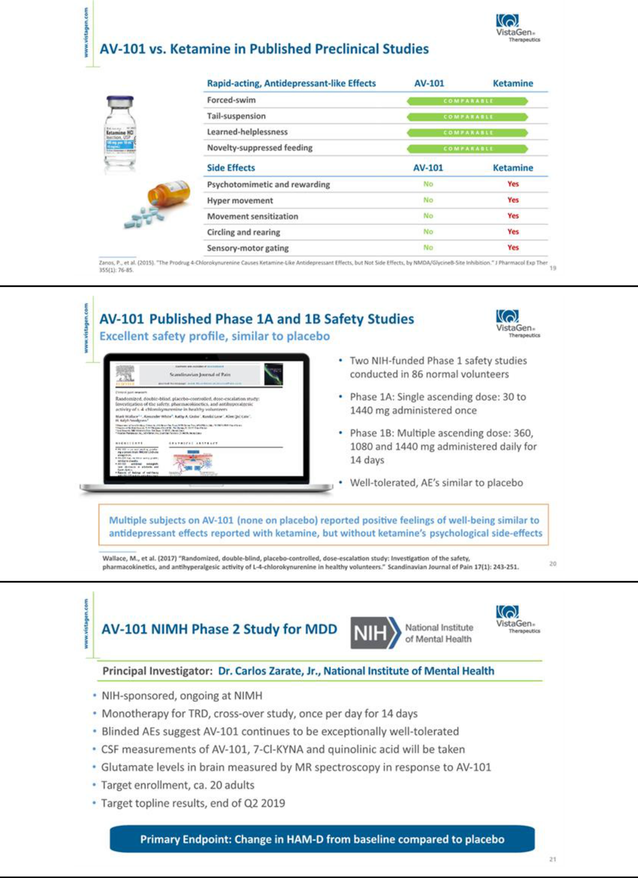

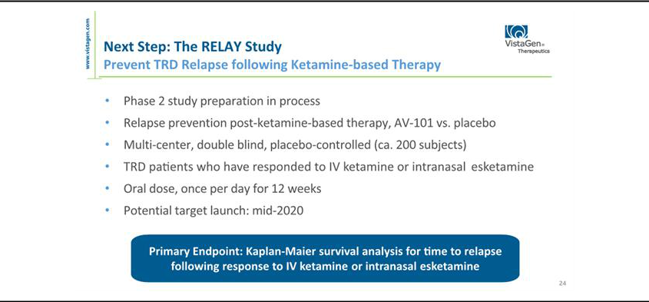

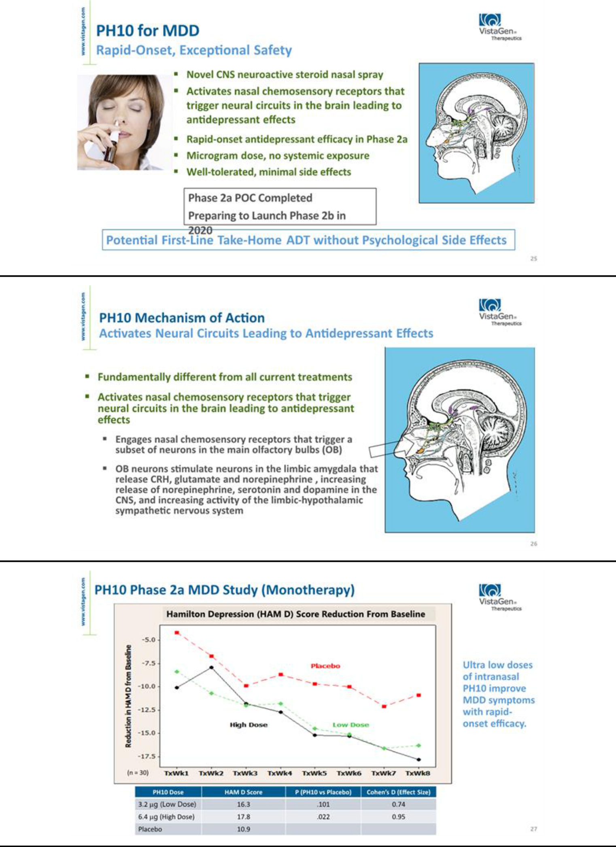

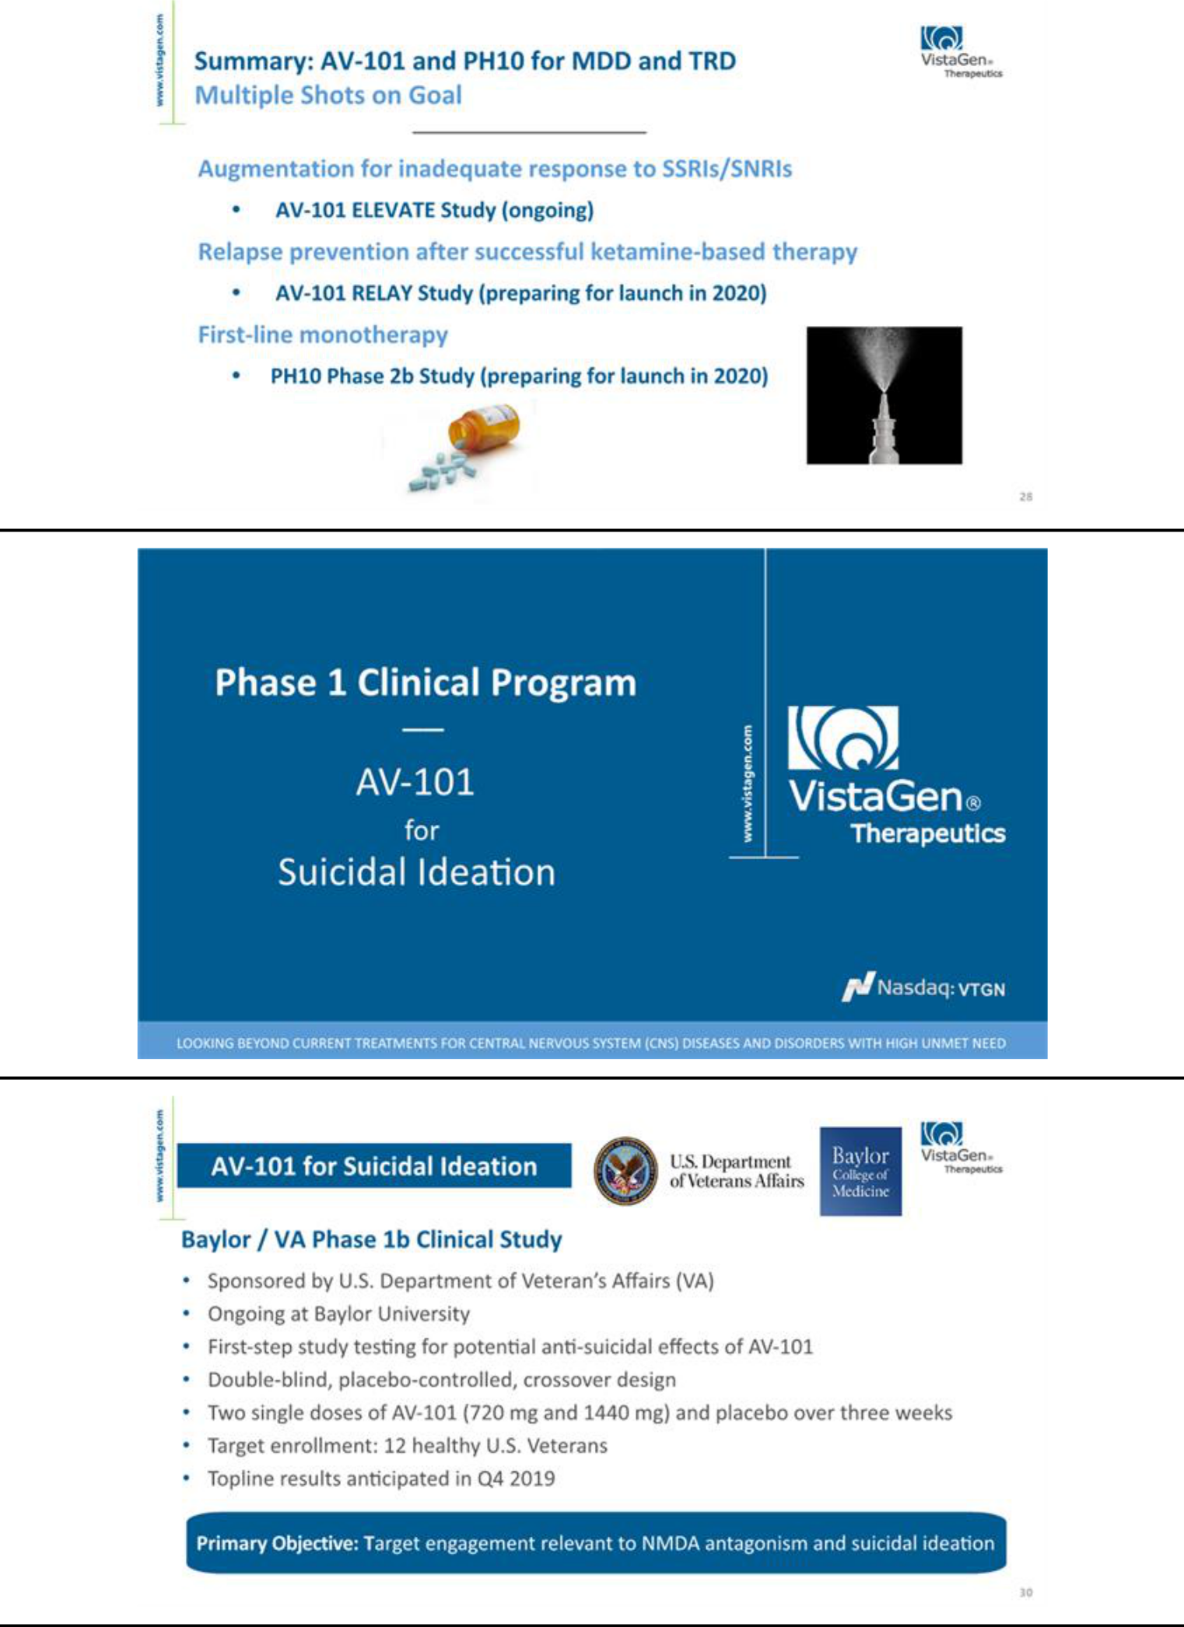

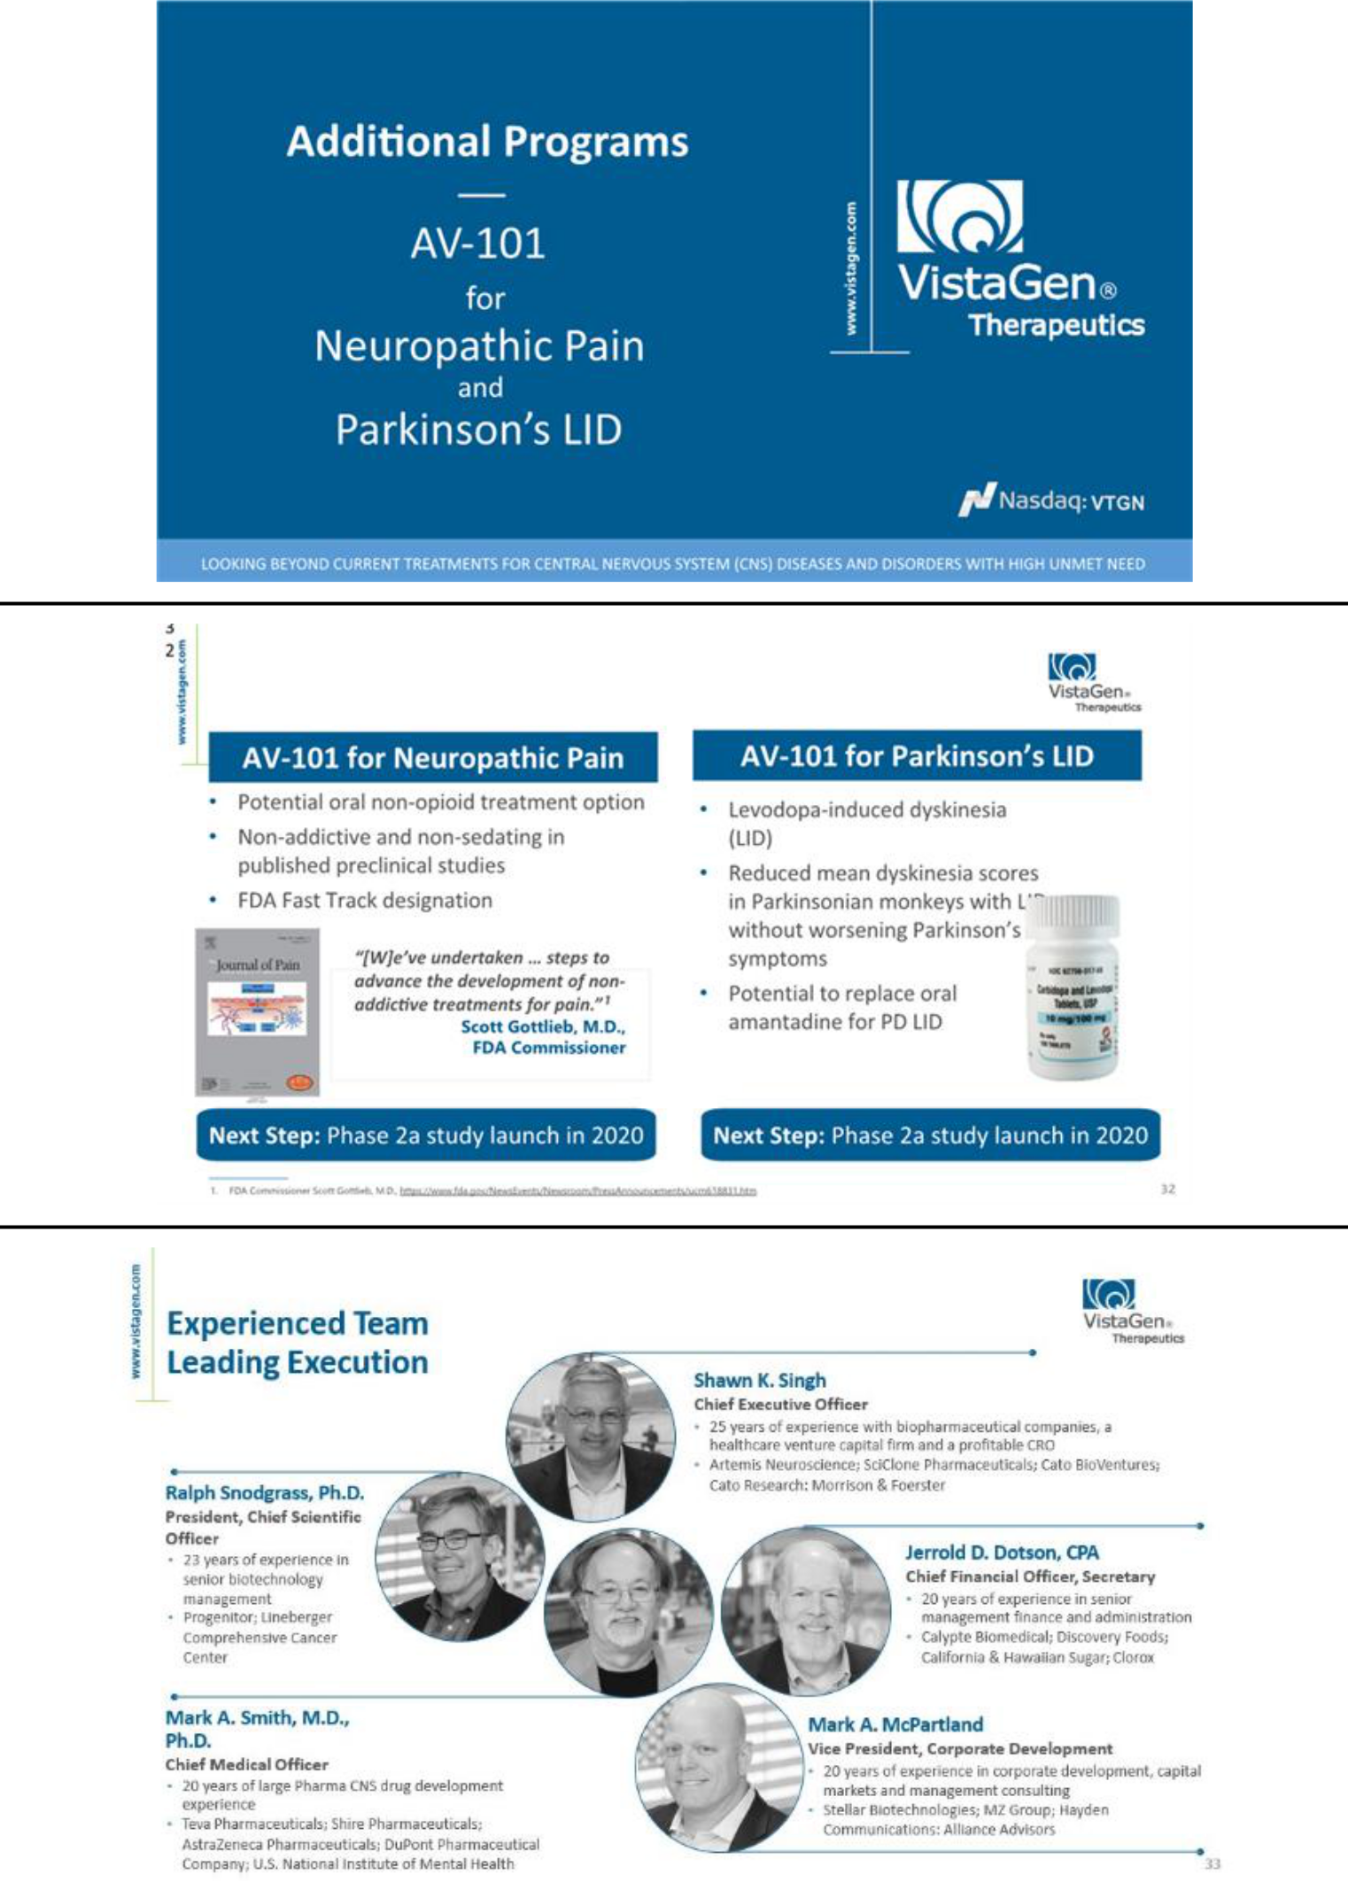

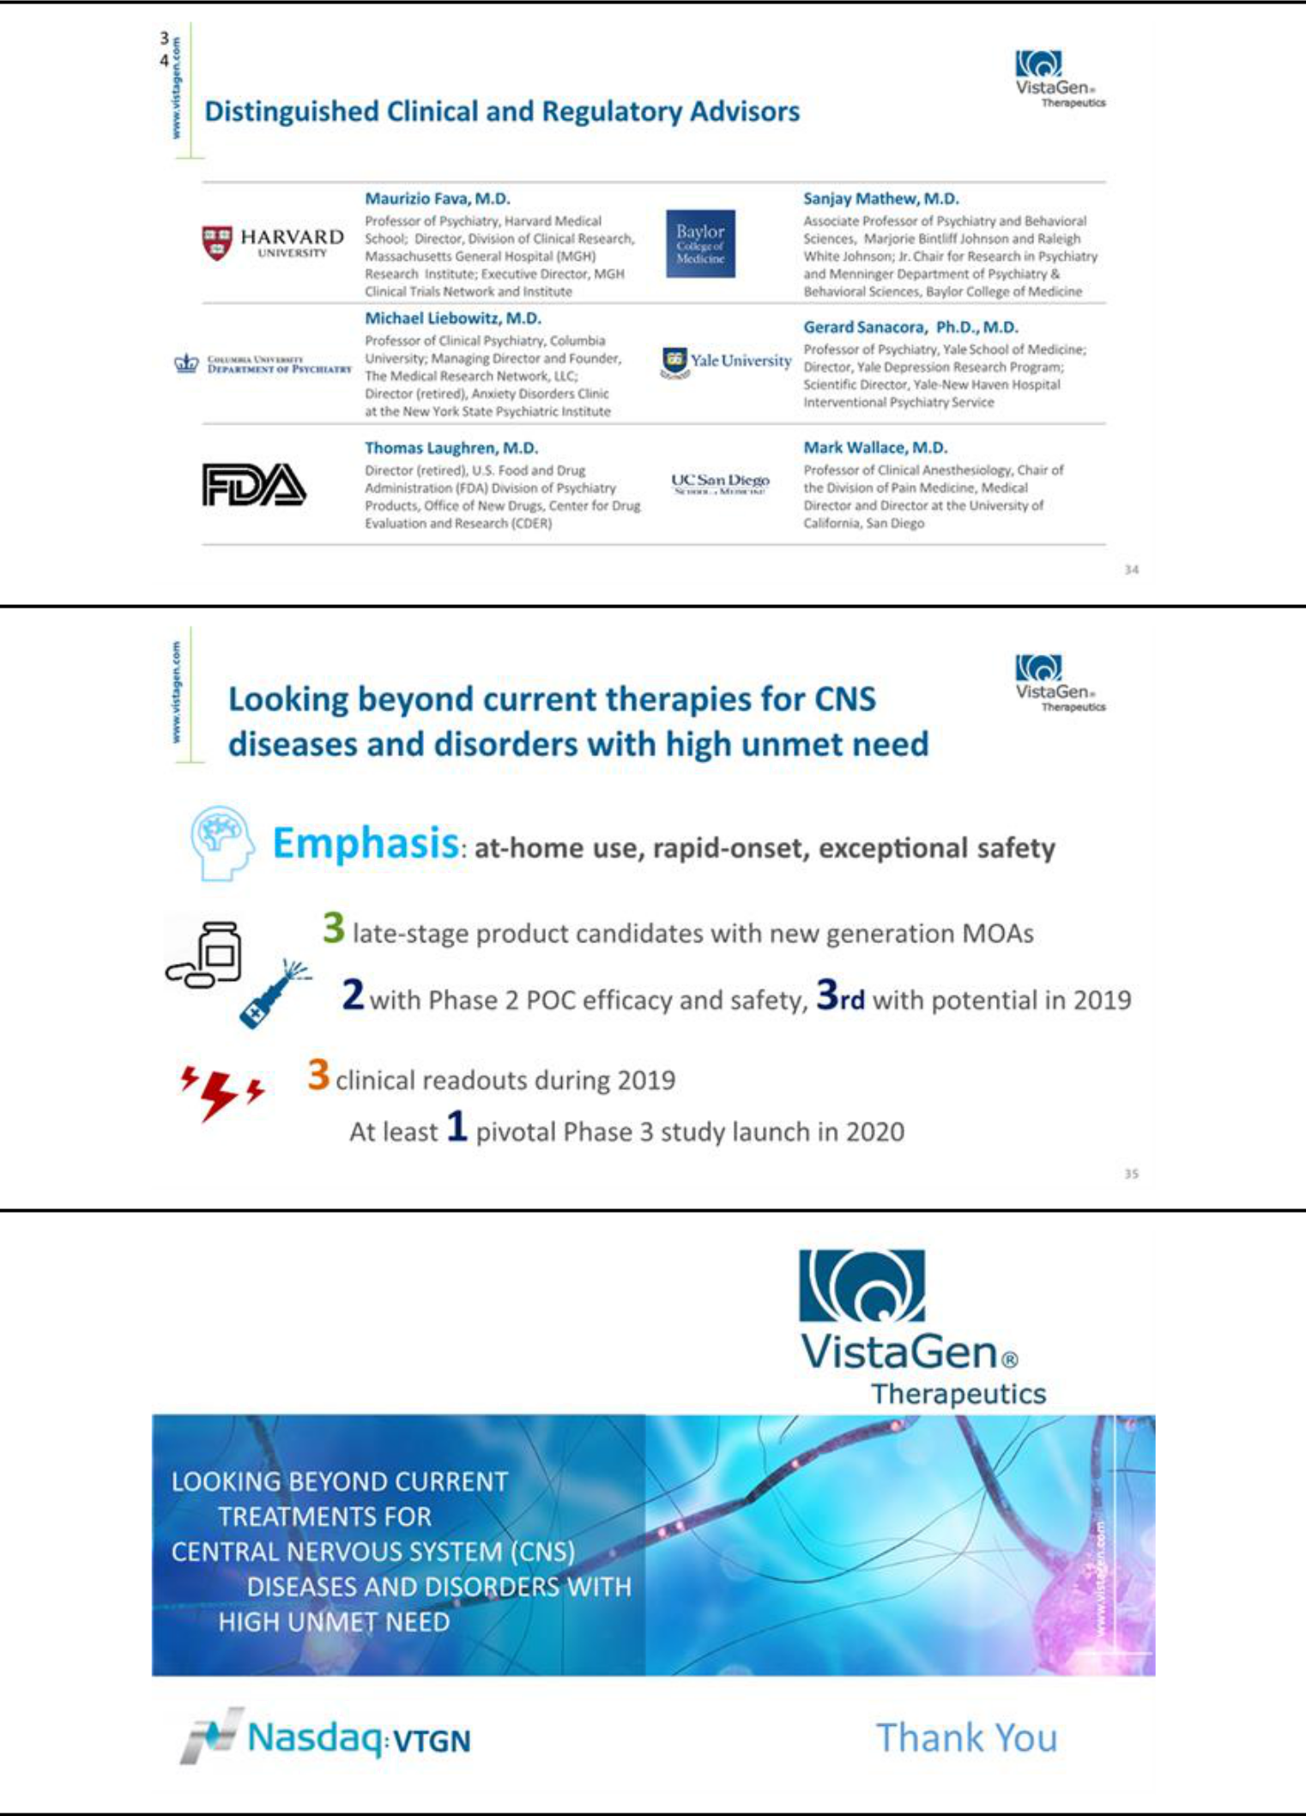

Exhibit 99.2


VistaGen Therapeutics Receives Notice of Allowance for Additional U.S. Patent Regarding Methods of Production for AV-101

SOUTH SAN FRANCISCO, Calif., March 13, 2019 - VistaGen Therapeutics (NASDAQ: VTGN), a clinical-stage biopharmaceutical company developing new generation medicines for depression and other central nervous system (CNS) diseases and disorders with high unmet need, today announced that the U.S. Patent and Trademark Office (USPTO) has issued a Notice of Allowance for U.S. Patent Application 15/812,599 related to certain methods of production for AV-101, VistaGen's oral NMDA receptor glycine site antagonist in Phase 2 development for major depressive disorder (MDD). The patent, once issued, will expand upon the related claims obtained in U.S. Patent No. 9,834,801 granted to VistaGen by the USPTO in December 2017 and will not expire until at least 2034.

About AV-101

VistaGen’s AV-101 (4-Cl-KYN) is an investigational, oral NMDA receptor glycine site antagonist with potential to be a treatment for multiple CNS indications with high unmet need. AV-101 is currently in Phase 2 clinical development in the U.S. for MDD and in a first-step target engagement study in healthy volunteer U.S. military Veterans for suicidal ideation. The U.S. Food and Drug Administration (FDA) has granted Fast Track designation for development of AV-101 as both a potential adjunctive treatment for MDD and as a non-opioid treatment for neuropathic pain.

About VistaGen

VistaGen Therapeutics is a clinical-stage biopharmaceutical company developing new generation medicines with for multiple CNS diseases and disorders with high unmet need. Each of VistaGen’s CNS pipeline candidates, AV-101, PH10 and PH94B, has potential for convenient, at-home use, rapid-onset therapeutic benefits, and exceptional safety. As noted above, AV-101 is an oral NMDA receptor glycine site antagonist (a full antagonist) in Phase 2 development in the U.S. for treatment of MDD and in a first-step target engagement study in healthy volunteer U.S. military Veterans for suicidal ideation. PH10 nasal spray is a potential first-in-class CNS neuroactive steroid with rapid-onset antidepressant effects observed at microgram doses and without systemic exposure. PH10 is in Phase 2 development for MDD. PH94B nasal spray is a potential first-in-class CNS neuroactive steroid with rapid-onset effects observed at microgram doses and without systemic exposure. Phase 2 development for PH94B for social anxiety disorder (SAD) has been completed successfully, and PH94B is now being prepared for Phase 3 development as an on-demand PRN treatment of SAD.

For more information, please visit www.vistagen.com and connect with VistaGen on Twitter, LinkedIn and Facebook.

Forward-Looking Statements

This release contains various statements concerning VistaGen's future expectations, plans and prospects, including without limitation, our expectations regarding development and commercialization of our CNS pipeline, including AV-101 for MDD, neuropathic pain and suicidal ideation, PH94B for SAD, and PH10 for MDD, as well as our intellectual property and commercial protection of our drug candidates, all of which constitute forward-looking statements for the purposes of the safe harbor provisions under the Private Securities Litigation Reform Act of 1995. These forward-looking statements are neither promises nor guarantees of future performance and are subject to a variety of risks and uncertainties, many of which are beyond our control, and may cause actual results to differ materially from those contemplated in these forward-looking statements. Among these risks is the possibility that (i) we may encounter unexpected adverse events in patients during our clinical development of any product candidate that cause us to discontinue further development, (ii) we may not be able to successfully demonstrate the safety and efficacy of our product candidates at each stage of clinical development, (iii) success in preclinical studies or in early-stage clinical trials may not be repeated or observed in ongoing or future studies, and ongoing or future preclinical and clinical results may not support further development of, or be sufficient to gain regulatory approval to market AV-101, PH94B, and/or PH10, (iv) decisions or actions of regulatory agencies may negatively affect the progress of, and our ability to proceed with, further clinical studies or to obtain marketing approval for our drug candidates, (v) we may not be able to obtain or maintain adequate intellectual property protection and other forms of marketing and data exclusivity for our product candidates, (vi) we may not have access to or be able to secure substantial additional capital to support our operations, including our ongoing clinical development activities; and (vii) we may encounter technical and other unexpected hurdles in the manufacturing and development of any of our product candidates. Certain other risks are more fully discussed in the section entitled "Risk Factors" in our most recent annual report on Form 10-K, and subsequent quarterly reports on Form 10-Q, as well as discussions of potential risks, uncertainties, and other important factors in our other filings with the Securities and Exchange Commission (SEC). Our SEC filings are available on the SEC's website at www.sec.gov. In addition, any forward-looking statements represent our views only as of the issuance of this release and should not be relied upon as representing our views as of any subsequent date. We explicitly disclaim any obligation to update any forward-looking statements.

Company Contact

Mark A. McPartland

VistaGen Therapeutics Inc.

Phone: +1 (650) 577-3600

Email: IR@vistagen.com

Investor Contact

Valter Pinto / Allison Soss

KCSA Strategic Communications

Phone: +1 (212) 896-1254/+1 (212) 896-1267

Email: VistaGen@KCSA.com

Media Contact

Caitlin Kasunich / Lisa Lipson

KCSA Strategic Communications

Phone: +1 (212) 896-1241/+1 (508) 843-6428

Email: VistaGen@KCSA.com

###

