UNITED STATES

SECURITIES AND EXCHANGE COMMISSION

Washington, DC 20549

FORM 8-K

CURRENT REPORT

Pursuant to Section 13 or 15(d) of the

Securities Exchange Act of 1934

Date of report (Date of earliest event reported): August 14, 2014

Commission File Number: 000-54014

VistaGen Therapeutics, Inc.

(Exact name of small business issuer as specified in its charter)

Nevada

(State or other jurisdiction of incorporation or organization)

20-5093315

(IRS Employer Identification No.)

343 Allerton Avenue, South San Francisco, California 94080

(Address of principal executive offices)

650-577-3600

(Registrant's Telephone number)

Not Applicable

(Former Name or Former Address, if Changed Since Last Report)

Check the appropriate box below if the Form 8-K filing is intended to simultaneously satisfy the filing obligation of the registrant under any of the following provisions (see General Instruction A.2. below):

- ] Written communications pursuant to Rule 425 under the Securities Act (17 CFR 230.425)

- ] Soliciting material pursuant to Rule 14a-12 under the Exchange Act (17 CFR 240.14a-12)

- ] Pre-commencement communications pursuant to Rule 14d-2(b) under the Exchange Act (17 CFR 240.14d-2(b))

- ] Pre-commencement communications pursuant to Rule 13e-4(c) under the Exchange Act (17 CFR 240.13e-4(c))

Item 8.01 Other Events.

Effective August 14, 2014, VistaGen Therapeutics, Inc. (the “Company”) filed a Certificate of Change with the Nevada Secretary of State (the “Certificate of Change”) to effect a 1-for-20 reverse split of the Company’s authorized, and issued and outstanding shares of common stock, par value $0.001 per share (“Common Stock”) (the “Reverse Split”). No fractional shares will be issued as a result of the Reverse Split. Instead, the Company will issue one whole post-split share of Common Stock to any stockholder who otherwise would have received a fractional share as a result of the Reverse Split. Copies of the Certificate of Change and the Company's press release announcing the implementation of the Reverse Split are attached hereto as Exhibits 3.1 and 99.1, respectively, and are incorporated by reference herein.

The Reverse Split was approved by the Financial Industry Regulatory Authority (“FINRA”) on August 13, 2014, and will become effective on the OTCQB at the opening of trading on August 14, 2014 under the symbol “VSTAD”. The “D” will appear on the Company's ticker symbol for the next 20 business days. After 20 business days, the Company’s Common Stock will resume trading under the symbol “VSTA”. The Company's new CUSIP number is 92840H202.

Item 9.01 Financial Statements and Exhibits.

See Exhibit Index.

SIGNATURES

Pursuant to the requirements of the Securities Exchange Act of 1934, the registrant has duly caused this report to be signed on its behalf by the undersigned hereunto duly authorized.

VistaGen Therapeutics, Inc.

Date: August 14, 2014

By: /s/ Shawn K. Singh

Name: Shawn K. Singh, JD

Title: Chief Executive Officer

 |  |  | Exhibit Index
 | Exhibit No. |  | Description
 | 3.1 | Certificate of Change of VistaGen Therapeutics, Inc., filed August 11, 2014
 | 99.1 | Press Release, dated August 13, 2014

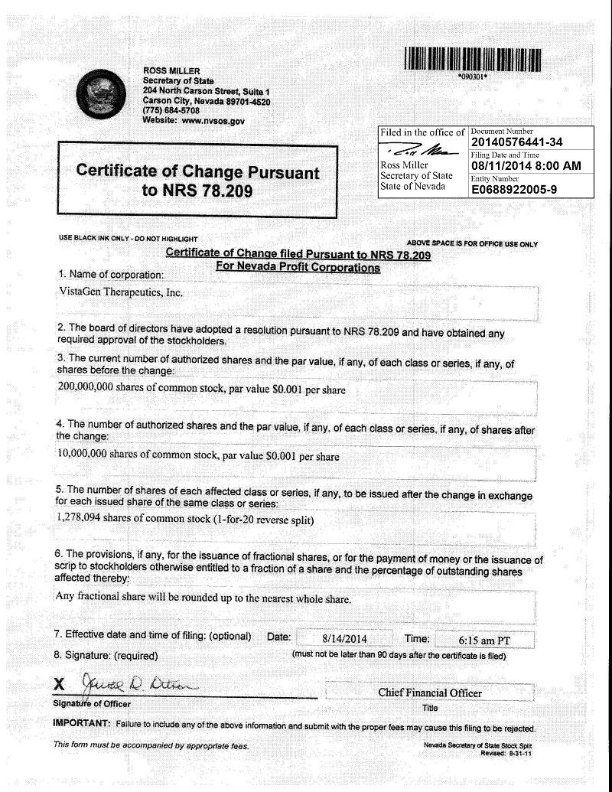



VistaGen Announces Reverse Stock Split

SOUTH SAN FRANCISCO, CA – August 13, 2014 (MARKETWIRE via COMTEX) – VistaGen Therapeutics, Inc. (OTCQB: VSTA), a stem cell company focused on drug rescue, drug discovery and regenerative medicine, announced today that will implement a 1-for-20 reverse split of its common stock effective at the opening of trading on August 14, 2014. At that time, VistaGen’s common stock will trade on a split-adjusted basis under new CUSIP number 92840H202 and temporary symbol “VSTAD,” with the “D” appended to signify that the reverse stock split has occurred. VistaGen’s trading symbol will revert to “VSTA” after approximately 20 trading days.

The reverse stock split is intended to increase market awareness of the Company’s common stock and position the Company for potential future listing of its common stock on a national securities exchange.

The reverse split will reduce the number of shares of the Company's common stock outstanding from approximately 25.5 million to approximately 1.2 million. Proportional adjustments will be made to the Company's authorized shares, outstanding common stock equivalents, options, warrants and conversion terms in convertible notes. Any fractional shares resulting from the reverse stock split will be rounded up to the next whole share.

INFORMATION FOR STOCKHOLDERS

Upon the effectiveness of the reverse stock split, each twenty shares of issued and outstanding VistaGen common stock will be converted into one share of VistaGen common stock. Stockholders who have existing stock certificates will receive written instructions by mail from the Company’s transfer agent, Registrar and Transfer Company. Stockholders who hold their shares in brokerage accounts or "street name" are not required to take any action to effect the exchange of their shares. Such stockholders will be contacted by their brokers with instructions.

More information on VistaGen's reverse stock split will be available beginning on or about August 15, 2014 in the "Reverse Stock Split FAQs" on the Investor page of the Company’s website at www.VistaGen.com.

About VistaGen Therapeutics

VistaGen is a stem cell company focused on drug rescue, drug discovery and regenerative medicine. We believe better cells lead to better medicines™ and that the key to making better cells is precisely controlling the differentiation of human pluripotent stem cells, which are the building blocks of all cells of the human body. For over 15 years, our stem cell research and development teams and collaborators have developed proprietary methods for controlling the differentiation of human pluripotent stem cells and the production and maturation of numerous specific types of adult human cells that we use, or plan to use, to reproduce complex human biology and disease and assess, in vitro, the potential therapeutic benefits and safety risks of new drug candidates, including the new chemical entities we are focused on producing through drug rescue. These are intended to be novel, proprietary and safer variants of once-promising small molecule drug candidates discovered, developed and optimized for efficacy by pharmaceutical and biotechnology companies, the U.S. National Institutes of Health, or academic laboratories, but discontinued prior to FDA approval due to unexpected heart or liver safety concerns.

Visit VistaGen at www.VistaGen.com, follow VistaGen at www.twitter.com/VistaGen or view VistaGen’s Facebook page at www.facebook.com/VistaGen.

Cautionary Statement Regarding Forward-Looking Statements

The statements in this press release that are not historical facts may constitute forward-looking statements that are based on current expectations and are subject to risks and uncertainties that could cause actual future results to differ materially from those expressed or implied by such statements. Those risks and uncertainties include, but are not limited to, risks related to the success of VistaGen’s efforts to meet all requirements necessary to obtain a listing of its common stock on a national securities exchange and its efforts to produce, develop and commercialize proprietary new chemical entities through its drug rescue drug rescue activities. These and other risks and uncertainties are identified and described in more detail in VistaGen’s filings with the Securities and Exchange Commission (SEC). These filings are available on the SEC’s website at www.sec.gov. VistaGen undertakes no obligation to publicly update or revise any forward-looking statements.

For more information:

Shawn K. Singh, J.D.

Chief Executive Officer

VistaGen Therapeutics, Inc.

www.VistaGen.com

650-577-3613

Investor.Relations@VistaGen.com

Mission Investor Relations

IR Communications

Atlanta, Georgia

www.MissionIR.com

404-941-8975

Investors@MissionIR.com

