UNITED STATES

SECURITIES AND EXCHANGE COMMISSION

Washington, D.C. 20549

FORM 8-K

CURRENT REPORT

PURSUANT TO SECTION 13 OR 15(d) of the SECURITIES EXCHANGE ACT OF 1934

Date of Report (Date of earliest event reported): March 3, 2025

Vistagen Therapeutics, Inc.

(Exact name of registrant as specified in its charter)

Nevada

000-54014

20-5093315

(State or other jurisdiction of

incorporation)

(Commission File Number)

(IRS Employer

Identification Number)

343 Allerton Ave.

South San Francisco, California 94080

(Address of principal executive offices)

(650) 577-3600

(Registrant’s telephone number, including area code)

Not Applicable

(Former name or former address, if changed since last report)

Check the appropriate box below if the Form 8-K filing is intended to simultaneously satisfy the filing obligation of the registrant under any of the following provisions:

o Written communications pursuant to Rule 425 under the Securities Act (17 CFR 230.425)

o Soliciting material pursuant to Rule 14a-12 under the Exchange Act (17 CFR 240.14a -12)

o Pre-commencement communications pursuant to Rule 14d-2(b) under the Exchange Act (17 CFR 240.14d -2(b))

o Pre-commencement communications pursuant to Rule 13e-4(c) under the Exchange Act (17 CFR 240.13e -4(c))

Securities registered pursuant to Section 12(b) of the Act:
Title of each class | Trading Symbol(s) | Name of each exchange on which registered
Common Stock, par value $0.001 per share | VTGN | Nasdaq Capital Market

Indicate by check mark whether the registrant is an emerging growth company as defined in Rule 405 of the Securities Act of 1933 (17 CFR 230.405) or Rule 12b-2 of the Securities Exchange Act of 1934 (17 CFR 240.12b-2)

Emerging Growth Company o

If an emerging growth company, indicate by check mark if the registrant has elected not to use the extended transition period for complying with any new or revised financial accounting standards provided pursuant to Section 13(a) of the Exchange Act o

Item 8.01 Other Events

On March 3, 2025, Vistagen Therapeutics, Inc. (the “Company”) presented at the 45th Annual TD Cowen Healthcare Conference. A copy of the slide presentation used during the TD Cowen Healthcare Conference is attached to this Current Report on Form 8-K as Exhibit 99.1.

On March 4, 2025, the Company announced that it will participate at the Stifel 2025 Virtual CNS Forum on March 18, 2025. A copy of the press release issued by the Company is attached hereto as Exhibit 99.2.

On February 13, 2025, John Cesario and David Preka (the “Plaintiffs”) filed a civil action (the “Complaint”) pro se (i.e., acting on their own behalf rather than through an attorney) against the Company and its Board of Directors (the “Board”), certain of its executive officers, professional services and financial advisors, and industry analysts in the United States District Court for the Northern District of California (Case No. 4:25-cv-01510). The Plaintiffs seek compensatory and punitive damages, as well as fees and costs. The Complaint alleges violations of Section 10(b) of the Securities Exchange Act of 1934, as amended, and Rule 10b-5 promulgated thereunder, and Sections 11 and 17(a) of the Securities Act of 1933, as amended, along with other causes of action. The Plaintiffs allege, among other things, that the Company, and certain of its executive officers, made misleading statements and material omissions in various public disclosures concerning clinical trials for certain of the Company’s product candidates, which they allege caused plaintiffs to incur compensable losses. The Complaint also alleges that the Board, certain of the Company’s professional and financial advisors, and industry analysts aided and abetted the alleged wrongful conduct. The Company believes all allegations asserted in the Complaint are wholly without merit, and intends to defend them vigorously.

Item 9.01 Financial Statements and Exhibits

(d) Exhibits Index
Exhibit No. |  |  |  |  | Description
99.1 |  |  | Corporate Presentation utilized by Vistagen Therapeutics, Inc., dated March 3, 2025.
99.2 |  |  | Press Release issued by Vistagen Therapeutics, Inc., dated March 4, 2025.
104 |  |  | Cover Page Interactive Data File (embedded within the Inline XBRL document)

Signatures

Pursuant to the requirements of the Securities Exchange Act of 1934, the registrant has duly caused this report to be signed on its behalf by the undersigned thereunto duly authorized.

Vistagen Therapeutics, Inc.

Date: March 6, 2025 By: /s/ Shawn K. Singh

Shawn K. Singh

President and Chief Executive Officer



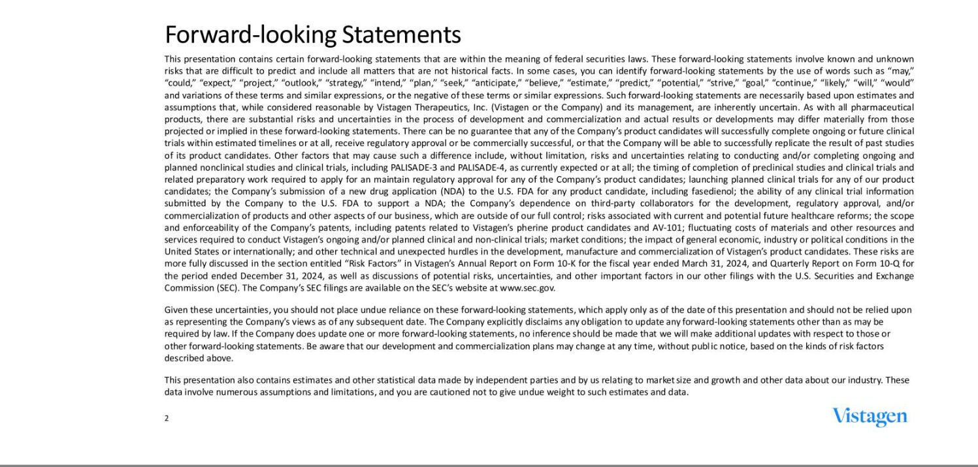

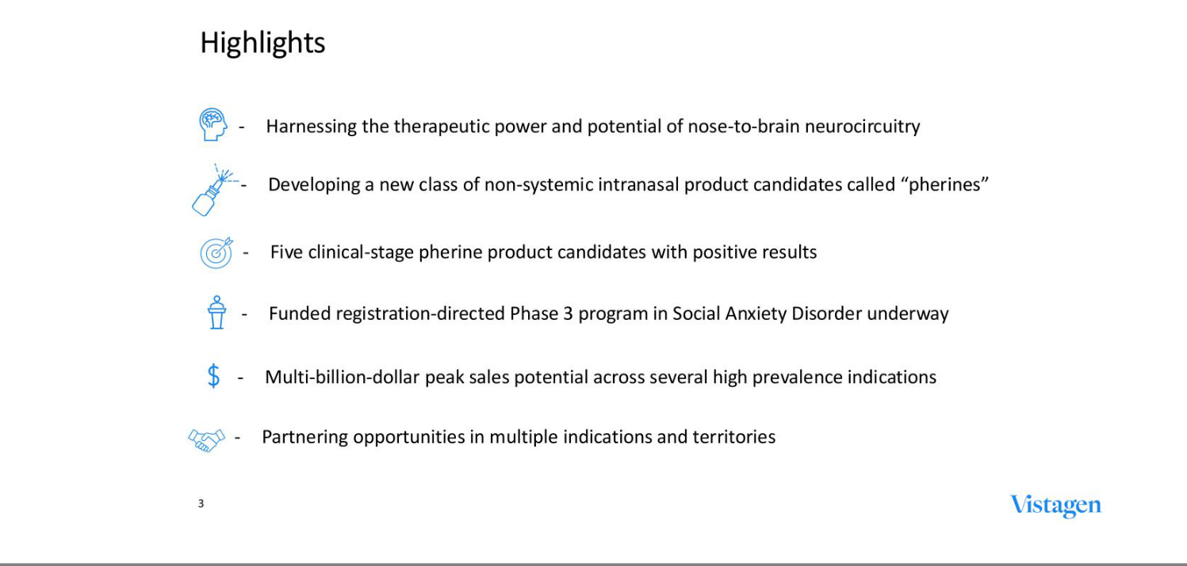



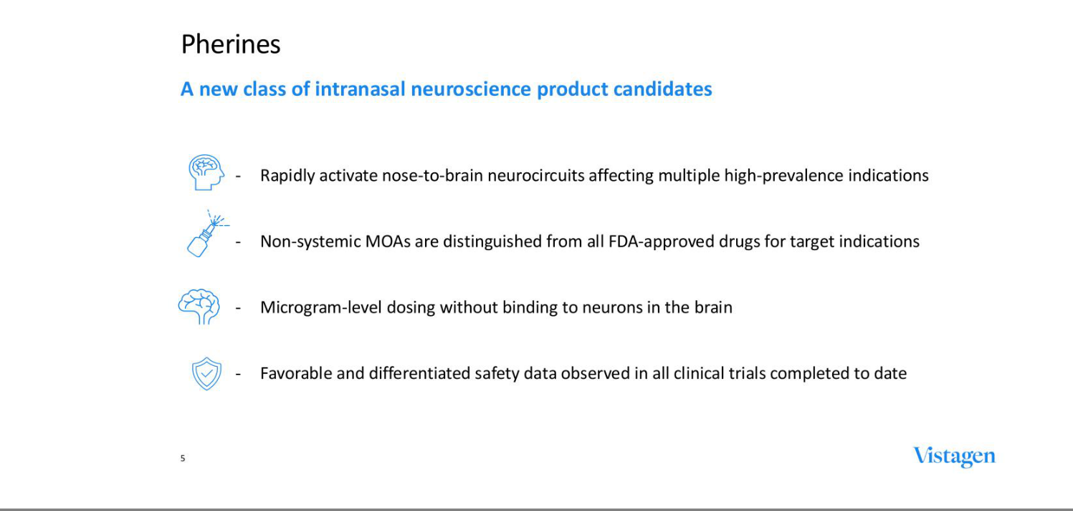

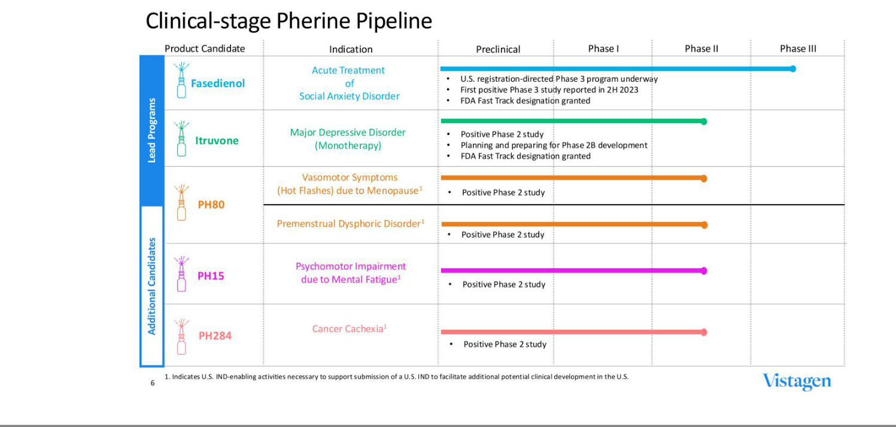



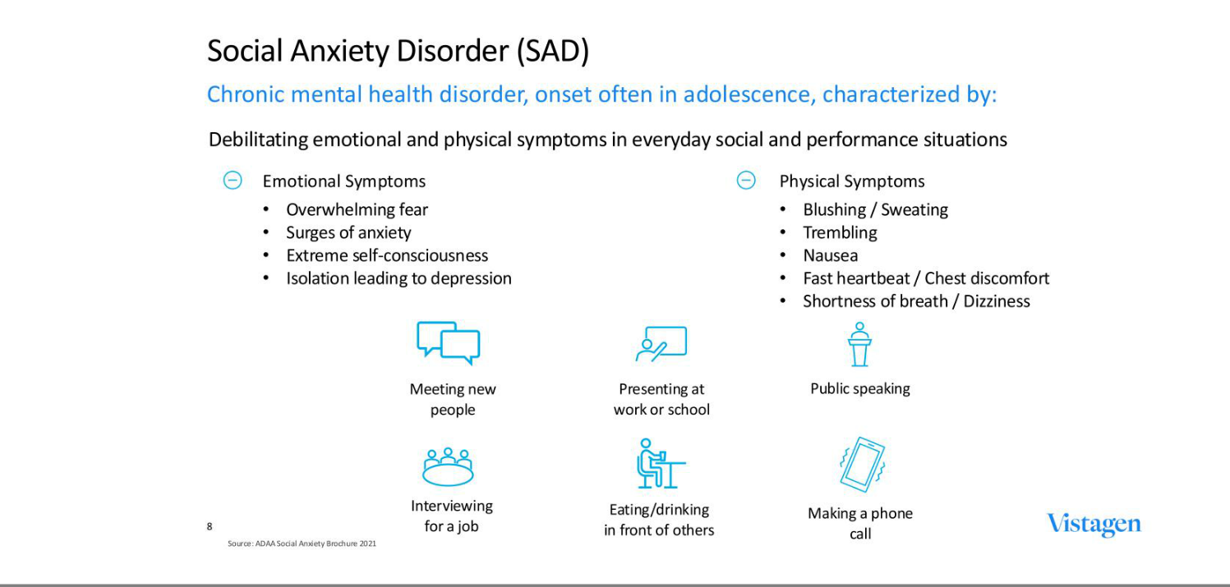

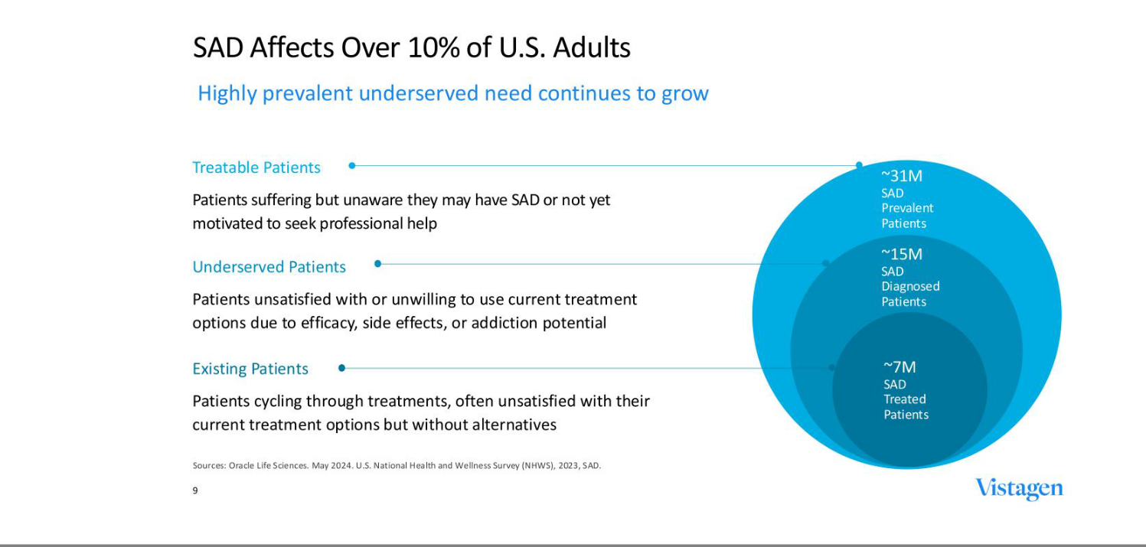

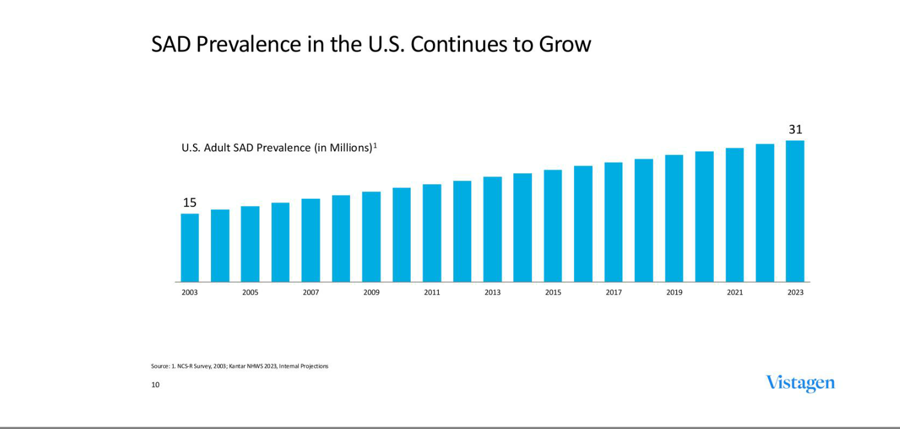

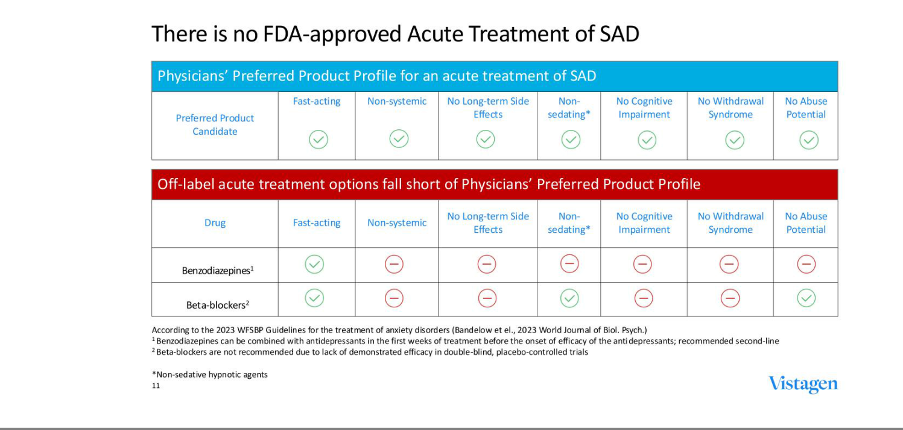

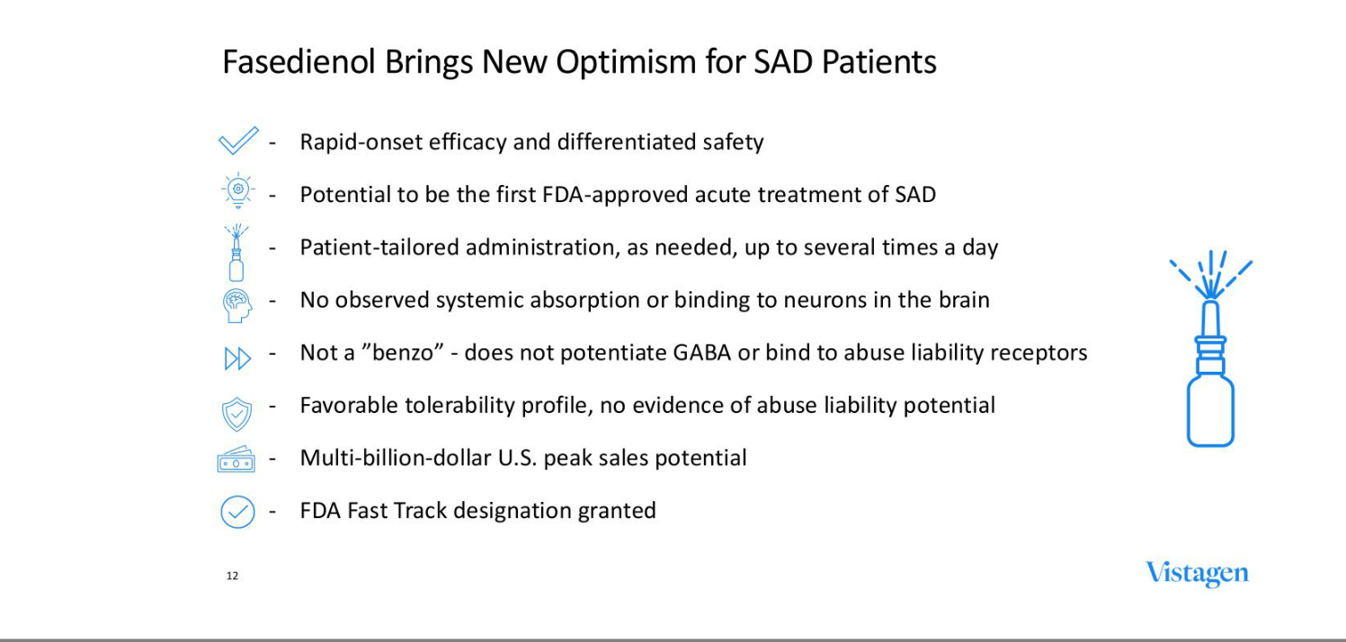

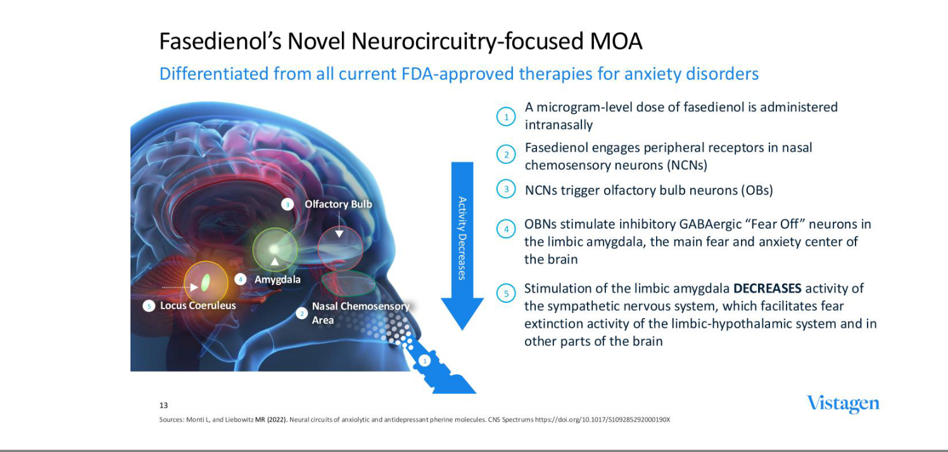

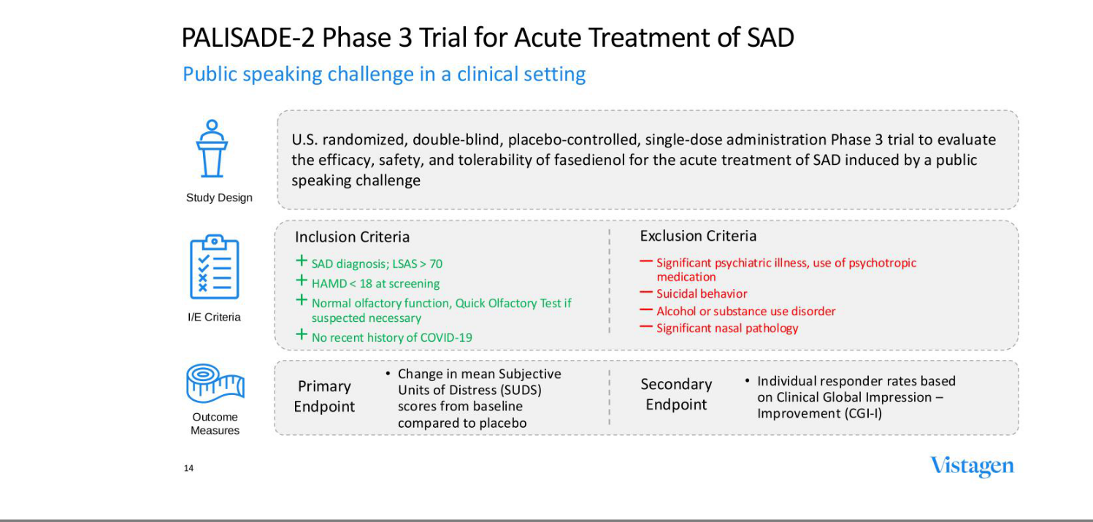

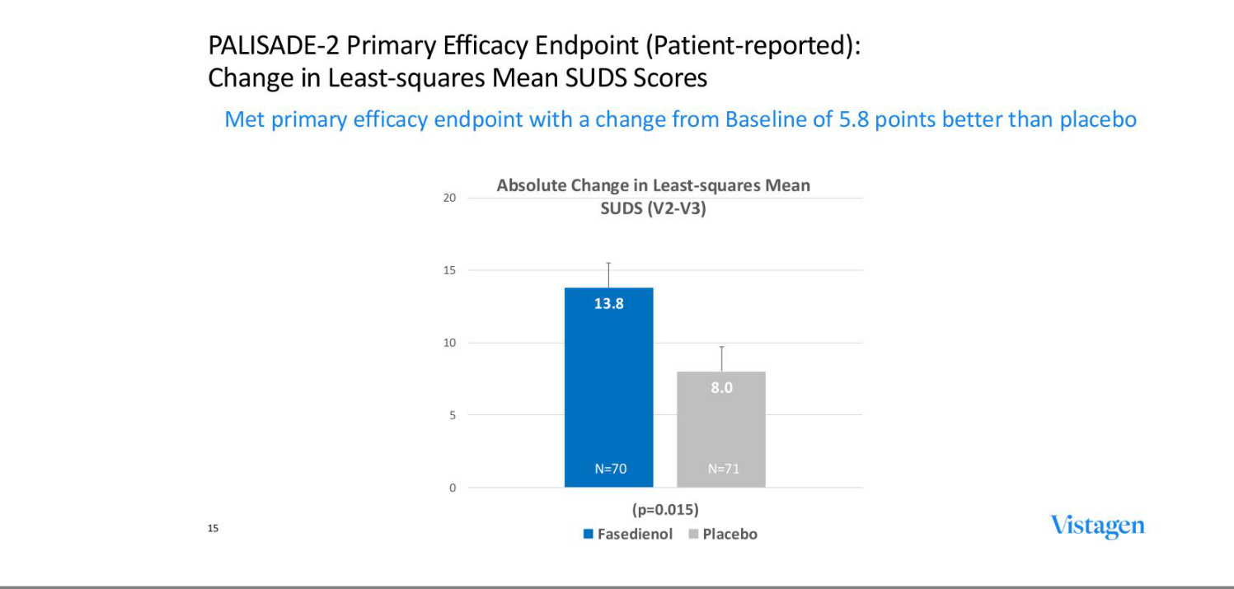

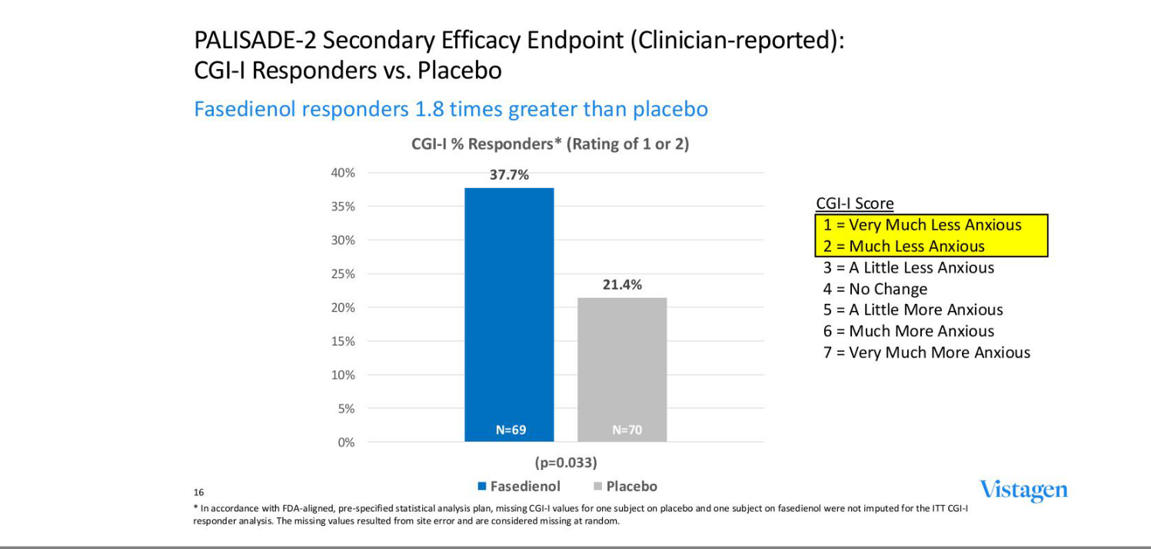

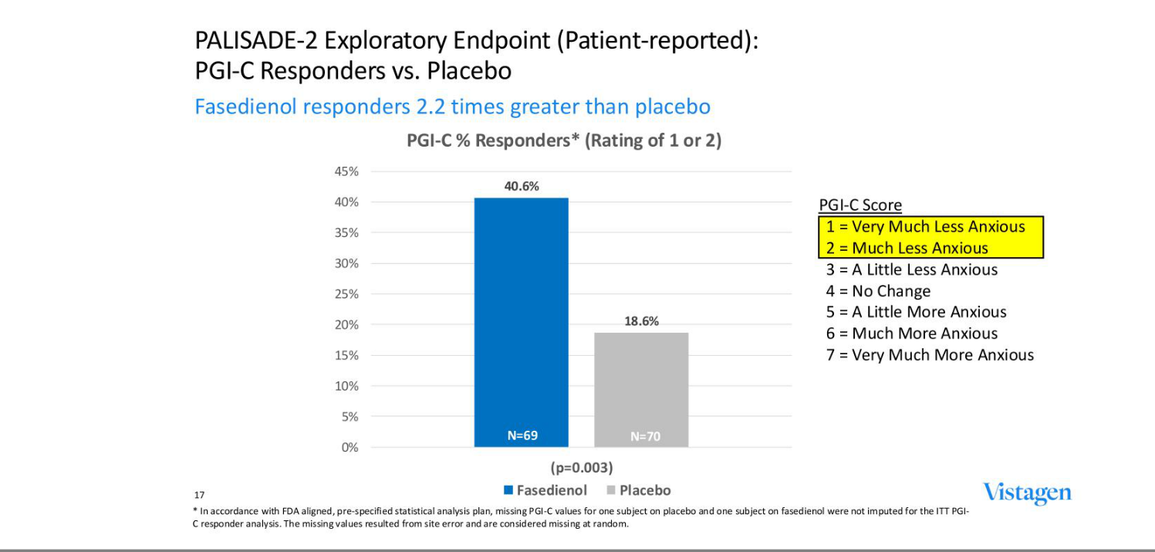

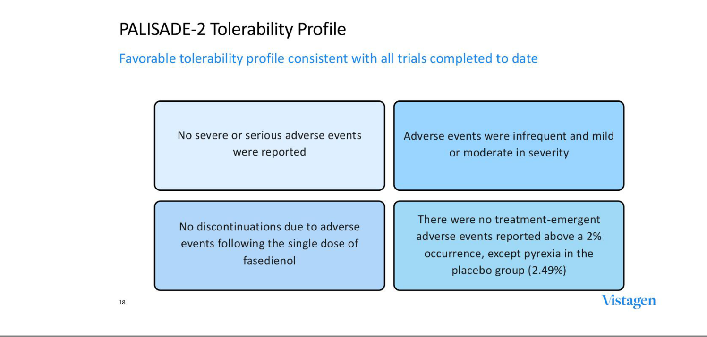

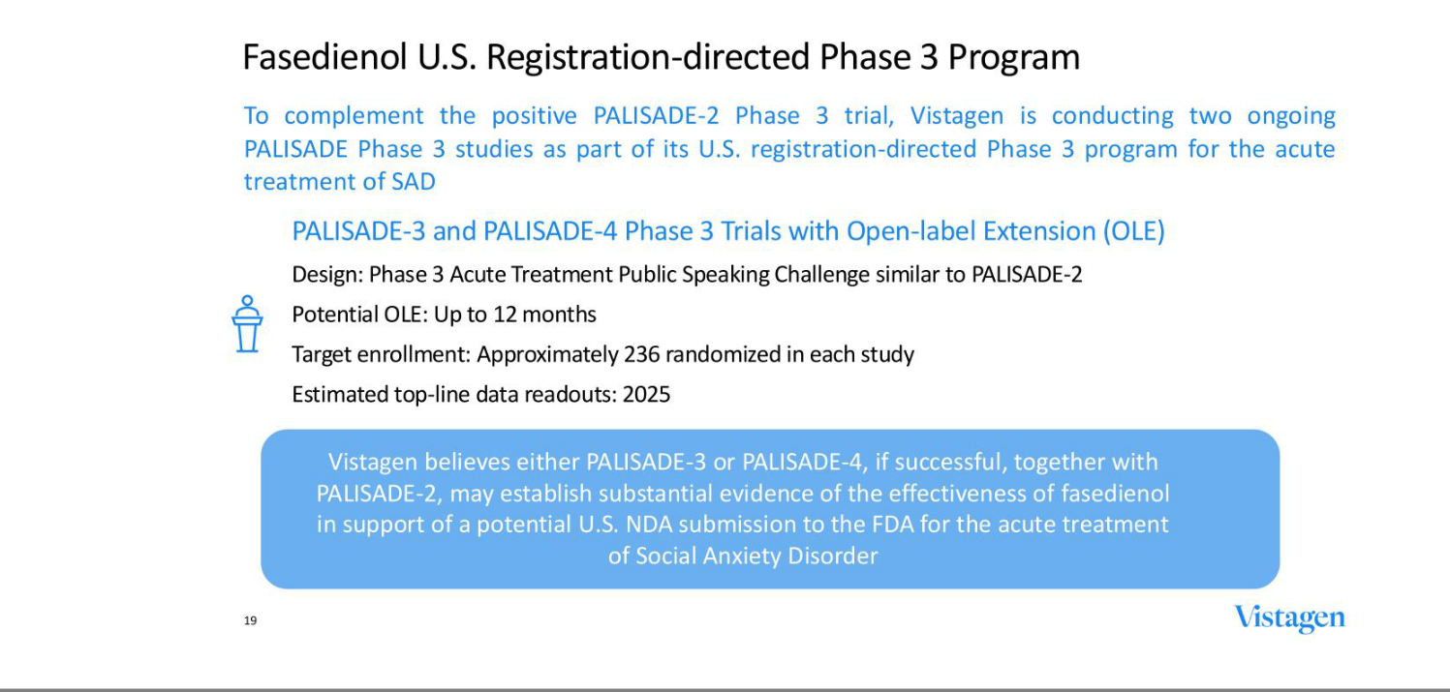

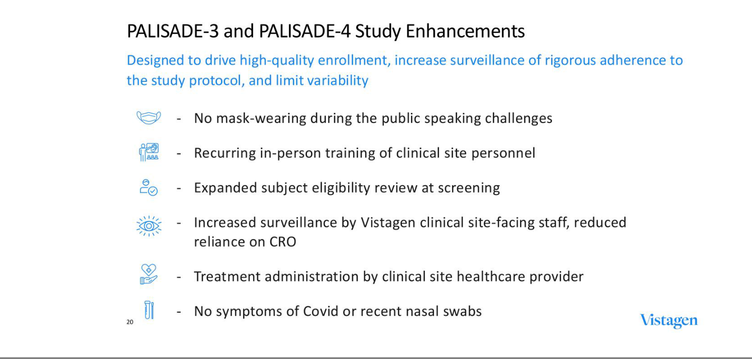

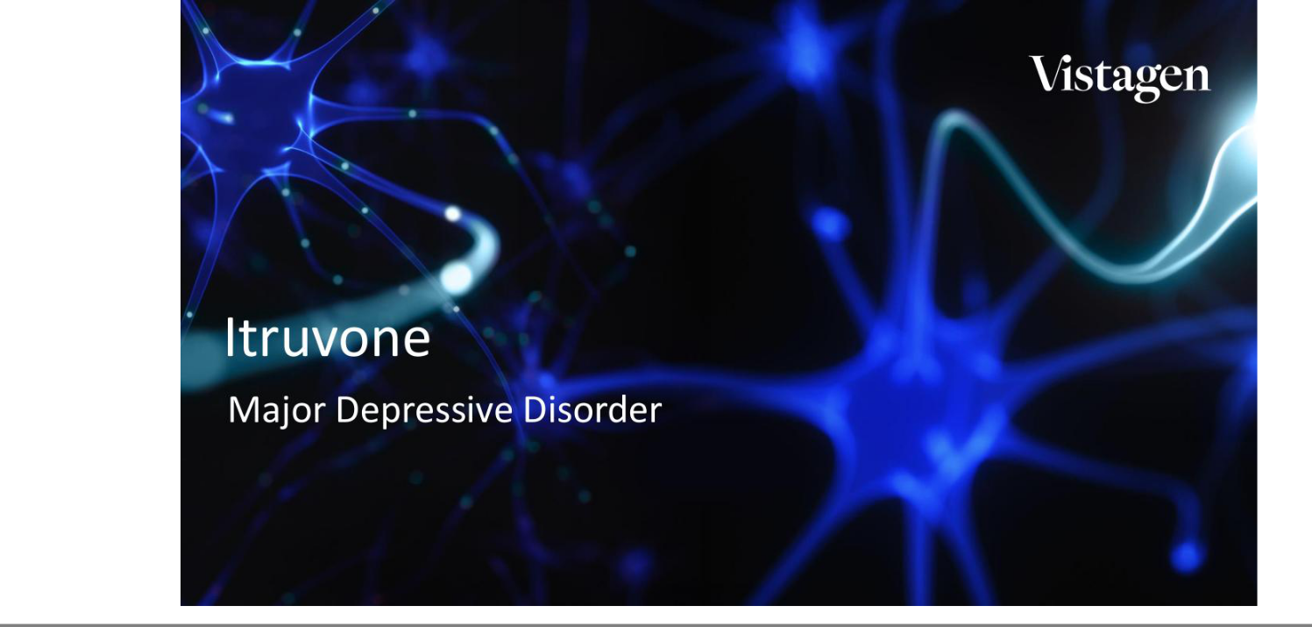

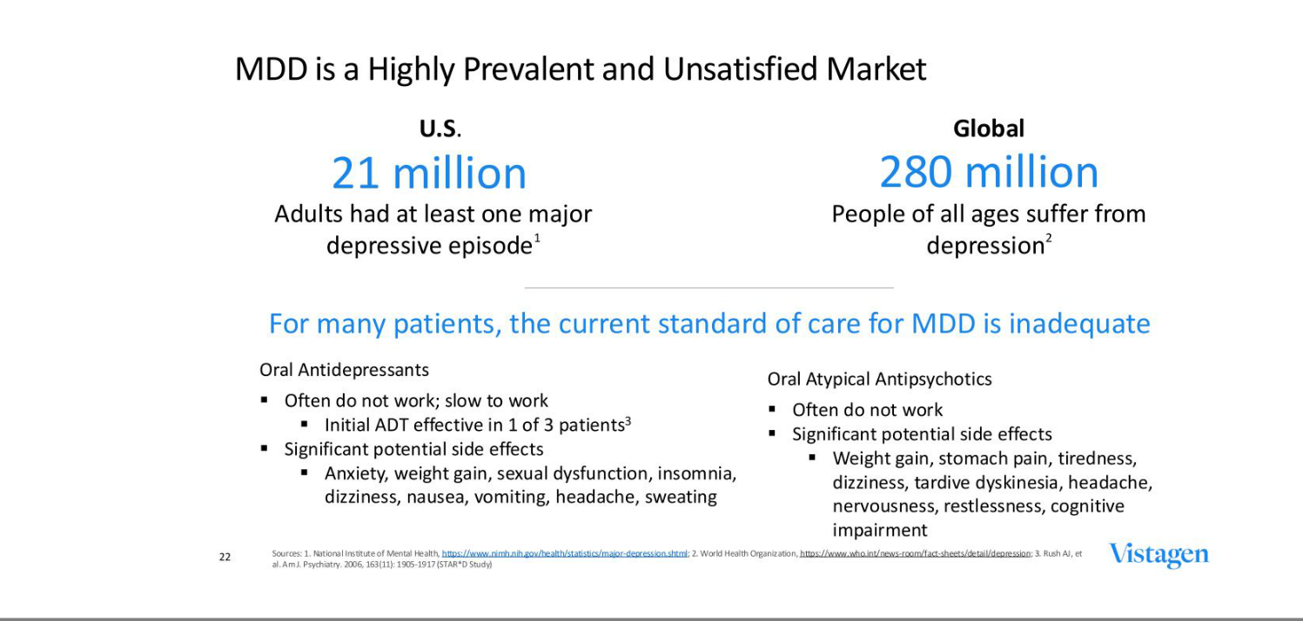

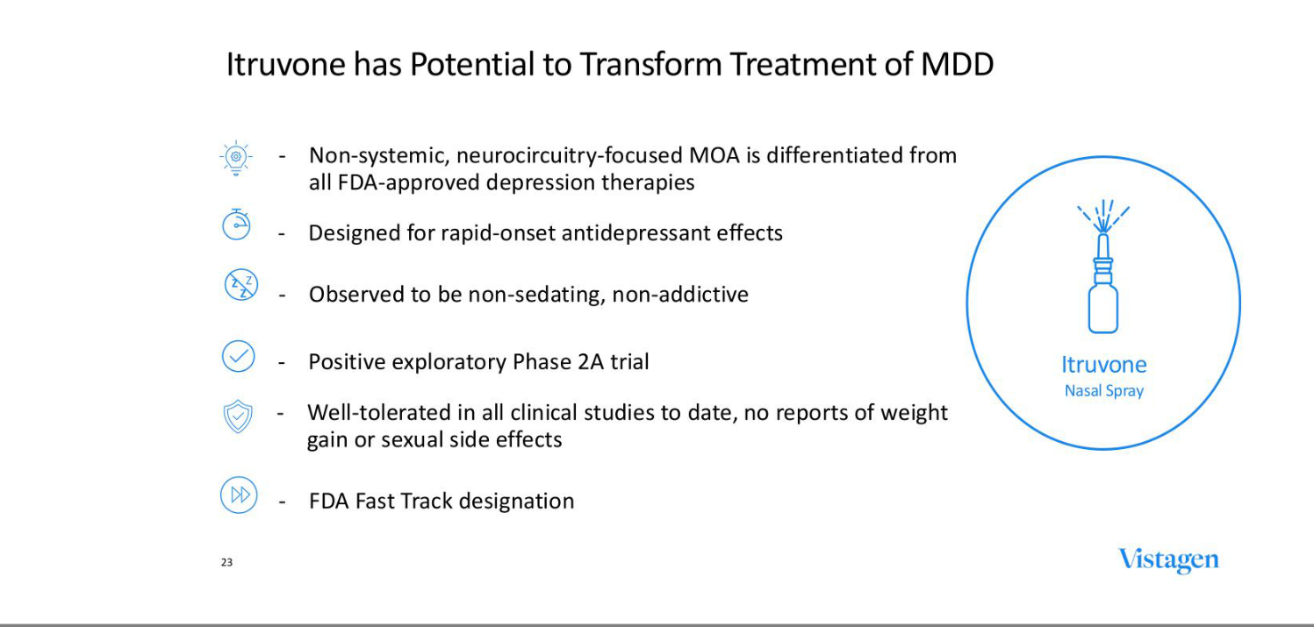

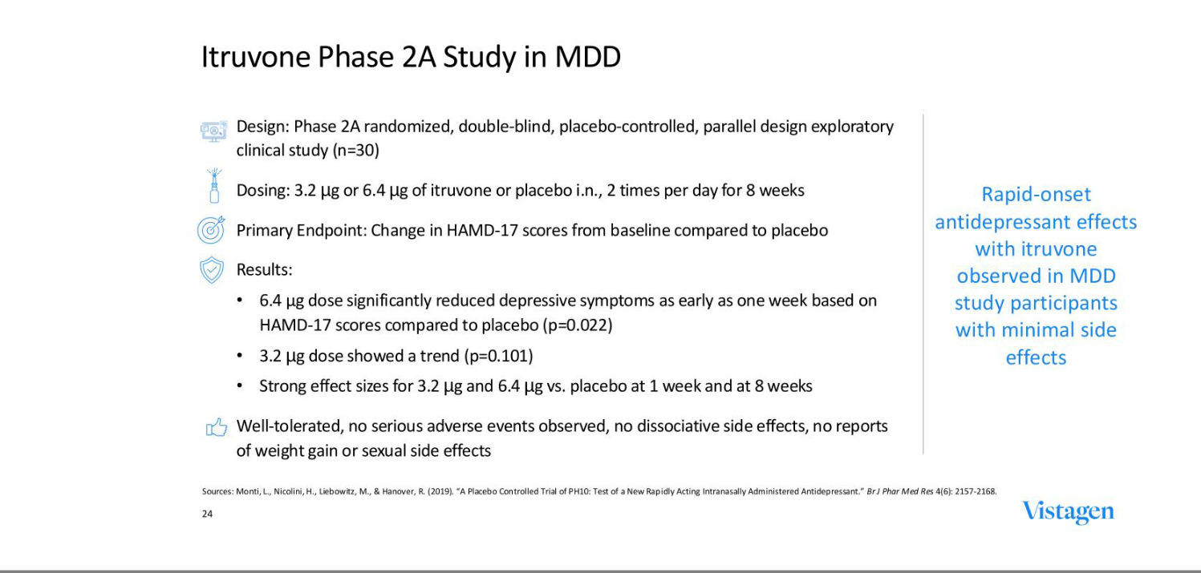

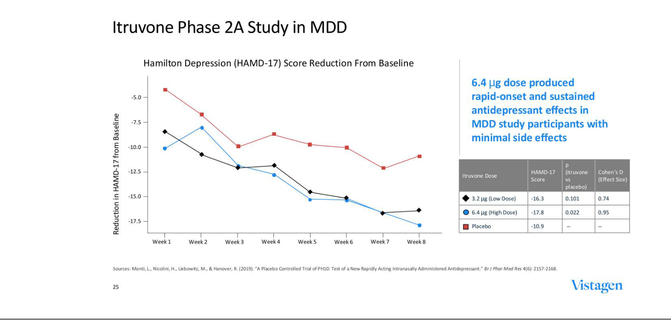

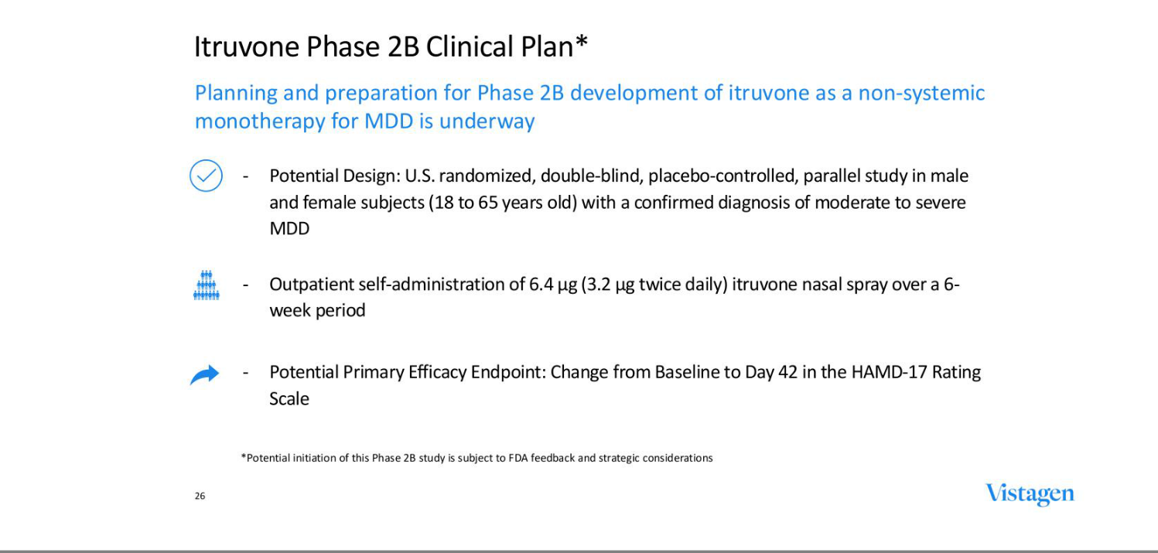

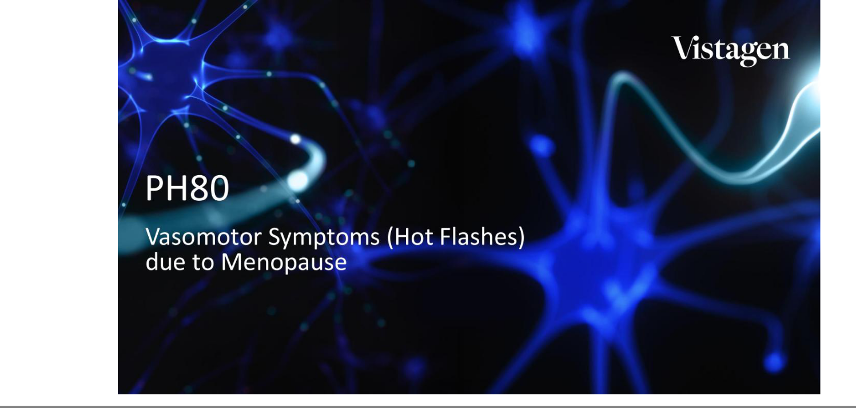

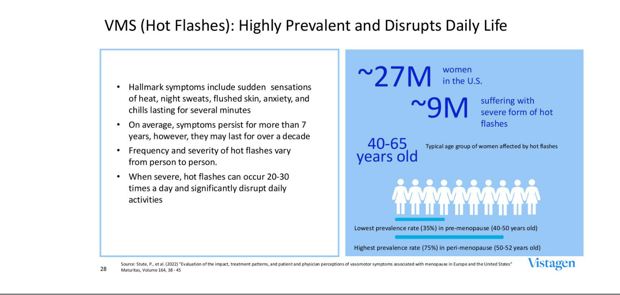

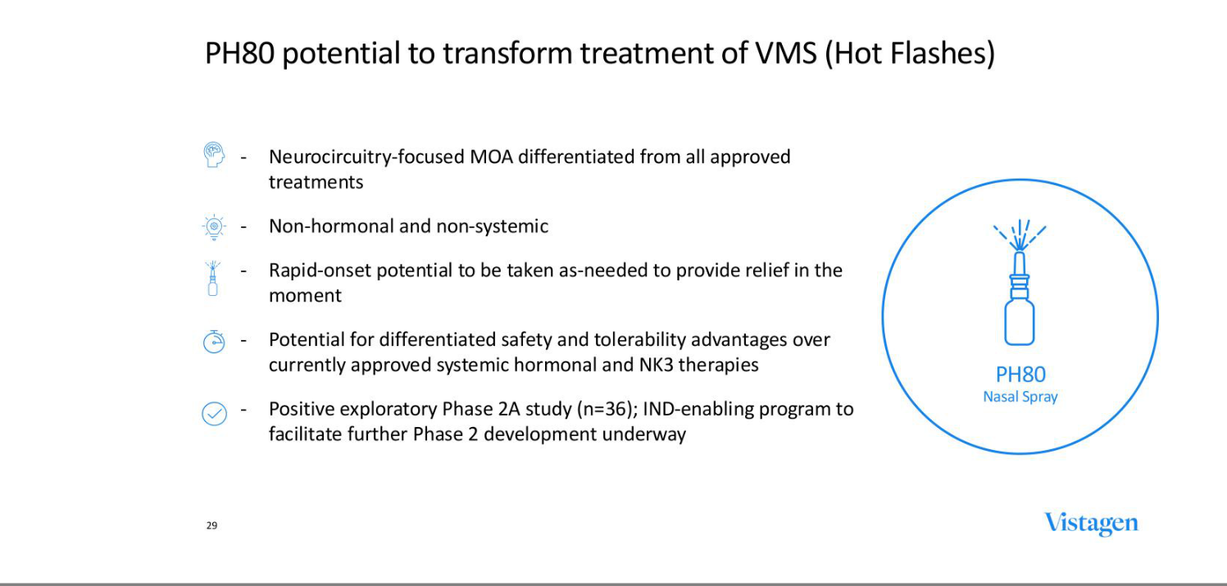

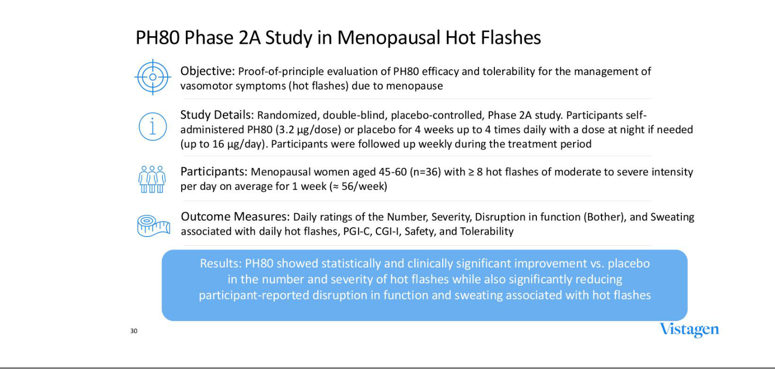

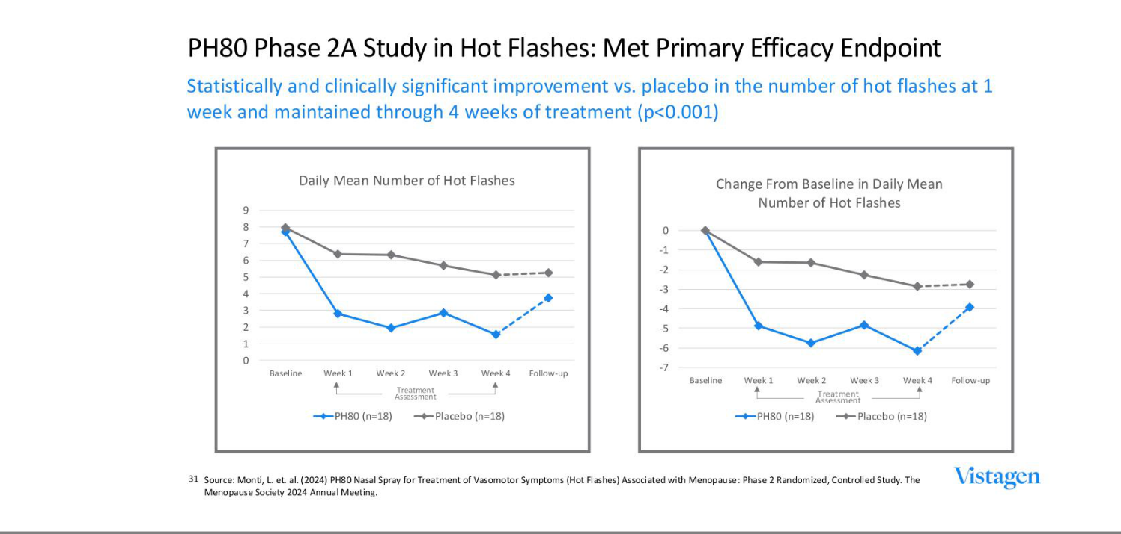

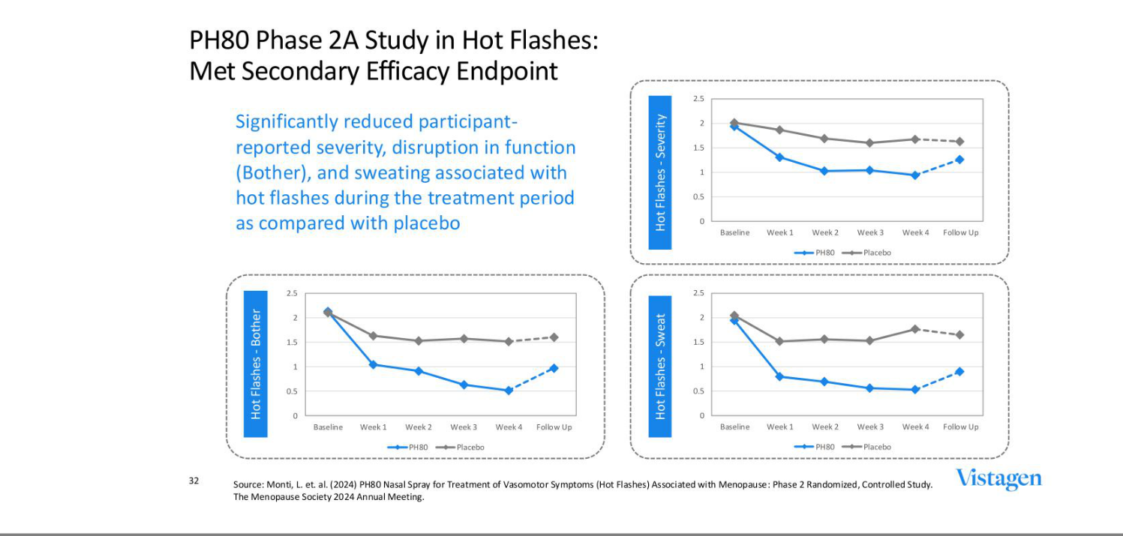

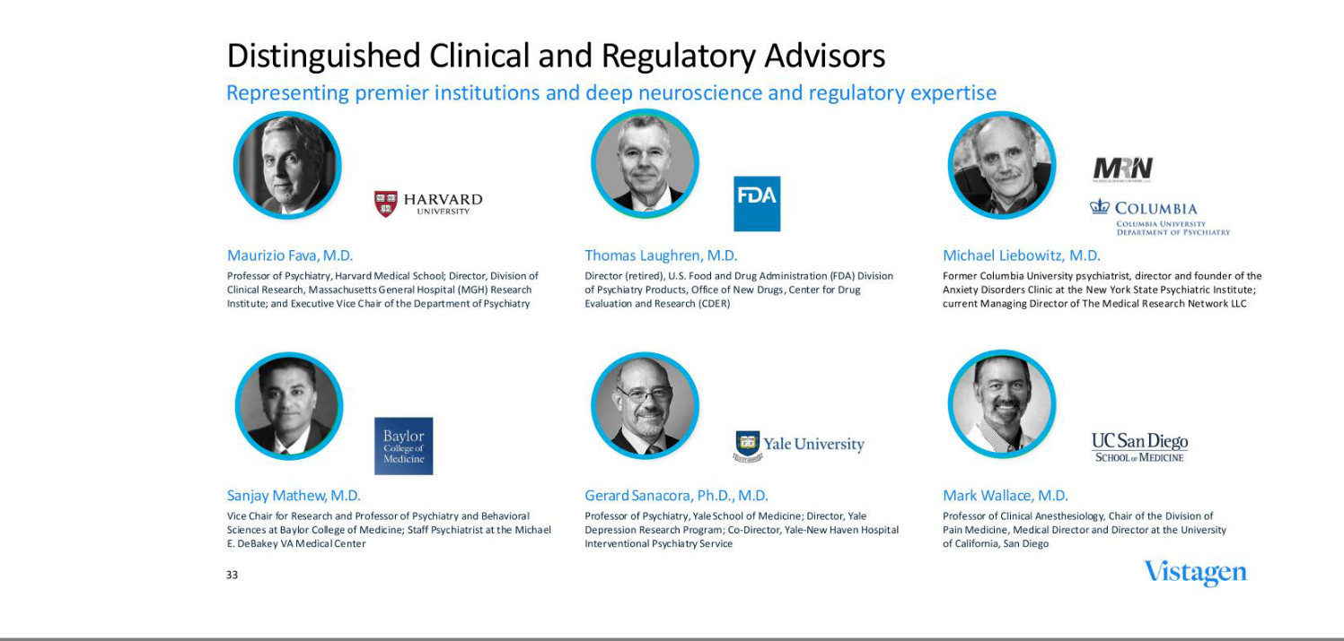



EXHIBIT 99.2


Vistagen to Participate in Stifel 2025 Virtual CNS Forum

SOUTH SAN FRANCISCO, Calif, March 4, 2025 - Vistagen (Nasdaq: VTGN), a clinical-stage biopharmaceutical company pioneering neuroscience with nose-to-brain neurocircuitry to develop and commercialize a new class of intranasal product candidates called pherines, today announced that management will participate in Stifel’s 2025 Virtual CNS Forum.

Vistagen’s President and Chief Executive Officer, Shawn Singh, will participate in a fireside chat presentation on Tuesday, March 18, 2025, at 12 p.m. Eastern Time. A live webcast will be accessible through the “Events” page in the “Investors” section of the Company’s website at www.Vistagen.com. A replay of the webcast will be archived and available following the event.

About Vistagen

Headquartered in South San Francisco, CA, Vistagen (Nasdaq: VTGN) is a clinical-stage biopharmaceutical company leveraging a deep understanding of nose-to-brain neurocircuitry to develop and commercialize a broad and diverse pipeline of clinical-stage product candidates from a new class of intranasal therapies called pherines.

Pherines specifically and selectively bind to peripheral receptors in human nasal chemosensory neurons, which activate olfactory bulb-to-brain neurocircuits without requiring systemic absorption or uptake into the brain to achieve desired therapeutic benefits and differentiated safety. Vistagen’s neuroscience pipeline also includes an oral prodrug with potential to impact certain neurological conditions involving the NMDA receptor. Vistagen is passionate about developing transformative treatment options to improve the lives of individuals underserved by the current standard of care for multiple highly prevalent indications, including social anxiety disorder, major depressive disorder, and vasomotor symptoms (hot flashes) associated with menopause. Connect at www.Vistagen.com.

Investor Inquiries:

Mark A. McPartland
markmcp@vistagen.com

Media Inquiries:

Michelle P. Wellington
mwellington@vistagen.com

-1-

