UNITED STATES
SECURITIES AND EXCHANGE COMMISSION
Washington, D.C. 20549

FORM 8-K

CURRENT REPORT
Pursuant to Section 13 or 15(d) of
the Securities Exchange Act of 1934

Date of report (Date of earliest event reported): October 2, 2023

Vistagen Therapeutics, Inc.
(Exact name of Registrant as Specified in its Charter)

Nevada |  | 000-54014 |  | 20-5093315
(State or other jurisdiction of  incorporation) |  | (Commission File Number) |  | (I.R.S. Employer  Identification No.)

343 Allerton Ave.
South San Francisco, California 94080
(Address of principal executive offices)

(650) 577-3600
(Registrant’s telephone number, including area code)

Not Applicable
(Former Name or Former Address, if Changed Since Last Report)

Check the appropriate box below if the Form 8-K filing is intended to simultaneously satisfy the filing obligation of the registrant under any of the following provisions:

☐ | Written communications pursuant to Rule 425 under the Securities Act (17 CFR 230.425)
☐ | Soliciting material pursuant to Rule 14a-12 under the Exchange Act (17 CFR 240.14a-12)
☐ | Pre-commencement communications pursuant to Rule 14d-2(b) under the Exchange Act (17 CFR 240.14d-2(b))
☐ | Pre-commencement communications pursuant to Rule 13e-4(c) under the Exchange Act (17 CFR 240.13e-4(c))

Securities registered pursuant to Section 12(b) of the Act:
Title of each class |  | Trading Symbol(s) |  | Name of each exchange on which registered
Common Stock,  par value $0.001 per share |  | VTGN |  | Nasdaq Capital Market

Indicate by check mark whether the registrant is an emerging growth company as defined in Rule 405 of the Securities Act of 1933 (§230.405 of this chapter) or Rule 12b-2 of the Securities Exchange Act of 1934 (§240.12b-2 of this chapter).

Emerging growth company ☐

If an emerging growth company, indicate by check mark if the registrant has elected not to use the extended transition period for complying with any new or revised financial accounting standards provided pursuant to Section 13(a) of the Exchange Act. ☐

Item 1.01. Entry into a Material Definitive Agreement.

On October 2, 2023, Vistagen Therapeutics, Inc. (the “Company”) entered into an underwriting agreement (the “Underwriting Agreement”) with Jefferies LLC, Stifel, Nicolaus & Company, Incorporated, and William Blair & Company, L.L.C., as the representatives of the underwriters listed on Schedule A attached thereto (the “Underwriters”), in connection with the underwritten offering, issuance and sale by the Company of 15,010,810 shares of the Company’s common stock, $0.001 par value per share (the “Common Stock”), pre-funded warrants to purchase up to 3,577,240 shares of Common Stock (the “Pre-Funded Warrants”), warrants to purchase up to 9,294,022 shares of Common Stock (or pre-funded warrants to purchase up to 9,294,022 shares of Common Stock in lieu thereof) (the “T1 Warrants”) and warrants to purchase 11,265,086 shares of Common Stock (or pre-funded warrants to purchase up to 11,265,086 shares of Common Stock in lieu thereof) (the “T2 Warrants”). The combined offering price for each share of Common Stock, accompanying T1 Warrant and accompanying T2 Warrant was $5.38. The combined offering price per Pre-Funded Warrant, accompanying T1 Warrant and accompanying T2 Warrant was $5.379. The securities were issued pursuant to an effective shelf registration statement on Form S-3 (File No. 333-254299) and a related prospectus supplement filed with the Securities and Exchange Commission (the “Offering”). The Offering closed on October 4, 2023.

Each Pre-Funded Warrant has an exercise price per share of Common Stock equal to $0.001 per share, subject to certain adjustments. The Pre-Funded Warrants are exercisable at any time after October 4, 2023 and will not expire. Under the Pre-Funded Warrants, the Company may not effect the exercise of any Pre-Funded Warrant, and a holder will not be entitled to exercise any portion of any Pre-Funded Warrant, which, upon giving effect to such exercise, would cause the aggregate number of shares of the Common Stock beneficially owned by the holder of the Pre-Funded Warrant (together with its affiliates) to exceed 9.99% of the number of shares of the Common Stock outstanding immediately after giving effect to the exercise. However, any holder may increase or decrease such percentage to any other percentage (but not in excess of 19.99% if exceeding such percentage would result in a change of control under Nasdaq Listing Rule 5636(b) or any successor rule) upon at least 61 days’ prior notice from the holder to the Company subject to the terms of the Pre-Funded Warrant. At the holder’s sole discretion, the Pre-Funded Warrants may be exercised through a cashless exercise.

Each T1 Warrant has an exercise price per share of Common Stock or pre-funded warrant equal to $5.38, subject to certain adjustments. The T1 Warrants are exercisable at any time on or after October 4, 2023 and will expire 60 days after the later of (i) the date on which the Company first publicly discloses, whether by press release or Form 8-K filing, the top-line data for its PALISADE-3 Phase 3 clinical trial of fasedienol for the acute treatment of anxiety in adults with social anxiety disorder (“SAD”) and (ii) the date on which the Company first publicly discloses, whether by press release or Form 8-K filing, the top-line data for its PALISADE-4 Phase 3 clinical trial of fasedienol for the acute treatment of anxiety in adults with SAD. However, under the T1 Warrant, the Company may not effect the exercise of any T1 Warrant, and a holder will not be entitled to exercise any portion of any T1 Warrant, which, upon giving effect to such exercise, would cause the aggregate number of shares of Common Stock beneficially owned by the holder of the T1 Warrant (together with its affiliates) to exceed 9.99% of the number of shares of the Common Stock outstanding immediately after giving effect to the exercise. However, any holder may increase or decrease such percentage to any other percentage (but not in excess of 19.99% if exceeding such percentage would result in a change of control under Nasdaq Listing Rule 5636(b) or any successor rule) upon at least 61 days’ prior notice from the holder to the Company subject to the terms of the T1 Warrant. Generally, the T1 Warrants may only be exercised through a cash exercise, however, the holder may elect to exercise the T1 Warrant through a cashless exercise if at the time of exercise hereof there is no effective registration statement registering, or the prospectus contained therein is not available for the issuance of the Common Stock or pre-funded warrants to the holder.

Each T2 Warrant has an exercise price per share of Common Stock or pre-funded warrant equal to $8.877, subject to certain adjustments. The T2 Warrants are exercisable at any time on or after October 4, 2023 and will expire on October 4, 2028. Under the T2 Warrant, the Company may not effect the exercise of any T2 Warrant, and a holder will not be entitled to exercise any portion of any T2 Warrant, which, upon giving effect to such exercise, would cause the aggregate number of shares of the Common Stock beneficially owned by the holder of the T2 Warrant (together with its affiliates) to exceed 9.99% of the number of shares of the Common Stock outstanding immediately after giving effect to the exercise. However, any holder may increase or decrease such percentage to any other percentage (but not in excess of 19.99% if exceeding such percentage would result in a change of control under Nasdaq Listing Rule 5636(b) or any successor rule) upon at least 61 days’ prior notice from the holder to the Company subject to the terms of the T2 Warrant. The holder may, in its sole discretion, elect to exercise the T2 Warrant through a cashless exercise or for cash.

The Company received approximately $93.5 million of net proceeds from the Offering, after deducting underwriting discounts and commissions and estimated offering expenses payable by the Company. The Company intends to use the net proceeds of the Offering together with its existing cash and cash equivalents, for research, development, manufacturing and regulatory expenses associated with development of its product candidates, including, primarily, its PALISADE Phase 3 development program for fasedienol for the acute treatment of anxiety in adults with SAD, and for other working capital and general corporate purposes. If the Company’s PALISADE Phase 3 program is successful, the Company believes the proceeds from this offering, together with its existing cash and cash equivalents, will be sufficient to fund its operations through its potential submission of a U.S. New Drug Application for fasedienol for the acute treatment of anxiety in adults with SAD.

The Underwriting Agreement contains customary representations, warranties and covenants by the Company, customary conditions to closing, indemnification obligations of the Company and the Underwriters, including for liabilities under the Securities Act of 1933, as amended (the “Securities Act”), other obligations of the parties and termination provisions. The representations, warranties and covenants contained in the Underwriting Agreement were made solely for the benefit of the parties thereto and may be subject to limitations agreed upon by the contracting parties. Accordingly, the Underwriting Agreement is incorporated herein by reference only to provide investors with information regarding the terms of the Underwriting Agreement and not to provide investors with any other factual information regarding the Company or its business, and should be read in conjunction with the disclosures in the Company’s periodic reports and other filings with the Securities and Exchange Commission.

The foregoing descriptions of the terms of the Underwriting Agreement, Pre-Funded Warrants, T1 Warrants and T2 Warrants are each qualified in their entirety by reference to the Underwriting Agreement, form of Pre-Funded Warrant, form of T1 Warrants and form of T2 Warrants, respectively, which are attached as Exhibit 1.1, Exhibit 4.1, Exhibit 4.2 and Exhibit 4.3 hereto, respectively, and incorporated by reference herein.

Woodburn and Wedge, counsel to the Company, has issued an opinion to the Company, dated October 4, 2023, regarding the validity of the securities to be issued and sold in the Offering. A copy of the opinion is filed as Exhibit 5.1 to this Current Report on Form 8-K (this “Current Report”).

Forward-Looking Statements

This Current Report contains forward-looking statements within the meaning of the Private Securities Litigation Reform Act of 1995. All statements contained in this Current Report that do not relate to matters of historical fact should be considered forward-looking statements, including, without limitation, statements regarding the anticipated use of the net proceeds from the Offering.

These forward-looking statements are based on the Company’s current expectations and are subject to inherent uncertainties, risks and assumptions that are difficult to predict. Factors that could cause actual results to differ include, but are not limited to, the risks inherent in oncology drug development, including clinical trials, and risks related to financial reporting.

These and other important factors discussed under the caption “Risk Factors” in the Company’s Annual Report on Form 10-K for the fiscal year ended March 31, 2023 and filed with the U.S. Securities and Exchange Commission (the “SEC”) on June 28, 2023 and the Company’s other reports filed with the SEC could cause actual results to differ materially from those indicated by the forward-looking statements made in this Current Report. Any such forward-looking statements represent management’s estimates as of the date of this Current Report. While the Company may elect to update such forward-looking statements at some point in the future, the Company disclaims any obligation to do so, even if subsequent events cause the Company’s views to change. These forward-looking statements should not be relied upon as representing the Company’s views as of any date subsequent to the date of this Current Report.

Item 7.01 Regulation FD Disclosure.

On October 4, 2023, the Company began utilizing a new corporate presentation, a copy of which is attached to this Current Report as Exhibit 99.1.

The information in this Current Report, including the information set forth in Exhibit 99.1, is being furnished and shall not be deemed “filed” for purposes of Section 18 of the Securities Exchange Act of 1934, as amended (the “Exchange Act”), nor shall Exhibit 99.1 filed herewith be deemed incorporated by reference in any filing under the Securities Act or the Exchange Act, except as shall be expressly set forth by specific reference in such a filing.

Item 8.01. Other Events.

Offering Press Release

On October 2, 2023, the Company issued a press release announcing the pricing of the Offering. A copy of the press release is attached hereto as Exhibit 99.2 and incorporated here by reference.

Item 9.01. Financial Statements and Exhibits.

(d) Exhibits

Exhibit No. |  | Description
1.1 |  | Underwriting Agreement, dated as of October 2, 2023, by and among the Company, Jefferies LLC, Stifel, Nicolaus & Company, Incorporated and William Blair & Company, L.L.C.
4.1 |  | Form of Pre-Funded Warrant
4.2 |  | Form of T1 Warrant
4.3 |  | Form of T2 Warrant
5.1 |  | Opinion of Woodburn and Wedge
23.1 |  | Consent of Woodburn and Wedge (included in Exhibit 5.1)
99.1 |  | Investor Presentation
99.2 |  | Press Release
104 |  | Cover Page Interactive Data File (embedded within the inline XBRL document)

SIGNATURES

Pursuant to the requirements of the Securities Exchange Act of 1934, the registrant has duly caused this report to be signed on its behalf by the undersigned hereunto duly authorized.

 | Vistagen Therapeutics, Inc.
Date: October 4, 2023 | By: | /s/ Shawn K. Singh
 |  | Shawn K. Singh
 |  | Chief Executive Officer

Exhibit 1.1

15,010,810 Shares of Common Stock

Pre-Funded Warrants to Purchase 3,577,240 Shares of Common Stock

Tranche 1 Warrants to Purchase 9,294,022 Shares of Common Stock (or Pre-Funded Warrants in Lieu Thereof)

and

Tranche 2 Warrants to Purchase 11,265,086 Shares of Common Stock (or Pre-Funded Warrants in Lieu Thereof)

Vistagen Therapeutics, Inc.

UNDERWRITING AGREEMENT

October 2, 2023

JEFFERIES LLC
STIFEL, NICOLAUS & COMPANY, INCORPORATED
WILLIAM BLAIR & COMPANY, L.L.C.

As Representatives of the several Underwriters

c/o JEFFERIES LLC
520 Madison Avenue
New York, New York 10022

c/o STIFEL, NICOLAUS & COMPANY, INCORPORATED
One Montgomery Street, Suite 3700
San Francisco, California 94104

c/o WILLIAM BLAIR & COMPANY, L.L.C.
150 North Riverside Plaza
Chicago, Illinois 60606

Ladies and Gentlemen:

Vistagen Therapeutics, Inc., a Nevada corporation (the “Company”), proposes to issue and sell to the several underwriters named in Schedule A (the “Underwriters”) (i) an aggregate of 15,010,810 shares (the “Offered Shares”) of its common stock, par value $0.001 per share (the “Common Stock”); (ii) pre-funded warrants to purchase 3,577,240 shares of Common Stock (the “Pre-Funded Warrants”); (iii) warrants to purchase 9,294,022 shares of Common Stock (or pre-funded warrants of the Company in lieu thereof) (the “Tranche 1 Warrants”); and (iv) warrants to purchase 11,265,086 shares of Common Stock (or pre-funded warrants of the Company in lieu thereof) (the “Tranche 2 Warrants” and, together with the Tranche 1 Warrants, the “Common Warrants”; the Common Warrants, together with the Pre-Funded Warrants, the “Offered Warrants”). The Offered Shares, the Pre-Funded Warrants, the Tranche 1 Warrants and the Tranche 2 Warrants to be sold by the Company are collectively referred to as the “Offered Securities.” Each Offered Share is being sold together with (i) a Tranche 1 Warrant to purchase one half share of Common Stock (or pre-funded warrants of the Company in lieu thereof) and (ii) a Tranche 2 Warrant to purchase 0.61 shares of Common Stock (or pre-funded warrants of the Company in lieu thereof); and each Pre-Funded Warrant is being sold together with (i) a Tranche 1 Warrant to purchase one half share of Common Stock (or pre-funded warrants of the Company in lieu thereof) and (ii) a Tranche 2 Warrant to purchase 0.61 shares of Common Stock (or pre-funded warrants of the Company in lieu thereof). Jefferies LLC (“Jefferies”), Stifel, Nicolaus & Company, Incorporated and William Blair & Company, L.L.C. have agreed to act as representatives of the several Underwriters (in such capacity, the “Representatives”) in connection with the offering and sale of the Offered Securities. To the extent there are no additional underwriters listed on Schedule A, the term “Representatives” as used herein shall mean you, as Underwriters, and the term “Underwriters” shall mean either the singular or the plural, as the context requires. As used herein, “Warrant Shares” means the shares of Common Stock issuable upon exercise of the Offered Warrants.

The Company has prepared and filed with the Securities and Exchange Commission (the “Commission”) a shelf registration statement on Form S-3, File No. 333-254299, including a base prospectus (the “Base Prospectus”) to be used in connection with the public offering and sale of the Offered Securities. Such registration statement, as amended, including the financial statements, exhibits and schedules thereto, in the form in which it became effective under the Securities Act of 1933, as amended, and the rules and regulations promulgated thereunder (collectively, the “Securities Act”), including all documents incorporated or deemed to be incorporated by reference therein and any information deemed to be a part thereof at the time of effectiveness pursuant to Rule 430A or 430B under the Securities Act, is called the “Registration Statement.” Any registration statement filed by the Company pursuant to Rule 462(b) under the Securities Act in connection with the offer and sale of the Offered Securities is called the “Rule 462(b) Registration Statement,” and from and after the date and time of filing of any such Rule 462(b) Registration Statement the term “Registration Statement” shall include the Rule 462(b) Registration Statement. Each preliminary prospectus supplement used in connection with the offering of the Offered Securities, if any, including the Base Prospectus, are collectively referred to herein as a “preliminary prospectus.” As used herein, the term “Prospectus” shall mean the prospectus supplement to the Base Prospectus that describes the Offered Securities and the offering thereof (the “Prospectus Supplement”), together with the Base Prospectus, in the form first used by the Underwriters to confirm sales of the Offered Securities or in the form first made available to the Underwriters by the Company to meet requests of purchasers pursuant to Rule 173 under the Securities Act. References herein to any preliminary prospectus and the Prospectus shall refer to both the prospectus supplement and the Base Prospectus components of such prospectus. As used herein, “Applicable Time” is 7:30 a.m. (New York City time) on October 2, 2023. As used herein, “free writing prospectus” has the meaning set forth in Rule 405 under the Securities Act, and “Time of Sale Prospectus” means the Base Prospectus, as amended or supplemented immediately prior to the Applicable Time, together with the free writing prospectuses, if any, identified in Schedule B hereto and the pricing information set forth on Schedule C hereto. As used herein, “Road Show” means a “road show” (as defined in Rule 433 under the Securities Act) relating to the offering of the Offered Securities contemplated hereby that is a “written communication” (as defined in Rule 405 under the Securities Act). “Marketing Materials” means any materials or information provided to investors by, or with the approval of, the Company in connection with the marketing of the offering of the Offered Securities, including any roadshow or investor presentations made to investors by the Company (whether in person or electronically).

2

All references in this Agreement to the Registration Statement, any preliminary prospectus, the Base Prospectus and the Prospectus shall include the documents incorporated or deemed to be incorporated by reference therein. All references in this Agreement to financial statements and schedules and other information which are “contained,” “included” or “stated” in, or “part of” the Registration Statement, the Rule 462(b) Registration Statement, any preliminary prospectus, the Base Prospectus, the Time of Sale Prospectus or the Prospectus, and all other references of like import, shall be deemed to mean and include all such financial statements and schedules and other information which is or is deemed to be incorporated by reference in the Registration Statement, the Rule 462(b) Registration Statement, any preliminary prospectus, the Base Prospectus, the Time of Sale Prospectus or the Prospectus, as the case may be. All references in this Agreement to amendments or supplements to the Registration Statement, any preliminary prospectus, the Base Prospectus, the Time of Sale Prospectus or the Prospectus shall be deemed to mean and include the filing of any document under the Securities Exchange Act of 1934, as amended, and the rules and regulations promulgated thereunder (collectively, the “Exchange Act”) that is or is deemed to be incorporated by reference in the Registration Statement, any preliminary prospectus, the Base Prospectus, or the Prospectus, as the case may be. All references in this Agreement to (i) the Registration Statement, any preliminary prospectus, the Base Prospectus or the Prospectus, any amendments or supplements to any of the foregoing, or any free writing prospectus, shall include any copy thereof filed with the Commission pursuant to its Electronic Data Gathering, Analysis and Retrieval System (“EDGAR”) and (ii) the Prospectus shall be deemed to include any “electronic Prospectus” provided for use in connection with the offering of the Offered Securities as contemplated by Section 3(n) of this Agreement.

The Company hereby confirms its agreements with the Underwriters as follows:

Section 1. Representations and Warranties.

The Company hereby represents, warrants and covenants to each Underwriter, as of the date of this Agreement and as of the Closing Date (as hereinafter defined), as follows:

(a) Compliance with Registration Requirements. The Registration Statement has become effective under the Securities Act. The Company has complied, to the Commission’s satisfaction, with all requests of the Commission for additional or supplemental information, if any. No stop order suspending the effectiveness of the Registration Statement is in effect and no proceedings for such purpose have been instituted or are pending or, to the knowledge of the Company, are contemplated or threatened by the Commission. At the time the Company’s Annual Report on Form 10-K for the fiscal year ended March 31, 2023 (the “Annual Report”) was filed with the Commission, or, if later, at the time the Registration Statement was originally filed with the Commission, the Company met the then-applicable requirements for use of Form S-3 under the Securities Act. The Company meets the requirements for use of Form S-3 under the Securities Act. The documents incorporated or deemed to be incorporated by reference in the Registration Statement, the Time of Sale Prospectus and the Prospectus, at the time they were or hereafter are filed with the Commission, or became effective under the Exchange Act, as the case may be, complied and will comply, in all material respects, with the requirements of the Exchange Act.

(b) Disclosure. Each preliminary prospectus and the Prospectus when filed complied, in all material respects, with the Securities Act and, if filed by electronic transmission pursuant to EDGAR, was identical (except as may be permitted by Regulation S-T under the Securities Act) to the copy thereof delivered to the Underwriters for use in connection with the offer and sale of the Offered Securities. Each of the Registration Statement and any post-effective amendment thereto, at the time it became or becomes effective, complied and will comply, in all material respects, with the Securities Act and did not and will not contain any untrue statement of a material fact or omit to state a material fact required to be stated therein or necessary to make the statements therein not misleading. As of the Applicable Time, the Time of Sale Prospectus did not, and at the Closing Date (as defined in ‎Section 2) will not, contain any untrue statement of a material fact or omit to state a material fact necessary to make the statements therein, in the light of the circumstances under which they were made, not misleading. The Prospectus, as of its date, did not, and at the Closing Date, will not, contain any untrue statement of a material fact or omit to state a material fact necessary in order to make the statements therein, in the light of the circumstances under which they were made, not misleading. The representations and warranties set forth in the three immediately preceding sentences do not apply to statements in or omissions from the Registration Statement or any post-effective amendment thereto, or the Prospectus or the Time of Sale Prospectus, or any amendments or supplements thereto, made in reliance upon and in conformity with written information relating to any Underwriter furnished to the Company in writing by the Representatives expressly for use therein, it being understood and agreed that the only such information consists of the information described in ‎Section 9(b) below. There are no contracts or other documents required to be described in the Time of Sale Prospectus or the Prospectus or to be filed as an exhibit to the Registration Statement which have not been described or filed as required.

3

(c) Free Writing Prospectuses; Road Show. As of the determination date referenced in Rule 164(h) under the Securities Act, the Company was not, is not or will not be (as applicable) an “ineligible issuer” in connection with the offering of the Offered Securities pursuant to Rules 164, 405 and 433 under the Securities Act. Each free writing prospectus that the Company is required to file pursuant to Rule 433(d) under the Securities Act has been, or will be, filed with the Commission in accordance with the requirements of the Securities Act. Each free writing prospectus that the Company has filed, or is required to file, pursuant to Rule 433(d) under the Securities Act or that was prepared by or on behalf of or used or referred to by the Company complies or will comply in all material respects with the requirements of Rule 433 under the Securities Act, including timely filing with the Commission, retention and legending, as applicable, and each such free writing prospectus, as of its issue date and at all subsequent times through the completion of the public offer and sale of the Offered Securities did not, does not and will not include any information that conflicted, conflicts or will conflict with the information contained in the Registration Statement, the Prospectus or any preliminary prospectus unless such information has been superseded or modified as of such time. Except for the free writing prospectuses, if any, identified in Schedule B, and electronic road shows, if any, furnished to you before first use, the Company has not prepared, used or referred to, and will not, without your prior written consent, which consent shall not be unreasonably withheld, prepare, use or refer to, any free writing prospectus. Each Road Show, when considered together with the Time of Sale Prospectus, did not, as of the Applicable Time, contain any untrue statement of a material fact or omit to state a material fact necessary to make the statements therein, in the light of the circumstances under which they were made, not misleading.

(d) Distribution of Offering Material By the Company. Prior to the completion of the Underwriters’ distribution of the Offered Securities, the Company has not distributed and will not distribute any offering material in connection with the offering and sale of the Offered Securities other than the Registration Statement, the Time of Sale Prospectus, the Prospectus or any free writing prospectus reviewed and consented to by the Representatives, which consent shall not be unreasonably withheld, the free writing prospectuses, if any, identified on Schedule B hereto.

(e) The Underwriting Agreement. This Agreement has been duly authorized, executed and delivered by the Company.

(f) Authorization of the Offered Securities. The Offered Shares have been duly authorized by the Company for issuance and sale pursuant to this Agreement and, when issued and delivered by the Company against payment therefor pursuant to this Agreement, will be validly issued, fully paid and nonassessable, and the issuance and sale of the Offered Shares is not subject to any preemptive rights, rights of first refusal or other similar rights to subscribe for or purchase the Offered Shares. The Offered Warrants have been duly authorized by the Company and, when executed and delivered by the Company, will be valid and binding agreements of the Company, enforceable against the Company in accordance with their terms, except as the enforcement thereof may be limited by bankruptcy, insolvency, reorganization, moratorium or other similar laws relating to or affecting the rights and remedies of creditors or by general equitable principles. The Warrant Shares have been duly authorized and validly reserved for issuance upon exercise of the Offered Warrants in a number sufficient to meet the current exercise requirements. The Warrant Shares, when issued and delivered upon exercise of the Pre-Funded Warrants and the Common Warrants, as applicable, and in accordance therewith, will be validly issued, fully paid and nonassessable, and the issuance of the Warrant Shares, is not subject to any preemptive rights, rights of first refusal or other similar rights to subscribe for or purchase the Warrant Shares.

4

(g) [Reserved.]

(h) [Reserved.]

(i) No Applicable Registration or Other Similar Rights. There are no persons with registration or other similar rights to have any equity or debt securities registered for sale under the Registration Statement or included in the offering contemplated by this Agreement, except for such rights as have been duly waived.

(j) No Material Adverse Change. Except as otherwise disclosed in the Registration Statement, the Time of Sale Prospectus and the Prospectus, subsequent to the respective dates as of which information is given in the Registration Statement, the Time of Sale Prospectus and the Prospectus: (i) there has been no material adverse change, or any development that could be expected to result in a material adverse change, in (A) the condition, financial or otherwise, or in the earnings, business, properties, operations, operating results, assets, liabilities or prospects, whether or not arising from transactions in the ordinary course of business, of the Company and its subsidiaries, considered as one entity or (B) the ability of the Company to consummate the transactions contemplated by this Agreement or perform its obligations hereunder (any such change being referred to herein as a “Material Adverse Change”); (ii) the Company and its subsidiaries, considered as one entity, have not incurred any material liability or obligation, indirect, direct or contingent, including without limitation any losses or interference with their business from fire, explosion, flood, earthquakes, accident or other calamity, whether or not covered by insurance, or from any strike, labor dispute or court or governmental action, order or decree, that are material, individually or in the aggregate, to the Company and its subsidiaries, considered as one entity, and have not entered into any material transactions not in the ordinary course of business; and (iii) there has not been any material decrease in the capital stock or any material increase in any short-term or long-term indebtedness of the Company or its subsidiaries and there has been no dividend or distribution of any kind declared, paid or made by the Company or, except for dividends paid to the Company or other subsidiaries, by any of the Company’s subsidiaries on any class of capital stock, or any repurchase or redemption by the Company or any of its subsidiaries of any class of capital stock.

(k) Independent Accountants. WithumSmith+Brown, PC, which has expressed its opinion with respect to the consolidated financial statements (which term as used in this Agreement includes the related notes thereto) filed with the Commission as a part of the Registration Statement, the Time of Sale Prospectus and the Prospectus, is (i) an independent registered public accounting firm as required by the Securities Act, the Exchange Act, and the rules of the Public Company Accounting Oversight Board (“PCAOB”), (ii) in compliance with the applicable requirements relating to the qualification of accountants under Rule 2-01 of Regulation S-X under the Securities Act and (iii) a registered public accounting firm as defined by the PCAOB whose registration has not been suspended or revoked and who has not requested such registration to be withdrawn.

5

(l) Financial Statements. The financial statements filed with the Commission as a part of the Registration Statement, the Time of Sale Prospectus and the Prospectus present fairly, in all material respects, the consolidated financial position of the Company and its subsidiaries as of the dates indicated and the results of their operations, changes in stockholders’ equity and cash flows for the periods specified. The supporting schedules included in the Registration Statement present fairly the information required to be stated therein. Such financial statements and supporting schedules have been prepared in conformity with generally accepted accounting principles as applied in the United States (“GAAP”) applied on a consistent basis throughout the periods involved, except as may be expressly stated in the related notes thereto. The interactive data in eXtensible Business Reporting Language included or incorporated by reference in the Registration Statement fairly presents the information called for in all material respects and has been prepared in accordance with the Commission’s rules and guidelines applicable thereto. No other financial statements or supporting schedules are required to be included in the Registration Statement, the Time of Sale Prospectus or the Prospectus. The financial data set forth in each of the Registration Statement, the Time of Sale Prospectus and the Prospectus under the caption “Capitalization” fairly present, in all material respects, the information set forth therein on a basis consistent with that of the audited financial statements contained in the Registration Statement, the Time of Sale Prospectus and the Prospectus. To the Company’s knowledge, no person who has been suspended or barred from being associated with a registered public accounting firm, or who has failed to comply with any sanction pursuant to Rule 5300 promulgated by the PCAOB, has participated in or otherwise aided the preparation of, or audited, the financial statements, supporting schedules or other financial data filed with the Commission as a part of the Registration Statement, the Time of Sale Prospectus and the Prospectus.

(m) Company’s Accounting System. The Company and each of its subsidiaries make and keep books and records that are accurate, in all material respects, and maintain a system of internal accounting controls sufficient to provide reasonable assurance that: (i) transactions are executed in accordance with management’s general or specific authorization; (ii) transactions are recorded as necessary to permit preparation of financial statements in conformity with GAAP and to maintain accountability for assets; (iii) access to assets is permitted only in accordance with management’s general or specific authorization; (iv) the recorded accountability for assets is compared with existing assets at reasonable intervals and appropriate action is taken with respect to any differences; and (v) the interactive data in eXtensible Business Reporting Language included or incorporated by reference in the Registration Statement, the Time of Sale Prospectus and the Prospectus fairly presents the information called for in all material respects and is prepared in accordance with the Commission's rules and guidelines applicable thereto.

(n) Disclosure Controls and Procedures; Deficiencies in or Changes to Internal Control Over Financial Reporting. The Company has established and maintains disclosure controls and procedures (as defined in Rules 13a-15 and 15d-15 under the Exchange Act), which (i) are designed to ensure that material information relating to the Company, including its consolidated subsidiaries, is made known to the Company’s principal executive officer and its principal financial officer by others within those entities, particularly during the periods in which the periodic reports required under the Exchange Act are being prepared; (ii) have been evaluated by management of the Company for effectiveness as of the end of the Company’s most recent fiscal quarter; and (iii) are effective in all material respects to perform the functions for which they were established. Since the end of the Company’s most recent audited fiscal year, there has been no material weakness in the Company’s internal control over financial reporting (whether or not remediated) and no change in the Company’s internal control over financial reporting that has materially affected, or is reasonably likely to materially affect, the Company’s internal control over financial reporting (as defined in Rule 13a-15(f) under the Exchange Act). The Company is not aware of any change in its internal control over financial reporting that has occurred during its most recent fiscal quarter that has materially affected, or is reasonably likely to materially affect, the Company’s internal control over financial reporting.

(o) Incorporation and Good Standing of the Company. The Company has been duly incorporated and is validly existing as a corporation in good standing under the laws of the jurisdiction of its incorporation and has the corporate power and authority to own, lease and operate its properties and to conduct its business as described in the Registration Statement, the Time of Sale Prospectus and the Prospectus and to enter into and perform its obligations under this Agreement. The Company is duly qualified as a foreign corporation to transact business and is in good standing in the State of jurisdiction of its principal place of business and each other jurisdiction in which such qualification is required, whether by reason of the ownership or leasing of property or the conduct of business, except where the failure to qualify would not reasonably be expected to result in a Material Adverse Change.

6

(p) Subsidiaries. Each of the Company’s “subsidiaries” (for purposes of this Agreement, as defined in Rule 405 under the Securities Act) has been duly incorporated or organized, as the case may be, and is validly existing as a corporation, partnership or limited liability company, as applicable, in good standing under the laws of the jurisdiction of its incorporation or organization and has the power and authority (corporate or other) to own, lease and operate its properties and to conduct its business as described in the Registration Statement, the Time of Sale Prospectus and the Prospectus. Each of the Company’s subsidiaries is duly qualified as a foreign corporation, partnership or limited liability company, as applicable, to transact business and is in good standing in each jurisdiction in which such qualification is required, whether by reason of the ownership or leasing of property or the conduct of business, except where the failure to qualify would not reasonably be expected to result in a Material Adverse Change. All of the issued and outstanding capital stock or other equity or ownership interests of each of the Company’s subsidiaries have been duly authorized and validly issued, are fully paid and nonassessable and are owned by the Company, directly or through subsidiaries, free and clear of any security interest, mortgage, pledge, lien, encumbrance or adverse claim. None of the outstanding capital stock or equity interest in any subsidiary was issued in violation of preemptive or similar rights of any security holder of such subsidiary. The constitutive or organizational documents of each of the subsidiaries comply, in all material respects, with the requirements of applicable laws of its jurisdiction of incorporation or organization and are in full force and effect. The Company does not own or control, directly or indirectly, any corporation, association or other entity other than the subsidiaries listed in Schedule D hereto.

(q) Capitalization and Other Capital Stock Matters. The authorized, issued and outstanding capital stock of the Company is as set forth in the Registration Statement, the Time of Sale Prospectus and the Prospectus under the caption “Capitalization” (other than for subsequent issuances, if any, pursuant to employee benefit plans, or upon the exercise of outstanding options or warrants, in each case as described in the Registration Statement, the Time of Sale Prospectus and the Prospectus). The Offered Securities (including the Warrant Shares) are consistent, in all material respects, to the description thereof contained in the Time of Sale Prospectus. All of the issued and outstanding shares of Common Stock have been duly authorized and validly issued, are fully paid and nonassessable and have been issued in compliance with all federal and state securities laws. None of the outstanding shares of Common Stock was issued in violation of any preemptive rights, rights of first refusal or other similar rights to subscribe for or purchase securities of the Company. There are no authorized or outstanding options, warrants, preemptive rights, rights of first refusal or other rights to purchase, or equity or debt securities convertible into or exchangeable or exercisable for, any capital stock of the Company or any of its subsidiaries other than those described in the Registration Statement, the Time of Sale Prospectus and the Prospectus. The descriptions of the Company’s stock option, stock bonus and other stock plans or arrangements, and the options or other rights granted thereunder, set forth in the Registration Statement, the Time of Sale Prospectus and the Prospectus accurately and fairly presents, in all material respects, the information required to be shown with respect to such plans, arrangements, options and rights.

(r) Stock Exchange Listing. The shares of Common Stock and the Warrant Shares are registered pursuant to Section 12(b) or 12(g) of the Exchange Act and are listed on the Nasdaq Capital Market (the “Nasdaq”), and the Company has taken no action designed to, or likely to have the effect of, terminating the registration of the Offered Securities under the Exchange Act or delisting the shares of Common Stock from the Nasdaq, has the Company received any notification that the Commission or the Nasdaq is contemplating terminating such registration or listing. To the Company’s knowledge, it is in compliance with all applicable listing requirements of Nasdaq.

7

(s) Non-Contravention of Existing Instruments; No Further Authorizations or Approvals Required. Neither the Company nor any of its subsidiaries is in violation of its charter or by-laws, partnership agreement or operating agreement or similar organizational documents, as applicable, or is in default (or, with the giving of notice or lapse of time, would be in default) (“Default”) under any indenture, loan, credit agreement, note, lease, license agreement, contract, franchise or other instrument (including, without limitation, any pledge agreement, security agreement, mortgage or other instrument or agreement evidencing, guaranteeing, securing or relating to indebtedness) to which the Company or any of its subsidiaries is a party or by which it or any of them may be bound, or to which any of their respective properties or assets are subject (each, an “Existing Instrument”), except for such Defaults as would not be reasonably expected, individually or in the aggregate, to result in a Material Adverse Change. The Company’s execution, delivery and performance of this Agreement, the Common Warrants and the Pre-Funded Warrants, consummation of the transactions contemplated hereby and by the Registration Statement, the Time of Sale Prospectus and the Prospectus and the issuance and sale of the Offered Securities (including the use of proceeds from the sale of the Offered Securities as described in the Registration Statement, the Time of Sale Prospectus and the Prospectus under the caption “Use of Proceeds”) (i) have been duly authorized by all necessary corporate action and will not result in any violation of the provisions of the charter or by-laws, partnership agreement or operating agreement or similar organizational documents, as applicable, of the Company or any subsidiary (ii) will not conflict with or constitute a breach of, or Default or a Debt Repayment Triggering Event (as defined below) under, or result in the creation or imposition of any lien, charge or encumbrance upon any property or assets of the Company or any of its subsidiaries pursuant to, or require the consent of any other party to, any Existing Instrument and (iii) will not result in any violation of any law, administrative regulation or administrative or court decree applicable to the Company or any of its subsidiaries, except for such conflicts, breaches or violations specified in subsection (ii) and (iii) above that would not reasonably be expected to result in a Material Adverse Change. No consent, approval, authorization or other order of, or registration or filing with, any court or other governmental or regulatory authority or agency, is required for the Company’s execution, delivery and performance of this Agreement, the Pre-Funded Warrants, the Common Warrants and consummation of the transactions contemplated hereby and by the Registration Statement, the Time of Sale Prospectus and the Prospectus, except such as have been obtained or made by the Company and are in full force and effect under the Securities Act and such as may be required under applicable state securities or blue sky laws or the Financial Industry Regulatory Authority, Inc. (“FINRA”). As used herein, a “Debt Repayment Triggering Event” means any event or condition which gives, or with the giving of notice or lapse of time would give, the holder of any note, debenture or other evidence of indebtedness (or any person acting on such holder’s behalf) the right to require the repurchase, redemption or repayment of all or a portion of such indebtedness by the Company or any of its subsidiaries.

(t) Compliance with Laws. The Company and its subsidiaries have been, during the past three (3) years, and are in compliance with all applicable laws, rules and regulations, except where failure to be so in compliance would not reasonably be expected, individually or in the aggregate, to result in a Material Adverse Change.

(u) No Material Actions or Proceedings. There is no action, suit, proceeding, inquiry or investigation brought by or before any legal or governmental entity now pending or, to the knowledge of the Company, threatened, against or affecting the Company or any of its subsidiaries, that would reasonably be expected, individually or in the aggregate, to result in a Material Adverse Change. No labor dispute with the employees of the Company or any of its subsidiaries, or with the employees of any principal supplier, manufacturer, customer or contractor of the Company, exists or, to the knowledge of the Company, is threatened or imminent, except as would not reasonably be expected to result in a Material Adverse Change.

8

(v) Intellectual Property Rights. The Company and its subsidiaries own, or have obtained valid and enforceable licenses for, the inventions, patent applications, patents, trademarks, trade names, service names, copyrights, trade secrets and other intellectual property described in the Registration Statement, the Time of Sale Prospectus and the Prospectus as being owned or licensed by them or used in the conduct of their respective businesses as currently conducted or as currently proposed to be conducted (collectively, “Intellectual Property”). To the Company’s knowledge, the conduct of their respective businesses does not and will not infringe, misappropriate or otherwise conflict in any material respect with any intellectual property rights of others, except as would not be reasonably be expected, individually or in the aggregate, to result in a Material Adverse Change. The Intellectual Property of the Company has not been adjudged by a court of competent jurisdiction to be invalid or unenforceable, in whole or in part, and the Company is unaware of any facts which, in the Company’s opinion, would form a reasonable basis for any such adjudication. To the Company's knowledge, except as otherwise described in the Registration Statement, the Time of Sale Prospectus and the Prospectus: (i) there are no third parties who have rights to any Intellectual Property, except for customary reversionary rights of third-party licensors with respect to Intellectual Property that is disclosed in the Registration Statement, the Time of Sale Prospectus and the Prospectus as licensed to the Company or one or more of its subsidiaries; and (ii) there is no infringement by third parties of any Intellectual Property, except, for each of (i) and (ii), as would not be reasonably be expected, individually or in the aggregate, to result in a Material Adverse Change. There is no pending or, to the Company’s knowledge, threatened action, suit, proceeding or claim by third parties: (A) challenging the Company’s and its subsidiaries’ rights in or to any Intellectual Property, and the Company is unaware of any facts which, in the Company’s opinion, would form a reasonable basis for any such action, suit, proceeding or claim; (B) challenging the validity, enforceability or scope of any Intellectual Property, and the Company is unaware of any facts which, in the Company’s opinion, would form a reasonable basis for any such action, suit, proceeding or claim; or (C) asserting that the Company or any of its subsidiaries infringes or otherwise violates, or would, upon the commercialization of any product or service described in the Registration Statement, the Time of Sale Prospectus or the Prospectus as under development, infringe or violate, any patent, trademark, trade name, service name, copyright, trade secret or other proprietary rights of third parties, and the Company is unaware of any facts which, in the Company’s opinion, would form a reasonable basis for any such action, suit, proceeding or claim; in each case of (A), (B) and (C), except as would not reasonably be expected to result in a Material Adverse Change. The Company and its subsidiaries have complied with the terms of each agreement pursuant to which Intellectual Property has been licensed to the Company or any subsidiary, and all such agreements are in full force and effect, except when the failure to be in compliance would not reasonably be expected to result in a Material Adverse Change. To the Company’s knowledge, there are no defects in any of the patents or patent applications included in the Intellectual Property, except as would not reasonably be expected to result in a Material Adverse Change. To the Company’s knowledge, the Company and its subsidiaries have taken all reasonable steps to protect, maintain and safeguard their Intellectual Property, including the execution of appropriate nondisclosure or confidentiality agreements and invention assignment agreements with their employees, and to the Company’s knowledge, no current employee of the Company involved in the development of Intellectual Property is in or has been in violation of any material term of any employment contract, patent disclosure agreement, invention assignment agreement, non-competition agreement, non-solicitation agreement, nondisclosure agreement, or any restrictive covenant to or with a former employer where the basis of such violation relates to such employee’s employment with the Company, in each case except when the failure to be in compliance would not reasonably be expected to result in a Material Adverse Change. To the Company’s knowledge, the duty of candor and good faith as required by the United States Patent and Trademark Office during the prosecution of the United States patents and patent applications included in the Intellectual Property has been complied with in all material respects; and in all foreign offices having similar requirements, all such requirements have been complied with in all material respects, in each case except when the failure to be in compliance would not reasonably be expected to result in a Material Adverse Change. To the knowledge of the Company, none of the Company owned Intellectual Property or technology (including information technology and outsourced arrangements) employed by the Company or its subsidiaries in the conduct of their respective businesses has been obtained or is being used by the Company or its subsidiaries in violation of any contractual obligation binding on the Company or its subsidiaries or any of their respective officers, directors or employees or otherwise in violation of the rights of any persons. The product candidates, other than PH284, described in the Registration Statement, the Time of Sale Prospectus and the Prospectus as under development by the Company or any subsidiary fall within the scope of the claims of one or more patents and/or pending patent applications owned by, or exclusively licensed to, the Company or its subsidiaries.

9

(w) All Necessary Permits, etc. The Company and its subsidiaries possess such valid and current certificates, authorizations or permits required by state, federal or foreign regulatory agencies or bodies to conduct their respective businesses as currently conducted and as described in the Registration Statement, the Time of Sale Prospectus or the Prospectus (“Permits”), except where the failure to so possess would not reasonably be expected to result in a Material Adverse Change. Neither the Company nor any of its subsidiaries is in violation of, or in default under, any of the Permits or has received any notice of proceedings relating to the revocation or modification of, or non-compliance with, any such certificate, authorization or permit, that, individually or in the aggregate, if the subject of an unfavorable decision, ruling or finding, would reasonably be expected to result in a Material Adverse Change.

(x) Title to Properties. The Company and its subsidiaries have good and marketable title to all of the real and personal property and other assets reflected as owned in the financial statements referred to in Section 1(l) above (or elsewhere in the Registration Statement, the Time of Sale Prospectus or the Prospectus), in each case free and clear of any security interests, mortgages, liens, encumbrances, equities, adverse claims and other defects that would reasonably be expected to result in a Material Adverse Change. The real property, improvements, equipment and personal property held under lease by the Company or any of its subsidiaries are held under valid and enforceable leases, with such exceptions as are not material and do not materially interfere with the use made or proposed to be made of such real property, improvements, equipment or personal property by the Company or such subsidiary.

(y) Tax Law Compliance. Except as would not reasonably be expected to result in a Material Adverse Change, the Company and its subsidiaries have filed all necessary federal, state and foreign income and franchise tax returns or have properly requested extensions thereof and have paid all taxes required to be paid by any of them and, if due and payable, any related or similar assessment, fine or penalty levied against any of them except as may be being contested in good faith and by appropriate proceedings. The Company has made adequate charges, accruals and reserves in the applicable financial statements referred to in Section 1(l) above in respect of all material federal, state and foreign income and franchise taxes applicable to the Company for all periods as to which the tax liability of the Company or any of its subsidiaries has not been finally determined.

(z) Insurance. Each of the Company and its subsidiaries are insured by recognized, financially sound and reputable institutions with policies in such amounts and with such deductibles and covering such risks as are generally deemed adequate and customary for their businesses including, but not limited to, policies covering real and personal property owned or leased by the Company and its subsidiaries against theft, damage, destruction, acts of vandalism and policies covering the Company and its subsidiaries for product liability claims and clinical trial liability claims. The Company has no reason to believe that it or any of its subsidiaries will not be able (i) to renew its existing insurance coverage as and when such policies expire or (ii) to obtain comparable coverage from similar institutions as may be necessary or appropriate to conduct its business as now conducted and at a cost that would not reasonably be expected to result in a Material Adverse Change. Neither the Company nor any of its subsidiaries has been denied any insurance coverage which it has sought or for which it has applied.

10

(aa) Compliance with Environmental Laws. Except as would not reasonably be expected, individually or in the aggregate, to result in a Material Adverse Change: (i) neither the Company nor any of its subsidiaries is in violation of any federal, state, local or foreign statute, law, rule, regulation, ordinance, code, policy or rule of common law or any judicial or administrative interpretation thereof, including any judicial or administrative order, consent, decree or judgment, relating to pollution or protection of human health, the environment (including, without limitation, ambient air, surface water, groundwater, land surface or subsurface strata) or wildlife, including, without limitation, laws and regulations relating to the release or threatened release of chemicals, pollutants, contaminants, wastes, toxic substances, hazardous substances, petroleum or petroleum products (collectively, “Hazardous Materials”) or to the manufacture, processing, distribution, use, treatment, storage, disposal, transport or handling of Hazardous Materials (collectively, “Environmental Laws”); (ii) the Company and its subsidiaries have all permits, authorizations and approvals required under any applicable Environmental Laws and are each in compliance with their requirements; (iii) there are no pending or, to the knowledge of the Company, threatened administrative, regulatory or judicial actions, suits, demands, demand letters, claims, liens, notices of noncompliance or violation, investigation or proceedings relating to any Environmental Law against the Company or any of its subsidiaries; and (iv) to the knowledge of the Company, there are no events or circumstances that might reasonably be expected to form the basis of an order for clean-up or remediation, or an action, suit or proceeding by any private party or governmental body or agency, against or affecting the Company or any of its subsidiaries relating to Hazardous Materials or any Environmental Laws.

(bb) [Reserved.]

(cc) ERISA Compliance. The Company and its subsidiaries and any “employee benefit plan” (as defined under the Employee Retirement Income Security Act of 1974, as amended, and the regulations and published interpretations thereunder (collectively, “ERISA”)) established or maintained by the Company, its subsidiaries or their “ERISA Affiliates” (as defined below) are in compliance in all material respects with ERISA. “ERISA Affiliate” means, with respect to the Company or any of its subsidiaries, any member of any group of organizations described in Sections 414(b), (c), (m) or (o) of the Internal Revenue Code of 1986, as amended, and the regulations and published interpretations thereunder (the “Code”) of which the Company or such subsidiary is a member. Except as would not, individually or in the aggregate, reasonably be expected to result in a Material Adverse Change: (i) no “reportable event” (as defined under ERISA) has occurred or is reasonably expected to occur with respect to any “employee benefit plan” established or maintained by the Company, its subsidiaries or any of their ERISA Affiliates; (ii) no “employee benefit plan” established or maintained by the Company, its subsidiaries or any of their ERISA Affiliates, if such “employee benefit plan” were terminated, would have any “amount of unfunded benefit liabilities” (as defined under ERISA); (iii) neither the Company, its subsidiaries nor any of their ERISA Affiliates has incurred or reasonably expects to incur (a) any liability under Title IV of ERISA with respect to termination of, or withdrawal from, any “employee benefit plan” or (b) any material liability under Sections 412, 4971, 4975 or 4980B of the Code; and (iv) each employee benefit plan established or maintained by the Company, its subsidiaries or any of their ERISA Affiliates that is intended to be qualified under Section 401(a) of the Code is so qualified and, to the Company’s knowledge, nothing has occurred, whether by action or failure to act, which would cause the loss of such qualification.

(dd) Company Not an “Investment Company.” The Company is not, and will not be, either after receipt of payment for the Offered Securities or after the application of the proceeds therefrom as described under “Use of Proceeds” in the Registration Statement, the Time of Sale Prospectus or the Prospectus, required to register as an “investment company” under the Investment Company Act of 1940, as amended (the “Investment Company Act”).

11

(ee) No Price Stabilization or Manipulation; Compliance with Regulation M. Neither the Company nor any of its subsidiaries has taken, directly or indirectly, any action designed to or that might cause or result in stabilization or manipulation of the price of the shares of Common Stock or of any “reference security” (as defined in Rule 100 of Regulation M under the Exchange Act (“Regulation M”)) with respect to the shares of Common Stock, whether to facilitate the sale or resale of the Offered Securities or otherwise, and has taken no action which would directly or indirectly violate Regulation M.

(ff) Related-Party Transactions. There are no business relationships or related-party transactions involving the Company or any of its subsidiaries or any other person required to be described in the Registration Statement, the Time of Sale Prospectus or the Prospectus that have not been described as required.

(gg) FINRA Matters. All of the information provided to the Underwriters or to counsel for the Underwriters by the Company, its counsel, its officers and directors and the holders of any securities (debt or equity) or options to acquire any securities of the Company in connection with the offering of the Offered Securities is true, complete, correct and compliant with FINRA’s rules, in all material respects, and any letters, filings or other supplemental information provided to FINRA pursuant to FINRA Rules or NASD Conduct Rules is true, complete and correct, in all material respects.

(hh) Parties to Lock-Up Agreements. The Company has furnished to the Underwriters a letter agreement in the form attached hereto as Exhibit A (the “Lock-up Agreement”) from each of the persons listed on Exhibit B. If any additional persons shall become directors or executive officers of the Company prior to the end of the Company Lock-up Period (as defined below), the Company shall cause each such person, prior to or contemporaneously with their appointment or election as a director or executive officer of the Company, to execute and deliver to Jefferies a Lock-up Agreement.

(ii) Statistical and Market-Related Data. All statistical, demographic and market-related data included in the Registration Statement, the Time of Sale Prospectus or the Prospectus are based on or derived from sources that the Company believes, after reasonable inquiry, to be reliable and accurate or represent the Company’s good faith estimates that are made on the basis of data derived from such sources. To the extent required, the Company has obtained the written consent to the use of such data from such sources.

(jj) Sarbanes-Oxley Act. There is, and has been, no failure on the part of the Company or, to the Company’s knowledge, any of the Company’s directors or officers, in their capacities as such, to comply in all material respects with any applicable provision of the Sarbanes-Oxley Act of 2002, as amended and the rules and regulations promulgated in connection therewith, including Section 402 related to loans and Sections 302 and 906 related to certifications.

(kk) No Unlawful Contributions or Other Payments. Neither the Company nor any of its subsidiaries nor, to the Company’s knowledge, any employee or agent of the Company or any subsidiary, has made any contribution or other payment to any official of, or candidate for, any federal, state or foreign office in violation of any law or of the character required to be disclosed in the Registration Statement, the Time of Sale Prospectus or the Prospectus.

12

(ll) Anti-Corruption and Anti-Bribery Laws. Neither the Company nor any of its subsidiaries nor any director, officer, or employee of the Company or any of its subsidiaries, nor to the knowledge of the Company, any agent, affiliate or other person acting on behalf of the Company or any of its subsidiaries has, in the course of its actions for, or on behalf of, the Company or any of its subsidiaries (i) used any corporate funds for any unlawful contribution, gift, entertainment or other unlawful expenses relating to political activity; (ii) made or taken any act in furtherance of an offer, promise, or authorization of any direct or indirect unlawful payment or benefit to any foreign or domestic government official or employee, including of any government-owned or controlled entity or public international organization, or any political party, party official, or candidate for political office; (iii) violated or is in violation of any provision of the U.S. Foreign Corrupt Practices Act of 1977, as amended (the “FCPA”), the UK Bribery Act 2010, or any other applicable anti-bribery or anti-corruption law; or (iv) made, offered, authorized, requested, or taken an act in furtherance of any unlawful bribe, rebate, payoff, influence payment, kickback or other unlawful payment or benefit. The Company and its subsidiaries and, to the knowledge of the Company, the Company’s affiliates have conducted their respective businesses in material compliance with the FCPA and have instituted and maintain policies and procedures designed to ensure, and which are reasonably expected to continue to ensure, continued compliance therewith.

(mm) Money Laundering Laws. The operations of the Company and its subsidiaries are, and have been conducted at all times, in material compliance with applicable financial recordkeeping and reporting requirements of the Currency and Foreign Transactions Reporting Act of 1970, as amended, the money laundering statutes of all applicable jurisdictions, the rules and regulations thereunder and any related or similar applicable rules, regulations or guidelines, issued, administered or enforced by any governmental agency (collectively, the “Money Laundering Laws”) and no action, suit or proceeding by or before any court or governmental agency, authority or body or any arbitrator involving the Company or any of its subsidiaries with respect to the Money Laundering Laws is pending or, to the knowledge of the Company, threatened.

(nn) Sanctions. Neither the Company nor any of its subsidiaries, directors, officers, or employees, nor, to the knowledge of the Company, after due inquiry, any agent, affiliate or other person acting on behalf of the Company or any of its subsidiaries is currently the subject or the target of any U.S. sanctions administered by the Office of Foreign Assets Control of the U.S. Department of the Treasury (“OFAC”) or the U.S. Department of State, the United Nations Security Council, the European Union, His Majesty’s Treasury of the United Kingdom, or other relevant sanctions authority (collectively, “Sanctions”); nor is the Company or any of its subsidiaries located, organized or resident in a country or territory that is the subject or the target of Sanctions, including, without limitation, Crimea, Cuba, Iran, North Korea, Syria, and the so-called Donetsk People’s Republic and so-called Luhansk People’s Republic regions of Ukraine; and the Company will not directly or indirectly use the proceeds of this offering, or lend, contribute or otherwise make available such proceeds to any subsidiary, or any joint venture partner or other person or entity, for the purpose of financing the activities of or business with any person, or in any country or territory, that at the time of such financing, is the subject or the target of Sanctions or in any other manner that will result in a violation by any person (including any person participating in the transaction whether as underwriter, advisor, investor or otherwise) of applicable Sanctions. For the past five years, the Company and its subsidiaries have not knowingly engaged in and are not now knowingly engaged in any dealings or transactions with any person that at the time of the dealing or transaction is or was the subject or the target of Sanctions or with any Sanctioned Country.

(oo) Brokers. Except pursuant to this Agreement, there is no broker, finder or other party that is entitled to receive from the Company any brokerage or finder’s fee or other fee or commission as a result of any transactions contemplated by this Agreement.

(pp) Forward-Looking Statements. Each financial or operational projection or other “forward-looking statement” (as defined by Section 27A of the Securities Act or Section 21E of the Exchange Act) contained in the Registration Statement, the Time of Sale Prospectus or the Prospectus (i) was so included by the Company in good faith and with reasonable basis after due consideration by the Company of the underlying assumptions, estimates and other applicable facts and circumstances and (ii) is accompanied by meaningful cautionary statements identifying those factors that could cause actual results to differ materially from those in such forward-looking statement. No such statement was made with the knowledge of an executive officer or director of the Company that it was false or misleading.

13

(qq) No Outstanding Loans or Other Extensions of Credit. The Company does not have any outstanding extension of credit, in the form of a personal loan, to or for any director or executive officer (or equivalent thereof) of the Company except for such extensions of credit as are expressly permitted by Section 13(k) of the Exchange Act.

(rr) Cybersecurity. Except as would not reasonably be expected, individually or in the aggregate, to result in a Material Adverse Change; (i) the Company and its subsidiaries’ information technology assets and equipment, computers, systems, networks, hardware, software, websites, applications, and databases, and, to the knowledge of the Company, those that are operated by or on behalf of the Company (collectively, “IT Systems”) are adequate for, and operate and perform in all material respects as required in connection with the operation of the business of the Company and its subsidiaries as currently conducted, and to the Company’s knowledge, are free and clear of all material bugs, errors, defects, Trojan horses, time bombs, malware and other corruptants; (ii) the Company and its subsidiaries have implemented and maintained commercially reasonable physical, technical and administrative controls, policies, procedures, and safeguards to maintain and protect their material confidential information and the integrity, continuous operation, redundancy and security of all IT Systems and data, all personal, personally identifiable, sensitive, confidential or regulated data (“Personal Data”) used in connection with their businesses. To the Company’s knowledge, there have been no material breaches, violations, outages or unauthorized uses of or accesses to same, except for those that have been remedied without material cost or liability or the duty to notify any other person, nor any incidents under internal review or investigations relating to the same. The Company and its subsidiaries are presently in compliance with all applicable laws or statutes and all applicable judgments, orders, rules and regulations of any court or arbitrator or governmental or regulatory authority, internal policies and contractual obligations relating to the privacy and security of IT Systems and Personal Data and to the protection of such IT Systems and Personal Data from unauthorized use, access, misappropriation or modification, except as would not reasonably be expected, individually or in the aggregate, to result in a Material Adverse Change.

(ss) Compliance with Data Privacy Laws. Except as would not reasonably be expected, individually or in the aggregate, to result in a Material Adverse Change, the Company and its subsidiaries are, and for the past three (3) years have been, in compliance with all applicable state and federal data privacy and security laws and regulations, including, to the extent applicable, HIPAA (collectively, the “Privacy Laws”). To ensure compliance with the Privacy Laws, the Company and its subsidiaries have in place, comply with, and take appropriate steps reasonably designed to ensure compliance, in all material respects, with their policies and procedures relating to data privacy and security and the collection, storage, use, disclosure, handling, and analysis of Personal Data (the “Policies”). Except as would not reasonably be expected, individually or in the aggregate, to result in a Material Adverse Change, the Company and its subsidiaries have at all times made all disclosures to users or customers required by applicable laws, Privacy Laws and regulatory rules or requirements, and none of such disclosures made or contained in any Policy have, to the knowledge of the Company, been inaccurate, misleading, deceptive or in violation of any applicable laws, Privacy Laws, Policies, and regulatory rules or requirements in any material respect. Neither the Company nor any subsidiary: (i) has received written notice of any actual or potential liability under or relating to, or actual or potential violation of, any of the Privacy Laws, and has no knowledge of any event or condition that would reasonably be expected to result in any such notice; (ii) is currently conducting or paying for, in whole or in part, any investigation, remediation, or other corrective action pursuant to any Privacy Law; (iii) is a party to any order, decree, or agreement that imposes any obligation or liability by any governmental or regulatory authority under any Privacy Laws.

14

(tt) [Reserved.]

(uu) Clinical Data and Regulatory Compliance. The preclinical tests and clinical trials, and other studies (collectively, “studies”) that are described in, or the results of which are referred to in, the Registration Statement, the Time of Sale Prospectus or the Prospectus were and, if still pending, are being conducted in all material respects in accordance with applicable Health Care Laws, each description of the results of such studies is accurate and complete in all material respects and fairly presents the data derived from such studies, and the Company and its subsidiaries have no knowledge of any other studies the results of which are materially inconsistent with, or otherwise materially call into question, the results described or referred to in the Registration Statement, the Time of Sale Prospectuses or the Prospectus; the Company and its subsidiaries have made all such filings and obtained all such approvals as may be required by the Food and Drug Administration of the U.S. Department of Health and Human Services or any committee thereof or from any other U.S. or foreign government or drug or medical device regulatory agency, or health care facility Institutional Review Board (collectively, the “Regulatory Agencies”), except for such failure which would not, individually or in the aggregate, reasonably be expected to result in a Material Adverse Change; and neither the Company nor any of its subsidiaries has received any notice of, or correspondence from, any Regulatory Agency requiring the termination, suspension or material adverse modification of any clinical trials that are described or referred to in the Registration Statement, the Time of Sale Prospectus or the Prospectus, other than any suspension that was subsequently lifted prior to January 1, 2018.

(vv) Compliance with Health Care Laws. The Company and its subsidiaries are, and at all times have been, in compliance with all Health Care Laws, except for such noncompliance which would not, individually or in the aggregate, reasonably be expected to result in a Material Adverse Change. For purposes of this Agreement, “Health Care Laws” means: (i) the Federal Food, Drug, and Cosmetic Act (21 U.S.C. Section 301 et seq.), the Public Health Service Act (42 U.S.C. Section 201 et seq.), and the regulations promulgated thereunder; (ii) all applicable federal, state, local and foreign health care fraud and abuse laws, including, without limitation, the Anti-Kickback Statute (42 U.S.C. Section 1320a-7b(b)), the Civil False Claims Act (31 U.S.C. Section 3729 et seq.), the criminal false statements law (42 U.S.C. Section 1320a-7b(a)), 18 U.S.C. Sections 286 and 287, the health care fraud criminal provisions under the U.S. Health Insurance Portability and Accountability Act of 1996 (“HIPAA”) (42 U.S.C. Section 1320d et seq.), the civil monetary penalties law (42 U.S.C. Section 1320a-7a), the exclusion law (42 U.S.C. Section 1320a-7), the Physician Payments Sunshine Act (42 U.S.C. Section 1320-7h), and applicable laws governing government funded or sponsored healthcare programs; (iii) HIPAA, as amended by the Health Information Technology for Economic and Clinical Health Act (42 U.S.C. Section 17921 et seq.); (iv) all other local, state, federal, national, supranational and foreign laws, relating to the regulation of the Company or its subsidiaries, and (v) the directives and regulations promulgated pursuant to such statutes and any state or non-U.S. counterpart thereof. Neither the Company nor any of its subsidiaries has received written notice of any claim, action, suit, proceeding, hearing, enforcement, investigation, arbitration or other action from any court or arbitrator or governmental or regulatory authority or third party alleging that any product operation or activity is in material violation of any Health Care Laws nor, to the Company’s knowledge, is any such claim, action, suit, proceeding, hearing, enforcement, investigation, arbitration or other action threatened. The Company and its subsidiaries have filed, maintained or submitted all material reports, documents, forms, notices, applications, records, claims, submissions and supplements or amendments as required by any Health Care Laws, and all such reports, documents, forms, notices, applications, records, claims, submissions and supplements or amendments were complete and accurate on the date filed in all material respects (or were corrected or supplemented by a subsequent submission), except as would not reasonably be expected to result in a Material Adverse Change. Neither the Company nor any of its subsidiaries is a party to any corporate integrity agreements, monitoring agreements, consent decrees, settlement orders, or similar agreements with or imposed by any governmental or regulatory authority. Additionally, neither the Company, any of its subsidiaries nor, to the knowledge of the Company and its subsidiaries, any of their respective employees, officers, directors, or agents has been excluded, suspended or debarred from participation in any U.S. federal health care program or human clinical research or, to the knowledge of the Company, is subject to a governmental inquiry, investigation, proceeding, or other similar action that could reasonably be expected to result in debarment, suspension, or exclusion.

15

(ww) No Contract Terminations. Neither the Company nor any of its subsidiaries has sent or received any communication regarding termination of, or intent not to renew, any of the contracts or agreements referred to or described in any preliminary prospectus, the Prospectus or any free writing prospectus, or referred to or described in, or filed as an exhibit to, the Registration Statement, or any document incorporated by reference therein, and no such termination or non-renewal has been threatened by the Company or any of its subsidiaries or, to the Company’s knowledge, any other party to any such contract or agreement, which threat of termination or non-renewal has not been rescinded as of the date hereof, in each case except as would not reasonably be expected to result in a Material Adverse Change.

Any certificate signed by any officer of the Company or any of its subsidiaries and delivered to any Underwriter or to counsel for the Underwriters in connection with the offering, or the purchase and sale, of the Offered Securities shall be deemed a representation and warranty by the Company to each Underwriter as to the matters covered thereby.

The Company has a reasonable basis for making each of the representations set forth in this Section 1. The Company acknowledges that the Underwriters and, for purposes of the opinions to be delivered pursuant to ‎Section 6 hereof, counsel to the Company and counsel to the Underwriters, will rely upon the accuracy and truthfulness of the foregoing representations and hereby consents to such reliance.

Section 2. Purchase, Sale and Delivery of the Offered Securities.

(a) The Offered Securities. Upon the terms herein set forth, the Company agrees to issue and sell to the several Underwriters, and on the basis of the representations, warranties and agreements herein contained, and upon the terms but subject to the conditions herein set forth, the Underwriters agree, severally and not jointly, to purchase from the Company, (i) at a combined purchase price for one Offered Share, one accompanying Tranche 1 Warrant and one accompanying Tranche 2 Warrant, of $5.0572 and (ii) at a combined purchase price for one Pre-Funded Warrant, one accompanying Tranche 1 Warrant and one accompanying Tranche 2 Warrant, of $5.05626, the respective number of Offered Securities set forth opposite their names on Schedule A hereto.

(b) The Closing Date. Delivery of certificates for the Offered Securities to be purchased by the Underwriters and payment therefor shall be made at the offices of Cooley LLP (or such other place as may be agreed to by the Company and the Representatives) at 9:00 a.m. New York City time, on October 4, 2023, or such other time and date not later than 1:30 p.m. New York City time, on October 19, 2023 as the Representatives shall designate by notice to the Company (the time and date of such closing are called the “Closing Date”). The Company hereby acknowledges that circumstances under which the Representatives may provide notice to postpone the Closing Date as originally scheduled include, but are not limited to, any determination by the Company or the Representatives to recirculate to the public copies of an amended or supplemented Prospectus or a delay as contemplated by the provisions of Section 11.

(c) Public Offering of the Offered Securities. The Representatives hereby advise the Company that the Underwriters intend to offer for sale to the public, initially on the terms set forth in the Registration Statement, the Time of Sale Prospectus and the Prospectus, their respective portions of the Offered Securities as soon after this Agreement has been executed as the Representatives, in their sole judgment, have determined is advisable and practicable.

16

(d) Payment for the Offered Securities. (i) Payment for the Offered Securities shall be made at the Closing Date by wire transfer of immediately available funds to the order of the Company.

(ii) It is understood that Jefferies has been authorized, for its own account and the accounts of the several Underwriters, to accept delivery of and receipt for, and make payment of the purchase price for, the Offered Securities have agreed to purchase. Jefferies, individually and not as a Representative of the Underwriters, may (but shall not be obligated to) make payment for any Offered Securities to be purchased by any Underwriter whose funds shall not have been received by Jefferies by the Closing Date, for the account of such Underwriter, but any such payment shall not relieve such Underwriter from any of its obligations under this Agreement.

(e) Delivery of the Offered Securities. The Company shall deliver, or cause to be delivered to Jefferies for the accounts of the several Underwriters certificates for the Offered Securities to be sold by them at the Closing Date, against release of a wire transfer of immediately available funds for the amount of the purchase price therefor. If Jefferies so elects, delivery of the Offered Securities may be made by credit to the accounts designated by Jefferies through The Depository Trust Company’s full fast transfer or DWAC programs. If Jefferies so elects, the certificates for the Offered Shares and the Offered Warrants shall be in definitive form and registered in such names and denominations as Jefferies shall have requested at least two full business days prior to the Closing Date and shall be made available for inspection on the business day preceding the Closing Date at a location in New York City as Jefferies may designate. Time shall be of the essence, and delivery at the time and place specified in this Agreement is a further condition to the obligations of the Underwriters.

Section 3. Additional Covenants.

(a) Delivery of Registration Statement, Time of Sale Prospectus and Prospectus. The Company shall furnish to you in New York City, without charge, prior to 10:00 a.m. New York City time on the business day next succeeding the date of this Agreement and during the period when a prospectus relating to the Offered Securities is required by the Securities Act to be delivered (whether physically or through compliance with Rule 172 under the Securities Act or any similar rule) in connection with sales of the Offered Securities, as many copies of the Time of Sale Prospectus, the Prospectus and any supplements and amendments thereto or to the Registration Statement as you may reasonably request.

(b) Representatives’ Review of Proposed Amendments and Supplements. During the period when a prospectus relating to the Offered Securities is required by the Securities Act to be delivered (whether physically or through compliance with Rule 172 under the Securities Act or any similar rule), the Company (i) will furnish to the Representatives for review, a reasonable period of time prior to the proposed time of filing of any proposed amendment or supplement to the Registration Statement, a copy of each such amendment or supplement and (ii) will not amend or supplement the Registration Statement (including any amendment or supplement through incorporation of any report filed under the Exchange Act) without the Representatives’ prior written consent, which shall not unreasonably be withheld. Prior to amending or supplementing any preliminary prospectus, the Time of Sale Prospectus or the Prospectus (including any amendment or supplement through incorporation of any report filed under the Exchange Act), the Company shall furnish to the Representatives for review, a reasonable amount of time prior to the time of filing or use of the proposed amendment or supplement, a copy of each such proposed amendment or supplement. The Company shall not file or use any such proposed amendment or supplement without the Representatives’ prior written consent, which shall not unreasonably be withheld. The Company shall file with the Commission within the applicable period specified in Rule 424(b) under the Securities Act any prospectus required to be filed pursuant to such Rule.

17

(c) Free Writing Prospectuses. The Company shall furnish to the Representatives for review, a reasonable amount of time prior to the proposed time of filing or use thereof, a copy of each proposed free writing prospectus or any amendment or supplement thereto prepared by or on behalf of, used by, or referred to by the Company, and the Company shall not file, use or refer to any proposed free writing prospectus or any amendment or supplement thereto without the Representatives’ prior written consent, which shall not unreasonably be withheld. The Company shall furnish to each Underwriter, without charge, as many copies of any free writing prospectus prepared by or on behalf of, used by or referred to by the Company as such Underwriter may reasonably request. If at any time when a prospectus is required by the Securities Act to be delivered (whether physically or through compliance with Rule 172 under the Securities Act or any similar rule) in connection with sales of the Offered Securities (but in any event if at any time through and including the Closing Date) there occurred or occurs an event or development as a result of which any free writing prospectus prepared by or on behalf of, used by, or referred to by the Company conflicted or would conflict with the information contained in the Registration Statement or included or would include an untrue statement of a material fact or omitted or would omit to state a material fact necessary in order to make the statements therein, in the light of the circumstances prevailing at such time, not misleading, the Company shall promptly amend or supplement such free writing prospectus to eliminate or correct such conflict so that the statements in such free writing prospectus as so amended or supplemented will not include an untrue statement of a material fact or omit to state a material fact necessary in order to make the statements therein, in the light of the circumstances prevailing at such time, not misleading, as the case may be; provided, however, that prior to amending or supplementing any such free writing prospectus, the Company shall furnish to the Representatives for review, a reasonable amount of time prior to the proposed time of filing or use thereof, a copy of such proposed amended or supplemented free writing prospectus, and the Company shall not file, use or refer to any such amended or supplemented free writing prospectus without the Representatives’ prior written consent, which shall not unreasonably be withheld.

(d) Filing of Underwriter Free Writing Prospectuses. The Company shall not take any action that would result in an Underwriter or the Company being required to file with the Commission pursuant to Rule 433(d) under the Securities Act a free writing prospectus prepared by or on behalf of such Underwriter that such Underwriter otherwise would not have been required to file thereunder.

(e) Amendments and Supplements to Time of Sale Prospectus. If the Time of Sale Prospectus is being used to solicit offers to buy the Offered Securities at a time when the Prospectus is not yet available to prospective purchasers, and any event shall occur or condition exist as a result of which it is necessary to amend or supplement the Time of Sale Prospectus so that the Time of Sale Prospectus does not include an untrue statement of a material fact or omit to state a material fact necessary in order to make the statements therein, in the light of the circumstances when delivered to a prospective purchaser, not misleading, or if any event shall occur or condition exist as a result of which the Time of Sale Prospectus conflicts with the information contained in the Registration Statement, or if, in the opinion of counsel for the Underwriters, it is necessary to amend or supplement the Time of Sale Prospectus to comply with applicable law, the Company shall (subject to Section 3(b) and Section 3(c) hereof) promptly prepare, file with the Commission and furnish, at its own expense, to the Underwriters and to any dealer upon request, either amendments or supplements to the Time of Sale Prospectus so that the statements in the Time of Sale Prospectus as so amended or supplemented will not include an untrue statement of a material fact or omit to state a material fact necessary in order to make the statements therein, in the light of the circumstances when delivered to a prospective purchaser, not misleading or so that the Time of Sale Prospectus, as amended or supplemented, will no longer conflict with the information contained in the Registration Statement, or so that the Time of Sale Prospectus, as amended or supplemented, will comply with applicable law.

18

(f) Certain Notifications and Required Actions. After the date of this Agreement and until such time as the Underwriters are no longer required to deliver a Prospectus in order to confirm sales of the Offered Securities, the Company shall promptly advise the Representatives in writing of: (i) the receipt of any comments of, or requests for additional or supplemental information from, the Commission; (ii) the time and date of any filing of any post-effective amendment to the Registration Statement or any amendment or supplement to any preliminary prospectus, the Time of Sale Prospectus, any free writing prospectus or the Prospectus; (iii) the time and date that any post-effective amendment to the Registration Statement becomes effective; and (iv) the issuance by the Commission of any stop order suspending the effectiveness of the Registration Statement or any post-effective amendment thereto or any amendment or supplement to any preliminary prospectus, the Time of Sale Prospectus or the Prospectus or of any order preventing or suspending the use of any preliminary prospectus, the Time of Sale Prospectus, any free writing prospectus or the Prospectus, or of any proceedings to remove, suspend or terminate from listing or quotation the shares of Common Stock from any securities exchange upon which they are listed for trading or included or designated for quotation, or of the threatening or initiation of any proceedings for any of such purposes. If the Commission shall enter any such stop order at any time, the Company will use its best efforts to obtain the lifting of such order at the earliest possible moment. Additionally, the Company agrees that it shall comply with all applicable provisions of Rule 424(b), Rule 433 and Rule 430B under the Securities Act and will use its reasonable efforts to confirm that any filings made by the Company under Rule 424(b) or Rule 433 were received in a timely manner by the Commission.

(g) Amendments and Supplements to the Prospectus and Other Securities Act Matters. If any event shall occur or condition exist as a result of which it is necessary to amend or supplement the Prospectus so that the Prospectus does not include an untrue statement of a material fact or omit to state a material fact necessary in order to make the statements therein, in the light of the circumstances when the Prospectus is delivered (whether physically or through compliance with Rule 172 under the Securities Act or any similar rule) to a purchaser, not misleading, or if in the opinion of the Representatives or counsel for the Underwriters it is otherwise necessary to amend or supplement the Prospectus to comply with applicable law, the Company agrees (subject to Section 3(b) and Section 3(c)) hereof to promptly prepare, file with the Commission and furnish, at its own expense, to the Underwriters and to any dealer upon request, amendments or supplements to the Prospectus so that the statements in the Prospectus as so amended or supplemented will not include an untrue statement of a material fact or omit to state a material fact necessary in order to make the statements therein, in the light of the circumstances when the Prospectus is delivered (whether physically or through compliance with Rule 172 under the Securities Act or any similar rule) to a purchaser, not misleading or so that the Prospectus, as amended or supplemented, will comply with applicable law. Neither the Representatives’ consent to, nor delivery of, any such amendment or supplement shall constitute a waiver of any of the Company’s obligations under Section 3(b) or Section 3(c).

(h) Blue Sky Compliance. The Company shall cooperate with the Representatives and counsel for the Underwriters to qualify or register the Offered Securities for sale under (or obtain exemptions from the application of) the state securities or blue sky laws (or other foreign laws) of those jurisdictions designated by the Representatives, shall comply with such laws and shall continue such qualifications, registrations and exemptions in effect so long as required for the distribution of the Offered Securities. The Company shall not be required to qualify as a foreign corporation or to take any action that would subject it to general service of process in any such jurisdiction where it is not presently qualified or where it would be subject to taxation as a foreign corporation. The Company will advise the Representatives promptly of the suspension of the qualification or registration of (or any such exemption relating to) the Offered Securities for offering, sale or trading in any jurisdiction or any initiation or threat of any proceeding for any such purpose, and in the event of the issuance of any order suspending such qualification, registration or exemption, the Company shall use its best efforts to obtain the withdrawal thereof at the earliest possible moment.

19

(i) Use of Proceeds. The Company shall apply the net proceeds from the sale of the Offered Securities sold by it in the manner described under the caption “Use of Proceeds” in the Registration Statement, the Time of Sale Prospectus and the Prospectus.

(j) Transfer Agent. The Company shall maintain, at its expense, a registrar and transfer agent for the Offered Shares and the Warrant Shares.

(k) Earnings Statement. The Company will make generally available to its security holders and to the Representatives as soon as reasonably practicable an earnings statement (which need not be audited) covering a period of at least twelve months beginning with the first fiscal quarter of the Company commencing after the date of this Agreement that will satisfy the provisions of Section 11(a) of the Securities Act and the rules and regulations of the Commission thereunder; provided, however, that the requirements of this Section 3(k) shall be satisfied to the extent that such information is available on EDGAR.

(l) Continued Compliance with Securities Laws. The Company will comply with the Securities Act and the Exchange Act so as to permit the completion of the distribution of the Offered Securities as contemplated by this Agreement, the Registration Statement, the Time of Sale Prospectus and the Prospectus. Without limiting the generality of the foregoing, the Company will, during the period when a prospectus relating to the Offered Securities is required by the Securities Act to be delivered (whether physically or through compliance with Rule 172 under the Securities Act or any similar rule), file on a timely basis with the Commission and the Nasdaq all reports and documents required to be filed under the Exchange Act. Additionally, the Company shall report the use of proceeds from the issuance of the Offered Securities as may be required under Rule 463 under the Securities Act.

(m) Listing. The Company will use its best efforts to list, subject to notice of issuance, the Offered Shares and the Warrant Shares on the Nasdaq.

(n) Company to Provide Copy of the Prospectus in Form That May be Downloaded from the Internet. If requested by the Representatives, the Company shall cause to be prepared and delivered, at its expense, within one business day from the effective date of this Agreement, to the Representatives an “electronic Prospectus” to be used by the Underwriters in connection with the offering and sale of the Offered Securities. As used herein, the term “electronic Prospectus” means a form of Prospectus, and any amendment or supplement thereto, that meets each of the following conditions: (i) it shall be encoded in an electronic format, satisfactory to the Representatives, that may be transmitted electronically by the Representatives and the other Underwriters to offerees and purchasers of the Offered Securities; (ii) it shall disclose the same information as the paper Prospectus, except to the extent that graphic and image material cannot be disseminated electronically, in which case such graphic and image material shall be replaced in the electronic Prospectus with a fair and accurate narrative description or tabular representation of such material, as appropriate; and (iii) it shall be in or convertible into a paper format or an electronic format, satisfactory to Jefferies, that will allow investors to store and have continuously ready access to the Prospectus at any future time, without charge to investors (other than any fee charged for subscription to the Internet as a whole and for on-line time). The Company hereby confirms that it has included or will include in the Prospectus filed pursuant to EDGAR or otherwise with the Commission and in the Registration Statement at the time it was declared effective an undertaking that, upon receipt of a request by an investor or his or her representative, the Company shall transmit or cause to be transmitted promptly, without charge, a paper copy of the Prospectus.

20

(o) Agreement Not to Offer or Sell Additional Securities of the Company. During the period commencing on and including the date hereof and continuing through and including the 90th calendar day following the date of the Prospectus (such period, as extended as described below, being referred to herein as the “Lock-up Period”), the Company will not, without the prior written consent of Jefferies and Stifel, Nicolaus & Company, Incorporated (which consent may be withheld in their sole discretion), directly or indirectly: (i) sell, offer to sell, contract to sell or lend any shares of Common Stock or any Related Securities (as defined below); (ii) effect any short sale, or establish or increase any “put equivalent position” (as defined in Rule 16a-1(h) under the Exchange Act) or liquidate or decrease any “call equivalent position” (as defined in Rule 16a-1(b) under the Exchange Act) of any shares of Common Stock or any Related Securities; (iii) pledge, hypothecate or grant any security interest in any shares of Common Stock or any Related Securities; (iv) in any other way transfer or dispose of any shares of Common Stock or any Related Securities; (v) enter into any swap, hedge or similar arrangement or agreement that transfers, in whole or in part, the economic risk of ownership of any shares of Common Stock or any Related Securities, regardless of whether any such transaction is to be settled in securities, in cash or otherwise; (vi) announce the offering of any shares of Common Stock or any Related Securities; (vii) submit or file any registration statement under the Securities Act in respect of any shares of Common Stock or Related Securities (other than as contemplated by this Agreement with respect to the Offered Securities or except for registration statements on Form S-8 with respect to any and all shares of Common Stock or Related Securities to be issued pursuant to any employee benefit plans); (viii) effect a reverse stock split, recapitalization, share consolidation, reclassification or similar transaction affecting the outstanding shares of Common Stock; or (ix) publicly announce the intention to do any of the foregoing; provided, however, that the Company may (A) effect the transactions contemplated hereby; (B) issue shares of Common Stock, options or warrants or other equity awards to acquire shares of Common Stock, pursuant to any stock option, stock bonus or other stock plan or arrangement described in the Registration Statement, the Time of Sale Prospectus and the Prospectus as such plans may be amended; (C) issue shares of Common Stock upon exercise of any such options, warrants or other equity awards to acquire shares of Common Stock; (D) issue shares of Common Stock upon exercise of options, warrants or other equity awards to acquire shares of Common Stock described as outstanding in the Registration Statement, the Time of Sale Prospectus and Prospectus; and (E) issue shares of Common Stock pursuant to the Company’s “at-the-market” offering program referred to in the Time of Sale Prospectus and the Prospectus, provided that no shares may be issued under the “at-the-market” program for the first 30 calendar days after the date of this Agreement. For purposes of the foregoing, “Related Securities” shall mean any options or warrants or other rights to acquire shares of Common Stock or any securities exchangeable or exercisable for or convertible into shares of Common Stock, or to acquire other securities or rights ultimately exchangeable or exercisable for, or convertible into, shares of Common Stock.

(p) Future Reports to the Representatives. During the period of three years hereafter, the Company will furnish to the Representatives, c/o Jefferies LLC, at 520 Madison Avenue, New York, New York 10022, Attention: Global Head of Syndicate, c/o Stifel, Nicolaus & Company, Incorporated, One South Street, 15th Floor, Baltimore, Maryland 21202, Fax No. (443) 224-1273, Attention: Syndicate Department, or William Blair & Company, L.L.C., 150 North Riverside Plaza, Chicago, Illinois 60606, fax: (312) 551-4646, Attention: Equity Capital Markets: (i) as soon as practicable after the end of each fiscal year, copies of the Annual Report of the Company containing the balance sheet of the Company as of the close of such fiscal year and statements of income, stockholders’ equity and cash flows for the year then ended and the opinion thereon of the Company’s independent public or certified public accountants; (ii) as soon as practicable after the filing thereof, copies of each proxy statement, Annual Report on Form 10-K, Quarterly Report on Form 10-Q, Current Report on Form 8-K or other report filed by the Company with the Commission or any securities exchange; and (iii) as soon as available, copies of any report or communication of the Company furnished or made available generally to holders of its capital stock; provided, however, that the requirements of this Section 3(p) shall be satisfied to the extent that such reports, statement, communications, financial statements or other documents are available on EDGAR.

(q) Investment Limitation. The Company shall not invest or otherwise use the proceeds received by the Company from its sale of the Offered Securities in such a manner as would require the Company or any of its subsidiaries to register as an investment company under the Investment Company Act.

21

(r) No Stabilization or Manipulation; Compliance with Regulation M. The Company will not take, and will ensure that no affiliate of the Company will take, directly or indirectly, any action designed to or that might reasonably be expected to cause or result in stabilization or manipulation of the price of the shares of Common Stock or any reference security with respect to the shares of Common Stock, whether to facilitate the sale or resale of the Offered Securities, and the Company will, and shall cause each of its affiliates to, comply with all applicable provisions of Regulation M.

(s) Enforce Lock-Up Agreements. During the Lock-up Period, the Company will enforce all agreements between the Company and any of its securityholders that restrict or prohibit, expressly or in operation, the offer, sale or transfer of shares of Common Stock or Related Securities or any of the other actions restricted or prohibited under the terms of the form of Lock-up Agreement. In addition, the Company will direct the transfer agent to place stop transfer restrictions upon any such securities of the Company that are bound by such “lock-up” agreements for the duration of the periods contemplated in such agreements, including, without limitation, “lock-up” agreements entered into by the Company’s officers and directors pursuant to ‎Section 6(k) hereof.

(t) Company to Provide Interim Financial Statements. Prior to the Closing Date, the Company will furnish the Underwriters, as soon as they have been prepared by or are available to the Company, a copy of any unaudited interim financial statements of the Company for any period subsequent to the period covered by the most recent financial statements appearing in the Registration Statement and the Prospectus.

(u) Warrant Shares Reserved. The Company shall, at all times while any Pre-Funded Warrants and Common Warrants are outstanding, reserve and keep available out of the aggregate of its authorized but unissued and otherwise unreserved Common Stock, solely for the purpose of enabling it to issue Warrant Shares upon exercise of such Pre-Funded Warrants and Common Warrants, the number of Warrant Shares that are initially issuable and deliverable upon the exercise of the then-outstanding Pre-Funded Warrants and Common Warrants.

Section 4. Payment of Expenses. The Company agrees to pay all costs, fees and expenses incurred in connection with the performance of its obligations hereunder and in connection with the transactions contemplated hereby, including without limitation (i) all expenses incident to the issuance and delivery of the Offered Securities (including all printing and engraving costs), (ii) all fees and expenses of the registrar and transfer agent of the Offered Shares and Warrant Shares, (iii) all necessary issue, transfer and other stamp taxes in connection with the issuance and sale of the Offered Securities to the Underwriters, (iv) all fees and expenses of the Company’s counsel, independent public or certified public accountants and other advisors, (v) all costs and expenses incurred in connection with the preparation, printing, filing, shipping and distribution of the Registration Statement (including financial statements, exhibits, schedules, consents and certificates of experts), the Time of Sale Prospectus, the Prospectus, each free writing prospectus prepared by or on behalf of, used by, or referred to by the Company, and each preliminary prospectus, and all amendments and supplements thereto, and this Agreement, (vi) all filing fees, attorneys’ fees and expenses incurred by the Company or the Underwriters in connection with qualifying or registering (or obtaining exemptions from the qualification or registration of) all or any part of the Offered Securities for offer and sale under the state securities or blue sky laws, and, if requested by the Representatives, preparing and printing a “Blue Sky Survey” or memorandum and a “Canadian wrapper”, and any supplements thereto, advising the Underwriters of such qualifications, registrations and exemptions, (vii) the costs, fees and expenses incurred by the Underwriters in connection with determining their compliance with the rules and regulations of FINRA related to the Underwriters’ participation in the offering and distribution of the Offered Securities, including any related filing fees and the legal fees of, and disbursements by, counsel to the Underwriters (such fees of and disbursements by counsel to the Underwriters pursuant to clauses (vi) and (vii) not to exceed $15,000 in the aggregate), (viii) the costs and expenses of the Company relating to investor presentations on any “road show”, including, without limitation, expenses associated with the preparation or dissemination of any electronic road show, expenses associated with the production of road show slides and graphics, fees and expenses of any consultants engaged in connection with the road show presentations with the prior approval of the Company, travel and lodging expenses of the representatives, employees and officers of the Company and any such consultants, and one-half the cost of any aircraft chartered in connection with the road show, (ix) the fees and expenses associated with listing the Offered Shares and Warrant Shares on the Nasdaq, and (x) all other fees, costs and expenses of the nature referred to in Item 14 of Part II of the Registration Statement. Except as provided in this ‎Section 4 or in ‎Section 7, ‎Section 9 or ‎Section 10 hereof, the Underwriters shall pay their own expenses, including the fees and disbursements of their counsel.

22

Section 5. Covenant of the Underwriters. Each Underwriter severally and not jointly covenants with the Company not to take any action that would result in the Company being required to file with the Commission pursuant to Rule 433(d) under the Securities Act a free writing prospectus prepared by or on behalf of such Underwriter that otherwise would not, but for such actions, be required to be filed by the Company under Rule 433(d).

Section 6. Conditions of the Obligations of the Underwriters. The respective obligations of the several Underwriters hereunder to purchase and pay for the Offered Securities as provided herein on the Closing Date shall be subject to (x) the accuracy of the representations and warranties on the part of the Company set forth in ‎Section 1 hereof as of the date hereof and as of the Closing Date, as though then made (except in each case for representations and warranties made as of a specified date, which shall be accurate (in all material respects or in all respects, as applicable) only as of the specified date), and (y) to the timely performance, in all material respects, by the Company of its covenants and other obligations hereunder, and to each of the following additional conditions:

(a) Comfort Letter. On the date hereof, the Representatives shall have received from WithumSmith+Brown, PC, independent registered public accountants for the Company, a letter dated the date hereof, addressed to the Underwriters, in form and substance satisfactory to the Representatives, containing statements and information of the type ordinarily included in accountant’s “comfort letters” to underwriters, delivered according to Statement of Auditing Standards No. 72 (or any successor bulletin), with respect to the audited and unaudited financial statements and certain financial information contained in the Registration Statement, the Time of Sale Prospectus, and each free writing prospectus, if any.

(b) Compliance with Registration Requirements; No Stop Order; No Objection from FINRA. For the period from and after the date of this Agreement and through and including the Closing Date:

(i) The Company shall have filed the Prospectus with the Commission (including the information previously omitted from the Registration Statement pursuant to Rule 430B under the Securities Act) in the manner and within the time period required by Rule 424(b) under the Securities Act.

(ii) No stop order suspending the effectiveness of the Registration Statement or any post-effective amendment to the Registration Statement shall be in effect, and no proceedings for such purpose shall have been instituted or, to the Company’s knowledge, threatened by the Commission.

(iii) If a filing has been made with FINRA, FINRA shall have raised no objection to the fairness and reasonableness of the underwriting terms and arrangements.

23

(c) No Material Adverse Change or Ratings Agency Change. For the period from and after the date of this Agreement and through and including the Closing Date:

(i) in the judgment of the Representatives there shall not have occurred any Material Adverse Change; and

(ii) there shall not have occurred any downgrading, nor shall any notice have been given of any intended or potential downgrading or of any review for a possible change that does not indicate the direction of the possible change, in the rating accorded any securities of the Company or any of its subsidiaries by any “nationally recognized statistical rating organization” as that term is used in Rule 15c3-1(c)(2)(vi)(F) under the Exchange Act.

(d) Opinion of Latham & Watkins. On the Closing Date, the Representatives shall have received the opinion and negative assurance letter of Latham & Watkins LLP, counsel for the Company, counsel for the Company with respect to intellectual property matters, each dated as of such date, in form and substance reasonably satisfactory to the Representatives.

(e) Opinion of General Counsel of the Company. On the Closing, the Representatives shall have received the opinion of the General Counsel of the Company with respect to intellectual property matters, each dated as of such date, in form and substance reasonably satisfactory to the Representatives.

(f) [Reserved].

(g) Opinion of Woodburn and Wedge. On the Closing Date, the Representatives shall have received an opinion of Woodburn and Wedge, counsel for the Company with respect to the due authorization and valid issuance of the Offered Securities, dated as of such date, in form and substance reasonably satisfactory to the Representatives.

(h) Opinion of Counsel for the Underwriters. On the Closing Date, the Representatives shall have received the opinion and negative assurance letter of Cooley LLP, counsel for the Underwriters in connection with the offer and sale of the Offered Securities, dated as of such date, in form and substance satisfactory to the Underwriters.

(i) Officers’ Certificate. On the Closing Date, the Representatives shall have received a certificate executed by the Chief Executive Officer of the Company and the Chief Financial Officer of the Company, dated as of such date, to the effect set forth in ‎Section 6(b)(ii) and further to the effect that:

(i) for the period from and including the date of this Agreement through and including such date, there has not occurred any Material Adverse Change;

(ii) the representations, warranties and covenants of the Company set forth in Section 1 of this Agreement are true and correct with the same force and effect as though expressly made on and as of such date; and

(iii) the Company has complied with all the agreements hereunder and satisfied all the conditions on its part to be performed or satisfied hereunder at or prior to such date.

(j) Bring-down Comfort Letter. On the Closing Date, the Representatives shall have received from WithumSmith+Brown, PC, independent registered public accountants for the Company, a letter dated such date, in form and substance satisfactory to the Representatives, which letter shall: (i) reaffirm the statements made in the letter furnished by them pursuant to ‎Section 6(a), except that the specified date referred to therein for the carrying out of procedures shall be no more than three business days prior to the Closing Date; and (ii) cover certain financial information contained in the Prospectus.

24

(k) Lock-Up Agreements. On or prior to the date hereof, the Company shall have furnished to the Representatives an agreement in the form of Exhibit A hereto from each of the persons listed on Exhibit B hereto, and each such agreement shall be in full force and effect on the Closing Date.

(l) Rule 462(b) Registration Statement. In the event that a Rule 462(b) Registration Statement is filed in connection with the offering contemplated by this Agreement, such Rule 462(b) Registration Statement shall have been filed with the Commission on the date of this Agreement and shall have become effective automatically upon such filing.

(m) Additional Documents. On or before the Closing Date, the Representatives and counsel for the Underwriters shall have received such information, documents and opinions as they may reasonably request for the purposes of enabling them to pass upon the issuance and sale of the Offered Securities as contemplated herein, or in order to evidence the accuracy of any of the representations and warranties, or the satisfaction of any of the conditions or agreements, herein contained; and all proceedings taken by the Company in connection with the issuance and sale of the Offered Securities as contemplated herein and in connection with the other transactions contemplated by this Agreement shall be satisfactory in form and substance to the Representatives and counsel for the Underwriters.

If any condition specified in this ‎Section 6 is not satisfied when and as required to be satisfied, this Agreement may be terminated by the Representatives by notice from Jefferies to the Company at any time on or prior to the Closing Date, which termination shall be without liability on the part of any party to any other party, except that ‎Section 4, ‎Section 7, ‎Section 9 and ‎Section 10 shall at all times be effective and shall survive such termination.

Section 7. Reimbursement of Underwriters’ Expenses. If this Agreement is terminated by the Representatives pursuant to ‎Section 6, ‎Section 11 or ‎Section 12, or if the sale to the Underwriters of the Offered Securities on the Closing Date is not consummated because of any refusal, inability or failure on the part of the Company to perform any agreement herein or to comply with any provision hereof, the Company agrees to reimburse the Representatives and the other Underwriters (or such Underwriters as have terminated this Agreement with respect to themselves), severally, upon demand for all out-of-pocket expenses that shall have been reasonably incurred and documented by the Representatives and the Underwriters in connection with the proposed purchase and the offering and sale of the Offered Securities, including, but not limited to, reasonable and documented fees and disbursements of counsel, printing expenses, travel expenses, postage, facsimile and telephone charges.

Section 8. Effectiveness of this Agreement. This Agreement shall become effective upon the execution and delivery hereof by the parties hereto.

25

Section 9. Indemnification.

(a) Indemnification of the Underwriters. The Company agrees to indemnify and hold harmless each Underwriter, its affiliates, directors, officers, employees and agents, and each person, if any, who controls any Underwriter within the meaning of the Securities Act or the Exchange Act against any loss, claim, damage, liability or expense, as incurred, to which such Underwriter or such affiliate, director, officer, employee, agent or controlling person may become subject, under the Securities Act, the Exchange Act, other federal or state statutory law or regulation, or the laws or regulations of foreign jurisdictions where Offered Securities have been offered or sold or at common law or otherwise (including in settlement of any litigation, if such settlement is effected with the written consent of the Company), insofar as such loss, claim, damage, liability or expense (or actions in respect thereof as contemplated below) arises out of or is based upon (i) any untrue statement or alleged untrue statement of a material fact contained in the Registration Statement, or any amendment thereto, or the omission or alleged omission to state therein a material fact required to be stated therein or necessary to make the statements therein not misleading; or (ii) any untrue statement or alleged untrue statement of a material fact included in any preliminary prospectus, the Time of Sale Prospectus, any free writing prospectus that the Company has used, referred to or filed, or is required to file, pursuant to Rule 433(d) of the Securities Act, any Marketing Material or the Prospectus (or any amendment or supplement to the foregoing), or the omission or alleged omission to state therein a material fact necessary in order to make the statements, in the light of the circumstances under which they were made, not misleading; and to reimburse each Underwriter and each such affiliate, director, officer, employee, agent and controlling person for any and all reasonable and documented expenses (including the reasonable and documented fees and disbursements of counsel) as such expenses are incurred by such Underwriter or such affiliate, director, officer, employee, agent or controlling person in connection with investigating, defending, settling, compromising or paying any such loss, claim, damage, liability, expense or action; provided, however, that the foregoing indemnity agreement shall not apply to any loss, claim, damage, liability or expense to the extent, but only to the extent, arising out of or based upon any untrue statement or alleged untrue statement or omission or alleged omission made in reliance upon and in conformity with information relating to any Underwriter furnished to the Company by the Representatives in writing expressly for use in the Registration Statement, any preliminary prospectus, the Time of Sale Prospectus, any such free writing prospectus, any Marketing Material or the Prospectus (or any amendment or supplement thereto), it being understood and agreed that the only such information consists of the information described in ‎Section 9(b) below. The indemnity agreement set forth in this ‎Section 9(a) shall be in addition to any liabilities that the Company may otherwise have.

(b) Indemnification of the Company, its Directors and Officers. Each Underwriter agrees, severally and not jointly, to indemnify and hold harmless the Company, each of its directors, each of its officers who signed the Registration Statement and each person, if any, who controls the Company within the meaning of the Securities Act or the Exchange Act, against any loss, claim, damage, liability or expense, as incurred, to which the Company, or any such director, officer or controlling person may become subject, under the Securities Act, the Exchange Act, or other federal or state statutory law or regulation, or at common law or otherwise (including in settlement of any litigation, if such settlement is effected with the written consent of such Underwriter), insofar as such loss, claim, damage, liability or expense (or actions in respect thereof as contemplated below) arises out of or is based upon (i) any untrue statement or alleged untrue statement of a material fact contained in the Registration Statement, or any amendment thereto, or any omission or alleged omission to state therein a material fact required to be stated therein or necessary to make the statements therein not misleading or (ii) any untrue statement or alleged untrue statement of a material fact included in any preliminary prospectus, the Time of Sale Prospectus, any free writing prospectus that the Company has used, referred to or filed, or is required to file, pursuant to Rule 433 of the Securities Act, any or the Prospectus (or any such amendment or supplement) or the omission or alleged omission to state therein a material fact necessary in order to make the statements, in the light of the circumstances under which they were made, not misleading, in each case to the extent, but only to the extent, that such untrue statement or alleged untrue statement or omission or alleged omission was made in the Registration Statement, such preliminary prospectus, the Time of Sale Prospectus, such free writing prospectus, such Marketing Material or the Prospectus (or any such amendment or supplement), in reliance upon and in conformity with information relating to such Underwriter furnished to the Company by the Representatives in writing expressly for use therein; and to reimburse the Company, or any such director, officer or controlling person for any and all expenses (including the reasonable and documented fees and disbursements of counsel) as such expenses are incurred by the Company, or any such director, officer, employee or controlling person in connection with investigating, defending, settling, compromising or paying any such loss, claim, damage, liability, expense or action. The Company hereby acknowledges that the only information that the Representatives has furnished to the Company expressly for use in the Registration Statement, any preliminary prospectus, the Time of Sale Prospectus, any free writing prospectus that the Company has filed, or is required to file, pursuant to Rule 433(d) of the Securities Act, any Marketing Material or the Prospectus (or any amendment or supplement to the foregoing) are the statements set forth in the first sentence of the third and fourth paragraphs under the caption “Underwriting,” the first three sentences of the first paragraph under the section entitled “Commission and Expenses,” and the first sentence of the first paragraph under the section entitled “Stabilization,” each under the caption “Underwriting” in the Prospectus Supplement. The indemnity agreement set forth in this ‎Section 9(b) shall be in addition to any liabilities that each Underwriter may otherwise have.

26

(c) Notifications and Other Indemnification Procedures. Promptly after receipt by an indemnified party under this ‎Section 9 of notice of the commencement of any action, such indemnified party will, if a claim in respect thereof is to be made against an indemnifying party under this ‎Section 9, notify the indemnifying party in writing of the commencement thereof, but the omission to so notify the indemnifying party will not relieve the indemnifying party from any liability which it may have to any indemnified party to the extent the indemnifying party is not materially prejudiced as a proximate result of such failure and shall not in any event relieve the indemnifying party from any liability that it may have otherwise than on account of this indemnity agreement. In case any such action is brought against any indemnified party and such indemnified party seeks or intends to seek indemnity from an indemnifying party, the indemnifying party will be entitled to participate in, and, to the extent that it shall elect, jointly with all other indemnifying parties similarly notified, by written notice delivered to the indemnified party promptly after receiving the aforesaid notice from such indemnified party, to assume the defense thereof with counsel reasonably satisfactory to such indemnified party; provided, however, that if the defendants in any such action include both the indemnified party and the indemnifying party and the indemnified party shall have reasonably concluded that a conflict may arise between the positions of the indemnifying party and the indemnified party in conducting the defense of any such action or that there may be legal defenses available to it and/or other indemnified parties which are different from or additional to those available to the indemnifying party, the indemnified party or parties shall have the right to select separate counsel to assume such legal defenses and to otherwise participate in the defense of such action on behalf of such indemnified party or parties. Upon receipt of notice from the indemnifying party to such indemnified party of such indemnifying party’s election to so assume the defense of such action and approval by the indemnified party of counsel, the indemnifying party will not be liable to such indemnified party under this ‎Section 9 for any legal or other expenses subsequently incurred by such indemnified party in connection with the defense thereof unless (i) the indemnified party shall have employed separate counsel in accordance with the proviso to the preceding sentence (it being understood, however, that the indemnifying party shall not be liable for the fees and expenses of more than one separate counsel (together with local counsel), representing the indemnified parties who are parties to such action), which counsel (together with any local counsel) for the indemnified parties shall be selected by Jefferies (in the case of counsel for the indemnified parties referred to in Section 9(a) above) or by the Company (in the case of counsel for the indemnified parties referred to in ‎Section 9(b) above)) or (ii) the indemnifying party shall not have employed counsel satisfactory to the indemnified party to represent the indemnified party within a reasonable time after notice of commencement of the action or (iii) the indemnifying party has authorized in writing the employment of counsel for the indemnified party at the expense of the indemnifying party, in each of which cases the fees and expenses of counsel shall be at the expense of the indemnifying party and shall be paid as they are incurred.

27

(d) Settlements. The indemnifying party under this ‎Section 9 shall not be liable for any settlement of any proceeding effected without its written consent, but if settled with such consent or if there be a final judgment for the plaintiff, the indemnifying party agrees to indemnify the indemnified party against any loss, claim, damage, liability or expense by reason of such settlement or judgment. Notwithstanding the foregoing sentence, if at any time an indemnified party shall have requested an indemnifying party to reimburse the indemnified party for fees and expenses of counsel as contemplated by Section 9(c) hereof, the indemnifying party shall be liable for any settlement of any proceeding effected without its written consent if (i) such settlement is entered into more than 45 days after receipt by such indemnifying party of the aforesaid request and (ii) such indemnifying party shall not have reimbursed the indemnified party in accordance with such request prior to the date of such settlement. No indemnifying party shall, without the prior written consent of the indemnified party, effect any settlement, compromise or consent to the entry of judgment in any pending or threatened action, suit or proceeding in respect of which any indemnified party is or could have been a party and indemnity was or could have been sought hereunder by such indemnified party, unless such settlement, compromise or consent includes an unconditional release of such indemnified party from all liability on claims that are the subject matter of such action, suit or proceeding and does not include an admission of fault or culpability or a failure to act by or on behalf of such indemnified party.

Section 10. Contribution. If the indemnification provided for in ‎Section 9 is for any reason held to be unavailable to or otherwise insufficient to hold harmless an indemnified party in respect of any losses, claims, damages, liabilities or expenses referred to therein, then each indemnifying party shall contribute to the aggregate amount paid or payable by such indemnified party, as incurred, as a result of any losses, claims, damages, liabilities or expenses referred to therein (i) in such proportion as is appropriate to reflect the relative benefits received by the Company, on the one hand, and the Underwriters, on the other hand, from the offering of the Offered Securities pursuant to this Agreement or (ii) if the allocation provided by clause (i) above is not permitted by applicable law, in such proportion as is appropriate to reflect not only the relative benefits referred to in clause (i) above but also the relative fault of the Company, on the one hand, and the Underwriters, on the other hand, in connection with the statements or omissions which resulted in such losses, claims, damages, liabilities or expenses, as well as any other relevant equitable considerations. The relative benefits received by the Company, on the one hand, and the Underwriters, on the other hand, in connection with the offering of the Offered Securities pursuant to this Agreement shall be deemed to be in the same respective proportions as the total proceeds from the offering of the Offered Securities pursuant to this Agreement (before deducting expenses) received by the Company, and the total underwriting discounts and commissions received by the Underwriters, in each case as set forth on the front cover page of the Prospectus, bear to the aggregate initial public offering price of the Offered Securities as set forth on such cover. The relative fault of the Company, on the one hand, and the Underwriters, on the other hand, shall be determined by reference to, among other things, whether any such untrue or alleged untrue statement of a material fact or omission or alleged omission to state a material fact relates to information supplied by the Company, on the one hand, or the Underwriters, on the other hand, and the parties’ relative intent, knowledge, access to information and opportunity to correct or prevent such statement or omission.

The amount paid or payable by a party as a result of the losses, claims, damages, liabilities and expenses referred to above shall be deemed to include, subject to the limitations set forth in ‎Section 9(c), any legal or other reasonable and documented fees or expenses incurred by such party in connection with investigating or defending any action or claim. The provisions set forth in ‎Section 9(c) with respect to notice of commencement of any action shall apply if a claim for contribution is to be made under this ‎Section 10; provided, however, that no additional notice shall be required with respect to any action for which notice has been given under ‎Section 9(c) for purposes of indemnification.

The Company and the Underwriters agree that it would not be just and equitable if contribution pursuant to this ‎Section 10 were determined by pro rata allocation (even if the Underwriters were treated as one entity for such purpose) or by any other method of allocation which does not take account of the equitable considerations referred to in this ‎Section 10.

28

Notwithstanding the provisions of this ‎Section 10, no Underwriter shall be required to contribute any amount in excess of the underwriting discounts and commissions received by such Underwriter in connection with the Offered Securities underwritten by it and distributed to the public. No person guilty of fraudulent misrepresentation (within the meaning of Section 11(f) of the Securities Act) shall be entitled to contribution from any person who was not guilty of such fraudulent misrepresentation. The Underwriters’ obligations to contribute pursuant to this ‎Section 10 are several, and not joint, in proportion to their respective underwriting commitments as set forth opposite their respective names on Schedule A. For purposes of this ‎Section 10, each affiliate, director, officer, employee and agent of an Underwriter and each person, if any, who controls an Underwriter within the meaning of the Securities Act or the Exchange Act shall have the same rights to contribution as such Underwriter, and each director, officer or employee of the Company, each officer of the Company who signed the Registration Statement, and each person, if any, who controls the Company within the meaning of the Securities Act and the Exchange Act shall have the same rights to contribution as the Company.

Section 11. Default of One or More of the Several Underwriters. If, on the Closing Date any one or more of the several Underwriters shall fail or refuse to purchase Offered Securities that it or they have agreed to purchase hereunder on such date, and the aggregate number of Offered Securities which such defaulting Underwriter or Underwriters agreed but failed or refused to purchase does not exceed 10% of the aggregate number of the Offered Securities to be purchased on such date, the Representatives may make arrangements satisfactory to the Company for the purchase of such Offered Securities by other persons, including any of the Underwriters, but if no such arrangements are made by such date, the other Underwriters shall be obligated, severally and not jointly, in the proportions that the number of Offered Securities set forth opposite their respective names on Schedule A bears to the aggregate number of Offered Securities set forth opposite the names of all such non-defaulting Underwriters, or in such other proportions as may be specified by the Representatives with the consent of the non-defaulting Underwriters, to purchase the Offered Securities which such defaulting Underwriter or Underwriters agreed but failed or refused to purchase on such date. If, on the Closing Date any one or more of the Underwriters shall fail or refuse to purchase Offered Securities and the aggregate number of Offered Securities with respect to which such default occurs exceeds 10% of the aggregate number of Offered Securities to be purchased on such date, and arrangements satisfactory to the Representatives and the Company for the purchase of such Offered Securities are not made within 48 hours after such default, this Agreement shall terminate without liability of any party to any other party except that the provisions of ‎Section 4, ‎Section 7, ‎Section 9 and ‎Section 10 shall at all times be effective and shall survive such termination. In any such case either the Representatives or the Company shall have the right to postpone the Closing Date, but in no event for longer than seven days in order that the required changes, if any, to the Registration Statement and the Prospectus or any other documents or arrangements may be effected.

As used in this Agreement, the term “Underwriter” shall be deemed to include any person substituted for a defaulting Underwriter under this ‎Section 11. Any action taken under this ‎Section 11 shall not relieve any defaulting Underwriter from liability in respect of any default of such Underwriter under this Agreement.

29

Section 12. Termination of this Agreement. Prior to the purchase of the Offered Securities by the Underwriters on the Closing Date, this Agreement may be terminated by Jefferies by notice given to the Company if at any time: (i) trading or quotation in any of the Company’s securities shall have been suspended or limited by the Commission or by the Nasdaq, or trading in securities generally on either the Nasdaq or the NYSE shall have been suspended or limited, or minimum or maximum prices shall have been generally established on any of such stock exchanges; (ii) a general banking moratorium shall have been declared by any of federal, New York or California authorities; (iii) there shall have occurred any outbreak or escalation of national or international hostilities or any crisis or calamity, or any substantial change in the United States or international financial markets, or any substantial change or development involving a prospective substantial change in United States’ or international political, financial or economic conditions, as in the judgment of Jefferies is material and adverse and makes it impracticable to market the Offered Securities in the manner and on the terms described in the Time of Sale Prospectus or the Prospectus or to enforce contracts for the sale of securities; (iv) in the judgment of Jefferies there shall have occurred any Material Adverse Change; or (v) the Company shall have sustained a loss by strike, fire, flood, earthquake, accident or other calamity of such character as in the judgment of Jefferies may interfere materially with the conduct of the business and operations of the Company regardless of whether or not such loss shall have been insured. Any termination pursuant to this ‎Section 12 shall be without liability on the part of (a) the Company to any Underwriter, except that the Company shall be obligated to reimburse the expenses of the Representatives and the Underwriters pursuant to ‎Section 4 or ‎Section 7 hereof or (b) any Underwriter to the Company; provided, however, that the provisions of ‎Section 9 and ‎Section 10 shall at all times be effective and shall survive such termination.

Section 13. No Advisory or Fiduciary Relationship. The Company acknowledges and agrees that (a) the purchase and sale of the Offered Securities pursuant to this Agreement, including the determination of the public offering price of the Offered Securities and any related discounts and commissions, is an arm’s-length commercial transaction between the Company, on the one hand, and the several Underwriters, on the other hand, (b) in connection with the offering contemplated hereby and the process leading to such transaction, each Underwriter is and has been acting solely as a principal and is not the agent or fiduciary of the Company, or its stockholders, creditors, employees or any other party, (c) no Underwriter has assumed or will assume an advisory or fiduciary responsibility in favor of the Company with respect to the offering contemplated hereby or the process leading thereto (irrespective of whether such Underwriter has advised or is currently advising the Company on other matters) and no Underwriter has any obligation to the Company with respect to the offering contemplated hereby except the obligations expressly set forth in this Agreement, (d) the Underwriters and their respective affiliates may be engaged in a broad range of transactions that involve interests that differ from those of the Company, and (e) the Underwriters have not provided any legal, accounting, regulatory or tax advice with respect to the offering contemplated hereby and the Company has consulted its own legal, accounting, regulatory and tax advisors to the extent it deemed appropriate.

Section 14. Representations and Indemnities to Survive Delivery. The respective indemnities, agreements, representations, warranties and other statements of the Company, of its officers and of the several Underwriters set forth in or made pursuant to this Agreement will remain in full force and effect, regardless of any investigation made by or on behalf of any Underwriter or the Company or any of its or their partners, officers or directors or any controlling person, as the case may be, and, anything herein to the contrary notwithstanding, will survive delivery of and payment for the Offered Securities sold hereunder and any termination of this Agreement.

Section 15. Notices. All communications hereunder shall be in writing and shall be mailed, hand delivered or telecopied and confirmed to the parties hereto as follows:

If to the Representatives: | Jefferies LLC
520 Madison Avenue
New York, New York 10022
Facsimile: (646) 619-4437
Attention: General Counsel

Stifel, Nicolaus & Company, Incorporated
One South Street 15th Floor
Baltimore, Maryland 21202
Facsimile: (443) 224-1273
Attention: Syndicate Department

30

William Blair & Company, L.L.C.
150 North Riverside Plaza
Chicago, Illinois 60606
Facsimile: (312) 551-4646
Attention: Equity Capital Markets
with a copy to: | Cooley LLP  3 Embarcadero Center, 20th Floor  San Francisco, California 94111  Attention: Denny Won  Charlie Kim  Courtney Tygesson
If to the Company: | Vistagen Therapeutics, Inc.  343 Allerton Avenue  South San Francisco, California 94080  Facsimile: (888) 482-2602  Attention: Shawn Singh, Chief Executive Officer
with a copy to: | Latham & Watkins LLP  330 North Wabash Avenue, Suite 2800  Chicago, Illinois 60611  Attention: Christopher Lueking  Scott Westhoff

Any party hereto may change the address for receipt of communications by giving written notice to the others.

Section 16. Successors. This Agreement will inure to the benefit of and be binding upon the parties hereto, including any substitute Underwriters pursuant to ‎Section 11 hereof, and to the benefit of the affiliates, directors, officers, employees, agents and controlling persons referred to in ‎Section 9 and ‎Section 10, and in each case their respective successors, and no other person will have any right or obligation hereunder. The term “successors” shall not include any purchaser of the Offered Securities as such from any of the Underwriters merely by reason of such purchase.

Section 17. Partial Unenforceability. The invalidity or unenforceability of any section, paragraph or provision of this Agreement shall not affect the validity or enforceability of any other section, paragraph or provision hereof. If any section, paragraph or provision of this Agreement is for any reason determined to be invalid or unenforceable, there shall be deemed to be made such minor changes (and only such minor changes) as are necessary to make it valid and enforceable.

Section 18. Recognition of the U.S. Special Resolution Regimes.

(a) In the event that any Underwriter that is a Covered Entity becomes subject to a proceeding under a U.S. Special Resolution Regime, the transfer from such Underwriter of this Agreement, and any interest and obligation in or under this Agreement, will be effective to the same extent as the transfer would be effective under the U.S. Special Resolution Regime if this Agreement, and any such interest and obligation, were governed by the laws of the United States or a state of the United States.

31

(b) In the event that any Underwriter that is a Covered Entity or a BHC Act Affiliate of such Underwriter becomes subject to a proceeding under a U.S. Special Resolution Regime, Default Rights under this Agreement that may be exercised against such Underwriter are permitted to be exercised to no greater extent than such Default Rights could be exercised under the U.S. Special Resolution Regime if this Agreement were governed by the laws of the United States or a state of the United States.

For purposes of this Agreement, (A) “BHC Act Affiliate” has the meaning assigned to the term “affiliate” in, and shall be interpreted in accordance with, 12 U.S.C. § 1841(k); (B) “Covered Entity” means any of the following: (i) a “covered entity” as that term is defined in, and interpreted in accordance with, 12 C.F.R. § 252.82(b); (ii) a “covered bank” as that term is defined in, and interpreted in accordance with, 12 C.F.R. § 47.3(b); or (iii) a “covered FSI” as that term is defined in, and interpreted in accordance with, 12 C.F.R. § 382.2(b); (C) “Default Right” has the meaning assigned to that term in, and shall be interpreted in accordance with, 12 C.F.R. §§ 252.81, 47.2 or 382.1, as applicable; and (D) “U.S. Special Resolution Regime” means each of (i) the Federal Deposit Insurance Act and the regulations promulgated thereunder and (ii) Title II of the Dodd-Frank Wall Street Reform and Consumer Protection Act and the regulations promulgated thereunder.

Section 19. Governing Law Provisions. This Agreement shall be governed by and construed in accordance with the internal laws of the State of New York applicable to agreements made and to be performed in such state. Any legal suit, action or proceeding arising out of or based upon this Agreement or the transactions contemplated hereby (“Related Proceedings”) may be instituted in the federal courts of the United States of America located in the Borough of Manhattan in the City of New York or the courts of the State of New York in each case located in the Borough of Manhattan in the City of New York (collectively, the “Specified Courts”), and each party irrevocably submits to the exclusive jurisdiction (except for proceedings instituted in regard to the enforcement of a judgment of any such court (a “Related Judgment”), as to which such jurisdiction is non-exclusive) of such courts in any such suit, action or proceeding. Service of any process, summons, notice or document by mail to such party’s address set forth above shall be effective service of process for any suit, action or other proceeding brought in any such court. The parties irrevocably and unconditionally waive any objection to the laying of venue of any suit, action or other proceeding in the Specified Courts and irrevocably and unconditionally waive and agree not to plead or claim in any such court that any such suit, action or other proceeding brought in any such court has been brought in an inconvenient forum.

Section 20. General Provisions. This Agreement constitutes the entire agreement of the parties to this Agreement and supersedes all prior written or oral and all contemporaneous oral agreements, understandings and negotiations with respect to the subject matter hereof. This Agreement may be executed in two or more counterparts, each one of which shall be an original, with the same effect as if the signatures thereto and hereto were upon the same instrument. This Agreement may not be amended or modified unless in writing by all of the parties hereto, and no condition herein (express or implied) may be waived unless waived in writing by each party whom the condition is meant to benefit. The section headings herein are for the convenience of the parties only and shall not affect the construction or interpretation of this Agreement.

Each of the parties hereto acknowledges that it is a sophisticated business person who was adequately represented by counsel during negotiations regarding the provisions hereof, including, without limitation, the indemnification provisions of ‎Section 9 and the contribution provisions of ‎Section 10, and is fully informed regarding said provisions. Each of the parties hereto further acknowledges that the provisions of ‎Section 9 and ‎Section 10 hereof fairly allocate the risks in light of the ability of the parties to investigate the Company, its affairs and its business in order to assure that adequate disclosure has been made in the Registration Statement, any preliminary prospectus, the Time of Sale Prospectus, each free writing prospectus and the Prospectus (and any amendments and supplements to the foregoing), as contemplated by the Securities Act and the Exchange Act.

32

If the foregoing is in accordance with your understanding of our agreement, kindly sign and return to the Company the enclosed copies hereof, whereupon this instrument, along with all counterparts hereof, shall become a binding agreement in accordance with its terms.

 | Very truly yours,
 | VISTAGEN THERAPEUTICS, INC.
 | By: | /s/ Shawn K. Singh
Name: Shawn K. Singh
Title: Chief Executive Officer

33

The foregoing Underwriting Agreement is hereby confirmed and accepted by the Representatives in New York, New York as of the date first above written.

JEFFERIES LLC
STIFEL, NICOLAUS & COMPANY, INCORPORATED
WILLIAM BLAIR & COMPANY, L.L.C.
Acting individually and as Representatives
of the several Underwriters named in
the attached Schedule A.

JEFFERIES LLC

By: | /s/ Matthew Kim
 | Name: Matthew Kim
 | Title: Joint U.S. Head of Biopharmaceuticals

STIFEL, NICOLAUS & COMPANY, INCORPORATED

By: | /s/ Nick Oust
 | Name: Nick Oust
 | Title: Managing Director

WILLIAM BLAIR & COMPANY, L.L.C.

By: | /s/ Steve Maletzky
 | Name: Steve Maletzky
 | Title: Head of Capital Markets

34

Schedule A

Underwriters |  | Number of Offered Shares to be Purchased |  |  |  | Number of Pre-Funded Warrants to be Purchased |  |  |  | Number of Tranche 1 Warrants to be Purchased |  |  |  | Number of Tranche 2 Warrants to be Purchased
Jefferies LLC |  |  | 8,255,946 |  |  |  | 1,967,482 |  |  |  | 5,111,712 |  |  |  | 6,195,797
Stifel, Nicolaus & Company, Incorporated |  |  | 4,127,973 |  |  |  | 983,741 |  |  |  | 2,555,856 |  |  |  | 3,097,899
William Blair & Company, L.L.C. |  |  | 2,626,891 |  |  |  | 626,017 |  |  |  | 1,626,454 |  |  |  | 1,971,390
Total |  |  | 15,010,810 |  |  |  | 3,577,240 |  |  |  | 9,294,022 |  |  |  | 11,265,086

Schedule B

Free Writing Prospectuses Included in the Time of Sale Prospectus

None

Schedule C

Pricing Information Included in the Time of Sale Prospectus

Combined price per share of Common Stock, accompanying Tranche 1 Warrant and Tranche 2 Warrant, to the public: |  | $5.38
Combined price per Pre-Funded Warrant, accompanying Tranche 1 Warrant and Tranche 2 Warrant, to the public: |  | $5.379
Shares of Common Stock offered: |  | 15,010,810 shares
Pre-Funded Warrants offered: |  | 3,577,240 warrants
Tranche 1 Warrants offered: |  | 9,294,022 warrants
Tranche 2 Warrants offered: |  | 11,265,086 warrants
Terms of Pre-Funded Warrants: |  | Pre-funded Warrants to purchase 3,577,240 shares of the Company’s Common Stock are being offered to certain existing large investors in lieu of shares of Common Stock. Each Pre-Funded Warrant will entitle the holder thereof to purchase one (1) share of the Company’s Common Stock, will have an exercise price of $0.001 per share, will be exercisable upon issuance and will not expire. In general, a holder will not have the right to exercise any portion of the Pre-Funded Warrant if the holder (together with its affiliates) would beneficially own in excess of 9.99% of the number of shares of the Company’s Common Stock outstanding immediately after giving effect to the exercise, as such percentage ownership is determined in accordance with the terms of the Pre-Funded Warrants.
Terms of Tranche 1 Warrants: |  | Tranche 1 Warrants to purchase up to 9,294,022 shares of the Company’s Common Stock (or pre-funded warrants to purchase up to 9,294,022 shares of the Company’s Common Stock in lieu thereof) are being offered to certain large investors. Each Tranche 1 Warrant will entitle the holder thereof to purchase one (1) share of the Company’s Common Stock or pre-funded warrant to purchase, will have an exercise price of $5.38 per share of Common Stock or pre-funded warrant, will be exercisable upon issuance and will expire 60 days after the later of (i) the date on which the Company first publicly discloses, whether by press release or Form 8-K filing, the top-line data for the Company’s PALISADE-3 study and (ii) the date on which the Company first publicly discloses, whether by press release or Form 8-K filing, the top-line data for the Company’s PALISADE-4 study. In general, a holder will not have the right to exercise any portion of the Tranche 1 Warrant if the holder (together with its affiliates) would beneficially own in excess of 9.99% of the number of shares of the Company’s Common Stock outstanding immediately after giving effect to the exercise, as such percentage ownership is determined in accordance with the terms of the Tranche 1 Warrants.
Terms of Tranche 2 Warrants: |  | Tranche 2 Warrants to purchase up to 11,265,086 shares of the Company’s Common Stock (or pre-funded warrants to purchase up to 11,265,086 shares of the Company’s Common Stock in lieu thereof) are being offered to certain large investors. Each Tranche 2 Warrant will entitle the holder thereof to purchase one (1) share of the Company’s Common Stock or pre-funded warrant to purchase one (1) share of the Company’s Common Stock, will have an exercise price of $8.877 per share of Common Stock or pre-funded warrant, will be exercisable upon issuance and will expire on the five year anniversary of the original issuance. In general, a holder will not have the right to exercise any portion of the Tranche 2 Warrant if the holder (together with its affiliates) would beneficially own in excess of 9.99% of the number of shares of the Company’s Common Stock outstanding immediately after giving effect to the exercise, as such percentage ownership is determined in accordance with the terms of the Tranche 2 Warrants.

Schedule D

Subsidiaries of the Company

Vistastem, Inc., a California corporation

Pherin Pharmaceuticals, Inc., a Delaware corporation

Exhibit A

Form of Lock-up Agreement

____________, 2023

Jefferies LLC
Stifel, Nicolaus & Company, Incorporated
William Blair & Company, L.L.C.
As Representatives of the Several Underwriters

c/o Jefferies LLC
520 Madison Avenue
New York, New York 10022

c/o Stifel, Nicolaus & Company, Incorporated
One Montgomery Street, Suite 3700
San Francisco, California 94104

c/o William Blair & Company, L.L.C.
150 N. Riverside Plaza
Chicago, Illinois 60606

RE: Vistagen Therapeutics, Inc. (the “Company”)

Ladies & Gentlemen:

The undersigned is an owner of shares of common stock, par value $0.001 per share, of the Company (“Shares”) or of securities convertible into or exchangeable or exercisable for Common Stock. The Company proposes to conduct a public offering (the “Offering”) for which Jefferies LLC (“Jefferies”), Stifel, Nicolaus & Company, Incorporated (“Stifel”) and William Blair & Company, L.L.C. will act as the representatives of the several underwriters (in such capacity, the “Representatives”). The undersigned recognizes that the Offering will benefit each of the Company and the undersigned. The undersigned acknowledges that the underwriters are relying on the representations and agreements of the undersigned contained in this letter agreement in conducting the Offering and, at a subsequent date, in entering into an underwriting agreement (the “Underwriting Agreement”) and other underwriting arrangements with the Company with respect to the Offering.

Annex A sets forth definitions for capitalized terms used in this letter agreement that are not defined in the body of this agreement. Those definitions are a part of this agreement.

In consideration of the foregoing, and for other good and valuable consideration, the receipt and sufficiency of which are hereby acknowledged, the undersigned hereby agrees that, during the Lock-up Period, the undersigned will not (and if the undersigned is a natural person, will cause any Family Member not to), without the prior written consent of Jefferies and Stifel, which may withhold their consent in their sole discretion:

 | ● | Sell or Offer to Sell any Shares or Related Securities currently or hereafter owned either of record or beneficially (as defined in Rule 13d-3 under the Exchange Act) by the undersigned or such Family Member,

 | ● | enter into any Swap,

 | ● | make any demand for, or exercise any right with respect to, the registration under the Securities Act of the offer and sale of any Shares or Related Securities, or cause to be filed a registration statement, prospectus or prospectus supplement (or an amendment or supplement thereto) with respect to any such registration, or

 | ● | publicly announce any intention to do any of the foregoing.

Notwithstanding the foregoing, the undersigned may transfer the Shares: (i) as a bona fide gift or gifts; (ii) to any trust for the direct or indirect benefit of the undersigned or a Family Member of the undersigned; (iii) if the undersigned is a corporation, partnership, limited liability company, trust or other business entity, (a) to another corporation, partnership, limited liability company, trust or other business entity that is a direct or indirect affiliate (as defined in Rule 405 promulgated under the Securities Act of 1933, as amended) of the undersigned or (b) in distributions of Shares or any security convertible into or exercisable for Shares to limited partners, limited liability company members or stockholders of the undersigned; (iv) if the undersigned is a trust, to the beneficiary of such trust; or (v) by testate succession or intestate succession; provided, in the case of clauses (i)-(v), that (x) such transfer shall not involve a disposition for value, (y) any such transferee executes and delivers to the Representatives a lock-up agreement in the form of this lock-up agreement and (z) no public disclosure nor any filing by any party under Section 16(a) of the Exchange Act, shall be required or shall be made voluntarily in connection with such transfer.

In addition, the foregoing restrictions shall not apply to the establishment of any contract, instruction or plan (a “Plan”) that satisfies all of the requirements of Rule 10b5-1(c)(1)(i)(B) under the Exchange Act; provided, that no sales of the undersigned’s Shares shall be made pursuant to such a Plan prior to the expiration of the Lock-up Period, and such a Plan may only be established if no public announcement of the establishment or existence thereof and no filing with the SEC or other regulatory authority in respect thereof or transactions thereunder or contemplated thereby, by the undersigned, the Company or any other person, shall be required, and no such announcement or filing is made voluntarily, by the undersigned, the Company or any other person, prior to the expiration of the Lock-up Period.

The undersigned also agrees and consents to the entry of stop transfer instructions with the Company’s transfer agent and registrar against the transfer of Shares or Related Securities held by the undersigned and the undersigned’s Family Members, if any, except in compliance with the foregoing restrictions.

With respect to the Offering only, the undersigned waives any registration rights relating to registration under the Securities Act of the offer and sale of any Shares and/or any Related Securities owned either of record or beneficially by the undersigned, including any rights to receive notice of the Offering.

The undersigned confirms that the undersigned has not, and has no knowledge that any Family Member has, directly or indirectly, taken any action designed to or that might reasonably be expected to cause or result in the stabilization or manipulation of the price of any security of the Company to facilitate the sale of the Shares. The undersigned will not, and will cause any Family Member not to take, directly or indirectly, any such action.

The undersigned acknowledges and agrees that the underwriters have not provided any recommendation or investment advice nor have the underwriters solicited any action from the undersigned with respect to the Offering and the undersigned has consulted their own legal, accounting, financial, regulatory and tax advisors to the extent deemed appropriate.

A-2

Whether or not the Offering occurs as currently contemplated or at all depends on market conditions and other factors. The Offering will only be made pursuant to the Underwriting Agreement, the terms of which are subject to negotiation between the Company and the underwriters.

The undersigned hereby represents and warrants that the undersigned has full power, capacity and authority to enter into this letter agreement. This letter agreement is irrevocable and will be binding on the undersigned and the successors, heirs, personal representatives and assigns of the undersigned.

This letter agreement shall be governed by, and construed in accordance with, the laws of the State of New York.

This Lock-up Agreement shall automatically terminate and be of no further force and effect if (i) the Representatives advise the Company, or the Company advises the Representatives, in writing, prior to the execution of the Underwriting Agreement, that they have determined not to proceed with the public offering of Shares, (ii) the Company files an application to withdraw the Registration Statement, (iii) the Underwriting Agreement is executed but is terminated (other than the provisions thereof that survive termination) prior to payment for and delivery of the Shares to be sold thereunder; or (iv) October 31, 2023 if the offering is not completed by such date.

[Signature Page Follows]

A-3

Signature

Printed Name of Person Signing

(Indicate capacity of person signing if
signing as custodian or trustee, or on behalf
of an entity)

A-4

Certain Defined Terms
Used in Lock-up Agreement

For purposes of the Lock-up Agreement to which this Annex A is attached and of which it is made a part:

 | ● | “Call Equivalent Position” shall have the meaning set forth in Rule 16a-1(b) under the Exchange Act.

 | ● | “Exchange Act” shall mean the Securities Exchange Act of 1934, as amended.

 | ● | “Family Member” shall mean the spouse of the undersigned, an immediate family member of the undersigned or an immediate family member of the undersigned's spouse, in each case living in the undersigned's household or whose principal residence is the undersigned's household (regardless of whether such spouse or family member may at the time be living elsewhere due to educational activities, health care treatment, military service, temporary internship or employment or otherwise). “Immediate family member” as used above shall have the meaning set forth in Rule 16a-1(e) under the Exchange Act.

 | ● | “Lock-up Period” shall mean the period beginning on the date hereof and continuing through the close of trading on the date that is 90 days after the date of the Prospectus (as defined in the Underwriting Agreement).

 | ● | “Put Equivalent Position” shall have the meaning set forth in Rule 16a-1(h) under the Exchange Act.

 | ● | “Related Securities” shall mean any options or warrants or other rights to acquire Shares or any securities exchangeable or exercisable for or convertible into Shares, or to acquire other securities or rights ultimately exchangeable or exercisable for or convertible into Shares.

 | ● | “Securities Act” shall mean the Securities Act of 1933, as amended.

 | ● | “Sell or Offer to Sell” shall mean to:

 | – | sell, offer to sell, contract to sell or lend,

 | – | effect any short sale or establish or increase a Put Equivalent Position or liquidate or decrease any Call Equivalent Position

 | – | pledge, hypothecate or grant any security interest in, or

 | – | in any other way transfer or dispose of,

in each case whether effected directly or indirectly.

 | ● | “Swap” shall mean any swap, hedge or similar arrangement or agreement that transfers, in whole or in part, the economic risk of ownership of Shares or Related Securities, regardless of whether any such transaction is to be settled in securities, in cash or otherwise.

Capitalized terms not defined in this Annex A shall have the meanings given to them in the body of this lock-up agreement.

A-5

Exhibit B

Directors and Executive Officers
Signing Lock-up Agreement

Directors:

Jon S. Saxe
Ann Cunningham
Joanne Curley
Mary L. Rotunno
Maggie FitzPatrick
Jerry Gin
Shawn K. Singh

Executive Officers:

Cindy Anderson
Reid G. Adler

Others:

Jerrold D. Dotson

B-1

Exhibit 4.1

VISTAGEN THERAPEUTICS, INC.

FORM OF PRE-FUNDED WARRANT TO PURCHASE COMMON STOCK

Warrant No. [ ● ] |  | Number of Shares: [ ● ]
 |  | (subject to adjustment)
 |  | Original Issue Date: October 4, 2023

Vistagen Therapeutics, Inc., a Nevada corporation (the “Company”), hereby certifies that, for good and valuable consideration, the receipt and sufficiency of which are hereby acknowledged, [ ● ] or its permitted registered assigns (the “Holder”), is entitled, subject to the terms set forth below, to purchase from the Company up to a total of [ ● ] shares of common stock, $0.001 par value per share (the “Common Stock”), of the Company (each such share, a “Warrant Share” and all such shares, the “Warrant Shares”) at an exercise price per share equal to $0.001 per share (as adjusted from time to time as provided in Section 9 herein, the “Exercise Price”), upon surrender of this Warrant to Purchase Common Stock (including any Warrants to Purchase Common Stock issued in exchange, transfer or replacement hereof, the “Warrant”), and subject to the following terms and conditions:

1. Definitions. For purposes of this Warrant, the following terms shall have the following meanings:

(a) “Affiliate” means any Person that, directly or indirectly through one or more intermediaries, controls or is controlled by or is under common control with a Person, as such terms are used in and construed under Rule 405 under the Securities Act.

(b) “Attribution Parties” means, collectively, the following Persons and entities: (i) any direct or indirect Affiliates of the Holder, (ii) any Person acting or who could be deemed to be acting as a group together with the Holder or any of the foregoing and (iii) any other Persons whose beneficial ownership of the Company’s Common Stock would or could be aggregated with the Holder’s and the other Attribution Parties for purposes of Section 13(d) or Section 16 of the 1934 Act. For clarity, the purpose of the foregoing is to subject collectively the Holder and all other Attribution Parties to the Maximum Percentage.

(c) “Closing Sale Price” means, for any security as of any date, the last trade price for such security on the Principal Trading Market for such security, as reported by Bloomberg Financial Markets, or, if such Principal Trading Market begins to operate on an extended hours basis and does not designate the last trade price, then the last trade price of such security prior to 4:00 P.M., New York City time, as reported by Bloomberg Financial Markets, or if the foregoing do not apply, the last trade price of such security in the over-the-counter market on the electronic bulletin board for such security as reported by Bloomberg Financial Markets, or, if no last trade price is reported for such security by Bloomberg Financial Markets, the average of the bid and ask prices, of any market makers for such security as reported in the “pink sheets” by Pink Sheets LLC. If the Closing Sale Price cannot be calculated for a security on a particular date on any of the foregoing bases, the Closing Sale Price of such security on such date shall be the fair market value as mutually determined by the Company and the Holder. If the Company and the Holder are unable to agree upon the fair market value of such security, then the Board of Directors of the Company shall use its good faith judgment to determine the fair market value. The determination of the Board of Directors of the Company shall be binding upon all parties absent demonstrable error. All such determinations shall be appropriately adjusted for any stock dividend, stock split, stock combination or other similar transaction during the applicable calculation period.

(d) “Exchange Act” means the Securities Exchange Act of 1934, as amended.

(e) “Person” means an individual, a limited liability company, a partnership, a joint venture, a corporation, a trust, an unincorporated organization, any other entity and a government or any department or agency thereof.

(f) “Principal Trading Market” means the trading market on which the Common Stock is primarily listed on and quoted for trading, which, as of the Original Issue Date shall be the Nasdaq Capital Market.

1

(g) “Registration Statement” means the Company’s Registration Statement on Form S-3 (File No. 333-254299), declared effective on March 26, 2021.

(h) “SEC” means the United States Securities and Exchange Commission.

(i) “Securities Act” means the Securities Act of 1933, as amended.

(j) “Trading Day” means any weekday on which the Principal Trading Market is normally open for trading.

(k) “Transfer Agent” means Computershare Trust Company, N.A., the Company’s transfer agent and registrar for the Common Stock, and any successor appointed in such capacity.

2. Registration of Warrants. The Company shall register this Warrant, upon records to be maintained by the Company for that purpose (the “Warrant Register”), in the name of the record Holder (which shall include the initial Holder or, as the case may be, any registered assignee to which this Warrant is permissibly assigned hereunder) from time to time. The Company may deem and treat the registered Holder of this Warrant as the absolute owner hereof for the purpose of any exercise hereof or any distribution to the Holder, and for all other purposes, absent actual notice to the contrary.

3. Registration of Transfers. Subject to compliance with all applicable securities laws, the Company shall, or will cause its Transfer Agent to, register the transfer of all or any portion of this Warrant in the Warrant Register, upon surrender of this Warrant, and payment for all applicable transfer taxes. Upon any such registration or transfer, a new warrant to purchase Common Stock in substantially the form of this Warrant (any such new warrant, a “New Warrant”) evidencing the portion of this Warrant so transferred shall be issued to the transferee, and a New Warrant evidencing the remaining portion of this Warrant not so transferred, if any, shall be issued to the transferring Holder. The acceptance of the New Warrant by the transferee thereof shall be deemed the acceptance by such transferee of all of the rights and obligations in respect of the New Warrant that the Holder has in respect of this Warrant. The Company shall, or will cause its Transfer Agent to, prepare, issue and deliver at the Company’s own expense any New Warrant under this Section 3. Until due presentment for registration of transfer, the Company may treat the registered Holder hereof as the owner and holder for all purposes, and the Company shall not be affected by any notice to the contrary.

4. Exercise of Warrants.

(a) All or any part of this Warrant shall be exercisable by the registered Holder in any manner permitted by Section 10 of this Warrant at any time and from time to time on or after the Original Issue Date.

(b) The Holder may exercise this Warrant by delivering to the Company (i) an exercise notice, in the form attached as Schedule 1 hereto (the “Exercise Notice”), completed and duly signed, and (ii) payment of the Exercise Price for the number of Warrant Shares as to which this Warrant is being exercised (which may take the form of a “cashless exercise” if so indicated in the Exercise Notice pursuant to Section 10 below), and the date on which the last of such items is delivered to the Company (as determined in accordance with the notice provisions hereof) is an “Exercise Date.” The Holder shall not be required to deliver the original Warrant in order to effect an exercise hereunder. Execution and delivery of the Exercise Notice shall have the same effect as cancellation of the original Warrant and issuance of a New Warrant evidencing the right to purchase the remaining number of Warrant Shares, if any.

5. Delivery of Warrant Shares.

(a) Upon exercise of this Warrant, the Company shall promptly (but in no event later than two (2) Trading Days after the Exercise Date), upon the request of the Holder, credit such aggregate number of shares of Common Stock to which the Holder is entitled pursuant to such exercise to the Holder’s or its designee’s balance account with The Depository Trust Company (“DTC”) through its Deposit Withdrawal Agent Commission system, or if the Transfer Agent is not participating in the Fast Automated Securities Transfer Program (FAST) or if the certificates are required to bear a legend regarding restriction on transferability, issue and dispatch by overnight courier to the address as specified in the Exercise Notice, a certificate, registered in the Company’s share register in the name of the Holder or its designee, for the number of shares of Common Stock to which the Holder is entitled pursuant to such exercise. The Holder, or any Person permissibly so designated by the Holder to receive Warrant Shares, shall be deemed to have become the holder of record of such Warrant Shares as of the Exercise Date, irrespective of the date such Warrant Shares are credited to the Holder’s or its designee’s DTC account or the date of delivery of the certificates evidencing such Warrant Shares, as the case may be.

2

(b) If by the close of the second (2nd) Trading Day after the Exercise Date, the Company fails to deliver to the Holder a certificate representing the required number of Warrant Shares in the manner required pursuant to Section 5(a) or fails to credit the Holder’s or its designee’s balance account with DTC for such number of Warrant Shares to which the Holder is entitled, and if after such second (2nd) Trading Day and prior to the receipt of such Warrant Shares, the Holder purchases (in an open market transaction or otherwise) shares of Common Stock to deliver in satisfaction of a sale by the Holder of the Warrant Shares which the Holder anticipated receiving upon such exercise (a “Buy-In”), then the Company shall, within two (2) Trading Days after the Holder’s request and in the Holder’s sole discretion, either (1) pay in cash to the Holder an amount equal to the Holder’s total purchase price (including brokerage commissions, if any) for the shares of Common Stock so purchased, at which point the Company’s obligation to deliver such certificate (and to issue such Warrant Shares) shall terminate or (2) promptly honor its obligation to deliver to the Holder a certificate or certificates representing such Warrant Shares or credit the Holder’s or its designee’s balance account with DTC for such Warrant Shares and pay cash to the Holder in an amount equal to the excess (if any) of Holder’s total purchase price (including brokerage commissions, if any) for the shares of Common Stock so purchased in the Buy-In over the product of (A) the number of shares of Common Stock purchased in the Buy-In, times (B) the Closing Sale Price of a share of Common Stock on the Exercise Date.

(c) To the extent permitted by law and subject to Section 5(b), the Company’s obligations to issue and deliver Warrant Shares in accordance with and subject to the terms hereof (including the limitations set forth in Section 11 below) are absolute and unconditional, irrespective of any action or inaction by the Holder to enforce the same, any waiver or consent with respect to any provision hereof, the recovery of any judgment against any Person or any action to enforce the same, or any setoff, counterclaim, recoupment, limitation or termination, or any breach or alleged breach by the Holder or any other Person of any obligation to the Company or any violation or alleged violation of law by the Holder or any other Person, and irrespective of any other circumstance that might otherwise limit such obligation of the Company to the Holder in connection with the issuance of Warrant Shares. Subject to Section 5(b), nothing herein shall limit the Holder’s right to pursue any other remedies available to it hereunder, at law or in equity including, without limitation, a decree of specific performance and/or injunctive relief with respect to the Company’s failure to timely deliver certificates representing shares of Common Stock upon exercise of the Warrant as required pursuant to the terms hereof.

6. Charges, Taxes and Expenses. Issuance and delivery of certificates for shares of Common Stock upon exercise of this Warrant shall be made without charge to the Holder for any issue or transfer tax, transfer agent fee or other incidental tax or expense (excluding any applicable stamp duties) in respect of the issuance of such certificates, all of which taxes and expenses shall be paid by the Company; provided, however, that the Company shall not be required to pay any tax that may be payable in respect of any transfer involved in the registration of any certificates for Warrant Shares or the Warrants in a name other than that of the Holder or an Affiliate thereof. The Holder shall be responsible for all other tax liability that may arise as a result of holding or transferring this Warrant or receiving Warrant Shares upon exercise hereof.

7. Replacement of Warrant. If this Warrant is mutilated, lost, stolen or destroyed, the Company shall issue or cause to be issued in exchange and substitution for and upon cancellation hereof, or in lieu of and substitution for this Warrant, a New Warrant, but only upon receipt of evidence reasonably satisfactory to the Company of such loss, theft or destruction (in such case) and, in each case, a customary and reasonable indemnity, if requested by the Company, but without any requirement that a surety bond be procured, provided or posted unless requested by a third-party transfer agent. Applicants for a New Warrant under such circumstances shall also comply with such other reasonable regulations and procedures and pay such other reasonable third-party costs as the Company may prescribe. If a New Warrant is requested as a result of a mutilation of this Warrant, then the Holder shall deliver such mutilated Warrant to the Company as a condition precedent to the Company’s obligation to issue the New Warrant.

3

8. Reservation of Warrant Shares. The Company covenants that it will, at all times while this Warrant is outstanding, reserve and keep available out of the aggregate of its authorized but unissued and otherwise unreserved Common Stock, solely for the purpose of enabling it to issue Warrant Shares upon exercise of this Warrant as herein provided, the number of Warrant Shares that are initially issuable and deliverable upon the exercise of this entire Warrant, free from preemptive rights or any other contingent purchase rights of persons other than the Holder (taking into account the adjustments and restrictions of Section 9). The failure of the Company to reserve and keep available out of the aggregate of its authorized but unissued and otherwise unreserved Common Stock a sufficient number of shares of Common Stock to enable it to issue Warrant Shares upon exercise of this Warrant as herein provided is referred to herein as an “Authorized Share Failure.” The Company covenants that all Warrant Shares so issuable and deliverable shall, upon issuance and the payment of the applicable Exercise Price in accordance with the terms hereof, be duly and validly authorized, issued and fully paid and non-assessable. The Company will take all commercially reasonable actions as may be necessary to assure that such shares of Common Stock may be issued as provided herein without violation of any applicable law or regulation, or of any requirements of any securities exchange or automated quotation system upon which the Common Stock may be listed. The Company further covenants that it will not, without the prior written consent of the Holder, take any actions to increase the par value of the Common Stock at any time while this Warrant is outstanding. In furtherance of the Company’s obligations set forth in this Section 8, as soon as practicable after the date of the occurrence of an Authorized Share Failure, but in no event later than one hundred twenty (120) days after the occurrence of such Authorized Share Failure, the Company shall hold a meeting of its stockholders for the approval of an increase in the number of authorized shares of Common Stock. In connection with such meeting, the Company shall provide each stockholder with a proxy statement and shall use its commercially reasonable efforts to solicit its stockholders’ approval of such increase in authorized shares of Common Stock and to cause its board of directors to recommend to the stockholders that they approve such proposal. Notwithstanding the foregoing, if any such time of an Authorized Share Failure, the Company is able to obtain the written consent of a majority of the shares of its issued and outstanding shares of Common Stock to approve the increase in the number of authorized shares of Common Stock, the Company may satisfy this obligation by obtaining such consent and submitting for filing with the SEC an Information Statement on Schedule 14C.

9. Certain Adjustments. The Exercise Price and number of Warrant Shares issuable upon exercise of this Warrant are subject to adjustment from time to time as set forth in this Section 9.

(a) Stock Dividends and Splits. If the Company, at any time while this Warrant is outstanding, (i) pays a stock dividend on its Common Stock or otherwise makes a distribution on any class of capital stock issued and outstanding on the Original Issue Date and in accordance with the terms of such stock on the Original Issue Date or as amended, as described in the Registration Statement, that is payable in shares of Common Stock, (ii) subdivides its outstanding shares of Common Stock into a larger number of shares of Common Stock, (iii) combines its outstanding shares of Common Stock into a smaller number of shares of Common Stock or (iv) issues by reclassification of shares of capital stock any additional shares of Common Stock of the Company, then in each such case the Exercise Price shall be multiplied by a fraction, the numerator of which shall be the number of shares of Common Stock outstanding immediately before such event and the denominator of which shall be the number of shares of Common Stock outstanding immediately after such event. Any adjustment made pursuant to clause (i) of this paragraph shall become effective immediately after the record date for the determination of stockholders entitled to receive such dividend or distribution, provided, however, that if such record date shall have been fixed and such dividend is not fully paid on the date fixed therefor, the Exercise Price shall be recomputed accordingly as of the close of business on such record date and thereafter the Exercise Price shall be adjusted pursuant to this paragraph as of the time of actual payment of such dividends. Any adjustment pursuant to clause (ii) or (iii) of this paragraph shall become effective immediately after the effective date of such subdivision or combination.

(b) Pro Rata Distributions. In addition to any adjustments pursuant to the other subsections of this Section 9, if, on or after the Original Issue Date, the Company shall declare or make any dividend or other pro rata distribution of its assets (or rights to acquire its assets) to holders of shares of Common Stock, by way of return of capital or otherwise (including, without limitation, any distribution of cash, stock or other securities, property, options, evidence of indebtedness or any other assets by way of a dividend, spin off, reclassification, corporate rearrangement, scheme of arrangement or other similar transaction) (a “Distribution”), at any time after the Original Issue Date, then, in each such case, the Holder shall be entitled to participate in such Distribution to the same extent that the Holder would have participated therein if the Holder had held the number of shares of Common Stock acquirable upon complete exercise of this Warrant (without regard to any limitations or restrictions on exercise of this Warrant, including without limitation, the Maximum Percentage (as defined below)) immediately before the date on which a record is taken for such Distribution, or, if no such record is taken, the date as of which the record holders of shares of Common Stock are to be determined for the participation in such Distribution (provided, that to the extent that the Holder’s right to participate in any such Distribution would result in the Holder and the other Attribution Parties exceeding the Maximum Percentage, then the Holder shall not be entitled to participate in such Distribution to such extent (and shall not be entitled to beneficial ownership of such shares of Common Stock as a result of such Distribution (and beneficial ownership) to such extent) and the portion of such Distribution shall be held in abeyance for the benefit of the Holder until such time or times as its right thereto would not result in the Holder and the other Attribution Parties exceeding the Maximum Percentage, at which time or times the Holder shall be granted such Distribution (and any Distributions declared or made on such initial Distribution or on any subsequent Distribution held similarly in abeyance) to the same extent as if there had been no such limitation).

4

(c) Purchase Rights. In addition to any adjustments pursuant to the other subsections of this Section 9, if at any time on or after the Original Issue Date, the Company grants, issues or sells any Options, Convertible Securities or rights to purchase stock, warrants, securities or other property, in each case pro rata to the record holders of any class of Common Stock (the “Purchase Rights”), then the Holder will be entitled to acquire, upon the terms applicable to such Purchase Rights, the aggregate Purchase Rights which the Holder could have acquired if the Holder had held the number of shares of Common Stock acquirable upon complete exercise of this Warrant (without regard to any limitations or restrictions on exercise of this Warrant, including without limitation, the Maximum Percentage) immediately before the date on which a record is taken for the grant, issuance or sale of such Purchase Rights, or, if no such record is taken, the date as of which the record holders of Common Stock are to be determined for the grant, issuance or sale of such Purchase Rights (provided, that to the extent that the Holder’s right to participate in any such Purchase Right would result in the Holder and the other Attribution Parties exceeding the Maximum Percentage, then the Holder shall not be entitled to participate in such Purchase Right to such extent (and shall not be entitled to beneficial ownership of such Common Stock as a result of such Purchase Right (and beneficial ownership) to such extent) and such Purchase Right to such extent shall be held in abeyance for the benefit of the Holder until such time or times as its right thereto would not result in the Holder and the other Attribution Parties exceeding the Maximum Percentage, at which time or times the Holder shall be granted such right (and any Purchase Right granted, issued or sold on such initial Purchase Right or on any subsequent Purchase Right to be held similarly in abeyance) to the same extent as if there had been no such limitation). As used in this Section 9(c), (i) “Options” means any rights, warrants or options to subscribe for or purchase shares of Common Stock or Convertible Securities and (ii) “Convertible Securities” mean any stock or securities (other than Options) directly or indirectly convertible into or exercisable or exchangeable for shares of Common Stock.

(d) Fundamental Transactions. If, at any time while this Warrant is outstanding (i) the Company effects any merger or consolidation of the Company with or into another Person, in which the Company is not the surviving entity or the stockholders of the Company immediately prior to such merger or consolidation do not own, directly or indirectly, at least 50% of the voting power of the surviving entity immediately after such merger or consolidation, (ii) the Company effects any sale to another Person of all or substantially all of its assets in one or a series of related transactions, (iii) pursuant to any tender offer or exchange offer (whether by the Company or another Person), holders of capital stock who tender shares representing more than 50% of the voting power of the capital stock of the Company and the Company or such other Person, as applicable, accepts such tender for payment, (iv) the Company consummates a stock purchase agreement or other business combination (including, without limitation, a reorganization, recapitalization, spin-off or scheme of arrangement) with another Person whereby such other Person acquires more than the 50% of the voting power of the capital stock of the Company or (v) the Company effects any reclassification of the Common Stock or any compulsory share exchange pursuant to which the Common Stock is effectively converted into or exchanged for other securities, cash or property (other than as a result of a subdivision or combination of shares of Common Stock covered by Section 9(a) above) (in any such case, a “Fundamental Transaction”), then following such Fundamental Transaction the Holder shall have the right to receive, upon exercise of this Warrant, the same amount and kind of securities, cash or property as it would have been entitled to receive upon the occurrence of such Fundamental Transaction if it had been, immediately prior to such Fundamental Transaction, the holder of the number of Warrant Shares then issuable upon exercise in full of this Warrant without regard to any limitations on exercise contained herein (the “Alternate Consideration”). The Company shall not effect any Fundamental Transaction in which the Company is not the surviving entity or the Alternate Consideration includes securities of another Person unless (i) the Alternate Consideration is solely cash and the Company provides for the simultaneous “cashless exercise” of this Warrant pursuant to Section 10 below or (ii) prior to or simultaneously with the consummation thereof, any successor to the Company, surviving entity or other Person (including any purchaser of assets of the Company) shall assume the obligation to deliver to the Holder such Alternate Consideration as, in accordance with the foregoing provisions, the Holder may be entitled to receive, and the other obligations under this Warrant. The provisions of this paragraph (d) shall similarly apply to subsequent transactions analogous of a Fundamental Transaction type.

5

(e) Number of Warrant Shares. Simultaneously with any adjustment to the Exercise Price pursuant to paragraph (a) of this Section 9, the number of Warrant Shares that may be purchased upon exercise of this Warrant shall be increased or decreased proportionately, so that after such adjustment the aggregate Exercise Price payable hereunder for the increased or decreased number of Warrant Shares shall be the same as the aggregate Exercise Price in effect immediately prior to such adjustment.

(f) Calculations. All calculations under this Section 9 shall be made to the nearest one tenth of one cent or the nearest share, as applicable.

(g) Notice of Adjustments. Upon the occurrence of each adjustment pursuant to this Section 9, the Company at its expense will, at the written request of the Holder, promptly compute such adjustment, in good faith, in accordance with the terms of this Warrant and prepare a certificate setting forth such adjustment, including a statement of the adjusted Exercise Price and adjusted number or type of Warrant Shares or other securities issuable upon exercise of this Warrant (as applicable), describing the transactions giving rise to such adjustments and showing in detail the facts upon which such adjustment is based. Upon written request, the Company will promptly deliver a copy of each such certificate to the Holder and to the Company’s transfer agent.

(h) Notice of Corporate Events. If, while this Warrant is outstanding, the Company (i) declares a dividend or any other pro rata distribution of cash, securities or other property in respect of its Common Stock, including, without limitation, any granting of rights or warrants to subscribe for or purchase any capital stock of the Company or any subsidiary, (ii) authorizes or approves, enters into any agreement contemplating or solicits stockholder approval for any Fundamental Transaction or (iii) authorizes the voluntary dissolution, liquidation or winding up of the affairs of the Company, then the Company shall deliver to the Holder a notice of such transaction at least ten (10) days prior to the applicable record or effective date on which a Person would need to hold Common Stock in order to participate in or vote with respect to such transaction; provided, however, that the failure to deliver such notice or any defect therein shall not affect the validity of the corporate action required to be described in such notice. In addition, if while this Warrant is outstanding, the Company authorizes or approves, enters into any agreement contemplating or solicits stockholder approval for any Fundamental Transaction contemplated by Section 9(d), other than a Fundamental Transaction under clause (iii) of Section 9(d), the Company shall deliver to the Holder a notice of such Fundamental Transaction at least thirty (30) days prior to the date such Fundamental Transaction is consummated. The Holder agrees to maintain any information disclosed pursuant to this Section 9(h) in confidence until such information is publicly available, and shall comply with applicable law with respect to trading in the Company’s securities following receipt of any such information.

10. Payment of Exercise Price. Notwithstanding anything contained herein to the contrary, the Holder may, in its sole discretion, satisfy its obligation to pay the Exercise Price through a “cashless exercise,” in which event the Company shall issue to the Holder the number of Warrant Shares in an exchange of securities effected pursuant to Section 3(a)(9) of the Securities Act, determined as follows:

X = Y [(A-B)/A]

where:

“X” equals the number of Warrant Shares to be issued to the Holder;

“Y” equals the total number of Warrant Shares with respect to which this Warrant is then being exercised;

“A” equals the Closing Sale Price of the shares of Common Stock (as reported by Bloomberg Financial Markets) as of the Trading Day on the date immediately preceding the Exercise Date; and

“B” equals the Exercise Price then in effect for the applicable Warrant Shares at the time of such exercise.

For purposes of Rule 144 promulgated under the Securities Act, it is intended, understood and acknowledged that the Warrant Shares issued in a “cashless exercise” transaction shall be deemed to have been acquired by the Holder, and the holding period for the Warrant Shares shall be deemed to have commenced, on the date this Warrant was originally issued (provided that the SEC continues to take the position that such treatment is proper at the time of such exercise).

In the event that the Registration Statement, or another registration statement registering the issuance of the Warrant Shares is, for any reason, not effective at the time of exercise of this Warrant, then the Warrant may only be exercised through a cashless exercise, as set forth in this Section 10. If Warrant Shares are issued in such a cashless exercise, the Company acknowledges and agrees that in accordance with Section 3(a)(9) of the Securities Act of 1933, as amended, the Warrant Shares shall take on the registered characteristics of the Warrants being exercised, and the holding period of the Warrants being exercised may be tacked on to the holding period of the Warrant Shares.

6

11. Limitations on Exercise.

(a) Notwithstanding anything to the contrary contained herein, the Company shall not effect the exercise of any portion of this Warrant, and the Holder shall not have the right to exercise any portion of this Warrant, pursuant to the terms and conditions of this Warrant and any such exercise shall be null and void and treated as if never made, to the extent that immediately prior to or after giving effect to such exercise, the Holder together with the other Attribution Parties collectively would beneficially own in excess of 9.99% (the “Maximum Percentage”) of the number of shares of Common Stock outstanding immediately after giving effect to such exercise. For purposes of the foregoing sentence, the aggregate number of shares of Common Stock beneficially owned by the Holder and the other Attribution Parties shall include the number of shares of Common Stock held by the Holder and all other Attribution Parties plus the number of shares of Common Stock issuable upon exercise of this Warrant with respect to which the determination of such sentence is being made, but shall exclude the number of shares of Common Stock which would be issuable upon (A) exercise of the remaining, unexercised portion of this Warrant beneficially owned by the Holder or any of the other Attribution Parties and (B) exercise or conversion of the unexercised or unconverted portion of any other securities of the Company (including, without limitation, any convertible notes or convertible preferred stock or warrants, including the other Warrants) beneficially owned by the Holder or any other Attribution Party subject to a limitation on conversion or exercise analogous to the limitation contained in this Section 11(a). For purposes of this Section 11(a), beneficial ownership shall be calculated in accordance with Section 13(d) of the Exchange Act, it being acknowledged by the Holder that the Company is not representing to the Holder that such calculation is in compliance with Section 13(d) of the Exchange Act and the Holder is solely responsible for any schedules required to be filed in accordance therewith. To the extent that the limitation contained in this Section 11(a) applies, the determination of whether this Warrant is exercisable (in relation to other securities owned by the Holder together with any Affiliates and Attribution Parties) and of which portion of this Warrant is exercisable shall be in the sole discretion of the Holder, and the Company shall have no obligation to verify or confirm the accuracy of such determination. In addition, a determination as to any group status as contemplated above shall be determined in accordance with Section 13(d) of the Exchange Act and the rules and regulations promulgated thereunder. For purposes of this Warrant, in determining the number of outstanding shares of Common Stock the Holder may acquire upon the exercise of this Warrant without exceeding the Maximum Percentage, the Holder may rely on the number of outstanding shares of Common Stock as reflected in (x) the Company’s most recent Annual Report on Form 10-K, Quarterly Report on Form 10-Q and Current Reports on Form 8-K or other public filing with the SEC, as the case may be, (y) a more recent public announcement by the Company or (z) any other written notice by the Company setting forth the number of shares of Common Stock outstanding (the “Reported Outstanding Share Number”). If the Company receives an Exercise Notice from the Holder at a time when the actual number of outstanding shares of Common Stock is less than the Reported Outstanding Share Number, the Company shall (i) notify the Holder in writing of the number of shares of Common Stock then outstanding and, to the extent that such Exercise Notice would otherwise cause the Holder’s beneficial ownership, as determined pursuant to this Section 11(a), to exceed the Maximum Percentage, the Holder must notify the Company of a reduced number of Warrant Shares to be purchased pursuant to such Exercise Notice (the number of shares by which such purchase is reduced, the “Reduction Shares”) and (ii) as soon as reasonably practicable, the Company shall return to the Holder any exercise price paid by the Holder for the Reduction Shares. For any reason at any time, upon the written or oral request of the Holder, the Company shall within one (1) business day confirm orally and in writing or by electronic mail to the Holder the number of shares of Common Stock then outstanding. In any case, the number of outstanding shares of Common Stock shall be determined after giving effect to the conversion or exercise of securities of the Company, including this Warrant, by the Holder and any other Attribution Party since the date as of which the Reported Outstanding Share Number was reported. In the event that the issuance of Common Stock to the Holder upon exercise of this Warrant results in the Holder and the other Attribution Parties being deemed to beneficially own, in the aggregate, more than the Maximum Percentage of the number of outstanding shares of Common Stock (as determined under Section 13(d) of the Exchange Act), the number of shares so issued by which the Holder’s and the other Attribution Parties’ aggregate beneficial ownership exceeds the Maximum Percentage (the “Excess Shares”) shall be deemed null and void and shall be cancelled ab initio, and the Holder shall not have the power to vote or to transfer the Excess Shares. As soon as reasonably practicable after the issuance of the Excess Shares has been deemed null and void, the Company shall return to the Holder the exercise price paid by the Holder for the Excess Shares. Upon delivery of a written notice to the Company, the Holder may from time to time increase or decrease the Maximum Percentage to any other percentage (not in excess of 19.99% of the issued and outstanding shares of Common Stock immediately after giving effect to the issuance of the shares of Common Stock issuable upon exercise of this Warrant if exceeding that limit would result in a change of control under Nasdaq Listing Rule 5636(b) or any successor rule) as specified in such notice; provided that (i) any such increase in the Maximum Percentage will not be effective until the sixty-first (61st) day after such notice is delivered to the Company and (ii) any such increase or decrease will apply only to the Holder and the other Attribution Parties and not to any other holder of Warrants that is not an Attribution Party of the Holder, and (iii) no such decrease shall affect the validity of any prior exercise of Warrants by Holder or any Attribution Party. For purposes of clarity, the shares of Common Stock issuable pursuant to the terms of this Warrant in excess of the Maximum Percentage shall not be deemed to be beneficially owned by the Holder for any purpose including for purposes of Section 13(d) or Rule 16a-1(a)(1) of the Exchange Act. No prior inability to exercise this Warrant pursuant to this paragraph shall have any effect on the applicability of the provisions of this paragraph with respect to any subsequent determination of exercisability. The provisions of this paragraph shall be construed and implemented in a manner otherwise than in strict conformity with the terms of this Section 11(a) to the extent necessary to correct this paragraph or any portion of this paragraph which may be defective or inconsistent with the intended beneficial ownership limitation contained in this Section 11(a) or to make changes or supplements necessary or desirable to properly give effect to such limitation. The limitation contained in this paragraph may not be waived and shall apply to a successor holder of this Warrant.

7

(b) This Section 11 shall not restrict the number of shares of Common Stock which a Holder may receive or beneficially own in order to determine the amount of securities or other consideration that such Holder may receive in the event of a Fundamental Transaction as contemplated in Section 9(d) of this Warrant.

12. No Fractional Shares. No fractional Warrant Shares will be issued in connection with any exercise of this Warrant. In lieu of any fractional shares that would otherwise be issuable, the number of Warrant Shares to be issued shall be rounded down to the next whole number and the Company shall pay the Holder in cash the fair market value (based on the Closing Sale Price) for any such fractional shares.

13. Notices. Any and all notices or other communications or deliveries hereunder (including, without limitation, any Exercise Notice) shall be in writing and shall be deemed given and effective on the earliest of (i) the date of transmission, if such notice or communication is delivered via facsimile or confirmed e-mail at the facsimile number or e-mail address specified in the books and records of the Transfer Agent prior to 5:30 P.M., New York City time, on a Trading Day, (ii) the next Trading Day after the date of transmission, if such notice or communication is delivered via facsimile or confirmed e-mail at the facsimile number or e-mail address specified in the books and records of the Transfer Agent on a day that is not a Trading Day or later than 5:30 P.M., New York City time, on any Trading Day, (iii) the Trading Day following the date of mailing, if sent by nationally recognized overnight courier service specifying next business day delivery, or (iv) upon actual receipt by the Person to whom such notice is required to be given, if by hand delivery.

14. Warrant Agent. The Company shall initially serve as warrant agent under this Warrant. Upon thirty (30) days’ notice to the Holder, the Company may appoint a new warrant agent. Any corporation into which the Company or any new warrant agent may be merged or any corporation resulting from any consolidation to which the Company or any new warrant agent shall be a party or any corporation to which the Company or any new warrant agent transfers substantially all of its corporate trust or shareholders services business shall be a successor warrant agent under this Warrant without any further act. Any such successor warrant agent shall promptly cause notice of its succession as warrant agent to be mailed (by first class mail, postage prepaid) to the Holder at the Holder’s last address as shown on the Warrant Register.

15. Miscellaneous.

(a) No Rights as a Stockholder. Except as otherwise set forth in this Warrant, the Holder, solely in such Person’s capacity as a holder of this Warrant, shall not be entitled to vote or receive dividends or be deemed the holder of share capital of the Company for any purpose, nor shall anything contained in this Warrant be construed to confer upon the Holder, solely in such Person’s capacity as the Holder of this Warrant, any of the rights of a stockholder of the Company or any right to vote, give or withhold consent to any corporate action (whether any reorganization, issue of stock, reclassification of stock, consolidation, merger, amalgamation, conveyance or otherwise), receive notice of meetings, receive dividends or subscription rights, or otherwise, prior to the issuance to the Holder of the Warrant Shares which such Person is then entitled to receive upon the due exercise of this Warrant. In addition, nothing contained in this Warrant shall be construed as imposing any liabilities on the Holder to purchase any securities (upon exercise of this Warrant or otherwise) or as a stockholder of the Company, whether such liabilities are asserted by the Company or by creditors of the Company.

(b) Authorized Shares.

(i) Except and to the extent as waived or consented to by the Holder, the Company shall not by any action, including, without limitation, amending its certificate or articles of incorporation or through any reorganization, transfer of assets, consolidation, merger, dissolution, issue or sale of securities or any other voluntary action, avoid or seek to avoid the observance or performance of any of the terms of this Warrant, but will at all times in good faith assist in the carrying out of all such terms and in the taking of all such actions as may be necessary or appropriate to protect the rights of Holder as set forth in this Warrant against impairment. Without limiting the generality of the foregoing, the Company will (a) not increase the par value of any Warrant Shares above the amount payable therefor upon such exercise immediately prior to such increase in par value, (b) take all such action as may be necessary or appropriate in order that the Company may validly and legally issue fully paid and nonassessable Warrant Shares upon the exercise of this Warrant, and (c) use commercially reasonable efforts to obtain all such authorizations, exemptions or consents from any public regulatory body having jurisdiction thereof as may be necessary to enable the Company to perform its obligations under this Warrant.

(ii) Before taking any action which would result in an adjustment in the number of Warrant Shares for which this Warrant is exercisable or in the Exercise Price, the Company shall obtain all such authorizations or exemptions thereof, or consents thereto, as may be necessary from any public regulatory body or bodies having jurisdiction thereof.

(c) Successors and Assigns. Subject to compliance with applicable securities laws, this Warrant may be transferred or assigned by the Holder. This Warrant may not be assigned by the Company without the written consent of the Holder except to a successor in the event of a Fundamental Transaction. This Warrant shall be binding on and inure to the benefit of the Company and the Holder and their respective successors and assigns. Subject to the preceding sentence, nothing in this Warrant shall be construed to give to any Person other than the Company and the Holder any legal or equitable right, remedy or cause of action under this Warrant. This Warrant may be amended only in writing signed by the Company and the Holder, or their successors and assigns.

8

(d) Amendment and Waiver. Except as otherwise provided herein, the provisions of the Warrants may be amended and the Company may take any action herein prohibited, or omit to perform any act herein required to be performed by it, only if the Company has obtained the written consent of the Holder.

(e) Acceptance. Receipt of this Warrant by the Holder shall constitute acceptance of and agreement to all of the terms and conditions contained herein.

(f) Governing Law; Jurisdiction. ALL QUESTIONS CONCERNING THE CONSTRUCTION, VALIDITY, ENFORCEMENT AND INTERPRETATION OF THIS WARRANT SHALL BE GOVERNED BY AND CONSTRUED AND ENFORCED IN ACCORDANCE WITH THE LAWS OF THE STATE OF NEVADA WITHOUT REGARD TO THE PRINCIPLES OF CONFLICTS OF LAW THEREOF. EACH OF THE COMPANY AND THE HOLDER HEREBY IRREVOCABLY SUBMITS TO THE EXCLUSIVE JURISDICTION OF THE STATE AND FEDERAL COURTS SITTING IN THE STATE OF NEVADA, FOR THE ADJUDICATION OF ANY DISPUTE HEREUNDER OR IN CONNECTION HEREWITH OR WITH ANY TRANSACTION CONTEMPLATED HEREBY OR DISCUSSED HEREIN (INCLUDING WITH RESPECT TO THE ENFORCEMENT OF ANY OF THE TRANSACTION DOCUMENTS), AND HEREBY IRREVOCABLY WAIVES, AND AGREES NOT TO ASSERT IN ANY SUIT, ACTION OR PROCEEDING, ANY CLAIM THAT IT IS NOT PERSONALLY SUBJECT TO THE JURISDICTION OF ANY SUCH COURT. EACH OF THE COMPANY AND THE HOLDER HEREBY IRREVOCABLY WAIVES PERSONAL SERVICE OF PROCESS AND CONSENTS TO PROCESS BEING SERVED IN ANY SUCH SUIT, ACTION OR PROCEEDING BY MAILING A COPY THEREOF VIA REGISTERED OR CERTIFIED MAIL OR OVERNIGHT DELIVERY (WITH EVIDENCE OF DELIVERY) TO SUCH PERSON AT THE ADDRESS IN EFFECT FOR NOTICES TO IT AND AGREES THAT SUCH SERVICE SHALL CONSTITUTE GOOD AND SUFFICIENT SERVICE OF PROCESS AND NOTICE THEREOF. NOTHING CONTAINED HEREIN SHALL BE DEEMED TO LIMIT IN ANY WAY ANY RIGHT TO SERVE PROCESS IN ANY MANNER PERMITTED BY LAW. EACH OF THE COMPANY AND THE HOLDER HEREBY WAIVES ALL RIGHTS TO A TRIAL BY JURY.

(g) Headings. The headings herein are for convenience only, do not constitute a part of this Warrant and shall not be deemed to limit or affect any of the provisions hereof.

(h) Severability. In case any one or more of the provisions of this Warrant shall be invalid or unenforceable in any respect, the validity and enforceability of the remaining terms and provisions of this Warrant shall not in any way be affected or impaired thereby, and the Company and the Holder will attempt in good faith to agree upon a valid and enforceable provision which shall be a commercially reasonable substitute therefor, and upon so agreeing, shall incorporate such substitute provision in this Warrant.

[remainder of page intentionally left blank]

9

IN WITNESS WHEREOF, the Company has caused this Pre-Funded Warrant to be duly executed as of the Original Issue Date set out above.

VISTAGEN THERAPEUTICS, INC.

By:
Name:
Title:

[Signature Page to Pre-Funded Warrant]

SCHEDULE 1

FORM OF EXERCISE NOTICE

[To be executed by the Holder to purchase shares of Common Stock under the Warrant]

Ladies and Gentlemen:

(1) | The undersigned is the Holder of Warrant No. [ ● ] (the “Warrant”) issued by Vistagen Therapeutics, Inc., a Nevada corporation (the “Company”). Capitalized terms used herein and not otherwise defined herein have the respective meanings set forth in the Warrant.

(2) | The undersigned hereby exercises its right to purchase Warrant Shares pursuant to the Warrant.

(3) | The Holder intends that payment of the Exercise Price shall be made as (check one):

☐ Cash Exercise

☐ “Cashless Exercise” under Section 10 of the Warrant

(4) | If the Holder has elected a Cash Exercise, the Holder shall pay the sum of $[ ● ] in immediately available funds to the Company in accordance with the terms of the Warrant.

(5) | Pursuant to this Exercise Notice, the Company shall deliver to the Holder Warrant Shares determined in accordance with the terms of the Warrant.

(6) | By its delivery of this Exercise Notice, the undersigned represents and warrants to the Company that in giving effect to the exercise evidenced hereby the Holder will not beneficially own in excess of the number of shares of Common Stock (as determined in accordance with Section 13(d) of the Securities Exchange Act of 1934, as amended) permitted to be owned under Section 11(a) or Section 11(b), as applicable, of the Warrant to which this notice relates.

Dated:

Name of Holder:

By:

Name:

Title:

(Signature must conform in all respects to name of Holder as specified on the face of the Warrant)

Schedule 1-1

Exhibit 4.2

VISTAGEN THERAPEUTICS, INC.

FORM OF WARRANT TO PURCHASE COMMON STOCK OR PREFUNDED WARRANTS

Warrant No. [ ● ] |  | Number of Shares: [ ● ]
 |  | (subject to adjustment)
 |  | Original Issue Date: October 4, 2023

Vistagen Therapeutics, Inc., a Nevada corporation (the “Company”), hereby certifies that, for good and valuable consideration, the receipt and sufficiency of which are hereby acknowledged, [ ● ] or its permitted registered assigns (the “Holder”), is entitled, subject to the terms set forth below, to purchase from the Company at any time or times on or after the Original Issue Date, but not after 11:59 p.m., New York time, on the Expiration Date (as defined below), up to a total of [ ● ] shares of common stock, $0.001 par value per share (the “Common Stock”), of the Company (each such share, a “Warrant Share” and all such shares, the “Warrant Shares”) at an exercise price per share equal to $5.38 per share, which price is equal to the price per unit set forth on the cover of the Company’s prospectus supplement dated October 2, 2023, filed in connection with the offering of the Warrant (as defined below) (as adjusted from time to time as provided in Section 9 herein, the “Exercise Price”), or Prefunded Warrants (as defined below) to purchase the same number of Warrant Shares (as subject to adjustment hereunder), upon surrender of this Warrant to Purchase Common Stock or Prefunded Warrants (including any Warrants to Purchase Common Stock or Prefunded Warrants issued in exchange, transfer or replacement hereof, the “Warrant”), and subject to the following terms and conditions:

1. Definitions. For purposes of this Warrant, the following terms shall have the following meanings:

(a) “Affiliate” means any Person that, directly or indirectly through one or more intermediaries, controls or is controlled by or is under common control with a Person, as such terms are used in and construed under Rule 405 under the Securities Act.

(b) “Attribution Parties” means, collectively, the following Persons and entities: (i) any direct or indirect Affiliates of the Holder, (ii) any Person acting or who could be deemed to be acting as a group together with the Holder or any of the foregoing and (iii) any other Persons whose beneficial ownership of the Company’s Common Stock would or could be aggregated with the Holder’s and the other Attribution Parties for purposes of Section 13(d) or Section 16 of the Exchange Act. For clarity, the purpose of the foregoing is to subject collectively the Holder and all other Attribution Parties to the Maximum Percentage.

(c) “Closing Sale Price” means, for any security as of any date, the last trade price for such security on the Principal Trading Market for such security, as reported by Bloomberg Financial Markets, or, if such Principal Trading Market begins to operate on an extended hours basis and does not designate the last trade price, then the last trade price of such security prior to 4:00 P.M., New York City time, as reported by Bloomberg Financial Markets, or if the foregoing do not apply, the last trade price of such security in the over-the-counter market on the electronic bulletin board for such security as reported by Bloomberg Financial Markets, or, if no last trade price is reported for such security by Bloomberg Financial Markets, the average of the bid and ask prices, of any market makers for such security as reported in the “pink sheets” by Pink Sheets LLC. If the Closing Sale Price cannot be calculated for a security on a particular date on any of the foregoing bases, the Closing Sale Price of such security on such date shall be the fair market value as mutually determined by the Company and the Holder. If the Company and the Holder are unable to agree upon the fair market value of such security, then the Board of Directors of the Company shall use its good faith judgment to determine the fair market value. The determination of the Board of Directors of the Company shall be binding upon all parties absent demonstrable error. All such determinations shall be appropriately adjusted for any stock dividend, stock split, stock combination or other similar transaction during the applicable calculation period.

(d) “Exchange Act” means the Securities Exchange Act of 1934, as amended.

1

(e) “Expiration Date” means the date sixty (60) days after the later of (i) the date on which the Company first publicly discloses, whether by press release or Form 8-K filing, the top-line data for the Company’s PALISADE-3 study and (ii) the date on which the Company first publicly discloses, whether by press release or Form 8-K filing, the top-line data for the Company’s PALISADE-4 study, or, in the case of either clause (i) or (ii), if such date falls on a day other than a business day or on which trading does not take place on the Principal Trading Market (a “Holiday”), the next day that is not a Holiday.

(f) “Person” means an individual, a limited liability company, a partnership, a joint venture, a corporation, a trust, an unincorporated organization, any other entity and a government or any department or agency thereof.

(g) “Prefunded Warrants” means, the prefunded warrants to purchase a number of shares of Common Stock equal to the number of Warrant Shares as to which this Warrant is being exercised in the form of a Prefunded Warrant attached as Exhibit A hereto.

(h) “Prefunded Warrant Exercise Price” equals $0.001 per share of Common Stock, subject to adjustment for reverse and forward share splits, share dividends, share combinations, ratio changes and other similar transactions of the shares of Common Stock that occur after the Original Issue Date; provided, that in no event shall the Prefunded Warrant Exercise Price be adjusted to an amount below the par value of the shares of Common Stock.

(i) “Principal Trading Market” means the trading market on which the Common Stock is primarily listed on and quoted for trading, which, as of the Original Issue Date shall be the Nasdaq Capital Market.

(j) “Registration Statement” means the Company’s Registration Statement on Form S-3 (File No. 333-254299), declared effective on March 26, 2021.

(k) “SEC” means the United States Securities and Exchange Commission.

(l) “Securities Act” means the Securities Act of 1933, as amended.

(m) “Trading Day” means any weekday on which the Principal Trading Market is normally open for trading.

(n) “Transfer Agent” means Computershare Trust Company, N.A., the Company’s transfer agent and registrar for the Common Stock, and any successor appointed in such capacity.

2. Registration of Warrants. The Company shall register this Warrant, upon records to be maintained by the Company for that purpose (the “Warrant Register”), in the name of the record Holder (which shall include the initial Holder or, as the case may be, any registered assignee to which this Warrant is permissibly assigned hereunder) from time to time. The Company may deem and treat the registered Holder of this Warrant as the absolute owner hereof for the purpose of any exercise hereof or any distribution to the Holder, and for all other purposes, absent actual notice to the contrary.

3. Registration of Transfers. Subject to compliance with all applicable securities laws, the Company shall, or will cause its Transfer Agent to, register the transfer of all or any portion of this Warrant in the Warrant Register, upon surrender of this Warrant, and payment for all applicable transfer taxes. Upon any such registration or transfer, a new warrant to purchase Common Stock or Prefunded Warrants in substantially the form of this Warrant (any such new warrant, a “New Warrant”) evidencing the portion of this Warrant so transferred shall be issued to the transferee, and a New Warrant evidencing the remaining portion of this Warrant not so transferred, if any, shall be issued to the transferring Holder. The acceptance of the New Warrant by the transferee thereof shall be deemed the acceptance by such transferee of all of the rights and obligations in respect of the New Warrant that the Holder has in respect of this Warrant. The Company shall, or will cause its Transfer Agent to, prepare, issue and deliver at the Company’s own expense any New Warrant under this Section 3. Until due presentment for registration of transfer, the Company may treat the registered Holder hereof as the owner and holder for all purposes, and the Company shall not be affected by any notice to the contrary.

2

4. Exercise of Warrants.

(a) All or any part of this Warrant shall be exercisable by the registered Holder in any manner permitted by Section 10 of this Warrant at any time and from time to time on or after the Original Issue Date and on or before the Expiration Date.

(b) The Holder may exercise this Warrant by delivering to the Company (i) an exercise notice, in the form attached as Schedule 1 hereto (the “Exercise Notice”), completed and duly signed, and (ii) payment of (x) the Exercise Price for the number of Warrant Shares as to which this Warrant is being exercised, or (y) the aggregate Exercise Price minus the aggregate Prefunded Warrant Exercise Price, if this Warrant is being exercised for Prefunded Warrants (which may in limited circumstances take the form of a “cashless exercise” if so indicated in the Exercise Notice pursuant to Section 10 below), and the date on which the last of such items is delivered to the Company (as determined in accordance with the notice provisions hereof) is an “Exercise Date.” The Holder shall not be required to deliver the original Warrant in order to effect an exercise hereunder. Execution and delivery of the Exercise Notice shall have the same effect as cancellation of the original Warrant and issuance of a New Warrant evidencing the right to purchase the remaining number of Warrant Shares or Prefunded Warrants, if any.

5. Delivery of Warrant Shares or Prefunded Warrants.

(a) If this Warrant is being exercised for Warrant Shares, upon exercise of this Warrant, the Company shall promptly (but in no event later than two (2) Trading Days after the Exercise Date), upon the request of the Holder, credit such aggregate number of shares of Common Stock to which the Holder is entitled pursuant to such exercise to the Holder’s or its designee’s balance account with The Depository Trust Company (“DTC”) through its Deposit Withdrawal Agent Commission system, or if the Transfer Agent is not participating in the Fast Automated Securities Transfer Program (FAST) or if the certificates are required to bear a legend regarding restriction on transferability, issue and dispatch by overnight courier to the address as specified in the Exercise Notice, a certificate, registered in the Company’s share register in the name of the Holder or its designee, for the number of shares of Common Stock to which the Holder is entitled pursuant to such exercise. The Holder, or any Person permissibly so designated by the Holder to receive Warrant Shares, shall be deemed to have become the holder of record of such Warrant Shares as of the Exercise Date, irrespective of the date such Warrant Shares are credited to the Holder’s or its designee’s DTC account or the date of delivery of the certificates evidencing such Warrant Shares, as the case may be.

(b) If this Warrant is being exercised for Prefunded Warrants, the Company shall issue and dispatch by overnight courier to the address as specified in the Exercise Notice, Prefunded Warrants to purchase a number of shares of Common Stock with respect to which this Warrant is being exercised by the date that is the latest of (i) five (5) Trading Days after the delivery to the Company of the Exercise Notice, (ii) five (5) Trading Days after delivery of the aggregate Exercise Price less the aggregate Prefunded Warrant Exercise Price to the Company and (iii) the number of Trading Days comprising the Standard Settlement Period after the delivery to the Company of the Exercise Notice (the “Delivery Date”). As used herein, “Standard Settlement Period” means the standard settlement period, expressed in a number of Trading Days, on the Company’s Principal Trading Market with respect to the shares of Common Stock as in effect on the date of delivery of the Exercise Notice.

(c) If by the close of the second (2nd) Trading Day after the Exercise Date, the Company fails to deliver to the Holder a certificate representing the required number of Warrant Shares in the manner required pursuant to Section 5(a) or fails to credit the Holder’s or its designee’s balance account with DTC for such number of Warrant Shares to which the Holder is entitled, and if after such second (2nd) Trading Day and prior to the receipt of such Warrant Shares, the Holder purchases (in an open market transaction or otherwise) shares of Common Stock to deliver in satisfaction of a sale by the Holder of the Warrant Shares which the Holder anticipated receiving upon such exercise (a “Buy-In”), then the Company shall, within two (2) Trading Days after the Holder’s request and in the Holder’s sole discretion, either (1) pay in cash to the Holder an amount equal to the Holder’s total purchase price (including brokerage commissions, if any) for the shares of Common Stock so purchased, at which point the Company’s obligation to deliver such certificate (and to issue such Warrant Shares) shall terminate or (2) promptly honor its obligation to deliver to the Holder a certificate or certificates representing such Warrant Shares or credit the Holder’s or its designee’s balance account with DTC for such Warrant Shares and pay cash to the Holder in an amount equal to the excess (if any) of Holder’s total purchase price (including brokerage commissions, if any) for the shares of Common Stock so purchased in the Buy-In over the product of (A) the number of shares of Common Stock purchased in the Buy-In, times (B) the Closing Sale Price of a share of Common Stock on the Exercise Date.

3

(d) To the extent permitted by law and subject to Section 5(c), the Company’s obligations to issue and deliver Warrant Shares or Prefunded Warrants in accordance with and subject to the terms hereof (including the limitations set forth in Section 11 below) are absolute and unconditional, irrespective of any action or inaction by the Holder to enforce the same, any waiver or consent with respect to any provision hereof, the recovery of any judgment against any Person or any action to enforce the same, or any setoff, counterclaim, recoupment, limitation or termination, or any breach or alleged breach by the Holder or any other Person of any obligation to the Company or any violation or alleged violation of law by the Holder or any other Person, and irrespective of any other circumstance that might otherwise limit such obligation of the Company to the Holder in connection with the issuance of Warrant Shares or Prefunded Warrants. Subject to Section 5(c), nothing herein shall limit the Holder’s right to pursue any other remedies available to it hereunder, at law or in equity including, without limitation, a decree of specific performance and/or injunctive relief with respect to the Company’s failure to timely deliver certificates representing shares of Common Stock upon exercise of the Warrant as required pursuant to the terms hereof.

6. Charges, Taxes and Expenses. Issuance and delivery of certificates for shares of Common Stock or Prefunded Warrants upon exercise of this Warrant shall be made without charge to the Holder for any issue or transfer tax, transfer agent fee or other incidental tax or expense (excluding any applicable stamp duties) in respect of the issuance of such certificates, all of which taxes and expenses shall be paid by the Company; provided, however, that the Company shall not be required to pay any tax that may be payable in respect of any transfer involved in the registration of any certificates for Warrant Shares, Prefunded Warrants or the Warrants in a name other than that of the Holder or an Affiliate thereof. The Holder shall be responsible for all other tax liability that may arise as a result of holding or transferring this Warrant or receiving Warrant Shares or Prefunded Warrants upon exercise hereof.

7. Replacement of Warrant. If this Warrant is mutilated, lost, stolen or destroyed, the Company shall issue or cause to be issued in exchange and substitution for and upon cancellation hereof, or in lieu of and substitution for this Warrant, a New Warrant, but only upon receipt of evidence reasonably satisfactory to the Company of such loss, theft or destruction (in such case) and, in each case, a customary and reasonable indemnity, if requested by the Company, but without any requirement that a surety bond be procured, provided or posted unless requested by a third-party transfer agent. Applicants for a New Warrant under such circumstances shall also comply with such other reasonable regulations and procedures and pay such other reasonable third-party costs as the Company may prescribe. If a New Warrant is requested as a result of a mutilation of this Warrant, then the Holder shall deliver such mutilated Warrant to the Company as a condition precedent to the Company’s obligation to issue the New Warrant.

8. Reservation of Warrant Sharesand Prefunded Warrants. The Company covenants that it will, at all times while this Warrant is outstanding, reserve and keep available out of the aggregate of its authorized but unissued and otherwise unreserved Common Stock, solely for the purpose of enabling it to issue Warrant Shares or Prefunded Warrants upon exercise of this Warrant as herein provided, the number of Warrant Shares that are initially issuable and deliverable upon the exercise of this entire Warrant, free from preemptive rights or any other contingent purchase rights of persons other than the Holder (taking into account the adjustments and restrictions of Section 9). The failure of the Company to reserve and keep available out of the aggregate of its authorized but unissued and otherwise unreserved Common Stock a sufficient number of shares of Common Stock to enable it to issue Warrant Shares upon exercise of this Warrant as herein provided is referred to herein as an “Authorized Share Failure.” The Company covenants that all Warrant Shares so issuable and deliverable shall, upon issuance and the payment of the applicable Exercise Price in accordance with the terms hereof, be duly and validly authorized, issued and fully paid and non-assessable. The Company will take all commercially reasonable actions as may be necessary to assure that such shares of Common Stock may be issued as provided herein without violation of any applicable law or regulation, or of any requirements of any securities exchange or automated quotation system upon which the Common Stock may be listed. The Company further covenants that it will not, without the prior written consent of the Holder, take any actions to increase the par value of the Common Stock at any time while this Warrant is outstanding. In furtherance of the Company’s obligations set forth in this Section 8, as soon as practicable after the date of the occurrence of an Authorized Share Failure, but in no event later than one hundred twenty (120) days after the occurrence of such Authorized Share Failure, the Company shall hold a meeting of its stockholders for the approval of an increase in the number of authorized shares of Common Stock. In connection with such meeting, the Company shall provide each stockholder with a proxy statement and shall use its commercially reasonable efforts to solicit its stockholders’ approval of such increase in authorized shares of Common Stock and to cause its board of directors to recommend to the stockholders that they approve such proposal. Notwithstanding the foregoing, if any such time of an Authorized Share Failure, the Company is able to obtain the written consent of a majority of the shares of its issued and outstanding shares of Common Stock to approve the increase in the number of authorized shares of Common Stock, the Company may satisfy this obligation by obtaining such consent and submitting for filing with the SEC an Information Statement on Schedule 14C.

4

9. Certain Adjustments. The Exercise Price and number of Warrant Shares or Prefunded Warrants issuable upon exercise of this Warrant are subject to adjustment from time to time as set forth in this Section 9.

(a) Stock Dividends and Splits. If the Company, at any time while this Warrant is outstanding, (i) pays a stock dividend on its Common Stock or otherwise makes a distribution on any class of capital stock issued and outstanding on the Original Issue Date and in accordance with the terms of such stock on the Original Issue Date or as amended, as described in the Registration Statement, that is payable in shares of Common Stock, (ii) subdivides its outstanding shares of Common Stock into a larger number of shares of Common Stock, (iii) combines its outstanding shares of Common Stock into a smaller number of shares of Common Stock or (iv) issues by reclassification of shares of capital stock any additional shares of Common Stock of the Company, then in each such case the Exercise Price shall be multiplied by a fraction, the numerator of which shall be the number of shares of Common Stock outstanding immediately before such event and the denominator of which shall be the number of shares of Common Stock outstanding immediately after such event. Any adjustment made pursuant to clause (i) of this paragraph shall become effective immediately after the record date for the determination of stockholders entitled to receive such dividend or distribution, provided, however, that if such record date shall have been fixed and such dividend is not fully paid on the date fixed therefor, the Exercise Price shall be recomputed accordingly as of the close of business on such record date and thereafter the Exercise Price shall be adjusted pursuant to this paragraph as of the time of actual payment of such dividends. Any adjustment pursuant to clause (ii) or (iii) of this paragraph shall become effective immediately after the effective date of such subdivision or combination.

(b) Pro Rata Distributions. In addition to any adjustments pursuant to the other subsections of this Section 9, if, on or after the Original Issue Date, the Company shall declare or make any dividend or other pro rata distribution of its assets (or rights to acquire its assets) to holders of shares of Common Stock, by way of return of capital or otherwise (including, without limitation, any distribution of cash, stock or other securities, property, options, evidence of indebtedness or any other assets by way of a dividend, spin off, reclassification, corporate rearrangement, scheme of arrangement or other similar transaction) (a “Distribution”), at any time after the Original Issue Date, then, in each such case, the Holder shall be entitled to participate in such Distribution to the same extent that the Holder would have participated therein if the Holder had held the number of shares of Common Stock acquirable upon complete exercise of this Warrant (without regard to any limitations or restrictions on exercise of this Warrant, including without limitation, the Maximum Percentage (as defined below)) immediately before the date on which a record is taken for such Distribution, or, if no such record is taken, the date as of which the record holders of shares of Common Stock are to be determined for the participation in such Distribution (provided, that to the extent that the Holder’s right to participate in any such Distribution would result in the Holder and the other Attribution Parties exceeding the Maximum Percentage, then the Holder shall not be entitled to participate in such Distribution to such extent (and shall not be entitled to beneficial ownership of such shares of Common Stock as a result of such Distribution (and beneficial ownership) to such extent) and the portion of such Distribution shall be held in abeyance for the benefit of the Holder until such time or times as its right thereto would not result in the Holder and the other Attribution Parties exceeding the Maximum Percentage, at which time or times the Holder shall be granted such Distribution (and any Distributions declared or made on such initial Distribution or on any subsequent Distribution held similarly in abeyance) to the same extent as if there had been no such limitation).

5

(c) Purchase Rights. In addition to any adjustments pursuant to the other subsections of this Section 9, if at any time on or after the Original Issue Date, the Company grants, issues or sells any Options, Convertible Securities or rights to purchase stock, warrants, securities or other property, in each case pro rata to the record holders of any class of Common Stock (the “Purchase Rights”), then the Holder will be entitled to acquire, upon the terms applicable to such Purchase Rights, the aggregate Purchase Rights which the Holder could have acquired if the Holder had held the number of shares of Common Stock acquirable upon complete exercise of this Warrant (without regard to any limitations or restrictions on exercise of this Warrant, including without limitation, the Maximum Percentage) immediately before the date on which a record is taken for the grant, issuance or sale of such Purchase Rights, or, if no such record is taken, the date as of which the record holders of Common Stock are to be determined for the grant, issuance or sale of such Purchase Rights (provided, that to the extent that the Holder’s right to participate in any such Purchase Right would result in the Holder and the other Attribution Parties exceeding the Maximum Percentage, then the Holder shall not be entitled to participate in such Purchase Right to such extent (and shall not be entitled to beneficial ownership of such Common Stock as a result of such Purchase Right (and beneficial ownership) to such extent) and such Purchase Right to such extent shall be held in abeyance for the benefit of the Holder until such time or times as its right thereto would not result in the Holder and the other Attribution Parties exceeding the Maximum Percentage, at which time or times the Holder shall be granted such right (and any Purchase Right granted, issued or sold on such initial Purchase Right or on any subsequent Purchase Right to be held similarly in abeyance) to the same extent as if there had been no such limitation). As used in this Section 9(c), (i) “Options” means any rights, warrants or options to subscribe for or purchase shares of Common Stock or Convertible Securities and (ii) “Convertible Securities” mean any stock or securities (other than Options) directly or indirectly convertible into or exercisable or exchangeable for shares of Common Stock.

(d) Fundamental Transactions. If, at any time while this Warrant is outstanding (i) the Company effects any merger or consolidation of the Company with or into another Person, in which the Company is not the surviving entity or the stockholders of the Company immediately prior to such merger or consolidation do not own, directly or indirectly, at least 50% of the voting power of the surviving entity immediately after such merger or consolidation, (ii) the Company effects any sale to another Person of all or substantially all of its assets in one or a series of related transactions, (iii) pursuant to any tender offer or exchange offer (whether by the Company or another Person), holders of capital stock who tender shares representing more than 50% of the voting power of the capital stock of the Company and the Company or such other Person, as applicable, accepts such tender for payment, (iv) the Company consummates a stock purchase agreement or other business combination (including, without limitation, a reorganization, recapitalization, spin-off or scheme of arrangement) with another Person whereby such other Person acquires more than the 50% of the voting power of the capital stock of the Company or (v) the Company effects any reclassification of the Common Stock or any compulsory share exchange pursuant to which the Common Stock is effectively converted into or exchanged for other securities, cash or property (other than as a result of a subdivision or combination of shares of Common Stock covered by Section 9(a) above) (in any such case, a “Fundamental Transaction”), then following such Fundamental Transaction the Holder shall have the right to receive, upon exercise of this Warrant, the same amount and kind of securities, cash or property as it would have been entitled to receive upon the occurrence of such Fundamental Transaction if it had been, immediately prior to such Fundamental Transaction, the holder of the number of Warrant Shares or Prefunded Warrants then issuable upon exercise in full of this Warrant without regard to any limitations on exercise contained herein (the “Alternate Consideration”). The Company shall not effect any Fundamental Transaction in which the Company is not the surviving entity or the Alternate Consideration includes securities of another Person unless (i) the Alternate Consideration is solely cash and the Company provides for the simultaneous “cashless exercise” of this Warrant pursuant to Section 10 below or (ii) prior to or simultaneously with the consummation thereof, any successor to the Company, surviving entity or other Person (including any purchaser of assets of the Company) shall assume the obligation to deliver to the Holder such Alternate Consideration as, in accordance with the foregoing provisions, the Holder may be entitled to receive, and the other obligations under this Warrant. The provisions of this paragraph (d) shall similarly apply to subsequent transactions analogous of a Fundamental Transaction type.

(e) Number of Warrant Shares or Prefunded Warrants. Simultaneously with any adjustment to the Exercise Price pursuant to paragraph (a) of this Section 9, the number of Warrant Shares or Prefunded Warrants that may be purchased upon exercise of this Warrant shall be increased or decreased proportionately, so that after such adjustment the aggregate Exercise Price payable hereunder for the increased or decreased number of Warrant Shares or Prefunded Warrants shall be the same as the aggregate Exercise Price in effect immediately prior to such adjustment.

(f) Calculations. All calculations under this Section 9 shall be made to the nearest one tenth of one cent or the nearest share, as applicable.

6

(g) Notice of Adjustments. Upon the occurrence of each adjustment pursuant to this Section 9, the Company at its expense will, at the written request of the Holder, promptly compute such adjustment, in good faith, in accordance with the terms of this Warrant and prepare a certificate setting forth such adjustment, including a statement of the adjusted Exercise Price and adjusted number or type of Warrant Shares or Prefunded Warrants or other securities issuable upon exercise of this Warrant (as applicable), describing the transactions giving rise to such adjustments and showing in detail the facts upon which such adjustment is based. Upon written request, the Company will promptly deliver a copy of each such certificate to the Holder and to the Company’s transfer agent.

(h) Notice of Corporate Events. If, while this Warrant is outstanding, the Company (i) declares a dividend or any other pro rata distribution of cash, securities or other property in respect of its Common Stock, including, without limitation, any granting of rights or warrants to subscribe for or purchase any capital stock of the Company or any subsidiary, (ii) authorizes or approves, enters into any agreement contemplating or solicits stockholder approval for any Fundamental Transaction or (iii) authorizes the voluntary dissolution, liquidation or winding up of the affairs of the Company, then the Company shall deliver to the Holder a notice of such transaction at least ten (10) days prior to the applicable record or effective date on which a Person would need to hold Common Stock in order to participate in or vote with respect to such transaction; provided, however, that the failure to deliver such notice or any defect therein shall not affect the validity of the corporate action required to be described in such notice. In addition, if while this Warrant is outstanding, the Company authorizes or approves, enters into any agreement contemplating or solicits stockholder approval for any Fundamental Transaction contemplated by Section 9(d), other than a Fundamental Transaction under clause (iii) of Section 9(d), the Company shall deliver to the Holder a notice of such Fundamental Transaction at least thirty (30) days prior to the date such Fundamental Transaction is consummated. The Holder agrees to maintain any information disclosed pursuant to this Section 9(h) in confidence until such information is publicly available, and shall comply with applicable law with respect to trading in the Company’s securities following receipt of any such information.

10. Payment of Exercise Price. Notwithstanding anything contained herein to the contrary and if and only if at the time of exercise hereof there is no effective registration statement registering, or the prospectus contained therein is not available for the issuance of the Warrant Shares or Prefunded Warrants to the Holder, then the Holder may satisfy its obligation to pay the Exercise Price through a “cashless exercise,” in which event the Company shall issue to the Holder the number of Warrant Shares or Prefunded Warrants in an exchange of securities effected pursuant to Section 3(a)(9) of the Securities Act, determined as follows:

X = Y [(A-B)/A]

where:

“X” equals the number of Warrant Shares or Prefunded Warrants to be issued to the Holder;

“Y” equals the total number of Warrant Shares or Prefunded Warrants with respect to which this Warrant is then being exercised;

“A” equals the Closing Sale Price of the shares of Common Stock (as reported by Bloomberg Financial Markets) as of the Trading Day on the date immediately preceding the Exercise Date; and

“B” equals the Exercise Price then in effect for the applicable Warrant Shares at the time of such exercise.

For purposes of Rule 144 promulgated under the Securities Act, it is intended, understood and acknowledged that the Warrant Shares or Prefunded Warrants issued in a “cashless exercise” transaction shall be deemed to have been acquired by the Holder, and the holding period for the Warrant Shares or Prefunded Warrants shall be deemed to have commenced, on the date this Warrant was originally issued (provided that the SEC continues to take the position that such treatment is proper at the time of such exercise).

In the event that the Registration Statement, or another registration statement registering the issuance of the Warrant Shares or Prefunded Warrants is, for any reason, not effective at the time of exercise of this Warrant, then the Warrant may only be exercised through a cashless exercise, as set forth in this Section 10. If Warrant Shares or Prefunded Warrants are issued in such a cashless exercise, the Company acknowledges and agrees that in accordance with Section 3(a)(9) of the Securities Act of 1933, as amended, the Warrant Shares or Prefunded Warrants shall take on the registered characteristics of the Warrants being exercised, and the holding period of the Warrants being exercised may be tacked on to the holding period of the Warrant Shares or Prefunded Warrants.

7

11. Limitations on Exercise.

(a) Notwithstanding anything to the contrary contained herein, the Company shall not effect the exercise of any portion of this Warrant (other than for Prefunded Warrants), and the Holder shall not have the right to exercise any portion of this Warrant (other than for Prefunded Warrants), pursuant to the terms and conditions of this Warrant and any such exercise shall be null and void and treated as if never made, to the extent that immediately prior to or after giving effect to such exercise, the Holder together with the other Attribution Parties collectively would beneficially own in excess of 9.99% (the “Maximum Percentage”) of the number of shares of Common Stock outstanding immediately after giving effect to such exercise. For purposes of the foregoing sentence, the aggregate number of shares of Common Stock beneficially owned by the Holder and the other Attribution Parties shall include the number of shares of Common Stock held by the Holder and all other Attribution Parties plus the number of shares of Common Stock issuable upon exercise of this Warrant with respect to which the determination of such sentence is being made, but shall exclude the number of shares of Common Stock which would be issuable upon (A) exercise of the remaining, unexercised portion of this Warrant beneficially owned by the Holder or any of the other Attribution Parties and (B) exercise or conversion of the unexercised or unconverted portion of any other securities of the Company (including, without limitation, any convertible notes or convertible preferred stock or warrants, including the other Warrants) beneficially owned by the Holder or any other Attribution Party subject to a limitation on conversion or exercise analogous to the limitation contained in this Section 11(a). For purposes of this Section 11(a), beneficial ownership shall be calculated in accordance with Section 13(d) of the Exchange Act, it being acknowledged by the Holder that the Company is not representing to the Holder that such calculation is in compliance with Section 13(d) of the Exchange Act and the Holder is solely responsible for any schedules required to be filed in accordance therewith. To the extent that the limitation contained in this Section 11(a) applies, the determination of whether this Warrant is exercisable (in relation to other securities owned by the Holder together with any Affiliates and Attribution Parties) and of which portion of this Warrant is exercisable shall be in the sole discretion of the Holder, and the Company shall have no obligation to verify or confirm the accuracy of such determination. In addition, a determination as to any group status as contemplated above shall be determined in accordance with Section 13(d) of the Exchange Act and the rules and regulations promulgated thereunder. For purposes of this Warrant, in determining the number of outstanding shares of Common Stock the Holder may acquire upon the exercise of this Warrant without exceeding the Maximum Percentage, the Holder may rely on the number of outstanding shares of Common Stock as reflected in (x) the Company’s most recent Annual Report on Form 10-K, Quarterly Report on Form 10-Q and Current Reports on Form 8-K or other public filing with the SEC, as the case may be, (y) a more recent public announcement by the Company or (z) any other written notice by the Company setting forth the number of shares of Common Stock outstanding (the “Reported Outstanding Share Number”). If the Company receives an Exercise Notice from the Holder at a time when the actual number of outstanding shares of Common Stock is less than the Reported Outstanding Share Number, the Company shall (i) notify the Holder in writing of the number of shares of Common Stock then outstanding and, to the extent that such Exercise Notice would otherwise cause the Holder’s beneficial ownership, as determined pursuant to this Section 11(a), to exceed the Maximum Percentage, the Holder must notify the Company of a reduced number of Warrant Shares or Prefunded Warrants to be purchased pursuant to such Exercise Notice (the number of shares by which such purchase is reduced, the “Reduction Shares”) and (ii) as soon as reasonably practicable, the Company shall return to the Holder any exercise price paid by the Holder for the Reduction Shares. For any reason at any time, upon the written or oral request of the Holder, the Company shall within one (1) business day confirm orally and in writing or by electronic mail to the Holder the number of shares of Common Stock then outstanding. In any case, the number of outstanding shares of Common Stock shall be determined after giving effect to the conversion or exercise of securities of the Company, including this Warrant, by the Holder and any other Attribution Party since the date as of which the Reported Outstanding Share Number was reported. In the event that the issuance of Common Stock to the Holder upon exercise of this Warrant results in the Holder and the other Attribution Parties being deemed to beneficially own, in the aggregate, more than the Maximum Percentage of the number of outstanding shares of Common Stock (as determined under Section 13(d) of the Exchange Act), the number of shares so issued by which the Holder’s and the other Attribution Parties’ aggregate beneficial ownership exceeds the Maximum Percentage (the “Excess Shares”) shall be deemed null and void and shall be cancelled ab initio, and the Holder shall not have the power to vote or to transfer the Excess Shares. As soon as reasonably practicable after the issuance of the Excess Shares has been deemed null and void, the Company shall return to the Holder the exercise price paid by the Holder for the Excess Shares. Upon delivery of a written notice to the Company, the Holder may from time to time increase or decrease the Maximum Percentage to any other percentage (not in excess of 19.99% of the issued and outstanding shares of Common Stock immediately after giving effect to the issuance of the shares of Common Stock issuable upon exercise of this Warrant if exceeding that limit would result in a change of control under Nasdaq Listing Rule 5636(b) or any successor rule) as specified in such notice; provided that (i) any such increase in the Maximum Percentage will not be effective until the sixty-first (61st) day after such notice is delivered to the Company and (ii) any such increase or decrease will apply only to the Holder and the other Attribution Parties and not to any other holder of Warrants that is not an Attribution Party of the Holder, and (iii) no such decrease shall affect the validity of any prior exercise of Warrants by Holder or any Attribution Party. For purposes of clarity, the shares of Common Stock issuable pursuant to the terms of this Warrant in excess of the Maximum Percentage shall not be deemed to be beneficially owned by the Holder for any purpose including for purposes of Section 13(d) or Rule 16a-1(a)(1) of the Exchange Act. No prior inability to exercise this Warrant pursuant to this paragraph shall have any effect on the applicability of the provisions of this paragraph with respect to any subsequent determination of exercisability. The provisions of this paragraph shall be construed and implemented in a manner otherwise than in strict conformity with the terms of this Section 11(a) to the extent necessary to correct this paragraph or any portion of this paragraph which may be defective or inconsistent with the intended beneficial ownership limitation contained in this Section 11(a) or to make changes or supplements necessary or desirable to properly give effect to such limitation. The limitation contained in this paragraph may not be waived and shall apply to a successor holder of this Warrant.

8

(b) This Section 11 shall not restrict the number of shares of Common Stock which a Holder may receive or beneficially own in order to determine the amount of securities or other consideration that such Holder may receive in the event of a Fundamental Transaction as contemplated in Section 9(d) of this Warrant.

12. No Fractional Shares. No fractional Warrant Shares will be issued in connection with any exercise of this Warrant. In lieu of any fractional shares that would otherwise be issuable, the number of Warrant Shares to be issued shall be rounded down to the next whole number and the Company shall pay the Holder in cash the fair market value (based on the Closing Sale Price) for any such fractional shares.

13. Notices. Any and all notices or other communications or deliveries hereunder (including, without limitation, any Exercise Notice) shall be in writing and shall be deemed given and effective on the earliest of (i) the date of transmission, if such notice or communication is delivered via facsimile or confirmed e-mail at the facsimile number or e-mail address specified in the books and records of the Transfer Agent prior to 5:30 P.M., New York City time, on a Trading Day, (ii) the next Trading Day after the date of transmission, if such notice or communication is delivered via facsimile or confirmed e-mail at the facsimile number or e-mail address specified in the books and records of the Transfer Agent on a day that is not a Trading Day or later than 5:30 P.M., New York City time, on any Trading Day, (iii) the Trading Day following the date of mailing, if sent by nationally recognized overnight courier service specifying next business day delivery, or (iv) upon actual receipt by the Person to whom such notice is required to be given, if by hand delivery.

14. Warrant Agent. The Company shall initially serve as warrant agent under this Warrant. Upon thirty (30) days’ notice to the Holder, the Company may appoint a new warrant agent. Any corporation into which the Company or any new warrant agent may be merged or any corporation resulting from any consolidation to which the Company or any new warrant agent shall be a party or any corporation to which the Company or any new warrant agent transfers substantially all of its corporate trust or shareholders services business shall be a successor warrant agent under this Warrant without any further act. Any such successor warrant agent shall promptly cause notice of its succession as warrant agent to be mailed (by first class mail, postage prepaid) to the Holder at the Holder’s last address as shown on the Warrant Register.

15. Miscellaneous.

(a) No Rights as a Stockholder. Except as otherwise set forth in this Warrant, the Holder, solely in such Person’s capacity as a holder of this Warrant, shall not be entitled to vote or receive dividends or be deemed the holder of share capital of the Company for any purpose, nor shall anything contained in this Warrant be construed to confer upon the Holder, solely in such Person’s capacity as the Holder of this Warrant, any of the rights of a stockholder of the Company or any right to vote, give or withhold consent to any corporate action (whether any reorganization, issue of stock, reclassification of stock, consolidation, merger, amalgamation, conveyance or otherwise), receive notice of meetings, receive dividends or subscription rights, or otherwise, prior to the issuance to the Holder of the Warrant Shares which such Person is then entitled to receive upon the due exercise of this Warrant. In addition, nothing contained in this Warrant shall be construed as imposing any liabilities on the Holder to purchase any securities (upon exercise of this Warrant or otherwise) or as a stockholder of the Company, whether such liabilities are asserted by the Company or by creditors of the Company.

9

(b) Authorized Shares.

(i) Except and to the extent as waived or consented to by the Holder, the Company shall not by any action, including, without limitation, amending its certificate or articles of incorporation or through any reorganization, transfer of assets, consolidation, merger, dissolution, issue or sale of securities or any other voluntary action, avoid or seek to avoid the observance or performance of any of the terms of this Warrant, but will at all times in good faith assist in the carrying out of all such terms and in the taking of all such actions as may be necessary or appropriate to protect the rights of Holder as set forth in this Warrant against impairment. Without limiting the generality of the foregoing, the Company will (a) not increase the par value of any Warrant Shares above the amount payable therefor upon such exercise immediately prior to such increase in par value, (b) take all such action as may be necessary or appropriate in order that the Company may validly and legally issue fully paid and nonassessable Warrant Shares upon the exercise of this Warrant, and (c) use commercially reasonable efforts to obtain all such authorizations, exemptions or consents from any public regulatory body having jurisdiction thereof as may be necessary to enable the Company to perform its obligations under this Warrant.

(ii) Before taking any action which would result in an adjustment in the number of Warrant Shares or Prefunded Warrants for which this Warrant is exercisable or in the Exercise Price, the Company shall obtain all such authorizations or exemptions thereof, or consents thereto, as may be necessary from any public regulatory body or bodies having jurisdiction thereof.

(c) Successors and Assigns. Subject to compliance with applicable securities laws, this Warrant may be transferred or assigned by the Holder. This Warrant may not be assigned by the Company without the written consent of the Holder except to a successor in the event of a Fundamental Transaction. This Warrant shall be binding on and inure to the benefit of the Company and the Holder and their respective successors and assigns. Subject to the preceding sentence, nothing in this Warrant shall be construed to give to any Person other than the Company and the Holder any legal or equitable right, remedy or cause of action under this Warrant. This Warrant may be amended only in writing signed by the Company and the Holder, or their successors and assigns.

(d) Amendment and Waiver. Except as otherwise provided herein, the provisions of the Warrants may be amended and the Company may take any action herein prohibited, or omit to perform any act herein required to be performed by it, only if the Company has obtained the written consent of the Holder.

(e) Acceptance. Receipt of this Warrant by the Holder shall constitute acceptance of and agreement to all of the terms and conditions contained herein.

(f) Governing Law; Jurisdiction. ALL QUESTIONS CONCERNING THE CONSTRUCTION, VALIDITY, ENFORCEMENT AND INTERPRETATION OF THIS WARRANT SHALL BE GOVERNED BY AND CONSTRUED AND ENFORCED IN ACCORDANCE WITH THE LAWS OF THE STATE OF NEVADA WITHOUT REGARD TO THE PRINCIPLES OF CONFLICTS OF LAW THEREOF. EACH OF THE COMPANY AND THE HOLDER HEREBY IRREVOCABLY SUBMITS TO THE EXCLUSIVE JURISDICTION OF THE STATE AND FEDERAL COURTS SITTING IN THE STATE OF NEVADA, FOR THE ADJUDICATION OF ANY DISPUTE HEREUNDER OR IN CONNECTION HEREWITH OR WITH ANY TRANSACTION CONTEMPLATED HEREBY OR DISCUSSED HEREIN (INCLUDING WITH RESPECT TO THE ENFORCEMENT OF ANY OF THE TRANSACTION DOCUMENTS), AND HEREBY IRREVOCABLY WAIVES, AND AGREES NOT TO ASSERT IN ANY SUIT, ACTION OR PROCEEDING, ANY CLAIM THAT IT IS NOT PERSONALLY SUBJECT TO THE JURISDICTION OF ANY SUCH COURT. EACH OF THE COMPANY AND THE HOLDER HEREBY IRREVOCABLY WAIVES PERSONAL SERVICE OF PROCESS AND CONSENTS TO PROCESS BEING SERVED IN ANY SUCH SUIT, ACTION OR PROCEEDING BY MAILING A COPY THEREOF VIA REGISTERED OR CERTIFIED MAIL OR OVERNIGHT DELIVERY (WITH EVIDENCE OF DELIVERY) TO SUCH PERSON AT THE ADDRESS IN EFFECT FOR NOTICES TO IT AND AGREES THAT SUCH SERVICE SHALL CONSTITUTE GOOD AND SUFFICIENT SERVICE OF PROCESS AND NOTICE THEREOF. NOTHING CONTAINED HEREIN SHALL BE DEEMED TO LIMIT IN ANY WAY ANY RIGHT TO SERVE PROCESS IN ANY MANNER PERMITTED BY LAW. EACH OF THE COMPANY AND THE HOLDER HEREBY WAIVES ALL RIGHTS TO A TRIAL BY JURY.

10

(g) Headings. The headings herein are for convenience only, do not constitute a part of this Warrant and shall not be deemed to limit or affect any of the provisions hereof.

(h) Severability. In case any one or more of the provisions of this Warrant shall be invalid or unenforceable in any respect, the validity and enforceability of the remaining terms and provisions of this Warrant shall not in any way be affected or impaired thereby, and the Company and the Holder will attempt in good faith to agree upon a valid and enforceable provision which shall be a commercially reasonable substitute therefor, and upon so agreeing, shall incorporate such substitute provision in this Warrant.

(i) Prefunded Warrants in lieu of Common Stock. Notwithstanding anything to the contrary in this Warrant, to the extent the limitations set forth in Section 11 restrict the exercise of this Warrant into Warrant Shares, the Holder may choose, in lieu of receiving Warrant Shares upon exercise of this Warrant, to receive a Prefunded Warrant in the form attached as Exhibit A hereto to purchase an identical number of shares of Common Stock it would have received upon the exercise of this Warrant for shares of Common Stock, provided, however that the Exercise Price shall instead be the Exercise Price less $0.001 per share, and the resulting issued Prefunded Warrant shall have an exercise price of $0.001 per share.

[remainder of page intentionally left blank]

11

IN WITNESS WHEREOF, the Company has caused this Warrant to be duly executed as of the Original Issue Date set out above.

VISTAGEN THERAPEUTICS, INC.

By:
Name:
Title:

[Signature Page to Tranche 1 Warrant]

SCHEDULE 1

FORM OF EXERCISE NOTICE

[To be executed by the Holder to purchase shares of Common Stock or Prefunded Warrants under the Warrant]

Ladies and Gentlemen:

(1) | The undersigned is the Holder of Warrant No. [ ● ] (the “Warrant”) issued by Vistagen Therapeutics, Inc., a Nevada corporation (the “Company”). Capitalized terms used herein and not otherwise defined herein have the respective meanings set forth in the Warrant.

(2) | The undersigned hereby exercises its right to purchase Warrant Shares or Prefunded Warrants pursuant to the Warrant.

(3) | The Holder intends that payment of the Exercise Price shall be made as (check one):

☐ Cash Exercise

☐ “Cashless Exercise” under Section 10 of the Warrant

(4) | If the Holder has elected a Cash Exercise, the Holder shall pay the sum of $[ ● ] in immediately available funds to the Company in accordance with the terms of the Warrant.

(5) | Except as set forth in paragraph (6), pursuant to this Exercise Notice, the Company shall deliver to the Holder Warrant Shares or Prefunded Warrants determined in accordance with the terms of the Warrant.

(6) | The Holder hereby elects to receive a Prefunded Warrant to purchase an identical number of shares of Common Stock that it would receive if it had exercised this Warrant for shares of Common Stock in lieu of receiving the Warrant Shares in accordance with this Warrant. ☐

(7) | By its delivery of this Exercise Notice, the undersigned represents and warrants to the Company that in giving effect to the exercise evidenced hereby the Holder will not beneficially own in excess of the number of shares of Common Stock (as determined in accordance with Section 13(d) of the Securities Exchange Act of 1934, as amended) permitted to be owned under Section 11(a) or Section 11(b), as applicable, of the Warrant to which this notice relates.

Dated:

Name of Holder:

By:

Name:

Title:

(Signature must conform in all respects to name of Holder as specified on the face of the Warrant)

Schedule 1-1

EXHIBIT A

FORM OF PREFUNDED WARRANT

A-1

VISTAGEN THERAPEUTICS, INC.

FORM OF PRE-FUNDED WARRANT TO PURCHASE COMMON STOCK

Warrant No. [ ● ] |  | Number of Shares: [ ● ]
 |  | (subject to adjustment)
 |  | Original Issue Date: October 4, 2023

Vistagen Therapeutics, Inc., a Nevada corporation (the “Company”), hereby certifies that, for good and valuable consideration, the receipt and sufficiency of which are hereby acknowledged, [ ● ] or its permitted registered assigns (the “Holder”), is entitled, subject to the terms set forth below, to purchase from the Company up to a total of [ ● ] shares of common stock, $0.001 par value per share (the “Common Stock”), of the Company (each such share, a “Warrant Share” and all such shares, the “Warrant Shares”) at an exercise price per share equal to $0.001 per share (as adjusted from time to time as provided in Section 9 herein, the “Exercise Price”), upon surrender of this Warrant to Purchase Common Stock (including any Warrants to Purchase Common Stock issued in exchange, transfer or replacement hereof, the “Warrant”), and subject to the following terms and conditions:

1. Definitions. For purposes of this Warrant, the following terms shall have the following meanings:

(a) “Affiliate” means any Person that, directly or indirectly through one or more intermediaries, controls or is controlled by or is under common control with a Person, as such terms are used in and construed under Rule 405 under the Securities Act.

(b) “Attribution Parties” means, collectively, the following Persons and entities: (i) any direct or indirect Affiliates of the Holder, (ii) any Person acting or who could be deemed to be acting as a group together with the Holder or any of the foregoing and (iii) any other Persons whose beneficial ownership of the Company’s Common Stock would or could be aggregated with the Holder’s and the other Attribution Parties for purposes of Section 13(d) or Section 16 of the 1934 Act. For clarity, the purpose of the foregoing is to subject collectively the Holder and all other Attribution Parties to the Maximum Percentage.

(c) “Closing Sale Price” means, for any security as of any date, the last trade price for such security on the Principal Trading Market for such security, as reported by Bloomberg Financial Markets, or, if such Principal Trading Market begins to operate on an extended hours basis and does not designate the last trade price, then the last trade price of such security prior to 4:00 P.M., New York City time, as reported by Bloomberg Financial Markets, or if the foregoing do not apply, the last trade price of such security in the over-the-counter market on the electronic bulletin board for such security as reported by Bloomberg Financial Markets, or, if no last trade price is reported for such security by Bloomberg Financial Markets, the average of the bid and ask prices, of any market makers for such security as reported in the “pink sheets” by Pink Sheets LLC. If the Closing Sale Price cannot be calculated for a security on a particular date on any of the foregoing bases, the Closing Sale Price of such security on such date shall be the fair market value as mutually determined by the Company and the Holder. If the Company and the Holder are unable to agree upon the fair market value of such security, then the Board of Directors of the Company shall use its good faith judgment to determine the fair market value. The determination of the Board of Directors of the Company shall be binding upon all parties absent demonstrable error. All such determinations shall be appropriately adjusted for any stock dividend, stock split, stock combination or other similar transaction during the applicable calculation period.

(d) “Exchange Act” means the Securities Exchange Act of 1934, as amended.

(e) “Person” means an individual, a limited liability company, a partnership, a joint venture, a corporation, a trust, an unincorporated organization, any other entity and a government or any department or agency thereof.

(f) “Principal Trading Market” means the trading market on which the Common Stock is primarily listed on and quoted for trading, which, as of the Original Issue Date shall be the Nasdaq Capital Market.

A-2

(g) “Registration Statement” means the Company’s Registration Statement on Form S-3 (File No. 333-254299), declared effective on March 26, 2021.

(h) “SEC” means the United States Securities and Exchange Commission.

(i) “Securities Act” means the Securities Act of 1933, as amended.

(j) “Trading Day” means any weekday on which the Principal Trading Market is normally open for trading.

(k) “Transfer Agent” means Computershare Trust Company, N.A., the Company’s transfer agent and registrar for the Common Stock, and any successor appointed in such capacity.

2. Registration of Warrants. The Company shall register this Warrant, upon records to be maintained by the Company for that purpose (the “Warrant Register”), in the name of the record Holder (which shall include the initial Holder or, as the case may be, any registered assignee to which this Warrant is permissibly assigned hereunder) from time to time. The Company may deem and treat the registered Holder of this Warrant as the absolute owner hereof for the purpose of any exercise hereof or any distribution to the Holder, and for all other purposes, absent actual notice to the contrary.

3. Registration of Transfers. Subject to compliance with all applicable securities laws, the Company shall, or will cause its Transfer Agent to, register the transfer of all or any portion of this Warrant in the Warrant Register, upon surrender of this Warrant, and payment for all applicable transfer taxes. Upon any such registration or transfer, a new warrant to purchase Common Stock in substantially the form of this Warrant (any such new warrant, a “New Warrant”) evidencing the portion of this Warrant so transferred shall be issued to the transferee, and a New Warrant evidencing the remaining portion of this Warrant not so transferred, if any, shall be issued to the transferring Holder. The acceptance of the New Warrant by the transferee thereof shall be deemed the acceptance by such transferee of all of the rights and obligations in respect of the New Warrant that the Holder has in respect of this Warrant. The Company shall, or will cause its Transfer Agent to, prepare, issue and deliver at the Company’s own expense any New Warrant under this Section 3. Until due presentment for registration of transfer, the Company may treat the registered Holder hereof as the owner and holder for all purposes, and the Company shall not be affected by any notice to the contrary.

4. Exercise of Warrants.

(a) All or any part of this Warrant shall be exercisable by the registered Holder in any manner permitted by Section 10 of this Warrant at any time and from time to time on or after the Original Issue Date.

(b) The Holder may exercise this Warrant by delivering to the Company (i) an exercise notice, in the form attached as Schedule A hereto (the “Exercise Notice”), completed and duly signed, and (ii) payment of the Exercise Price for the number of Warrant Shares as to which this Warrant is being exercised (which may take the form of a “cashless exercise” if so indicated in the Exercise Notice pursuant to Section 10 below), and the date on which the last of such items is delivered to the Company (as determined in accordance with the notice provisions hereof) is an “Exercise Date.” The Holder shall not be required to deliver the original Warrant in order to effect an exercise hereunder. Execution and delivery of the Exercise Notice shall have the same effect as cancellation of the original Warrant and issuance of a New Warrant evidencing the right to purchase the remaining number of Warrant Shares, if any.

5. Delivery of Warrant Shares.

(a) Upon exercise of this Warrant, the Company shall promptly (but in no event later than two (2) Trading Days after the Exercise Date), upon the request of the Holder, credit such aggregate number of shares of Common Stock to which the Holder is entitled pursuant to such exercise to the Holder’s or its designee’s balance account with The Depository Trust Company (“DTC”) through its Deposit Withdrawal Agent Commission system, or if the Transfer Agent is not participating in the Fast Automated Securities Transfer Program (FAST) or if the certificates are required to bear a legend regarding restriction on transferability, issue and dispatch by overnight courier to the address as specified in the Exercise Notice, a certificate, registered in the Company’s share register in the name of the Holder or its designee, for the number of shares of Common Stock to which the Holder is entitled pursuant to such exercise. The Holder, or any Person permissibly so designated by the Holder to receive Warrant Shares, shall be deemed to have become the holder of record of such Warrant Shares as of the Exercise Date, irrespective of the date such Warrant Shares are credited to the Holder’s or its designee’s DTC account or the date of delivery of the certificates evidencing such Warrant Shares, as the case may be.

A-3

(b) If by the close of the second (2nd) Trading Day after the Exercise Date, the Company fails to deliver to the Holder a certificate representing the required number of Warrant Shares in the manner required pursuant to Section 5(a) or fails to credit the Holder’s or its designee’s balance account with DTC for such number of Warrant Shares to which the Holder is entitled, and if after such second (2nd) Trading Day and prior to the receipt of such Warrant Shares, the Holder purchases (in an open market transaction or otherwise) shares of Common Stock to deliver in satisfaction of a sale by the Holder of the Warrant Shares which the Holder anticipated receiving upon such exercise (a “Buy-In”), then the Company shall, within two (2) Trading Days after the Holder’s request and in the Holder’s sole discretion, either (1) pay in cash to the Holder an amount equal to the Holder’s total purchase price (including brokerage commissions, if any) for the shares of Common Stock so purchased, at which point the Company’s obligation to deliver such certificate (and to issue such Warrant Shares) shall terminate or (2) promptly honor its obligation to deliver to the Holder a certificate or certificates representing such Warrant Shares or credit the Holder’s or its designee’s balance account with DTC for such Warrant Shares and pay cash to the Holder in an amount equal to the excess (if any) of Holder’s total purchase price (including brokerage commissions, if any) for the shares of Common Stock so purchased in the Buy-In over the product of (A) the number of shares of Common Stock purchased in the Buy-In, times (B) the Closing Sale Price of a share of Common Stock on the Exercise Date.

(c) To the extent permitted by law and subject to Section 5(b), the Company’s obligations to issue and deliver Warrant Shares in accordance with and subject to the terms hereof (including the limitations set forth in Section 11 below) are absolute and unconditional, irrespective of any action or inaction by the Holder to enforce the same, any waiver or consent with respect to any provision hereof, the recovery of any judgment against any Person or any action to enforce the same, or any setoff, counterclaim, recoupment, limitation or termination, or any breach or alleged breach by the Holder or any other Person of any obligation to the Company or any violation or alleged violation of law by the Holder or any other Person, and irrespective of any other circumstance that might otherwise limit such obligation of the Company to the Holder in connection with the issuance of Warrant Shares. Subject to Section 5(b), nothing herein shall limit the Holder’s right to pursue any other remedies available to it hereunder, at law or in equity including, without limitation, a decree of specific performance and/or injunctive relief with respect to the Company’s failure to timely deliver certificates representing shares of Common Stock upon exercise of the Warrant as required pursuant to the terms hereof.

6. Charges, Taxes and Expenses. Issuance and delivery of certificates for shares of Common Stock upon exercise of this Warrant shall be made without charge to the Holder for any issue or transfer tax, transfer agent fee or other incidental tax or expense (excluding any applicable stamp duties) in respect of the issuance of such certificates, all of which taxes and expenses shall be paid by the Company; provided, however, that the Company shall not be required to pay any tax that may be payable in respect of any transfer involved in the registration of any certificates for Warrant Shares or the Warrants in a name other than that of the Holder or an Affiliate thereof. The Holder shall be responsible for all other tax liability that may arise as a result of holding or transferring this Warrant or receiving Warrant Shares upon exercise hereof.

7. Replacement of Warrant. If this Warrant is mutilated, lost, stolen or destroyed, the Company shall issue or cause to be issued in exchange and substitution for and upon cancellation hereof, or in lieu of and substitution for this Warrant, a New Warrant, but only upon receipt of evidence reasonably satisfactory to the Company of such loss, theft or destruction (in such case) and, in each case, a customary and reasonable indemnity, if requested by the Company, but without any requirement that a surety bond be procured, provided or posted unless requested by a third-party transfer agent. Applicants for a New Warrant under such circumstances shall also comply with such other reasonable regulations and procedures and pay such other reasonable third-party costs as the Company may prescribe. If a New Warrant is requested as a result of a mutilation of this Warrant, then the Holder shall deliver such mutilated Warrant to the Company as a condition precedent to the Company’s obligation to issue the New Warrant.

A-4

8. Reservation of Warrant Shares. The Company covenants that it will, at all times while this Warrant is outstanding, reserve and keep available out of the aggregate of its authorized but unissued and otherwise unreserved Common Stock, solely for the purpose of enabling it to issue Warrant Shares upon exercise of this Warrant as herein provided, the number of Warrant Shares that are initially issuable and deliverable upon the exercise of this entire Warrant, free from preemptive rights or any other contingent purchase rights of persons other than the Holder (taking into account the adjustments and restrictions of Section 9). The failure of the Company to reserve and keep available out of the aggregate of its authorized but unissued and otherwise unreserved Common Stock a sufficient number of shares of Common Stock to enable it to issue Warrant Shares upon exercise of this Warrant as herein provided is referred to herein as an “Authorized Share Failure.” The Company covenants that all Warrant Shares so issuable and deliverable shall, upon issuance and the payment of the applicable Exercise Price in accordance with the terms hereof, be duly and validly authorized, issued and fully paid and non-assessable. The Company will take all commercially reasonable actions as may be necessary to assure that such shares of Common Stock may be issued as provided herein without violation of any applicable law or regulation, or of any requirements of any securities exchange or automated quotation system upon which the Common Stock may be listed. The Company further covenants that it will not, without the prior written consent of the Holder, take any actions to increase the par value of the Common Stock at any time while this Warrant is outstanding. In furtherance of the Company’s obligations set forth in this Section 8, as soon as practicable after the date of the occurrence of an Authorized Share Failure, but in no event later than one hundred twenty (120) days after the occurrence of such Authorized Share Failure, the Company shall hold a meeting of its stockholders for the approval of an increase in the number of authorized shares of Common Stock. In connection with such meeting, the Company shall provide each stockholder with a proxy statement and shall use its commercially reasonable efforts to solicit its stockholders’ approval of such increase in authorized shares of Common Stock and to cause its board of directors to recommend to the stockholders that they approve such proposal. Notwithstanding the foregoing, if any such time of an Authorized Share Failure, the Company is able to obtain the written consent of a majority of the shares of its issued and outstanding shares of Common Stock to approve the increase in the number of authorized shares of Common Stock, the Company may satisfy this obligation by obtaining such consent and submitting for filing with the SEC an Information Statement on Schedule 14C.

9. Certain Adjustments. The Exercise Price and number of Warrant Shares issuable upon exercise of this Warrant are subject to adjustment from time to time as set forth in this Section 9.

(a) Stock Dividends and Splits. If the Company, at any time while this Warrant is outstanding, (i) pays a stock dividend on its Common Stock or otherwise makes a distribution on any class of capital stock issued and outstanding on the Original Issue Date and in accordance with the terms of such stock on the Original Issue Date or as amended, as described in the Registration Statement, that is payable in shares of Common Stock, (ii) subdivides its outstanding shares of Common Stock into a larger number of shares of Common Stock, (iii) combines its outstanding shares of Common Stock into a smaller number of shares of Common Stock or (iv) issues by reclassification of shares of capital stock any additional shares of Common Stock of the Company, then in each such case the Exercise Price shall be multiplied by a fraction, the numerator of which shall be the number of shares of Common Stock outstanding immediately before such event and the denominator of which shall be the number of shares of Common Stock outstanding immediately after such event. Any adjustment made pursuant to clause (i) of this paragraph shall become effective immediately after the record date for the determination of stockholders entitled to receive such dividend or distribution, provided, however, that if such record date shall have been fixed and such dividend is not fully paid on the date fixed therefor, the Exercise Price shall be recomputed accordingly as of the close of business on such record date and thereafter the Exercise Price shall be adjusted pursuant to this paragraph as of the time of actual payment of such dividends. Any adjustment pursuant to clause (ii) or (iii) of this paragraph shall become effective immediately after the effective date of such subdivision or combination.

(b) Pro Rata Distributions. In addition to any adjustments pursuant to the other subsections of this Section 9, if, on or after the Original Issue Date, the Company shall declare or make any dividend or other pro rata distribution of its assets (or rights to acquire its assets) to holders of shares of Common Stock, by way of return of capital or otherwise (including, without limitation, any distribution of cash, stock or other securities, property, options, evidence of indebtedness or any other assets by way of a dividend, spin off, reclassification, corporate rearrangement, scheme of arrangement or other similar transaction) (a “Distribution”), at any time after the Original Issue Date, then, in each such case, the Holder shall be entitled to participate in such Distribution to the same extent that the Holder would have participated therein if the Holder had held the number of shares of Common Stock acquirable upon complete exercise of this Warrant (without regard to any limitations or restrictions on exercise of this Warrant, including without limitation, the Maximum Percentage (as defined below)) immediately before the date on which a record is taken for such Distribution, or, if no such record is taken, the date as of which the record holders of shares of Common Stock are to be determined for the participation in such Distribution (provided, that to the extent that the Holder’s right to participate in any such Distribution would result in the Holder and the other Attribution Parties exceeding the Maximum Percentage, then the Holder shall not be entitled to participate in such Distribution to such extent (and shall not be entitled to beneficial ownership of such shares of Common Stock as a result of such Distribution (and beneficial ownership) to such extent) and the portion of such Distribution shall be held in abeyance for the benefit of the Holder until such time or times as its right thereto would not result in the Holder and the other Attribution Parties exceeding the Maximum Percentage, at which time or times the Holder shall be granted such Distribution (and any Distributions declared or made on such initial Distribution or on any subsequent Distribution held similarly in abeyance) to the same extent as if there had been no such limitation).

A-5

(c) Purchase Rights. In addition to any adjustments pursuant to the other subsections of this Section 9, if at any time on or after the Original Issue Date, the Company grants, issues or sells any Options, Convertible Securities or rights to purchase stock, warrants, securities or other property, in each case pro rata to the record holders of any class of Common Stock (the “Purchase Rights”), then the Holder will be entitled to acquire, upon the terms applicable to such Purchase Rights, the aggregate Purchase Rights which the Holder could have acquired if the Holder had held the number of shares of Common Stock acquirable upon complete exercise of this Warrant (without regard to any limitations or restrictions on exercise of this Warrant, including without limitation, the Maximum Percentage) immediately before the date on which a record is taken for the grant, issuance or sale of such Purchase Rights, or, if no such record is taken, the date as of which the record holders of Common Stock are to be determined for the grant, issuance or sale of such Purchase Rights (provided, that to the extent that the Holder’s right to participate in any such Purchase Right would result in the Holder and the other Attribution Parties exceeding the Maximum Percentage, then the Holder shall not be entitled to participate in such Purchase Right to such extent (and shall not be entitled to beneficial ownership of such Common Stock as a result of such Purchase Right (and beneficial ownership) to such extent) and such Purchase Right to such extent shall be held in abeyance for the benefit of the Holder until such time or times as its right thereto would not result in the Holder and the other Attribution Parties exceeding the Maximum Percentage, at which time or times the Holder shall be granted such right (and any Purchase Right granted, issued or sold on such initial Purchase Right or on any subsequent Purchase Right to be held similarly in abeyance) to the same extent as if there had been no such limitation). As used in this Section 9(c), (i) “Options” means any rights, warrants or options to subscribe for or purchase shares of Common Stock or Convertible Securities and (ii) “Convertible Securities” mean any stock or securities (other than Options) directly or indirectly convertible into or exercisable or exchangeable for shares of Common Stock.

(d) Fundamental Transactions. If, at any time while this Warrant is outstanding (i) the Company effects any merger or consolidation of the Company with or into another Person, in which the Company is not the surviving entity or the stockholders of the Company immediately prior to such merger or consolidation do not own, directly or indirectly, at least 50% of the voting power of the surviving entity immediately after such merger or consolidation, (ii) the Company effects any sale to another Person of all or substantially all of its assets in one or a series of related transactions, (iii) pursuant to any tender offer or exchange offer (whether by the Company or another Person), holders of capital stock who tender shares representing more than 50% of the voting power of the capital stock of the Company and the Company or such other Person, as applicable, accepts such tender for payment, (iv) the Company consummates a stock purchase agreement or other business combination (including, without limitation, a reorganization, recapitalization, spin-off or scheme of arrangement) with another Person whereby such other Person acquires more than the 50% of the voting power of the capital stock of the Company or (v) the Company effects any reclassification of the Common Stock or any compulsory share exchange pursuant to which the Common Stock is effectively converted into or exchanged for other securities, cash or property (other than as a result of a subdivision or combination of shares of Common Stock covered by Section 9(a) above) (in any such case, a “Fundamental Transaction”), then following such Fundamental Transaction the Holder shall have the right to receive, upon exercise of this Warrant, the same amount and kind of securities, cash or property as it would have been entitled to receive upon the occurrence of such Fundamental Transaction if it had been, immediately prior to such Fundamental Transaction, the holder of the number of Warrant Shares then issuable upon exercise in full of this Warrant without regard to any limitations on exercise contained herein (the “Alternate Consideration”). The Company shall not effect any Fundamental Transaction in which the Company is not the surviving entity or the Alternate Consideration includes securities of another Person unless (i) the Alternate Consideration is solely cash and the Company provides for the simultaneous “cashless exercise” of this Warrant pursuant to Section 10 below or (ii) prior to or simultaneously with the consummation thereof, any successor to the Company, surviving entity or other Person (including any purchaser of assets of the Company) shall assume the obligation to deliver to the Holder such Alternate Consideration as, in accordance with the foregoing provisions, the Holder may be entitled to receive, and the other obligations under this Warrant. The provisions of this paragraph (d) shall similarly apply to subsequent transactions analogous of a Fundamental Transaction type.

A-6

(e) Number of Warrant Shares. Simultaneously with any adjustment to the Exercise Price pursuant to paragraph (a) of this Section 9, the number of Warrant Shares that may be purchased upon exercise of this Warrant shall be increased or decreased proportionately, so that after such adjustment the aggregate Exercise Price payable hereunder for the increased or decreased number of Warrant Shares shall be the same as the aggregate Exercise Price in effect immediately prior to such adjustment.

(f) Calculations. All calculations under this Section 9 shall be made to the nearest one tenth of one cent or the nearest share, as applicable.

(g) Notice of Adjustments. Upon the occurrence of each adjustment pursuant to this Section 9, the Company at its expense will, at the written request of the Holder, promptly compute such adjustment, in good faith, in accordance with the terms of this Warrant and prepare a certificate setting forth such adjustment, including a statement of the adjusted Exercise Price and adjusted number or type of Warrant Shares or other securities issuable upon exercise of this Warrant (as applicable), describing the transactions giving rise to such adjustments and showing in detail the facts upon which such adjustment is based. Upon written request, the Company will promptly deliver a copy of each such certificate to the Holder and to the Company’s transfer agent.

(h) Notice of Corporate Events. If, while this Warrant is outstanding, the Company (i) declares a dividend or any other pro rata distribution of cash, securities or other property in respect of its Common Stock, including, without limitation, any granting of rights or warrants to subscribe for or purchase any capital stock of the Company or any subsidiary, (ii) authorizes or approves, enters into any agreement contemplating or solicits stockholder approval for any Fundamental Transaction or (iii) authorizes the voluntary dissolution, liquidation or winding up of the affairs of the Company, then the Company shall deliver to the Holder a notice of such transaction at least ten (10) days prior to the applicable record or effective date on which a Person would need to hold Common Stock in order to participate in or vote with respect to such transaction; provided, however, that the failure to deliver such notice or any defect therein shall not affect the validity of the corporate action required to be described in such notice. In addition, if while this Warrant is outstanding, the Company authorizes or approves, enters into any agreement contemplating or solicits stockholder approval for any Fundamental Transaction contemplated by Section 9(d), other than a Fundamental Transaction under clause (iii) of Section 9(d), the Company shall deliver to the Holder a notice of such Fundamental Transaction at least thirty (30) days prior to the date such Fundamental Transaction is consummated. The Holder agrees to maintain any information disclosed pursuant to this Section 9(h) in confidence until such information is publicly available, and shall comply with applicable law with respect to trading in the Company’s securities following receipt of any such information.

10. Payment of Exercise Price. Notwithstanding anything contained herein to the contrary, the Holder may, in its sole discretion, satisfy its obligation to pay the Exercise Price through a “cashless exercise,” in which event the Company shall issue to the Holder the number of Warrant Shares in an exchange of securities effected pursuant to Section 3(a)(9) of the Securities Act, determined as follows:

X = Y [(A-B)/A]

where:

“X” equals the number of Warrant Shares to be issued to the Holder;

“Y” equals the total number of Warrant Shares with respect to which this Warrant is then being exercised;

“A” equals the Closing Sale Price of the shares of Common Stock (as reported by Bloomberg Financial Markets) as of the Trading Day on the date immediately preceding the Exercise Date; and

“B” equals the Exercise Price then in effect for the applicable Warrant Shares at the time of such exercise.

For purposes of Rule 144 promulgated under the Securities Act, it is intended, understood and acknowledged that the Warrant Shares issued in a “cashless exercise” transaction shall be deemed to have been acquired by the Holder, and the holding period for the Warrant Shares shall be deemed to have commenced, on the date this Warrant was originally issued (provided that the SEC continues to take the position that such treatment is proper at the time of such exercise).

In the event that the Registration Statement, or another registration statement registering the issuance of the Warrant Shares is, for any reason, not effective at the time of exercise of this Warrant, then the Warrant may only be exercised through a cashless exercise, as set forth in this Section 10. If Warrant Shares are issued in such a cashless exercise, the Company acknowledges and agrees that in accordance with Section 3(a)(9) of the Securities Act of 1933, as amended, the Warrant Shares shall take on the registered characteristics of the Warrants being exercised, and the holding period of the Warrants being exercised may be tacked on to the holding period of the Warrant Shares.

A-7

11. Limitations on Exercise.

(a) Notwithstanding anything to the contrary contained herein, the Company shall not effect the exercise of any portion of this Warrant, and the Holder shall not have the right to exercise any portion of this Warrant, pursuant to the terms and conditions of this Warrant and any such exercise shall be null and void and treated as if never made, to the extent that immediately prior to or after giving effect to such exercise, the Holder together with the other Attribution Parties collectively would beneficially own in excess of 9.99% (the “Maximum Percentage”) of the number of shares of Common Stock outstanding immediately after giving effect to such exercise. For purposes of the foregoing sentence, the aggregate number of shares of Common Stock beneficially owned by the Holder and the other Attribution Parties shall include the number of shares of Common Stock held by the Holder and all other Attribution Parties plus the number of shares of Common Stock issuable upon exercise of this Warrant with respect to which the determination of such sentence is being made, but shall exclude the number of shares of Common Stock which would be issuable upon (A) exercise of the remaining, unexercised portion of this Warrant beneficially owned by the Holder or any of the other Attribution Parties and (B) exercise or conversion of the unexercised or unconverted portion of any other securities of the Company (including, without limitation, any convertible notes or convertible preferred stock or warrants, including the other Warrants) beneficially owned by the Holder or any other Attribution Party subject to a limitation on conversion or exercise analogous to the limitation contained in this Section 11(a). For purposes of this Section 11(a), beneficial ownership shall be calculated in accordance with Section 13(d) of the Exchange Act, it being acknowledged by the Holder that the Company is not representing to the Holder that such calculation is in compliance with Section 13(d) of the Exchange Act and the Holder is solely responsible for any schedules required to be filed in accordance therewith. To the extent that the limitation contained in this Section 11(a) applies, the determination of whether this Warrant is exercisable (in relation to other securities owned by the Holder together with any Affiliates and Attribution Parties) and of which portion of this Warrant is exercisable shall be in the sole discretion of the Holder, and the Company shall have no obligation to verify or confirm the accuracy of such determination. In addition, a determination as to any group status as contemplated above shall be determined in accordance with Section 13(d) of the Exchange Act and the rules and regulations promulgated thereunder. For purposes of this Warrant, in determining the number of outstanding shares of Common Stock the Holder may acquire upon the exercise of this Warrant without exceeding the Maximum Percentage, the Holder may rely on the number of outstanding shares of Common Stock as reflected in (x) the Company’s most recent Annual Report on Form 10-K, Quarterly Report on Form 10-Q and Current Reports on Form 8-K or other public filing with the SEC, as the case may be, (y) a more recent public announcement by the Company or (z) any other written notice by the Company setting forth the number of shares of Common Stock outstanding (the “Reported Outstanding Share Number”). If the Company receives an Exercise Notice from the Holder at a time when the actual number of outstanding shares of Common Stock is less than the Reported Outstanding Share Number, the Company shall (i) notify the Holder in writing of the number of shares of Common Stock then outstanding and, to the extent that such Exercise Notice would otherwise cause the Holder’s beneficial ownership, as determined pursuant to this Section 11(a), to exceed the Maximum Percentage, the Holder must notify the Company of a reduced number of Warrant Shares to be purchased pursuant to such Exercise Notice (the number of shares by which such purchase is reduced, the “Reduction Shares”) and (ii) as soon as reasonably practicable, the Company shall return to the Holder any exercise price paid by the Holder for the Reduction Shares. For any reason at any time, upon the written or oral request of the Holder, the Company shall within one (1) business day confirm orally and in writing or by electronic mail to the Holder the number of shares of Common Stock then outstanding. In any case, the number of outstanding shares of Common Stock shall be determined after giving effect to the conversion or exercise of securities of the Company, including this Warrant, by the Holder and any other Attribution Party since the date as of which the Reported Outstanding Share Number was reported. In the event that the issuance of Common Stock to the Holder upon exercise of this Warrant results in the Holder and the other Attribution Parties being deemed to beneficially own, in the aggregate, more than the Maximum Percentage of the number of outstanding shares of Common Stock (as determined under Section 13(d) of the Exchange Act), the number of shares so issued by which the Holder’s and the other Attribution Parties’ aggregate beneficial ownership exceeds the Maximum Percentage (the “Excess Shares”) shall be deemed null and void and shall be cancelled ab initio, and the Holder shall not have the power to vote or to transfer the Excess Shares. As soon as reasonably practicable after the issuance of the Excess Shares has been deemed null and void, the Company shall return to the Holder the exercise price paid by the Holder for the Excess Shares. Upon delivery of a written notice to the Company, the Holder may from time to time increase or decrease the Maximum Percentage to any other percentage (not in excess of 19.99% of the issued and outstanding shares of Common Stock immediately after giving effect to the issuance of the shares of Common Stock issuable upon exercise of this Warrant if exceeding that limit would result in a change of control under Nasdaq Listing Rule 5636(b) or any successor rule) as specified in such notice; provided that (i) any such increase in the Maximum Percentage will not be effective until the sixty-first (61st) day after such notice is delivered to the Company and (ii) any such increase or decrease will apply only to the Holder and the other Attribution Parties and not to any other holder of Warrants that is not an Attribution Party of the Holder, and (iii) no such decrease shall affect the validity of any prior exercise of Warrants by Holder or any Attribution Party. For purposes of clarity, the shares of Common Stock issuable pursuant to the terms of this Warrant in excess of the Maximum Percentage shall not be deemed to be beneficially owned by the Holder for any purpose including for purposes of Section 13(d) or Rule 16a-1(a)(1) of the Exchange Act. No prior inability to exercise this Warrant pursuant to this paragraph shall have any effect on the applicability of the provisions of this paragraph with respect to any subsequent determination of exercisability. The provisions of this paragraph shall be construed and implemented in a manner otherwise than in strict conformity with the terms of this Section 11(a) to the extent necessary to correct this paragraph or any portion of this paragraph which may be defective or inconsistent with the intended beneficial ownership limitation contained in this Section 11(a) or to make changes or supplements necessary or desirable to properly give effect to such limitation. The limitation contained in this paragraph may not be waived and shall apply to a successor holder of this Warrant.

A-8

(b) This Section 11 shall not restrict the number of shares of Common Stock which a Holder may receive or beneficially own in order to determine the amount of securities or other consideration that such Holder may receive in the event of a Fundamental Transaction as contemplated in Section 9(d) of this Warrant.

12. No Fractional Shares. No fractional Warrant Shares will be issued in connection with any exercise of this Warrant. In lieu of any fractional shares that would otherwise be issuable, the number of Warrant Shares to be issued shall be rounded down to the next whole number and the Company shall pay the Holder in cash the fair market value (based on the Closing Sale Price) for any such fractional shares.

13. Notices. Any and all notices or other communications or deliveries hereunder (including, without limitation, any Exercise Notice) shall be in writing and shall be deemed given and effective on the earliest of (i) the date of transmission, if such notice or communication is delivered via facsimile or confirmed e-mail at the facsimile number or e-mail address specified in the books and records of the Transfer Agent prior to 5:30 P.M., New York City time, on a Trading Day, (ii) the next Trading Day after the date of transmission, if such notice or communication is delivered via facsimile or confirmed e-mail at the facsimile number or e-mail address specified in the books and records of the Transfer Agent on a day that is not a Trading Day or later than 5:30 P.M., New York City time, on any Trading Day, (iii) the Trading Day following the date of mailing, if sent by nationally recognized overnight courier service specifying next business day delivery, or (iv) upon actual receipt by the Person to whom such notice is required to be given, if by hand delivery.

14. Warrant Agent. The Company shall initially serve as warrant agent under this Warrant. Upon thirty (30) days’ notice to the Holder, the Company may appoint a new warrant agent. Any corporation into which the Company or any new warrant agent may be merged or any corporation resulting from any consolidation to which the Company or any new warrant agent shall be a party or any corporation to which the Company or any new warrant agent transfers substantially all of its corporate trust or shareholders services business shall be a successor warrant agent under this Warrant without any further act. Any such successor warrant agent shall promptly cause notice of its succession as warrant agent to be mailed (by first class mail, postage prepaid) to the Holder at the Holder’s last address as shown on the Warrant Register.

15. Miscellaneous.

(a) No Rights as a Stockholder. Except as otherwise set forth in this Warrant, the Holder, solely in such Person’s capacity as a holder of this Warrant, shall not be entitled to vote or receive dividends or be deemed the holder of share capital of the Company for any purpose, nor shall anything contained in this Warrant be construed to confer upon the Holder, solely in such Person’s capacity as the Holder of this Warrant, any of the rights of a stockholder of the Company or any right to vote, give or withhold consent to any corporate action (whether any reorganization, issue of stock, reclassification of stock, consolidation, merger, amalgamation, conveyance or otherwise), receive notice of meetings, receive dividends or subscription rights, or otherwise, prior to the issuance to the Holder of the Warrant Shares which such Person is then entitled to receive upon the due exercise of this Warrant. In addition, nothing contained in this Warrant shall be construed as imposing any liabilities on the Holder to purchase any securities (upon exercise of this Warrant or otherwise) or as a stockholder of the Company, whether such liabilities are asserted by the Company or by creditors of the Company.

(b) Authorized Shares.

(i) Except and to the extent as waived or consented to by the Holder, the Company shall not by any action, including, without limitation, amending its certificate or articles of incorporation or through any reorganization, transfer of assets, consolidation, merger, dissolution, issue or sale of securities or any other voluntary action, avoid or seek to avoid the observance or performance of any of the terms of this Warrant, but will at all times in good faith assist in the carrying out of all such terms and in the taking of all such actions as may be necessary or appropriate to protect the rights of Holder as set forth in this Warrant against impairment. Without limiting the generality of the foregoing, the Company will (a) not increase the par value of any Warrant Shares above the amount payable therefor upon such exercise immediately prior to such increase in par value, (b) take all such action as may be necessary or appropriate in order that the Company may validly and legally issue fully paid and nonassessable Warrant Shares upon the exercise of this Warrant, and (c) use commercially reasonable efforts to obtain all such authorizations, exemptions or consents from any public regulatory body having jurisdiction thereof as may be necessary to enable the Company to perform its obligations under this Warrant.

(ii) Before taking any action which would result in an adjustment in the number of Warrant Shares for which this Warrant is exercisable or in the Exercise Price, the Company shall obtain all such authorizations or exemptions thereof, or consents thereto, as may be necessary from any public regulatory body or bodies having jurisdiction thereof.

A-9

(c) Successors and Assigns. Subject to compliance with applicable securities laws, this Warrant may be transferred or assigned by the Holder. This Warrant may not be assigned by the Company without the written consent of the Holder except to a successor in the event of a Fundamental Transaction. This Warrant shall be binding on and inure to the benefit of the Company and the Holder and their respective successors and assigns. Subject to the preceding sentence, nothing in this Warrant shall be construed to give to any Person other than the Company and the Holder any legal or equitable right, remedy or cause of action under this Warrant. This Warrant may be amended only in writing signed by the Company and the Holder, or their successors and assigns.

(d) Amendment and Waiver. Except as otherwise provided herein, the provisions of the Warrants may be amended and the Company may take any action herein prohibited, or omit to perform any act herein required to be performed by it, only if the Company has obtained the written consent of the Holder.

(e) Acceptance. Receipt of this Warrant by the Holder shall constitute acceptance of and agreement to all of the terms and conditions contained herein.

(f) Governing Law; Jurisdiction. ALL QUESTIONS CONCERNING THE CONSTRUCTION, VALIDITY, ENFORCEMENT AND INTERPRETATION OF THIS WARRANT SHALL BE GOVERNED BY AND CONSTRUED AND ENFORCED IN ACCORDANCE WITH THE LAWS OF THE STATE OF NEVADA WITHOUT REGARD TO THE PRINCIPLES OF CONFLICTS OF LAW THEREOF. EACH OF THE COMPANY AND THE HOLDER HEREBY IRREVOCABLY SUBMITS TO THE EXCLUSIVE JURISDICTION OF THE STATE AND FEDERAL COURTS SITTING IN THE STATE OF NEVADA, FOR THE ADJUDICATION OF ANY DISPUTE HEREUNDER OR IN CONNECTION HEREWITH OR WITH ANY TRANSACTION CONTEMPLATED HEREBY OR DISCUSSED HEREIN (INCLUDING WITH RESPECT TO THE ENFORCEMENT OF ANY OF THE TRANSACTION DOCUMENTS), AND HEREBY IRREVOCABLY WAIVES, AND AGREES NOT TO ASSERT IN ANY SUIT, ACTION OR PROCEEDING, ANY CLAIM THAT IT IS NOT PERSONALLY SUBJECT TO THE JURISDICTION OF ANY SUCH COURT. EACH OF THE COMPANY AND THE HOLDER HEREBY IRREVOCABLY WAIVES PERSONAL SERVICE OF PROCESS AND CONSENTS TO PROCESS BEING SERVED IN ANY SUCH SUIT, ACTION OR PROCEEDING BY MAILING A COPY THEREOF VIA REGISTERED OR CERTIFIED MAIL OR OVERNIGHT DELIVERY (WITH EVIDENCE OF DELIVERY) TO SUCH PERSON AT THE ADDRESS IN EFFECT FOR NOTICES TO IT AND AGREES THAT SUCH SERVICE SHALL CONSTITUTE GOOD AND SUFFICIENT SERVICE OF PROCESS AND NOTICE THEREOF. NOTHING CONTAINED HEREIN SHALL BE DEEMED TO LIMIT IN ANY WAY ANY RIGHT TO SERVE PROCESS IN ANY MANNER PERMITTED BY LAW. EACH OF THE COMPANY AND THE HOLDER HEREBY WAIVES ALL RIGHTS TO A TRIAL BY JURY.

(g) Headings. The headings herein are for convenience only, do not constitute a part of this Warrant and shall not be deemed to limit or affect any of the provisions hereof.

(h) Severability. In case any one or more of the provisions of this Warrant shall be invalid or unenforceable in any respect, the validity and enforceability of the remaining terms and provisions of this Warrant shall not in any way be affected or impaired thereby, and the Company and the Holder will attempt in good faith to agree upon a valid and enforceable provision which shall be a commercially reasonable substitute therefor, and upon so agreeing, shall incorporate such substitute provision in this Warrant.

[remainder of page intentionally left blank]

A-10

IN WITNESS WHEREOF, the Company has caused this Pre-Funded Warrant to be duly executed as of the Original Issue Date set out above.

VISTAGEN THERAPEUTICS, INC.

By:
Name:
Title:

A-11

SCHEDULE A

FORM OF EXERCISE NOTICE

[To be executed by the Holder to purchase shares of Common Stock under the Warrant]

Ladies and Gentlemen:

(1) | The undersigned is the Holder of Warrant No. [ ● ] (the “Warrant”) issued by Vistagen Therapeutics, Inc., a Nevada corporation (the “Company”). Capitalized terms used herein and not otherwise defined herein have the respective meanings set forth in the Warrant.

(2) | The undersigned hereby exercises its right to purchase Warrant Shares pursuant to the Warrant.

(3) | The Holder intends that payment of the Exercise Price shall be made as (check one):

☐ Cash Exercise

☐ “Cashless Exercise” under Section 10 of the Warrant

(4) | If the Holder has elected a Cash Exercise, the Holder shall pay the sum of $[ ● ] in immediately available funds to the Company in accordance with the terms of the Warrant.

(5) | Pursuant to this Exercise Notice, the Company shall deliver to the Holder Warrant Shares determined in accordance with the terms of the Warrant.

(6) | By its delivery of this Exercise Notice, the undersigned represents and warrants to the Company that in giving effect to the exercise evidenced hereby the Holder will not beneficially own in excess of the number of shares of Common Stock (as determined in accordance with Section 13(d) of the Securities Exchange Act of 1934, as amended) permitted to be owned under Section 11(a) or Section 11(b), as applicable, of the Warrant to which this notice relates.

Dated:

Name of Holder:

By:

Name:

Title:

(Signature must conform in all respects to name of Holder as specified on the face of the Warrant)

A-12

Exhibit 4.3

VISTAGEN THERAPEUTICS, INC.

FORM OF WARRANT TO PURCHASE COMMON STOCK OR PREFUNDED WARRANTS

Warrant No. [ ● ] |  | Number of Shares: [ ● ]
 |  | (subject to adjustment)
 |  | Original Issue Date: October 4, 2023

Vistagen Therapeutics, Inc., a Nevada corporation (the “Company”), hereby certifies that, for good and valuable consideration, the receipt and sufficiency of which are hereby acknowledged, [ ● ] or its permitted registered assigns (the “Holder”), is entitled, subject to the terms set forth below, to purchase from the Company at any time or times on or after the Original Issue Date, but not after 11:59 p.m., New York time, on the Expiration Date (as defined below), up to a total of [ ● ] shares of common stock, $0.001 par value per share (the “Common Stock”), of the Company (each such share, a “Warrant Share” and all such shares, the “Warrant Shares”) at an exercise price per share equal to $8.877 per share, which price is equal to the price per unit set forth on the cover of the Company’s prospectus supplement dated October 2, 2023, filed in connection with the offering of the Warrant (as defined below) (as adjusted from time to time as provided in Section 9 herein, the “Exercise Price”), or Prefunded Warrants (as defined below) to purchase the same number of Warrant Shares (as subject to adjustment hereunder), upon surrender of this Warrant to Purchase Common Stock or Prefunded Warrants (including any Warrants to Purchase Common Stock or Prefunded Warrants issued in exchange, transfer or replacement hereof, the “Warrant”), and subject to the following terms and conditions:

1. Definitions. For purposes of this Warrant, the following terms shall have the following meanings:

(a) “Affiliate” means any Person that, directly or indirectly through one or more intermediaries, controls or is controlled by or is under common control with a Person, as such terms are used in and construed under Rule 405 under the Securities Act.

(b) “Attribution Parties” means, collectively, the following Persons and entities: (i) any direct or indirect Affiliates of the Holder, (ii) any Person acting or who could be deemed to be acting as a group together with the Holder or any of the foregoing and (iii) any other Persons whose beneficial ownership of the Company’s Common Stock would or could be aggregated with the Holder’s and the other Attribution Parties for purposes of Section 13(d) or Section 16 of the Exchange Act. For clarity, the purpose of the foregoing is to subject collectively the Holder and all other Attribution Parties to the Maximum Percentage.

(c) “Closing Sale Price” means, for any security as of any date, the last trade price for such security on the Principal Trading Market for such security, as reported by Bloomberg Financial Markets, or, if such Principal Trading Market begins to operate on an extended hours basis and does not designate the last trade price, then the last trade price of such security prior to 4:00 P.M., New York City time, as reported by Bloomberg Financial Markets, or if the foregoing do not apply, the last trade price of such security in the over-the-counter market on the electronic bulletin board for such security as reported by Bloomberg Financial Markets, or, if no last trade price is reported for such security by Bloomberg Financial Markets, the average of the bid and ask prices, of any market makers for such security as reported in the “pink sheets” by Pink Sheets LLC. If the Closing Sale Price cannot be calculated for a security on a particular date on any of the foregoing bases, the Closing Sale Price of such security on such date shall be the fair market value as mutually determined by the Company and the Holder. If the Company and the Holder are unable to agree upon the fair market value of such security, then the Board of Directors of the Company shall use its good faith judgment to determine the fair market value. The determination of the Board of Directors of the Company shall be binding upon all parties absent demonstrable error. All such determinations shall be appropriately adjusted for any stock dividend, stock split, stock combination or other similar transaction during the applicable calculation period.

(d) “Exchange Act” means the Securities Exchange Act of 1934, as amended.

1

(e) “Expiration Date” means the date five (5) years after the Original Issue Date, or, if such date falls on a day other than a business day or on which trading does not take place on the Principal Trading Market (a “Holiday”), the next day that is not a Holiday.

(f) “Person” means an individual, a limited liability company, a partnership, a joint venture, a corporation, a trust, an unincorporated organization, any other entity and a government or any department or agency thereof.

(g) “Prefunded Warrants” means, the prefunded warrants to purchase a number of shares of Common Stock equal to the number of Warrant Shares as to which this Warrant is being exercised in the form of a Prefunded Warrant attached as Exhibit A hereto.

(h) “Prefunded Warrant Exercise Price” equals $0.001 per share of Common Stock, subject to adjustment for reverse and forward share splits, share dividends, share combinations, ratio changes and other similar transactions of the shares of Common Stock that occur after the Original Issue Date; provided, that in no event shall the Prefunded Warrant Exercise Price be adjusted to an amount below the par value of the shares of Common Stock.

(i) “Principal Trading Market” means the trading market on which the Common Stock is primarily listed on and quoted for trading, which, as of the Original Issue Date shall be the Nasdaq Capital Market.

(j) “Registration Statement” means the Company’s Registration Statement on Form S-3 (File No. 333-254299), declared effective on March 26, 2021.

(k) “SEC” means the United States Securities and Exchange Commission.

(l) “Securities Act” means the Securities Act of 1933, as amended.

(m) “Trading Day” means any weekday on which the Principal Trading Market is normally open for trading.

(n) “Transfer Agent” means Computershare Trust Company, N.A., the Company’s transfer agent and registrar for the Common Stock, and any successor appointed in such capacity.

2. Registration of Warrants. The Company shall register this Warrant, upon records to be maintained by the Company for that purpose (the “Warrant Register”), in the name of the record Holder (which shall include the initial Holder or, as the case may be, any registered assignee to which this Warrant is permissibly assigned hereunder) from time to time. The Company may deem and treat the registered Holder of this Warrant as the absolute owner hereof for the purpose of any exercise hereof or any distribution to the Holder, and for all other purposes, absent actual notice to the contrary.

3. Registration of Transfers. Subject to compliance with all applicable securities laws, the Company shall, or will cause its Transfer Agent to, register the transfer of all or any portion of this Warrant in the Warrant Register, upon surrender of this Warrant, and payment for all applicable transfer taxes. Upon any such registration or transfer, a new warrant to purchase Common Stock or Prefunded Warrants in substantially the form of this Warrant (any such new warrant, a “New Warrant”) evidencing the portion of this Warrant so transferred shall be issued to the transferee, and a New Warrant evidencing the remaining portion of this Warrant not so transferred, if any, shall be issued to the transferring Holder. The acceptance of the New Warrant by the transferee thereof shall be deemed the acceptance by such transferee of all of the rights and obligations in respect of the New Warrant that the Holder has in respect of this Warrant. The Company shall, or will cause its Transfer Agent to, prepare, issue and deliver at the Company’s own expense any New Warrant under this Section 3. Until due presentment for registration of transfer, the Company may treat the registered Holder hereof as the owner and holder for all purposes, and the Company shall not be affected by any notice to the contrary.

2

4. Exercise of Warrants.

(a) All or any part of this Warrant shall be exercisable by the registered Holder in any manner permitted by Section 10 of this Warrant at any time and from time to time on or after the Original Issue Date and on or before the Expiration Date.

(b) The Holder may exercise this Warrant by delivering to the Company (i) an exercise notice, in the form attached as Schedule 1 hereto (the “Exercise Notice”), completed and duly signed, and (ii) payment of (x) the Exercise Price for the number of Warrant Shares as to which this Warrant is being exercised, or (y) the aggregate Exercise Price minus the aggregate Prefunded Warrant Exercise Price, if this Warrant is being exercised for Prefunded Warrants (which may take the form of a “cashless exercise” if so indicated in the Exercise Notice pursuant to Section 10 below), and the date on which the last of such items is delivered to the Company (as determined in accordance with the notice provisions hereof) is an “Exercise Date.” The Holder shall not be required to deliver the original Warrant in order to effect an exercise hereunder. Execution and delivery of the Exercise Notice shall have the same effect as cancellation of the original Warrant and issuance of a New Warrant evidencing the right to purchase the remaining number of Warrant Shares or Prefunded Warrants, if any.

5. Delivery of Warrant Shares or Prefunded Warrants.

(a) If this Warrant is being exercised for Warrant Shares, upon exercise of this Warrant, the Company shall promptly (but in no event later than two (2) Trading Days after the Exercise Date), upon the request of the Holder, credit such aggregate number of shares of Common Stock to which the Holder is entitled pursuant to such exercise to the Holder’s or its designee’s balance account with The Depository Trust Company (“DTC”) through its Deposit Withdrawal Agent Commission system, or if the Transfer Agent is not participating in the Fast Automated Securities Transfer Program (FAST) or if the certificates are required to bear a legend regarding restriction on transferability, issue and dispatch by overnight courier to the address as specified in the Exercise Notice, a certificate, registered in the Company’s share register in the name of the Holder or its designee, for the number of shares of Common Stock to which the Holder is entitled pursuant to such exercise. The Holder, or any Person permissibly so designated by the Holder to receive Warrant Shares, shall be deemed to have become the holder of record of such Warrant Shares as of the Exercise Date, irrespective of the date such Warrant Shares are credited to the Holder’s or its designee’s DTC account or the date of delivery of the certificates evidencing such Warrant Shares, as the case may be.

(b) If this Warrant is being exercised for Prefunded Warrants, the Company shall issue and dispatch by overnight courier to the address as specified in the Exercise Notice, Prefunded Warrants to purchase a number of shares of Common Stock with respect to which this Warrant is being exercised by the date that is the latest of (i) five (5) Trading Days after the delivery to the Company of the Exercise Notice, (ii) five (5) Trading Days after delivery of the aggregate Exercise Price less the aggregate Prefunded Warrant Exercise Price to the Company and (iii) the number of Trading Days comprising the Standard Settlement Period after the delivery to the Company of the Exercise Notice (the “Delivery Date”). As used herein, “Standard Settlement Period” means the standard settlement period, expressed in a number of Trading Days, on the Company’s Principal Trading Market with respect to the shares of Common Stock as in effect on the date of delivery of the Exercise Notice.

(c) If by the close of the second (2nd) Trading Day after the Exercise Date, the Company fails to deliver to the Holder a certificate representing the required number of Warrant Shares in the manner required pursuant to Section 5(a) or fails to credit the Holder’s or its designee’s balance account with DTC for such number of Warrant Shares to which the Holder is entitled, and if after such second (2nd) Trading Day and prior to the receipt of such Warrant Shares, the Holder purchases (in an open market transaction or otherwise) shares of Common Stock to deliver in satisfaction of a sale by the Holder of the Warrant Shares which the Holder anticipated receiving upon such exercise (a “Buy-In”), then the Company shall, within two (2) Trading Days after the Holder’s request and in the Holder’s sole discretion, either (1) pay in cash to the Holder an amount equal to the Holder’s total purchase price (including brokerage commissions, if any) for the shares of Common Stock so purchased, at which point the Company’s obligation to deliver such certificate (and to issue such Warrant Shares) shall terminate or (2) promptly honor its obligation to deliver to the Holder a certificate or certificates representing such Warrant Shares or credit the Holder’s or its designee’s balance account with DTC for such Warrant Shares and pay cash to the Holder in an amount equal to the excess (if any) of Holder’s total purchase price (including brokerage commissions, if any) for the shares of Common Stock so purchased in the Buy-In over the product of (A) the number of shares of Common Stock purchased in the Buy-In, times (B) the Closing Sale Price of a share of Common Stock on the Exercise Date.

3

(d) To the extent permitted by law and subject to Section 5(c), the Company’s obligations to issue and deliver Warrant Shares or Prefunded Warrants in accordance with and subject to the terms hereof (including the limitations set forth in Section 11 below) are absolute and unconditional, irrespective of any action or inaction by the Holder to enforce the same, any waiver or consent with respect to any provision hereof, the recovery of any judgment against any Person or any action to enforce the same, or any setoff, counterclaim, recoupment, limitation or termination, or any breach or alleged breach by the Holder or any other Person of any obligation to the Company or any violation or alleged violation of law by the Holder or any other Person, and irrespective of any other circumstance that might otherwise limit such obligation of the Company to the Holder in connection with the issuance of Warrant Shares or Prefunded Warrants. Subject to Section 5(c), nothing herein shall limit the Holder’s right to pursue any other remedies available to it hereunder, at law or in equity including, without limitation, a decree of specific performance and/or injunctive relief with respect to the Company’s failure to timely deliver certificates representing shares of Common Stock upon exercise of the Warrant as required pursuant to the terms hereof.

6. Charges, Taxes and Expenses. Issuance and delivery of certificates for shares of Common Stock or Prefunded Warrants upon exercise of this Warrant shall be made without charge to the Holder for any issue or transfer tax, transfer agent fee or other incidental tax or expense (excluding any applicable stamp duties) in respect of the issuance of such certificates, all of which taxes and expenses shall be paid by the Company; provided, however, that the Company shall not be required to pay any tax that may be payable in respect of any transfer involved in the registration of any certificates for Warrant Shares, Prefunded Warrants or the Warrants in a name other than that of the Holder or an Affiliate thereof. The Holder shall be responsible for all other tax liability that may arise as a result of holding or transferring this Warrant or receiving Warrant Shares or Prefunded Warrants upon exercise hereof.

7. Replacement of Warrant. If this Warrant is mutilated, lost, stolen or destroyed, the Company shall issue or cause to be issued in exchange and substitution for and upon cancellation hereof, or in lieu of and substitution for this Warrant, a New Warrant, but only upon receipt of evidence reasonably satisfactory to the Company of such loss, theft or destruction (in such case) and, in each case, a customary and reasonable indemnity, if requested by the Company, but without any requirement that a surety bond be procured, provided or posted unless requested by a third-party transfer agent. Applicants for a New Warrant under such circumstances shall also comply with such other reasonable regulations and procedures and pay such other reasonable third-party costs as the Company may prescribe. If a New Warrant is requested as a result of a mutilation of this Warrant, then the Holder shall deliver such mutilated Warrant to the Company as a condition precedent to the Company’s obligation to issue the New Warrant.

8. Reservation of Warrant Shares and Prefunded Warrants. The Company covenants that it will, at all times while this Warrant is outstanding, reserve and keep available out of the aggregate of its authorized but unissued and otherwise unreserved Common Stock, solely for the purpose of enabling it to issue Warrant Shares or Prefunded Warrants upon exercise of this Warrant as herein provided, the number of Warrant Shares that are initially issuable and deliverable upon the exercise of this entire Warrant, free from preemptive rights or any other contingent purchase rights of persons other than the Holder (taking into account the adjustments and restrictions of Section 9). The failure of the Company to reserve and keep available out of the aggregate of its authorized but unissued and otherwise unreserved Common Stock a sufficient number of shares of Common Stock to enable it to issue Warrant Shares upon exercise of this Warrant as herein provided is referred to herein as an “Authorized Share Failure.” The Company covenants that all Warrant Shares so issuable and deliverable shall, upon issuance and the payment of the applicable Exercise Price in accordance with the terms hereof, be duly and validly authorized, issued and fully paid and non-assessable. The Company will take all commercially reasonable actions as may be necessary to assure that such shares of Common Stock may be issued as provided herein without violation of any applicable law or regulation, or of any requirements of any securities exchange or automated quotation system upon which the Common Stock may be listed. The Company further covenants that it will not, without the prior written consent of the Holder, take any actions to increase the par value of the Common Stock at any time while this Warrant is outstanding. In furtherance of the Company’s obligations set forth in this Section 8, as soon as practicable after the date of the occurrence of an Authorized Share Failure, but in no event later than one hundred twenty (120) days after the occurrence of such Authorized Share Failure, the Company shall hold a meeting of its stockholders for the approval of an increase in the number of authorized shares of Common Stock. In connection with such meeting, the Company shall provide each stockholder with a proxy statement and shall use its commercially reasonable efforts to solicit its stockholders’ approval of such increase in authorized shares of Common Stock and to cause its board of directors to recommend to the stockholders that they approve such proposal. Notwithstanding the foregoing, if any such time of an Authorized Share Failure, the Company is able to obtain the written consent of a majority of the shares of its issued and outstanding shares of Common Stock to approve the increase in the number of authorized shares of Common Stock, the Company may satisfy this obligation by obtaining such consent and submitting for filing with the SEC an Information Statement on Schedule 14C.

4

9. Certain Adjustments. The Exercise Price and number of Warrant Shares or Prefunded Warrants issuable upon exercise of this Warrant are subject to adjustment from time to time as set forth in this Section 9.

(a) Stock Dividends and Splits. If the Company, at any time while this Warrant is outstanding, (i) pays a stock dividend on its Common Stock or otherwise makes a distribution on any class of capital stock issued and outstanding on the Original Issue Date and in accordance with the terms of such stock on the Original Issue Date or as amended, as described in the Registration Statement, that is payable in shares of Common Stock, (ii) subdivides its outstanding shares of Common Stock into a larger number of shares of Common Stock, (iii) combines its outstanding shares of Common Stock into a smaller number of shares of Common Stock or (iv) issues by reclassification of shares of capital stock any additional shares of Common Stock of the Company, then in each such case the Exercise Price shall be multiplied by a fraction, the numerator of which shall be the number of shares of Common Stock outstanding immediately before such event and the denominator of which shall be the number of shares of Common Stock outstanding immediately after such event. Any adjustment made pursuant to clause (i) of this paragraph shall become effective immediately after the record date for the determination of stockholders entitled to receive such dividend or distribution, provided, however, that if such record date shall have been fixed and such dividend is not fully paid on the date fixed therefor, the Exercise Price shall be recomputed accordingly as of the close of business on such record date and thereafter the Exercise Price shall be adjusted pursuant to this paragraph as of the time of actual payment of such dividends. Any adjustment pursuant to clause (ii) or (iii) of this paragraph shall become effective immediately after the effective date of such subdivision or combination.

(b) Pro Rata Distributions. In addition to any adjustments pursuant to the other subsections of this Section 9, if, on or after the Original Issue Date, the Company shall declare or make any dividend or other pro rata distribution of its assets (or rights to acquire its assets) to holders of shares of Common Stock, by way of return of capital or otherwise (including, without limitation, any distribution of cash, stock or other securities, property, options, evidence of indebtedness or any other assets by way of a dividend, spin off, reclassification, corporate rearrangement, scheme of arrangement or other similar transaction) (a “Distribution”), at any time after the Original Issue Date, then, in each such case, the Holder shall be entitled to participate in such Distribution to the same extent that the Holder would have participated therein if the Holder had held the number of shares of Common Stock acquirable upon complete exercise of this Warrant (without regard to any limitations or restrictions on exercise of this Warrant, including without limitation, the Maximum Percentage (as defined below)) immediately before the date on which a record is taken for such Distribution, or, if no such record is taken, the date as of which the record holders of shares of Common Stock are to be determined for the participation in such Distribution (provided, that to the extent that the Holder’s right to participate in any such Distribution would result in the Holder and the other Attribution Parties exceeding the Maximum Percentage, then the Holder shall not be entitled to participate in such Distribution to such extent (and shall not be entitled to beneficial ownership of such shares of Common Stock as a result of such Distribution (and beneficial ownership) to such extent) and the portion of such Distribution shall be held in abeyance for the benefit of the Holder until such time or times as its right thereto would not result in the Holder and the other Attribution Parties exceeding the Maximum Percentage, at which time or times the Holder shall be granted such Distribution (and any Distributions declared or made on such initial Distribution or on any subsequent Distribution held similarly in abeyance) to the same extent as if there had been no such limitation).

(c) Purchase Rights. In addition to any adjustments pursuant to the other subsections of this Section 9, if at any time on or after the Original Issue Date, the Company grants, issues or sells any Options, Convertible Securities or rights to purchase stock, warrants, securities or other property, in each case pro rata to the record holders of any class of Common Stock (the “Purchase Rights”), then the Holder will be entitled to acquire, upon the terms applicable to such Purchase Rights, the aggregate Purchase Rights which the Holder could have acquired if the Holder had held the number of shares of Common Stock acquirable upon complete exercise of this Warrant (without regard to any limitations or restrictions on exercise of this Warrant, including without limitation, the Maximum Percentage) immediately before the date on which a record is taken for the grant, issuance or sale of such Purchase Rights, or, if no such record is taken, the date as of which the record holders of Common Stock are to be determined for the grant, issuance or sale of such Purchase Rights (provided, that to the extent that the Holder’s right to participate in any such Purchase Right would result in the Holder and the other Attribution Parties exceeding the Maximum Percentage, then the Holder shall not be entitled to participate in such Purchase Right to such extent (and shall not be entitled to beneficial ownership of such Common Stock as a result of such Purchase Right (and beneficial ownership) to such extent) and such Purchase Right to such extent shall be held in abeyance for the benefit of the Holder until such time or times as its right thereto would not result in the Holder and the other Attribution Parties exceeding the Maximum Percentage, at which time or times the Holder shall be granted such right (and any Purchase Right granted, issued or sold on such initial Purchase Right or on any subsequent Purchase Right to be held similarly in abeyance) to the same extent as if there had been no such limitation). As used in this Section 9(c), (i) “Options” means any rights, warrants or options to subscribe for or purchase shares of Common Stock or Convertible Securities and (ii) “Convertible Securities” mean any stock or securities (other than Options) directly or indirectly convertible into or exercisable or exchangeable for shares of Common Stock.

5

(d) Fundamental Transactions. If, at any time while this Warrant is outstanding (i) the Company effects any merger or consolidation of the Company with or into another Person, in which the Company is not the surviving entity or the stockholders of the Company immediately prior to such merger or consolidation do not own, directly or indirectly, at least 50% of the voting power of the surviving entity immediately after such merger or consolidation, (ii) the Company effects any sale to another Person of all or substantially all of its assets in one or a series of related transactions, (iii) pursuant to any tender offer or exchange offer (whether by the Company or another Person), holders of capital stock who tender shares representing more than 50% of the voting power of the capital stock of the Company and the Company or such other Person, as applicable, accepts such tender for payment, (iv) the Company consummates a stock purchase agreement or other business combination (including, without limitation, a reorganization, recapitalization, spin-off or scheme of arrangement) with another Person whereby such other Person acquires more than the 50% of the voting power of the capital stock of the Company or (v) the Company effects any reclassification of the Common Stock or any compulsory share exchange pursuant to which the Common Stock is effectively converted into or exchanged for other securities, cash or property (other than as a result of a subdivision or combination of shares of Common Stock covered by Section 9(a) above) (in any such case, a “Fundamental Transaction”), then following such Fundamental Transaction the Holder shall have the right to receive, upon exercise of this Warrant, the same amount and kind of securities, cash or property as it would have been entitled to receive upon the occurrence of such Fundamental Transaction if it had been, immediately prior to such Fundamental Transaction, the holder of the number of Warrant Shares or Prefunded Warrants then issuable upon exercise in full of this Warrant without regard to any limitations on exercise contained herein (the “Alternate Consideration”). The Company shall not effect any Fundamental Transaction in which the Company is not the surviving entity or the Alternate Consideration includes securities of another Person unless (i) the Alternate Consideration is solely cash and the Company provides for the simultaneous “cashless exercise” of this Warrant pursuant to Section 10 below or (ii) prior to or simultaneously with the consummation thereof, any successor to the Company, surviving entity or other Person (including any purchaser of assets of the Company) shall assume the obligation to deliver to the Holder such Alternate Consideration as, in accordance with the foregoing provisions, the Holder may be entitled to receive, and the other obligations under this Warrant. The provisions of this paragraph (d) shall similarly apply to subsequent transactions analogous of a Fundamental Transaction type.

(e) Number of Warrant Shares or Prefunded Warrants. Simultaneously with any adjustment to the Exercise Price pursuant to paragraph (a) of this Section 9, the number of Warrant Shares or Prefunded Warrants that may be purchased upon exercise of this Warrant shall be increased or decreased proportionately, so that after such adjustment the aggregate Exercise Price payable hereunder for the increased or decreased number of Warrant Shares or Prefunded Warrants shall be the same as the aggregate Exercise Price in effect immediately prior to such adjustment.

(f) Calculations. All calculations under this Section 9 shall be made to the nearest one tenth of one cent or the nearest share, as applicable.

(g) Notice of Adjustments. Upon the occurrence of each adjustment pursuant to this Section 9, the Company at its expense will, at the written request of the Holder, promptly compute such adjustment, in good faith, in accordance with the terms of this Warrant and prepare a certificate setting forth such adjustment, including a statement of the adjusted Exercise Price and adjusted number or type of Warrant Shares or Prefunded Warrants or other securities issuable upon exercise of this Warrant (as applicable), describing the transactions giving rise to such adjustments and showing in detail the facts upon which such adjustment is based. Upon written request, the Company will promptly deliver a copy of each such certificate to the Holder and to the Company’s transfer agent.

6

(h) Notice of Corporate Events. If, while this Warrant is outstanding, the Company (i) declares a dividend or any other pro rata distribution of cash, securities or other property in respect of its Common Stock, including, without limitation, any granting of rights or warrants to subscribe for or purchase any capital stock of the Company or any subsidiary, (ii) authorizes or approves, enters into any agreement contemplating or solicits stockholder approval for any Fundamental Transaction or (iii) authorizes the voluntary dissolution, liquidation or winding up of the affairs of the Company, then the Company shall deliver to the Holder a notice of such transaction at least ten (10) days prior to the applicable record or effective date on which a Person would need to hold Common Stock in order to participate in or vote with respect to such transaction; provided, however, that the failure to deliver such notice or any defect therein shall not affect the validity of the corporate action required to be described in such notice. In addition, if while this Warrant is outstanding, the Company authorizes or approves, enters into any agreement contemplating or solicits stockholder approval for any Fundamental Transaction contemplated by Section 9(d), other than a Fundamental Transaction under clause (iii) of Section 9(d), the Company shall deliver to the Holder a notice of such Fundamental Transaction at least thirty (30) days prior to the date such Fundamental Transaction is consummated. The Holder agrees to maintain any information disclosed pursuant to this Section 9(h) in confidence until such information is publicly available, and shall comply with applicable law with respect to trading in the Company’s securities following receipt of any such information.

10. Payment of Exercise Price. Notwithstanding anything contained herein to the contrary, the Holder may, in its sole discretion, satisfy its obligation to pay the Exercise Price through a “cashless exercise,” in which event the Company shall issue to the Holder the number of Warrant Shares or Prefunded Warrants in an exchange of securities effected pursuant to Section 3(a)(9) of the Securities Act, determined as follows:

X = Y [(A-B)/A]

where:

“X” equals the number of Warrant Shares or Prefunded Warrants to be issued to the Holder;

“Y” equals the total number of Warrant Shares or Prefunded Warrants with respect to which this Warrant is then being exercised;

“A” equals the Closing Sale Price of the shares of Common Stock (as reported by Bloomberg Financial Markets) as of the Trading Day on the date immediately preceding the Exercise Date; and

“B” equals the Exercise Price then in effect for the applicable Warrant Shares at the time of such exercise.

For purposes of Rule 144 promulgated under the Securities Act, it is intended, understood and acknowledged that the Warrant Shares or Prefunded Warrants issued in a “cashless exercise” transaction shall be deemed to have been acquired by the Holder, and the holding period for the Warrant Shares or Prefunded Warrants shall be deemed to have commenced, on the date this Warrant was originally issued (provided that the SEC continues to take the position that such treatment is proper at the time of such exercise).

In the event that the Registration Statement, or another registration statement registering the issuance of the Warrant Shares or Prefunded Warrants is, for any reason, not effective at the time of exercise of this Warrant, then the Warrant may only be exercised through a cashless exercise, as set forth in this Section 10. If Warrant Shares or Prefunded Warrants are issued in such a cashless exercise, the Company acknowledges and agrees that in accordance with Section 3(a)(9) of the Securities Act of 1933, as amended, the Warrant Shares or Prefunded Warrants shall take on the registered characteristics of the Warrants being exercised, and the holding period of the Warrants being exercised may be tacked on to the holding period of the Warrant Shares or Prefunded Warrants.

7

11. Limitations on Exercise.

(a) Notwithstanding anything to the contrary contained herein, the Company shall not effect the exercise of any portion of this Warrant (other than for Prefunded Warrants), and the Holder shall not have the right to exercise any portion of this Warrant (other than for Prefunded Warrants), pursuant to the terms and conditions of this Warrant and any such exercise shall be null and void and treated as if never made, to the extent that immediately prior to or after giving effect to such exercise, the Holder together with the other Attribution Parties collectively would beneficially own in excess of 9.99% (the “Maximum Percentage”) of the number of shares of Common Stock outstanding immediately after giving effect to such exercise. For purposes of the foregoing sentence, the aggregate number of shares of Common Stock beneficially owned by the Holder and the other Attribution Parties shall include the number of shares of Common Stock held by the Holder and all other Attribution Parties plus the number of shares of Common Stock issuable upon exercise of this Warrant with respect to which the determination of such sentence is being made, but shall exclude the number of shares of Common Stock which would be issuable upon (A) exercise of the remaining, unexercised portion of this Warrant beneficially owned by the Holder or any of the other Attribution Parties and (B) exercise or conversion of the unexercised or unconverted portion of any other securities of the Company (including, without limitation, any convertible notes or convertible preferred stock or warrants, including the other Warrants) beneficially owned by the Holder or any other Attribution Party subject to a limitation on conversion or exercise analogous to the limitation contained in this Section 11(a). For purposes of this Section 11(a), beneficial ownership shall be calculated in accordance with Section 13(d) of the Exchange Act, it being acknowledged by the Holder that the Company is not representing to the Holder that such calculation is in compliance with Section 13(d) of the Exchange Act and the Holder is solely responsible for any schedules required to be filed in accordance therewith. To the extent that the limitation contained in this Section 11(a) applies, the determination of whether this Warrant is exercisable (in relation to other securities owned by the Holder together with any Affiliates and Attribution Parties) and of which portion of this Warrant is exercisable shall be in the sole discretion of the Holder, and the Company shall have no obligation to verify or confirm the accuracy of such determination. In addition, a determination as to any group status as contemplated above shall be determined in accordance with Section 13(d) of the Exchange Act and the rules and regulations promulgated thereunder. For purposes of this Warrant, in determining the number of outstanding shares of Common Stock the Holder may acquire upon the exercise of this Warrant without exceeding the Maximum Percentage, the Holder may rely on the number of outstanding shares of Common Stock as reflected in (x) the Company’s most recent Annual Report on Form 10-K, Quarterly Report on Form 10-Q and Current Reports on Form 8-K or other public filing with the SEC, as the case may be, (y) a more recent public announcement by the Company or (z) any other written notice by the Company setting forth the number of shares of Common Stock outstanding (the “Reported Outstanding Share Number”). If the Company receives an Exercise Notice from the Holder at a time when the actual number of outstanding shares of Common Stock is less than the Reported Outstanding Share Number, the Company shall (i) notify the Holder in writing of the number of shares of Common Stock then outstanding and, to the extent that such Exercise Notice would otherwise cause the Holder’s beneficial ownership, as determined pursuant to this Section 11(a), to exceed the Maximum Percentage, the Holder must notify the Company of a reduced number of Warrant Shares or Prefunded Warrants to be purchased pursuant to such Exercise Notice (the number of shares by which such purchase is reduced, the “Reduction Shares”) and (ii) as soon as reasonably practicable, the Company shall return to the Holder any exercise price paid by the Holder for the Reduction Shares. For any reason at any time, upon the written or oral request of the Holder, the Company shall within one (1) business day confirm orally and in writing or by electronic mail to the Holder the number of shares of Common Stock then outstanding. In any case, the number of outstanding shares of Common Stock shall be determined after giving effect to the conversion or exercise of securities of the Company, including this Warrant, by the Holder and any other Attribution Party since the date as of which the Reported Outstanding Share Number was reported. In the event that the issuance of Common Stock to the Holder upon exercise of this Warrant results in the Holder and the other Attribution Parties being deemed to beneficially own, in the aggregate, more than the Maximum Percentage of the number of outstanding shares of Common Stock (as determined under Section 13(d) of the Exchange Act), the number of shares so issued by which the Holder’s and the other Attribution Parties’ aggregate beneficial ownership exceeds the Maximum Percentage (the “Excess Shares”) shall be deemed null and void and shall be cancelled ab initio, and the Holder shall not have the power to vote or to transfer the Excess Shares. As soon as reasonably practicable after the issuance of the Excess Shares has been deemed null and void, the Company shall return to the Holder the exercise price paid by the Holder for the Excess Shares. Upon delivery of a written notice to the Company, the Holder may from time to time increase or decrease the Maximum Percentage to any other percentage (not in excess of 19.99% of the issued and outstanding shares of Common Stock immediately after giving effect to the issuance of the shares of Common Stock issuable upon exercise of this Warrant if exceeding that limit would result in a change of control under Nasdaq Listing Rule 5636(b) or any successor rule) as specified in such notice; provided that (i) any such increase in the Maximum Percentage will not be effective until the sixty-first (61st) day after such notice is delivered to the Company and (ii) any such increase or decrease will apply only to the Holder and the other Attribution Parties and not to any other holder of Warrants that is not an Attribution Party of the Holder, and (iii) no such decrease shall affect the validity of any prior exercise of Warrants by Holder or any Attribution Party. For purposes of clarity, the shares of Common Stock issuable pursuant to the terms of this Warrant in excess of the Maximum Percentage shall not be deemed to be beneficially owned by the Holder for any purpose including for purposes of Section 13(d) or Rule 16a-1(a)(1) of the Exchange Act. No prior inability to exercise this Warrant pursuant to this paragraph shall have any effect on the applicability of the provisions of this paragraph with respect to any subsequent determination of exercisability. The provisions of this paragraph shall be construed and implemented in a manner otherwise than in strict conformity with the terms of this Section 11(a) to the extent necessary to correct this paragraph or any portion of this paragraph which may be defective or inconsistent with the intended beneficial ownership limitation contained in this Section 11(a) or to make changes or supplements necessary or desirable to properly give effect to such limitation. The limitation contained in this paragraph may not be waived and shall apply to a successor holder of this Warrant.

8

(b) This Section 11 shall not restrict the number of shares of Common Stock which a Holder may receive or beneficially own in order to determine the amount of securities or other consideration that such Holder may receive in the event of a Fundamental Transaction as contemplated in Section 9(d) of this Warrant.

12. No Fractional Shares. No fractional Warrant Shares will be issued in connection with any exercise of this Warrant. In lieu of any fractional shares that would otherwise be issuable, the number of Warrant Shares to be issued shall be rounded down to the next whole number and the Company shall pay the Holder in cash the fair market value (based on the Closing Sale Price) for any such fractional shares.

13. Notices. Any and all notices or other communications or deliveries hereunder (including, without limitation, any Exercise Notice) shall be in writing and shall be deemed given and effective on the earliest of (i) the date of transmission, if such notice or communication is delivered via facsimile or confirmed e-mail at the facsimile number or e-mail address specified in the books and records of the Transfer Agent prior to 5:30 P.M., New York City time, on a Trading Day, (ii) the next Trading Day after the date of transmission, if such notice or communication is delivered via facsimile or confirmed e-mail at the facsimile number or e-mail address specified in the books and records of the Transfer Agent on a day that is not a Trading Day or later than 5:30 P.M., New York City time, on any Trading Day, (iii) the Trading Day following the date of mailing, if sent by nationally recognized overnight courier service specifying next business day delivery, or (iv) upon actual receipt by the Person to whom such notice is required to be given, if by hand delivery.

14. Warrant Agent. The Company shall initially serve as warrant agent under this Warrant. Upon thirty (30) days’ notice to the Holder, the Company may appoint a new warrant agent. Any corporation into which the Company or any new warrant agent may be merged or any corporation resulting from any consolidation to which the Company or any new warrant agent shall be a party or any corporation to which the Company or any new warrant agent transfers substantially all of its corporate trust or shareholders services business shall be a successor warrant agent under this Warrant without any further act. Any such successor warrant agent shall promptly cause notice of its succession as warrant agent to be mailed (by first class mail, postage prepaid) to the Holder at the Holder’s last address as shown on the Warrant Register.

15. Miscellaneous.

(a) No Rights as a Stockholder. Except as otherwise set forth in this Warrant, the Holder, solely in such Person’s capacity as a holder of this Warrant, shall not be entitled to vote or receive dividends or be deemed the holder of share capital of the Company for any purpose, nor shall anything contained in this Warrant be construed to confer upon the Holder, solely in such Person’s capacity as the Holder of this Warrant, any of the rights of a stockholder of the Company or any right to vote, give or withhold consent to any corporate action (whether any reorganization, issue of stock, reclassification of stock, consolidation, merger, amalgamation, conveyance or otherwise), receive notice of meetings, receive dividends or subscription rights, or otherwise, prior to the issuance to the Holder of the Warrant Shares which such Person is then entitled to receive upon the due exercise of this Warrant. In addition, nothing contained in this Warrant shall be construed as imposing any liabilities on the Holder to purchase any securities (upon exercise of this Warrant or otherwise) or as a stockholder of the Company, whether such liabilities are asserted by the Company or by creditors of the Company.

9

(b) Authorized Shares.

(i) Except and to the extent as waived or consented to by the Holder, the Company shall not by any action, including, without limitation, amending its certificate or articles of incorporation or through any reorganization, transfer of assets, consolidation, merger, dissolution, issue or sale of securities or any other voluntary action, avoid or seek to avoid the observance or performance of any of the terms of this Warrant, but will at all times in good faith assist in the carrying out of all such terms and in the taking of all such actions as may be necessary or appropriate to protect the rights of Holder as set forth in this Warrant against impairment. Without limiting the generality of the foregoing, the Company will (a) not increase the par value of any Warrant Shares above the amount payable therefor upon such exercise immediately prior to such increase in par value, (b) take all such action as may be necessary or appropriate in order that the Company may validly and legally issue fully paid and nonassessable Warrant Shares upon the exercise of this Warrant, and (c) use commercially reasonable efforts to obtain all such authorizations, exemptions or consents from any public regulatory body having jurisdiction thereof as may be necessary to enable the Company to perform its obligations under this Warrant.

(ii) Before taking any action which would result in an adjustment in the number of Warrant Shares or Prefunded Warrants for which this Warrant is exercisable or in the Exercise Price, the Company shall obtain all such authorizations or exemptions thereof, or consents thereto, as may be necessary from any public regulatory body or bodies having jurisdiction thereof.

(c) Successors and Assigns. Subject to compliance with applicable securities laws, this Warrant may be transferred or assigned by the Holder. This Warrant may not be assigned by the Company without the written consent of the Holder except to a successor in the event of a Fundamental Transaction. This Warrant shall be binding on and inure to the benefit of the Company and the Holder and their respective successors and assigns. Subject to the preceding sentence, nothing in this Warrant shall be construed to give to any Person other than the Company and the Holder any legal or equitable right, remedy or cause of action under this Warrant. This Warrant may be amended only in writing signed by the Company and the Holder, or their successors and assigns.

(d) Amendment and Waiver. Except as otherwise provided herein, the provisions of the Warrants may be amended and the Company may take any action herein prohibited, or omit to perform any act herein required to be performed by it, only if the Company has obtained the written consent of the Holder.

(e) Acceptance. Receipt of this Warrant by the Holder shall constitute acceptance of and agreement to all of the terms and conditions contained herein.

(f) Governing Law; Jurisdiction. ALL QUESTIONS CONCERNING THE CONSTRUCTION, VALIDITY, ENFORCEMENT AND INTERPRETATION OF THIS WARRANT SHALL BE GOVERNED BY AND CONSTRUED AND ENFORCED IN ACCORDANCE WITH THE LAWS OF THE STATE OF NEVADA WITHOUT REGARD TO THE PRINCIPLES OF CONFLICTS OF LAW THEREOF. EACH OF THE COMPANY AND THE HOLDER HEREBY IRREVOCABLY SUBMITS TO THE EXCLUSIVE JURISDICTION OF THE STATE AND FEDERAL COURTS SITTING IN THE STATE OF NEVADA, FOR THE ADJUDICATION OF ANY DISPUTE HEREUNDER OR IN CONNECTION HEREWITH OR WITH ANY TRANSACTION CONTEMPLATED HEREBY OR DISCUSSED HEREIN (INCLUDING WITH RESPECT TO THE ENFORCEMENT OF ANY OF THE TRANSACTION DOCUMENTS), AND HEREBY IRREVOCABLY WAIVES, AND AGREES NOT TO ASSERT IN ANY SUIT, ACTION OR PROCEEDING, ANY CLAIM THAT IT IS NOT PERSONALLY SUBJECT TO THE JURISDICTION OF ANY SUCH COURT. EACH OF THE COMPANY AND THE HOLDER HEREBY IRREVOCABLY WAIVES PERSONAL SERVICE OF PROCESS AND CONSENTS TO PROCESS BEING SERVED IN ANY SUCH SUIT, ACTION OR PROCEEDING BY MAILING A COPY THEREOF VIA REGISTERED OR CERTIFIED MAIL OR OVERNIGHT DELIVERY (WITH EVIDENCE OF DELIVERY) TO SUCH PERSON AT THE ADDRESS IN EFFECT FOR NOTICES TO IT AND AGREES THAT SUCH SERVICE SHALL CONSTITUTE GOOD AND SUFFICIENT SERVICE OF PROCESS AND NOTICE THEREOF. NOTHING CONTAINED HEREIN SHALL BE DEEMED TO LIMIT IN ANY WAY ANY RIGHT TO SERVE PROCESS IN ANY MANNER PERMITTED BY LAW. EACH OF THE COMPANY AND THE HOLDER HEREBY WAIVES ALL RIGHTS TO A TRIAL BY JURY.

10

(g) Headings. The headings herein are for convenience only, do not constitute a part of this Warrant and shall not be deemed to limit or affect any of the provisions hereof.

(h) Severability. In case any one or more of the provisions of this Warrant shall be invalid or unenforceable in any respect, the validity and enforceability of the remaining terms and provisions of this Warrant shall not in any way be affected or impaired thereby, and the Company and the Holder will attempt in good faith to agree upon a valid and enforceable provision which shall be a commercially reasonable substitute therefor, and upon so agreeing, shall incorporate such substitute provision in this Warrant.

(i) Prefunded Warrants in lieu of Common Stock. Notwithstanding anything to the contrary in this Warrant, to the extent the limitations set forth in Section 11 restrict the exercise of this Warrant into Warrant Shares, the Holder may choose, in lieu of receiving Warrant Shares upon exercise of this Warrant, to receive a Prefunded Warrant in the form attached as Exhibit A hereto to purchase an identical number of shares of Common Stock it would have received upon the exercise of this Warrant for shares of Common Stock, provided, however that the Exercise Price shall instead be the Exercise Price less $0.001 per share, and the resulting issued Prefunded Warrant shall have an exercise price of $0.001 per share.

[remainder of page intentionally left blank]

11

IN WITNESS WHEREOF, the Company has caused this Warrant to be duly executed as of the Original Issue Date set out above.

VISTAGEN THERAPEUTICS, INC.

By:
Name:
Title:

[Signature Page to Tranche 2 Warrant]

SCHEDULE 1

FORM OF EXERCISE NOTICE

[To be executed by the Holder to purchase shares of Common Stock or Prefunded Warrants under the Warrant]

Ladies and Gentlemen:

(1) | The undersigned is the Holder of Warrant No. [ ● ] (the “Warrant”) issued by Vistagen Therapeutics, Inc., a Nevada corporation (the “Company”). Capitalized terms used herein and not otherwise defined herein have the respective meanings set forth in the Warrant.

(2) | The undersigned hereby exercises its right to purchase Warrant Shares or Prefunded Warrants pursuant to the Warrant.

(3) | The Holder intends that payment of the Exercise Price shall be made as (check one):

☐ Cash Exercise

☐ “Cashless Exercise” under Section 10 of the Warrant

(4) | If the Holder has elected a Cash Exercise, the Holder shall pay the sum of $[ ● ] in immediately available funds to the Company in accordance with the terms of the Warrant.

(5) | Except as set forth in paragraph (6), pursuant to this Exercise Notice, the Company shall deliver to the Holder Warrant Shares or Prefunded Warrants determined in accordance with the terms of the Warrant.

(6) | The Holder hereby elects to receive a Prefunded Warrant to purchase an identical number of shares of Common Stock that it would receive if it had exercised this Warrant for shares of Common Stock in lieu of receiving the Warrant Shares in accordance with this Warrant. ☐

(7) | By its delivery of this Exercise Notice, the undersigned represents and warrants to the Company that in giving effect to the exercise evidenced hereby the Holder will not beneficially own in excess of the number of shares of Common Stock (as determined in accordance with Section 13(d) of the Securities Exchange Act of 1934, as amended) permitted to be owned under Section 11(a) or Section 11(b), as applicable, of the Warrant to which this notice relates.

Dated:

Name of Holder:

By:

Name:

Title:

(Signature must conform in all respects to name of Holder as specified on the face of the Warrant)

Schedule 1-1

EXHIBIT A

FORM OF PREFUNDED WARRANT

A-1

VISTAGEN THERAPEUTICS, INC.

FORM OF PRE-FUNDED WARRANT TO PURCHASE COMMON STOCK

Warrant No. [ ● ] |  | Number of Shares: [ ● ]
 |  | (subject to adjustment)
 |  | Original Issue Date: October 4, 2023

Vistagen Therapeutics, Inc., a Nevada corporation (the “Company”), hereby certifies that, for good and valuable consideration, the receipt and sufficiency of which are hereby acknowledged, [ ● ] or its permitted registered assigns (the “Holder”), is entitled, subject to the terms set forth below, to purchase from the Company up to a total of [ ● ] shares of common stock, $0.001 par value per share (the “Common Stock”), of the Company (each such share, a “Warrant Share” and all such shares, the “Warrant Shares”) at an exercise price per share equal to $0.001 per share (as adjusted from time to time as provided in Section 9 herein, the “Exercise Price”), upon surrender of this Warrant to Purchase Common Stock (including any Warrants to Purchase Common Stock issued in exchange, transfer or replacement hereof, the “Warrant”), and subject to the following terms and conditions:

1. Definitions. For purposes of this Warrant, the following terms shall have the following meanings:

(a) “Affiliate” means any Person that, directly or indirectly through one or more intermediaries, controls or is controlled by or is under common control with a Person, as such terms are used in and construed under Rule 405 under the Securities Act.

(b) “Attribution Parties” means, collectively, the following Persons and entities: (i) any direct or indirect Affiliates of the Holder, (ii) any Person acting or who could be deemed to be acting as a group together with the Holder or any of the foregoing and (iii) any other Persons whose beneficial ownership of the Company’s Common Stock would or could be aggregated with the Holder’s and the other Attribution Parties for purposes of Section 13(d) or Section 16 of the 1934 Act. For clarity, the purpose of the foregoing is to subject collectively the Holder and all other Attribution Parties to the Maximum Percentage.

(c) “Closing Sale Price” means, for any security as of any date, the last trade price for such security on the Principal Trading Market for such security, as reported by Bloomberg Financial Markets, or, if such Principal Trading Market begins to operate on an extended hours basis and does not designate the last trade price, then the last trade price of such security prior to 4:00 P.M., New York City time, as reported by Bloomberg Financial Markets, or if the foregoing do not apply, the last trade price of such security in the over-the-counter market on the electronic bulletin board for such security as reported by Bloomberg Financial Markets, or, if no last trade price is reported for such security by Bloomberg Financial Markets, the average of the bid and ask prices, of any market makers for such security as reported in the “pink sheets” by Pink Sheets LLC. If the Closing Sale Price cannot be calculated for a security on a particular date on any of the foregoing bases, the Closing Sale Price of such security on such date shall be the fair market value as mutually determined by the Company and the Holder. If the Company and the Holder are unable to agree upon the fair market value of such security, then the Board of Directors of the Company shall use its good faith judgment to determine the fair market value. The determination of the Board of Directors of the Company shall be binding upon all parties absent demonstrable error. All such determinations shall be appropriately adjusted for any stock dividend, stock split, stock combination or other similar transaction during the applicable calculation period.

(d) “Exchange Act” means the Securities Exchange Act of 1934, as amended.

(e) “Person” means an individual, a limited liability company, a partnership, a joint venture, a corporation, a trust, an unincorporated organization, any other entity and a government or any department or agency thereof.

(f) “Principal Trading Market” means the trading market on which the Common Stock is primarily listed on and quoted for trading, which, as of the Original Issue Date shall be the Nasdaq Capital Market.

A-2

(g) “Registration Statement” means the Company’s Registration Statement on Form S-3 (File No. 333-254299), declared effective on March 26, 2021.

(h) “SEC” means the United States Securities and Exchange Commission.

(i) “Securities Act” means the Securities Act of 1933, as amended.

(j) “Trading Day” means any weekday on which the Principal Trading Market is normally open for trading.

(k) “Transfer Agent” means Computershare Trust Company, N.A., the Company’s transfer agent and registrar for the Common Stock, and any successor appointed in such capacity.

2. Registration of Warrants. The Company shall register this Warrant, upon records to be maintained by the Company for that purpose (the “Warrant Register”), in the name of the record Holder (which shall include the initial Holder or, as the case may be, any registered assignee to which this Warrant is permissibly assigned hereunder) from time to time. The Company may deem and treat the registered Holder of this Warrant as the absolute owner hereof for the purpose of any exercise hereof or any distribution to the Holder, and for all other purposes, absent actual notice to the contrary.

3. Registration of Transfers. Subject to compliance with all applicable securities laws, the Company shall, or will cause its Transfer Agent to, register the transfer of all or any portion of this Warrant in the Warrant Register, upon surrender of this Warrant, and payment for all applicable transfer taxes. Upon any such registration or transfer, a new warrant to purchase Common Stock in substantially the form of this Warrant (any such new warrant, a “New Warrant”) evidencing the portion of this Warrant so transferred shall be issued to the transferee, and a New Warrant evidencing the remaining portion of this Warrant not so transferred, if any, shall be issued to the transferring Holder. The acceptance of the New Warrant by the transferee thereof shall be deemed the acceptance by such transferee of all of the rights and obligations in respect of the New Warrant that the Holder has in respect of this Warrant. The Company shall, or will cause its Transfer Agent to, prepare, issue and deliver at the Company’s own expense any New Warrant under this Section 3. Until due presentment for registration of transfer, the Company may treat the registered Holder hereof as the owner and holder for all purposes, and the Company shall not be affected by any notice to the contrary.

4. Exercise of Warrants.

(a) All or any part of this Warrant shall be exercisable by the registered Holder in any manner permitted by Section 10 of this Warrant at any time and from time to time on or after the Original Issue Date.

(b) The Holder may exercise this Warrant by delivering to the Company (i) an exercise notice, in the form attached as Schedule A hereto (the “Exercise Notice”), completed and duly signed, and (ii) payment of the Exercise Price for the number of Warrant Shares as to which this Warrant is being exercised (which may take the form of a “cashless exercise” if so indicated in the Exercise Notice pursuant to Section 10 below), and the date on which the last of such items is delivered to the Company (as determined in accordance with the notice provisions hereof) is an “Exercise Date.” The Holder shall not be required to deliver the original Warrant in order to effect an exercise hereunder. Execution and delivery of the Exercise Notice shall have the same effect as cancellation of the original Warrant and issuance of a New Warrant evidencing the right to purchase the remaining number of Warrant Shares, if any.

5. Delivery of Warrant Shares.

(a) Upon exercise of this Warrant, the Company shall promptly (but in no event later than two (2) Trading Days after the Exercise Date), upon the request of the Holder, credit such aggregate number of shares of Common Stock to which the Holder is entitled pursuant to such exercise to the Holder’s or its designee’s balance account with The Depository Trust Company (“DTC”) through its Deposit Withdrawal Agent Commission system, or if the Transfer Agent is not participating in the Fast Automated Securities Transfer Program (FAST) or if the certificates are required to bear a legend regarding restriction on transferability, issue and dispatch by overnight courier to the address as specified in the Exercise Notice, a certificate, registered in the Company’s share register in the name of the Holder or its designee, for the number of shares of Common Stock to which the Holder is entitled pursuant to such exercise. The Holder, or any Person permissibly so designated by the Holder to receive Warrant Shares, shall be deemed to have become the holder of record of such Warrant Shares as of the Exercise Date, irrespective of the date such Warrant Shares are credited to the Holder’s or its designee’s DTC account or the date of delivery of the certificates evidencing such Warrant Shares, as the case may be.

A-3

(b) If by the close of the second (2nd) Trading Day after the Exercise Date, the Company fails to deliver to the Holder a certificate representing the required number of Warrant Shares in the manner required pursuant to Section 5(a) or fails to credit the Holder’s or its designee’s balance account with DTC for such number of Warrant Shares to which the Holder is entitled, and if after such second (2nd) Trading Day and prior to the receipt of such Warrant Shares, the Holder purchases (in an open market transaction or otherwise) shares of Common Stock to deliver in satisfaction of a sale by the Holder of the Warrant Shares which the Holder anticipated receiving upon such exercise (a “Buy-In”), then the Company shall, within two (2) Trading Days after the Holder’s request and in the Holder’s sole discretion, either (1) pay in cash to the Holder an amount equal to the Holder’s total purchase price (including brokerage commissions, if any) for the shares of Common Stock so purchased, at which point the Company’s obligation to deliver such certificate (and to issue such Warrant Shares) shall terminate or (2) promptly honor its obligation to deliver to the Holder a certificate or certificates representing such Warrant Shares or credit the Holder’s or its designee’s balance account with DTC for such Warrant Shares and pay cash to the Holder in an amount equal to the excess (if any) of Holder’s total purchase price (including brokerage commissions, if any) for the shares of Common Stock so purchased in the Buy-In over the product of (A) the number of shares of Common Stock purchased in the Buy-In, times (B) the Closing Sale Price of a share of Common Stock on the Exercise Date.

(c) To the extent permitted by law and subject to Section 5(b), the Company’s obligations to issue and deliver Warrant Shares in accordance with and subject to the terms hereof (including the limitations set forth in Section 11 below) are absolute and unconditional, irrespective of any action or inaction by the Holder to enforce the same, any waiver or consent with respect to any provision hereof, the recovery of any judgment against any Person or any action to enforce the same, or any setoff, counterclaim, recoupment, limitation or termination, or any breach or alleged breach by the Holder or any other Person of any obligation to the Company or any violation or alleged violation of law by the Holder or any other Person, and irrespective of any other circumstance that might otherwise limit such obligation of the Company to the Holder in connection with the issuance of Warrant Shares. Subject to Section 5(b), nothing herein shall limit the Holder’s right to pursue any other remedies available to it hereunder, at law or in equity including, without limitation, a decree of specific performance and/or injunctive relief with respect to the Company’s failure to timely deliver certificates representing shares of Common Stock upon exercise of the Warrant as required pursuant to the terms hereof.

6. Charges, Taxes and Expenses. Issuance and delivery of certificates for shares of Common Stock upon exercise of this Warrant shall be made without charge to the Holder for any issue or transfer tax, transfer agent fee or other incidental tax or expense (excluding any applicable stamp duties) in respect of the issuance of such certificates, all of which taxes and expenses shall be paid by the Company; provided, however, that the Company shall not be required to pay any tax that may be payable in respect of any transfer involved in the registration of any certificates for Warrant Shares or the Warrants in a name other than that of the Holder or an Affiliate thereof. The Holder shall be responsible for all other tax liability that may arise as a result of holding or transferring this Warrant or receiving Warrant Shares upon exercise hereof.

7. Replacement of Warrant. If this Warrant is mutilated, lost, stolen or destroyed, the Company shall issue or cause to be issued in exchange and substitution for and upon cancellation hereof, or in lieu of and substitution for this Warrant, a New Warrant, but only upon receipt of evidence reasonably satisfactory to the Company of such loss, theft or destruction (in such case) and, in each case, a customary and reasonable indemnity, if requested by the Company, but without any requirement that a surety bond be procured, provided or posted unless requested by a third-party transfer agent. Applicants for a New Warrant under such circumstances shall also comply with such other reasonable regulations and procedures and pay such other reasonable third-party costs as the Company may prescribe. If a New Warrant is requested as a result of a mutilation of this Warrant, then the Holder shall deliver such mutilated Warrant to the Company as a condition precedent to the Company’s obligation to issue the New Warrant.

A-4

8. Reservation of Warrant Shares. The Company covenants that it will, at all times while this Warrant is outstanding, reserve and keep available out of the aggregate of its authorized but unissued and otherwise unreserved Common Stock, solely for the purpose of enabling it to issue Warrant Shares upon exercise of this Warrant as herein provided, the number of Warrant Shares that are initially issuable and deliverable upon the exercise of this entire Warrant, free from preemptive rights or any other contingent purchase rights of persons other than the Holder (taking into account the adjustments and restrictions of Section 9). The failure of the Company to reserve and keep available out of the aggregate of its authorized but unissued and otherwise unreserved Common Stock a sufficient number of shares of Common Stock to enable it to issue Warrant Shares upon exercise of this Warrant as herein provided is referred to herein as an “Authorized Share Failure.” The Company covenants that all Warrant Shares so issuable and deliverable shall, upon issuance and the payment of the applicable Exercise Price in accordance with the terms hereof, be duly and validly authorized, issued and fully paid and non-assessable. The Company will take all commercially reasonable actions as may be necessary to assure that such shares of Common Stock may be issued as provided herein without violation of any applicable law or regulation, or of any requirements of any securities exchange or automated quotation system upon which the Common Stock may be listed. The Company further covenants that it will not, without the prior written consent of the Holder, take any actions to increase the par value of the Common Stock at any time while this Warrant is outstanding. In furtherance of the Company’s obligations set forth in this Section 8, as soon as practicable after the date of the occurrence of an Authorized Share Failure, but in no event later than one hundred twenty (120) days after the occurrence of such Authorized Share Failure, the Company shall hold a meeting of its stockholders for the approval of an increase in the number of authorized shares of Common Stock. In connection with such meeting, the Company shall provide each stockholder with a proxy statement and shall use its commercially reasonable efforts to solicit its stockholders’ approval of such increase in authorized shares of Common Stock and to cause its board of directors to recommend to the stockholders that they approve such proposal. Notwithstanding the foregoing, if any such time of an Authorized Share Failure, the Company is able to obtain the written consent of a majority of the shares of its issued and outstanding shares of Common Stock to approve the increase in the number of authorized shares of Common Stock, the Company may satisfy this obligation by obtaining such consent and submitting for filing with the SEC an Information Statement on Schedule 14C.

9. Certain Adjustments. The Exercise Price and number of Warrant Shares issuable upon exercise of this Warrant are subject to adjustment from time to time as set forth in this Section 9.

(a) Stock Dividends and Splits. If the Company, at any time while this Warrant is outstanding, (i) pays a stock dividend on its Common Stock or otherwise makes a distribution on any class of capital stock issued and outstanding on the Original Issue Date and in accordance with the terms of such stock on the Original Issue Date or as amended, as described in the Registration Statement, that is payable in shares of Common Stock, (ii) subdivides its outstanding shares of Common Stock into a larger number of shares of Common Stock, (iii) combines its outstanding shares of Common Stock into a smaller number of shares of Common Stock or (iv) issues by reclassification of shares of capital stock any additional shares of Common Stock of the Company, then in each such case the Exercise Price shall be multiplied by a fraction, the numerator of which shall be the number of shares of Common Stock outstanding immediately before such event and the denominator of which shall be the number of shares of Common Stock outstanding immediately after such event. Any adjustment made pursuant to clause (i) of this paragraph shall become effective immediately after the record date for the determination of stockholders entitled to receive such dividend or distribution, provided, however, that if such record date shall have been fixed and such dividend is not fully paid on the date fixed therefor, the Exercise Price shall be recomputed accordingly as of the close of business on such record date and thereafter the Exercise Price shall be adjusted pursuant to this paragraph as of the time of actual payment of such dividends. Any adjustment pursuant to clause (ii) or (iii) of this paragraph shall become effective immediately after the effective date of such subdivision or combination.

A-5

(b) Pro Rata Distributions. In addition to any adjustments pursuant to the other subsections of this Section 9, if, on or after the Original Issue Date, the Company shall declare or make any dividend or other pro rata distribution of its assets (or rights to acquire its assets) to holders of shares of Common Stock, by way of return of capital or otherwise (including, without limitation, any distribution of cash, stock or other securities, property, options, evidence of indebtedness or any other assets by way of a dividend, spin off, reclassification, corporate rearrangement, scheme of arrangement or other similar transaction) (a “Distribution”), at any time after the Original Issue Date, then, in each such case, the Holder shall be entitled to participate in such Distribution to the same extent that the Holder would have participated therein if the Holder had held the number of shares of Common Stock acquirable upon complete exercise of this Warrant (without regard to any limitations or restrictions on exercise of this Warrant, including without limitation, the Maximum Percentage (as defined below)) immediately before the date on which a record is taken for such Distribution, or, if no such record is taken, the date as of which the record holders of shares of Common Stock are to be determined for the participation in such Distribution (provided, that to the extent that the Holder’s right to participate in any such Distribution would result in the Holder and the other Attribution Parties exceeding the Maximum Percentage, then the Holder shall not be entitled to participate in such Distribution to such extent (and shall not be entitled to beneficial ownership of such shares of Common Stock as a result of such Distribution (and beneficial ownership) to such extent) and the portion of such Distribution shall be held in abeyance for the benefit of the Holder until such time or times as its right thereto would not result in the Holder and the other Attribution Parties exceeding the Maximum Percentage, at which time or times the Holder shall be granted such Distribution (and any Distributions declared or made on such initial Distribution or on any subsequent Distribution held similarly in abeyance) to the same extent as if there had been no such limitation).

(c) Purchase Rights. In addition to any adjustments pursuant to the other subsections of this Section 9, if at any time on or after the Original Issue Date, the Company grants, issues or sells any Options, Convertible Securities or rights to purchase stock, warrants, securities or other property, in each case pro rata to the record holders of any class of Common Stock (the “Purchase Rights”), then the Holder will be entitled to acquire, upon the terms applicable to such Purchase Rights, the aggregate Purchase Rights which the Holder could have acquired if the Holder had held the number of shares of Common Stock acquirable upon complete exercise of this Warrant (without regard to any limitations or restrictions on exercise of this Warrant, including without limitation, the Maximum Percentage) immediately before the date on which a record is taken for the grant, issuance or sale of such Purchase Rights, or, if no such record is taken, the date as of which the record holders of Common Stock are to be determined for the grant, issuance or sale of such Purchase Rights (provided, that to the extent that the Holder’s right to participate in any such Purchase Right would result in the Holder and the other Attribution Parties exceeding the Maximum Percentage, then the Holder shall not be entitled to participate in such Purchase Right to such extent (and shall not be entitled to beneficial ownership of such Common Stock as a result of such Purchase Right (and beneficial ownership) to such extent) and such Purchase Right to such extent shall be held in abeyance for the benefit of the Holder until such time or times as its right thereto would not result in the Holder and the other Attribution Parties exceeding the Maximum Percentage, at which time or times the Holder shall be granted such right (and any Purchase Right granted, issued or sold on such initial Purchase Right or on any subsequent Purchase Right to be held similarly in abeyance) to the same extent as if there had been no such limitation). As used in this Section 9(c), (i) “Options” means any rights, warrants or options to subscribe for or purchase shares of Common Stock or Convertible Securities and (ii) “Convertible Securities” mean any stock or securities (other than Options) directly or indirectly convertible into or exercisable or exchangeable for shares of Common Stock.

(d) Fundamental Transactions. If, at any time while this Warrant is outstanding (i) the Company effects any merger or consolidation of the Company with or into another Person, in which the Company is not the surviving entity or the stockholders of the Company immediately prior to such merger or consolidation do not own, directly or indirectly, at least 50% of the voting power of the surviving entity immediately after such merger or consolidation, (ii) the Company effects any sale to another Person of all or substantially all of its assets in one or a series of related transactions, (iii) pursuant to any tender offer or exchange offer (whether by the Company or another Person), holders of capital stock who tender shares representing more than 50% of the voting power of the capital stock of the Company and the Company or such other Person, as applicable, accepts such tender for payment, (iv) the Company consummates a stock purchase agreement or other business combination (including, without limitation, a reorganization, recapitalization, spin-off or scheme of arrangement) with another Person whereby such other Person acquires more than the 50% of the voting power of the capital stock of the Company or (v) the Company effects any reclassification of the Common Stock or any compulsory share exchange pursuant to which the Common Stock is effectively converted into or exchanged for other securities, cash or property (other than as a result of a subdivision or combination of shares of Common Stock covered by Section 9(a) above) (in any such case, a “Fundamental Transaction”), then following such Fundamental Transaction the Holder shall have the right to receive, upon exercise of this Warrant, the same amount and kind of securities, cash or property as it would have been entitled to receive upon the occurrence of such Fundamental Transaction if it had been, immediately prior to such Fundamental Transaction, the holder of the number of Warrant Shares then issuable upon exercise in full of this Warrant without regard to any limitations on exercise contained herein (the “Alternate Consideration”). The Company shall not effect any Fundamental Transaction in which the Company is not the surviving entity or the Alternate Consideration includes securities of another Person unless (i) the Alternate Consideration is solely cash and the Company provides for the simultaneous “cashless exercise” of this Warrant pursuant to Section 10 below or (ii) prior to or simultaneously with the consummation thereof, any successor to the Company, surviving entity or other Person (including any purchaser of assets of the Company) shall assume the obligation to deliver to the Holder such Alternate Consideration as, in accordance with the foregoing provisions, the Holder may be entitled to receive, and the other obligations under this Warrant. The provisions of this paragraph (d) shall similarly apply to subsequent transactions analogous of a Fundamental Transaction type.

A-6

(e) Number of Warrant Shares. Simultaneously with any adjustment to the Exercise Price pursuant to paragraph (a) of this Section 9, the number of Warrant Shares that may be purchased upon exercise of this Warrant shall be increased or decreased proportionately, so that after such adjustment the aggregate Exercise Price payable hereunder for the increased or decreased number of Warrant Shares shall be the same as the aggregate Exercise Price in effect immediately prior to such adjustment.

(f) Calculations. All calculations under this Section 9 shall be made to the nearest one tenth of one cent or the nearest share, as applicable.

(g) Notice of Adjustments. Upon the occurrence of each adjustment pursuant to this Section 9, the Company at its expense will, at the written request of the Holder, promptly compute such adjustment, in good faith, in accordance with the terms of this Warrant and prepare a certificate setting forth such adjustment, including a statement of the adjusted Exercise Price and adjusted number or type of Warrant Shares or other securities issuable upon exercise of this Warrant (as applicable), describing the transactions giving rise to such adjustments and showing in detail the facts upon which such adjustment is based. Upon written request, the Company will promptly deliver a copy of each such certificate to the Holder and to the Company’s transfer agent.

(h) Notice of Corporate Events. If, while this Warrant is outstanding, the Company (i) declares a dividend or any other pro rata distribution of cash, securities or other property in respect of its Common Stock, including, without limitation, any granting of rights or warrants to subscribe for or purchase any capital stock of the Company or any subsidiary, (ii) authorizes or approves, enters into any agreement contemplating or solicits stockholder approval for any Fundamental Transaction or (iii) authorizes the voluntary dissolution, liquidation or winding up of the affairs of the Company, then the Company shall deliver to the Holder a notice of such transaction at least ten (10) days prior to the applicable record or effective date on which a Person would need to hold Common Stock in order to participate in or vote with respect to such transaction; provided, however, that the failure to deliver such notice or any defect therein shall not affect the validity of the corporate action required to be described in such notice. In addition, if while this Warrant is outstanding, the Company authorizes or approves, enters into any agreement contemplating or solicits stockholder approval for any Fundamental Transaction contemplated by Section 9(d), other than a Fundamental Transaction under clause (iii) of Section 9(d), the Company shall deliver to the Holder a notice of such Fundamental Transaction at least thirty (30) days prior to the date such Fundamental Transaction is consummated. The Holder agrees to maintain any information disclosed pursuant to this Section 9(h) in confidence until such information is publicly available, and shall comply with applicable law with respect to trading in the Company’s securities following receipt of any such information.

10. Payment of Exercise Price. Notwithstanding anything contained herein to the contrary, the Holder may, in its sole discretion, satisfy its obligation to pay the Exercise Price through a “cashless exercise,” in which event the Company shall issue to the Holder the number of Warrant Shares in an exchange of securities effected pursuant to Section 3(a)(9) of the Securities Act, determined as follows:

X = Y [(A-B)/A]

where:

“X” equals the number of Warrant Shares to be issued to the Holder;

“Y” equals the total number of Warrant Shares with respect to which this Warrant is then being exercised;

“A” equals the Closing Sale Price of the shares of Common Stock (as reported by Bloomberg Financial Markets) as of the Trading Day on the date immediately preceding the Exercise Date; and

“B” equals the Exercise Price then in effect for the applicable Warrant Shares at the time of such exercise.

For purposes of Rule 144 promulgated under the Securities Act, it is intended, understood and acknowledged that the Warrant Shares issued in a “cashless exercise” transaction shall be deemed to have been acquired by the Holder, and the holding period for the Warrant Shares shall be deemed to have commenced, on the date this Warrant was originally issued (provided that the SEC continues to take the position that such treatment is proper at the time of such exercise).

In the event that the Registration Statement, or another registration statement registering the issuance of the Warrant Shares is, for any reason, not effective at the time of exercise of this Warrant, then the Warrant may only be exercised through a cashless exercise, as set forth in this Section 10. If Warrant Shares are issued in such a cashless exercise, the Company acknowledges and agrees that in accordance with Section 3(a)(9) of the Securities Act of 1933, as amended, the Warrant Shares shall take on the registered characteristics of the Warrants being exercised, and the holding period of the Warrants being exercised may be tacked on to the holding period of the Warrant Shares.

A-7

11. Limitations on Exercise.

(a) Notwithstanding anything to the contrary contained herein, the Company shall not effect the exercise of any portion of this Warrant, and the Holder shall not have the right to exercise any portion of this Warrant, pursuant to the terms and conditions of this Warrant and any such exercise shall be null and void and treated as if never made, to the extent that immediately prior to or after giving effect to such exercise, the Holder together with the other Attribution Parties collectively would beneficially own in excess of 9.99% (the “Maximum Percentage”) of the number of shares of Common Stock outstanding immediately after giving effect to such exercise. For purposes of the foregoing sentence, the aggregate number of shares of Common Stock beneficially owned by the Holder and the other Attribution Parties shall include the number of shares of Common Stock held by the Holder and all other Attribution Parties plus the number of shares of Common Stock issuable upon exercise of this Warrant with respect to which the determination of such sentence is being made, but shall exclude the number of shares of Common Stock which would be issuable upon (A) exercise of the remaining, unexercised portion of this Warrant beneficially owned by the Holder or any of the other Attribution Parties and (B) exercise or conversion of the unexercised or unconverted portion of any other securities of the Company (including, without limitation, any convertible notes or convertible preferred stock or warrants, including the other Warrants) beneficially owned by the Holder or any other Attribution Party subject to a limitation on conversion or exercise analogous to the limitation contained in this Section 11(a). For purposes of this Section 11(a), beneficial ownership shall be calculated in accordance with Section 13(d) of the Exchange Act, it being acknowledged by the Holder that the Company is not representing to the Holder that such calculation is in compliance with Section 13(d) of the Exchange Act and the Holder is solely responsible for any schedules required to be filed in accordance therewith. To the extent that the limitation contained in this Section 11(a) applies, the determination of whether this Warrant is exercisable (in relation to other securities owned by the Holder together with any Affiliates and Attribution Parties) and of which portion of this Warrant is exercisable shall be in the sole discretion of the Holder, and the Company shall have no obligation to verify or confirm the accuracy of such determination. In addition, a determination as to any group status as contemplated above shall be determined in accordance with Section 13(d) of the Exchange Act and the rules and regulations promulgated thereunder. For purposes of this Warrant, in determining the number of outstanding shares of Common Stock the Holder may acquire upon the exercise of this Warrant without exceeding the Maximum Percentage, the Holder may rely on the number of outstanding shares of Common Stock as reflected in (x) the Company’s most recent Annual Report on Form 10-K, Quarterly Report on Form 10-Q and Current Reports on Form 8-K or other public filing with the SEC, as the case may be, (y) a more recent public announcement by the Company or (z) any other written notice by the Company setting forth the number of shares of Common Stock outstanding (the “Reported Outstanding Share Number”). If the Company receives an Exercise Notice from the Holder at a time when the actual number of outstanding shares of Common Stock is less than the Reported Outstanding Share Number, the Company shall (i) notify the Holder in writing of the number of shares of Common Stock then outstanding and, to the extent that such Exercise Notice would otherwise cause the Holder’s beneficial ownership, as determined pursuant to this Section 11(a), to exceed the Maximum Percentage, the Holder must notify the Company of a reduced number of Warrant Shares to be purchased pursuant to such Exercise Notice (the number of shares by which such purchase is reduced, the “Reduction Shares”) and (ii) as soon as reasonably practicable, the Company shall return to the Holder any exercise price paid by the Holder for the Reduction Shares. For any reason at any time, upon the written or oral request of the Holder, the Company shall within one (1) business day confirm orally and in writing or by electronic mail to the Holder the number of shares of Common Stock then outstanding. In any case, the number of outstanding shares of Common Stock shall be determined after giving effect to the conversion or exercise of securities of the Company, including this Warrant, by the Holder and any other Attribution Party since the date as of which the Reported Outstanding Share Number was reported. In the event that the issuance of Common Stock to the Holder upon exercise of this Warrant results in the Holder and the other Attribution Parties being deemed to beneficially own, in the aggregate, more than the Maximum Percentage of the number of outstanding shares of Common Stock (as determined under Section 13(d) of the Exchange Act), the number of shares so issued by which the Holder’s and the other Attribution Parties’ aggregate beneficial ownership exceeds the Maximum Percentage (the “Excess Shares”) shall be deemed null and void and shall be cancelled ab initio, and the Holder shall not have the power to vote or to transfer the Excess Shares. As soon as reasonably practicable after the issuance of the Excess Shares has been deemed null and void, the Company shall return to the Holder the exercise price paid by the Holder for the Excess Shares. Upon delivery of a written notice to the Company, the Holder may from time to time increase or decrease the Maximum Percentage to any other percentage (not in excess of 19.99% of the issued and outstanding shares of Common Stock immediately after giving effect to the issuance of the shares of Common Stock issuable upon exercise of this Warrant if exceeding that limit would result in a change of control under Nasdaq Listing Rule 5636(b) or any successor rule) as specified in such notice; provided that (i) any such increase in the Maximum Percentage will not be effective until the sixty-first (61st) day after such notice is delivered to the Company and (ii) any such increase or decrease will apply only to the Holder and the other Attribution Parties and not to any other holder of Warrants that is not an Attribution Party of the Holder, and (iii) no such decrease shall affect the validity of any prior exercise of Warrants by Holder or any Attribution Party. For purposes of clarity, the shares of Common Stock issuable pursuant to the terms of this Warrant in excess of the Maximum Percentage shall not be deemed to be beneficially owned by the Holder for any purpose including for purposes of Section 13(d) or Rule 16a-1(a)(1) of the Exchange Act. No prior inability to exercise this Warrant pursuant to this paragraph shall have any effect on the applicability of the provisions of this paragraph with respect to any subsequent determination of exercisability. The provisions of this paragraph shall be construed and implemented in a manner otherwise than in strict conformity with the terms of this Section 11(a) to the extent necessary to correct this paragraph or any portion of this paragraph which may be defective or inconsistent with the intended beneficial ownership limitation contained in this Section 11(a) or to make changes or supplements necessary or desirable to properly give effect to such limitation. The limitation contained in this paragraph may not be waived and shall apply to a successor holder of this Warrant.

A-8

(b) This Section 11 shall not restrict the number of shares of Common Stock which a Holder may receive or beneficially own in order to determine the amount of securities or other consideration that such Holder may receive in the event of a Fundamental Transaction as contemplated in Section 9(d) of this Warrant.

12. No Fractional Shares. No fractional Warrant Shares will be issued in connection with any exercise of this Warrant. In lieu of any fractional shares that would otherwise be issuable, the number of Warrant Shares to be issued shall be rounded down to the next whole number and the Company shall pay the Holder in cash the fair market value (based on the Closing Sale Price) for any such fractional shares.

13. Notices. Any and all notices or other communications or deliveries hereunder (including, without limitation, any Exercise Notice) shall be in writing and shall be deemed given and effective on the earliest of (i) the date of transmission, if such notice or communication is delivered via facsimile or confirmed e-mail at the facsimile number or e-mail address specified in the books and records of the Transfer Agent prior to 5:30 P.M., New York City time, on a Trading Day, (ii) the next Trading Day after the date of transmission, if such notice or communication is delivered via facsimile or confirmed e-mail at the facsimile number or e-mail address specified in the books and records of the Transfer Agent on a day that is not a Trading Day or later than 5:30 P.M., New York City time, on any Trading Day, (iii) the Trading Day following the date of mailing, if sent by nationally recognized overnight courier service specifying next business day delivery, or (iv) upon actual receipt by the Person to whom such notice is required to be given, if by hand delivery.

14. Warrant Agent. The Company shall initially serve as warrant agent under this Warrant. Upon thirty (30) days’ notice to the Holder, the Company may appoint a new warrant agent. Any corporation into which the Company or any new warrant agent may be merged or any corporation resulting from any consolidation to which the Company or any new warrant agent shall be a party or any corporation to which the Company or any new warrant agent transfers substantially all of its corporate trust or shareholders services business shall be a successor warrant agent under this Warrant without any further act. Any such successor warrant agent shall promptly cause notice of its succession as warrant agent to be mailed (by first class mail, postage prepaid) to the Holder at the Holder’s last address as shown on the Warrant Register.

15. Miscellaneous.

(a) No Rights as a Stockholder. Except as otherwise set forth in this Warrant, the Holder, solely in such Person’s capacity as a holder of this Warrant, shall not be entitled to vote or receive dividends or be deemed the holder of share capital of the Company for any purpose, nor shall anything contained in this Warrant be construed to confer upon the Holder, solely in such Person’s capacity as the Holder of this Warrant, any of the rights of a stockholder of the Company or any right to vote, give or withhold consent to any corporate action (whether any reorganization, issue of stock, reclassification of stock, consolidation, merger, amalgamation, conveyance or otherwise), receive notice of meetings, receive dividends or subscription rights, or otherwise, prior to the issuance to the Holder of the Warrant Shares which such Person is then entitled to receive upon the due exercise of this Warrant. In addition, nothing contained in this Warrant shall be construed as imposing any liabilities on the Holder to purchase any securities (upon exercise of this Warrant or otherwise) or as a stockholder of the Company, whether such liabilities are asserted by the Company or by creditors of the Company.

(b) Authorized Shares.

(i) Except and to the extent as waived or consented to by the Holder, the Company shall not by any action, including, without limitation, amending its certificate or articles of incorporation or through any reorganization, transfer of assets, consolidation, merger, dissolution, issue or sale of securities or any other voluntary action, avoid or seek to avoid the observance or performance of any of the terms of this Warrant, but will at all times in good faith assist in the carrying out of all such terms and in the taking of all such actions as may be necessary or appropriate to protect the rights of Holder as set forth in this Warrant against impairment. Without limiting the generality of the foregoing, the Company will (a) not increase the par value of any Warrant Shares above the amount payable therefor upon such exercise immediately prior to such increase in par value, (b) take all such action as may be necessary or appropriate in order that the Company may validly and legally issue fully paid and nonassessable Warrant Shares upon the exercise of this Warrant, and (c) use commercially reasonable efforts to obtain all such authorizations, exemptions or consents from any public regulatory body having jurisdiction thereof as may be necessary to enable the Company to perform its obligations under this Warrant.

(ii) Before taking any action which would result in an adjustment in the number of Warrant Shares for which this Warrant is exercisable or in the Exercise Price, the Company shall obtain all such authorizations or exemptions thereof, or consents thereto, as may be necessary from any public regulatory body or bodies having jurisdiction thereof.

A-9

(c) Successors and Assigns. Subject to compliance with applicable securities laws, this Warrant may be transferred or assigned by the Holder. This Warrant may not be assigned by the Company without the written consent of the Holder except to a successor in the event of a Fundamental Transaction. This Warrant shall be binding on and inure to the benefit of the Company and the Holder and their respective successors and assigns. Subject to the preceding sentence, nothing in this Warrant shall be construed to give to any Person other than the Company and the Holder any legal or equitable right, remedy or cause of action under this Warrant. This Warrant may be amended only in writing signed by the Company and the Holder, or their successors and assigns.

(d) Amendment and Waiver. Except as otherwise provided herein, the provisions of the Warrants may be amended and the Company may take any action herein prohibited, or omit to perform any act herein required to be performed by it, only if the Company has obtained the written consent of the Holder.

(e) Acceptance. Receipt of this Warrant by the Holder shall constitute acceptance of and agreement to all of the terms and conditions contained herein.

(f) Governing Law; Jurisdiction. ALL QUESTIONS CONCERNING THE CONSTRUCTION, VALIDITY, ENFORCEMENT AND INTERPRETATION OF THIS WARRANT SHALL BE GOVERNED BY AND CONSTRUED AND ENFORCED IN ACCORDANCE WITH THE LAWS OF THE STATE OF NEVADA WITHOUT REGARD TO THE PRINCIPLES OF CONFLICTS OF LAW THEREOF. EACH OF THE COMPANY AND THE HOLDER HEREBY IRREVOCABLY SUBMITS TO THE EXCLUSIVE JURISDICTION OF THE STATE AND FEDERAL COURTS SITTING IN THE STATE OF NEVADA, FOR THE ADJUDICATION OF ANY DISPUTE HEREUNDER OR IN CONNECTION HEREWITH OR WITH ANY TRANSACTION CONTEMPLATED HEREBY OR DISCUSSED HEREIN (INCLUDING WITH RESPECT TO THE ENFORCEMENT OF ANY OF THE TRANSACTION DOCUMENTS), AND HEREBY IRREVOCABLY WAIVES, AND AGREES NOT TO ASSERT IN ANY SUIT, ACTION OR PROCEEDING, ANY CLAIM THAT IT IS NOT PERSONALLY SUBJECT TO THE JURISDICTION OF ANY SUCH COURT. EACH OF THE COMPANY AND THE HOLDER HEREBY IRREVOCABLY WAIVES PERSONAL SERVICE OF PROCESS AND CONSENTS TO PROCESS BEING SERVED IN ANY SUCH SUIT, ACTION OR PROCEEDING BY MAILING A COPY THEREOF VIA REGISTERED OR CERTIFIED MAIL OR OVERNIGHT DELIVERY (WITH EVIDENCE OF DELIVERY) TO SUCH PERSON AT THE ADDRESS IN EFFECT FOR NOTICES TO IT AND AGREES THAT SUCH SERVICE SHALL CONSTITUTE GOOD AND SUFFICIENT SERVICE OF PROCESS AND NOTICE THEREOF. NOTHING CONTAINED HEREIN SHALL BE DEEMED TO LIMIT IN ANY WAY ANY RIGHT TO SERVE PROCESS IN ANY MANNER PERMITTED BY LAW. EACH OF THE COMPANY AND THE HOLDER HEREBY WAIVES ALL RIGHTS TO A TRIAL BY JURY.

(g) Headings. The headings herein are for convenience only, do not constitute a part of this Warrant and shall not be deemed to limit or affect any of the provisions hereof.

(h) Severability. In case any one or more of the provisions of this Warrant shall be invalid or unenforceable in any respect, the validity and enforceability of the remaining terms and provisions of this Warrant shall not in any way be affected or impaired thereby, and the Company and the Holder will attempt in good faith to agree upon a valid and enforceable provision which shall be a commercially reasonable substitute therefor, and upon so agreeing, shall incorporate such substitute provision in this Warrant.

[remainder of page intentionally left blank]

A-10

IN WITNESS WHEREOF, the Company has caused this Pre-Funded Warrant to be duly executed as of the Original Issue Date set out above.

VISTAGEN THERAPEUTICS, INC.

By:
Name:
Title:

A-11

SCHEDULE A

FORM OF EXERCISE NOTICE

[To be executed by the Holder to purchase shares of Common Stock under the Warrant]

Ladies and Gentlemen:

(1) | The undersigned is the Holder of Warrant No. [ ● ] (the “Warrant”) issued by Vistagen Therapeutics, Inc., a Nevada corporation (the “Company”). Capitalized terms used herein and not otherwise defined herein have the respective meanings set forth in the Warrant.

(2) | The undersigned hereby exercises its right to purchase Warrant Shares pursuant to the Warrant.

(3) | The Holder intends that payment of the Exercise Price shall be made as (check one):

☐ Cash Exercise

☐ “Cashless Exercise” under Section 10 of the Warrant

(4) | If the Holder has elected a Cash Exercise, the Holder shall pay the sum of $[ ● ] in immediately available funds to the Company in accordance with the terms of the Warrant.

(5) | Pursuant to this Exercise Notice, the Company shall deliver to the Holder Warrant Shares determined in accordance with the terms of the Warrant.

(6) | By its delivery of this Exercise Notice, the undersigned represents and warrants to the Company that in giving effect to the exercise evidenced hereby the Holder will not beneficially own in excess of the number of shares of Common Stock (as determined in accordance with Section 13(d) of the Securities Exchange Act of 1934, as amended) permitted to be owned under Section 11(a) or Section 11(b), as applicable, of the Warrant to which this notice relates.

Dated:

Name of Holder:

By:

Name:

Title:

(Signature must conform in all respects to name of Holder as specified on the face of the Warrant)

A-12
Exhibit 5.1

Sierra Plaza  6100 Neil Road, Suite 500  Reno, Nevada 89511-1159  775.688.3000  woodburnandwedge.com | 

October 4, 2023

Vistagen Therapeutics, Inc.
343 Allerton Avenue
South San Francisco, California 94090

Ladies and Gentlemen:

We have acted as special Nevada counsel to Vistagen Therapeutics, Inc., a Nevada corporation (the “Company”), in connection with the offer and sale by the Company of (i) 15,010,810 shares of common stock of the Company, $0.001 par value per share (the “Common Shares”), (ii) pre-funded warrants of the Company to purchase up to 3,577,240 Common Shares (the “Pre-Funded Warrants”), (iii) warrants of the Company to purchase up to 9,294,022 Common Shares (or Pre-Funded Warrants to purchase up to 9,294,022 Common Shares in lieu thereof) (the “Tranche 1 Warrants”), and (iv) warrants of the Company to purchase up to 11,265,086 Common Shares (or Pre-Funded Warrants to purchase up to 11,265,086 Common Shares in lieu thereof) (the “Tranche 2 Warrants,” and together with the Pre-Funded Warrants, the Tranche 1 Warrants and the Common Shares, the “Securities”). The offer and sale of the Securities have been registered pursuant to a Registration Statement on Form S-3 (Registration No. 333-254299) filed by the Company with the Securities and Exchange Commission (the “Commission”), under the Securities Act of 1933, as amended (the “Securities Act”) (the “Registration Statement”), including a base prospectus dated March 26, 2021 (the “Base Prospectus”), and a final prospectus supplement dated October 2, 2023 relating to the Securities (together with the Base Prospectus, the “Prospectus”). The Company has entered into an Underwriting Agreement, dated as of October 2, 2023, by and among the Company and Jefferies LLC, Stifel, Nicolaus & Company, Incorporated and William Blair & Company, L.L.C., as representatives of the Underwriters listed on Schedule A thereto (the “Underwriting Agreement”), relating to the sale of the Securities. Capitalized terms used herein without definition shall have the meanings ascribed to them in the Underwriting Agreement.

In connection with this opinion, we have examined originals or copies, certified, or otherwise identified to our satisfaction, of:

 | (i) | the Underwriting Agreement;
 | (ii) | the Restated Articles of Incorporation of the Company, as filed with the Nevada Secretary of State on August 11, 2016;
 | (iii) | Certificate of Amendment to Articles of Incorporation of the Company, as filed with the Nevada Secretary of State on September 15, 2017;
 | (iv) | Certificate of Amendment to Articles of Incorporation of the Company, as filed with the Nevada Secretary of State on September 6, 2019;



Vistagen Therapeutics, Inc.
October 4, 2023
Page 2

 | (v) | Certificate of Amendment to Articles of Incorporation of the Company, as filed with the Nevada Secretary of State on March 5, 2021;
 | (vi) | Certificate of Amendment to Articles of Incorporation of the Company, as filed with the Nevada Secretary of State on June 5, 2023;
 | (vii) | Second Amended and Restated Bylaws of the Company, adopted August 16, 2016, as amended through the date hereof, and certified to us to be currently in effect;
 | (viii) | a Certificate of Good Standing for the Company issued by the Nevada Secretary of State on October 4, 2023;
 | (ix) | the Registration Statement;
 | (x) | the Base Prospectus;
 | (xi) | the Prospectus;
 | (xii) | the notice of effectiveness filed on March 26, 2021 on the Electronic Data Gathering, Analysis and Retrieval System as to the effective time and date of the Registration Statement being on March 26, 2021;
 | (xiii) | Resolutions adopted by the Board of Directors of the Company (the “Board of Directors”) dated March 12, 2021, authorizing and approving the Registration Statement, the issuance and sale of the securities described in the Registration Statement;
 | (xiv) | Resolutions of the Board of Directors adopted as of September 25, 2023, authorizing and approving the Underwriting Agreement, the issuance and sale of the Securities described in the Prospectus, and constituting the Pricing Committee;
 | (xv) | Unanimous Written Consent of the Pricing Committee adopted as of October 2, 2023, authorizing:
 | a. | the issuance of the Securities at a price of (x) $5.38 per share of Common Stock and accompanying Tranche 1 Warrant and Tranche 2 Warrant or (y) $5.379 per Pre-Funded Warrant and accompanying Tranche 1 Warrant and Tranche 2 Warrant; and
 | b. | an exercise price per share of Common Stock or Pre-Funded Warrant for each Tranche 1 Warrant of $5.38, and an exercise price per share of Common Stock or Pre-Funded Warrant for each Tranche 2 Warrant of $8.877;
 | (xvi) | the form of Pre-Funded Warrant;
 | (xvii) | the form of Tranche 1 Warrant;
 | (xviii) | the form of Tranche 2 Warrant; and
 | (xix) | a certificate, dated October 4, 2023, from an Officer of the Company as to certain factual matters, including, the incumbency of the officers of the Company (the “Officer's Certificate”).

In addition to the foregoing, we have examined such other instruments, documents and records that we deemed relevant and necessary for the basis of our opinion hereinafter expressed. We have assumed the authenticity of all records, documents and instruments submitted to us as originals, the genuineness of all signatures, the legal capacity of natural persons and the conformity to the originals of all records, documents and instruments submitted to us as copies.

Vistagen Therapeutics, Inc.
October 4, 2023
Page 3

In rendering the opinions contained herein, we have, with your permission, made the following assumptions: (i) all documents submitted to or reviewed by us, including all amendments and supplements thereto, are accurate and complete and, if not originals, are true, correct, and complete copies of the originals; (ii) the signatures on each of such documents by the parties thereto are genuine; (iii) each individual who signed such documents had the legal capacity to do so; (iv) all persons who signed such documents on behalf of a business entity were duly authorized to do so; (v) all statements in certificates of public officials and officers of the Company that we reviewed were and are accurate, and (vi) all representations made by the Company as to matters of fact in the documents that we reviewed were and are accurate. We have assumed that there are no amendments, modifications, or supplements to such documents other than those amendments, modifications, and supplements that are known to us.

This opinion is limited to the Nevada Revised Statutes, and we disclaim any opinion as to the laws of any other jurisdiction. We further disclaim any opinion as to any other statute, rule, regulation, ordinance, order or other promulgation of any other jurisdiction or any regional or local governmental body or as to any related judicial or administrative opinion.

Based upon the foregoing and our examination of such questions of law as we have deemed necessary or appropriate for the purpose of this opinion, it is our opinion that the ‎Common Shares have been duly authorized and, when issued and delivered pursuant to the Underwriting Agreement upon receipt by the Company of the consideration described therein, will be validly issued, fully paid and non-assessable. The Pre-Funded Warrants, the Tranche 1 Warrants, and the Tranche 2 Warrants have been duly authorized and, when executed and delivered by the Company pursuant to the Underwriting Agreement upon receipt by the Company of the consideration described therein, will be valid and binding obligations of the Company. The Common Shares issuable upon exercise of the Pre-Funded Warrants, the Tranche 1 Warrants, and the Tranche 2 Warrants have been duly authorized and, when issued and paid for upon exercise of the Pre-Funded Warrants, the Tranche 1 Warrants, or the Tranche 2 Warrants in accordance with the terms of the Pre-Funded Warrants, the Tranche 1 Warrants, or the Tranche 2 Warrants, as the case may be, will be validly issued, fully paid and nonassessable, to the extent such issues are governed by Nevada law.

This opinion is rendered to you in connection with the Registration Statement and is not to be relied upon for any other purpose. We disclaim any obligation to advise you of any change of law that occurs, or any facts of which we may become aware, after the date of this opinion.

This opinion is based upon our knowledge of the law and facts relevant to the transactions herein referenced as of the date hereof. We assume no duty to update or supplement this opinion to reflect any facts or circumstances that may hereafter come to our attention or to reflect any changes in any law that may hereafter occur or become effective.

Vistagen Therapeutics, Inc.
October 4, 2023
Page 4

We hereby consent to the filing of this opinion as an exhibit to the Registration Statement. In giving this consent, we do not thereby admit that we are included in the category of persons whose consent is required under Section 7 of the Securities Act or the rules and regulations of the Securities and Exchange Commission.

Very truly yours,
WOODBURN AND WEDGE
 | By: | /s/ Shawn G. Pearson
 |  | Shawn G. Pearson

Exhibit 99.1



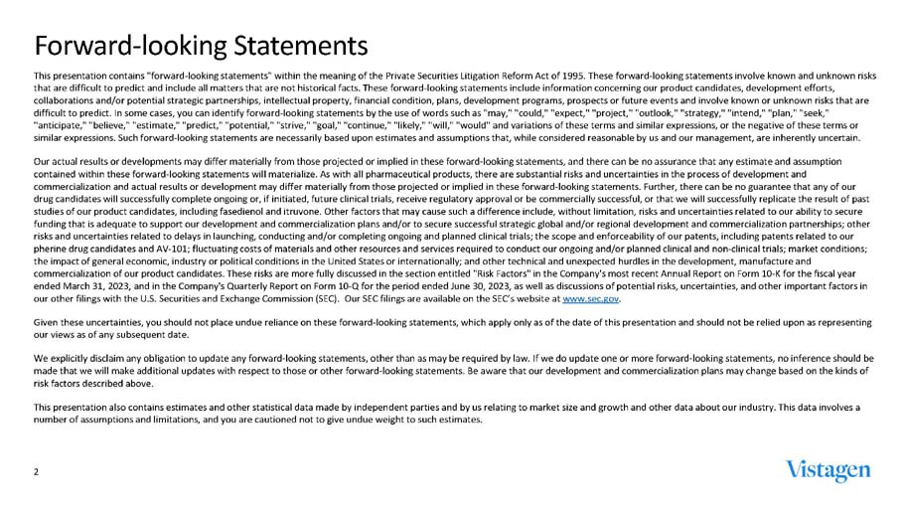

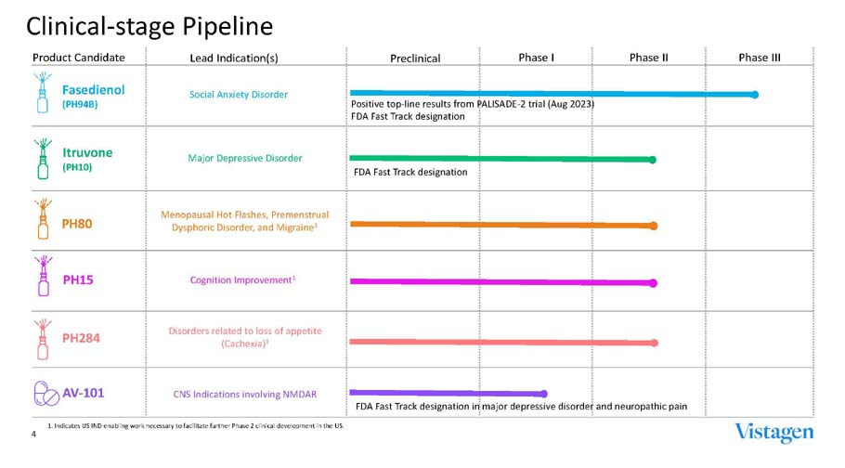



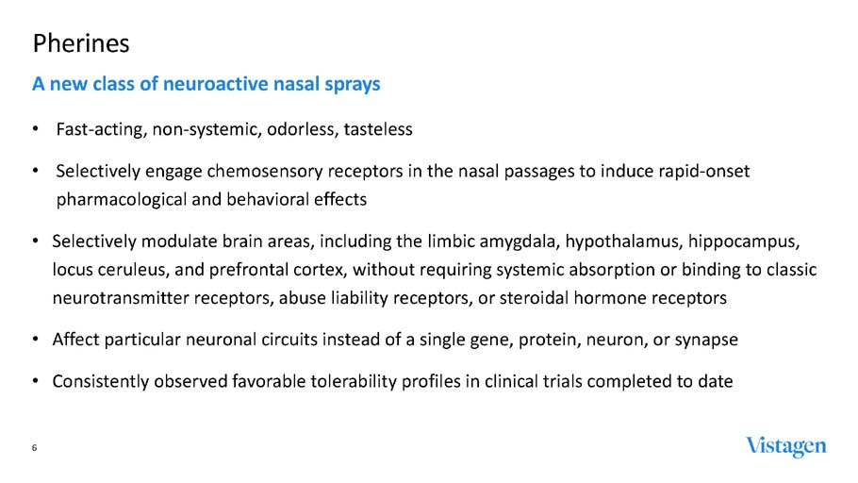





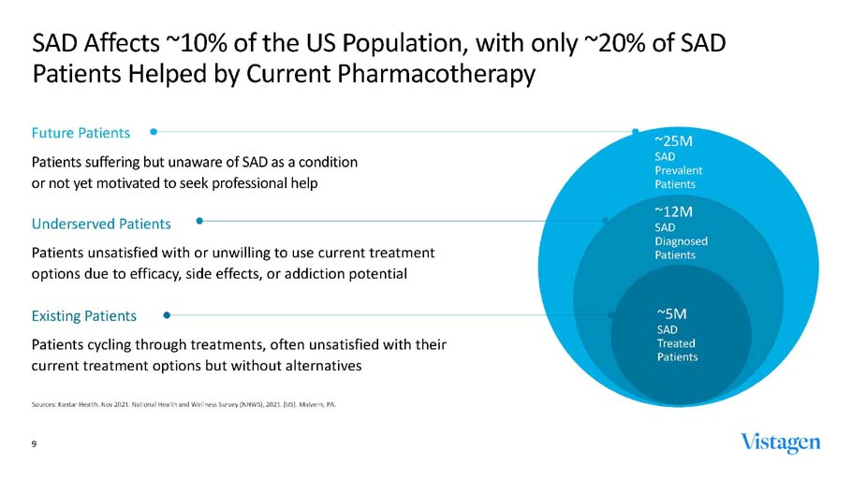



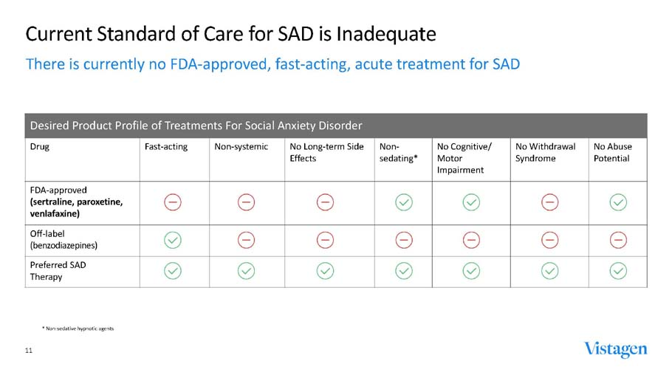

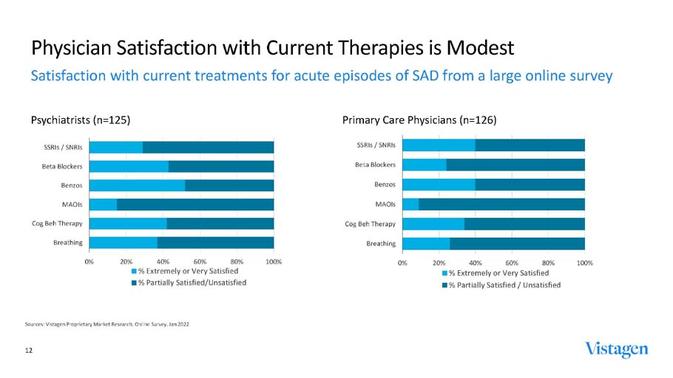

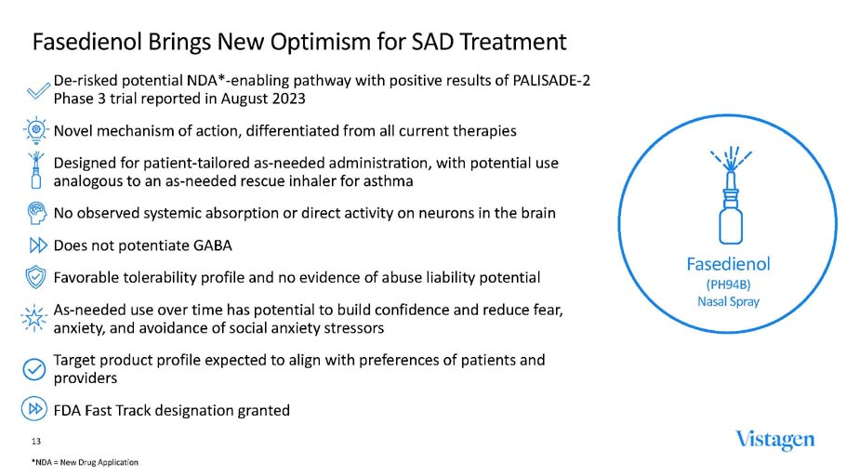

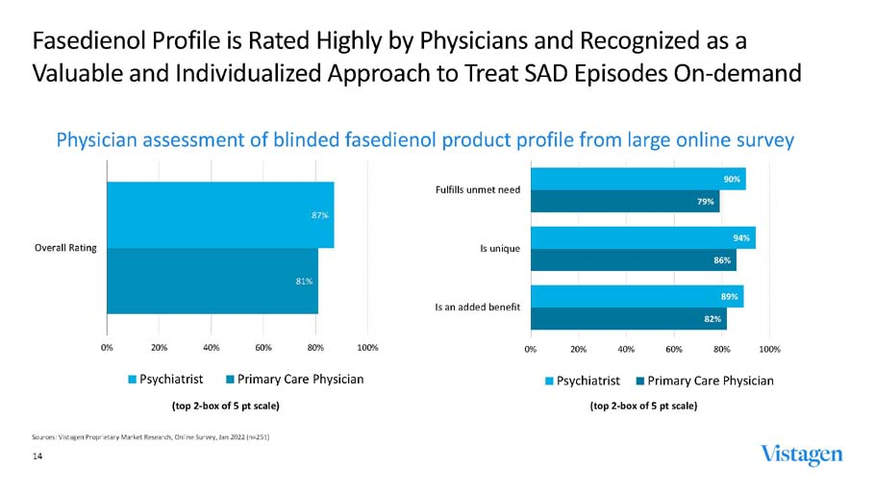

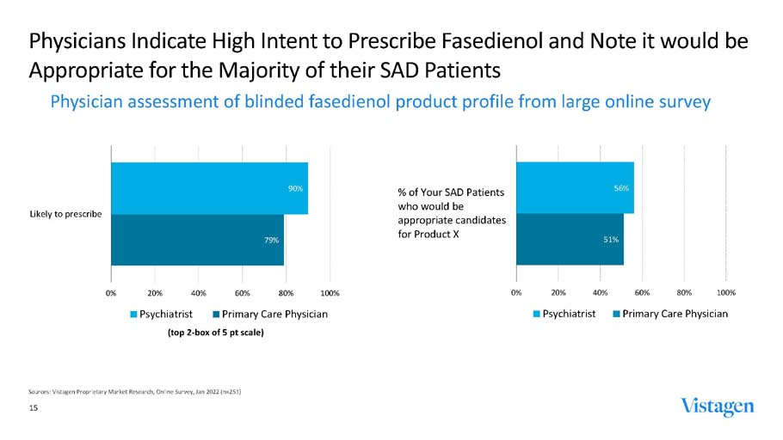



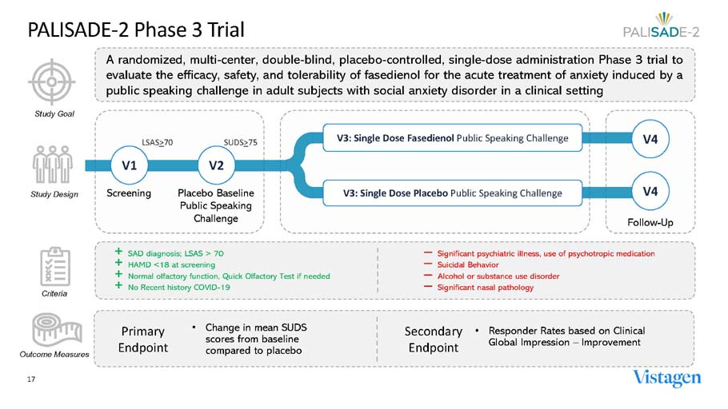

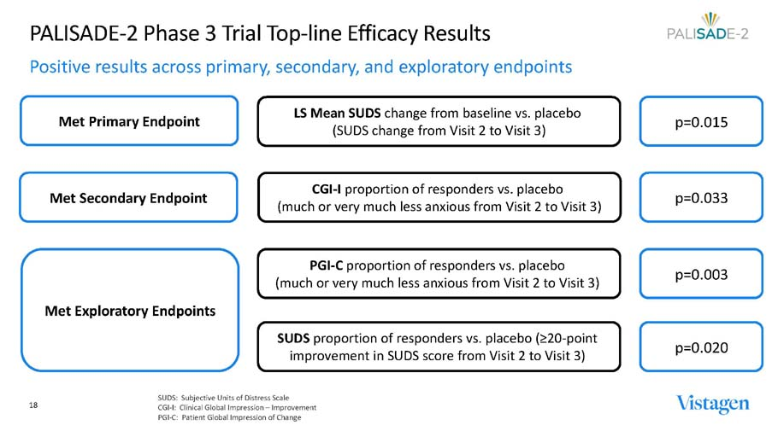

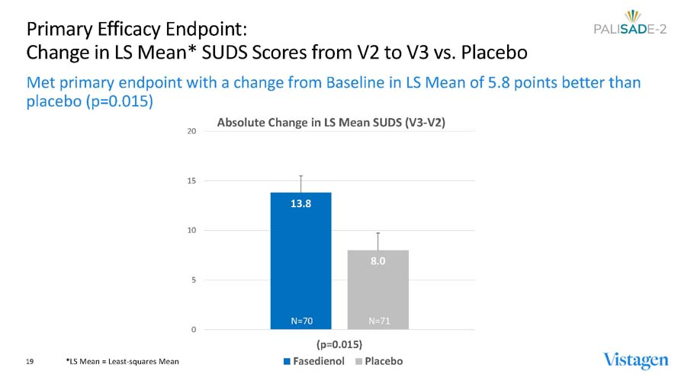

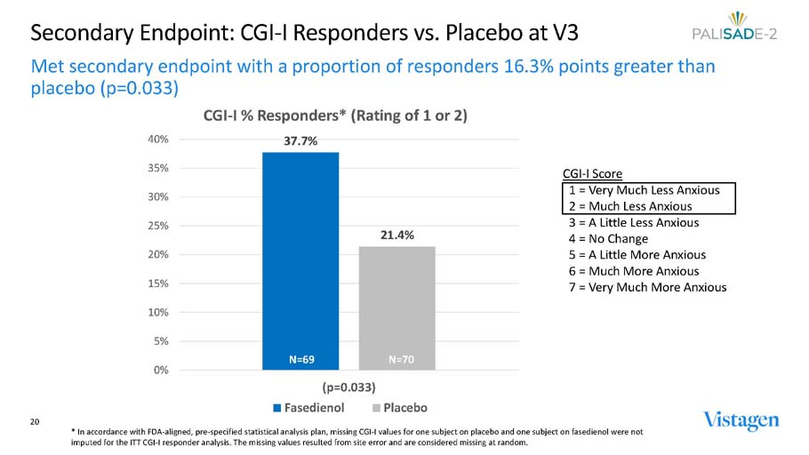

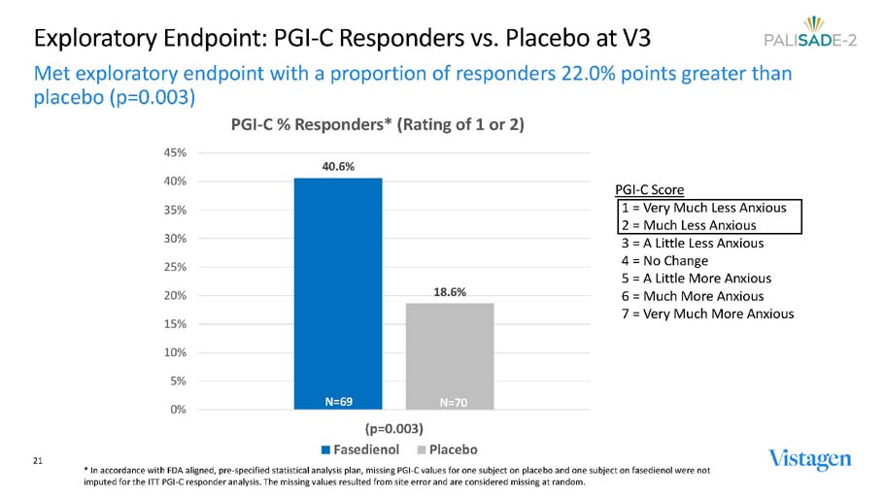

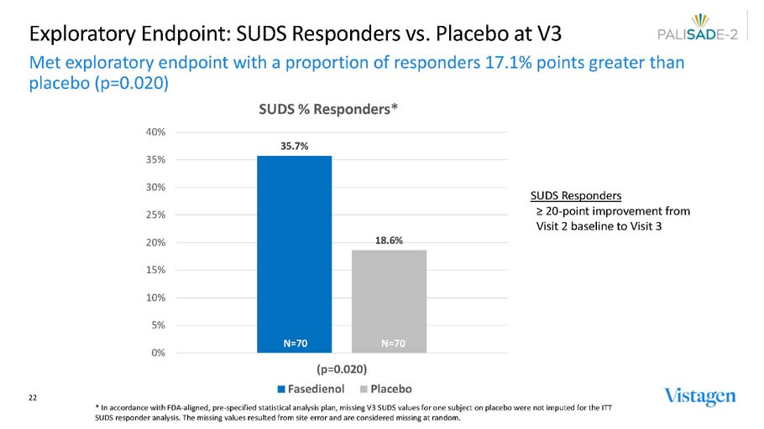

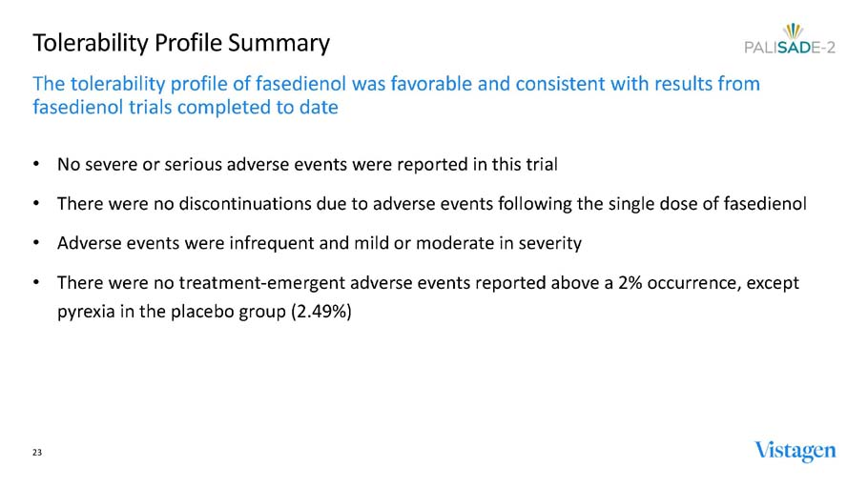

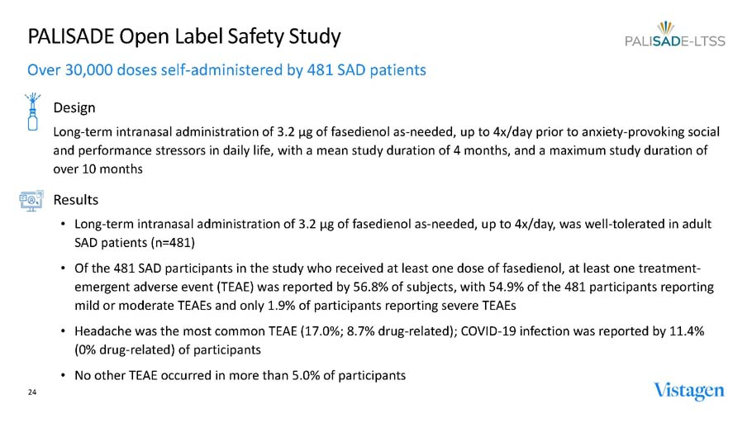

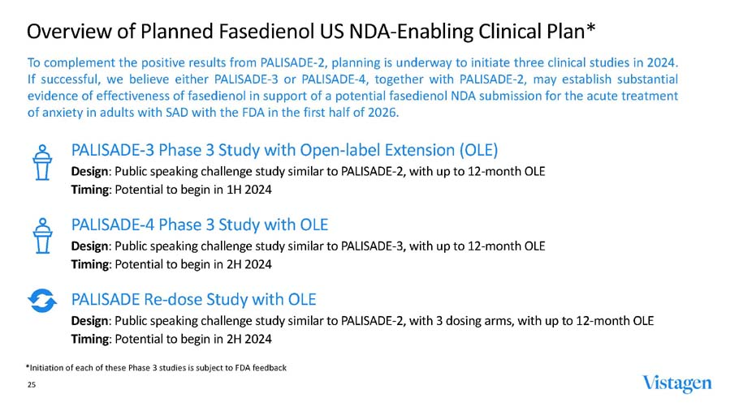

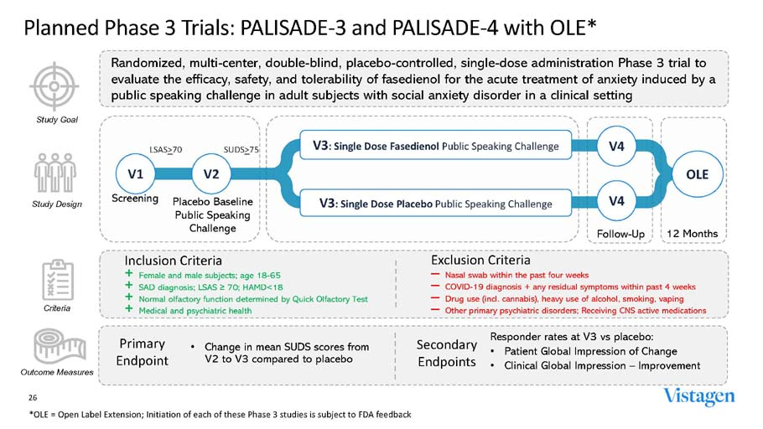

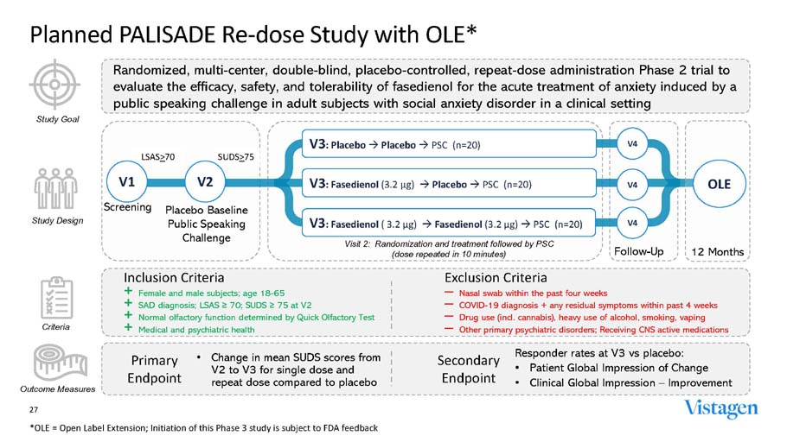



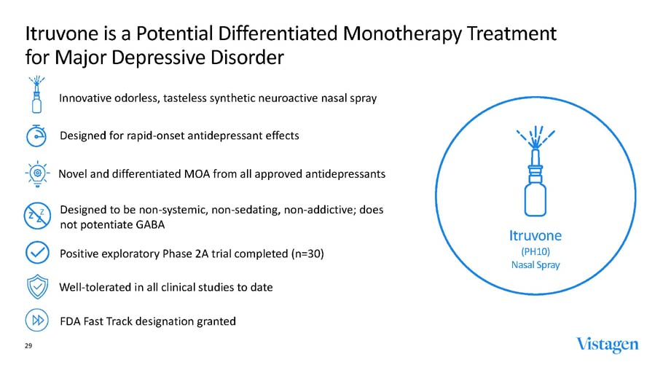

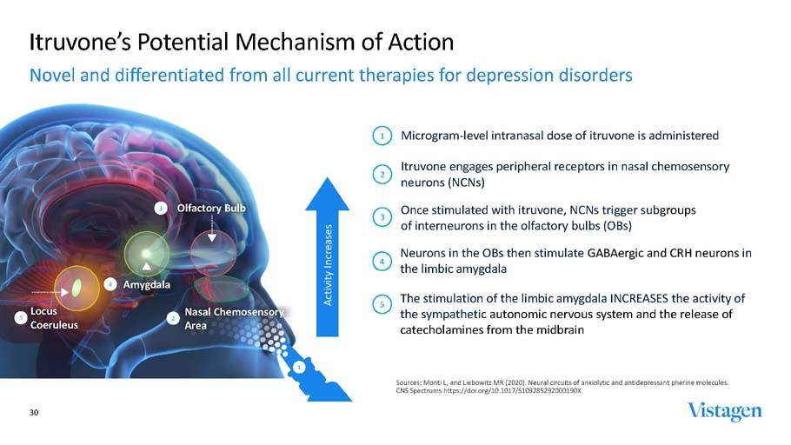

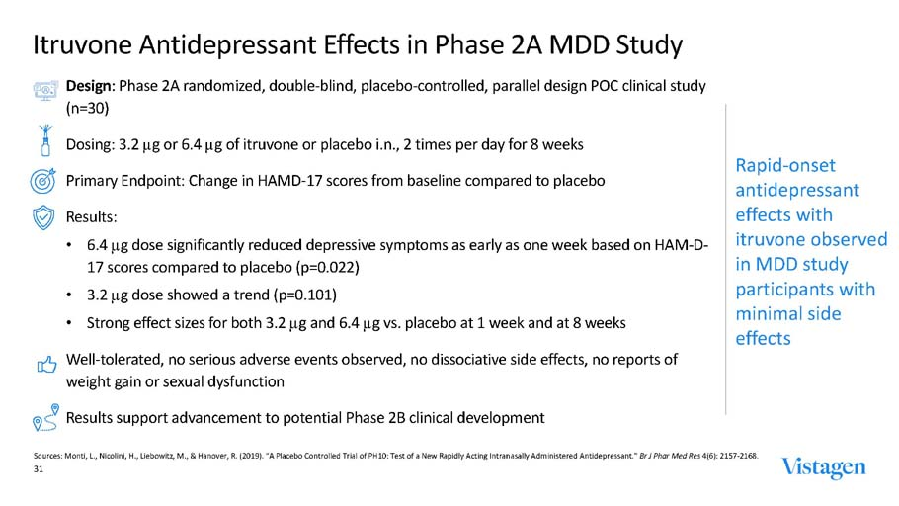

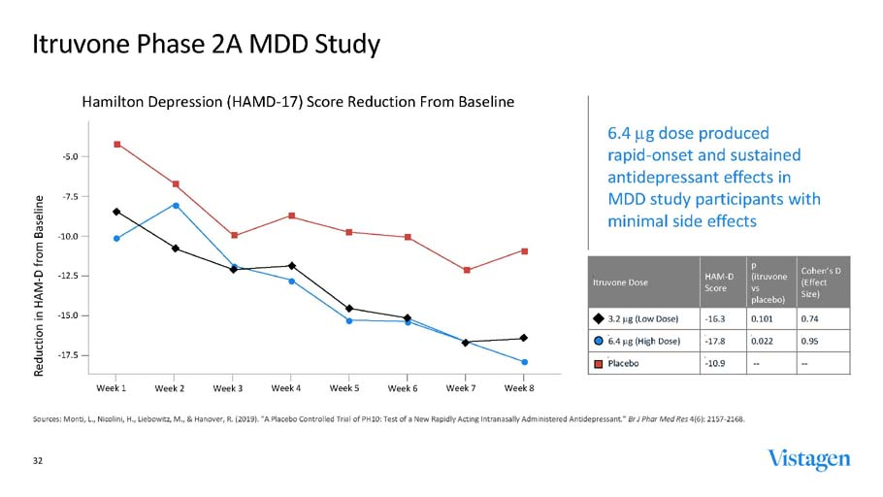

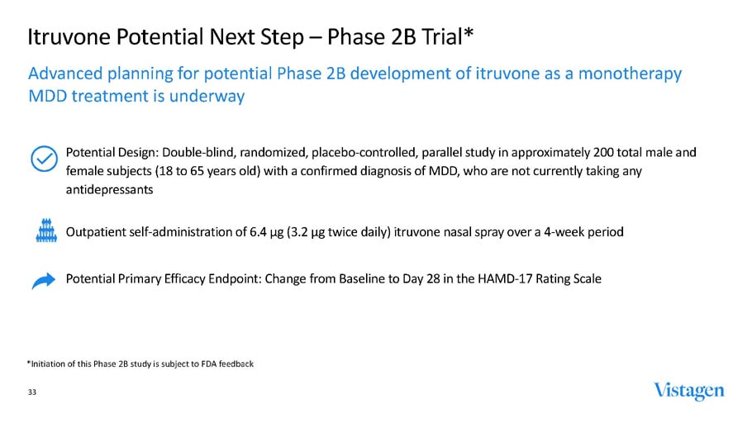



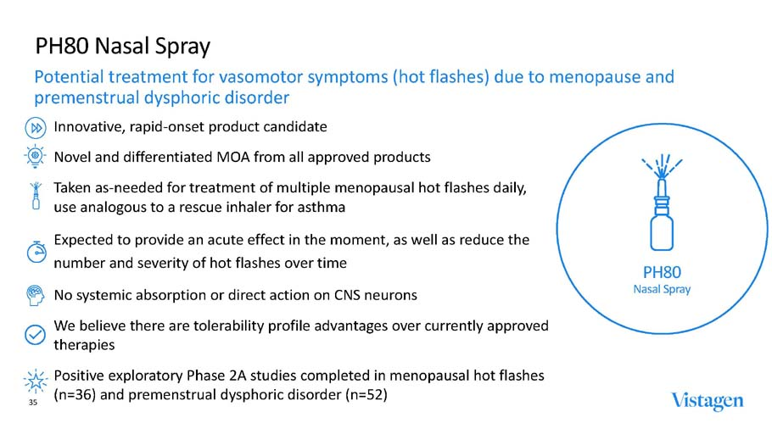

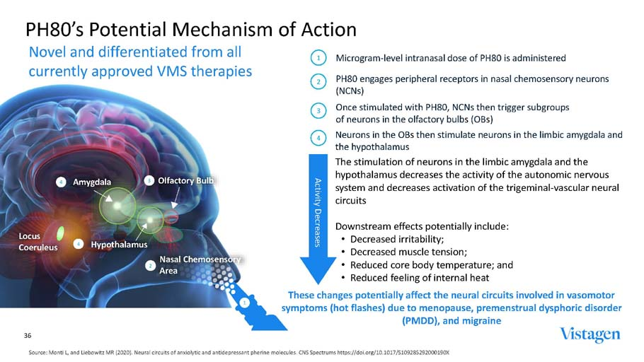

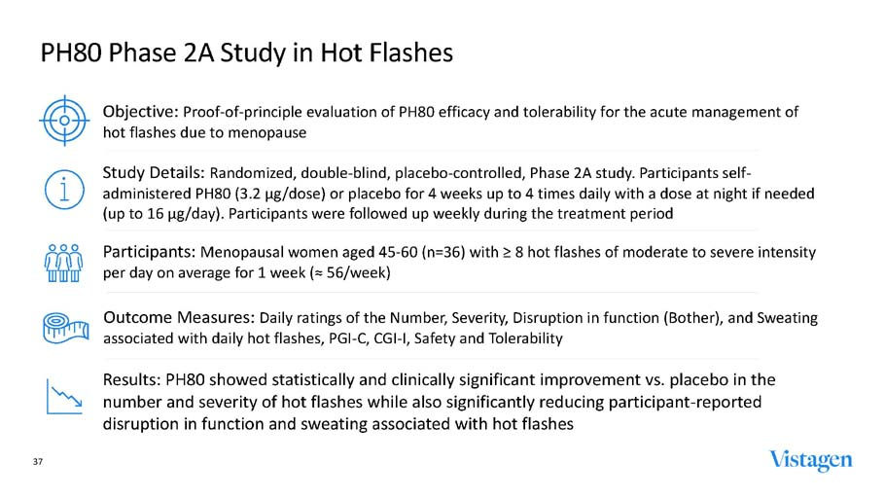

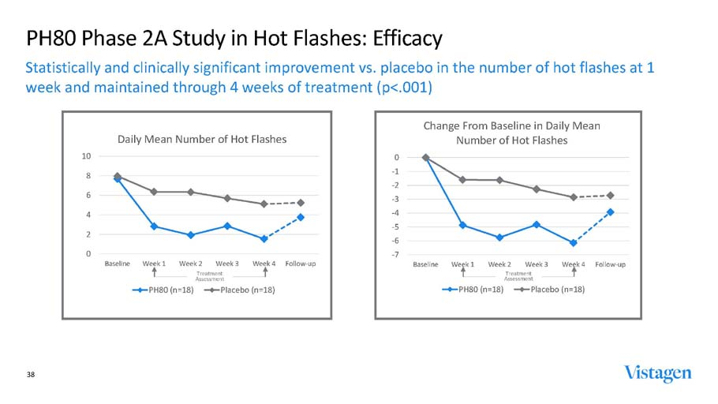

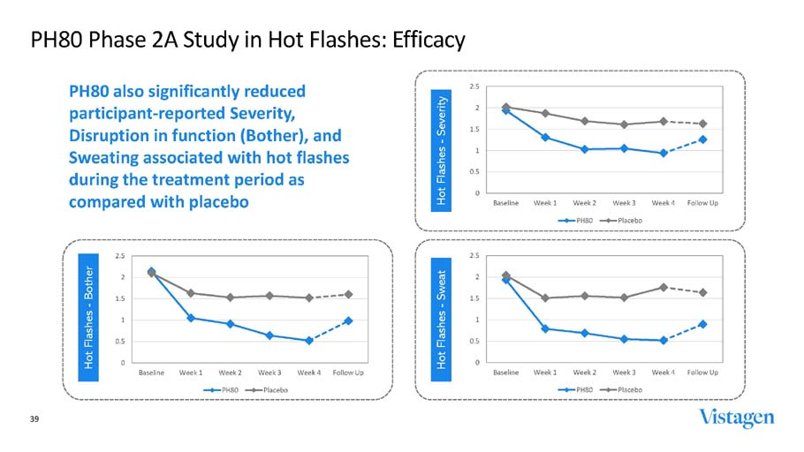

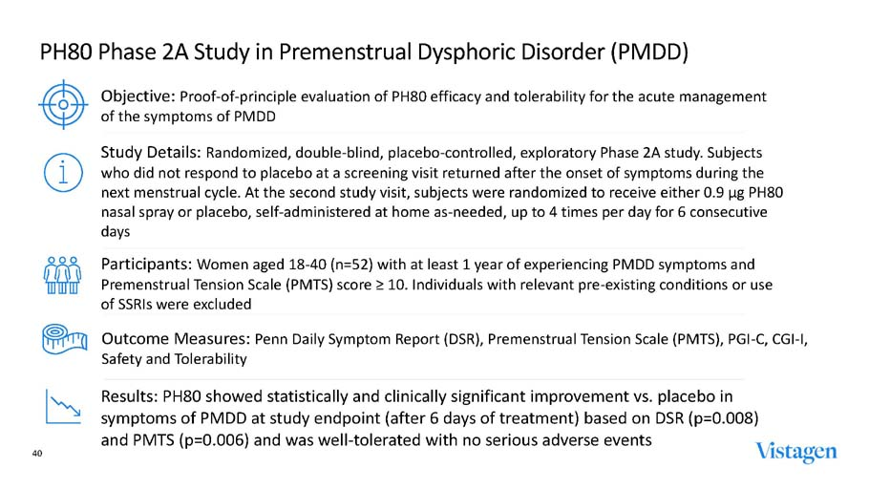

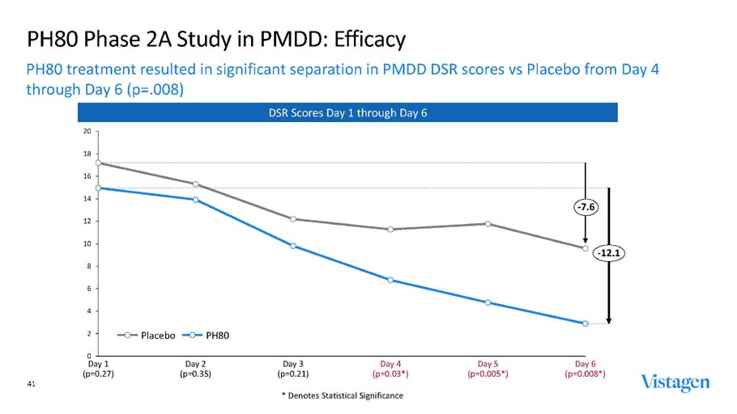

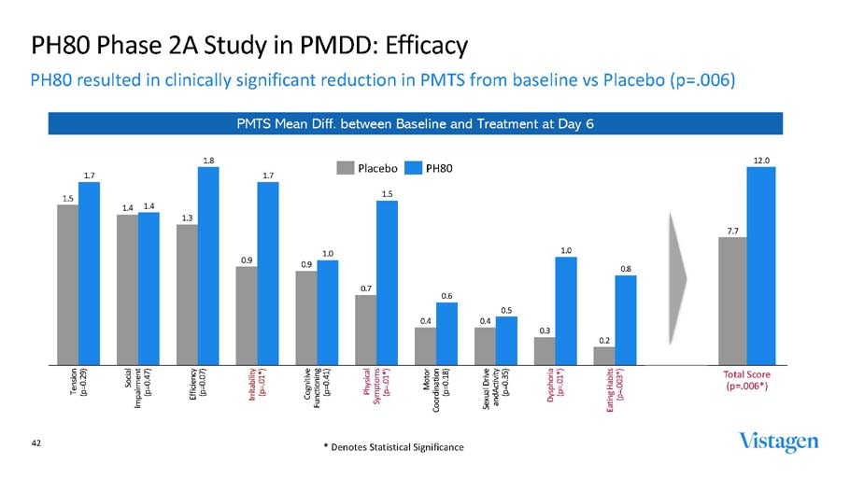



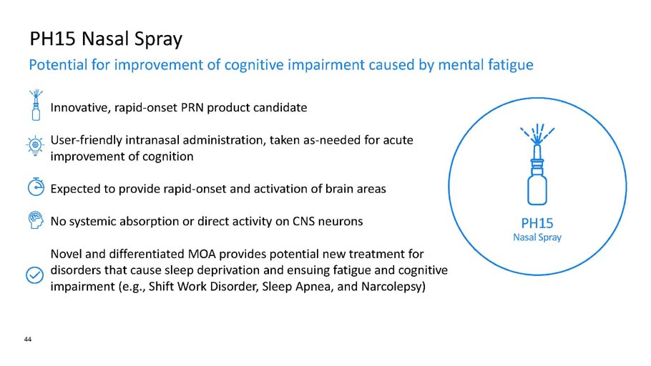

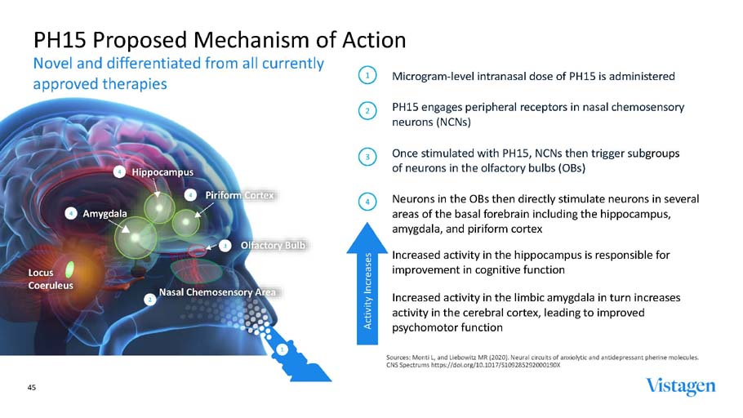



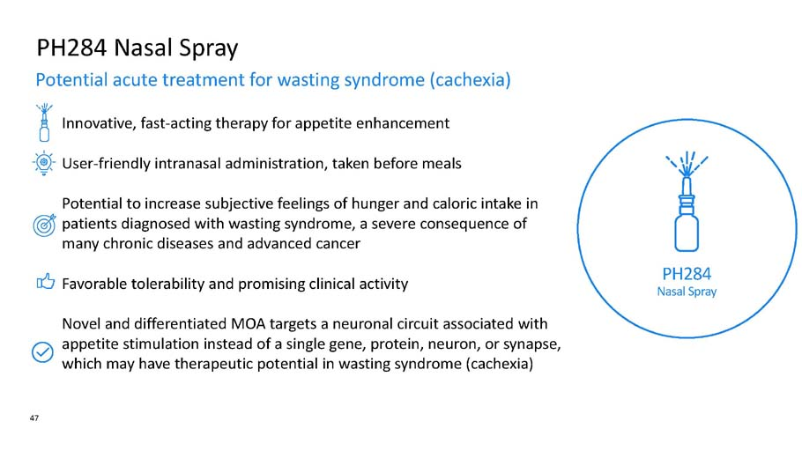





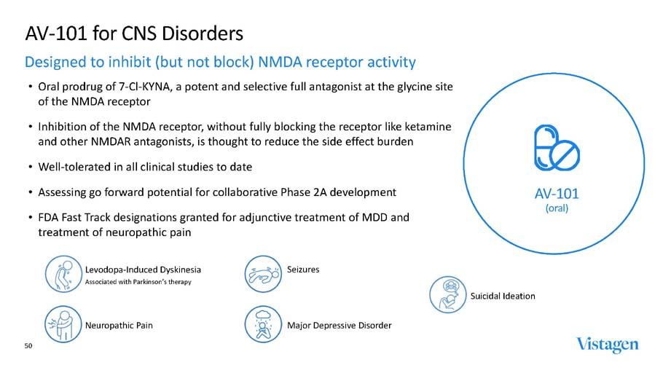

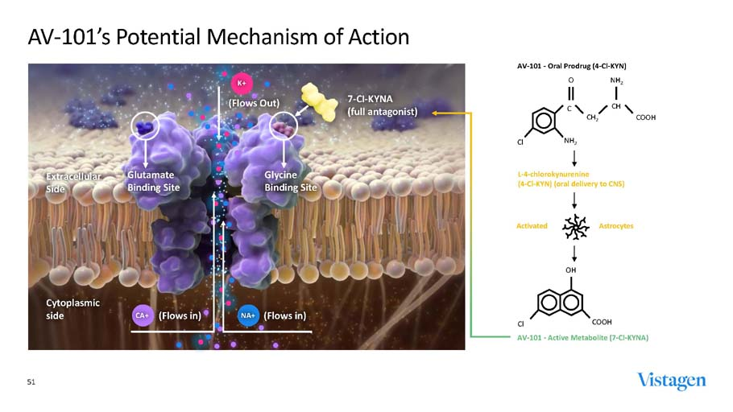

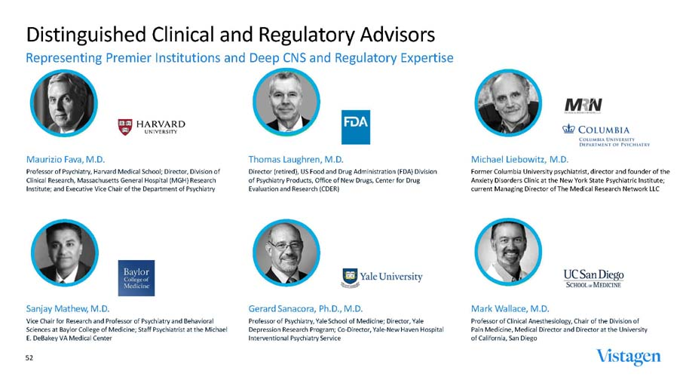





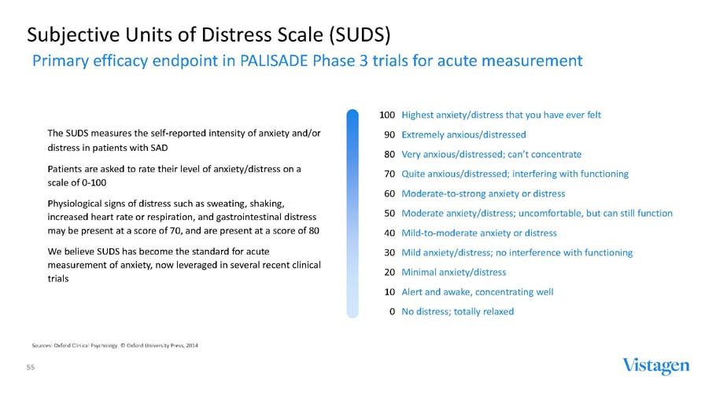

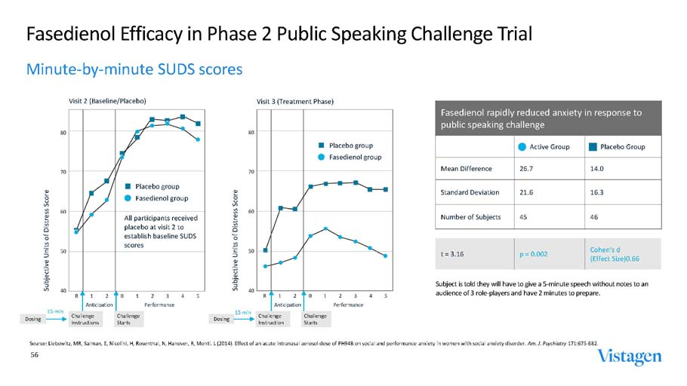

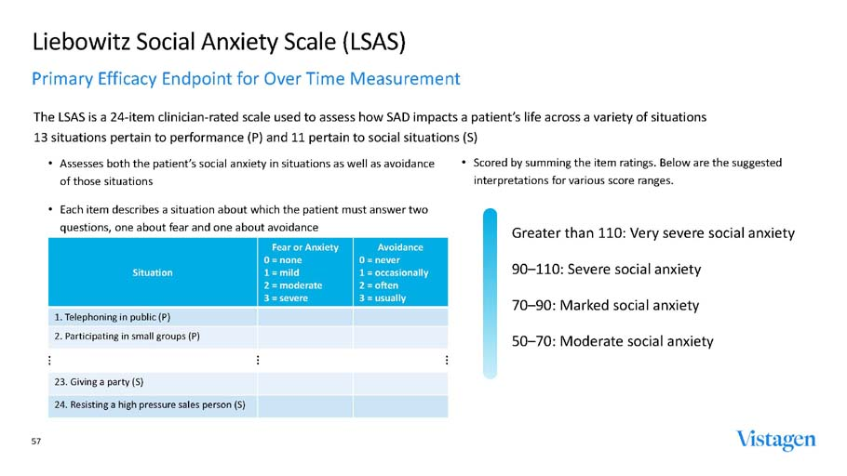

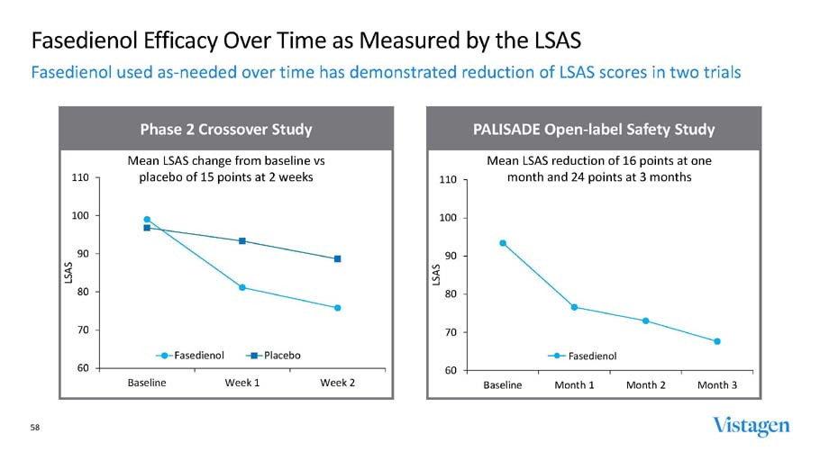

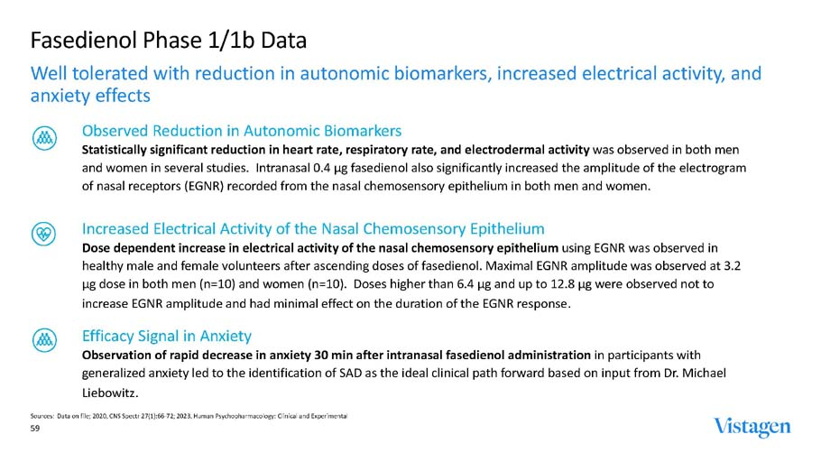

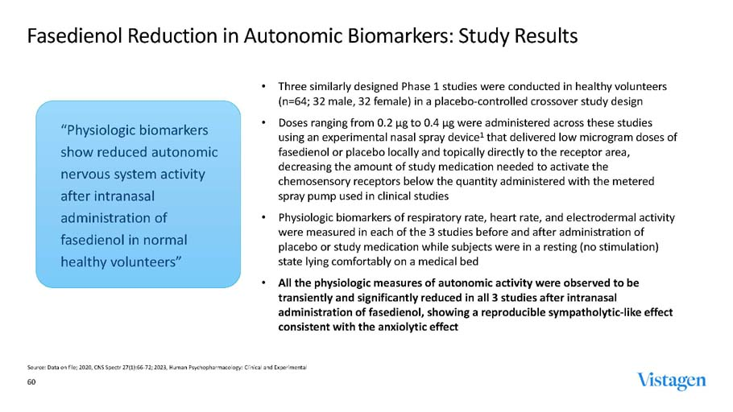

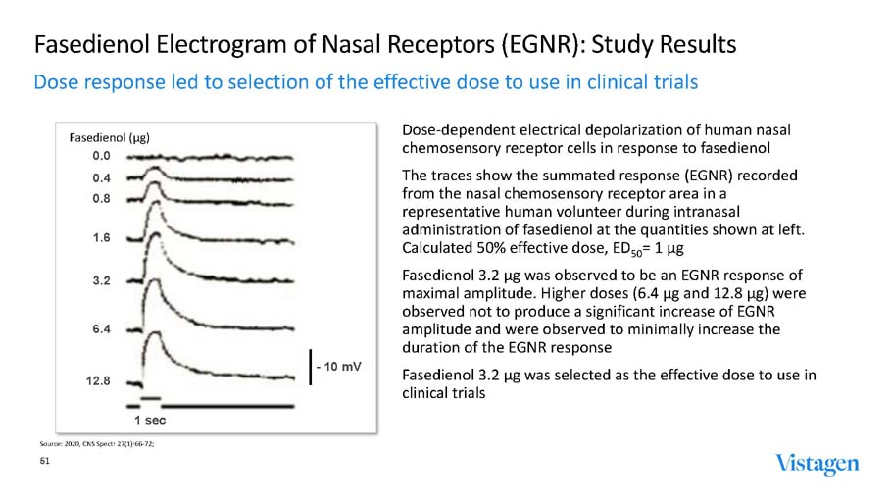

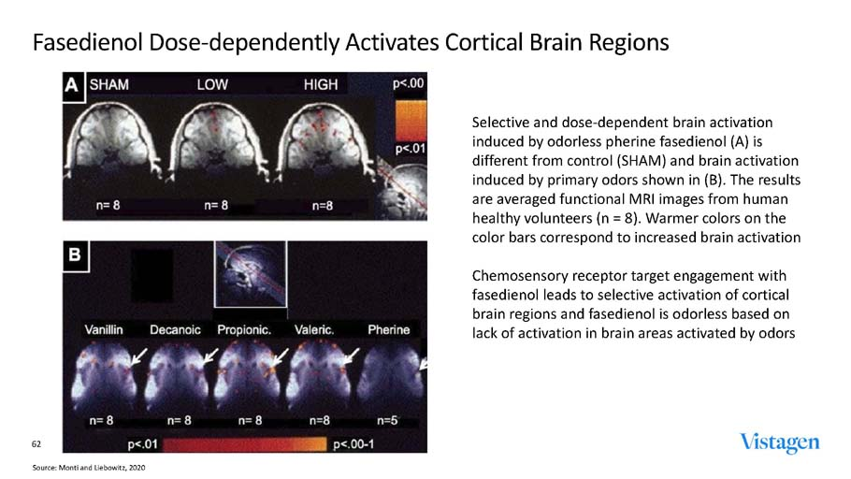

Exhibit 99.2



Vistagen Announces Pricing of $100 Million Underwritten Offering

October 2, 2023

SOUTH SAN FRANCISCO, Calif.--(BUSINESS WIRE)--Oct. 2, 2023-- Vistagen Therapeutics, Inc. (“Vistagen”) (Nasdaq: VTGN), a late clinical-stage biopharmaceutical company aiming to transform the treatment landscape for individuals living with anxiety, depression, and other central nervous system (“CNS”) disorders, today announced the pricing of a $100 million underwritten offering of its common stock (or pre-funded warrants to purchase common stock) and warrants to purchase common stock (or pre-funded warrants in lieu thereof), before deducting underwriting discounts and commissions and estimated offering expenses.

The financing was led by BVF Partners LP with participation from Commodore Capital, Great Point Partners, Logos Capital, Nantahala Capital, Surveyor Capital (a Citadel company), and TCGX along with additional institutional investors.

At a combined purchase price of $5.38 per share of common stock, accompanying T1 Warrant and accompanying T2 Warrant (as defined below), the offering consists of 15,010,810 shares of Vistagen common stock, accompanying warrants to purchase up to 9,294,022 shares of Vistagen common stock (or pre-funded warrants in lieu thereof) at an exercise price of $5.38 per share or pre-funded warrant (the “T1 Warrants”), and accompanying warrants to purchase up to 11,265,086 shares of its common stock (or pre-funded warrants in lieu thereof) at an exercise price of $8.877 per share or pre-funded warrant (the “T2 Warrants”); and, to certain investors in lieu of common stock, pre-funded warrants to purchase up to 3,577,240 shares of Vistagen common stock, accompanying T1 Warrants and accompanying T2 Warrants at a combined price of $5.379 per pre-funded warrant, accompanying T1 Warrant and accompanying T2 Warrant, which represents the per share offering price for the common stock, accompanying T1 Warrant and accompanying T2 Warrant less the $0.001 per share exercise price for each such pre-funded warrant, in each case before deducting underwriting discounts and commissions. Each share of common stock or pre-funded warrant will be sold with an accompanying T1 Warrant and T2 Warrant.

The total gross proceeds to Vistagen from this offering are expected to be approximately $100 million, before deducting underwriting discounts and commissions and estimated offering expenses payable by Vistagen and excluding any potential future proceeds of up to $50 million from the exercise of the T1 Warrants and up to $100 million from the exercise of the T2 Warrants. Vistagen intends to use the net proceeds from the offering, together with its existing cash and cash equivalents, for research, development, manufacturing, and regulatory expenses associated with development of its product candidates, including, primarily, its PALISADE Phase 3 program for fasedienol for the acute treatment of anxiety in adults with social anxiety disorder ("SAD"), and for other working capital and general corporate purposes. If its PALISADE Phase 3 program is successful, Vistagen believes the proceeds from this offering, together with its existing cash and cash equivalents, will be sufficient to fund its operations through its potential submission of a U.S. New Drug Application for fasedienol for the acute treatment of anxiety in adults with SAD. All of the shares of common stock, pre-funded warrants, T1 Warrants, and T2 Warrants to be sold in the offering are being sold by Vistagen. The offering is expected to close on October 4, 2023, subject to the satisfaction of customary closing conditions.

Jefferies, Stifel, and William Blair are acting as joint book-running managers for the offering.

These securities were offered by Vistagen pursuant to its existing shelf registration statement (File No. 333-254299) filed with the Securities and Exchange Commission (“SEC”) on March 15, 2021 and declared effective on March 26, 2021. A prospectus supplement describing the terms of the offering will be filed with the SEC and will form a part of the effective registration statement. When available, copies of the prospectus supplement and accompanying prospectus relating to the offering may be obtained by contacting Jefferies LLC, Attention: Equity Syndicate Prospectus Department, 520 Madison Avenue, 2nd Floor, New York, NY 10022, by telephone at (877) 547-6340, or by email at Prospectus_Department@Jefferies.com; Stifel, Nicolaus & Company, Incorporated, Attention: Syndicate, One Montgomery Street, Suite 3700, San Francisco, CA 94104, by telephone at (415) 364-2720, or by email at syndprospectus@stifel.com; or William Blair & Company, L.L.C., Attention: Prospectus Department, 150 North Riverside Plaza, Chicago, IL 60606, by telephone at (800) 621-0687, or by email at prospectus@williamblair.com. An electronic copy of the prospectus supplement and accompanying prospectus relating to the offering will be available on the SEC website at www.sec.gov.

This press release does not constitute an offer to sell or the solicitation of offers to buy any securities of Vistagen, and shall not constitute an offer, solicitation, or sale of any security in any state or jurisdiction in which such offer, solicitation, or sale would be unlawful prior to registration or qualification under the securities laws of any such state or jurisdiction.

About Vistagen

Vistagen is a late clinical-stage biopharmaceutical company aiming to transform the treatment landscape for individuals living with anxiety, depression, and other CNS disorders. Vistagen is advancing therapeutics with the potential to be faster-acting, and with fewer side effects and safety concerns, than those currently available for the treatment of anxiety, depression, and multiple CNS disorders. Vistagen’s pipeline includes six clinical-stage product candidates, including fasedienol, itruvone, PH80, PH15, and PH284, each an investigational agent belonging to a new class of drugs known as pherines, as well as AV-101, which is an oral prodrug of an antagonist of the N-methyl-D-aspartate receptor. Pherines are neuroactive nasal sprays designed with an innovative proposed mechanism of action that activates chemosensory neurons in the nasal cavity and can beneficially impact key neural circuits in the brain without systemic absorption or direct activity on neurons in the brain. Vistagen is passionate about transforming mental health care and redefining what is possible in the treatment of anxiety, depression, and several other CNS disorders.

Forward-looking Statements

Certain of the statements made in this press release are forward-looking, such as those, among others, relating to Vistagen’s expectations regarding the completion of the offering, including the anticipated use of proceeds therefrom. Actual results or developments may differ materially from those

projected or implied in these forward-looking statements. Factors that may cause such a difference include, without limitation, risks and uncertainties related to whether or not Vistagen will be able to raise capital through the sale of shares of common stock, pre-funded warrants, T1 Warrants, and T2 Warrants; the final terms of the offering, market, and other conditions; the satisfaction of customary closing conditions related to the offering; and the general economic, industry, or political conditions in the United States or internationally. There can be no assurance that Vistagen will be able to complete the offering on the anticipated terms, or at all. Vistagen will need to raise additional capital to fund its operations and may be unable to raise capital when needed, which would force Vistagen to delay, reduce, or eliminate its product development programs and/or commercialization efforts. You should not place undue reliance on these forward-looking statements, which apply only as of the date of this press release. Other risks and uncertainties include, but are not limited to, issues related to: adverse healthcare reforms and changes of laws and regulations; manufacturing and marketing risks; inadequate and/or untimely supply of one or more of Vistagen’s drug candidates to meet demand; entry of competitive products; and other technical and unexpected hurdles in the development, manufacture, and commercialization of its drug candidates, as well as those risks more fully discussed in the section entitled "Risk Factors" in Vistagen’s most recent Annual Report on Form 10-K for the year ended March 31, 2023, and in its most recent Quarterly Report on Form 10-Q for the quarter and three months ended June 30, 2023, as well as discussions of potential risks, uncertainties, and other important factors in its other filings with the SEC. Vistagen’s SEC filings are available on the SEC’s website at www.sec.gov. In addition, any forward-looking statements represent Vistagen’s views only as of the issuance of this release and should not be relied upon as representing its views as of any subsequent date. Vistagen explicitly disclaims any obligation to update any forward-looking statements.

View source version on businesswire.com: https://www.businesswire.com/news/home/20231002934206/en/

Investors
Mark McPartland
Senior Vice President, Investor Relations (650) 577-3606
markmcp@vistagen.com

Media
Nate Hitchings SKDK
nhitchings@skdknick.com

Source: Vistagen Therapeutics, Inc.

